Nolan Strait

CSE 446

24 October 2017

Assignment 2

**1)** Let’s define $sign\left(a\right)=\left\{\begin{aligned}+1 if a>0 \\ -1 otherwise\end{aligned}\right.$

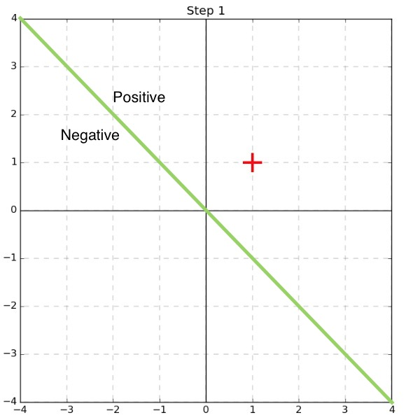

$$w={\left[0 0\right]}^{T}, x_{1}={\left[1 1\right]}^{T}, y_{1}=1$$

$$\hat{y}=sign\left({\left[0 0\right]}^{T}∙{\left[1 1\right]}^{T}\right)=sign\left(0\right)$$

Since this training example is on the boundary, we’ll count it as a mistake

$$w={\left[\begin{matrix}0 & 0\end{matrix}\right]}^{T}+1*{\left[\begin{matrix}1 & 1\end{matrix}\right]}^{T}={\left[\begin{matrix}1 & 1\end{matrix}\right]}^{T}$$

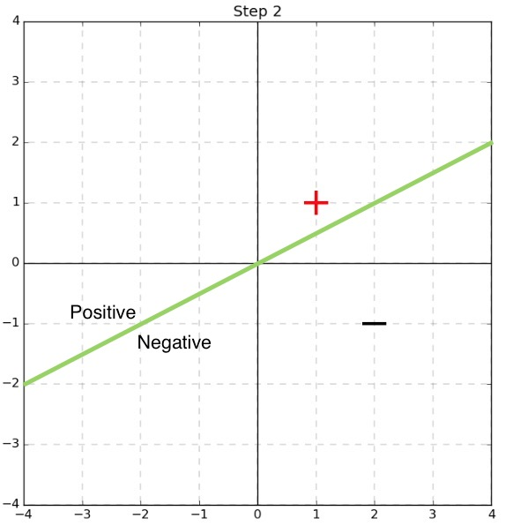

$$w={\left[\begin{matrix}1 & 1\end{matrix}\right]}^{T}, x_{2}={\left[2 -1\right]}^{T}, y_{2}=-1$$

$$\hat{y}=sign\left({\left[\begin{matrix}1 & 1\end{matrix}\right]}^{T}∙{\left[\begin{matrix}2 & -1\end{matrix}\right]}^{T}\right)=sign\left(1\right)=+1≠y_{2}$$

$$w={\left[\begin{matrix}1 & 1\end{matrix}\right]}^{T}-1*{\left[\begin{matrix}2 & -1\end{matrix}\right]}^{T}={\left[\begin{matrix}-1 & 2\end{matrix}\right]}^{T}$$

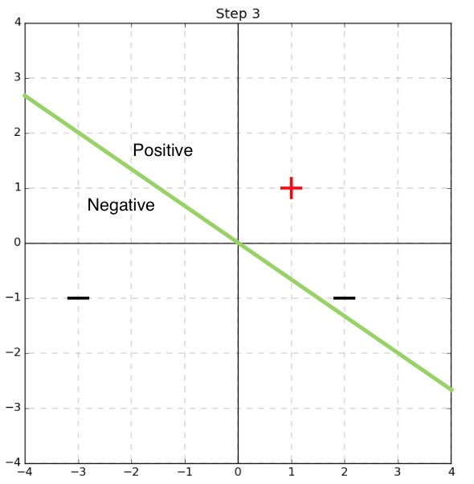

$$w={\left[\begin{matrix}-1 & 2\end{matrix}\right]}^{T}, x_{3}={\left[\begin{matrix}-3 & -1\end{matrix}\right]}^{T}, y_{3}=-1$$

$$\hat{y}=sign\left({\left[\begin{matrix}-1 & 2\end{matrix}\right]}^{T}∙{\left[\begin{matrix}-3 & -1\end{matrix}\right]}^{T}\right)=sign\left(1\right)=1≠y_{3}$$

$$w={\left[\begin{matrix}-1 & 2\end{matrix}\right]}^{T}-1*{\left[\begin{matrix}-3 & -1\end{matrix}\right]}^{T}={\left[\begin{matrix}2 & 3\end{matrix}\right]}^{T}$$

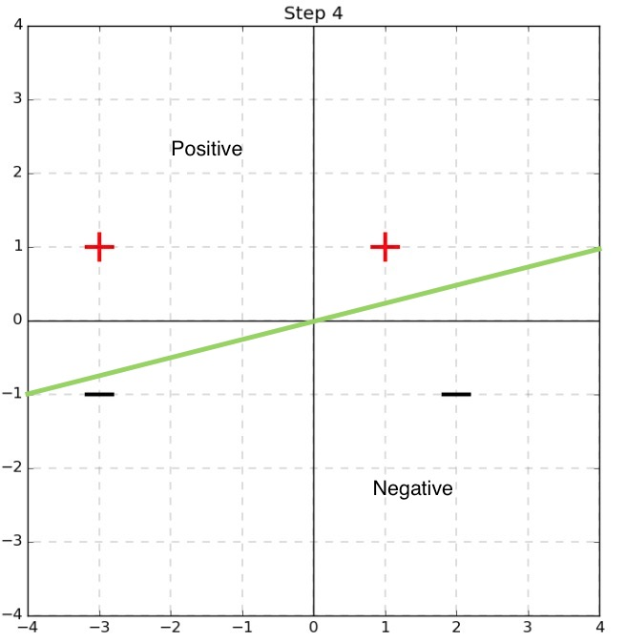

$$w={\left[\begin{matrix}2 & 3\end{matrix}\right]}^{T}, x_{4}={\left[\begin{matrix}-3 & 1\end{matrix}\right]}^{T}, y_{4}=1$$

$$\hat{y}=sign\left({\left[\begin{matrix}2 & 3\end{matrix}\right]}^{T}∙{\left[\begin{matrix}-3 & 1\end{matrix}\right]}^{T}\right)=sign\left(-3\right)=-1≠y_{4}$$

$$w={\left[\begin{matrix}2 & 3\end{matrix}\right]}^{T}+1*{\left[\begin{matrix}-3 & 1\end{matrix}\right]}^{T}={\left[\begin{matrix}-1 & 4\end{matrix}\right]}^{T}$$

**2)** Our learned perceptron does not maximize the margin between the training data and the decision boundary. Here is the maximized boundary:

