Kristine Trinh

nlt895

11190412

**UML State-Change-Model:**



The system can be in three states (excluding the initial and final states): Home State, DVD Mode and Internet Mode. Pressing the following buttons force the system to transit from one state to another: PowerBtn, PlayBtn, InternetBtn.

Both initial and final states represent the turned off player. Pressing PowerBtn turns the player on (transition from the initial state to Home State) if it was turned off and turns the player off (transition from any of the three above mentioned states to the final state) if it was turned on and doing something.

**UML Class Diagram: (Updated)**

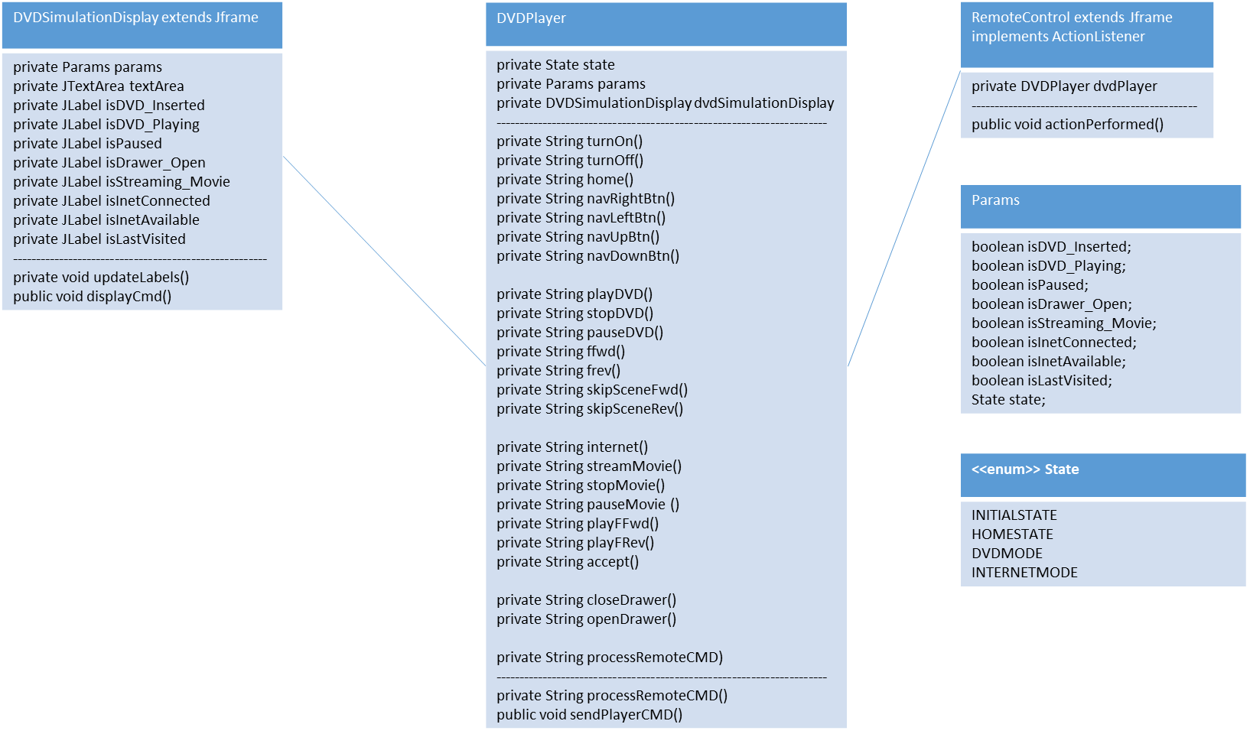

**Implementation:**

1. Execute main.java to run the program. (Note: The RemoteControl will appear on top of the DVD player display, so you need to drag the RemoteControl window to the other side to see the message after each performance)
2. The program consists of two windows, the first one representing the remote control:

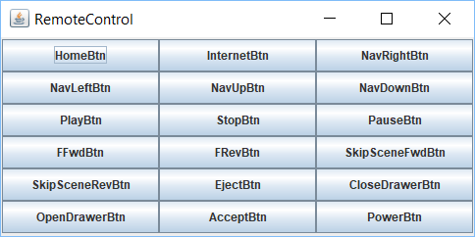

The user may press different buttons in response to which DVD Player will perform different operations.

The second window represents DVD Player:

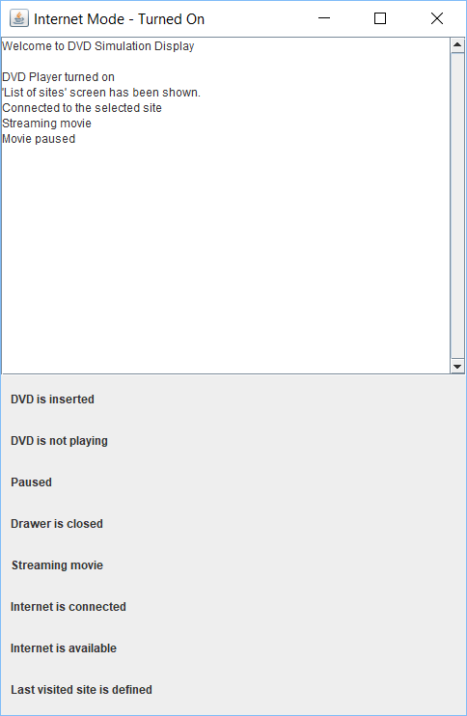

The upper half of the window textually shows the result of the operation, performed DVD Player in response to the user’s actions. The lower half of the window shows the state of different elements of the player, such as whether the drawer is open or closed etc.

1. There is an additional class called params.java in this program. The params class was added for clarity – to encapsulate a set of parameters and states as well. The DVDPlayer (the model in terms of MVC) class is responsible for the business logic of the program and relies on the DVDSimulationDisplay class for displaying the state/processes of the system. So it invokes:

…

dvdSimulationDisplay.displayCmd(result,params);

…

Without the Params class we would have to pass every single parameter (Boolean variable) – 9 in total – to achieve the same result.

It would have been to ugly/additional source for errors/problematic for modification.

And in the current version we only have to deal with the constructor of the Params class, which is much easier.