Class 05 R Graphics Intro

Nasha Luevit

Jan 22nd, 2019

# Class 05 R Graphics Intro

# my first boxplot   
x <- rnorm(1000,0)  
boxplot(x)

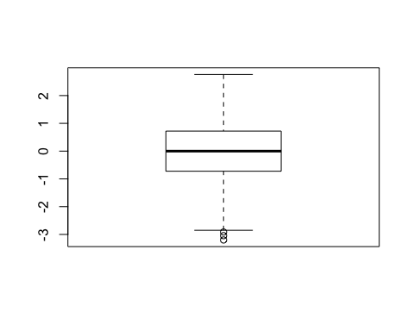

summary(x)

## Min. 1st Qu. Median Mean 3rd Qu. Max.   
## -3.199365 -0.723720 -0.000420 -0.006078 0.720524 2.759563

hist(x)

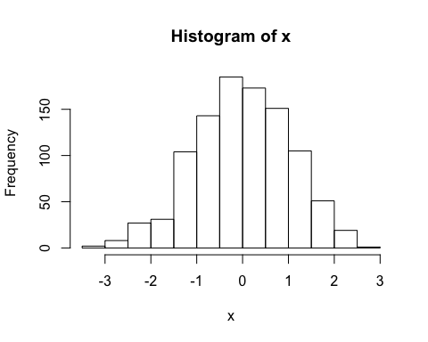

boxplot(x, horizontal = TRUE)

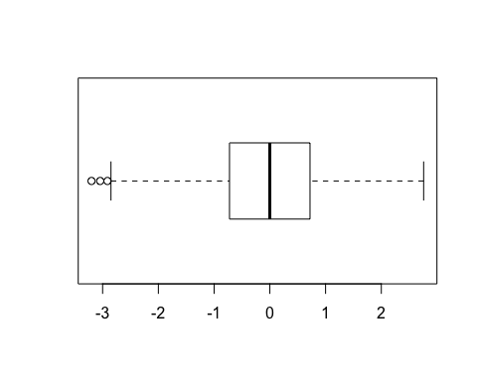

# Hands On Session  
  
#import weight chart into R  
#read.table("weight_chart.txt", header = TRUE)  
#read.table("weight_chart.txt", header = FALSE)  
weight <- read.table("bimm143_05_rstats/weight_chart.txt", header = TRUE)  
#graph weight chart with changes  
#plot(weight)  
plot(weight, typ = "o", pch = 15, cex = 1.5, lwd = 2, ylim = c(2,10), xlab = "Age (months)", ylab = "Weight (kg)", main = "Baby Weight with Age")

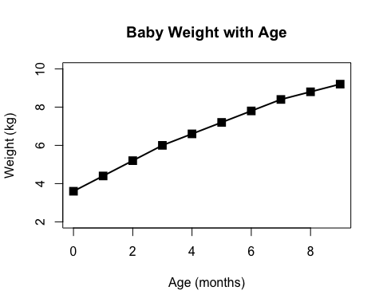

#import feature counts  
#read.table("feature_counts.txt", header = TRUE, sep = "\t")  
feature_counts <- read.table("bimm143_05_rstats/feature_counts.txt", header = TRUE, sep = "\t")  
#plot feature counts  
barplot(height = feature_counts[,2])  
barplot(feature_counts$Count)

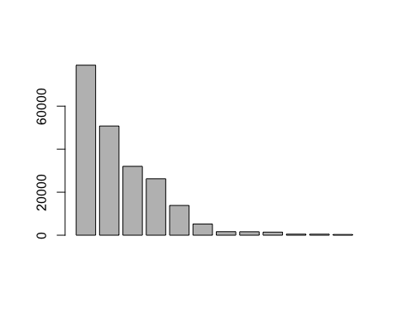

barplot(feature_counts$Count, horiz = TRUE, names.arg = feature_counts$Feature, main = "Number of Features in the Mouse GRCm38 Genome", las = 1, xlim = c(0,80000))  
#change margins so we can see the labels   
par()$mar

## [1] 5.1 4.1 4.1 2.1

par(mar = c(3.1, 11.1, 4.1, 2))  
barplot(feature_counts$Count, horiz = TRUE, names.arg = feature_counts$Feature, main = "Number of Features in the Mouse GRCm38 Genome", las = 1, xlim = c(0,80000))

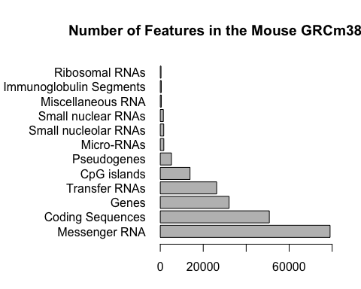

#import male female counts  
#read.table("male_female_counts.txt", header = TRUE, sep = "\t")  
male_female_counts <- read.table("bimm143_05_rstats/male_female_counts.txt", header = TRUE, sep = "\t")  
#plot male female counts  
barplot(male_female_counts$Count, names.arg = male_female_counts$Sample, ylab = "Counts", col = rainbow(10))  
barplot(male_female_counts$Count, names.arg = male_female_counts$Sample, ylab = "Counts", col = rainbow(nrow(male_female_counts)))

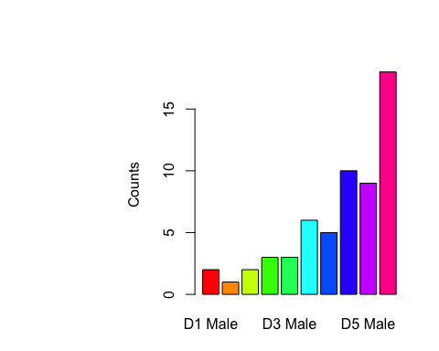

#plot with color by gender  
barplot(male_female_counts$Count, names.arg = male_female_counts$Sample, ylab = "Counts", col = c("blue2", "pink2"))

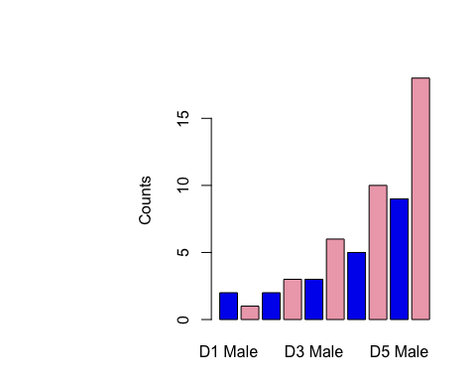

#import up down expression  
#read.table("up_down_expression.txt", header = TRUE, sep = "\t")  
up_down_expression <- read.table("bimm143_05_rstats/up_down_expression.txt", header = TRUE, sep = "\t")  
#plot up down expression  
plot.default(up_down_expression)

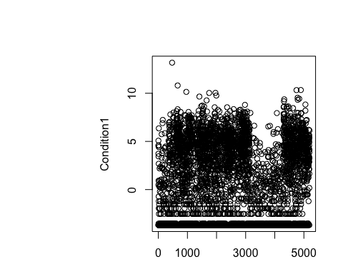

## determine how many genes are up, down, or unchanging  
table(up_down_expression$State)

##   
## down unchanging up   
## 72 4997 127

## plot w color by up, down, unchanging   
plot.default(up_down_expression$Condition1, up_down_expression$Condition2, ylab = "Expression Condition 2", xlab = "Expression Condition 1", col = up_down_expression$State)

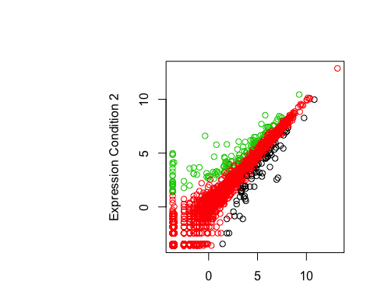

palette()

## [1] "black" "red" "green3" "blue" "cyan" "magenta" "yellow"   
## [8] "gray"

levels(up_down_expression$State)

## [1] "down" "unchanging" "up"

palette(c("blue", "gray", "red"))  
plot.default(up_down_expression$Condition1, up_down_expression$Condition2, ylab = "Expression Condition 2", xlab = "Expression Condition 1", col = up_down_expression$State)

