
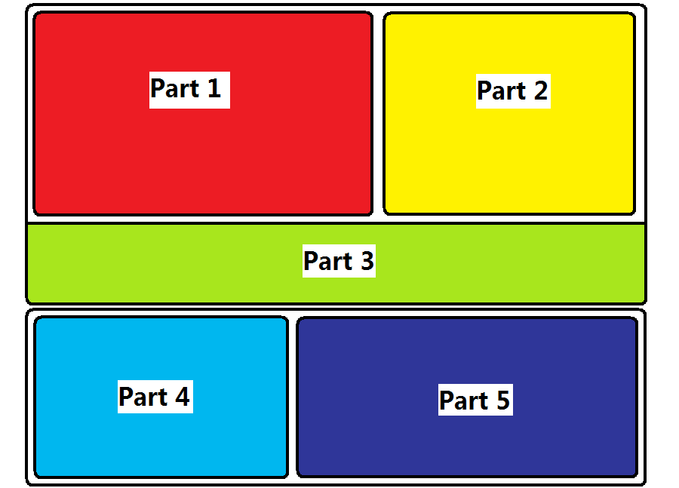

Part 1 – Displays result in graph with two curves
For example
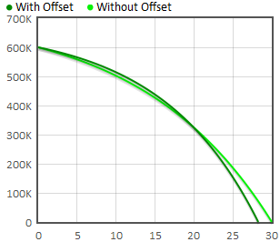

Part 2 – Displays the total repayment amount and period and presents the difference
For example
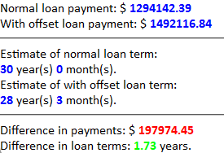
Part 3 – Users input details in this area
For example
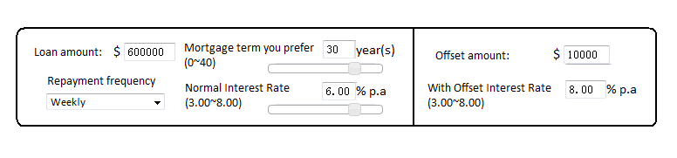
Part 4 – Users input the date and amount of expenses
For example
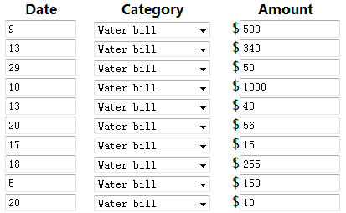
Part 5 – Displays the each expenses and the total amount of expenses
For example
