GIT LINK:- https://github.com/nlvmadhav/Drought_Info.git

**PROBLEM STATEMENT: -**

Though shortage of water triggers drought, it has been classified into various types viz., meteorological, hydrological, agricultural for better understanding, monitoring and management. Drought is characterized by its creeping onset and withdrawal and there can't be any definitive beginning or end of its occurrence. What is considered as a drought like condition in a particular climatic setting may not be considered to have the same impact in another climatic setting. Effective management and mitigation of drought impacts are not easy due to such ambiguities. Drought Management (2016) of the Ministry of Agriculture & Farmers' Welfare, Govt of India has desired that declaration of drought by the State Governments should be supported by the matrix-based analysis based on rainfall indices, hydrological indices, vegetative indices, progression of crop sowing and other parameters. Further, National Crisis Management Plan for Drought (2019) suggested a framework of crisis analysis with vulnerability magnitude, on a scale of 0-10, as area specific measure with appropriate strategic response matrix. With the available information and forecast by agencies on rainfall, soil moisture, surface and groundwater levels, color coded areas may be generated using google maps for display of vulnerability magnitude for the whole country at district/sub-district level. It may also be designed as easily accessible stand-alone App which can generate location specific notifications to the common user. It will aid in better monitoring and management of portents of drought by inter-ministerial Crop Weather Watch Group (CWWG) and State Drought Monitoring Centers (DMCs) apart from disseminating information to the general public.

**Reference websites**: -

1. Ref:http://agricoop.nic.in/sites/default/files/Manual%20Drought%202016.pdf
2. Ref: [http://agricoop.nic.in/sites/default/files/CRISISMANAGEMENT- PLAN 2019.pdf](http://agricoop.nic.in/sites/default/files/CRISISMANAGEMENT-%20PLAN%202019.pdf)

**Abstract: -**

Drought is **a prolonged dry period in the natural climate cycle.** They have the potential to cause severe economic and social impacts. In recent years, with the increasing frequency and severity of droughts India, the need for effective drought information and management is very much need of the day. Through this project we can effectively develop an integrated approach to drought management that combines the data like rain patterns, vegetation, reservoir levels, ground water levels, and provide the category of the drought in that area.

**Number of tables: -**

|  |  |  |  |
| --- | --- | --- | --- |
| **Table name** | **Number of columns** | **Primary key** | **Foreign key** |
| Rain | 2 | Dev_id | - |
| Vegetation | 2 | VCI_id | - |
| Moisture | 2 | MAI_id | - |
| Reservoir_Storage_Index | 2 | Storage_level_id | - |
| Groundwater | 2 | Groundwater_level_id | - |
| Area | 2 | Area_id | - |
| Crisis_evaluation_index | 2 | Category_of_drought | - |
| Matrix_impact_indicators | 6 | Area_id | primary keys of tables mentioned above |
| Area_rainfall | 3 | Area_id,Month | Area_id |
| Area_vegetation | 3 | Area_id,Month | Area_id |
| Area_moisture | 3 | Area_id,Month | Area_id |
| Area_groundwater | 3 | Area_id,Month | Area_id |
| Area_reservoir | 3 | Area_id,Month | Area_id |

**ENTITY-REALATIONSHIP DIAGRAM: -**

IMPACT_INDIACATORS table E-R diagram:

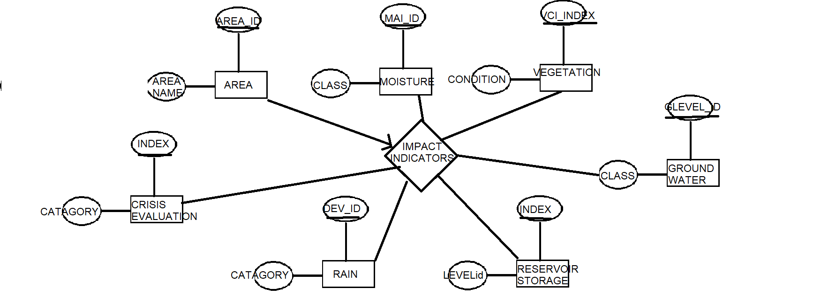

**DDL commands: -**

**DDL command for creation of rain table**

SQL> create table rain(

2 dev_id number,

3 rainfall_dev number,

4 category varchar2(20));

**Output: -**

SQL> desc rain

Name Null? Type

----------------------------------------- -------- ----------------------------

DEV_ID NOT NULL NUMBER

CATEGORY VARCHAR2(20)

**DDL command for creation of vegetation table**

SQL> create table vegetation(

2 vci_index number,

3 vegetation_condiation varchar2(20));

Table created.

**Output: -**

**SQL> desc vegetation**

Name Null? Type

----------------------------------------- -------- ----------------------------

VCI_INDEX NOT NULL NUMBER

VEGETATION_CONDIATION VARCHAR2(20)

**DDL command for creation of moisture table**

SQL> create table moisture(

2 MAI_ID number,

3 agriculture_drought_class varchar2(30));

Table created.

**Output**

SQL> desc moisture

Name Null? Type

----------------------------------------- -------- ----------------------------

MAI_ID NOT NULL NUMBER

AGRICULTURE_DROUGHT_CLASS VARCHAR2(30)

**DDL command for creation of reservoir_storage_index table**

SQL> create table Reservoir_Storage_Index(

2 storage_level_id number,

3 category varchar2(30));

Table created.

**Output**

SQL> desc reservoir_storage_index

Name Null? Type

----------------------------------------- -------- ----------------------------

STORAGE_LEVEL_ID NOT NULL NUMBER

CATEGORY VARCHAR2(30)

**DDL command for creation of groundwater table**

SQL> create table groundwater(

2 Groundwater_level_id number,

3 groundwater_deficit_class varchar2(30));

Table created.

**Output**

**SQL> desc groundwater**

Name Null? Type

----------------------------------------- -------- ----------------------------

GROUNDWATER_LEVEL_ID NOT NULL NUMBER

GROUNDWATER_DEFICIT_CLASS VARCHAR2(30)

**DDL command for creation of area table**

SQL> create table area(

2 area_Id number,

3 area_Name varchar2(30));

Table created.

**Output**

SQL> desc area

Name Null? Type

----------------------------------------- -------- ----------------------------

AREA_ID NOT NULL NUMBER

AREA_NAME VARCHAR2(30)

**DDL command for creation of crisis_evaluation_index table**

SQL> create table crisis_evaluation_index(

2 category_of_drought number,

3 phase_of_crisis varchar2(40));

Table created.

**Output**

SQL> desc crisis_evaluation_index

Name Null? Type

----------------------------------------- -------- ----------------------------

CATEGORY_OF_DROUGHT NOT NULL NUMBER

PHASE_OF_CRISIS VARCHAR2(40)

**DDL command for creation of matrix_impact_indiacatiors**

SQL> create table matrix_impact_indicators(

2 area_Id number,

3 dev_id number,

4 vci_index number,

5 storage_level_id number,

6 groundwater_level_id number,

7 category_of_drought number);

Table created.

**Output**

SQL> desc matrix_impact_indicators

Name Null? Type

----------------------------------------- -------- ----------------------------

AREA_ID NOT NULL NUMBER

DEV_ID NUMBER

VCI_INDEX NUMBER

STORAGE_LEVEL_ID NUMBER

GROUNDWATER_LEVEL_ID NUMBER

CATEGORY_OF_DROUGHT NUMBER

**DDL command for creation of area_rainfall**

SQL> create table area_rainfall(

2 area_id number,

3 rainfall number,

4 month varchar2(20));

Table created.

**Output**

SQL> desc area_rainfall

Name Null? Type

----------------------------------------- -------- ----------------------------

AREA_ID NUMBER

RAINFALL NUMBER

MONTH VARCHAR2(20)

**DDL command for creation of area_vegetation**

SQL> create table area_vegetation(

2 area_id number,

3 vci_percentage number,

4 month varchar2(20),

Tablecreated.

**Output**

SQL> desc area_vegetation

Name Null? Type

----------------------------------------- -------- ----------------------------

AREA_ID NOT NULL NUMBER

VCI_PERCENTAGE NUMBER

MONTH NOT NULL VARCHAR2(20)

**DDL command for creation of area_moisture**

SQL> create table area_moisture(

2 area_id number,

3 percent_availabel_soil_moisture number,

4 month varchar2(20),

Table created.

**Output**

SQL> desc area_moisture

Name Null? Type

----------------------------------------- -------- ------------------------------------------

AREA_ID NOT NULL NUMBER

PERCENT_AVAILABEL_SOIL_MOISTURE NUMBER

MONTH NOT NULL VARCHAR2(20)

**DDL command to create area_reservoir_storage table**

SQL> create table area_reservoir_storage(

2 area_id number,

3 percent_deficit number,

4 month varchar2(20));

Table created.

**Output**

SQL> desc area_reservoir_storage;

Name Null? Type

----------------------------------------- -------- ----------------------------

AREA_ID NOT NULL NUMBER

PERCENT_DEFICIT NUMBER

MONTH NOT NULL VARCHAR2(20)

**DDL command to create area_groundwater table**

SQL> create table area_groundwater(

2 area_id number,

3 groundwater_drought_index number,

4 month varchar2(20),

Table created.

**Output**

SQL> desc area_groundwater

Name Null? Type

----------------------------------------- -------- ----------------------------

AREA_ID NOT NULL NUMBER

GROUNDWATER_DROUGHT_INDEX NUMBER

MONTH NOT NULL VARCHAR2(20)

**DDL command for establishing constraints on rain table**

SQL> alter table rain add primary key(dev_id);

Table altered.

**DDL command for establishing constraints on vegetation table**

SQL> alter table vegetation add primary key(vci_index);

Table altered.

**DDL command for establishing constraints on moisture table**

SQL> alter table moisture add primary key(mai_id);

Table altered.

**DDL command for establishing constraints on reservoir_storage_index table**

SQL> alter table Reservoir_Storage_Index add primary key(storage_level_id);

Table altered.

**DDL command for establishing constraints on groundwater table**

SQL> alter table groundwater add primary key(Groundwater_level_id);

Table altered.

**DDL command for establishing constraints on area table**

SQL> alter table area add primary key(area_id);

Table altered.

**DDL command for establishing constraints on crisis_evaluation_index table**

SQL> alter table crisis_evaluation_index add primary key(category_of_drought);

Table altered.

**DDL command for establishing constraints on matrix_impact_indicator table**

SQL> alter table matrix_impact_indicators add foreign key(area_Id) references area on delete cascade;

Table altered.

SQL> alter table matrix_impact_indicators add primary key(area_id);

Table altered.

SQL> alter table matrix_impact_indicators add foreign key(dev_id) references rain on delete cascade;

Table altered.

SQL> alter table matrix_impact_indicators add foreign key(vci_index) references vegetation on delete cascade;

Table altered.

SQL> alter table matrix_impact_indicators add foreign key(storage_level_id) references reservoir_storage_index on delete cascade;

Table altered.

SQL> alter table matrix_impact_indicators add foreign key( groundwater_level_id) references groundwater on delete cascade;

Table altered.

SQL> alter table matrix_impact_indicators add foreign key(category_of_drought) references crisis_evaluation_index on delete cascade;

Table altered.

**DDL command for establishing constraints on area_rainfall table**

SQL> alter table area_rainfall add primary key(area_id,month);

Table altered.

SQL> alter table area_rainfall add foreign key(area_id) references area;

Table altered.

**DDL command for establishing constraints on area_vegetation table**

SQL> alter table area_vegetation add primary key(area_id,month);

Table altered.

SQL> alter table area_vegetation add foreign key(area_id) references area;

Table altered.

**DDL command for establishing constraints on area_moisture table**

SQL> alter table area_moisture add primary key(area_id,month);

Table altered.

SQL> alter table area_moisture add foreign key(area_id) references area;

Table altered.

**DDL command for establishing constraints on area_reservoir_storage_index table**

SQL> alter table area_reservoir_storage add primary key(area_id,month);

Table altered.

SQL> alter table area_reservoir_storage add foreign key(area_id) references area;

Table altered.

**DDL command for establishing constraints on area_groundwater_index table**

SQL> alter table area_groundwater add primary key(area_id,month);

Table altered.

SQL> alter table area_groundwater add foreign key(area_id) references area;

Table altered.

**DML commands: -**

**DML command to insert values into rain table**

SQL> insert into rain values(&dev_id,'&category');

Enter value for dev_id: 0

Enter value for category: normal

old 1: insert into rain values(&dev_id,'&category')

new 1: insert into rain values(0,'normal')

1 row created.

SQL> /

Enter value for dev_id: 1

Enter value for category: deficient

old 1: insert into rain values(&dev_id,'&category')

new 1: insert into rain values(1,'deficient')

1 row created.

SQL> /

Enter value for dev_id: 2

Enter value for category: large deficient

old 1: insert into rain values(&dev_id,'&category')

new 1: insert into rain values(2,'large deficient')

1 row created.

SQL> /

Enter value for dev_id: 3

Enter value for category: no rain

old 1: insert into rain values(&dev_id,'&category')

new 1: insert into rain values(3,'no rain')

1 row created.

**Output: -**

SQL> select * from rain;

DEV_ID CATEGORY

---------- --------------------

0 normal

1 deficient

2 large deficient

3 no rain

**DML command to insert values into vegetation table**

SQL> insert into vegetation values(&vci_index,'&vegetation_condition');

Enter value for vci_index: 0

Enter value for vegetation_condition: good

old 1: insert into vegetation values(&vci_index,'&vegetation_condition')

new 1: insert into vegetation values(0,'good')

1 row created.

SQL> /

Enter value for vci_index: 1

Enter value for vegetation_condition: fair

old 1: insert into vegetation values(&vci_index,'&vegetation_condition')

new 1: insert into vegetation values(1,'fair')

1 row created.

SQL> /

Enter value for vci_index: 2

Enter value for vegetation_condition: poor

old 1: insert into vegetation values(&vci_index,'&vegetation_condition')

new 1: insert into vegetation values(2,'poor')

1 row created.

**Output**

SQL> select * from vegetation;

VCI_INDEX VEGETATION_CONDIATIO

--------------- -------------------------

0 good

1 fair

2 poor

**DML command to insert values into moisture table**

SQL> insert into moisture

values(&mai_id,'&agriculture_dorught_class');

Enter value for mai_id: 0

Enter value for agriculture_dorught_class: no drought

old 1: insert into moisture

values(&mai_id,'&agriculture_dorught_class')

new 1: insert into moisture values(0,'no drought')

1 row created.

SQL> /

Enter value for mai_id: 1

Enter value for agriculture_dorught_class: mild drought

old 1:

insert into moisture values(&mai_id,'&agriculture_dorught_class')

new 1: insert into moisture values(1,'mild drought')

1 row created.

SQL> /

Enter value for mai_id: 2

Enter value for agriculture_dorught_class: moderate drought

old 1: insert into moisture

values(&mai_id,'&agriculture_dorught_class')

new 1: insert into moisture values(2,'moderate drought')

1 row created.

SQL> /

Enter value for mai_id: 3

Enter value for agriculture_dorught_class: severe drought

old 1: insert into moisture

values(&mai_id,'&agriculture_dorught_class')

new 1: insert into moisture values(3,'severe drought')

1 row created.

**Output**

SQL> select * from moisture;

MAI_ID AGRICULTURE_DROUGHT_CLASS

-------------- -------------------------------------------

0 no drought

1 mild drought

2 moderate drought

3 severe drought

**DML command to insert values into reservoir_storeage_index table**

SQL> insert into reservoir_storage_index

values(&storage_level_id,'&catagory');

Enter value for storage_level_id: 0

Enter value for catagory: normal deficit

old 1: insert into reservoir_storage_index

values(&storage_level_id,'&catagory')

new 1: insert into reservoir_storage_index values(0,'normal deficit')

1 row created.

SQL> /

Enter value for storage_level_id: 1

Enter value for catagory: mild deficit

old 1: insert into reservoir_storage_index

values(&storage_level_id,'&catagory')

new 1: insert into reservoir_storage_index values(1,'mild deficit')

1 row created.

SQL> /

Enter value for storage_level_id: 2

Enter value for catagory: moderate deficit

old 1: insert into reservoir_storage_index

values(&storage_level_id,'&catagory')

new 1: insert into reservoir_storage_index values(2,'moderate deficit')

1 row created.

SQL> /

Enter value for storage_level_id: 3

Enter value for catagory: severe deficit

old 1: insert into reservoir_storage_index

values(&storage_level_id,'&catagory')

new 1: insert into reservoir_storage_index values(3,'severe deficit')

1 row created.

SQL> /

Enter value for storage_level_id: 4

Enter value for catagory: extreme deficit

old 1: insert into reservoir_storage_index

values(&storage_level_id,'&catagory')

new 1: insert into reservoir_storage_index values(4,'extreme deficit')

1 row created.

**Output**

SQL> select * from reservoir_storage_index;

STORAGE_LEVEL_ID CATEGORY

-------------------------- --------------------

0 normal deficit

1 mild deficit

2 moderate deficit

3 severe deficit

4 extreme deficit

**DML command to insert values into groundwater table**

SQL> insert into groundwater

values(&groundwater_level_id,'&Groundwater_deficit_class');

Enter value for groundwater_level_id: 0

Enter value for groundwater_deficit_class: normal

old 1: insert into groundwater

values(&groundwater_level_id,'&Groundwater_deficit_class')

new 1: insert into groundwater values(0,'normal')

1 row created.

SQL> /

Enter value for groundwater_level_id: 1

Enter value for groundwater_deficit_class: mild

old 1: insert into groundwater

values(&groundwater_level_id,'&Groundwater_deficit_class')

new 1: insert into groundwater values(1,'mild')

1 row created.

SQL> /

Enter value for groundwater_level_id: 2

Enter value for groundwater_deficit_class: moderate

old 1: insert into groundwater

values(&groundwater_level_id,'&Groundwater_deficit_class')

new 1: insert into groundwater values(2,'moderate')

1 row created.

SQL> /

Enter value for groundwater_level_id: 3

Enter value for groundwater_deficit_class: severe

old 1: insert into groundwater

values(&groundwater_level_id,'&Groundwater_deficit_class')

new 1: insert into groundwater values(3,'severe')

1 row created.

SQL> /

Enter value for groundwater_level_id: 4

Enter value for groundwater_deficit_class: extreme

old 1: insert into groundwater

values(&groundwater_level_id,'&Groundwater_deficit_class')

new 1: insert into groundwater values(4,'extreme')

1 row created.

**Output**

SQL> select* from groundwater;

GROUNDWATER_LEVEL_ID GROUNDWATER_DEFICIT_CLASS

----------------------------------- -------------------------------------------

0 normal

1 mild

2 moderate

3 severe

4 extreme

**DML command to insert values into crisis_evaluation_index table**

SQL> insert into crisis_evaluation_index

values(&category_of_drought,'&phase_of_crisis');

Enter value for category_of_drought: 0

Enter value for phase_of_crisis: normal

old 1: insert into crisis_evaluation_index

values(&category_of_drought,'&phase_of_crisis')

new 1: insert into crisis_evaluation_index values(0,'normal')

1 row created.

SQL> /

Enter value for category_of_drought: 1

Enter value for phase_of_crisis: alert/watch

old 1: insert into crisis_evaluation_index

values(&category_of_drought,'&phase_of_crisis')

new 1: insert into crisis_evaluation_index values(1,'alert/watch')

1 row created.

SQL> /

Enter value for category_of_drought: 2

Enter value for phase_of_crisis: warning

old 1: insert into crisis_evaluation_index

values(&category_of_drought,'&phase_of_crisis')

new 1: insert into crisis_evaluation_index values(2,'warning')

1 row created.

SQL> /

Enter value for category_of_drought: 3

Enter value for phase_of_crisis: emergency

old 1: insert into crisis_evaluation_index

values(&category_of_drought,'&phase_of_crisis')

new 1: insert into crisis_evaluation_index values(3,'emergency')

1 row created.

SQL> /

Enter value for category_of_drought: 4

Enter value for phase_of_crisis: extreme

old 1: insert into crisis_evaluation_index

values(&category_of_drought,'&phase_of_crisis')

new 1: insert into crisis_evaluation_index values(4,'extreme')

1 row created.

SQL> /

Enter value for category_of_drought: 5

Enter value for phase_of_crisis: mitigated

old 1: insert into crisis_evaluation_index

values(&category_of_drought,'&phase_of_crisis')

new 1: insert into crisis_evaluation_index values(5,'mitigated')

1 row created.

**Output**

SQL> select * from crisis_evaluation_index;

CATEGORY_OF_DROUGHT PHASE_OF_CRISIS

---------------------------------- -------------------------

0 normal

1 alert/watch

2 warning

3 emergency

4 extreme

5 mitigated

6 rows selected.

**DML command to insert values into area table**

SQL> insert into area values(&area_id,'&area_name');

Enter value for area_id: 1

Enter value for area_name: Tamil Nadu

old 1: insert into area values(&area_id,'&area_name')

new 1: insert into area values(1,'Tamil Nadu')

1 row created.

SQL> insert into area values(&area_id,'&area_name');

Enter value for area_id: 2

Enter value for area_name: Andhra pradesh

old 1: insert into area values(&area_id,'&area_name')

new 1: insert into area values(2,'Andhra pradesh')

1 row created.

SQL> /

Enter value for area_id: 3

Enter value for area_name: Telangana

old 1: insert into area values(&area_id,'&area_name')

new 1: insert into area values(3,'Telangana')

1 row created.

SQL> /

Enter value for area_id: 4

Enter value for area_name: Karnataka

old 1: insert into area values(&area_id,'&area_name')

new 1: insert into area values(4,'Karnataka')

1 row created.

SQL> /

Enter value for area_id: 5

Enter value for area_name: Kerala

old 1: insert into area values(&area_id,'&area_name')

new 1: insert into area values(5,'Kerala')

1 row created.

**Output**

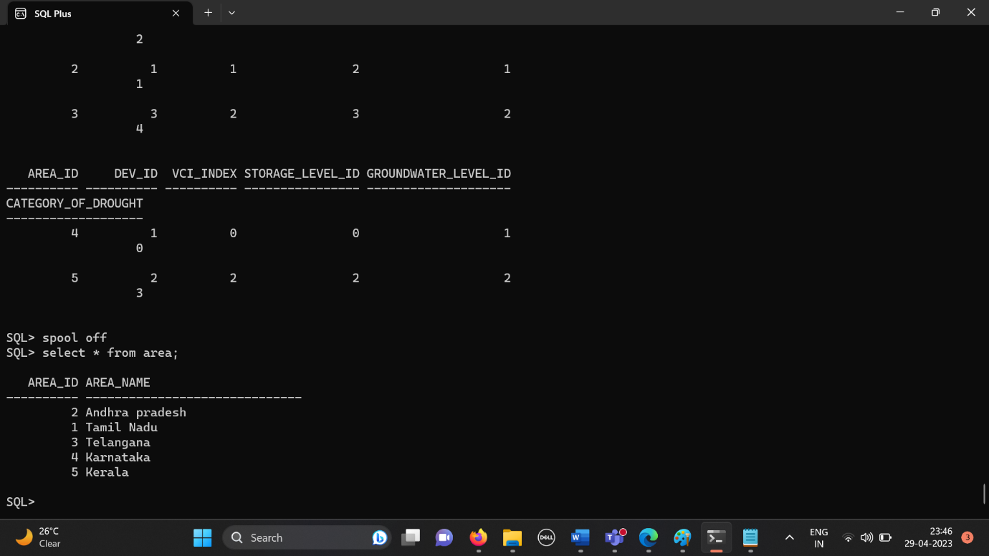

**DML command to insert values into matrix_impact_indicators table**

SQL> insert into matrix_impact_indicators

values(&area_id,&dev_id,&vci_index,&storage_level_id,&ground_level_id,&category_of_drought);

Enter value for area_id: 1

Enter value for dev_id: 2

Enter value for vci_index: 2

Enter value for storage_level_id: 3

Enter value for ground_level_id: 2

Enter value for category_of_drought: 2

old 1: insert into matrix_impact_indicators

values(&area_id,&dev_id,&vci_index,&storage_level_id,&ground_level_id,&category_of_drought)

new 1: insert into matrix_impact_indicators values(1,2,2,3,2,2)

1 row created.

SQL> /

Enter value for area_id: 2

Enter value for dev_id: 1

Enter value for vci_index: 1

Enter value for storage_level_id: 2

Enter value for ground_level_id: 1

Enter value for category_of_drought: 1

old 1: insert into matrix_impact_indicators

values(&area_id,&dev_id,&vci_index,&storage_level_id,&ground_level_id,&category_of_drought)

new 1: insert into matrix_impact_indicators values(2,1,1,2,1,1)

1 row created.

SQL> /

Enter value for area_id: 3

Enter value for dev_id: 3

Enter value for vci_index: 2

Enter value for storage_level_id: 3

Enter value for ground_level_id: 2

Enter value for category_of_drought: 4

old 1: insert into matrix_impact_indicators

values(&area_id,&dev_id,&vci_index,&storage_level_id,&ground_level_id,&category_of_drought)

new 1: insert into matrix_impact_indicators values(3,3,2,3,2,4)

1 row created.

SQL> insert into matrix_impact_indicators values(&area_id,&dev_id,&vci_index,&storage_level_id,&ground_level_id,&category_of_drought);

Enter value for area_id: 4

Enter value for dev_id: 1

Enter value for vci_index: 0

Enter value for storage_level_id: 0

Enter value for ground_level_id: 1

Enter value for category_of_drought: 0

old 1: insert into matrix_impact_indicators

values(&area_id,&dev_id,&vci_index,&storage_level_id,&ground_level_id,&category_of_drought)

new 1: insert into matrix_impact_indicators values(4,1,0,0,1,0)

1 row created.

SQL> /

Enter value for area_id: 5

Enter value for dev_id: 2

Enter value for vci_index: 2

Enter value for storage_level_id: 2

Enter value for ground_level_id: 2

Enter value for category_of_drought: 3

old 1: insert into matrix_impact_indicators

values(&area_id,&dev_id,&vci_index,&storage_level_id,&ground_level_id,&category_of_drought)

new 1: insert into matrix_impact_indicators values(5,2,2,2,2,3)

1 row created.

**Output**

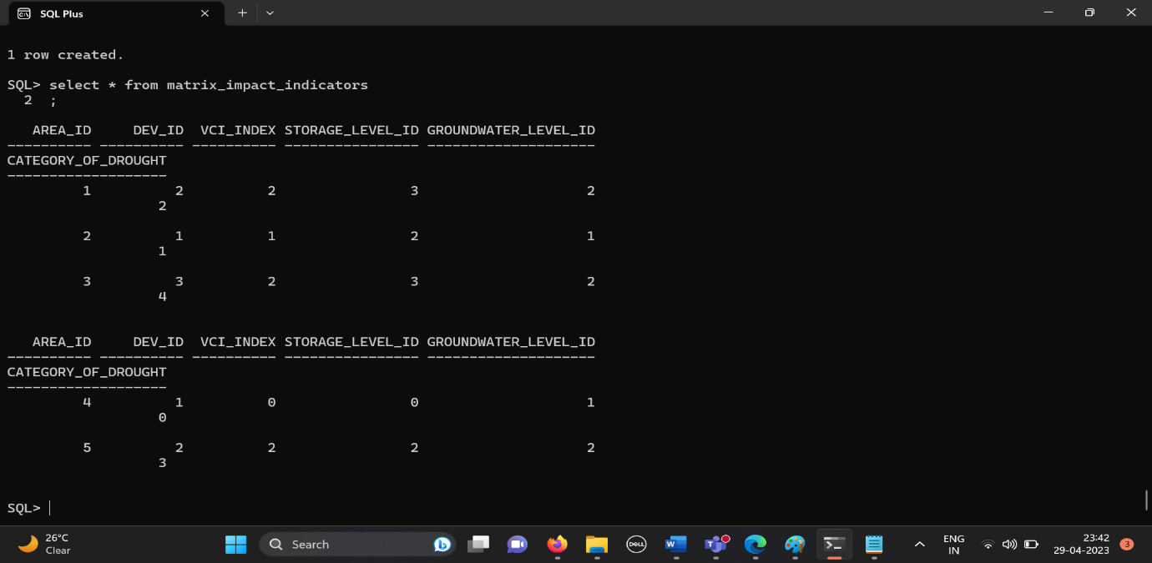

**DML command to insert values into area_rainfall table**

SQL> insert into area_rainfall values(&area_id,&rainfall,'&month');

Enter value for area_id: 1

Enter value for rainfall: 20

Enter value for month: jan

old 1: insert into area_rainfall values(&area_id,&rainfall,'&month')

new 1: insert into area_rainfall values(1,20,'jan')

1 row created.

SQL> /

Enter value for area_id: 2

Enter value for rainfall: 30

Enter value for month: jan

old 1: insert into area_rainfall values(&area_id,&rainfall,'&month')

new 1: insert into area_rainfall values(2,30,'jan')

1 row created.

SQL> /

Enter value for area_id: 1

Enter value for rainfall: 70

Enter value for month: mar

old 1: insert into area_rainfall values(&area_id,&rainfall,'&month')

new 1: insert into area_rainfall values(1,70,'mar')

1 row created.

SQL> /

Enter value for area_id: 2

Enter value for rainfall: 20

Enter value for month: feb

old 1: insert into area_rainfall values(&area_id,&rainfall,'&month')

new 1: insert into area_rainfall values(2,20,'feb')

1 row created.

**Output: -**

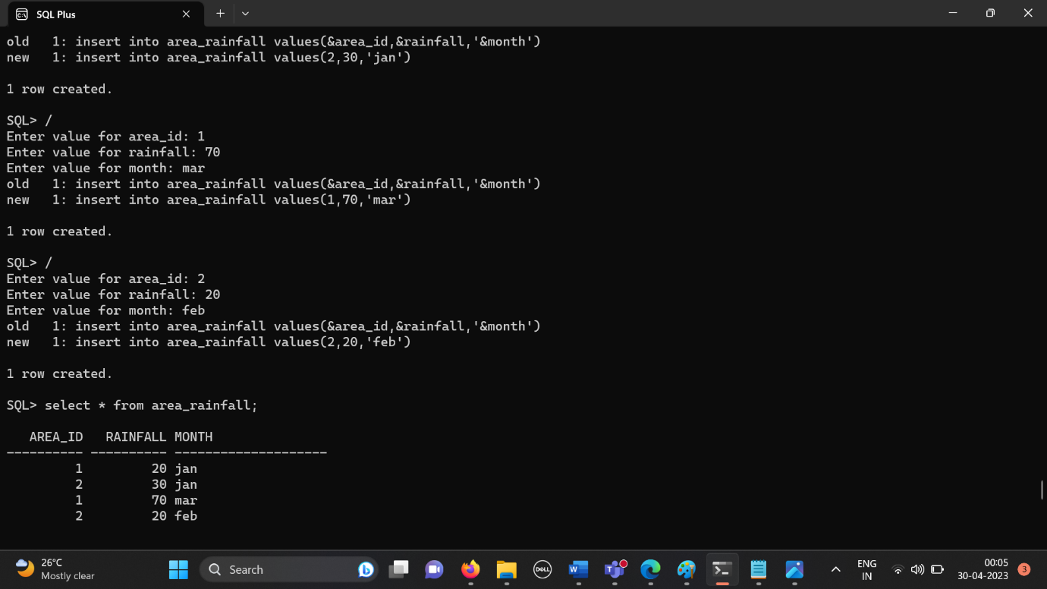

**DML command to insert values into area_vegetation table**

SQL> insert into area_vegetation values(&area_id,&vci_percentage,'&month');

Enter value for area_id: 1

Enter value for vci_percentage: 20

Enter value for month: jan

old 1: insert into area_vegetation

values(&area_id,&vci_percentage,'&month')

new 1: insert into area_vegetation values(1,20,'jan')

1 row created.

SQL> /

Enter value for area_id: 2

Enter value for vci_percentage: 30

Enter value for month: jan

old 1: insert into area_vegetation

values(&area_id,&vci_percentage,'&month')

new 1: insert into area_vegetation values(2,30,'jan')

1 row created.

SQL> /

Enter value for area_id: 1

Enter value for vci_percentage: 40

Enter value for month: mar

old 1: insert into area_vegetation

values(&area_id,&vci_percentage,'&month')

new 1: insert into area_vegetation values(1,40,'mar')

1 row created.

SQL> /

Enter value for area_id: 2

Enter value for vci_percentage: 30

Enter value for month: feb

old 1: insert into area_vegetation

values(&area_id,&vci_percentage,'&month')

new 1: insert into area_vegetation values(2,30,'feb')

1 row created.

**Output**

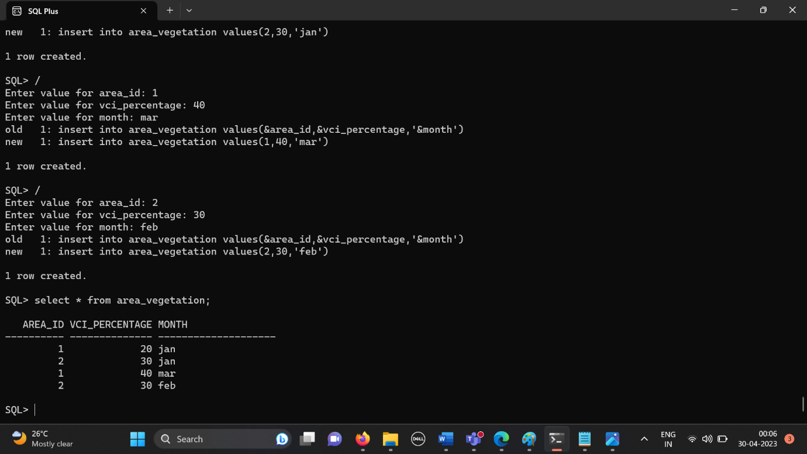

**DML command to insert values into area_moisture table**

SQL> insert into area_moisture

values(&area_id,&percent_availabel_soil_moisture,'&month');

Enter value for area_id: 1

Enter value for percent_availabel_soil_moisture: 30

Enter value for month: jan

old 1: insert into area_moisture

values(&area_id,&percent_availabel_soil_moisture,'&month')

new 1: insert into area_moisture values(1,30,'jan')

1 row created.

SQL> /

Enter value for area_id: 2

Enter value for percent_availabel_soil_moisture: 40

Enter value for month: jan

old 1: insert into area_moisture

values(&area_id,&percent_availabel_soil_moisture,'&month')

new 1: insert into area_moisture values(2,40,'jan')

1 row created.

SQL> /

Enter value for area_id: 1

Enter value for percent_availabel_soil_moisture: 60

Enter value for month: mar

old 1: insert into area_moisture

values(&area_id,&percent_availabel_soil_moisture,'&month')

new 1: insert into area_moisture values(1,60,'mar')

1 row created.

SQL> /

Enter value for area_id: 2

Enter value for percent_availabel_soil_moisture: 50

Enter value for month: feb

old 1: insert into area_moisture

values(&area_id,&percent_availabel_soil_moisture,'&month')

new 1: insert into area_moisture values(2,50,'feb')

1 row created.

**Output**

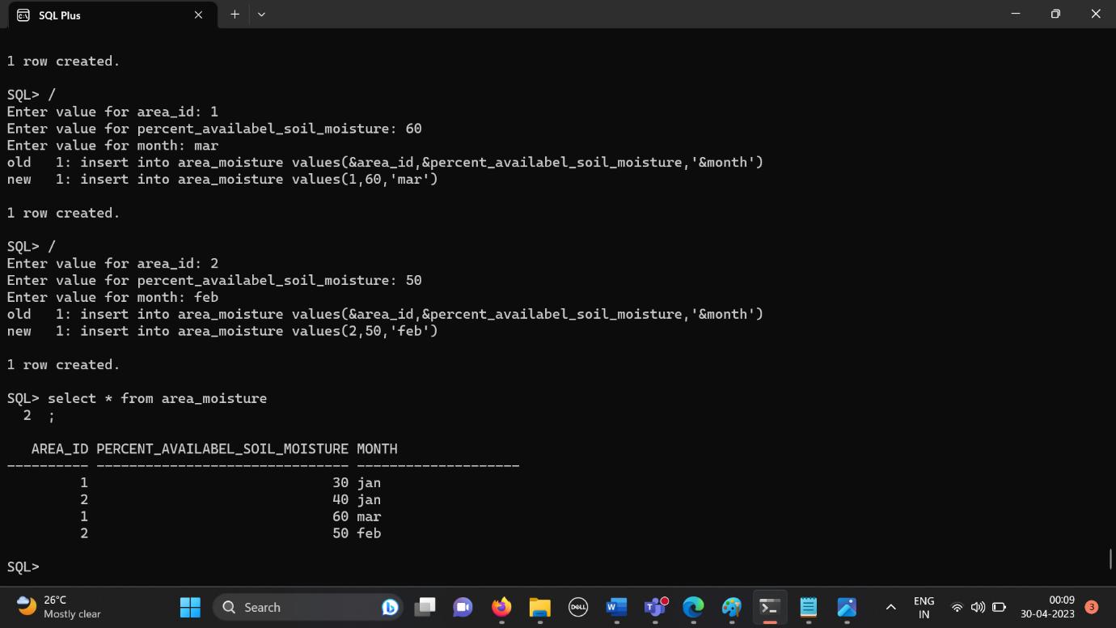

**DML command to insert values into area_** **reservoir_storage table**

SQL> insert into area_reservoir_storage

values(&area_id,&percent_deficit,'&month');

Enter value for area_id: 1

Enter value for percent_deficit: 40

Enter value for month: jan

old 1: insert into area_reservoir_storage

values(&area_id,&percent_deficit,'&month')

new 1: insert into area_reservoir_storage values(1,40,'jan')

1 row created.

SQL> /

Enter value for area_id: 2

Enter value for percent_deficit: 20

Enter value for month: jan

old 1: insert into area_reservoir_storage

values(&area_id,&percent_deficit,'&month')

new 1: insert into area_reservoir_storage values(2,20,'jan')

1 row created.

SQL> /

Enter value for area_id: 1

Enter value for percent_deficit: 10

Enter value for month: mar

old 1: insert into area_reservoir_storage

values(&area_id,&percent_deficit,'&month')

new 1: insert into area_reservoir_storage values(1,10,'mar')

1 row created.

SQL> /

Enter value for area_id: 2

Enter value for percent_deficit: 15

Enter value for month: feb

old 1: insert into area_reservoir_storage

values(&area_id,&percent_deficit,'&month')

new 1: insert into area_reservoir_storage values(2,15,'feb')

1 row created.

**Output**

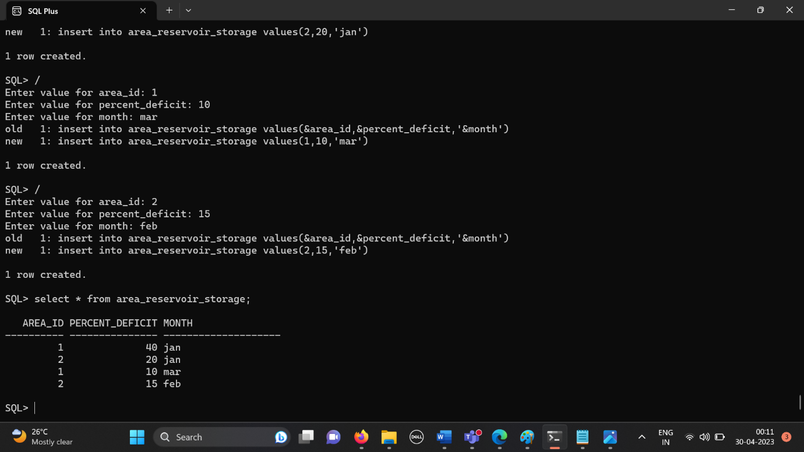

**DML command to insert values into area_** **groundwater table**

SQL> insert into area_groundwater

values(&area_id,&groundwater_drought_index,'&month');

Enter value for area_id: 1

Enter value for groundwater_drought_index: 70

Enter value for month: jan

old 1: insert into area_groundwater

values(&area_id,&groundwater_drought_index,'&month')

new 1: insert into area_groundwater values(1,70,'jan')

1 row created.

SQL> /

Enter value for area_id: 2

Enter value for groundwater_drought_index: 39

Enter value for month: feb

old 1: insert into area_groundwater

values(&area_id,&groundwater_drought_index,'&month')

new 1: insert into area_groundwater values(2,39,'feb')

1 row created.

**Output**

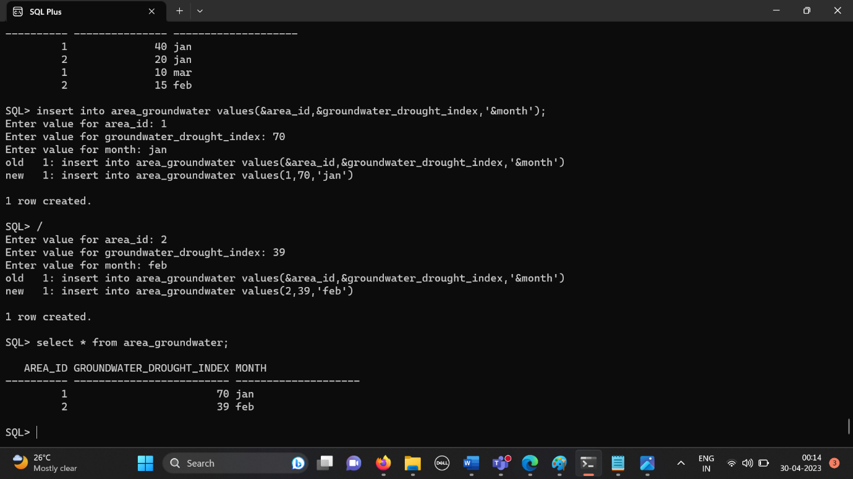

**IMPLEMENTATION**

**JAVA-SQL connectivity :-**

JDBC stands for Java Database Connectivity. JDBC is a Java API to connect and execute the query with the database. It is a part of JavaSE (Java Standard Edition). JDBC API uses JDBC drivers to connect with the database. There are four types of JDBC drivers

* JDBC-ODBC Bridge Driver,
* Native Driver,
* Network Protocol Driver, and
* Thin Driver

For this project I have used OJDBC.8 version java driver. The connection and the implementation of the application code is as follows.

**Connection:-**

 Connection con=DriverManager.getConnection("jdbc:oracle:thin:@localhost:1521:orcl","project","proj");

            Statement stmt = con.createStatement();

            String qry = "Select * from "+*tablename*;

            ResultSet rs = stmt.executeQuery(qry);

            ResultSetMetaData rsm = rs.getMetaData();

**Application code with connection is as follows :-**

import javax.lang.model.util.ElementScanner14;

import javax.swing.*;

import java.sql.*;

import java.util.Properties;

import java.awt.event.*;

import java.awt.*;

public class frameclass extends JFrame implements ActionListener

{

    //private JFrame mainframe;

    private JScrollPane scrollPane;

    private JPanel mainPanel;

    private JRadioButton ins;

    private JRadioButton upd;

    private JRadioButton del;

    private JRadioButton view;

    private JTextField[] jtf;

    private JComboBox<String> tables;

    private JTextArea textArea;

    private JPanel updatPanel;

    private JPanel insertPanel;

    private JPanel deletPanel;

    private JPanel selectPanel;

    private JScrollPane scrol;

    private *int* i,size;

    private String tablename;

    public frameclass()

    {

        setTitle("Drought det sys");

        setDefaultCloseOperation(JFrame.EXIT_ON_CLOSE);

        setLayout(null);

        mainPanel = new JPanel();

        mainPanel.setBounds(0,0,600,500);

        mainPanel.setLayout(null);

        add(mainPanel);

        createMenuBar();

        selectPanel = new JPanel();

        selectPanel.setBounds(0,0,600,300);

        selectPanel.setLayout(null);

        System.out.println("hello1");

        JLabel msgop = new JLabel("Select the Table which you want ");

        msgop.setBounds(50, 50, 300, 25);

        tables = new JComboBox<String>();

        tables.setBounds(50, 80, 200, 25);

        tables.addItem("area");

        tables.addItem("area_vegetation");

        tables.addItem("area_moisture");

        tables.addItem("area_reservoir_storage");

        tables.addItem("area_groundwater");

        tables.addItem("area_rainfall");

        tables.addItem("matrix_impact_indicators");

        System.out.println("hello1");

        JLabel oprop = new JLabel("Select the operation you want to perform ");

        oprop.setBounds(50, 120, 300, 25);

        ins = new JRadioButton("INSERT", true);

        ins.setBounds(50, 150, 100, 25);

        upd = new JRadioButton("UPDATE", false);

        upd.setBounds(150, 150, 100, 25);

        del = new JRadioButton("DELETE", false);

        del.setBounds(250, 150, 100, 25);

        view = new JRadioButton("VIEW",false);

        view.setBounds(350,150, 100, 25);

        System.out.println("hello2");

        ButtonGroup bg = new ButtonGroup();

        bg.add(ins);

        bg.add(upd);

        bg.add(del);

        bg.add(view);

        JButton submit = new JButton("SUBMIT");

        submit.setBounds(50, 200, 100, 25);

        submit.addActionListener(this);

        selectPanel.add(msgop);

        selectPanel.add(tables);

        selectPanel.add(oprop);

        selectPanel.add(ins);

        selectPanel.add(upd);

        selectPanel.add(del);

        selectPanel.add(view);

        selectPanel.add(submit);

        insertPanel = new JPanel();

        insertPanel.setBounds(0,0,700,500);

        insertPanel.setLayout(null);

        insertPanel.setVisible(false);

        deletPanel = new JPanel();

        deletPanel.setBounds(0,0,700,500);

        deletPanel.setLayout(null);

        deletPanel.setVisible(false);

        updatPanel = new JPanel();

        updatPanel.setBounds(0,0,700,500);

        updatPanel.setLayout(null);

        updatPanel.setVisible(false);

        textArea = new JTextArea();

        scrollPane = new JScrollPane(textArea);

        scrollPane.setBounds(50, 400, 500, 125);

        mainPanel.add(scrollPane);

        mainPanel.add(selectPanel);

        mainPanel.add(insertPanel);

        mainPanel.add(deletPanel);

        mainPanel.add(updatPanel);

        //selectPanel.setVisible(true);

        //setBounds(100, 100, 1000, 1000);

        //scrol = new JScrollPane(mainPanel);

        //add(scrol);

        setPreferredSize(new Dimension(700,625));

        pack();

        setVisible(true);

    }

    @*Override*

    public *void* actionPerformed(ActionEvent *ae*)

    {

        tablename =(String)tables.getSelectedItem();

        if(ins.isSelected())

        {

            insertvalues(tablename);

        }else if(del.isSelected())

        {

            delete(tablename);

        }else if(upd.isSelected())

        {

            update(tablename);

        }else if(view.isSelected())

        {

            viewtable(tablename);

        }

    }

    public *void* viewtable(String *tablename*)

    {

        textArea.setText("");

        try{

            Connection con=DriverManager.getConnection("jdbc:oracle:thin:@localhost:1521:orcl","project","proj");

            Statement stmt = con.createStatement();

            String qry = "Select * from "+*tablename*;

            ResultSet rs = stmt.executeQuery(qry);

            ResultSetMetaData rsm = rs.getMetaData();

            String s = "";

            for(*int* j = 1;j<= rsm.getColumnCount();j++)

            {

                s+= rsm.getColumnName(j);

                s+= "   ";

            }

            textArea.append(s+"\n");

            s= "";

            while(rs.next())

            {

                for(*int* j = 1;j<=rsm.getColumnCount();j++)

                {

                    s+= rs.getString(rsm.getColumnName(j));

                    s+= "     ";

                }

                textArea.append(s+"\n");

                s = "";

            }

        }catch(Exception ex)

        {

            textArea.append("couldnt display the table");

        }

    }

    private *void* insertvalues(String *tablename*)

    {

        deletPanel.removeAll();

        deletPanel.revalidate();

        deletPanel.repaint();

        updatPanel.removeAll();

        updatPanel.revalidate();

        updatPanel.repaint();

        insertPanel.removeAll();

        insertPanel.revalidate();

        insertPanel.repaint();

        try{

            Connection con=DriverManager.getConnection("jdbc:oracle:thin:@localhost:1521:orcl","project","proj");

            Statement stmt = con.createStatement();

            String qry = "Select * from "+*tablename*;

            ResultSet rs = stmt.executeQuery(qry);

            ResultSetMetaData rsm = rs.getMetaData();

            jtf = new JTextField[rsm.getColumnCount()];

            JLabel[] jl = new JLabel[rsm.getColumnCount()];

            JLabel title = new JLabel(" INSERT ");

            //insertPanel.setBounds(50, 50, 700, 500);

            size = rsm.getColumnCount();

*int* x = 50; // Initial x-coordinate

*int* y = 25; // Initial y-coordinate

*int* labelWidth = 200; // Width of the label

*int* textFieldWidth = 150; // Width of the text field

*int* height = 25; // Height of each component

*int* spacing = 20; // Vertical spacing between components

            //title.setBounds(x,y,labelWidth,height);

            //insertPanel.add(title);

*int* panelHeight = (rsm.getColumnCount() * (height + spacing)) + 100; // Adjust the value as needed

    insertPanel.setSize(700, panelHeight);

            for(*int* i = 0;i<rsm.getColumnCount();i++)

            {

                jl[i] = new JLabel(rsm.getColumnName(i+1));

                jtf[i] = new JTextField();

                jl[i].setBounds(x,y,labelWidth,height);

                jtf[i].setBounds(x + labelWidth + spacing, y, textFieldWidth, height);

                insertPanel.add(jl[i]);

                insertPanel.add(jtf[i]);

                y += height+spacing;

            }

            JButton sub = new JButton("SUBMIT", null);

            sub.addActionListener(new ActionListener()

            {

                @*Override*

                public *void* actionPerformed(ActionEvent *e*)

                {

                    try{

                        Connection con=DriverManager.getConnection("jdbc:oracle:thin:@localhost:1521:orcl","project","proj");

                        Statement stmt = con.createStatement();

                        String qry = "insert into "+*tablename*+" values(";

                        String qry2 = "select calc_catg_of_drought(";

                        //System.out.println(qry);

                        if(size == 2)

                        {

                            qry += jtf[0].getText()+",";

                            qry += "'"+jtf[1].getText()+"'";

                        }else if(size == 3)

                        {

                            qry += jtf[0].getText()+",";

                            qry += jtf[1].getText()+",";

                            qry += "'"+jtf[2].getText()+"'";

                        }

                        else if(size == 6)

                        {

                            System.out.println("hello3");

                                qry+=jtf[0].getText()+","+jtf[1].getText()+","+jtf[2].getText()+","+jtf[3].getText()+","+jtf[4].getText()+",";

                                /*if(i != 4)

                                    qry2+= jtf[i].getText();

                                else

                                    qry2+=jtf[i];*/

                            //System.out.println(qry2);

                            qry2 += jtf[1].getText()+","+jtf[2].getText()+","+jtf[3].getText()+","+jtf[4].getText()+") from dual";

                            System.out.println(qry2);

                            ResultSet rs = stmt.executeQuery(qry2);

                            while(rs.next())

                            {

                                qry += Integer.toString(rs.getInt(1));

                                break;

                            }

                        }

                        qry+=")";

                        System.out.println(qry);

                        stmt.executeQuery(qry);

                        textArea.setText("");

                        textArea.append("a row is inserted into "+*tablename*);

                        con.commit();

                    }

                    catch(Exception ex)

                    {

                        System.out.println(ex);

                        textArea.setText("");

                        textArea.append("couldnt perform insert");

                    }

                }

            }

            );

            sub.setBounds(x, y+spacing, textFieldWidth, height);

            insertPanel.add(sub);

            //f.setLayout(new GridLayout(size+1, 2, 3, 1));

            insertPanel.setSize(700,500);

            //System.out.println("hello");

            deletPanel.setVisible(false);

            selectPanel.setVisible(false);

            insertPanel.setVisible(true);

        }catch(Exception ex)

        {

            System.out.println(ex);

        }

    }

    private *void* update(String *tablename*)

    {

        deletPanel.removeAll();

        deletPanel.revalidate();

        deletPanel.repaint();

        insertPanel.removeAll();

        insertPanel.revalidate();

        insertPanel.repaint();

        updatPanel.removeAll();

        updatPanel.revalidate();

        updatPanel.repaint();

        try{

            Connection con=DriverManager.getConnection("jdbc:oracle:thin:@localhost:1521:orcl","project","proj");

            Statement stmt = con.createStatement();

            String qry = "Select * from "+*tablename*;

            ResultSet rs = stmt.executeQuery(qry);

            ResultSetMetaData rsm = rs.getMetaData();

            jtf = new JTextField[rsm.getColumnCount()];

            JLabel title = new JLabel(" DELETE ");

            updatPanel.add(title);

            JLabel[] jl = new JLabel[rsm.getColumnCount()];

            size = rsm.getColumnCount();

*int* x = 50; // Initial x-coordinate

*int* y = 50; // Initial y-coordinate

*int* labelWidth = 200; // Width of the label

*int* textFieldWidth = 150; // Width of the text field

*int* height = 25; // Height of each component

*int* spacing = 20; // Vertical spacing between components

            for(*int* i = 0;i<rsm.getColumnCount();i++)

            {

                jl[i] = new JLabel(rsm.getColumnName(i+1));

                jtf[i] = new JTextField();

                jl[i].setBounds(x,y,labelWidth,height);

                jtf[i].setBounds(x + labelWidth + spacing, y, textFieldWidth, height);

                updatPanel.add(jl[i]);

                updatPanel.add(jtf[i]);

                y += height+spacing;

            }

            JButton sub = new JButton("SUBMIT", null);

            sub.addActionListener(new ActionListener()

            {

                @*Override*

                public *void* actionPerformed(ActionEvent *e*)

                {

                    try{

                        Connection con=DriverManager.getConnection("jdbc:oracle:thin:@localhost:1521:orcl","project","proj");

                        Statement stmt = con.createStatement();

                        String qry = "update "+*tablename*+" set ";

                        if(size == 2)

                        {

                            if(jtf[0].getText().length() == 0)

                            {

                                System.out.println("Cannot append");

                            }else

                            {

                                qry+= rsm.getColumnName(2)+" = '"+jtf[1].getText()+"' where "+rsm.getColumnName(1)+" = "+jtf[0].getText();

                            }

                        }else if(size == 3)

                        {

                            if(jtf[0].getText().length() == 0 || jtf[2].getText().length() == 0)

                            {

                                System.out.println("Cannot append");

                            }else{

                                qry += rsm.getColumnName(2)+" = "+jtf[1].getText()+" where "+rsm.getColumnName(1)+" = "+jtf[0].getText()+" and "+ rsm.getColumnName(3)+" = '"+jtf[2].getText()+" ' ";

                            }

                        }

                        else if(size == 6)

                        {

                            if(jtf[0].getText().length() == 0)

                            {

                                System.out.println("Cannot append");

                            }else{

*int* flag = 0;

*int*[] arr = new *int*[5];

                                    for(*int* j = 1;j<size-1;j++)

                                    {

                                        arr[j]= jtf[j].getText().length();

                                    }

                                    for(*int* j = 1;j<size-1;j++)

                                    {

                                        if(flag == 0)

                                        {

                                            qry += rsm.getColumnName(j+1) + " = "+ jtf[j].getText();

                                            flag = 1;

                                        }else{

                                            qry += " , "+rsm.getColumnName(j+1) + " = "+ jtf[j].getText();

                                        }

                                    }

                                    String qry2 = "select calc_catg_of_drought("+jtf[1].getText()+","+jtf[2].getText()+","+jtf[3].getText()+","+jtf[4].getText()+") from dual";

                                    ResultSet rs = stmt.executeQuery(qry2);

                                    while(rs.next())

                                    {

                                        qry += ","+rsm.getColumnName(6)+" = "+rs.getInt(1);

                                        break;

                                    }

                                    qry += " where "+rsm.getColumnName(1)+" = "+jtf[0].getText();

                            }

                        }

                        System.out.println(qry);

                        stmt.executeQuery(qry);

                        textArea.setText("");

                        textArea.append(*tablename*+" is updated ");

                        con.commit();

                    }

                    catch(Exception ex)

                    {

                        ex.printStackTrace();

                        System.out.println(ex);

                    }

                }

            });

            sub.setBounds(x, y, textFieldWidth, height);

            updatPanel.add(sub);

            //f.setLayout(new GridLayout(size+1, 2, 3, 1));

            updatPanel.setSize(700,500);

            //System.out.println("hello");

            insertPanel.setVisible(false);

            selectPanel.setVisible(false);

            updatPanel.setVisible(true);

            deletPanel.setVisible(false);

        }catch(Exception e)

        {

            System.out.println(e);

        }

    }

    private *void* delete(String *tablename*)

    {

        insertPanel.removeAll();

        insertPanel.revalidate();

        insertPanel.repaint();

        updatPanel.removeAll();

        updatPanel.revalidate();

        updatPanel.repaint();

        deletPanel.removeAll();

        deletPanel.revalidate();

        deletPanel.repaint();

        try{

            Connection con=DriverManager.getConnection("jdbc:oracle:thin:@localhost:1521:orcl","project","proj");

            Statement stmt = con.createStatement();

            String qry = "Select * from "+*tablename*;

            ResultSet rs = stmt.executeQuery(qry);

            ResultSetMetaData rsm = rs.getMetaData();

            jtf = new JTextField[rsm.getColumnCount()];

            JLabel title = new JLabel(" DELETE ");

            //deletPanel.add(title);

            JLabel[] jl = new JLabel[rsm.getColumnCount()];

            size = rsm.getColumnCount();

*int* x = 50; // Initial x-coordinate

*int* y = 50; // Initial y-coordinate

*int* labelWidth = 200; // Width of the label

*int* textFieldWidth = 150; // Width of the text field

*int* height = 25; // Height of each component

*int* spacing = 20; // Vertical spacing between components

            for(*int* i = 0;i<rsm.getColumnCount();i++)

            {

                jl[i] = new JLabel(rsm.getColumnName(i+1));

                jtf[i] = new JTextField();

                jl[i].setBounds(x,y,labelWidth,height);

                jtf[i].setBounds(x + labelWidth + spacing, y, textFieldWidth, height);

                deletPanel.add(jl[i]);

                deletPanel.add(jtf[i]);

                y += height+spacing;

            }

            JButton sub = new JButton("SUBMIT", null);

            sub.addActionListener(new ActionListener()

            {

                @*Override*

                public *void* actionPerformed(ActionEvent *e*)

                {

                    try{

                        Connection con=DriverManager.getConnection("jdbc:oracle:thin:@localhost:1521:orcl","project","proj");

                        Statement stmt = con.createStatement();

                        String qry = "Delete from "+*tablename*+" where ";

                        if(size == 2)

                        {

                            if(jtf[1].getText().length() == 0)

                            {

                                qry += rsm.getColumnName(1)+" = ";

                                qry += jtf[0].getText();

                            }else if(jtf[0].getText().length() == 0)

                            {

                                qry += rsm.getColumnName(2)+" = ";

                                qry += "'"+jtf[1].getText()+"'";

                            }else if(jtf[0].getText().length() != 0 && jtf[1].getText().length() != 0)

                            {

                                qry += rsm.getColumnName(1)+" = ";

                                qry += jtf[0].getText()+" and ";

                                qry += rsm.getColumnName(2)+" = ";

                                qry += "'"+jtf[1].getText()+"'";

                            }else

                            {

                                System.out.println("no");

                            }

                        }else if(size == 3)

                        {

*int*[] arr = new *int*[3];

                            for(*int* j = 0;j<3;j++)

                            {

                                arr[j] = jtf[j].getText().length();

                            }

*int* flag = 0;

                            for(*int* j = 0;j<size;j++)

                            {

                                if(arr[j] != 0)

                                {

                                    if(flag == 0)

                                    {

                                        if(j == size-1)

                                        {

                                            qry += rsm.getColumnName(j+1)+" = ";

                                            qry += "'"+jtf[j].getText()+"'";

                                        }else{

                                            qry += rsm.getColumnName(j+1)+" = ";

                                            qry += jtf[j].getText();

                                            flag = 1;

                                        }

                                    }else

                                    {

                                        if(j == size-1)

                                        {

                                            qry += " and "+rsm.getColumnName(j+1)+" = ";

                                            qry += "'"+jtf[j].getText()+"'";

                                        }else{

                                            qry += " and "+ rsm.getColumnName(j+1)+" = ";

                                            qry += jtf[j].getText();

                                        }

                                    }

                                }

                            }

                        }

                        else if(size == 6)

                        {

                            for(*int* i = 0;i<size;i++)

                            {

*int*[] arr = new *int*[3];

                                for(*int* j = 0;j<3;j++)

                                {

                                    arr[j] = jtf[j].getText().length();

                                }

*int* flag = 0;

                                for(*int* j = 0;j<size;j++)

                                {

                                    if(arr[j] != 0)

                                    {

                                        if(flag == 0)

                                        {

                                            qry += rsm.getColumnName(j+1)+" = ";

                                            qry += jtf[j].getText();

                                            flag = 1;

                                        }else

                                        {

                                            qry += " and "+ rsm.getColumnName(j+1)+" = ";

                                            qry += jtf[j].getText();

                                        }

                                    }

                                }

                            }

                        }

                        System.out.println(qry);

                        stmt.executeQuery(qry);

                        textArea.setText("");

                        textArea.append("1 row deleted from "+*tablename*);

                        con.commit();

                    }

                    catch(Exception ex)

                    {

                        System.out.println(ex);

                    }

                }

            });

            sub.setBounds(x, y, textFieldWidth, height);

            deletPanel.add(sub);

            //f.setLayout(new GridLayout(size+1, 2, 3, 1));

            deletPanel.setSize(500,400);

            //System.out.println("hello");

            insertPanel.setVisible(false);

            updatPanel.setVisible(false);

            selectPanel.setVisible(false);

            deletPanel.setVisible(true);

        }catch(Exception e)

        {

            System.out.println(e);

        }

    }

    private *void* createMenuBar()

    {

        JMenuBar menuBar = new JMenuBar();

        JMenu updateTables = new JMenu("UPDATE");

        JMenu insertTables = new JMenu("INSERT");

        JMenu deleteTables = new JMenu("DELETE");

        JMenu menuop = new JMenu("MENU");

        JMenu view = new JMenu("VIEW");

        JMenuItem[] updateItems = new JMenuItem[7];

        JMenuItem[] insertItems = new JMenuItem[7];

        JMenuItem[] deleteItems = new JMenuItem[7];

        JMenuItem[] viewItems = new JMenuItem[7];

        String[] tableNames = {"area", "area_vegetation", "area_moisture", "area_reservoir_storage", "area_groundwater", "area_rainfall","matrix_impact_indicators"};

        JMenuItem menu = new JMenuItem("MENU");

        JMenuItem exit = new JMenuItem("EXIT");

        menu.addActionListener(new ActionListener() {

            @*Override*

            public *void* actionPerformed(ActionEvent *e*){

                updatPanel.setVisible(false);

                deletPanel.setVisible(false);

                insertPanel.setVisible(false);

                selectPanel.setVisible(true);

            }

        }

        );

        exit.addActionListener(new ActionListener() {

            @*Override*

            public *void* actionPerformed(ActionEvent *e*){

                System.exit(0);

            }

        });

        menuop.add(menu);

        menuop.add(exit);

        for (*int* i = 0; i < 7; i++) {

            String tableName = tableNames[i];

            updateItems[i] = new JMenuItem(tableName);

            updateItems[i].addActionListener(new ActionListener() {

            @*Override*

            public *void* actionPerformed(ActionEvent *e*) {

                update(tableName);

            }

            });

        updateTables.add(updateItems[i]);

        insertItems[i] = new JMenuItem(tableName);

        insertItems[i].addActionListener(new ActionListener() {

            @*Override*

            public *void* actionPerformed(ActionEvent *e*) {

                System.out.println(tableName);

                insertvalues(tableName);

            }

        });

        insertTables.add(insertItems[i]);

        deleteItems[i] = new JMenuItem(tableName);

        deleteItems[i].addActionListener(new ActionListener() {

            @*Override*

            public *void* actionPerformed(ActionEvent *e*) {

                delete(tableName);

            }

        });

        deleteTables.add(deleteItems[i]);

        viewItems[i] = new JMenuItem(tableName);

        viewItems[i].addActionListener(new ActionListener() {

            @*Override*

            public *void* actionPerformed(ActionEvent *e*) {

                viewtable(tableName);

            }

        });

        view.add(viewItems[i]);

        }

        menuBar.add(menuop);

        menuBar.add(updateTables);

        menuBar.add(insertTables);

        menuBar.add(deleteTables);

        menuBar.add(view);

        setJMenuBar(menuBar);

    }

    public static *void* main(String[] *args*) {

        new frameclass();

    }

}

**The plsql function used to generate the category of drought of a place is :-**

create or replace function calc_catg_of_drought(d_id number,sto_id number,g_water_id number,vci_id number)

2 return number

3 is

4 cod number;

5 sd number;

6 md number;

7 nd number;

8 begin

9

10 nd:= 0;

11 md := 0;

12 sd:= 0;

13

14 if d_id <1 then

15 nd := nd+1;

16 elsif d_id<=2 then

17 md := md+1;

18 elsif d_id = 3 then

19 sd := sd+1;

20 end if;

21

22 if sto_id<=1 then

23 nd := nd+1;

24 elsif sto_id=2 then

25 md:= md+1;

26 elsif sto_id<=4 then

27 sd := sd+1;

28 end if;

29

30 if g_water_id<=1 then

31 nd := nd+1;

32 elsif g_water_id=2 then

33 md:= md+1;

34 elsif g_water_id<=4 then

35 sd := sd+1;

36 end if;

37

38 if vci_id=0 then

39 nd:= nd+1;

40 elsif vci_id = 1 then

41 md:= md+1;

42 elsif vci_id = 2 then

43 sd:= sd+1;

44 end if;

45

46 if sd = 4 then

47 cod:=4;

48 elsif md >= 2 or sd >= 2 then

49 cod := 2;

50 else

51 cod := 0;

52 end if;

53

54 return cod;

55 end;

56 /

This function generates the drought index id for a particular area.

**TESTING**

**Homepage:-**

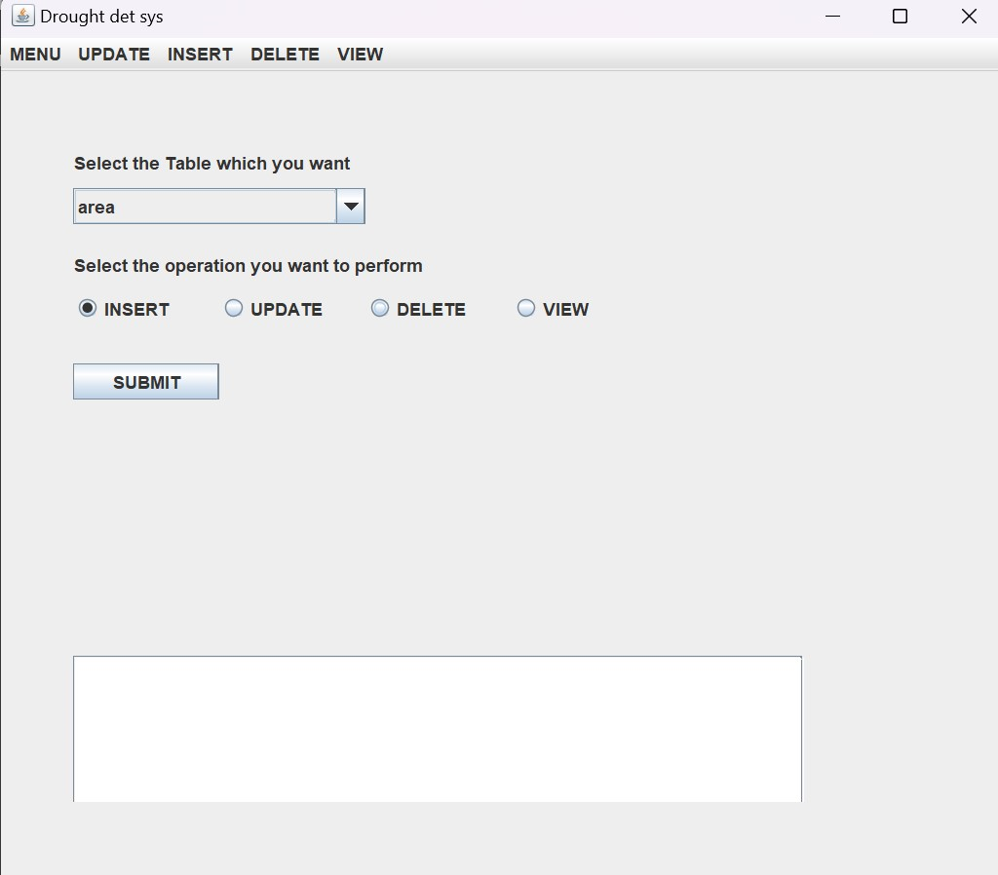

**Insert operations :-**

Insert without giving any information:-

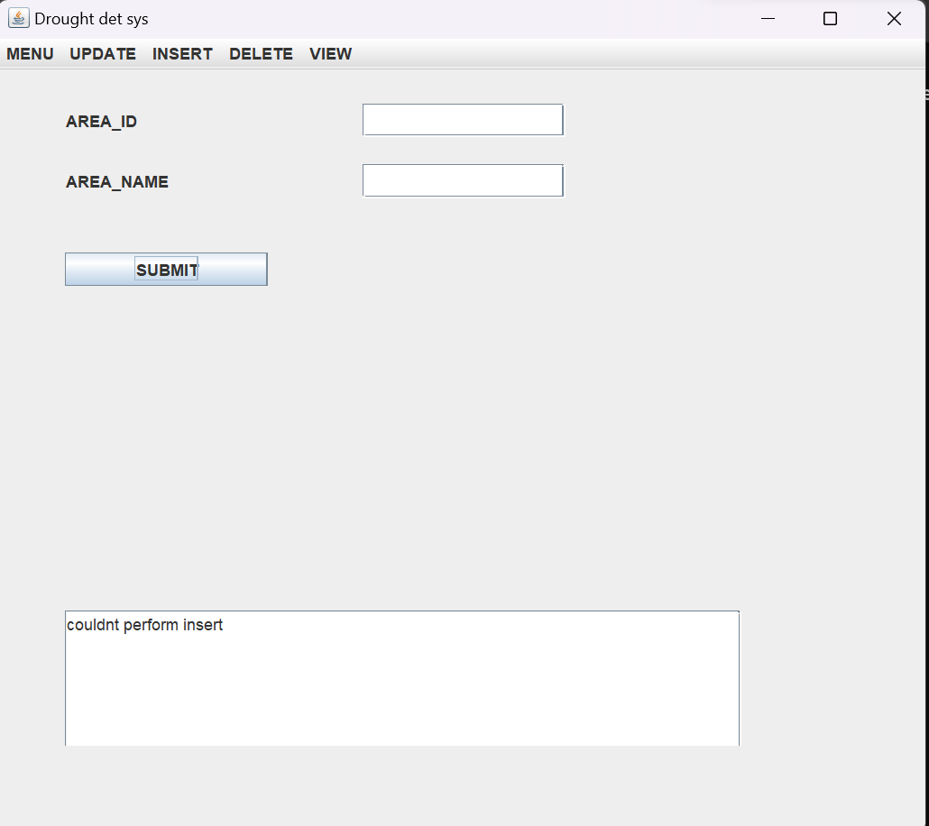

Insert with information:-

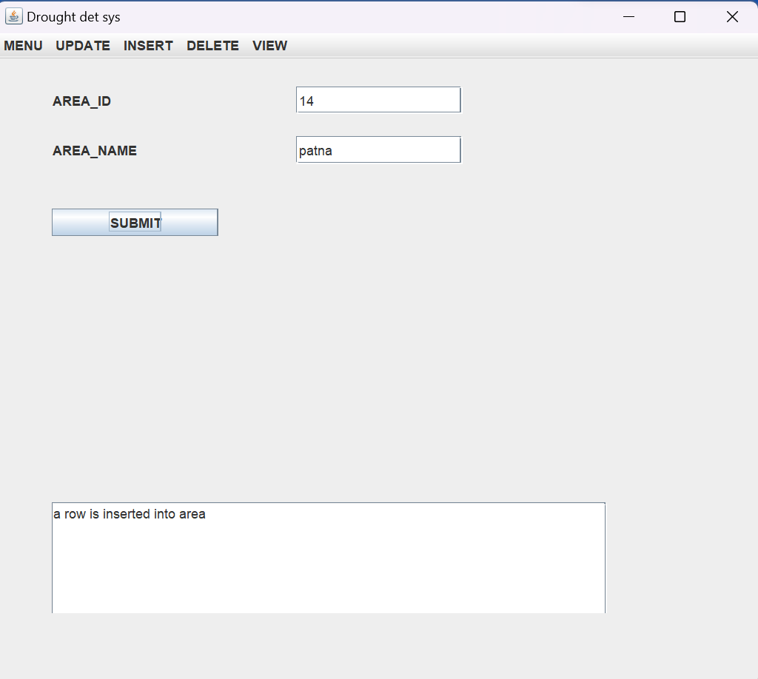

Insert by using plsql function:-

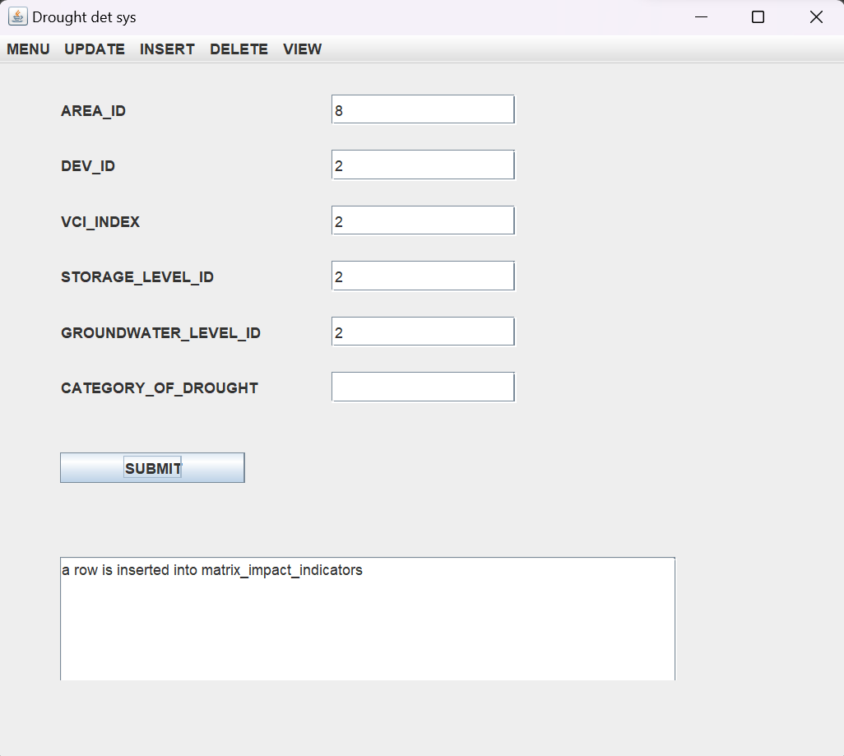

Matrix_impact indicators table after insertion:-

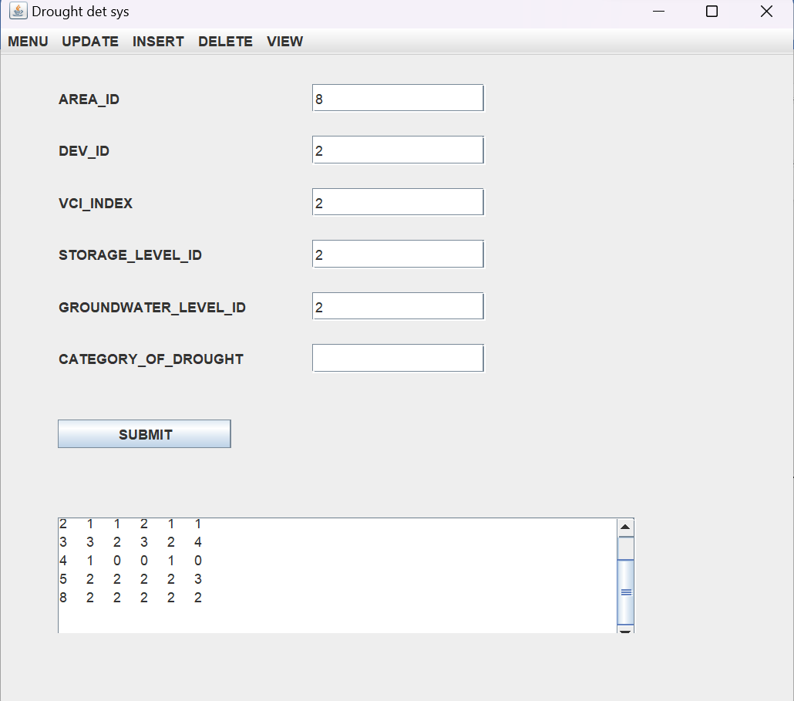

Updating of table area:-

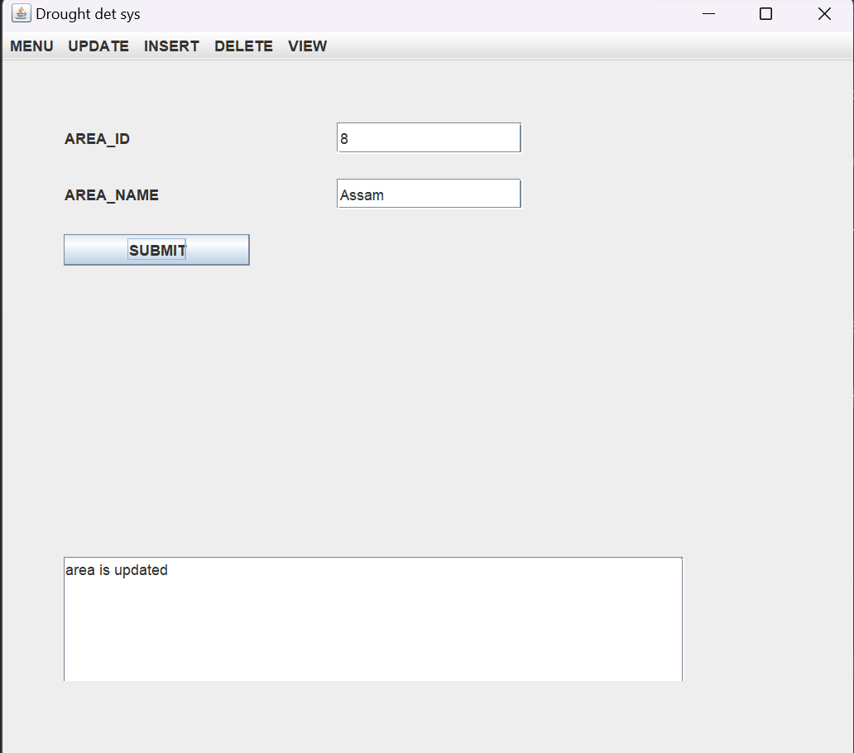

Updating table with plsql function:-

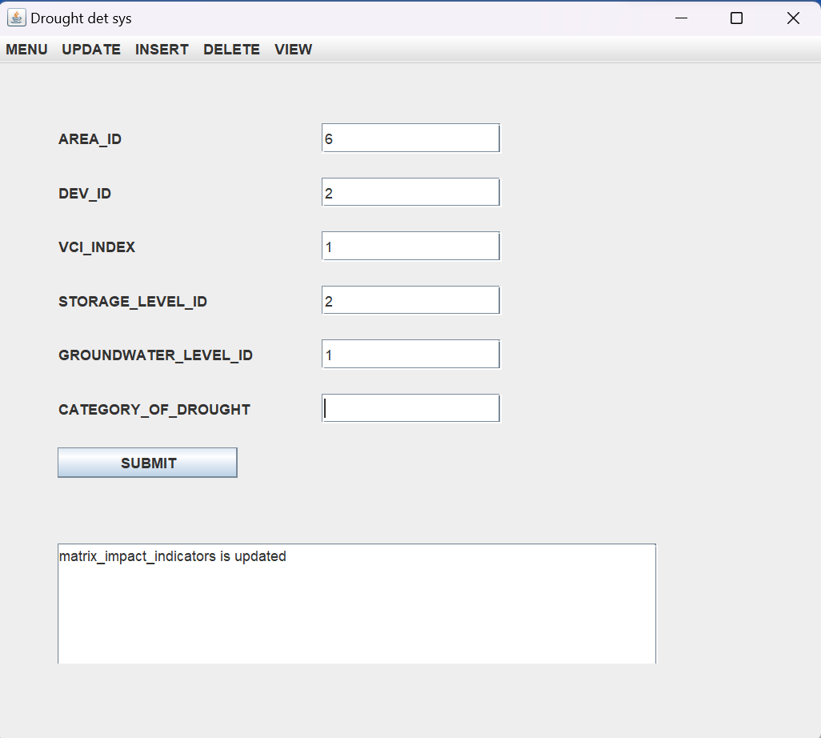

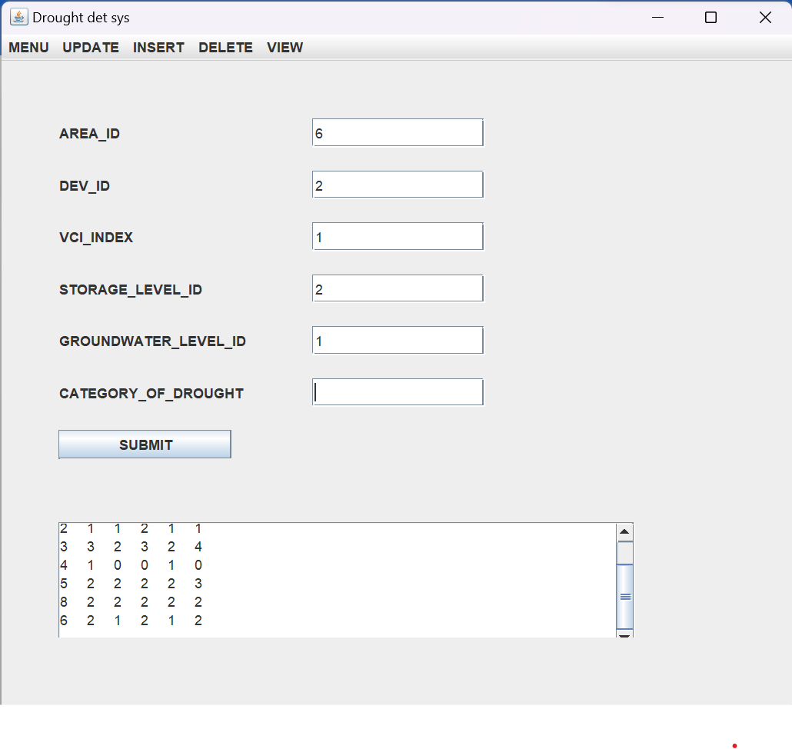

Deleting from tables: -

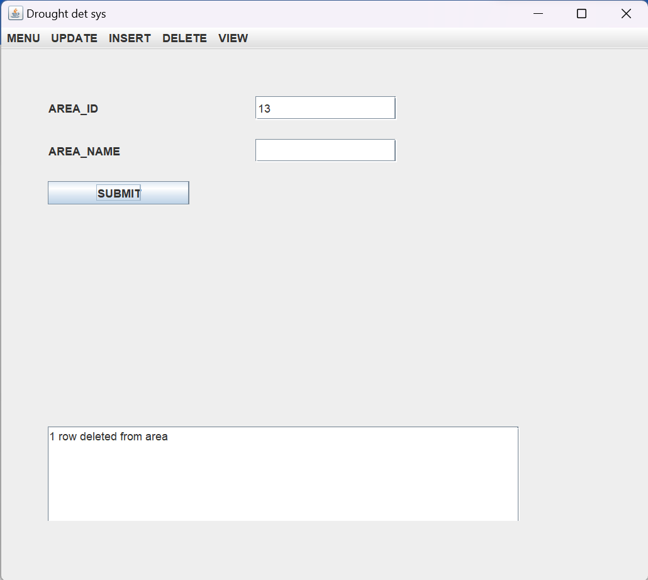

**Result :-**

I have successfully implemented **drought detection system** project

**Reference and future work:-**

This project drought detection system has several potential areas of future development and expansion. As technology advances and our understanding of droughts improves, there are numerous opportunities to enhance the system's functionality, incorporate additional data sources, and provide more advanced analysis and prediction capabilities.

The future scope of the Drought Detection System is vast and promising. By incorporating advanced data sources, machine learning techniques, climate models, GIS visualization, real-time monitoring, and citizen engagement, the system can evolve into a comprehensive and proactive drought management platform.

**References :-**

1. Java docs :- <https://docs.oracle.com/en/java/>
2. Oracle jdbc tutorial <https://docs.oracle.com/javase/tutorial/jdbc/basics/>