**lut_mapping_adder**

regular 128 bit SSB(square scheme block) CSLA(carry select adder) [1]:

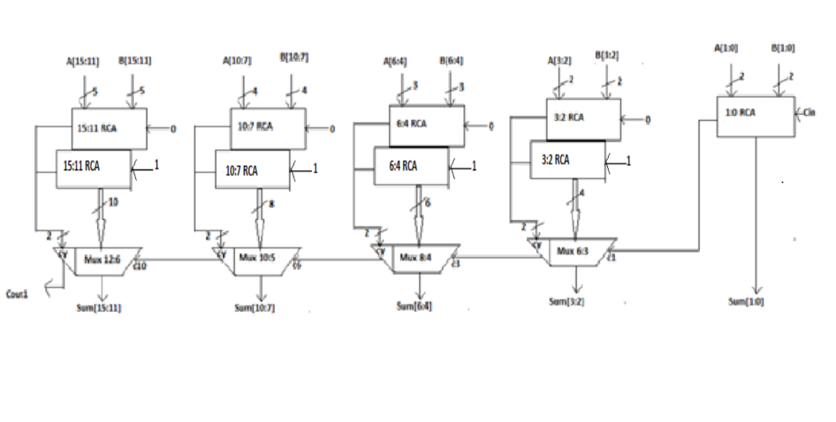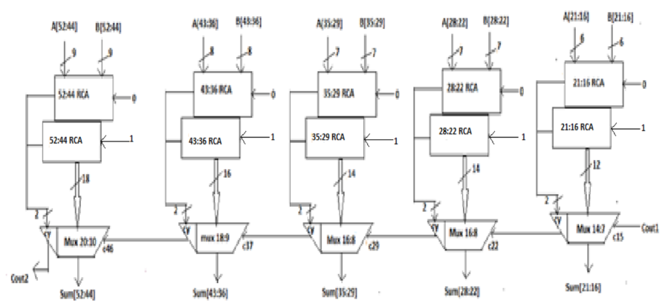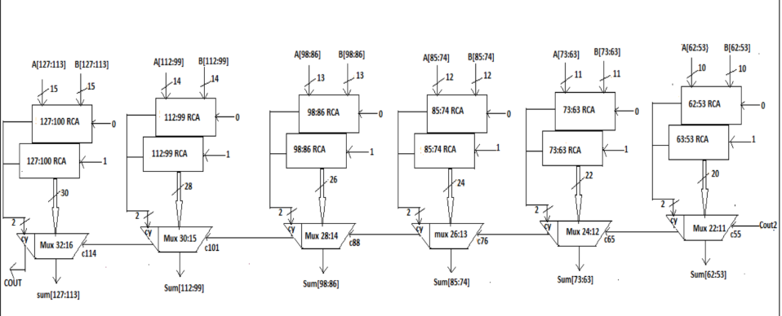

[1] 128-bit-low-power-area-efficient-carry-select-adder.

adder.v

input: 256

output: 129

wire: 891

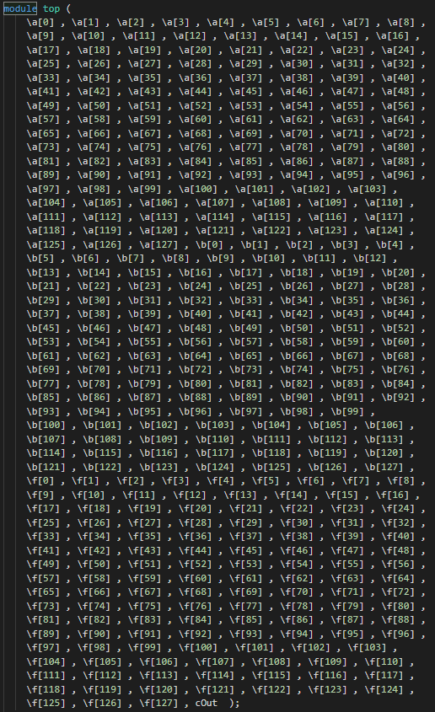       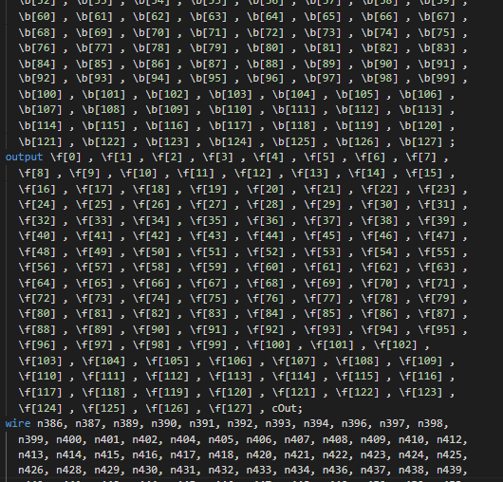

adder_synthed.v

input: 256

output: 129

wire: 1020

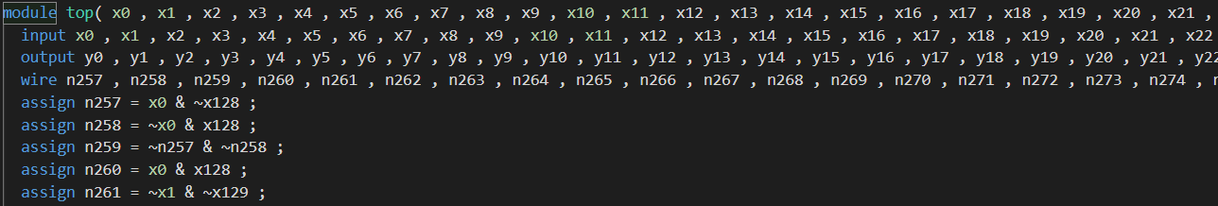

综合前：

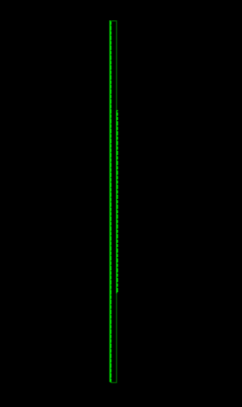

综合后：

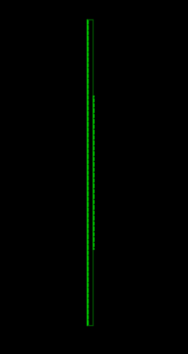

Report:

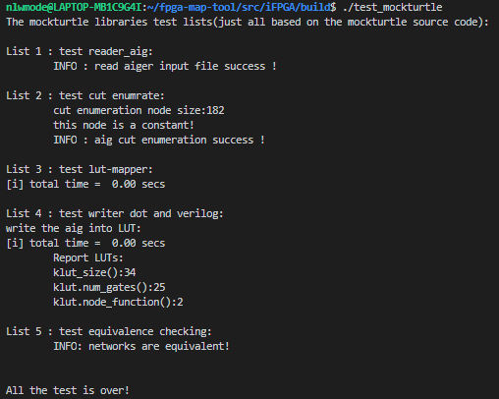

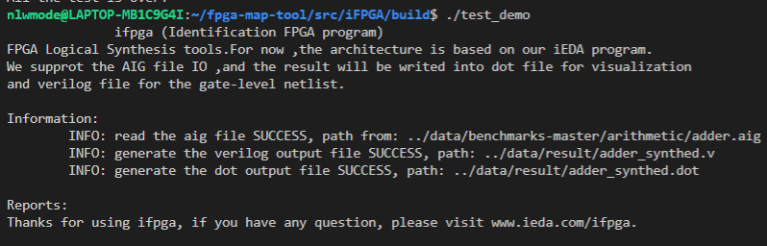

formality:

test_mockturtle.cpp: (**not matched**)

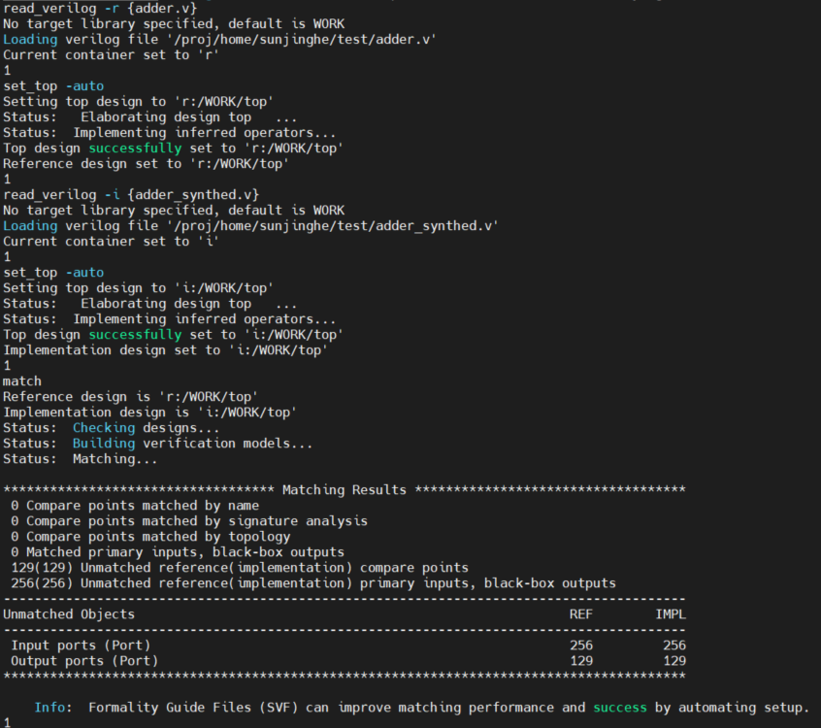

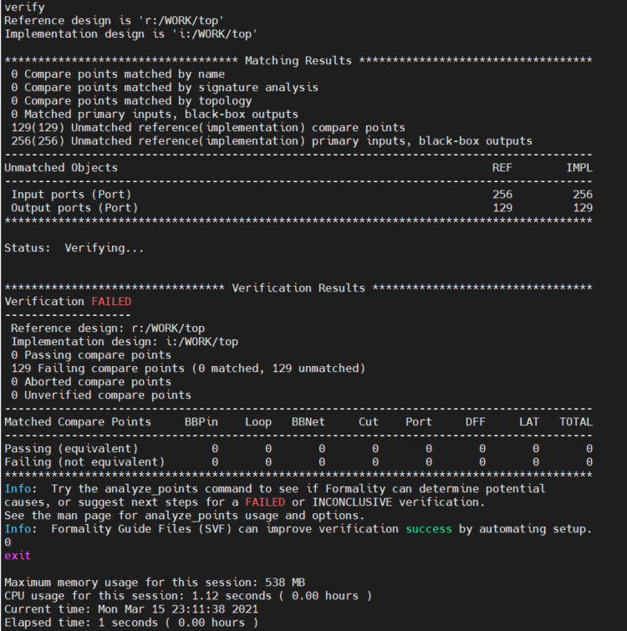

demo.cpp:(**matched**)

