Software Requirements Specification
for
Airline Reservation System
Version 1.0 approved
Prepared by: Muhammad Moaaz bin Sajjad and Saad bin Khalid
FAST NUCES, Karachi
3/12/2022
Table of Contents
Table of Contents ii
Revision History ii
1. Introduction 1
1.1 Purpose 1
1.2 Document Conventions 1
1.3 Intended Audience and Reading Suggestions 1
1.4 Product Scope 1
1.5 References 1
2. Overall Description 2
2.1 Product Perspective 2
2.2 Product Functions 2
2.3 User Classes and Characteristics 2
2.4 Operating Environment 2
2.5 Design and Implementation Constraints 2
2.6 User Documentation 2
2.7 Assumptions and Dependencies 3
3. External Interface Requirements 3
3.1 User Interfaces 3
3.2 Hardware Interfaces 3
3.3 Software Interfaces 3
3.4 Communications Interfaces 3
4. System Features 4
4.1 System Feature 1 4
4.2 System Feature 2 (and so on) 4
5. Other Nonfunctional Requirements 4
5.1 Performance Requirements 4
5.2 Safety Requirements 5
5.3 Security Requirements 5
5.4 Software Quality Attributes 5
5.5 Business Rules 5
6. Other Requirements 5
Appendix A: Glossary 5
Appendix B: Analysis Models 5
Appendix C: To Be Determined List 6

Revision History
Name | Date | Reason For Changes | Version

Introduction

Purpose
We aim to implement an airline reservation system where the company can post details about its flights, and the users can search for flights as per their needs and then book one.

Document Conventions
The document is written in Times font style with a font size of 14. The headings are emboldened for emphasis.

Intended Audience and Reading Suggestions
The intended audience are as follows:
- Sir Abdul Rahman Mahmood – teacher of “Software Design and Analysis”
- Sir Ahmed Budhi – teacher of “Database Lab”
- Miss Eman Shahid – teacher of “Database”
Our reading suggestion is to read this document with an open heart rather than with bias and prejudice. However, having said that, both the authors unanimously agree that the aforementioned readers are highly unlikely to engage in vile acts of prejudice and bias; rather, they will show utmost compassion and care.

Product Scope
Our product can be used by different airline companies to provide their customers the facility of online booking and payment.

References
<List any other documents or Web addresses to which this SRS refers. These may include user interface style guides, contracts, standards, system requirements specifications, use case documents, or a vision and scope document. Provide enough information so that the reader could access a copy of each reference, including title, author, version number, date, and source or location.>

Overall Description

Product Perspective
The product is a new, self-contained product.
(Insert component diagram here)

Product Functions
The main features of our product are as follows:
- Admin portal for airline company.
- Authentication (including via Facebook and Google).
- Customers can search for flights and then book one.
- Customers must specify the start location and the destination.
- They can further filter by days, timings, cost, and class (business or economy).
- The flights will be displayed from most recent to least.
- After booking, a payment page will appear.
- After payment, ticket(s) will be generated for printing.
- The customers can share ticket(s) on social media such as WhatsApp.
- After the flight, customers can give rating out of 5 and also leave a comment.
- Airline company will enter various data such as number of flights and for each, its timings, starting location and destination, number of seats in business and economy, and cost of business and economy ticket.
- For each flight, the airline company will be able to view how many business and economy seats have been booked.
- They can postpone flights.
- They can cancel flights.
- In case of any postponement or cancellation, a notification will be sent to customers.
- In case of cancellation, the customers will also be refunded.
- A notification will also be sent to users 3 hours before the flight.
- Customers can view most popular destinations.
- A profile page which will display customer's information as well as his or her flight history.
- Ability to use the app in light or dark mode.
- Airline company can offer discount coupons.
- Customers will be warned if they try to book flights with overlapping timings.
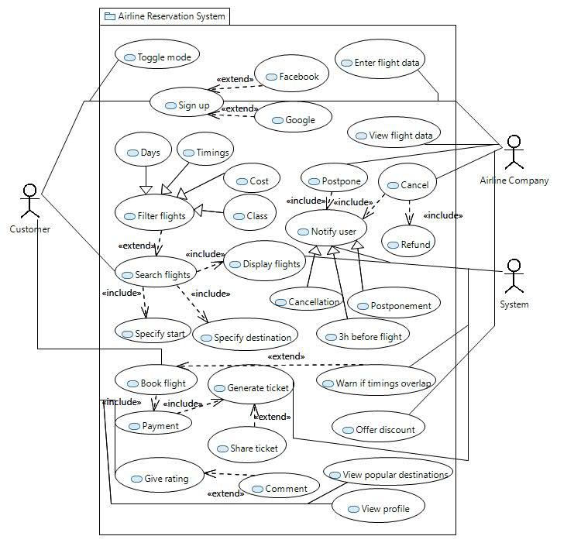

User Classes and Characteristics
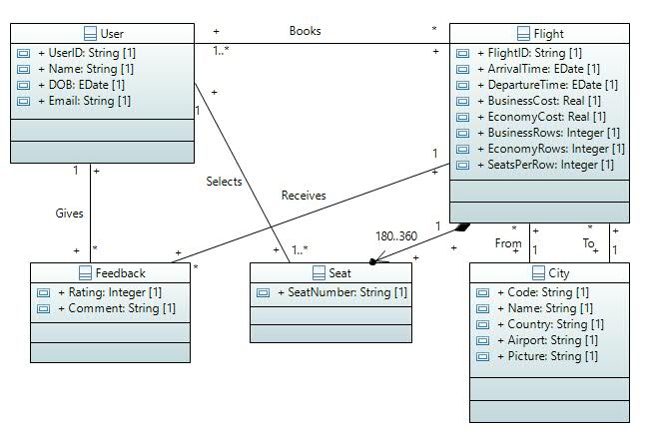
- User: This class stores data of all the users who have signed up such as name, date of birth, and email.
- Flight: This class stores data of each and every flight including the unique flight ID, the arrival and departure times, the number of seats per row, the number of economy and business rows, as well as the cost of economy and business seats.
- Feedback: This class stores the feedback, if any, given by customers of a flight. The feedback consists of a rating out of five, as well as an optional comment.
- Seat: This class stores seat numbers.
- City: This class stores the data of every city such as city code, city name, country, and airport name.

Operating Environment
The application is a mobile app which can work for both Android and iOS.

Design and Implementation Constraints
<Describe any items or issues that will limit the options available to the developers. These might include: corporate or regulatory policies; hardware limitations (timing requirements, memory requirements); interfaces to other applications; specific technologies, tools, and databases to be used; parallel operations; language requirements; communications protocols; security considerations; design conventions or programming standards (for example, if the customer’s organization will be responsible for maintaining the delivered software).>

User Documentation
<List the user documentation components (such as user manuals, on-line help, and tutorials) that will be delivered along with the software. Identify any known user documentation delivery formats or standards.>

Assumptions and Dependencies
<List any assumed factors (as opposed to known facts) that could affect the requirements stated in the SRS. These could include third-party or commercial components that you plan to use, issues around the development or operating environment, or constraints. The project could be affected if these assumptions are incorrect, are not shared, or change. Also identify any dependencies the project has on external factors, such as software components that you intend to reuse from another project, unless they are already documented elsewhere (for example, in the vision and scope document or the project plan).>

External Interface Requirements

User Interfaces
<Describe the logical characteristics of each interface between the software product and the users. This may include sample screen images, any GUI standards or product family style guides that are to be followed, screen layout constraints, standard buttons and functions (e.g., help) that will appear on every screen, keyboard shortcuts, error message display standards, and so on. Define the software components for which a user interface is needed. Details of the user interface design should be documented in a separate user interface specification.>

Hardware Interfaces
<Describe the logical and physical characteristics of each interface between the software product and the hardware components of the system. This may include the supported device types, the nature of the data and control interactions between the software and the hardware, and communication protocols to be used.>

Software Interfaces
<Describe the connections between this product and other specific software components (name and version), including databases, operating systems, tools, libraries, and integrated commercial components. Identify the data items or messages coming into the system and going out and describe the purpose of each. Describe the services needed and the nature of communications. Refer to documents that describe detailed application programming interface protocols. Identify data that will be shared across software components. If the data sharing mechanism must be implemented in a specific way (for example, use of a global data area in a multitasking operating system), specify this as an implementation constraint.>

Communications Interfaces
<Describe the requirements associated with any communications functions required by this product, including e-mail, web browser, network server communications protocols, electronic forms, and so on. Define any pertinent message formatting. Identify any communication standards that will be used, such as FTP or HTTP. Specify any communication security or encryption issues, data transfer rates, and synchronization mechanisms.>

System Features
<This template illustrates organizing the functional requirements for the product by system features, the major services provided by the product. You may prefer to organize this section by use case, mode of operation, user class, object class, functional hierarchy, or combinations of these, whatever makes the most logical sense for your product.>

System Feature 1
<Don’t really say “System Feature 1.” State the feature name in just a few words.>
4.1.1 Description and Priority
<Provide a short description of the feature and indicate whether it is of High, Medium, or Low priority. You could also include specific priority component ratings, such as benefit, penalty, cost, and risk (each rated on a relative scale from a low of 1 to a high of 9).>
4.1.2 Stimulus/Response Sequences
<List the sequences of user actions and system responses that stimulate the behavior defined for this feature. These will correspond to the dialog elements associated with use cases.>
4.1.3 Functional Requirements
<Itemize the detailed functional requirements associated with this feature. These are the software capabilities that must be present in order for the user to carry out the services provided by the feature, or to execute the use case. Include how the product should respond to anticipated error conditions or invalid inputs. Requirements should be concise, complete, unambiguous, verifiable, and necessary. Use “TBD” as a placeholder to indicate when necessary information is not yet available.>

<Each requirement should be uniquely identified with a sequence number or a meaningful tag of some kind.>

REQ-1:
REQ-2:

System Feature 2 (and so on)

Other Nonfunctional Requirements

Performance Requirements
<If there are performance requirements for the product under various circumstances, state them here and explain their rationale, to help the developers understand the intent and make suitable design choices. Specify the timing relationships for real time systems. Make such requirements as specific as possible. You may need to state performance requirements for individual functional requirements or features.>

Safety Requirements
<Specify those requirements that are concerned with possible loss, damage, or harm that could result from the use of the product. Define any safeguards or actions that must be taken, as well as actions that must be prevented. Refer to any external policies or regulations that state safety issues that affect the product’s design or use. Define any safety certifications that must be satisfied.>

Security Requirements
<Specify any requirements regarding security or privacy issues surrounding use of the product or protection of the data used or created by the product. Define any user identity authentication requirements. Refer to any external policies or regulations containing security issues that affect the product. Define any security or privacy certifications that must be satisfied.>

Software Quality Attributes
<Specify any additional quality characteristics for the product that will be important to either the customers or the developers. Some to consider are: adaptability, availability, correctness, flexibility, interoperability, maintainability, portability, reliability, reusability, robustness, testability, and usability. Write these to be specific, quantitative, and verifiable when possible. At the least, clarify the relative preferences for various attributes, such as ease of use over ease of learning.>

Business Rules
<List any operating principles about the product, such as which individuals or roles can perform which functions under specific circumstances. These are not functional requirements in themselves, but they may imply certain functional requirements to enforce the rules.>

Other Requirements
<Define any other requirements not covered elsewhere in the SRS. This might include database requirements, internationalization requirements, legal requirements, reuse objectives for the project, and so on. Add any new sections that are pertinent to the project.>
Appendix A: Glossary
<Define all the terms necessary to properly interpret the SRS, including acronyms and abbreviations. You may wish to build a separate glossary that spans multiple projects or the entire organization, and just include terms specific to a single project in each SRS.>
Appendix B: Analysis Models
<Optionally, include any pertinent analysis models, such as data flow diagrams, class diagrams, state-transition diagrams, or entity-relationship diagrams.>
Appendix C: To Be Determined List
<Collect a numbered list of the TBD (to be determined) references that remain in the SRS so they can be tracked to closure.>

