Neo Morocho
Ozone Park, NY | 347-358-0160 neomor8@gmail.com

Summary
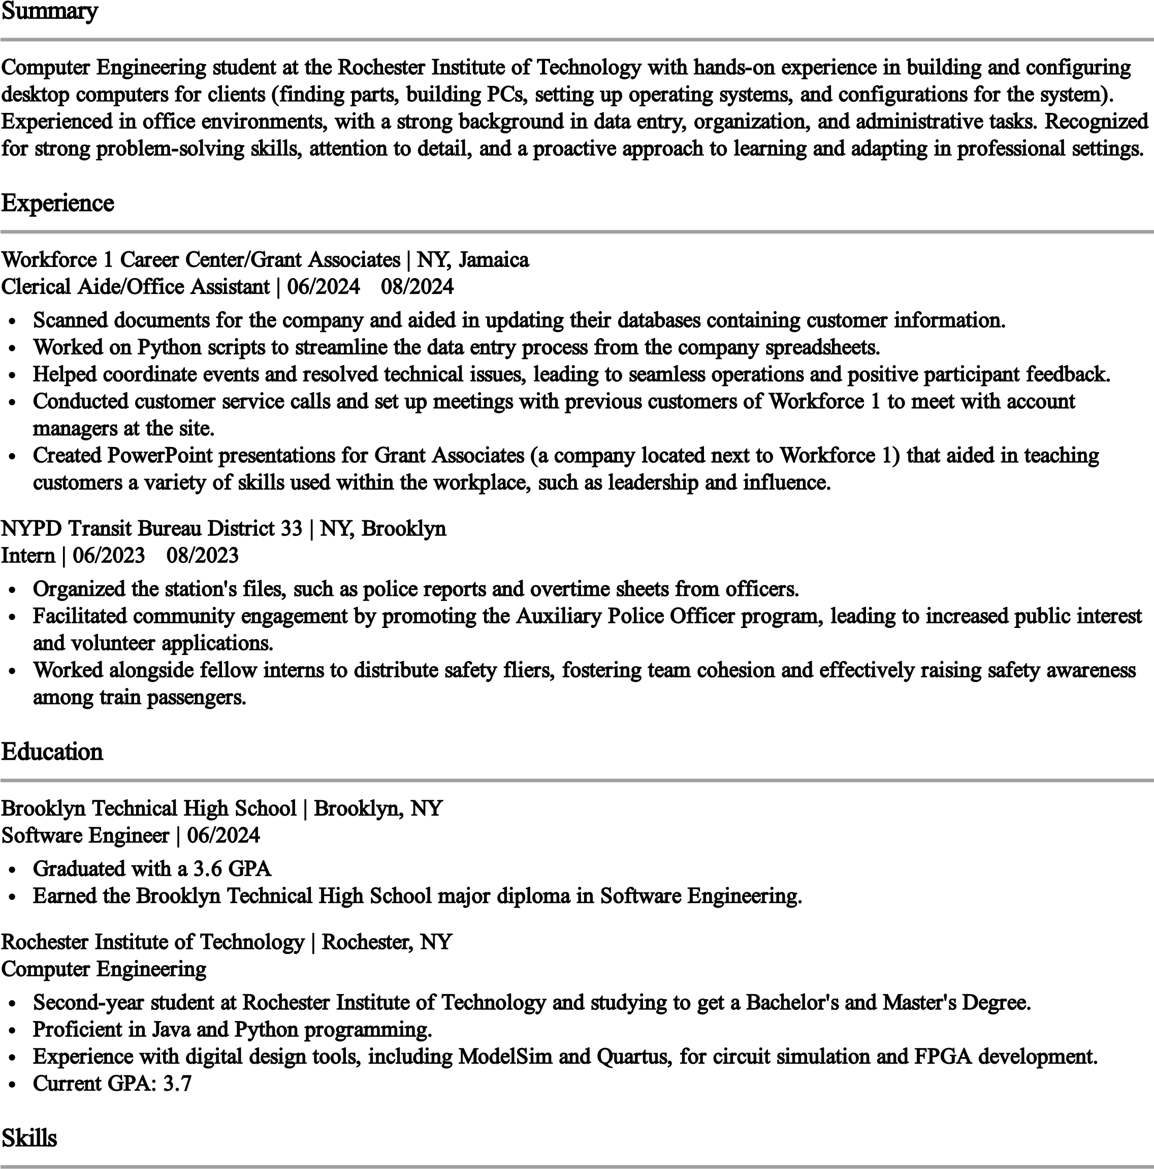
Computer Engineering student at the Rochester Institute of Technology with hands-on experience in building and configuring desktop computers for clients (finding parts, building PCs, setting up operating systems, and configurations for the system). Experienced in office environments, with a strong background in data entry, organization, and administrative tasks. Recognized for strong problem-solving skills, attention to detail, and a proactive approach to learning and adapting in professional settings.

Experience
Workforce 1 Career Center/Grant Associates | NY, Jamaica
Clerical Aide/Office Assistant | 06/2024 - 08/2024
Scanned documents for the company and aided in updating their databases containing customer information.
Worked on Python scripts to streamline the data entry process from the company spreadsheets.
Helped coordinate events and resolved technical issues, leading to seamless operations and positive participant feedback. Conducted customer service calls and set up meetings with previous customers of Workforce 1 to meet with account managers at the site.
Created PowerPoint presentations for Grant Associates (a company located next to Workforce 1) that aided in teaching customers a variety of skills used within the workplace, such as leadership and influence.
NYPD Transit Bureau District 33 | NY, Brooklyn
Intern | 06/2023 - 08/2023
Organized the station's files, such as police reports and overtime sheets from officers.
Facilitated community engagement by promoting the Auxiliary Police Officer program, leading to increased public interest and volunteer applications.
Worked alongside fellow interns to distribute safety fliers, fostering team cohesion and effectively raising safety awareness among train passengers.

Education
Brooklyn Technical High School | Brooklyn, NY Software Engineer | 06/2024
Graduated with a 3.6 GPA
Earned the Brooklyn Technical High School major diploma in Software Engineering.
Rochester Institute of Technology | Rochester, NY
Computer Engineering
Second-year student at Rochester Institute of Technology and studying to get a Bachelor's and Master's Degree.
Proficient in Java and Python programming.
Experience with digital design tools, including ModelSim and Quartus, for circuit simulation and FPGA development.
Current GPA: 3.7

Skills
Customer service, Time management, Communication skills, Computer literacy, Leadership, Microsoft word, Microsoft excel, Computer Hardware, Computer Repair, Data Entry, Java, Python
Awards
National Cyber Scholars and Finalists - 2024 , Course Certificate of Completion-2024

