**1. INTRODUCTION**

***1.1.OVERVIEW:***

Under the scheme of Naan mudhalvaan we had done a salesforce project in the field of the customer relationship management for the application of schools and colleges. In this project we had done one empathy map , brainstorm and idea prioritization and creation of an application for school management.

***1.2.PURPOSE:***

This project aims to provide a real-time knowledge to the students about salesforce. This project will also help those professionals who are in cross-technology and want to switch to salesforce. With the help of this project we gained the knowledge about salesforce and can include it in our resume as well.

**2.PROBLEM DEFINITION AND DEFINE THINKING**: **2.1.*EMPATHY MAP:***

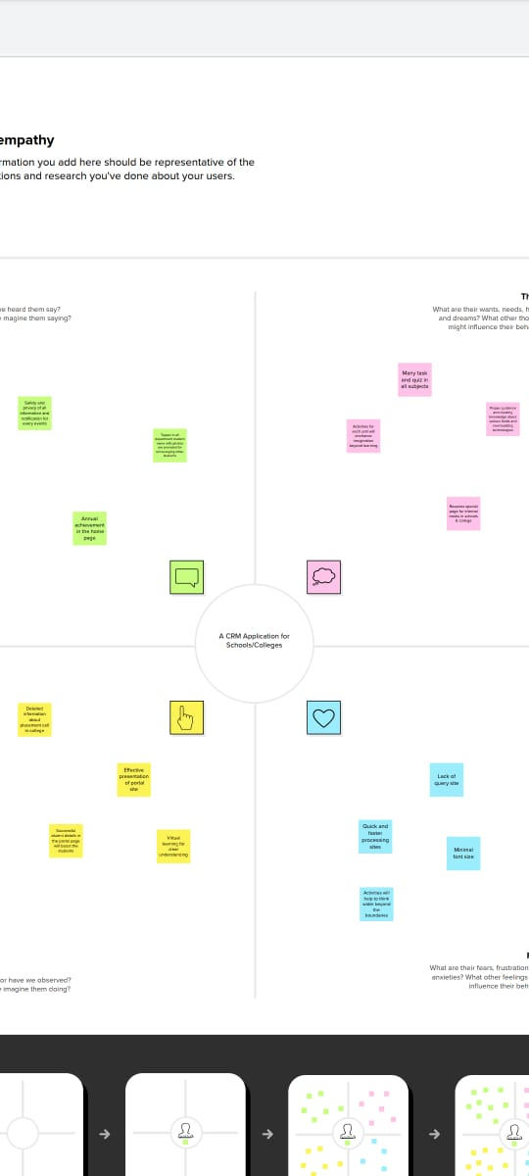

**2.2.IDEATION & BRAINSTORMING MAP****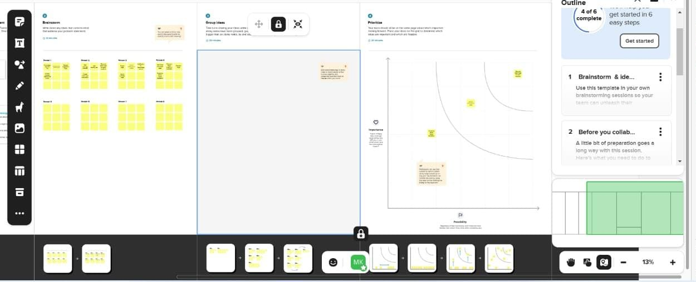**

**3.RESULT:**

***3.1.DATA MODEL***:

|  |  |
| --- | --- |
| **OBJECT NAME** | **FIELDS IN THE OBJECT** |
| 1. **SCHOOL** | |  |  | | --- | --- | | **FIELD LABEL** | **DATA TYPE** | | ADDRESS | ADDRESS | | DISTRICT | TEXT AREA | | STATE | TEXT AREA | | SCHOOL | TEXT AREA | | PHONE NUMBER | PHONE | | NUMBER OF STUDENTS | ROLL – UP SUMMARY | | HIGHEST MARKS | ROLL - UP SUMMARY | |
| 1. **STUDENTS** | |  |  | | --- | --- | | **FIELD LABEL** | **DATA TYPE** | | PHONE NUMBER | PHONE | | SCHOOL | MASTER DETAIL RELATIONSHIP | | RESULTS | PICKLIST | | CLASS | NUMBER | | MARKS | NUMBER | |
| 1. **PARENT** | |  |  | | --- | --- | | **FIELD LABEL** | **DATA TYPE** | | PARENT ADDRESS | TEXT AREA | | PARENT NUMBER | PHONE | |

* 1. **ACTIVITY AND SCREENSHOT:**

**MILESTONE 1:**

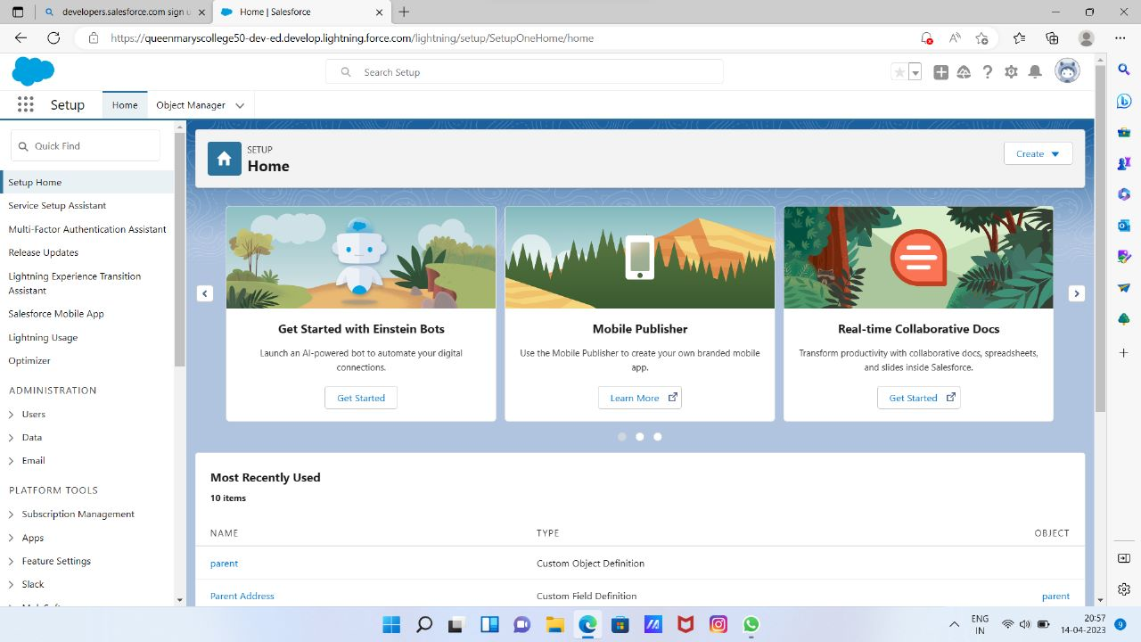 **MILESTONE 2 ACTIVITY 1:**

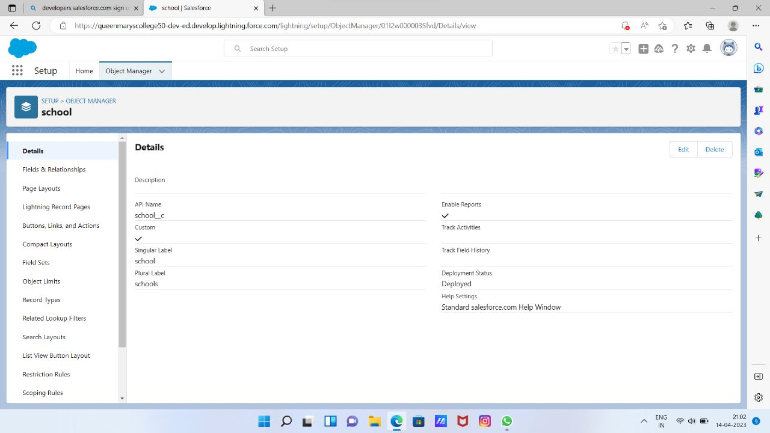 **MILESTONE 2 ACTIVITY 2**

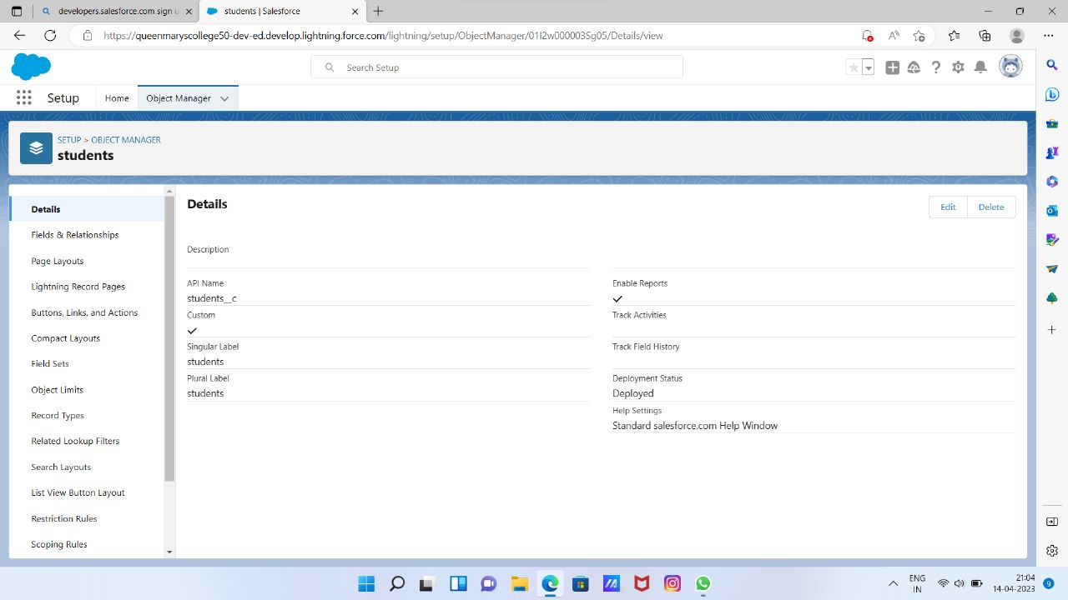

**MILESTONE 2 ACTIVITY 3**

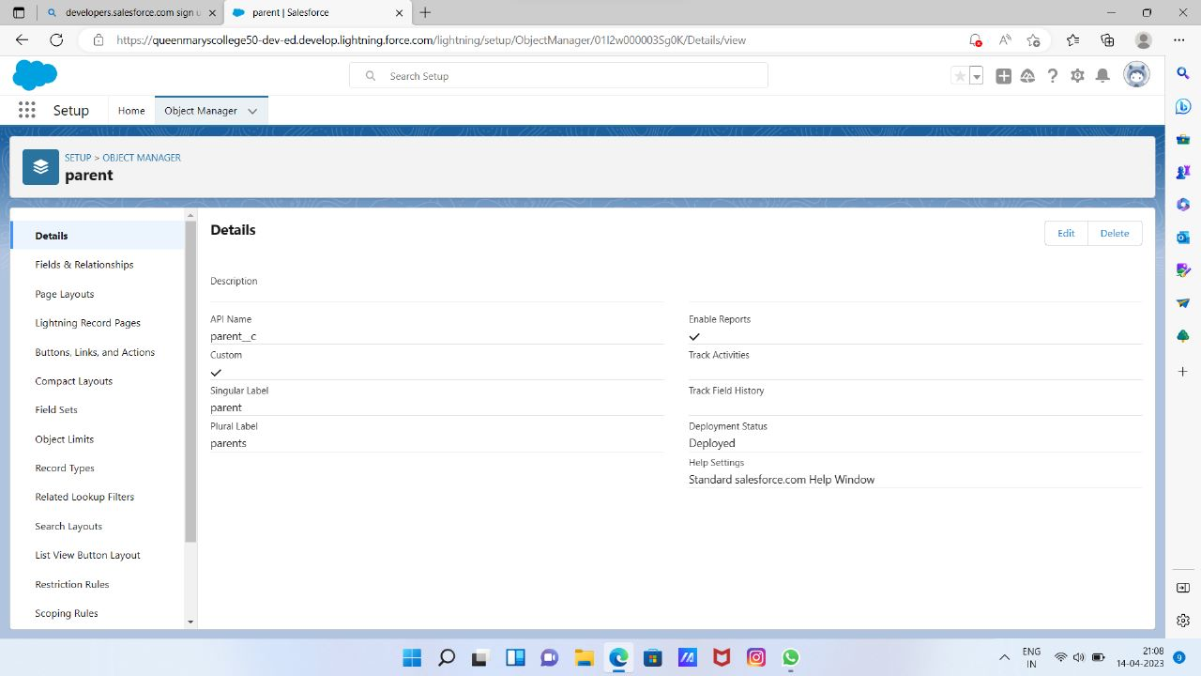 **MILESTONE 3**

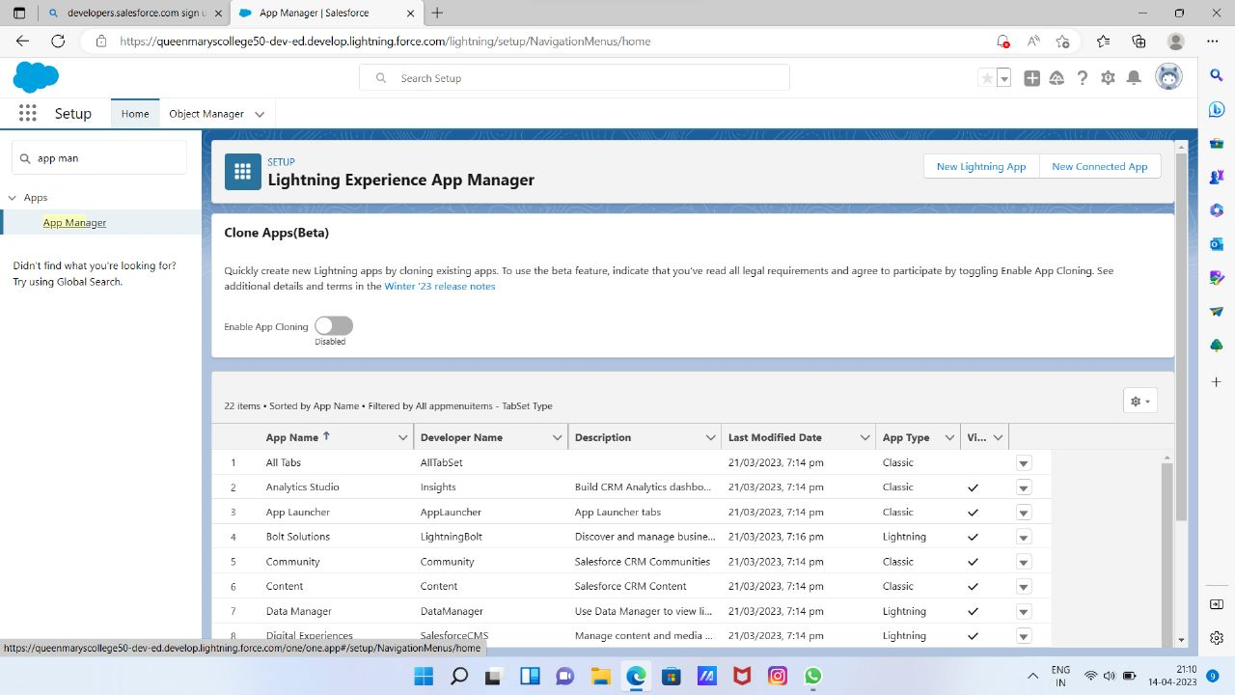

**MILESTONE 4 ACTIVITY 1**

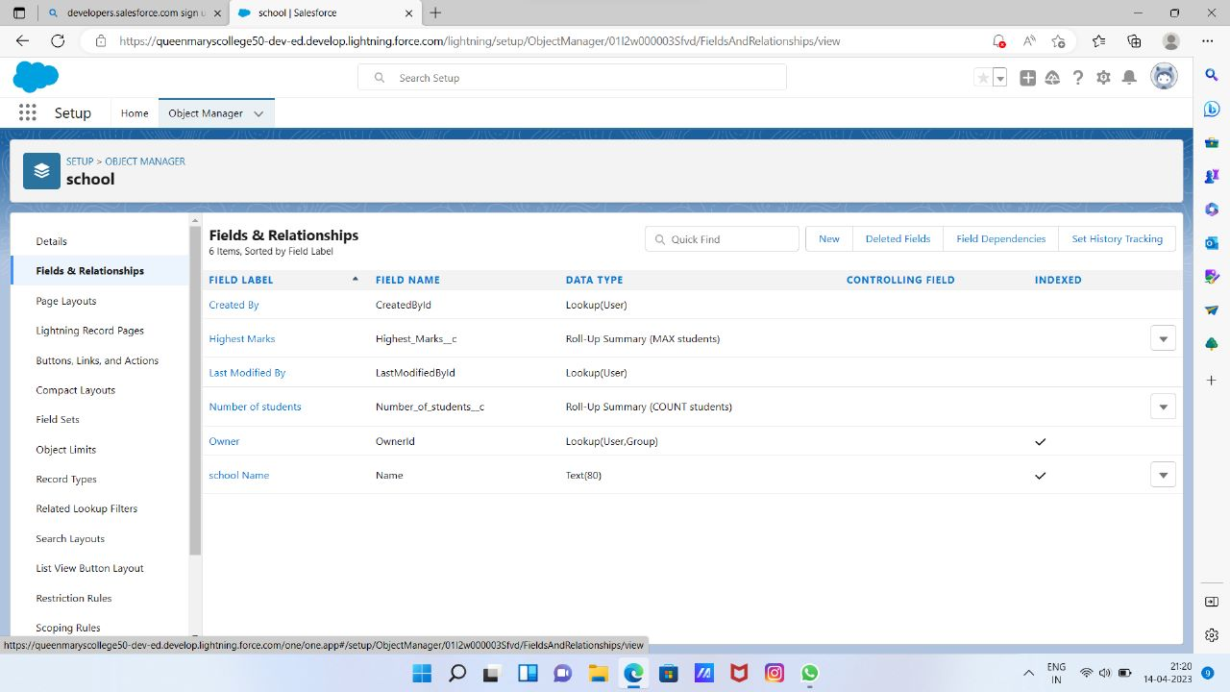 **MILESTONE 4 ACTIVITY 2**

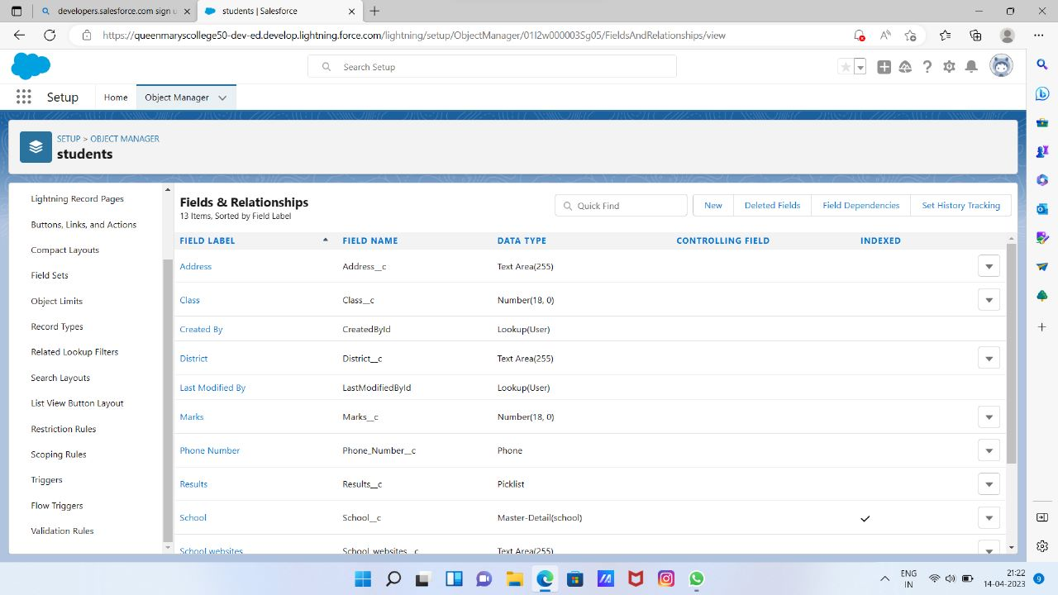

**MILESTONE 4 ACTIVITY 3**

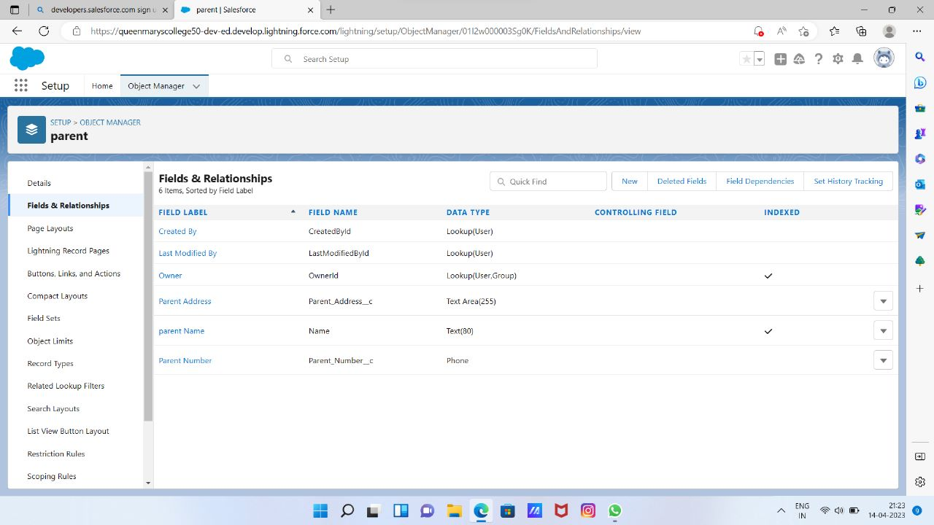 **MILESTONE 5**

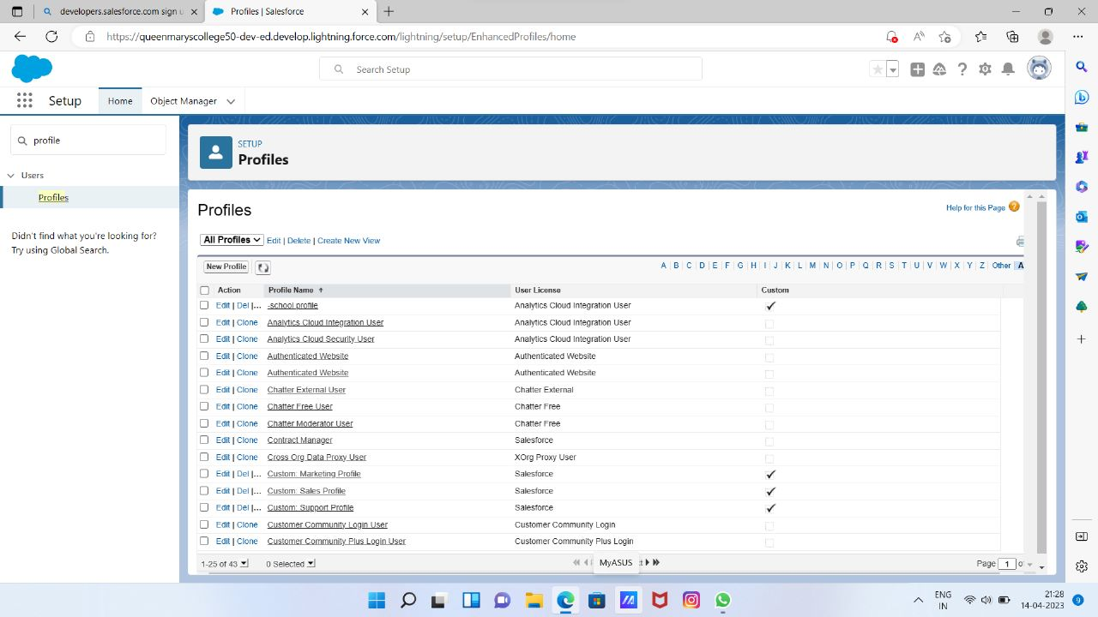

**MILESTONE 6**

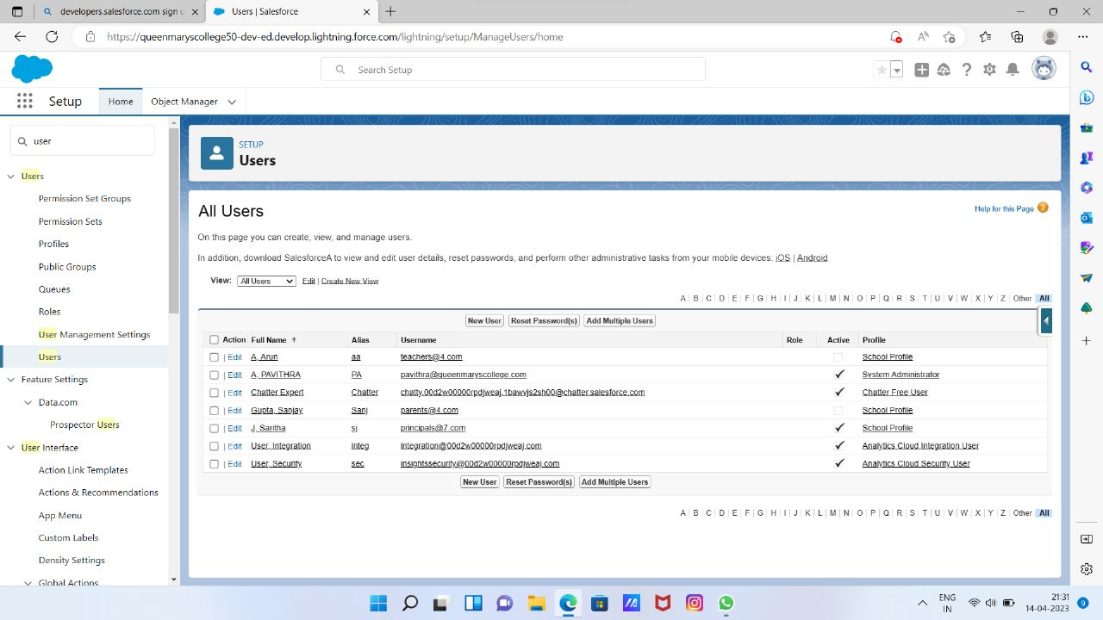 **MILESTONE 7**

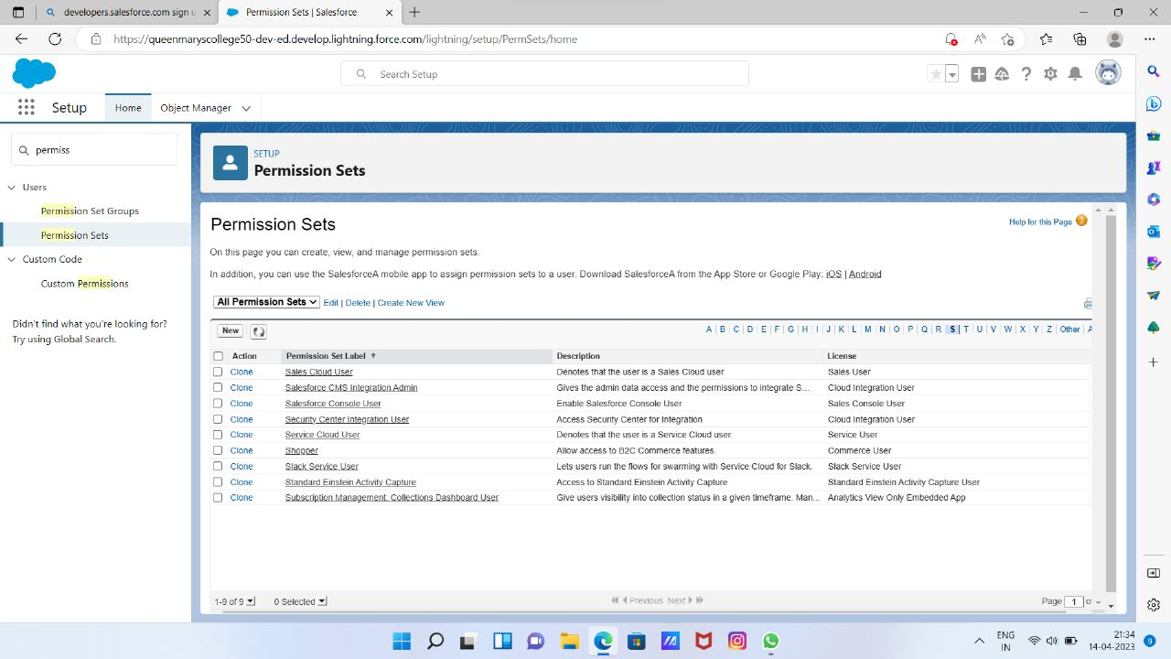

**MILESTONE 8**

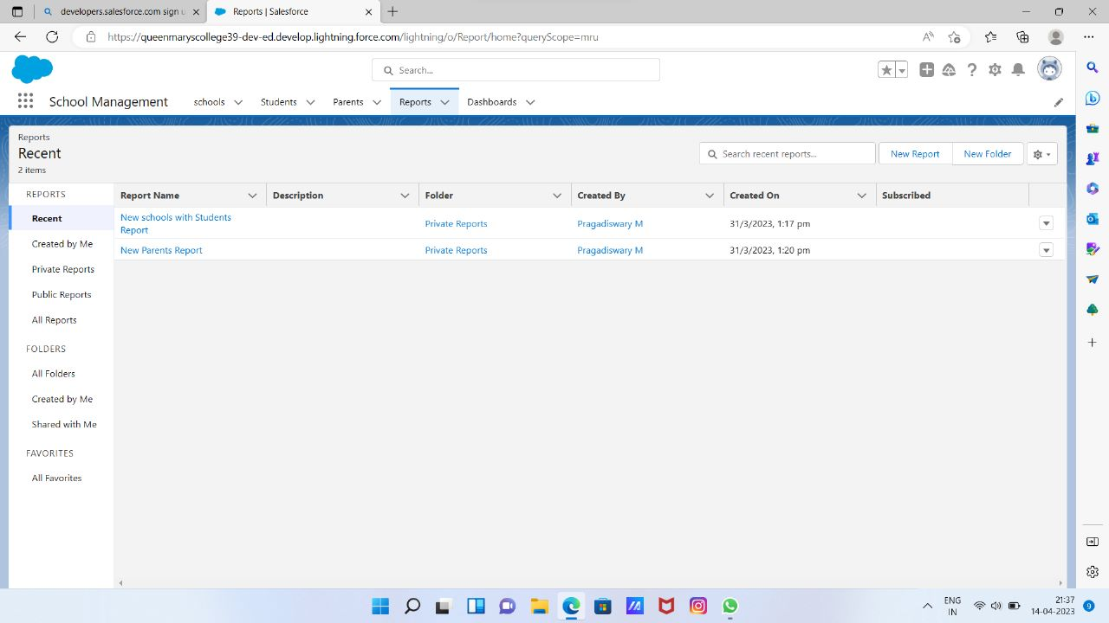

**4.TRAILHEAD PROFILE PUBLIC URL:** TEAM LEAD:[**https://trailblazer.me/id/pavithra290603**](https://trailblazer.me/id/pavithra290603)

TEAM MEMBER 1: [**https://trailblazer.me/id/mohak56**](https://trailblazer.me/id/mohak56)

TEAM MEMBER 2:[**https://trailblazer.me/id/monikasg210103**](https://trailblazer.me/id/monikasg210103)

TEAM MEMBER 3:[**https://trailblazer.me/id/pragathi05**](https://trailblazer.me/id/pragathi05)

**5.ADVANTAGES AND DISADVANTAGES:**

**ADVANTAGES:**

* We had learned the new things which helps to add in our resume as well.
* In the empathy map, we think a lot to complete the tasks.
* We also learned the softskills i.e., Team work, Group discussion,Leadership quality etc…
* Chat with mentor option helps a lot to complete these project**.**

**DISADVATAGES:**

* In the brainstorming and ideation we faced a lots of difficulties i.e., Its has only two trials.
* In the project procedure especially in the milestone 4 rolls up summary given was unordered i.e., Master detail relationship was given after the roll up summary**.**

**6. APPLICATIONS**:

* Real time salesforce project
* CRM Platform and also a centralized platform for managing customer accounts , sales leads , activities , customer support cases .
* Salesforce is a massive infrastructure of customer relationship management software products that helps marketing , sales , commerce , service and IT teams connect with their customers.

**7.CONCLUSION:**

This project enhance us to learn a lot and will definitely helps in the future.

**8.** **FUTURE SCOPE:**

This works enhance a better relationship between a customer and the sales which further helps in the development and increases the rate of profit for the companies and industries.

**HOTS:**