

ECSE 4235: Embedded Systems II

Aubrey David, Nevan Mukherjee

Final Project CP2

10/30/2025

# Roles and Responsibilities

Nevan – App UI and Bluetooth

Aubrey – Motor Driver, Documentation

# Code

<https://github.com/nm67037/Nevan_Aubrey_4235_AI_Project/tree/34ec13d767f5d8422d9736e5861b0ed256085baf/CP2>

# Table of Contents

Roles and Responsibilities 1

Code 2

Table of Contents 2

RP4 Motor Driver 2

Schematic 3

Parts List 4

Motor Driver Components 4

Sensor Components 4

Main Components & Load 4

Power & Prototyping 4

Building Instructions 4

1. Physical Motor Assembly 4

2. Component Placement 5

3. MOSFET (Master Switch) Circuit 5

4. L293D (Motor Driver) Circuit 5

5. Raspberry Pi Connections 6

6. Power Up and Calibrate Sensor 6

Analysis of Design 7

1. Motor Driver Sub-system 7

2. RPM Sensor Sub-system 7

References 8

# App UI/Bluetooth

While developing the app for this checkpoint, we had to test what code the AI was writing to ensure it worked as intended. “Good” output was defined as a working color-changing circle and Bluetooth connection through the app. Both Gemini and Claude were used, Claude especially for the extra help on establishing Bluetooth through the phone app.

# RP4 Motor Driver

The addition of an H-bridge in the motor driver introduced some changes in the schematic, parts list, and analysis. It’s noteworthy to mention that Gemini 2.5 Pro was able to give a viable step-by-step process in building this circuit very quickly but requires lots of guidance in generating a good schematic of the design. We ended up using Claude 4.5 Sonnet for the final schematic, as it handled it much better. The IR sensor has yet to be implemented but is still included in this design.

## Schematic

By giving the circuit building instructions generated by Gemini and a few more prompts for tweaking, Claude came up with this:

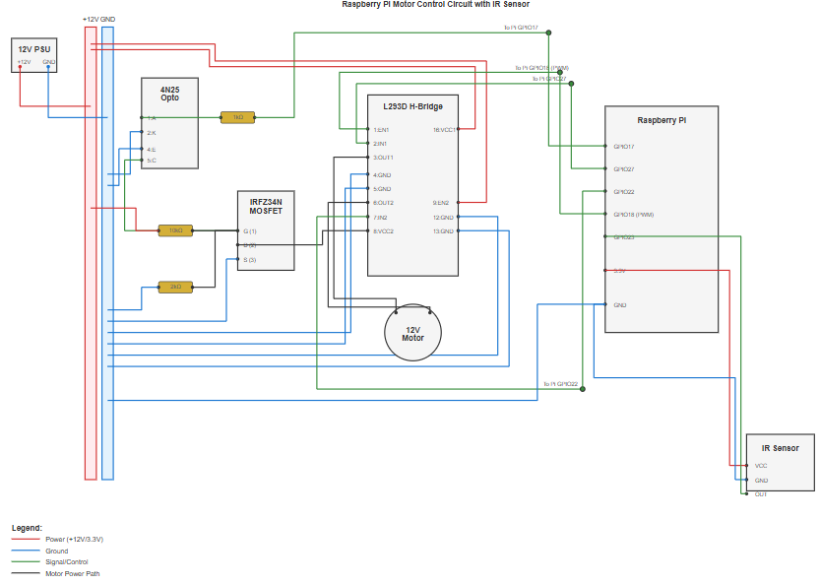

This schematic has all components (power supply, optocoupler, MOSFET, H-Bridge, Raspberry Pi, motor, IR sensor, various resistors) and connections correct with only a few issues with overlapping. Wires go over the optocoupler, MOSFET, and PI, and one wire goes under the motor. But the continuity is there, and we believe that a human could definitely build a working circuit from this. Because the instructions focused so hard on the power/ground rails, we decided to keep those instead of trying to get the AI to draw some common ground/power supply symbols.

## Parts List

## **Motor Driver Components**

* 1x **IRFZ34N N-Channel MOSFET** (M1)
* 1x **4N25 Optocoupler** (U1)
* 1x **L293D H-Bridge IC** (U2)
* 1x **1kΩ Resistor** (R_LIMIT)
* 1x **2kΩ Resistor** (R_PULLDOWN)
* 1x **10kΩ Resistor** (R_PULLUP)

### **Sensor Components**

* 1x **IR Sensor Module** (HiLetgo Infrared Obstacle Avoidance)
* 1x **2mm Propeller**

### **Main Components & Load**

* 1x **Raspberry Pi 4**
* 1x **12V DC Motor**

### **Power & Prototyping**

* 1x **12V DC Power Supply**
* 1x **5V USB-C Power Supply** (for Pi)
* 1x **Solderless Breadboard**
* 1x **Set of Jumper Wires**

Cross-examining this with the schematic and building instructions proves this list to be accurate.

## Building Instructions

**Safety First! ⚠️** Ensure all power is disconnected before you begin.

### **1. Physical Motor Assembly**

1. Press the **2mm Propeller** firmly onto the shaft of your 12V DC motor.
2. Make one blade of the propeller reflective. The simplest method is to paint one blade with white-out or cover it with a small, neat piece of aluminum foil.

### **2. Component Placement**

1. **Establish Power Rails:** Use the side rails of your breadboard for power.
   1. Red + Rail: For your 12V supply.
   2. Blue - Rail: For the common ground (GND).
2. **Place ICs:** Gently press the **L293D (U2)** and **4N25 Optocoupler (U1)** chips onto the breadboard, straddling the center ravine. Make sure the small dot/notch on each chip is on your left (marking Pin 1).
3. **Place MOSFET:** Place the **IRFZ34N MOSFET (M1)** with its flat, labeled face towards you. Its three pins (Gate, Drain, Source) should each be in their own row.
4. **Place Sensor:** Place the **IR Sensor Module** on the breadboard (or mount it securely off-board). Ensure it is positioned to "look" at the path of the propeller blades.

### **3. MOSFET (Master Switch) Circuit**

This circuit controls the 12V power to the L293D.

1. **MOSFET to Ground:** Connect the MOSFET's **Source** (Pin 3) to the **blue (-) ground rail**.
2. **Optocoupler Output:**
   1. Connect 4N25 **Pin 5** (Collector) to the MOSFET's **Gate** (Pin 1).
   2. Connect 4N25 **Pin 4** (Emitter) to the **blue (-) ground rail**.
3. **Gate Resistors:**
   1. **10kΩ Resistor (Pull-up):** Connect from the **red (+) 12V rail** to the MOSFET's **Gate** (Pin 1).
   2. **2kΩ Resistor (Pull-down):** Connect from the MOSFET's **Gate** (Pin 1) to the **blue (-) ground rail**.

### **4. L293D (Motor Driver) Circuit**

1. **L293D Power:**
   1. **VCC2 (Motor Power):** Connect L293D **Pin 8** to the MOSFET's **Drain** (Pin 2). *The MOSFET now switches power to this pin.*
   2. **VCC1 (Logic Power):** Connect L293D **Pin 16** to a **5V pin** on the Raspberry Pi.
   3. **Grounds:** Connect L293D **Pins 4, 5, 12, and 13** to the **blue (-) ground rail**.
2. **Motor Connections:**
   1. Connect one wire from your 12V DC motor to L293D **Pin 3 (OUT1)**.
   2. Connect the other motor wire to L293D **Pin 6 (OUT2)**.
3. **Enable Pins:**
   1. Connect L293D **Pin 1 (EN1)** to an empty row. This will connect to the Pi's PWM pin for speed control.
   2. Connect L293D **Pin 9 (EN2)** to the **red (+) 12V rail** to enable the unused driver side (this ensures stability).

### **5. Raspberry Pi Connections**

1. **COMMON GROUND (Critical):** Connect a **GND pin** from the Raspberry Pi (e.g., Physical Pin 6) to the **blue (-) ground rail** on your breadboard.
2. **Motor Driver Connections:**
   1. **Master Power (Start/Stop):** Connect the **1kΩ Resistor** from **GPIO 17** (Physical Pin 11) to 4N25 **Pin 1 (Anode)**. Connect 4N25 **Pin 2 (Cathode)** to the **blue (-) ground rail**.
   2. **Direction A:** Connect **GPIO 27** (Physical Pin 13) to L293D **Pin 2 (IN1)**.
   3. **Direction B:** Connect **GPIO 22** (Physical Pin 15) to L293D **Pin 7 (IN2)**.
   4. **Speed (PWM):** Connect **GPIO 18** (Physical Pin 12) to L293D **Pin 1 (EN1)**.
3. **RPM Sensor Connections:**
   1. **VCC:** Connect the sensor's VCC pin to a **3.3V pin** on the Pi (e.g., Physical Pin 1).
   2. **GND:** Connect the sensor's GND pin to the **blue (-) ground rail**.
   3. **OUT:** Connect the sensor's OUT pin to **GPIO 23** (Physical Pin 16).

### **6. Power Up and Calibrate Sensor**

1. **Connect Power:** Double-check all wiring.
   1. Connect your 12V power supply to the breadboard's + and - rails.
   2. Plug in the USB-C power to the Raspberry Pi.
2. **Calibrate Sensor:**
   1. The **PWR LED** on the IR sensor should be on.
   2. Manually turn the propeller. The sensor's **OUT LED** should **turn ON** *only* when the reflective blade passes it and **turn OFF** for the non-reflective blade.
   3. If it's always on or always off, slowly turn the **small blue potentiometer** on the sensor module with a screwdriver until you get this behavior.

The best way to test these instructions was to follow them. With a good program (also generated by AI), this design successfully drives the motor.

## Analysis of Design

This circuit consists of two main sub-systems: the **Motor Driver** and the **RPM Sensor**.

### **1. Motor Driver Sub-system**

This system is responsible for making the motor move. It has three levels of control:

1. **Master Power (Start/Stop):**
   1. The Pi's **GPIO 17** controls the **4N25 Optocoupler**. This acts as a light-based switch, safely isolating the 3.3V Pi from the 12V motor circuit.
   2. The optocoupler's output controls the **Gate** (the "on" switch) of the **IRFZ34N MOSFET**.
   3. The MOSFET acts as a heavy-duty power switch, connecting or disconnecting the 12V supply from the L293D's motor power pin (**VCC2, Pin 8**).
   4. This gives the Pi a master "Start" (s key) and "Stop" (x key) function for the entire motor.
2. **Direction Control (Clockwise/Counter-Clockwise):**
   1. The **L293D** is an H-bridge. It can reverse the polarity of the voltage sent to the motor.
   2. The Pi's **GPIO 27 (IN1)** and **GPIO 22 (IN2)** set the direction.
   3. (IN1=HIGH, IN2=LOW) spins the motor one way.
   4. (IN1=LOW, IN2=HIGH) spins the motor the other way.
3. **Speed Control (Faster/Slower):**
   1. The Pi's **GPIO 18** sends a **Pulse Width Modulation (PWM)** signal to the L293D's **Enable pin (EN1)**.
   2. A PWM signal is a digital signal that rapidly pulses ON and OFF.
   3. A **100% duty cycle** (always ON) means full speed.
   4. A **50% duty cycle** (ON half the time, OFF half the time) means ~50% speed.
   5. A **0% duty cycle** (always OFF) means 0 speed.

### **2. RPM Sensor Sub-system**

This system is responsible for *measuring* the motor's speed.

1. **Physical Setup:** The **IR Sensor** module shines an infrared (IR) beam of light. The **propeller** spins, and its one **reflective blade** bounces this light back.
2. **Signal Generation:**
   1. When the non-reflective blade passes, no light is reflected. The sensor's OUT pin is at one logic level (e.g., HIGH).
   2. When the reflective blade passes, the IR light is reflected to the sensor's detector. The OUT pin flips to the other logic level (e.g., LOW).
3. **Signal Reading:**
   1. This process generates one digital pulse for every single revolution of the motor.
   2. This pulse train is sent to the Pi's **GPIO 23**.
4. **Calculation (in Software):** The Pi's software will be set up to count these pulses. By counting how many pulses arrive in one second, it can calculate the "Revolutions Per Second" and multiply by 60 to get **Revolutions Per Minute (RPM)**.

Reading through the documentation of each component proves that the AI is correct about each function, and how they will work together.

# References

1. Gemini 2.5 Pro
2. Claude 4.5 Sonnet
3. <https://www.vishay.com/docs/83725/4n25.pdf>
4. <https://www.ti.com/lit/ds/symlink/l293d.pdf?ts=1761751851491&ref_url=https%253A%252F%252Fwww.ti.com%252Fproduct%252FL293D>
5. <https://www.vishay.com/docs/91290/irfz34.pdf>
6. <https://www.amazon.com/HiLetgo-Infrared-Avoidance-Reflective-Photoelectric/dp/B07W97H2WS>