From the given equations, visualizing the geometry of the tumor, OAR, and the normal tissue. Also, visualizing the beams from the collimator:

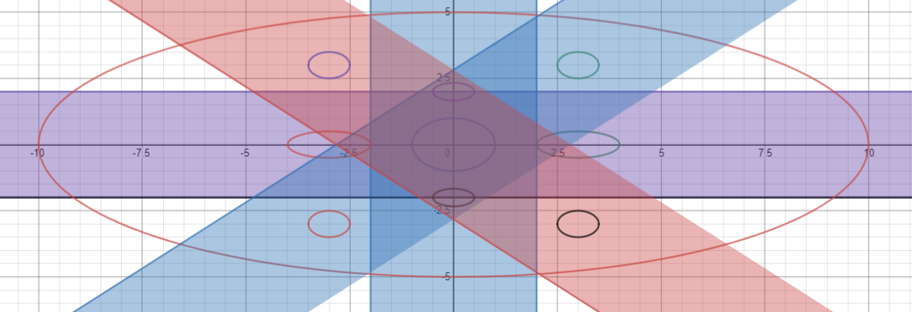

Drawn to scale.

Our goal is to maximize the dosage to the tumor, and minimize the dosage to OARs and normal tissue. Therefore, from the above figure it’s clear that it’s best to use only the 2x2 area of the collimator of the available 4x4. This means the two leaves (out of 8) at both the ends will be always closed. Now, we’ll have a total of 4 leaves for the collimator.

Visualizing after this change,

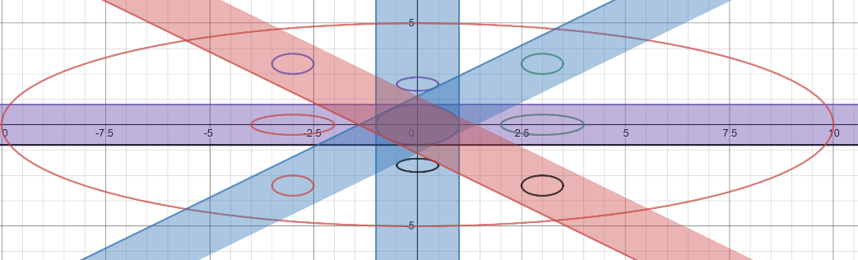

Drawn to scale.

Formulating the problem, based on the above diagram:

Assumptions:

The whole body [x: -10 to 10, y: -5 to 5, z: -2 to 2] is divided into v voxels.

The beam from the collimator is divided 0.5x0.5 beamlets, to discretize the beam and optimize the beamlet map.

|  |  |  |  |  |  |  |  |
| --- | --- | --- | --- | --- | --- | --- | --- |
|  |  |  |  |  |  |  |  |
|  |  |  |  |  |  |  |  |
|  |  |  |  |  |  |  |  |
|  |  |  |  |  |  |  |  |
|  |  |  |  |  |  |  |  |
|  |  |  |  |  |  |  |  |
|  |  |  |  |  |  |  |  |
|  |  |  |  |  |  |  |  |

Beamlet map

The shaded ones will always be closed (0s) based on the above assumption.

Therefore, in each of the 8-beam direction we have 16 (0.5x0.5) beamlets.

Our aim is to find the optimal beamlet map in all the 8 directions.

Dose Influence Matrix:

We define the dose influence matrix D, such that each element Dij represents the dosage delivered at voxel vi by beamlet j, for unit intensity.

Therefore, the dosage delivered by beamlet j of intensity xj at voxel i is given by:

$$d_{i}=D_{ij}x_{j}$$

The dose influence matrix is computed initially and stored in memory.

The intensity of the beam as it travels y units in the beam direction is given by:

$I\left(y\right)=I\left(y_{0}\right)*e^{-α\left(y-y_{0}\right)}{ }$

$y_{0}$ is the point at which the beam enters the corresponding tissue.

Formulation:

The voxels are classified as tumor |𝑇|, OAR |O|, and normal |𝑁|.

to represent the dose deposition matrix on tumor, OAR and normal tissue, they are the sub matrices of 𝐷 consisting of the elements $D_{ij}$ in voxel set T , O and N , respectively.

Let x represent the flattened vector consisting of all the beamlets in 8 directions.

Our decision variable is x.

Dimensions:

$$D_{T}=\left(\# of tumor voxels\right)*(total beamlets)$$

$$D_{O}=\left(\# of OAR voxels\right)*(total beamlets)$$

$$D_{N}=\left(\# of normal voxels\right)*(total beamlets)$$

$$x=\left(total beamlets\right)*1$$

Objectives:

Minimize underdosage of tumor voxels:

$$f_{t}= -∑D_{T}x$$

Minimize overdosage of OAR voxels:

$$f_{o}=∑D_{O}x$$

Minimize overdosage of Normal voxels:

$$f_{n}=∑D_{N}x$$

Constraints:

Tumor should receive at least the minimum dosage:

$$∑D_{T}x≥μ_{t}*d_{T}*\left(volume of the tumor\right)*(factor)$$

Factor is the conversion factor from meters to inches.

OAR should receive less than the safe dosage levels:

$$∑D_{O}x≥μ_{o}*s_{o}*\left(∑volume of the OARs\right)*(factor)$$

Normal tissue should receive less than safe dosage levels:

$$∑D_{N}x≥μ_{o}*s_{n}*\left(∑volume of normal tissue\right)*(factor)$$

MLOP:

$$\min{f_{t},f_{o}, f_{n}}$$

Subject to:

$$∑D_{T}x≥μ_{t}*d_{T}*\left(volume of the tumor\right)*(factor)$$

$$∑D_{O}x≤μ_{o}*s_{o}*\left(∑volume of the OARs\right)*(factor)$$

$$∑D_{O}x≤μ_{o}*s_{o}*\left(∑volume of the OARs\right)*(factor)$$

$$x≥0$$

Decision variable:

$$x$$

It is the flattened vector of consisting of all beamlet intensities.

Dimension: $\left(total beamlets\right)*1$

Output of the Optimization problem:

Optimal beamlet map.