Intensity Modulated Radiation Therapy (IMRT) as a Multi-Objective Optimization Problem

*Naveen Madapana*

**Introduction**

Intensity Modulated Radiation Therapy (IMRT) has been extensively used in the recent years to treat cancerous cells or malignant tumors while not harming the nearby healthy tissues or organs [1]. IMRT utilizes radiology imaging techniques such as Magnetic Resonance Imaging (MRI) and Computed Tomography (CT) to trace and localize the 3D locations of the tumors with respect to the body. With the advent of these imaging techniques, IMRT has been successfully utilized in the radiation oncology to develop treatment plans to inhibit the division of cancer cells [2]. Specifically, IMRT utilizes ionizing radiation generated from several linear accelerators and targets them at the malignant cells at different angles as shown in the Figure 1.

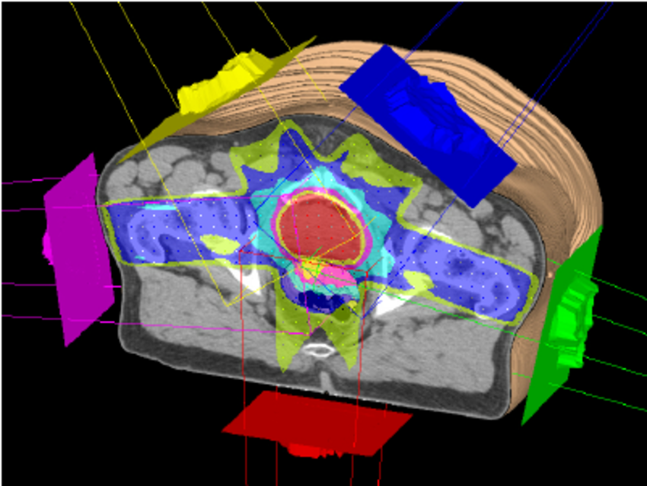

Figure 1. Illustrating the IMRT treatment using radiotherapy [3].

*Source: Courtesy of the Advanced Oncology Center, Inc.*

The intensity of the radiation is gradually increased, and the angle is appropriately varied so that the tumor cells are destroyed without affecting the healthy cells or nearby tissues. In other words, we need to find a beam direction that irradiates the tumor; however, it should not penetrate through the nearby critical organs. While IMRT has great potential in cancer treatment, it requires meticulous planning by an oncologist, simulation and appropriate tuning of parameters to make sure that the radiation affects the cancer cells alone. The leakage of the radiation to the adjacent cells can lead to the formation of new cancer cells that are radiation-induced. Hence, it is considered as a time-consuming process as it requires continuous refinement of parameters of the linear accelerators before executing the procedure on a patient. In this regard, the problem of finding the optimal parameters of the accelerators can be modeled as a multi objective optimization with linear and quadratic constraints. The objective and constraints depend on the task at hand i.e. type of tumor, severity of the cancer, part of the body, nearby organs, etc [4].

For instance, consider that there are cancer cells that are actively dividing at a particular part of the body. The imaging techniques such as CT scan would give us a 3D location and the range of the tumor region. Now, assume that there are $Z$ beamlets, where we can adjust the intensity ($I$) and the angle ($α$) of them. Hence, there are $2Z$ variables, where half of them correspond to intensity and the other half corresponding to the angle of the radiation accelerators. Now, our objective is to make sure that we are not underdosing the tumor or overdosing the critical organs or overdosing the normal tissue, etc. In addition, there are constraints on the dosage of malignant and healthy cells. If we exceed a certain threshold, healthy cells might be adversely affected so the parameters of the system need to be tuned so that the dosage at the target point does not exceed a threshold. Similarly, we want the dosage at the cancerous cells to be greater than a specific threshold in order to destroy those cells and stop them from further dividing. This requires us to increase the intensity of the radiation, however, there is a trade-off between how much we can increase it as we do not want to irradiate nearby cells.

Therefore, the problem of finding such optimal parameters can be modeled as a multi-objective optimization problem. There are several ways of approaching this problem. First, multiple objectives can be converted into a single objective which is a weighted sum of the cost functions. While this objective function can be easily solved by using SIMPLEX method, it is hard to determine the weights that are assigned to each objective function. Second approach involves solving a multi objective problem which might lead to pareto solutions. These solutions are nothing but the ones that are equally good according to the cost functions. In other words, these solutions satisfy the property that the any criterion cannot be improved without negatively affecting other criteria. Since these solutions are equally good, surgeons will be asked to pick the solution among the pareto efficient solutions according to their expertise.

**References**

[1] E. J. Hall, “Intensity-modulated radiation therapy, protons, and the risk of second cancers,” *Int. J. Radiat. Oncol.*, vol. 65, no. 1, pp. 1–7, 2006, doi: https://doi.org/10.1016/j.ijrobp.2006.01.027.

[2] B. Cho, “Intensity-modulated radiation therapy: a review with a physics perspective,” *Radiat. Oncol. J.*, vol. 36, no. 1, p. 1, 2018.

[3] H. Cambazard, E. O’Mahony, and B. O’Sullivan, “A shortest path-based approach to the multileaf collimator sequencing problem,” in *International Conference on AI and OR Techniques in Constriant Programming for Combinatorial Optimization Problems*, 2009, pp. 41–55.

[4] L. Engberg, A. Forsgren, K. Eriksson, and B. H\aardemark, “Explicit optimization of plan quality measures in intensity-modulated radiation therapy treatment planning,” *Med. Phys.*, vol. 44, no. 6, pp. 2045–2053, 2017.