Intensity Modulated Radiation Therapy (IMRT) as a Multi-Objective Optimization Problem

*Naveen Madapana*

**Introduction**

Intensity Modulated Radiation Therapy (IMRT) has been extensively used in the recent years to treat cancerous cells or malignant tumors while not harming the nearby healthy tissues or organs [1]. IMRT utilizes radiology imaging techniques such as Magnetic Resonance Imaging (MRI) and Computed Tomography (CT) to trace and localize the 3D locations of the tumors with respect to the body. With the advent of these imaging techniques, IMRT has been successfully utilized in the radiation oncology to develop treatment plans to inhibit the division of cancer cells [2]. Specifically, IMRT utilizes ionizing radiation generated from several linear accelerators and targets them at the malignant cells at different angles as shown in the Figure 1.

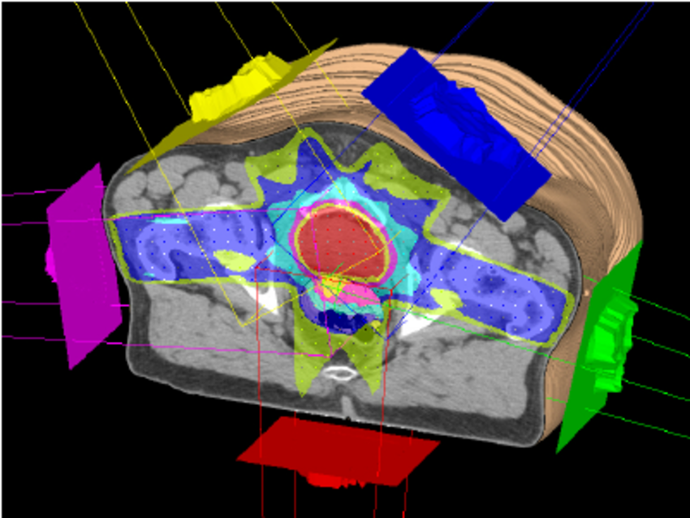

Figure 1. Illustrating the IMRT treatment using radiotherapy [3].

*Source: Courtesy of the Advanced Oncology Center, Inc.*

The intensity of the radiation is gradually increased, and the angle is appropriately varied so that the tumor cells are destroyed without affecting the healthy cells or nearby tissues. In other words, we need to find a beam direction that irradiates the tumor; however, it should not penetrate through the nearby critical organs. While IMRT has great potential in cancer treatment, it requires meticulous planning by an oncologist, simulation and appropriate tuning of parameters to make sure that the radiation affects the cancer cells alone. The leakage of the radiation to the adjacent cells can lead to the formation of new cancer cells that are radiation-induced. Hence, it is considered as a time-consuming process as it requires continuous refinement of parameters of the linear accelerators before executing the procedure on a patient. In this regard, the problem of finding the optimal parameters of the accelerators can be modeled as a multi objective optimization with linear and quadratic constraints. The objective and constraints depend on the task at hand i.e. type of tumor, severity of the cancer, part of the body, nearby organs, etc [4].

For instance, consider that there are cancer cells that are actively dividing at a particular part of the body. The imaging techniques such as CT scan would give us a 3D location and the range of the tumor region. Now, assume that there are $Z$ beamlets, where we can adjust the intensity ($I$) and the angle ($α$) of them. Hence, there are $2Z$ variables, where half of them correspond to intensity and the other half corresponding to the angle of the radiation accelerators. Now, our objective is to make sure that we are not underdosing the tumor or overdosing the critical organs or overdosing the normal tissue, etc. In addition, there are constraints on the dosage of malignant and healthy cells. If we exceed a certain threshold, healthy cells might be adversely affected so the parameters of the system need to be tuned so that the dosage at the target point does not exceed a threshold. Similarly, we want the dosage at the cancerous cells to be greater than a specific threshold in order to destroy those cells and stop them from further dividing. This requires us to increase the intensity of the radiation, however, there is a trade-off between how much we can increase it as we do not want to irradiate nearby cells.

Therefore, the problem of finding such optimal parameters can be modeled as a multi-objective optimization problem. There are several ways of approaching this problem. First, multiple objectives can be converted into a single objective which is a weighted sum of the cost functions. While this objective function can be easily solved by using SIMPLEX method, it is hard to determine the weights that are assigned to each objective function. Second approach involves solving a multi objective problem which might lead to pareto solutions. These solutions are nothing but the ones that are equally good according to the cost functions. In other words, these solutions satisfy the property that the any criterion cannot be improved without negatively affecting other criteria. Since these solutions are equally good, surgeons will be asked to pick the solution among the pareto efficient solutions according to their expertise.

**Problem Modeling**

Let us start by defining the notations. Let the specified region be divided into voxels i.e. the space is divided into small three-dimensional cuboids. Let each voxel be denoted by the coordinates of its center ($p_{i}$) for $i^{th}$ voxel. Now, the goal is to find the amount of energy absorbed by each voxel when the collimator of the linear accelerator is emitting the radiation at the body.

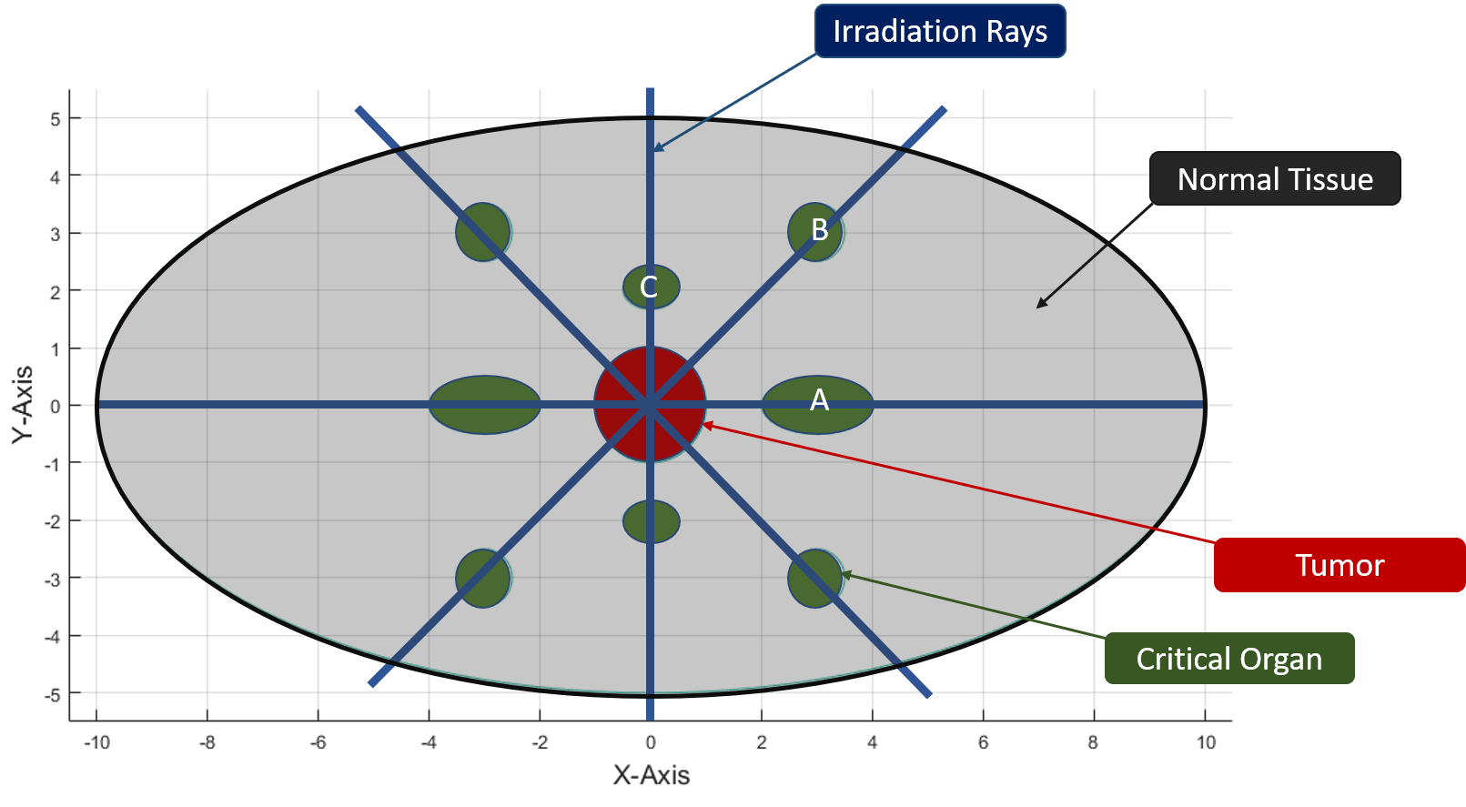

Figure 2. Depicting the tumor (red region), critical organ (dark green region) and normal tissue (rest of the area in the large ellipse marked in gray color).

The equation of the large ellipse is given by the following. The diameter along the major axis is 20 units while the one along the minor axis is 10 units. Further, the gray shaded regions inside the large ellipse correspond to the normal tissue, red region in the center of the ellipse is the tumor, and dark green regions are critical organs at risk (OAR) as shown in Figure 2.

$\frac{x^{2}}{100}+\frac{y^{2}}{25}=1$ (large ellipse)

$x^{2}+y^{2}+z^{2}≤1$ (red region – tumor)

${\left(x-3\right)}^{2}+4y^{2}+\frac{z^{2}}{4}≤1$ (A – critical organ at risk)

$4{\left(x-3\right)}^{2}+4{\left(y-3\right)}^{2}+4z^{2}≤1$ (B – critical organ at risk)

$4x^{2}+9{\left(y-2\right)}^{2}+16z^{2}≤1$ (C – critical organ at risk)

It is assumed that the irradiation can occur only along eight directions (separated by $45°$) as shown in the Figure 2. The z-axis is assumed to be coming out of the paper. Further, the absorption coefficient of the normal tissue, OAR and tumor are given by $α_{n}, α_{o},$ and $α_{t}$ respectively. Let intensity of the radiation at $x_{0}$ be $I(x_{0})$, then, the intensity at $x$ is given by the following equation, where $α$ is the absorption coefficient of the medium.

$$I\left(x\right)=I\left(x_{0}\right) e^{α(x-x_{0})}$$

Next, we will assume that the multileaf collimator has the square cross section with the side of the square being 4 inches long. The thickness of the retractable rods in the collimator is 0.5 inches. Further, the energy flux of the linear accelerator is assumed to be $F$ Joules per inch2 per second. The density of the normal tissue, OAR and tumor are given by $μ_{n}, μ_{o},$ and kg/m3 respectively. Next, the safe dosage level for normal tissue and the OAR are given by $s_{n}$ and $s_{o}$ centi-gray (J/kg) respectively. Lastly, it is assumed that the safe dosage for the tumor is $d_{T}$.

Our first task is to discretize the collimator cross section as shown in the Figure 3. The default values of $dy$ and $dz$ are set to 0.5. Given the side of the collimator is 4 inches, the cross section is sub-divided into an 8x8 grid. The index for each unit is numbered in a raster scan order (1, 2, …, 64). Each unit is referred to as a beamlet.

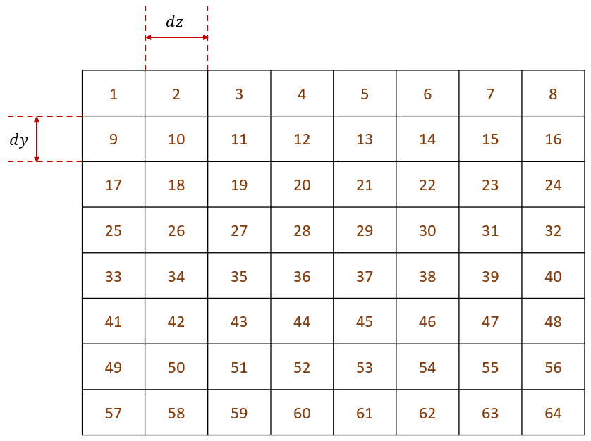

Figure 3. Cross section of the collimator is discretized along y-z axis.

Now, our task is to identify the dose influence matrix $D_{ij}^{A}$, where $i$ indicates the index of the collimator cross section and $j$ indicates the index of the voxel when the irradiation occurs along the direction A. Similarly, $D_{ij}^{B}$ and $D_{ij}^{C}$ denote the dose influence matrices along the direction B and C respectively. Note that the large ellipse is discretized in a similar manner as shown in the Figure 4.

Let $x_{1}^{A}, x_{2}^{A}, …, x_{64}^{A}$ be the values between 0 and 1 indicating the percentage of beamlet that is irradiated at the body along the horizontal direction A. If the collimator’s retractable rods cover the entire first column, then the corresponding values are set to be zero. Similarly, $x_{1}^{B}, x_{2}^{B}, …, x_{64}^{B}$ and $x_{1}^{C}, x_{2}^{C}, …, x_{64}^{C}$ be the variables along the directions B and C respectively.

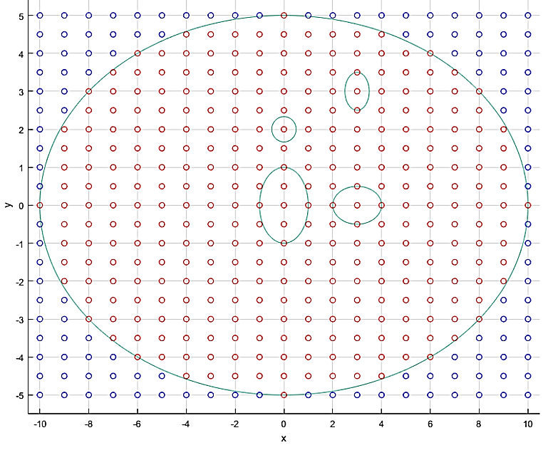

Figure 4. The blue points indicate that the voxels are outside the ellipse and the red points indicate the voxels that are inside the ellipse. Though the body is in 3D, we depict a cross section in the x-y plane.

Our end goal is to determine the values of the variables $x_{j}^{k}$ that optimize for multiple objective functions while complying with a given set of linear constraints. Assuming that the energy is irradiated in three directions (A, B and C), the energy absorbed by voxel $j$ is given by $e_{j}$. The values of $F_{i}^{k}$ are computed according to the equation: $I\left(x\right)=I\left(x_{0}\right) e^{α(x-x_{0})}$. Note that the $A_{A}$, $A_{B}$ and $A_{C}$ are the projected area normal to the directions A, B and C respectively. Their values depend on how well the mesh is refined. Note that ${\left(dx\right)}^{E}, {\left(dy\right)}^{E}$, and ${\left(dz\right)}^{E}$ are grid dimensions of the ellipse along $x, y$ and $z$ axes.

$A_{A}={\left(dy\right)}^{E} {\left(dz\right)}^{E}$, $A_{B}={\sqrt{2}\left(dy\right)}^{E} {\left(dz\right)}^{E}$ and $A_{C}={\left(dx\right)}^{E} {\left(dz\right)}^{E}$

$e_{j}^{A}=TA_{A}\sum_{i}{F_{i}^{A}{ D}_{ij}^{A} x_{i}^{A}}$

$e_{j}^{B}=TA_{B}\sum_{i}{F_{i}^{B} D_{ij}^{B} x_{i}^{B}}$

$e_{j}^{C}=TA_{C}\sum_{i}{{F_{i}^{C} D}_{ij}^{C} x_{i}^{C}}$

$$e_{j}=e_{j}^{A}+e_{j}^{B}+e_{j}^{C}$$

Now, this formulation is used to compute the energy absorbed by tumor ($e_{tumor}$), normal tissue ( $e_{normal}$) and the organs at risk ($e_{oar}$). Let $t, n$ and $r$ be the index variables that correspond to the voxels related to tumor, normal tissue and organs at risk.

$$e_{tumor}= \sum_{t}{e_{t}}$$

$$e_{tumor}= \sum_{n}{e_{n}}$$

$$e_{tumor}= \sum_{r}{e_{r}}$$

MOOP objective functions that need to be minimized are given below:

$$π_{1}=-e_{tumor}$$

$$π_{2}=e_{normal}$$

$$π_{3}=e_{oar}$$

MOOP constraints are given below. Note that $V_{T}$, $V_{N}$ and $V_{OAR}$ are the volume of the tumor, normal tissue and organs at risk respectively.

$$-e_{tumor}≤V_{T}{ μ}_{T}{ d}_{T}$$

$$e_{normal}≤{V_{N}{ μ}_{N} s}_{n}$$

$$e_{oar}≤{V_{OAR}{ μ}_{o} s}_{o}$$

Where, the decision variables are: $x_{1}^{A}, x_{2}^{A}, …, x_{64}^{A}$, $x_{1}^{B}, x_{2}^{B}, …, x_{64}^{B}$ and $x_{1}^{C}, x_{2}^{C}, …, x_{64}^{C}$

**References**

[1] E. J. Hall, “Intensity-modulated radiation therapy, protons, and the risk of second cancers,” *Int. J. Radiat. Oncol.*, vol. 65, no. 1, pp. 1–7, 2006, doi: https://doi.org/10.1016/j.ijrobp.2006.01.027.

[2] B. Cho, “Intensity-modulated radiation therapy: a review with a physics perspective,” *Radiat. Oncol. J.*, vol. 36, no. 1, p. 1, 2018.

[3] H. Cambazard, E. O’Mahony, and B. O’Sullivan, “A shortest path-based approach to the multileaf collimator sequencing problem,” in *International Conference on AI and OR Techniques in Constriant Programming for Combinatorial Optimization Problems*, 2009, pp. 41–55.

[4] L. Engberg, A. Forsgren, K. Eriksson, and B. H\aardemark, “Explicit optimization of plan quality measures in intensity-modulated radiation therapy treatment planning,” *Med. Phys.*, vol. 44, no. 6, pp. 2045–2053, 2017.