**STAT 477/577**

**HW 1**

**Neha Maddali**

1. Survey Data

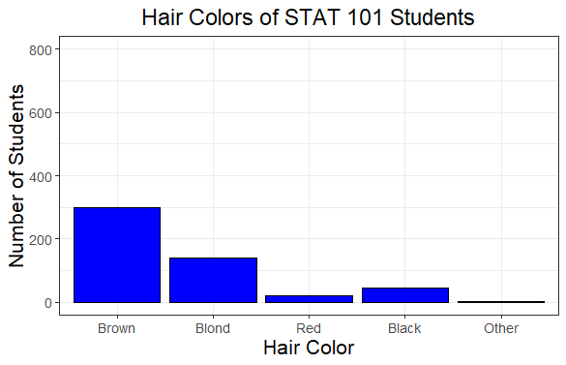**HairColor**:

**HairLength**:

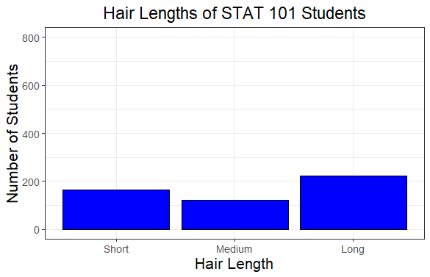

**EyeColor**:

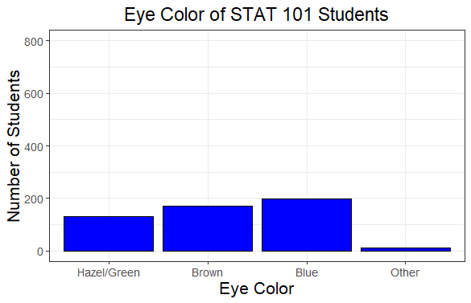

2. Genetic Mutation

a. n = **40**, p = **0.5**

b. Probability = **0.8714878**

c. Probability = **0.8618502**

d. Mean = 40*0.05 = **2**

e. Variance = 40*0.05*0.95 = **1.9**, Std. Dev. = sqrt(1.9) = **1.378405**

f. Graph

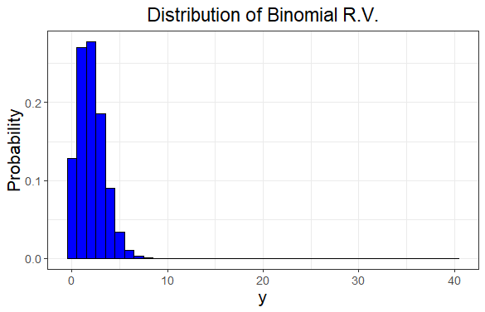

Describe graph shape: **The distribution of this binomial random variable is right skewed.**

3. Cocker Spaniels

a. n = **40**, p = **0.30**

b. Probability = **0.4228191**

c. Probability = **0.1110092**

d. Mean = 40*0.3 = **12**

e. Variance = 40*0.3*0.7 = **8.4**, Std. Dev. = sqrt(8.4) = **2.898275**

f. Graph

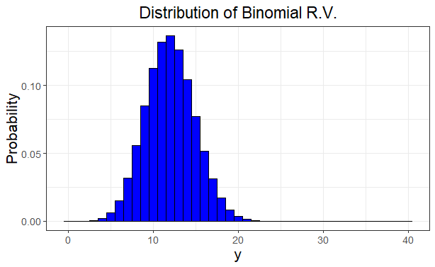

Describe graph shape: **The distribution of this binomial random variable is not entirely a uniform distribution, it is slightly right skewed.**

4. Chess

a. Probability = **0.02483712**

b. Means: Player A = 12*0.4 = **4.8**, Player B = 12*0.35 = **4.2**

c. Variances: Player A = 12*0.4*0.6 = **2.88**, Player B = 12*0.35*0.65 = **2.73**

d. Correlation = -sqrt((0.4*0.35)/(0.6*0.65)) = **-0.682**