**STAT 477/STAT 577**

**HW 2**

**Neha Maddali**

1. Sampling Distribution of Proportion of Green M&Ms

a. Shape = **Approximately normal**

Mean = **0.16**

Standard Deviation = sqrt((0.16(1-0.16))/100) = **0.0367**

b. Probability = **0.1376168**

c. Probability = **0.05085347**

2. Shake

a. Summary Table

Bar Graph

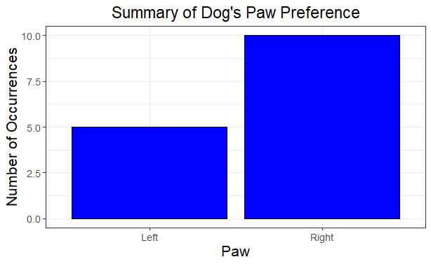

b. Null Hypothesis = **The dog doesn’t prefer its right paw when shaking hands. The probability of choosing the right paw H0: p = 0.5**

Alternative Hypothesis = **The dog prefers its right paw when shaking hands. The probability of choosing the right paw is HA: p > 0.5**

Test Statistic = **10**

P-value = **0.1509**

Conclusion = **There is not sufficient evidence to conclude that the dog favors its right paw when shaking hands.**

c. Rejection Region = **y ≥ 12**

d. Observed Type I Error = **0.01757812**

e. Power if p = 0.6 = 0.0905019

Power if p = 0.75 = 0.4612869

Power if p = 0.9 = 0.9444444

3. Antacid

a. Summary Table

Bar Graph

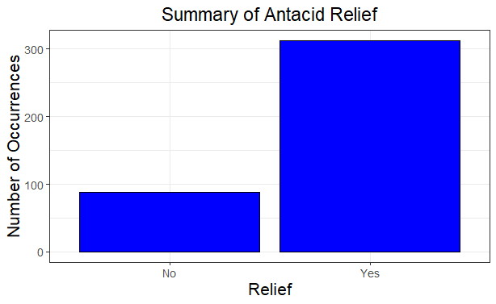

b. Why can you use score test? = **The sample size is sufficiently large (n=400), satisfying the conditions for the asymptotic normality of the sample proportion. The proportion of individuals experiencing relief under the old antacid formula (75%) is known, the score test is a suitable choice for comparing the observed proportion in the sample to this known value, facilitating the testing of the hypothesis regarding the effectiveness of the new antacid formula.**Top of Form

c. Null Hypothesis = **The new antacid formula is as effective as the old formula H0: p =0.75**

Alternative Hypothesis = **The new antacid formula is better than the old formula HA: p > 0.75**

Test Statistic = **1.385641**

P-value = **0.08293**

Conclusion = **There is moderate evidence to suggest that the new formula is better than the old formula.**

d. Fill in table with power values

|  |  |  |  |
| --- | --- | --- | --- |
| $$α$$ | Population Proportion ($p$) | | |
| 0.8 | 0.85 | 0.9 |
| 0.1 | **0.867077** | **0.9999741** | **1** |
| 0.05 | **0.7640508** | **0.9998448** | **1** |
| 0.01 | **0.4926816** | **0.9972821** | **1** |

e. Effect of $α$ on power of test = **as alpha decreases, power decreases**

Effect of $p$ on power of test = **as p increases, power increases**

f. Sample size = **498**