A Convert data for Tdict
Project ConvertDataForTDict to convert data from open source dict StartDict to data format database(.db) for Tdict program use.

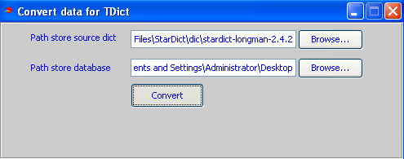

Convert data can perfrom 2-3 hour per dictiocnary
- Run Tdict
After you create database for Tdict(file .db) to use for device, you have to imort this data input SDcard. To pefrom this, use command line:
adb push db /sdcard/Tdict/db
db is directory to store data in PC
/sdcard/Tdict/db is directory on SDcard to store file data for Tdict program

C. GUI program
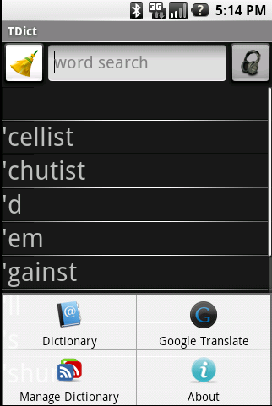

Functions of Program:
Dictionary
GoogleTranslate
Manage Dictionary

1. Dictionary function

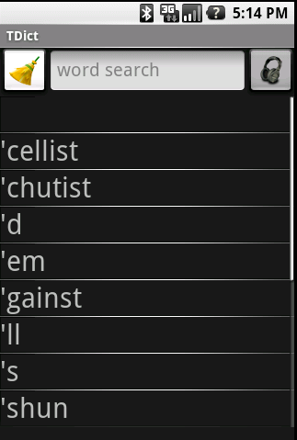

Support dictionary many languages:
Display language Japanese

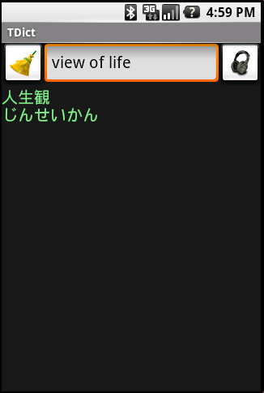

Display language Viet Nam

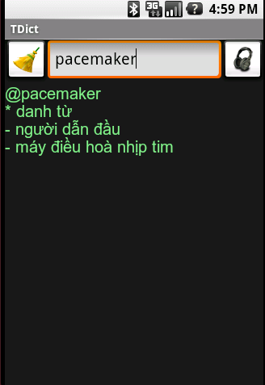

2. Manage Dictionary function

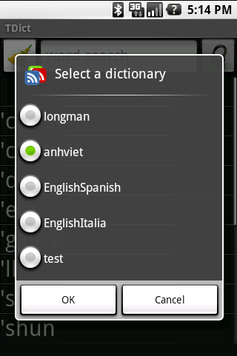s

3.Google Translate function

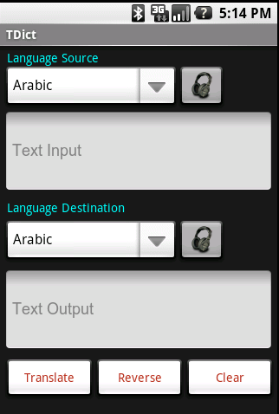

Screen display waiting in GoogleTranslate

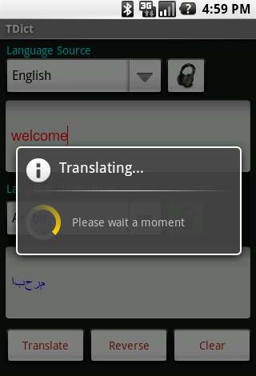

Display many languages

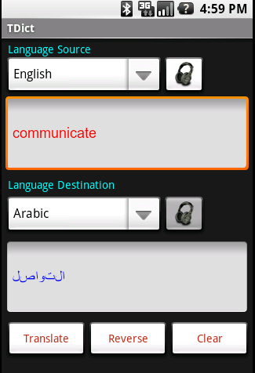

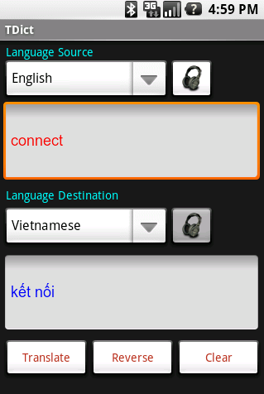

4. Program support Text to speech in Dictionary and Google Translate
In Dictionary
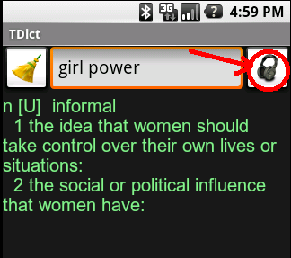

In Google Translate
