REGISTER FLOW

RECEIVE PARAMETER

REGISTER

START

Create Parameter List

REGISTER

false

PROCESS

VALID

REGISTER

REGISTER TABLE

true

EMAIL USER ABOUT REGISTER

VALID

false

EMAIL USER ACCOUNT

CREATE USER

false

USER TABLE

REPORT THE PROBLEM

EMAIL ADMIN

MT 4 SERVER

BACKEND

CLIENT

# REGISTRATION

The process as follow

* User Register in register page
* The register page request checked by front-end
* If the register valid then save to **register table**. If the register invalid, return to register page
* Send register email to user. The register email contain info the user has been register to system .
* Create parameter variable, contain user detail ,username , password, and related paramaters.
* Send the parameter to MT4 Server..
* Process by MT4
* If the parameter valid, respond as success respond. If invalid, respond as failed respond
* If the MT4 Respond valid. Enter the register user to **user table,** send email to user account and password
* If the MT4 Respond invalid. Send admin email about user failed to register in MT4.

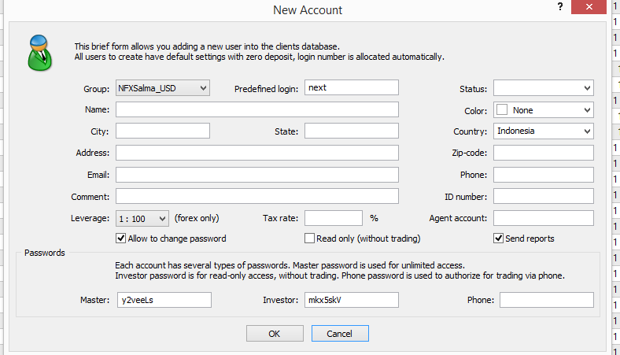

# Parameter

To register to MT4. System will create a list parameter. Contain:

* Group
* Username
* User real name
* Address detail : address, city, state, zip code
* Email
* Phone
* Password : Master & Investor
* ID number
* Agent number
* Leverage
* Status

Above parameter send as POST variable using CURL from php.

# TABLE

Table contain data before and after user register in the system. There is another table for supporting register and login

1. Register Table  
   Contain register detail from user. This is contain all parameter send from register form.
2. User Table  
   Contain verified user from MT4
3. Login history.  
   Contain login and logout history.
4. Register history  
   Contain register user and register server to MT4