- Difference between Array and Array List.
Array | ArrayList
Array is static i.e., size is fixed | ArrayList is dynamic. We don’t define the size
Contain both primitives and objects. | Contains only objects.
Not Type Safety i.e. holds same data type, homogeneous | Type Safety means generics.
Use for loop or for each loop through iterate the Array. | Use iterate through iterate ArrayList.
. length is used for length of the Array. | Size () method use for length of the ArrayList.
Array does not provides remove an element. | ArrayList provides you to remove an elements.
Since Java 5, primitives are automatically converted in objects which is known as auto-boxing.

Q. Difference between ArrayList and Linked List.
ArrayList and LinkedList both implements List interface and maintains insertion order. Both are non-synchronized classes.
ArrayList | Linked List
ArrayList internally uses a dynamic array to store the elements. | LinkedList internally uses a doubly linked list to store the elements.
Manipulation with ArrayList is slow because it internally uses an array. If any element is removed from the array, all the bits are shifted in memory. | Manipulation with LinkedList is faster than ArrayList because it uses a doubly linked list, so no bit shifting is required in memory.
An ArrayList class can act as a list only because it implements List only. | LinkedList class can act as a list and queue both because it implements List and Deque interfaces.
ArrayList is better for storing and accessing data. | LinkedList is better for manipulating data.

Q. Difference between ArrayList and Vector:
ArrayList | Vector
1) ArrayList is not synchronized. | Vector is synchronized.
2) ArrayList increments 50% of current array size if the number of elements exceeds from its capacity. | Vector increments 100% means doubles the array size if the total number of elements exceeds than its capacity.
3) ArrayList is not a legacy class. It is introduced in JDK 1.2. | Vector is a legacy class.
4) ArrayList is fast because it is non-synchronized. | Vector is slow because it is synchronized, i.e., in a multithreading environment, it holds the other threads in runnable or non-runnable state until current thread releases the lock of the object.
5) ArrayList uses the Iterator interface to traverse the elements. | A Vector can use the Iterator interface or Enumeration interface to traverse the elements.

Q. Difference between HashMap and Hash-Table:
HashMap and Hashtable both are used to store data in key and value form. Both are using hashing technique to store unique keys.
HashMap | Hash-Table
1) HashMap is non synchronized. It is not-thread safe and can't be shared between many threads without proper synchronization code. | Hashtable is synchronized. It is thread-safe and can be shared with many threads.
2) HashMap allows one null key and multiple null values. | Hashtable doesn't allow any null key or value.
3) HashMap is a new class introduced in JDK 1.2. | Hashtable is a legacy class.
4) HashMap is fast. | Hashtable is slow.
5) We can make the HashMap as synchronized by calling the code  Map m = Collections.synchronizedMap(hashMap); | Hashtable is internally synchronized and can't be unsynchronized.
6) HashMap is traversed by Iterator. | Hashtable is traversed by Enumerator and Iterator.
7) Iterator in HashMap is fail-fast. | Enumerator in Hashtable is not fail-fast.
8) HashMap inherits Abstract Map class. | Hashtable inherits Dictionary class.

Q. Difference between Hash Set and Hash Map:
Hash Map | Hash Set
Hash Map is implementation of Map interface. | Hash Set is an implementation of Set interface.
Hash Map store data in form of key value pair. | Hash Set store only object.
Put method is used to add element in map. | Add method is used to add element is Set.
Hash Map is faster than Hash Set because unique key is used to access object. | Hash Set is slower than Hash Map.

Q. What is collection in Java?
Collection represents is a single of objects i.e., a group.
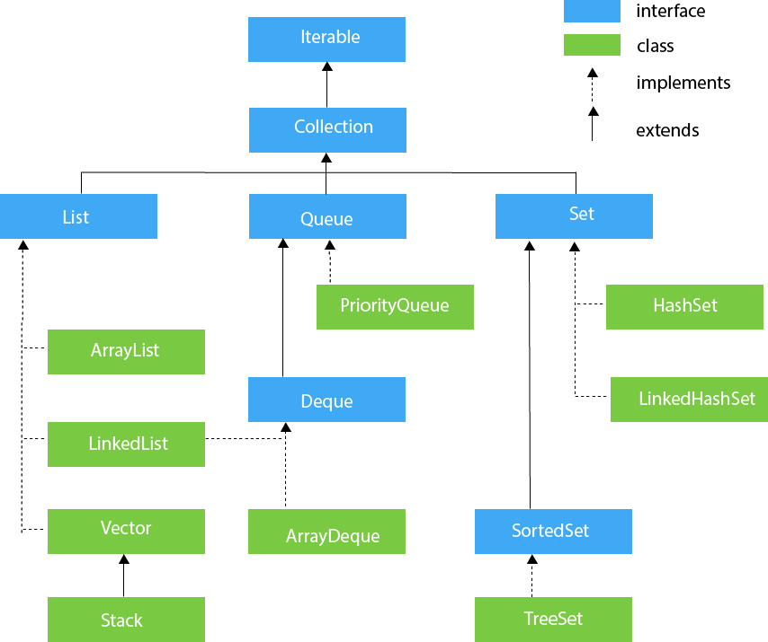

Q. Difference between length of Array and size() of ArrayList?
Array has length property which provides the length or capacity of the Array. It is the total space allocated during the initialization of the array.

ArrayList doesn't have length() method, the size() method of ArrayList provides the number of objects available in the collection.

Q. What is Array?
- To store similar data type values in array variable.
- Arrays are used to store multiple values in a single variable, instead of declaring separate variables for each value.
- Lowest bound/index=0 and highest bound/index=(n-1) (n is size of array)
- Advantage: One variable can store multiple value.
- Disadvantage: size is fixed---static array--to overcome this we use collections--Arraylist, Hash Table
- Store similar data types value---to overcome this we use object array.
- Random access: We can retrieve any data from array with the help of the index value.
- Add elements with the help of assignment operator
- Does not support generic i.e., not type safe.

Q. What is ArrayList?
- Arraylist---dynamic array---we don't define the size.
- The ArrayList class implements the List interface.
- It uses a dynamic array to store the duplicate element of different data types.
- The ArrayList class maintains the insertion order and is non synchronized.
- Allows random access to fetch the element because it stores values on the basis of indexes.
- Only store one object.
- Arraylist allows you to remove elements, but array doesn't provide such methods.

Q. What is List?
- List is an interface found in the java. util package and inherits the Collection interface.
- The implementation classes of List interface are ArrayList, LinkedList, Stack, Vector.

Q. What is LinkedList?
- A linked list can also be defined as the collection of the nodes in which one node is connected to another node.
- Each and every node is divided into two parts. 1st parts store the value and 2nd part stores the reference of the next element.
- Each and every node has reference of next element that’s why its called singly linked list if there is a requirement of frequent addition and deletion in application then LinkedList is a best choice.

Q. Types of Linked list
- Singly Linked list
- Doubly Linked list
- Circular Linked list
- Doubly Circular Linked list

Q. What is Map?
- Map is an Interface and a map contains values on the basis of key, i.e. key and value pair. Each key and value pair is known as an entry. A Map contains unique keys.
- A Map is useful if you have to search, update or delete elements on the basis of a key.
- Java Map Hierarchy:
- There are two interfaces for implementing Map in java: Map and SortedMap, and three classes:
- HashMap, LinkedHashMap, and TreeMap.
- A Map doesn't allow duplicate keys, but you can have duplicate values.
- HashMap and LinkedHashMap allow null keys and values, but TreeMap doesn't allow any null key or value.

Q. What is HashMap?
- HashMap is a class implements Map interface and extend AbstractMap.
  - HashMap stores two objects key and value and HashMap doesn't allow duplicate key
  - It may have one null key and multiple null value and it maintains no order
  - HashMap is non-synchronized i.e., not thread safe
  - Concurrent modification exception---Fail Fast condition
  - when one thread is adding or removing the value and at the same time T2 T3 T4
  - try to access particular value but that value is gone from that object
  - immediately it gives you..cme.

Q1. Difference between abstract class and interference.
Abstract Class | Interface
Abstract keyword | Interface keyword
Subclasses extend abstract class. | Subclasses implements interfaces.
Abstract Classes can have non abstract method and 0 or more abstract methods. | 100% abstract methods.
We can extend only one abstract class. | We can implement multiple interfaces.
Support multiple inheritance. | Does not support multiple inheritance.
Contains Data Member. | Does not contain Data Member.
Contains constructors. | Does not contain constructor.

