1. Check whether two arrays are equal or not? SUM of ARRAY

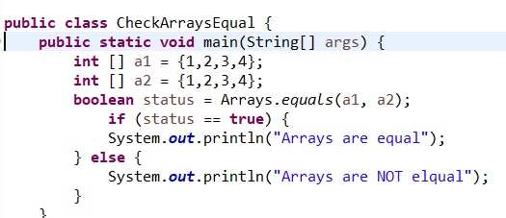 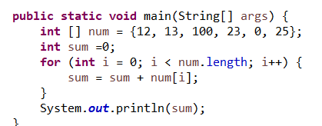

1. Program to print the LARGEST/ SMALLEST element in Array?

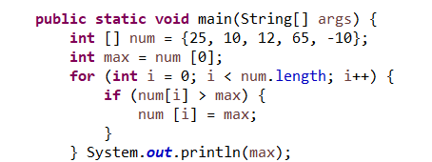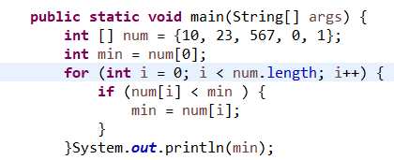

1. Array in REVERSE ORDER. 4. SORT ARRAY ASC OR DESC

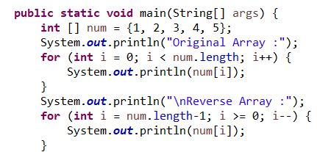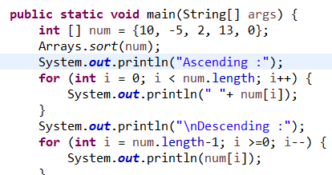

5. ODD OR EVEN NUMBER of an ARRAY MISSING NUMBER ARRAY

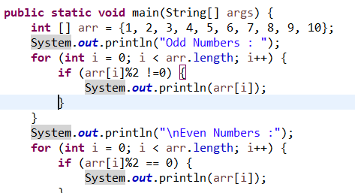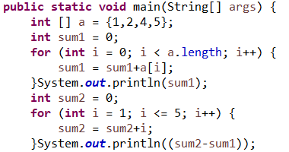

6. THIRD LARGEST NUMBER

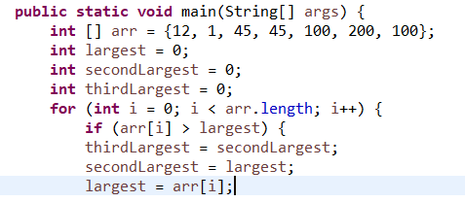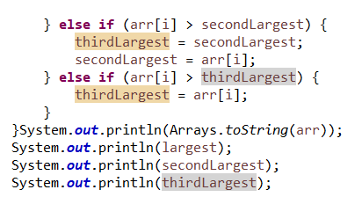

7. REMOVE DUPLICATE VALUES FIND DULICATE ELEMENT

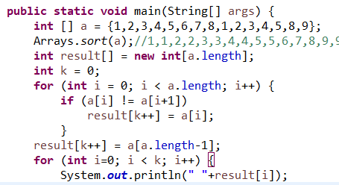 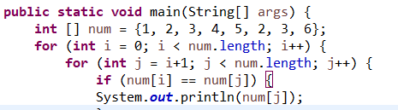

8. CONVERTING ARRAY to LIST.

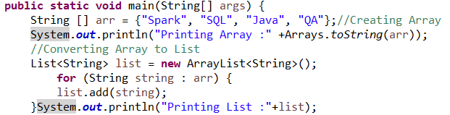

9. CONVERTING LIST to ARRAY.

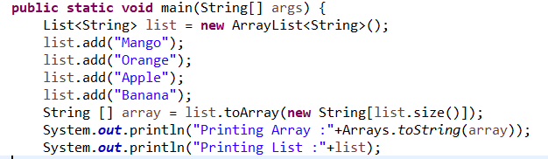

10. SORT an LIST CONVERTING ARRAYLIST to ARRAY

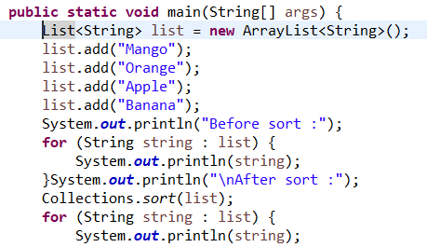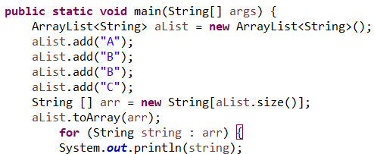

11. All pair of elements in an Array whose sum is equal to a specified number?

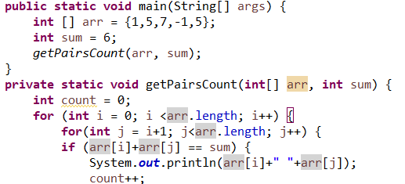

12. MERGE two Array and REMOVE duplicate:

