1. Convert String to Integer \*\*First and Last Letter of a String?

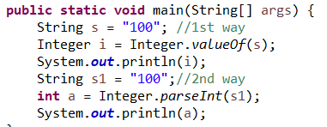 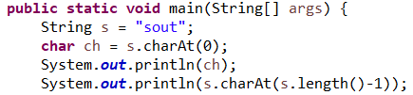

1. How to REMOVE a Char? \*\*Print Characters at ODD positions by charAt()

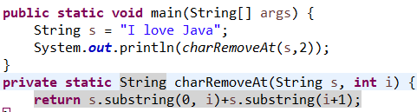 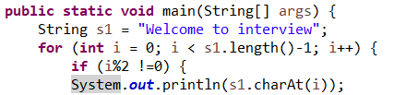

1. Count FREQUENCY of characters \*\*REVERSE a String

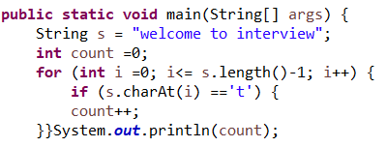 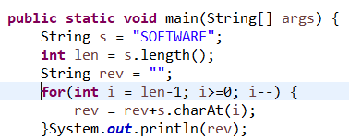

1. PALINDROME OR NOT \*\*\*Two Strings are ANAGRAM OR NOT

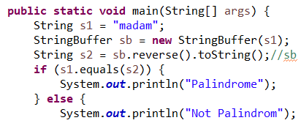 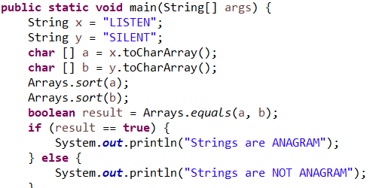

5. SWAP TWO STRING WITHOT THIRD \*\*\*Count Number of Letter in String

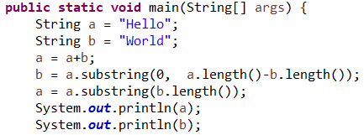 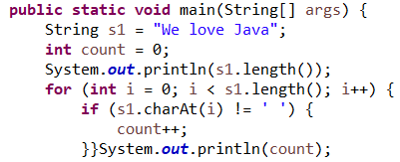

6. Get First Letter of Each Word in String \*\*\*DUPLICATE CHAR in String

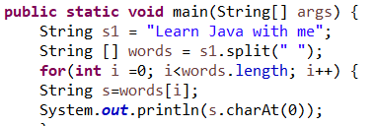 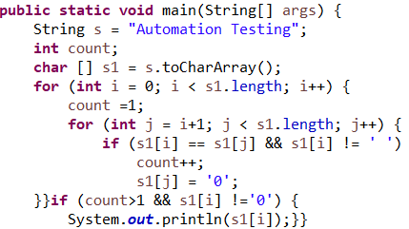

7. Remove all WHITE SPACE from STRING \*\*\*ROTATION of Another STRING

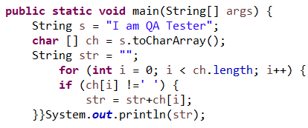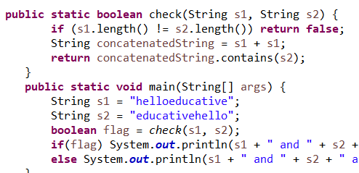

8. First letter of each word to UPPERCASE

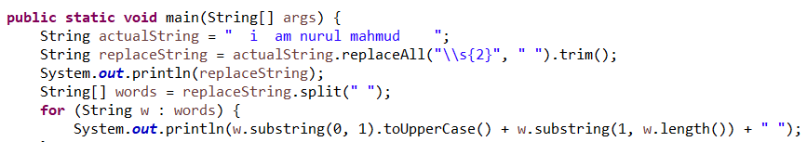

9. Find the Prime Number Find the FIBONACCI Series

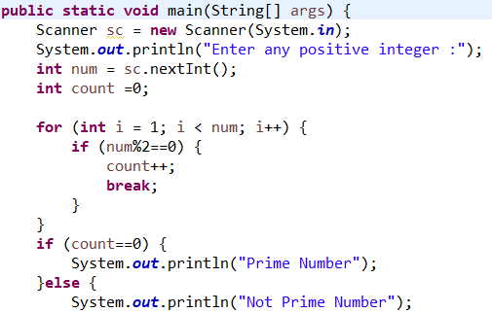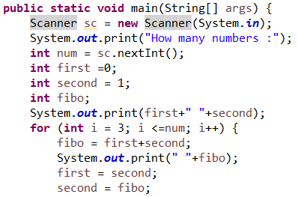

10. Find the FACTORIAL number SUM of DIGITS like 1234 = 10

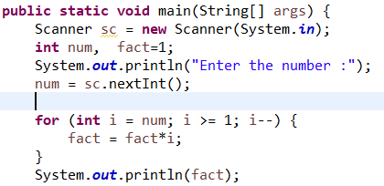 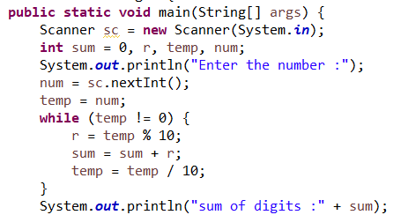

11. Get CUBE of Each Number:

