**Output Screen Shots**

**Program Run**

The following demonstrate a full program run for Part 1 and 2. As depicted, the programs run until the user presses enter without entering a word. The for each word that the user enters, the performance time and anagrams are displayed.

**Part 1:**

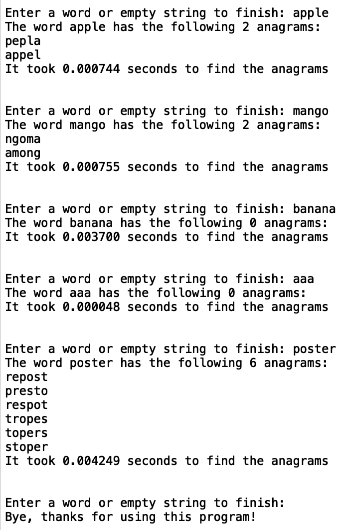

**Part 2:**

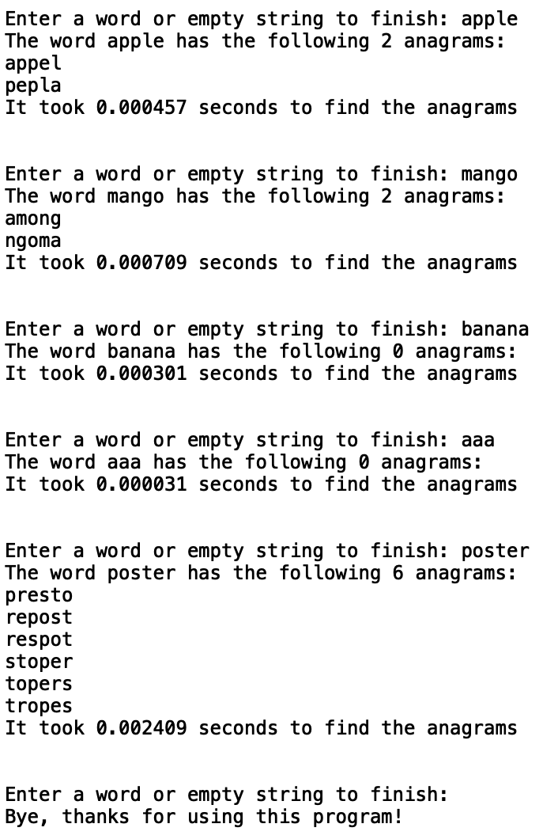

**Program Run with Different Directory**

The following demonstrates what occurs for Part 1 and Part 2 when the words_alpha.txt file and the programs are in a different directory. Both programs allow the user to enter the directory and will continue to prompt the user until the correct directory is found. In both parts the programs were in “/Users/nichole_maldonado/Desktop” and the words_alpha.txt file was in “/Users/nichole_maldonado/Desktop/folder”. In both runs below, the user inputs the wrong directory twice until finally entering the correct directory and allowing the program to run.

**Part 1:**

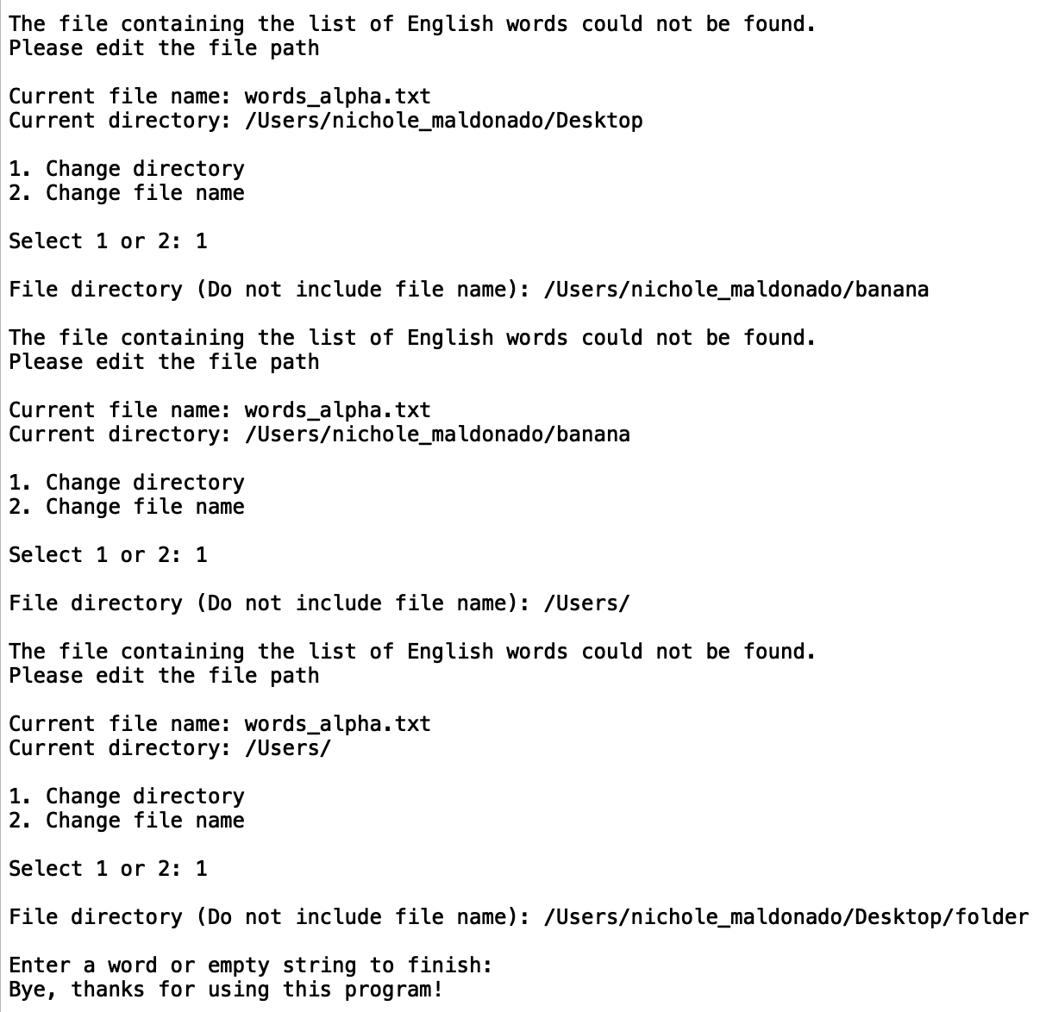

**Part 2:**

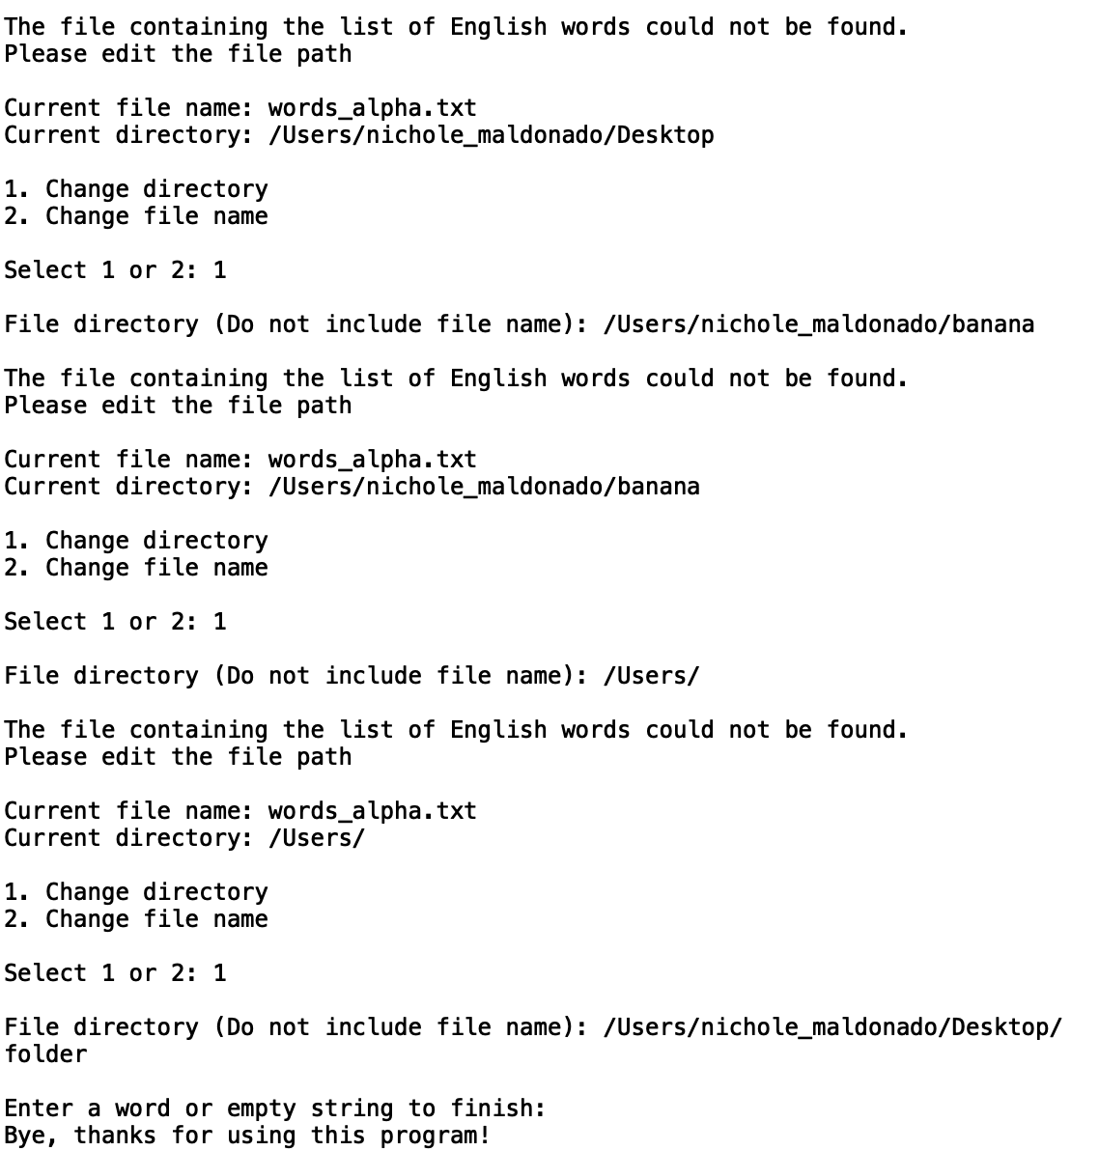

**Program Run with Different File Name**

The following demonstrates what occurs when the file name is not words_alpha.txt. Just as the case above, the user can input the new file name. For this example, the words_alpha.txt has been renamed to word.txt. These cases also shows that if the user attempts to access a non .txt file, they must try again.

**Part 1:**

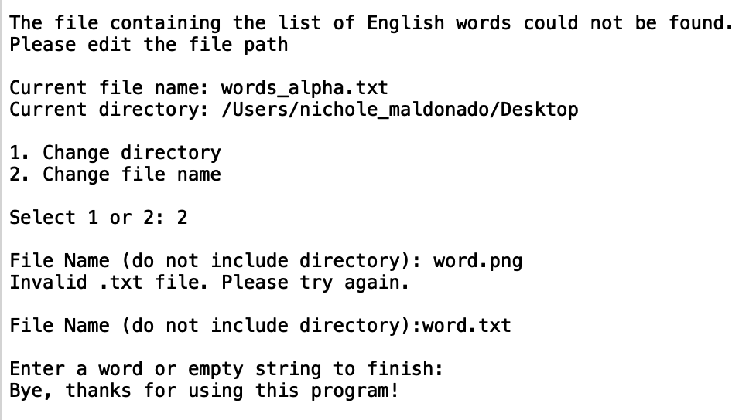

**Part 2:**

