**Program Run**

The following demonstrates a full program run for Lab 4. The user must first enter the path for the file with the word embeddings. They are then able to determine whether they want to find the similarities of pairs from a file or insert a pair to compare.

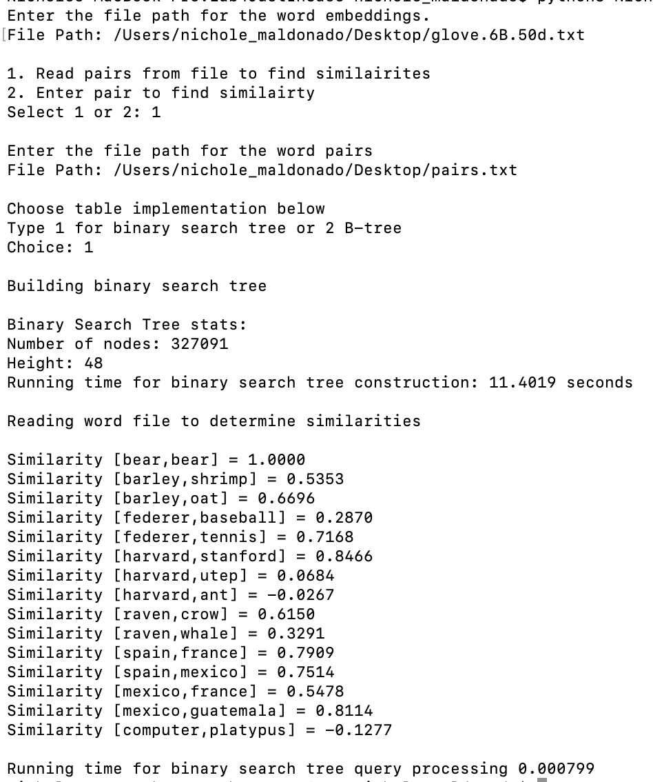

Users can also select whether they want a Binary Search tree or B-Tree to store the word embedding objects. The run above selects a Binary Search tree and uses the file with word pairs.

The following picture depicts a run with a user’s selected pair of words and a B-Tree. The user can select the max data that each B-Tree node will have as an attribute.

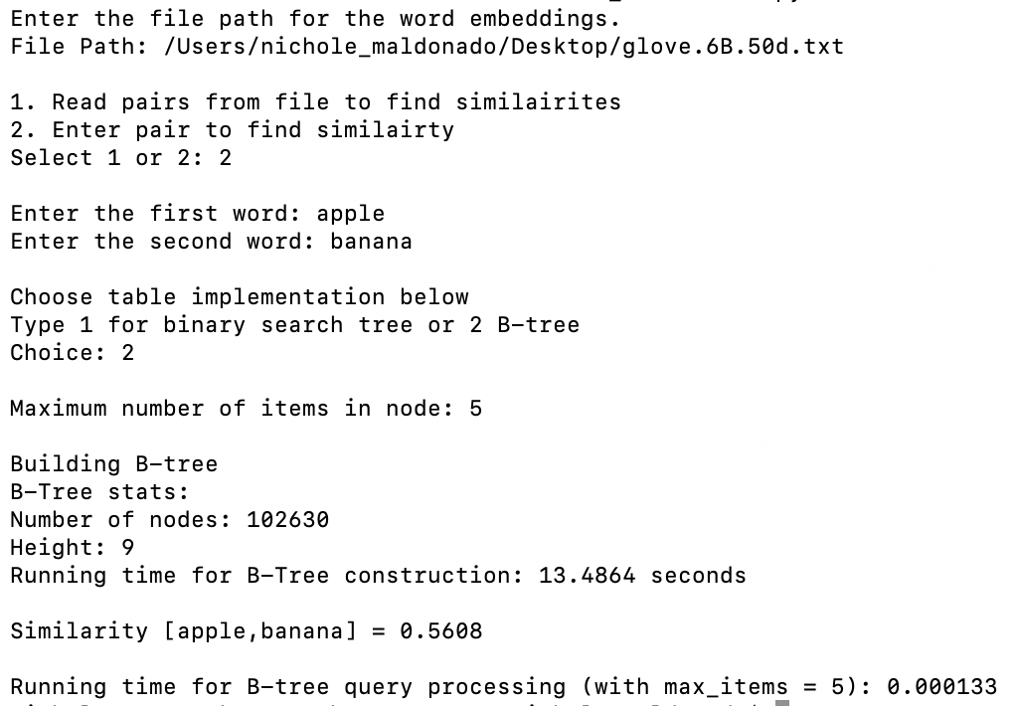

In the event that a user inserts a file path without a .txt extensions, the program will terminate. This is to ensure that the program will not attempt to open other file types.

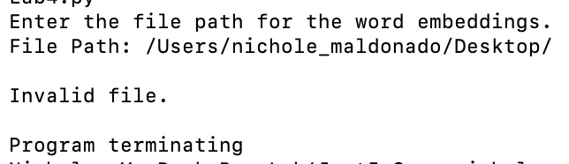

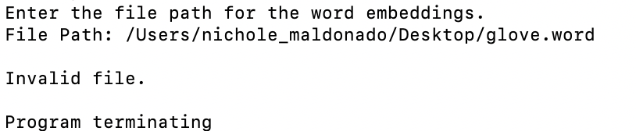

If a user enters a pair of words that contains more than letters, then the program will terminate. Since the tree will only be comprised of actual words, a search for a non-existent word would be wasteful.

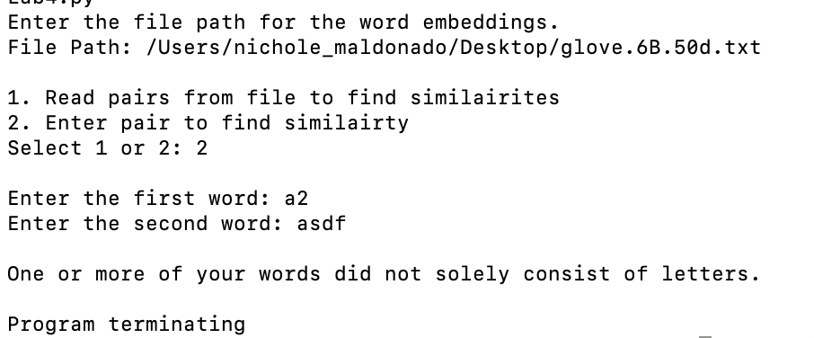

The overall capitalization of letters does not affect the search for the word, since all the words are converted to lowercase. This is crucial since all the words in the glove file are already lowercase. The program run below demonstrates that even though the user may provide a weird word format, its search will still be successful.

