**Program Run**

The following demonstrates a full program run for Lab 5. The user must first enter the path for the file with the word embeddings. They are then able to determine whether they want to find the similarities of pairs from a file or insert a pair to compare. The user then selects whether they want to use a hash table with linear probing or chaining. The user then selects the hash function that they want to use for the table and the load factor.

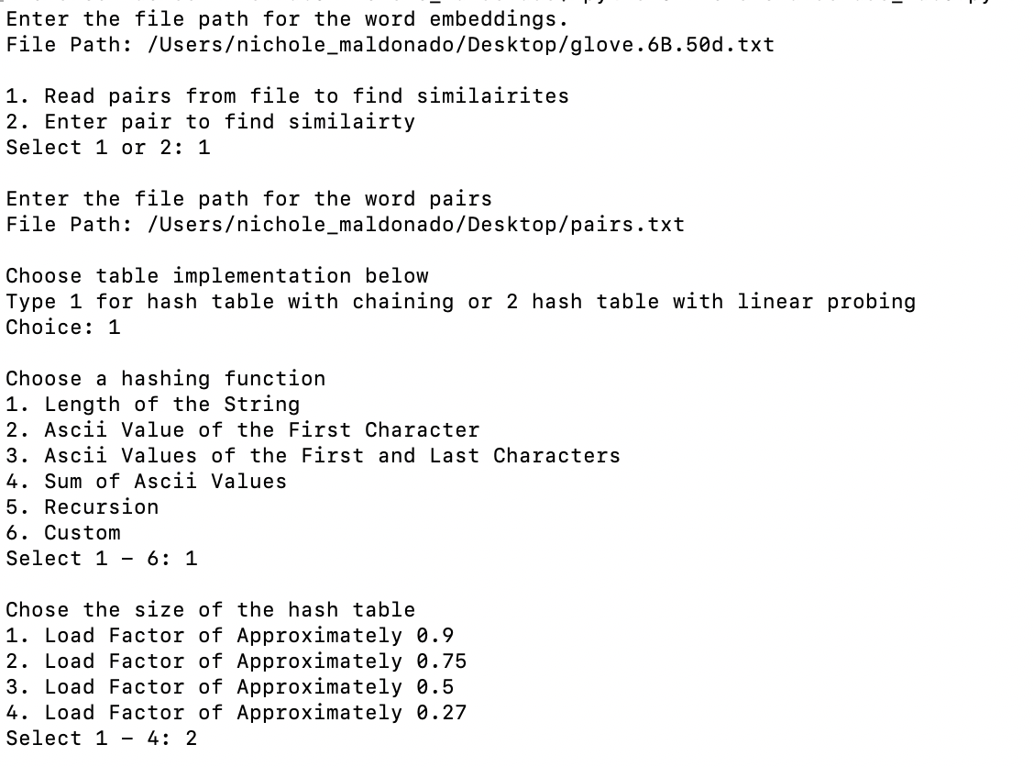

If the user selects linear chaining and hash functions 1 through 4, they are able to select whether they want to insert the elements linearly (append to the end of the chain) or in order.

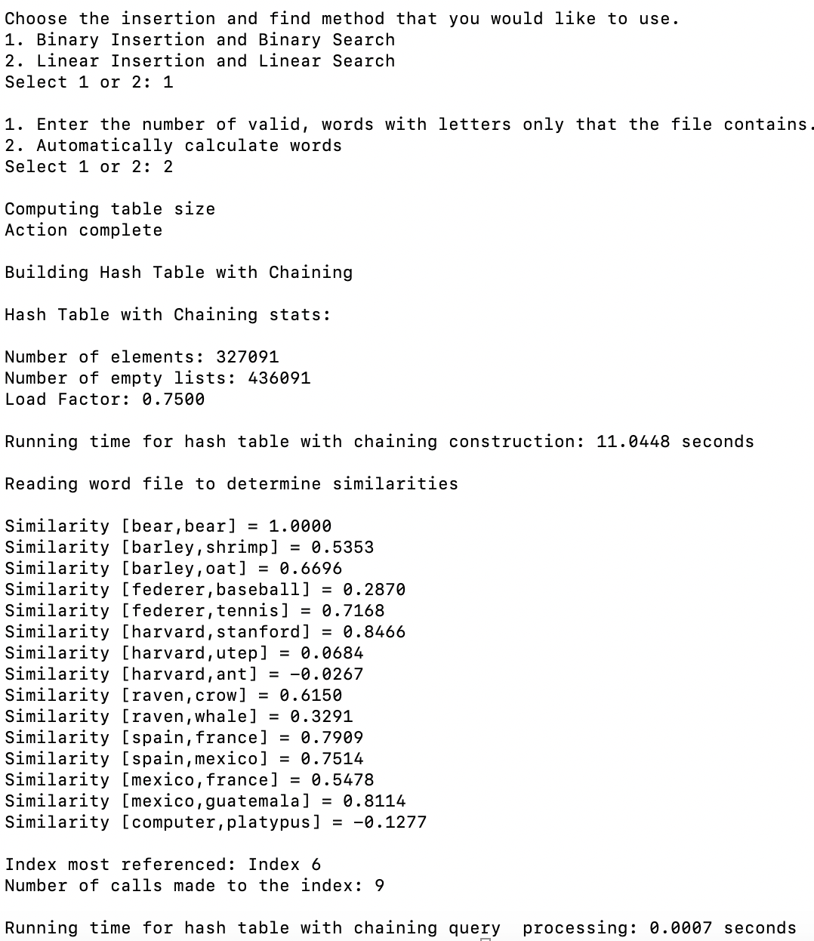

Users who know the number of valid words (words with only letters) that the file contains can enter them or allow the computer to compute the number of valid words to find the correct table size.



If the file has more words then the user enters, then the table will only be populated with a set number of words to reach the designated load factor. The program will also tell the user if the file still has more words, but was stopped since the load factor was reached.

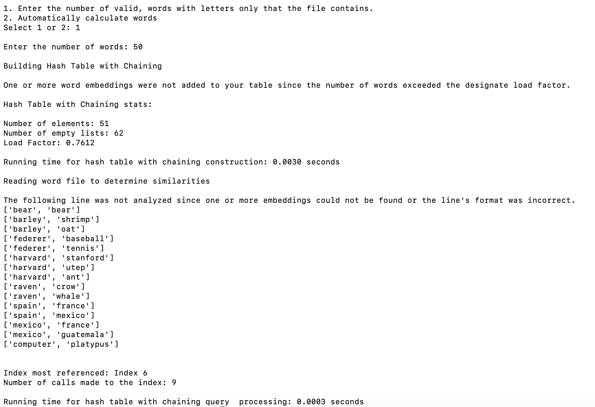

Below is a run for the hash table with chaining with the string length hash function using the binary insertion.

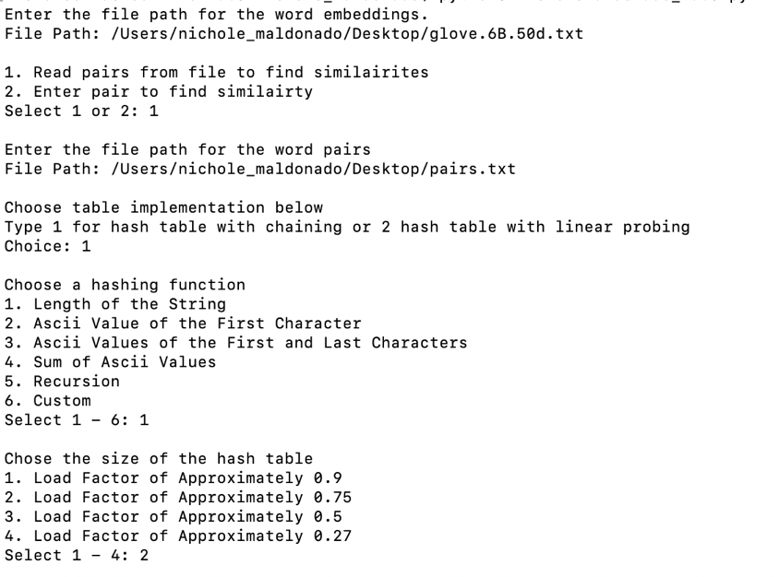



Below is a run for the hash table with chaining with the string length hash function using the linear insertion.

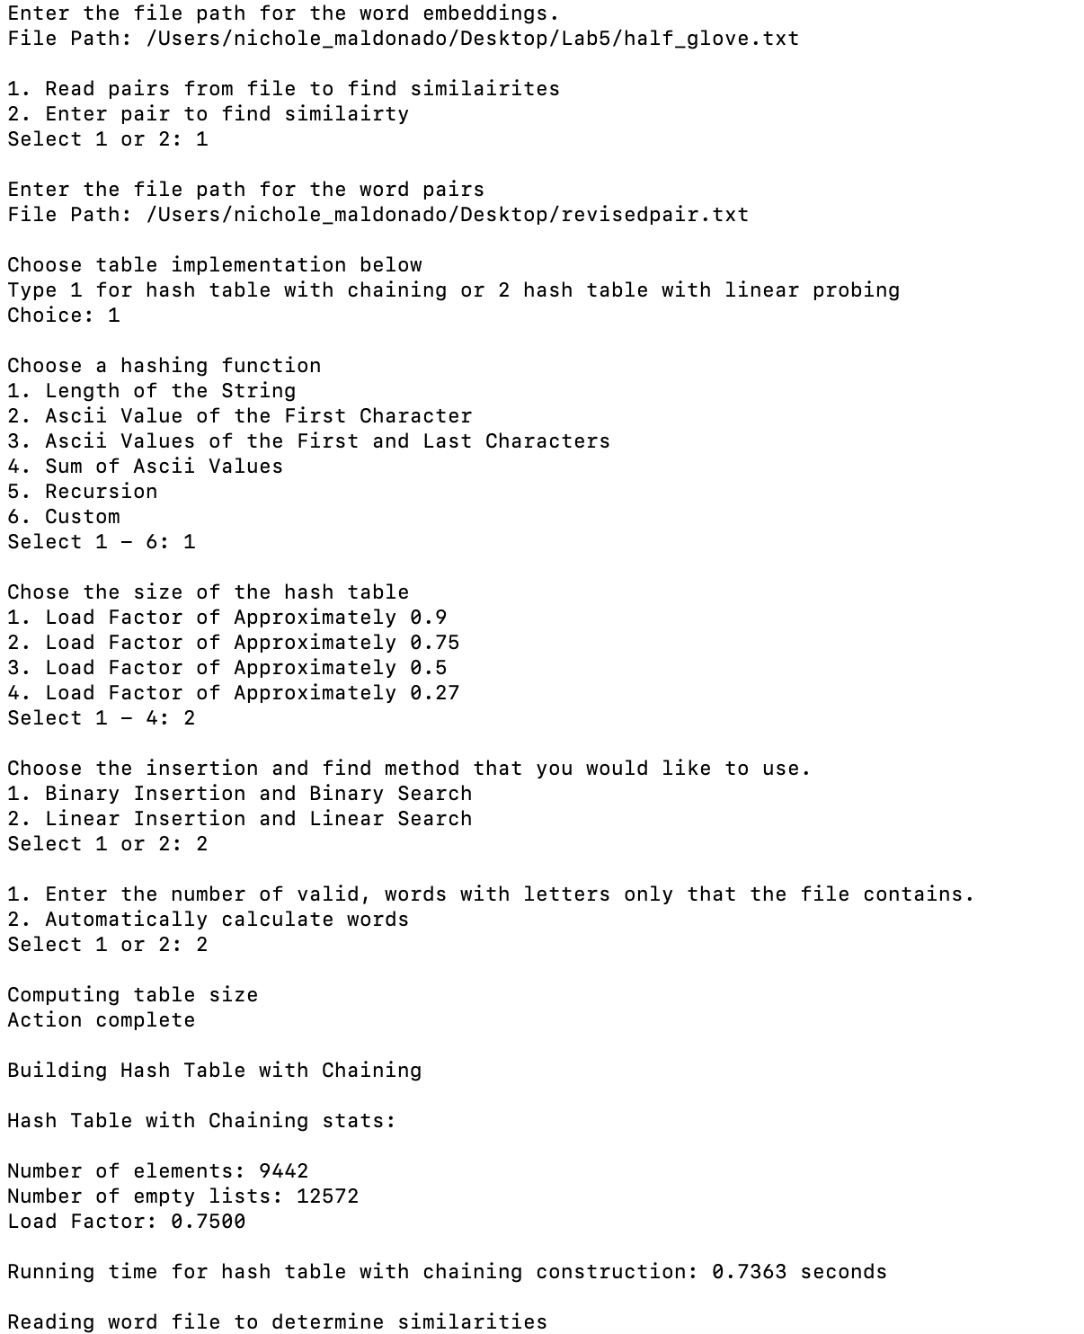

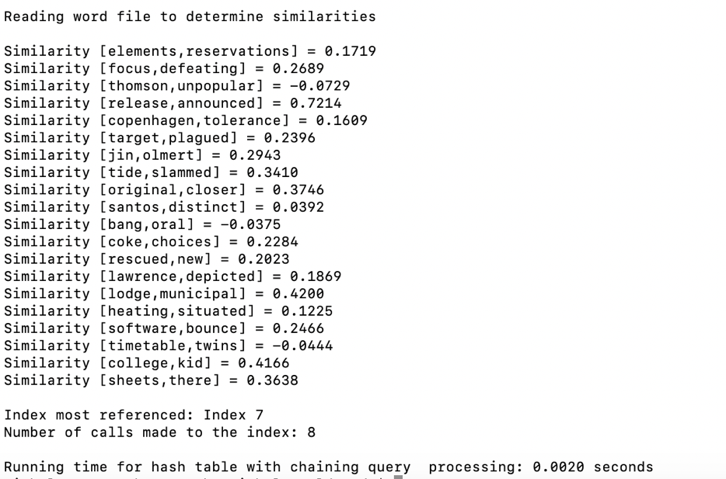

Below is a run for the hash table with linear probing with the string length hash function.

