**Program Run**

The following demonstrate a full program run for Part 1 and 2. As depicted, the programs run until the user presses 3 to exit. The user can select to run automated tests or create their own custom test.

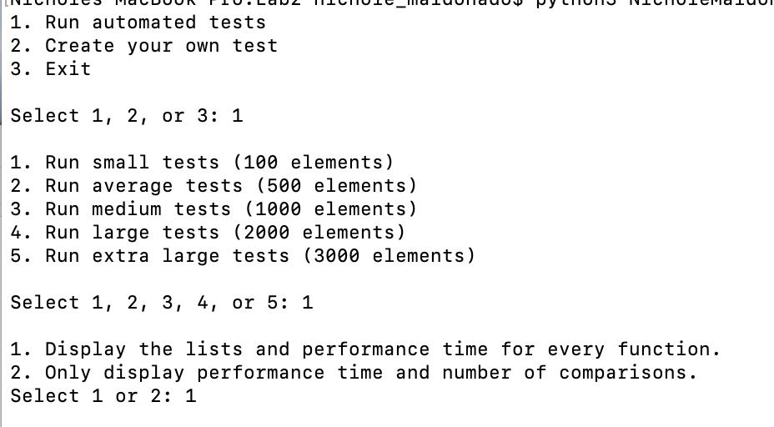

Users can decide to only print the number of comparisons and performance time for each algorithm or to also display each list after the algorithm was applied.

Example of displaying lists:

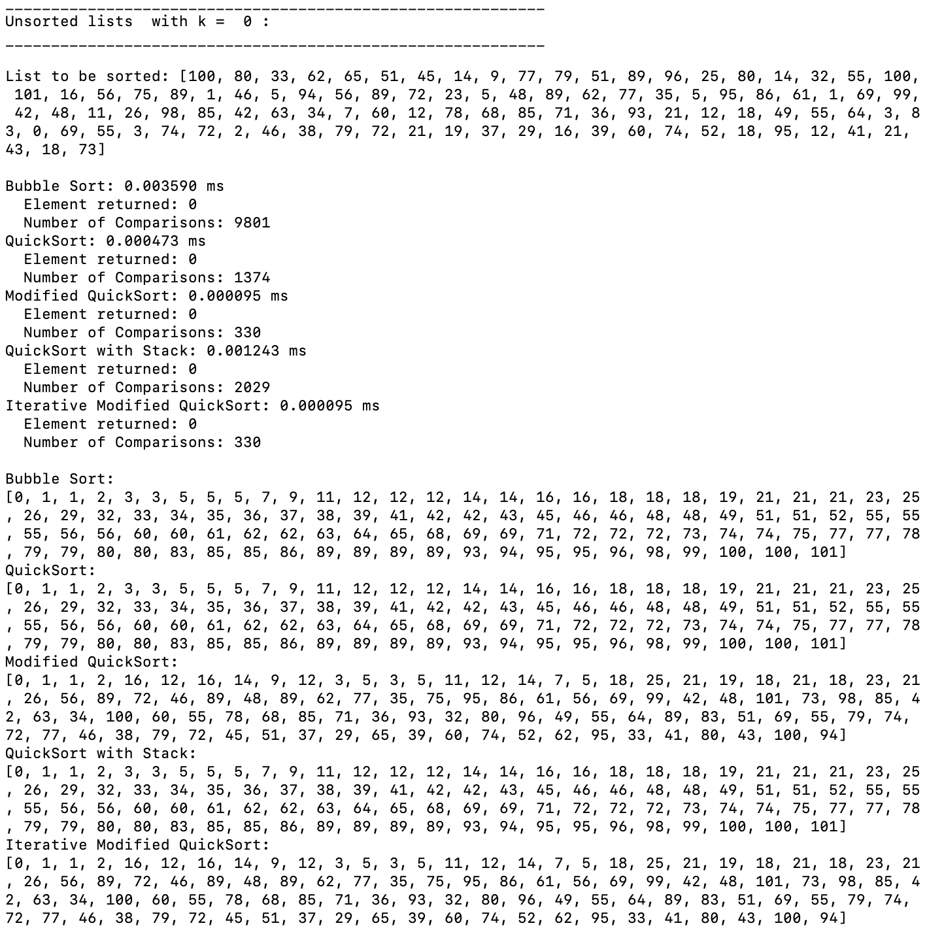

Example of only displaying the performance time and runtime complexity:

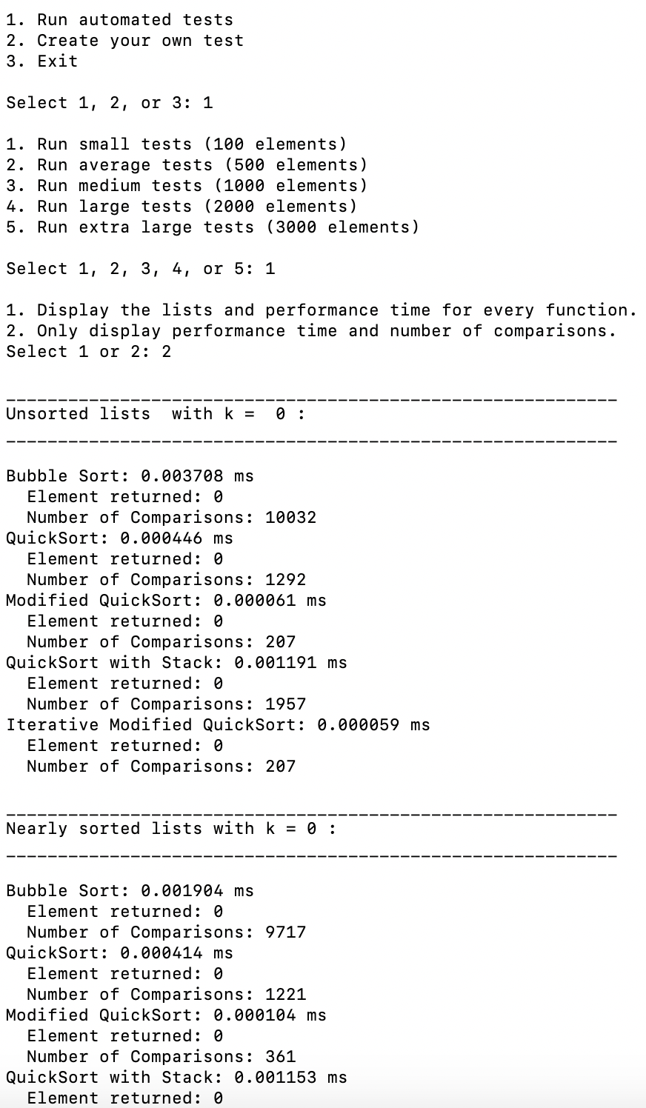

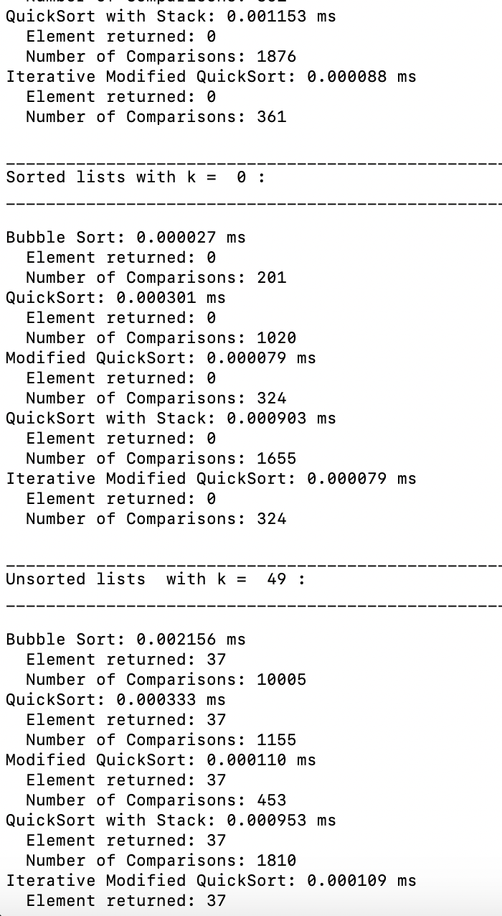



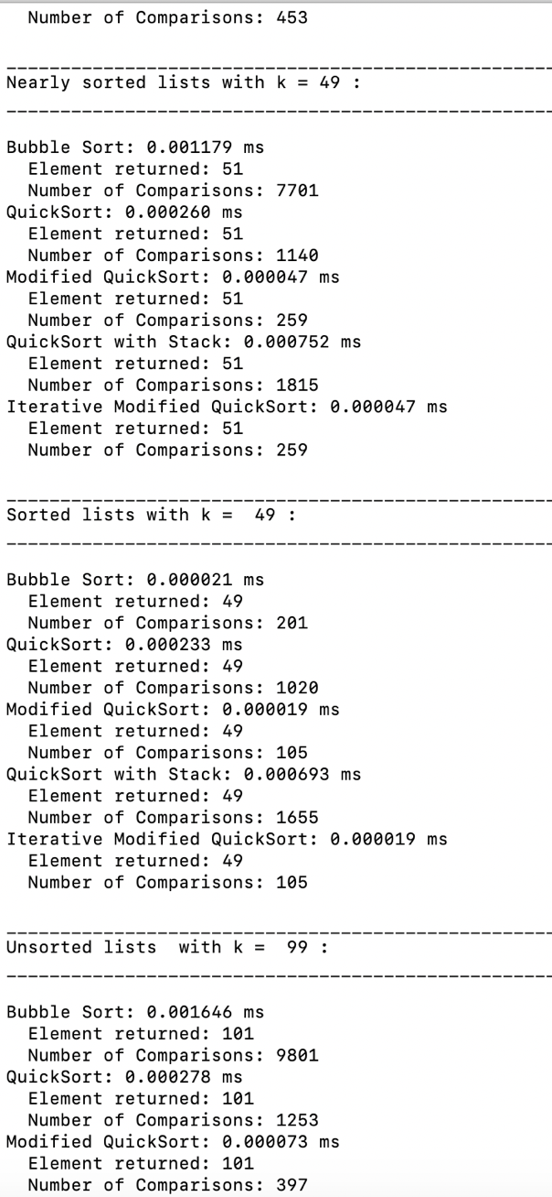

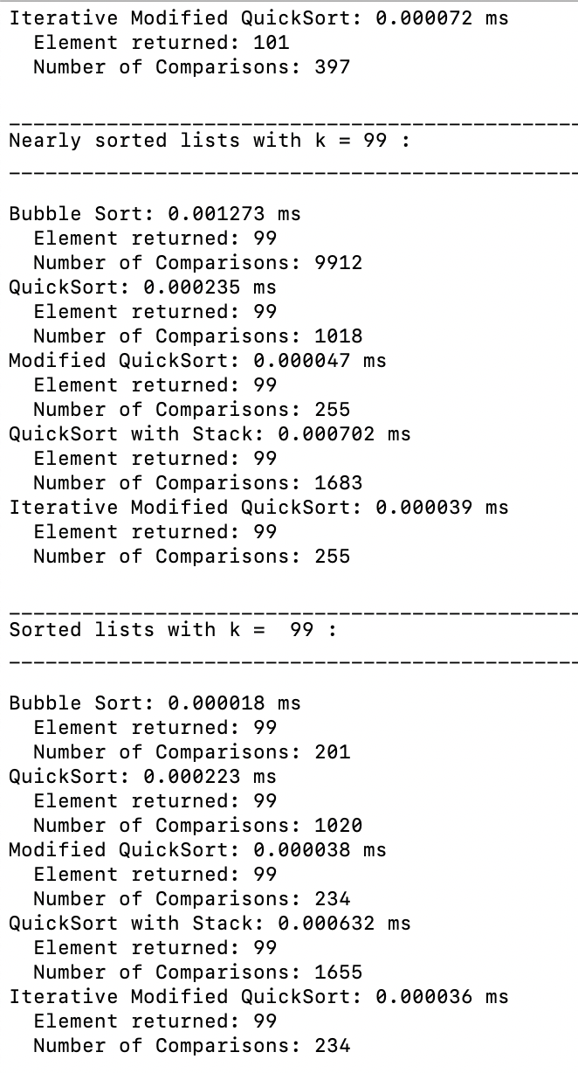

Note each automated test shows output for sorted, nearly sorted, and unsorted lists with k = 0, the middle index, and last index.

Example of custom test:

