

**Systems Qualification Platform**

**User’s Guide**

**Release 2.0**

**Neeraj Mallampet**

**Table of Contents**

1. **Introduction**
   1. Operation Platform Inputs
      1. Design Files(s)
      2. Configuration Files(s)
      3. EDA Tool selection
   2. Operation Platform Outputs
2. **Usage**

**2.1** New project

**2.2** Saving project

**2.3** Open project

**2.4** Main Window

**2.5** Add Suite

**2.6** Removing Suite

**2.7** Changing Order of Testcases

**2.8** Global Configuration

**2.8** Test case properties

**2.8.1** Design File(s)

**2.8.2** Configuration File

**2.8.2.1** Creating a Configuration file

**2.8.3** EDA Tool selection  
 **2.8.4** Running Testcase

1. **Results**
2. **Introduction**

System Qualifications Platform’s operation platform (OP) is a GUI tool that lets users test their input designs on a board. OP will take the user’s input on design, EDA tool (diamond, iceCube etc.) to run the design through, and the board(s) to send the design to. OP will then run the design through the EDA tool of choice and program the board(s) (via programmer) one by one through the USB hubs. Finally, OP will generate a stimulus, based on the design and configuration file, and send it to the boards and display the results.

* 1. **Operation Platform User Input**

This section goes over all the required inputs by the operation platform (OP).  **1.1.1 Design File(s)**

OP requires an input of one or more verilog design files. This design will be used to run the selected EDA tool and program the selected board.

**1.1.2 Configuration File(s)**

OP requires an input of a configuration file which, as the name suggests, is a file that lets user configure the data being sent to a board.

The configuration file must follow the following format:

|  |  |  |  |  |  |  |
| --- | --- | --- | --- | --- | --- | --- |
| **Byte 0** | | | ADDR_H | | | |
| **Byte 1** | | | ADDR_L | | | |
| **Byte 2** | Burst Length | Board Address | | RBOP | A_MOD | WR_N |
| **Byte 3** | | | Padding/Data | | | |
| **Byte 4** | | | Data | | | |
| **Byte …** | | | … | | | |
| **Byte n** | | | Data | | | |

**Byte 0**

Byte 0 contains ADDR_H [7:0] which is the higher byte of the register mapping interface (RMI) address.

**Byte 1**

Byte 1 contains ADDR_L [7:0] which is the lower byte of the RMI address.

**Byte 2**

Bytes 2 is composed of the following:

* **Burst Length**: (2 bits)
* **Board Address**: address of the board (3 bits)
* **RBOP**: Repeated bytes address mode operation indicator (1 bit)
* **A_MOD**: address mode indicator (1 bit)
* **WR_N:** write enable indicator (1 bit)

|  |  |  |  |  |  |
| --- | --- | --- | --- | --- | --- |
| **Byte 2** | Burst Length | Board Address | RBOP | A_MOD | WR_N |

**Byte 3 – Byte n**

**Padding**-

8 bit width, [7:0]. Padding byte exists only in read packet. It gives the time to the SPI slave to prepare the reading data. Padding field can be any value and it is insignificance.

**Data:**

8 bit width, [7:0]. Read/write data.

Here is an example of a line in the configuration file:

00 00 09 XX AA

This line can be decomposed into the following:

**Byte 0**: 00

**Byte 1**: 00

**Byte 2**: 09 (00001001)  
 **Burst Length:** 00

**Board Address**: 001

**RBOP**: 0

**A_MOD**: 0

**WR_N**: 1

**Byte 3-n**: XX AA

In summary, the configuration file is used to send data to the selected board.

**1.1.3 EDA Tool selection**

OP requires the user to select an EDA tool from a list of EDA tools. OP generates this list by detecting the installed EDA software in the user’s system. For example, if the user’s PC has Diamond 3.7 and 3.8 installed, the generated list will have Diamond 3.7 and 3.8 only.

Users will also have the option of specifying an EDA tool’s bin path if the OP fails to detect an installed EDA software.

The selected EDA tool will be used to run the input design file and program the selected board.

* 1. **Operation Platform Outputs**

OP generates the following:  
**Under Suite directory:** - input.txt:- this is the input file used for CLI/TMP  
  
**Under testcase directory**:  
 - logs: - directory that stores log files  
 - _scratch: - directory generated from trunk script; has rbt file  
 - sim/output_files/output.txt:- stores read back data from board  
 - bqs.conf/bqs.info:- needed to run trunk script  
 -programmer:- directory having xdf file to run programmer

1. **Usage**

This section will go over the usage of the operation platform (OP)

* 1. **New Project**

To being using OP, user must first create a new project. A project is synonymous to a test suite in that it is a **collection** of test cases. Each test case contains design, configuration file, EDA tool, and device info which the user can configure.

The user can create a new project by either:

1. Clicking File
2. Selecting New Project

-----------OR-------------

1. Pressing Ctrl + N

User will be prompted to enter the name of the file and select the destination of the project file.

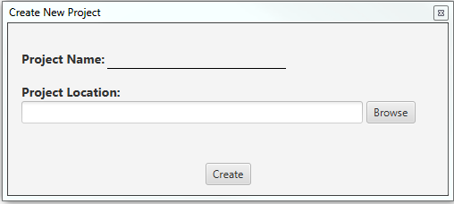

For example, if user creates a project with the name ***proj***and chooses desktop as the destination location, the user’s desktop will now contains the file ***proj.sqp***

* 1. **Saving Project**

To save the current working project, the user can either:

1. Click File
2. Select Save Project

------------OR------------

1. Pressing Ctrl + S

The proj file ([name of proj].sqp) will be overwritten with new contents.

For example, if user is working on a project named ***proj.sqp***, saving the work will result in ***proj.sqp*** will be written.

* 1. **Open Project**

To open an already created project, the user can either:

1. Click File
2. Select Open Project

------------OR------------

1. Press Ctrl + O

User will be prompted with a filechooser to navigate to the project’s destination. All project’s extension is sqp.

For example, if user wants to reopen a project named ***proj.sqp***, the user can press ctrl + O, navigate to its destination, and click on ***proj.sqp***

* 1. **Main Window**

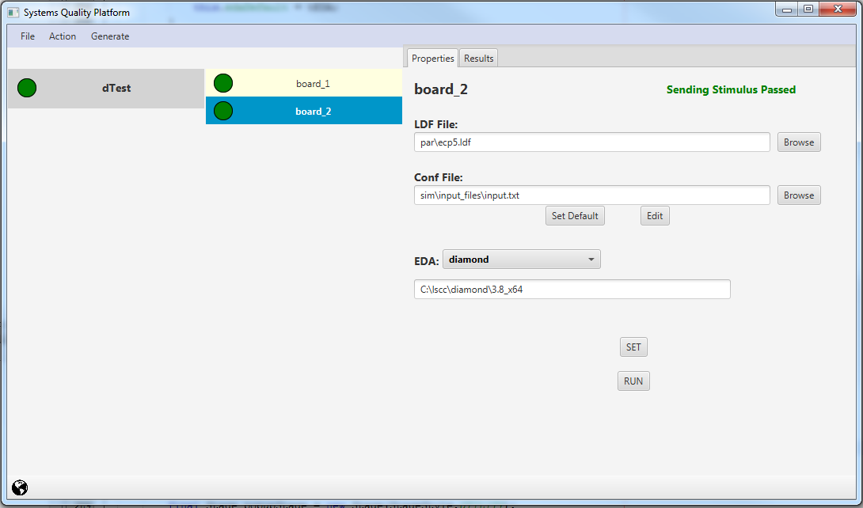

**SuiteCase Pane**

* This pane has a list of all the user created suites
* Each suite has a status indicator with the color circle on the left
  + Yellow = in Progress
  + Green = finished
  + Red = finished w/ errors
* Note: Suite contains testcase

**TestCase Pane**

* This pane contains the list of testcase of the user selected suite.
* Like the suite pane, each testcase has a status indicator

**Properties Pane**

Each test case has a properties pane where the user can:

* Edit the properties
  + User can choose the LDF file, configuration file, the EDA tool to run the design through,
  + User can also create a new conf file
* View the Results

**Global Configuration**

This button lets user select the default EDA tool.

(More details in section 2.6)

* 1. **Add Suite**

To create/add a new suite, the user can either:  
1) Click Action  
2) Select Add Suite

--------OR---------  
3) Press Ctrl + T

You will be prompted with the following:

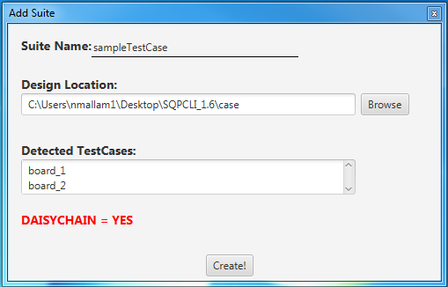

* User will be prompted to enter the name of the suite and its location.  
  Note: The location must be a directory with testcases (which are also directories)
* After selecting the location, the application will display the detected testcases and will consider the suite as a daisychain if the suite contains more than one testcase
* In the picture to the left, the suite’s, sampleTestCase, contains 2 testcases: board_1 and board_2. This is a daisy chain case.

Press “Create!” to successfully create the suite.   
  
  
Upon completion, the main window will list your newly created suite with its corresponding testcases:

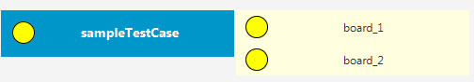

* Each created suite name will be listed at the left side of the main window.
* Each suite is clickable, and will show an initial status of yellow (in progress)
  + Clicking on the suite will display its testcases

* 1. **Removing Suites** User has the option of removing a suite from the list of already created suites. To remove a suite, the user can do the following **after** selecting the suite(s):  
       
     1) Click on Action and choosing Delete Suite  
     --------------OR--------------  
     2) Selecting the suite and pressing delete
  2. **Changing Order of Testcases** The order of the testcases in a suite can be changed with the shortcuts F3 (to move up) or F4 (to move down). These options can be found in the top file menu under Action.   
       
     **Example:**  
     Suppose you have a suite s1 with testcases t1 and t2. The original order is t1 and t2, but if you want to change the order to t2 and t1. Simply click on t2 and press F3 to move up or click on t1 and press F4 to move down.
  3. **Global Configuration**



User can set the default EDA tool by clicking on the button. The user will be prompted with the following:

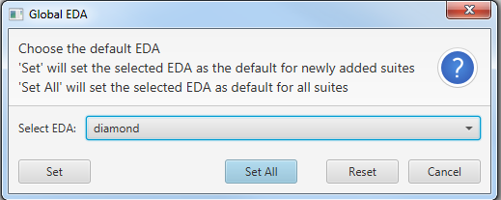

After selecting an EDA tool, the user have the following options:

**“Set” –** sets the EDA tool as the default for the newly created suites

Ex: Suppose SQP already has 2 created suites s1 and s2, clicking on the **Set** button after selecting the default EDA tool will set all the newly created suites with the default EDA tool

“**Set All**” – sets the EDA tool as the default for both newly created and preexisting suites

Ex: Suppose SQP already has 2 created suites s1 and s2, clicking on the **Set All** button after selecting the default EDA tool will set both the preexisting and all the newly created suites with the default EDA tool  
  
“**Reset” –** resets the default EDA (if a default eda tool was set beforehand)

* 1. **Test case properties**

Selecting a testcase will display the following properties of that testcase:

This lets users upload and modify the testcase’s ldf file, configuration file, and EDA tool.

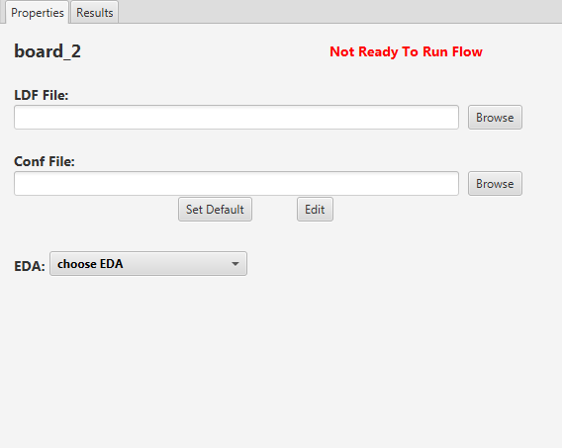

**2.8.1 LDF File**

Users can upload the desired LDF file corresponding to the testcase by clicking on the browse button near the header “LDF File”. The text field underneath will display the location of the LDF file.   
  
Note: If the file chosen is in the testcase’s directory, then the path will be truncated and start from the testcase’s directory.   
  
Ex: if test.ldf is in the par directory of that testcase. The path will be truncated to “par/test.ldf”

**2.8.2 Configuration File**

User can upload their configuration file or create a new configuration file:

The User can choose the default location (sim/input_files/input.txt) by clicking on “Set Default”

The User can upload a configuration file by clicking on “Browse”  
  
The User can Edit/Create a new configuration file by clicking on “Edit”

**2.8.2.1 Creating a Configuration File**



User can create a configuration file by clicking on , and will be prompted with the following:

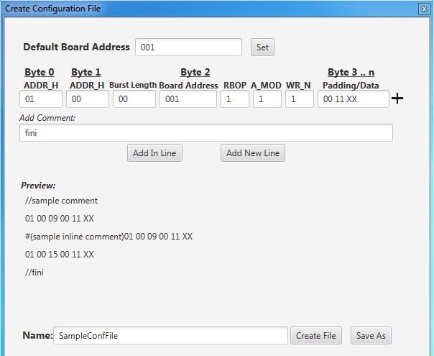

In this editor, user must specific the default board address before adding data. This board address can be changed later on, but changing it will result in the changing the already created data.

The user also has the option of adding two different types of comments:

“**Add New Line**”: adds a new line following a new line ***ex: //sample comment***

“**Add In Line**”: adds a comment without a new line, the next addition should be a data and not a comment. ***Ex: #(sample inline comment) data***

User can create the file in the default location (sim/input_files/filename.txt) or specify another path.

**2.8.3 EDA Tool**

Users can select their EDA tool in the following section of the properties tab:

Choosing an EDA tool will the read its corresponding env variable and print the value in the textfield below.   
  
For example, choosing diamond will read the env variable “EXTERNAL_DIAMOND_PATH” and output the value in the textfield below:

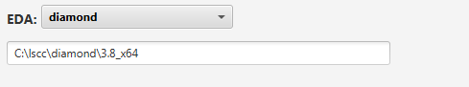

User can edit the path and set that as the new value if desired:

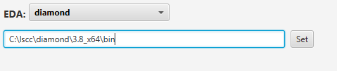

**2.8.4 Running Testcase**

After choosing an LDF file, conf file, and EDA tool, the prop screen looks like this:

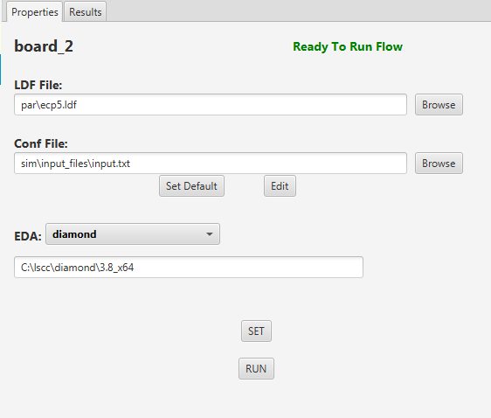

New buttons “SET” and “RUN” will appear in the bottom.   
 “SET”: this button saves all the user inputs for the testcase  
 “RUN”: this button runs the testcase

At the top right of the testcase’s properties pane, there is a status indicator that   
 changes depending on which point of the SQP run flow it’s on.

For example, if the testcase is running bitgen, the status will be “Running Bitgen”

1. **Results**In a testcase’s properties pane, the user has the option of viewing the results of the testcase’s results. Right next to the “properties” tab, clicking on the results tab will display the following screen:

**Output.txt**

This file is generated from running the ftdi program. This file contains the read back data from the board

Original Location: {testcase}/sim/output_files/output.txt

**FTDI Log**

This is the log file resulting from running the ftdi program to send the stimulus to board

Original Location: {testcase}/logs/ftdiLog.txt

**Programmer Log**

This is the log file resulting from running programmer to program the board

Original Location: {testcase}/logs/ProgrammerOutput.txt

**Trunk Script Log**

This is the log file resulting from running the trunk script to generate bitgen.

Original Location: {testcase}/logs/trunkLog.txt

**DISPLAY SCREEN**This is where the results will be displayed

