# Project_Citi-Bike-Analytics_Tableau

For the purpose of this assignment 2018 aggregated data was used from Citi Bike Trip History Logs and Citi Bike Daily Ridership and Membership Data. Data cleanup was done using jupyter notebook. 2018 data was huge. To avoid system crashing only 1 million rows were used. Two datasets were then joined in tableau to get answers to question the city officials have.

The design includes about 14 visualizations of 2018 data. Along with 5 dashboards and 1 story

Expected and unexpected phenomena

1. Total number of Annual members are higher that Customer who have a 24hr pass or 3day pass. This phenomenon was also proved with Citi Bike Daily Ridership and Membership Data.

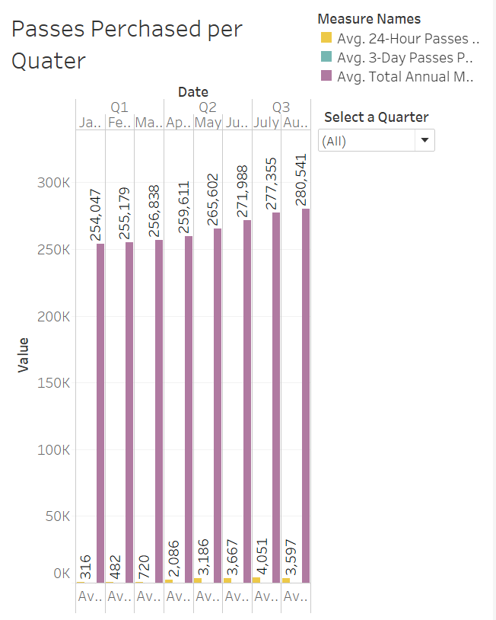

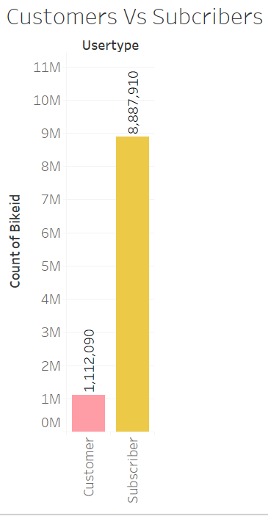

1. Peak hours of bike riders are at 8AM and 5PM during the day. This phenomenon is the same no matter the month of the year.

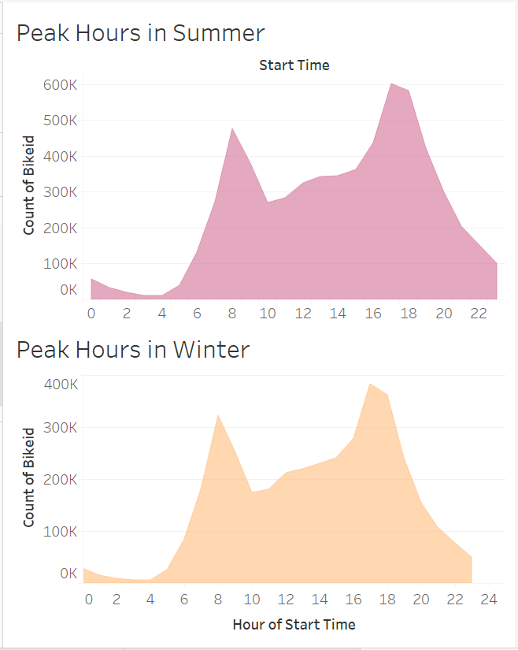

1. Trip duration for women is higher that men. Younger people tend to use bike a lot (ages: 16 to 30)

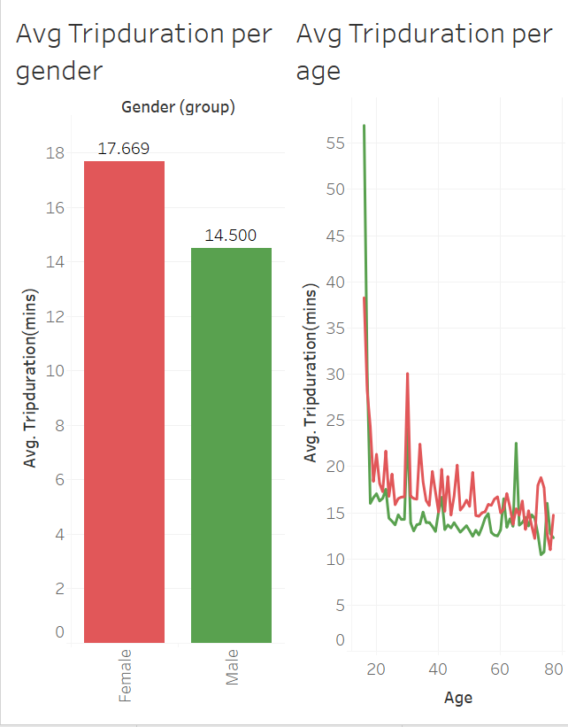

Map of the stations with most popularity for start stations and end station.

