**Schoology Push Notifications and Updates**

Below are the steps you can use to set up notifications for Schoology. Please make sure to check your teachers calendar for updates.

1. Go to <https://schoology.montville.net/home>
2. Click on the drop down menu under your profile (right hand corner)
3. 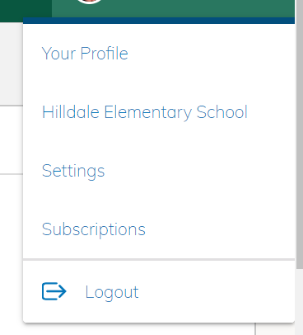Click on **“Settings”**
4. Click the 2nd tab **“ Notifications”**

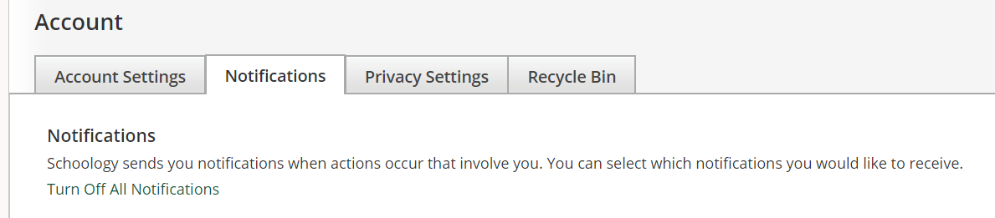

1. Scroll down to the area labeled **“Group”**
2. 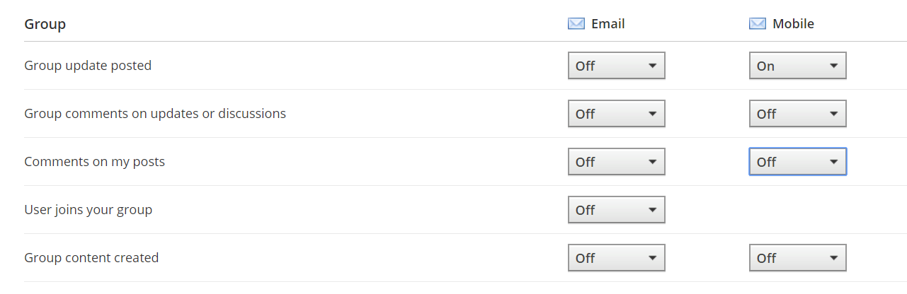Use the drop down boxes and select “On” for “group update posted.”