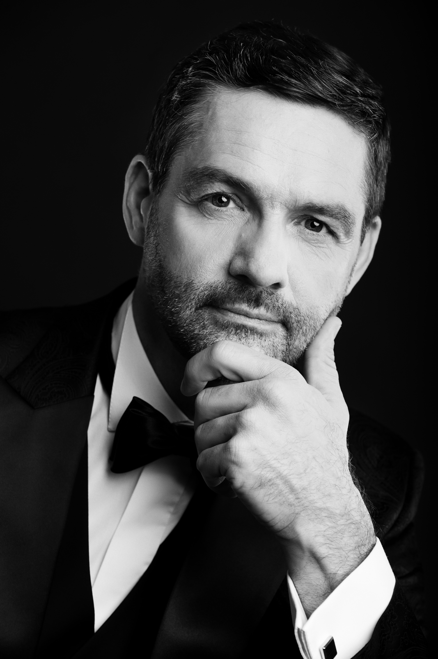
PAWEŁ CZEKAŁA
Bass

The graduate of The Fryderyk Chopin University of Music in Warsaw. A first class honours degree in vocal studies under direction of prof. Kazimierz Pustelak. A constant vocal cooperation with dr hab. Artur Stefanowicz. Completed the courses under direction of: prof. Ryszard Karczykowski, Jan Van Elsacker, Kaja Wessela, Rudolf Piernaya, Izabela Kłosińska, Maja Nosowska.
Performed on the stages of: Teatr Wielki, Collegium Nobilium Theatre, Filharmonia Świętokrzyska, The Warsaw Chamber Opera, Opera Nova, International Music Festival in Gdańsk, Polskie Radio.
His repertoire contains opera parties and oratorio works. Repeatedly performed Reqiem, Coronation Mass and Great Mass in C minor by W.A. Mozart, Sabat Mater by F.J. Haydn, Sabat Mater by G. Rossini, The Seven Last Words of Christ by J. Haydn, The Cantatas of J.S. Bach, Eugene Onegin by P.I. Tchaikovsky (Prince Gremin’s part), Don Giovanni by W.A. Mozart (part of Il Commendatore (Don Pedro)), The Coronation of Poppea by C.G.A. Monteverdi (Seneca’s part), Rodelinda by G.F. Händl (Garibaldo’s part), A Midsummer Night’s Dream by B. Britten (Peter Quince’s part), Krakowiacy i Górale (Bartłomiej’s part), The Tempest by H. Purcell (Prospero’s part).
Collaborated with conductors such as: M. Kulczyńska, R. Janiak, D. Zimnicki, J. Przybylski, J. Rogala, J. Łukaszewski, P. Wajrak, W. Kłosiewicz.

