**A.1**

**1. “If stock market movements are serially uncorrelated, then the risk of holding stocks diminishes as the holding period lengthens.” Comment.**

As discussed in the first class lecture, expected asset return increases linearly with the length of the holding period, while the volatility or risk of the asset increases linearly with the square root of the holding period. Thus, purchasing a risky asset with a lengthy intended holding period is less risky than purchasing the same asset for a short duration.

**2. Reconstruct as much as you can of Exhibits 1 and 2, and describe how you did it.**

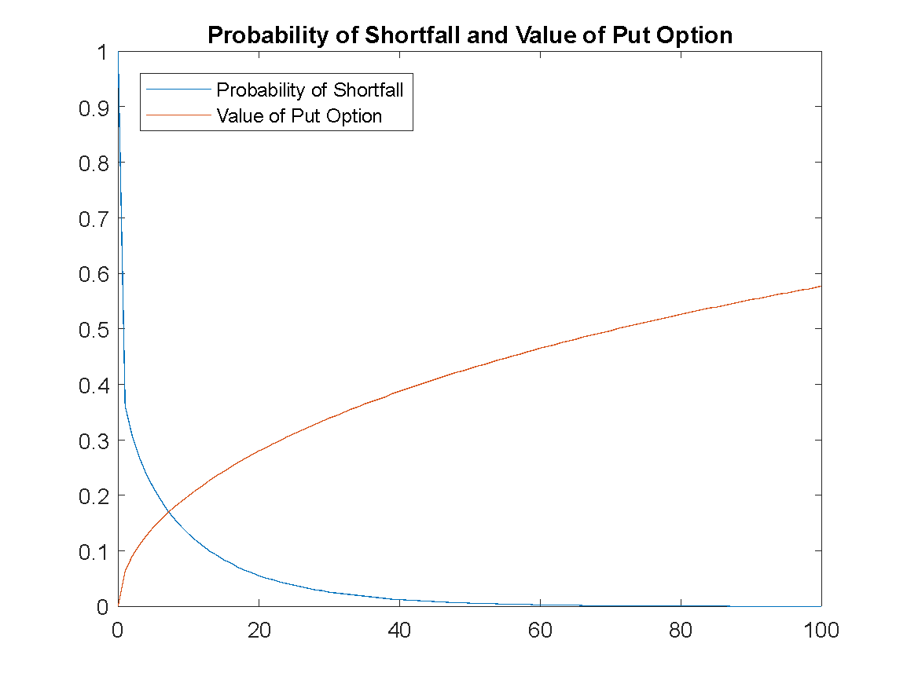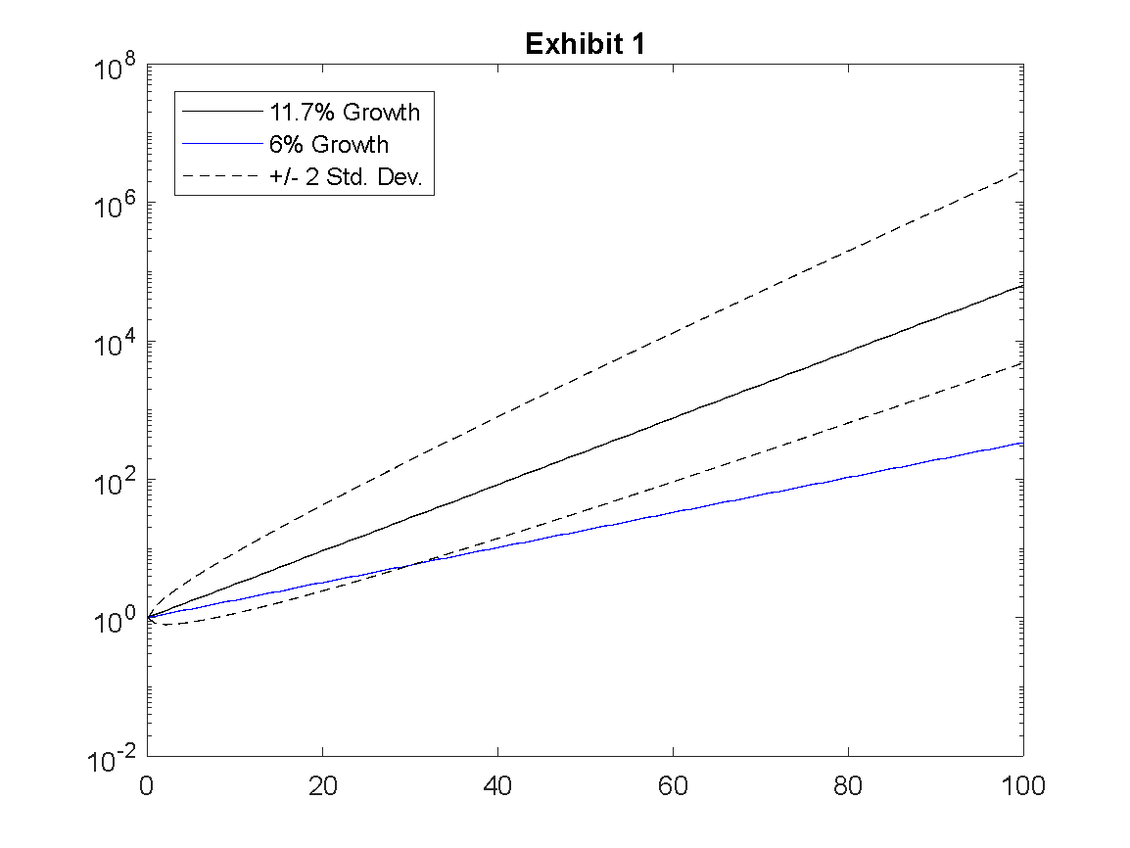

We recreated exhibit 1 using growth rate formulas of Y = (1+r)t on a logarithmic y-axis, with 2σ confidence intervals at ert ± 2σsqrt(t).

We recreated exhibit 2 using Matlab’s “normcdf” function at 0 with mean 0.057t and standard deviation sqrt(t)*σ for the relative shortfall probability. For the put option value we used the “blsprice” function with price = 1, strike = e.06t, risk free rate = 0.06, time = t, and volatility = 0.16, all as given in the case.

**3. Which of the two proposals (if any) should Ms. Adams accept?**

A.2

**1. Briefly summarize the key features of Vanguard’s business philosophy.**

Vanguard’s goal is to manage clients’ funds with a long-term view, and to offer better returns than competitors, with an emphasis on low costs to investors. The company reinforces this philosophy by being investor-owned, in order to ensure their goals remain aligned with their customers’.

**2. What are the two main theoretical arguments for reducing one’s stock allocation as one grows older?**

The human wealth argument: According to this rationale, an individual’s money-earning capacity (i.e. their salary) can be interpreted as a bond-like asset in that it pays a somewhat predictable revenue stream over time. Because this future revenue stream decreases as an investor ages, the present value of this bond-like cash flow decreases so the investor should allocate more of their portfolio to traditional fixed income assets to compensate.

Mean reversion of stock returns argument: According to the case, empirical evidence has shown that stock returns tend to be mean reverting, which results in stocks having a lower annualized volatility when held over longer time horizons. Because of this, investors would want to hold more stocks when they are younger and have a longer anticipated holding period.

**3. Do you agree with those arguments? Why or why not?**

We agree with the human wealth argument but not necessarily mean reversion. Intuitively, investors will want a stable, low risk cash flow stream to replace their foregone salaries after retirement as the human wealth argument states. Regardless of whether returns are mean reverting or unit root, investors will want a larger stock allocation when they are young, as the annualized volatility will increase as their holding period decreases.

**B.**

**1.**

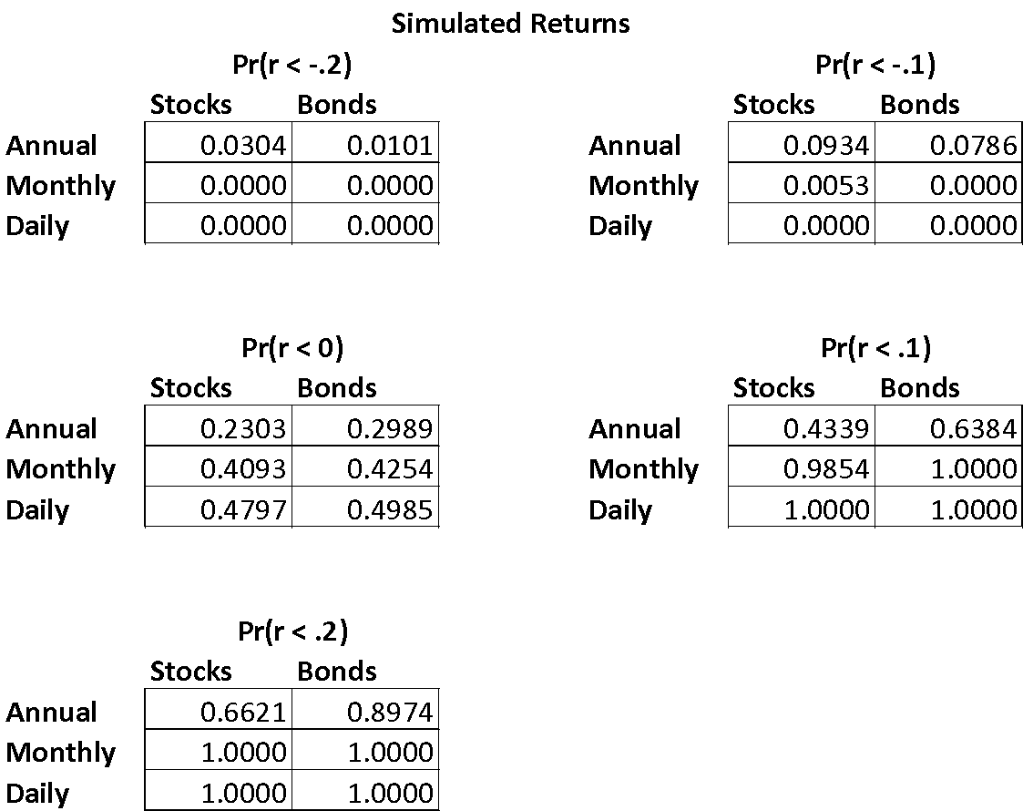

Our simulated returns match those obtained in homework one very closely, as expected since both assumed normality.

**2.**

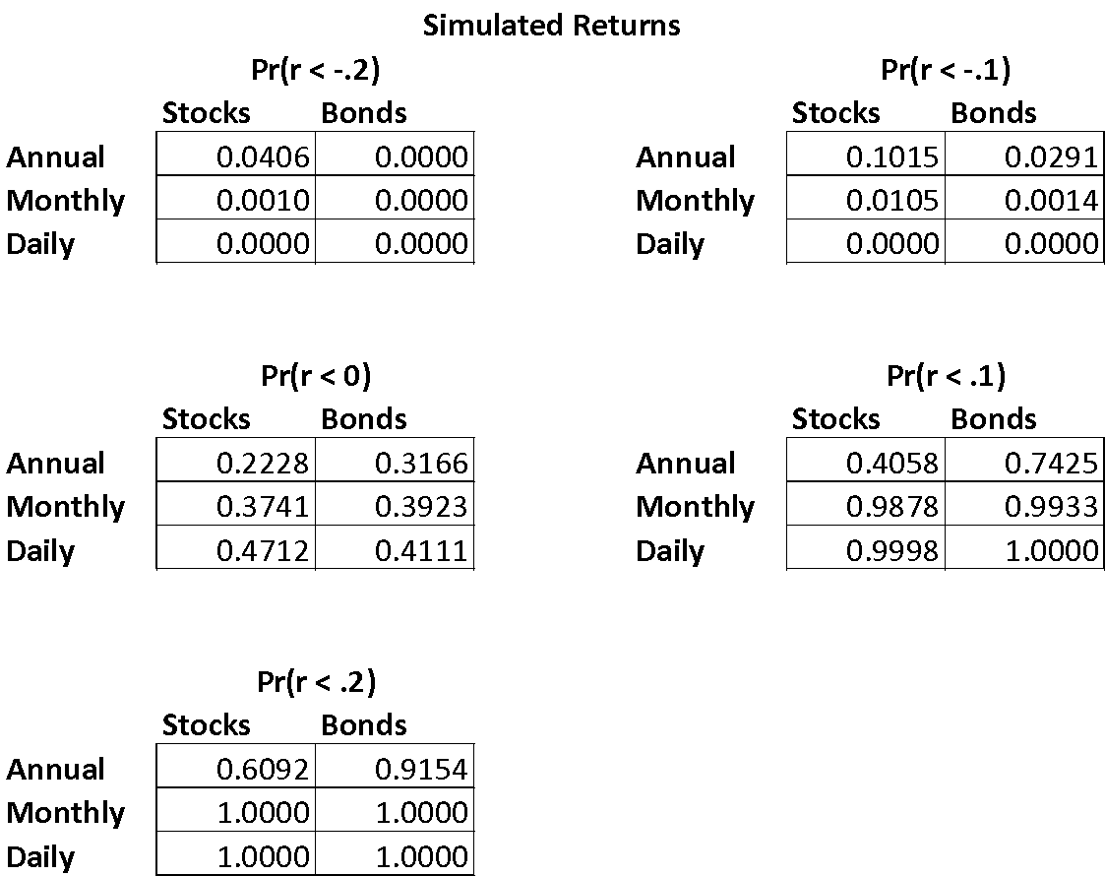

Our answers here do differ from those we obtained in part one, but in ways that we would expect given the high kurtosis and non-zero skewness of returns that we calculated last week (for example, we see a larger tail risk than normality predicted). Overall the predictions are fairly close to those under the normality assumption, but we do see differences of up to about 5% in some cases.

**3.**

The probability that an asset returns more than 20% over five periods assuming lognormal returns:

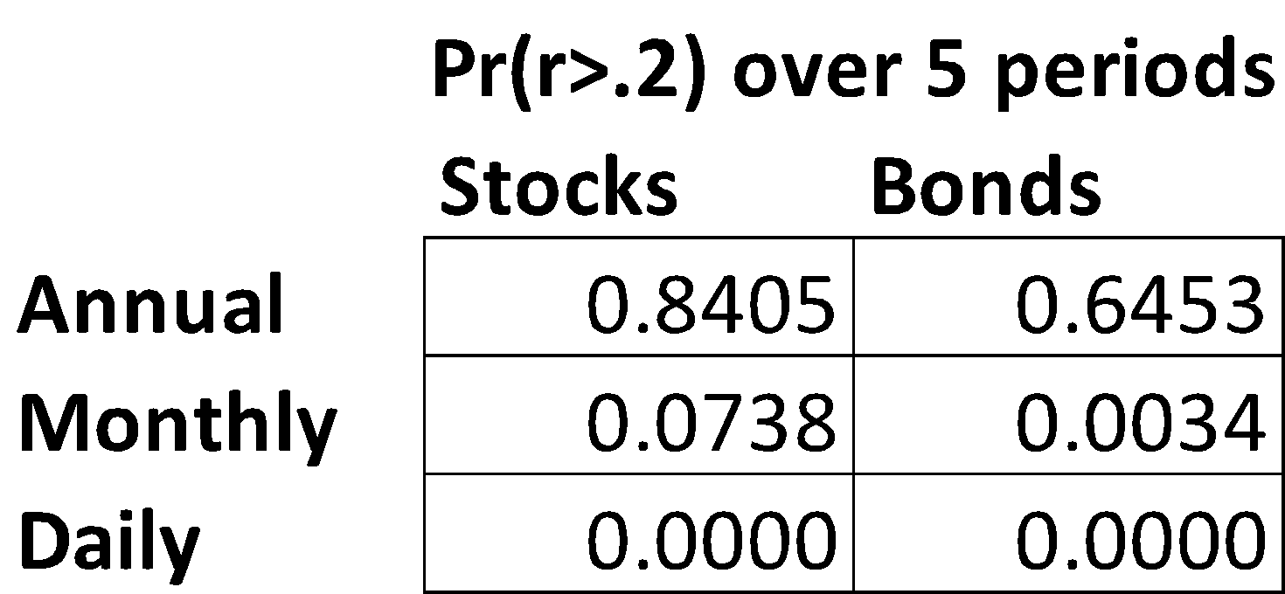

**4.**

The probability that an asset returns more than 20% over five periods based on simulation of a lognormal distribution of returns. As expected, the results are very close to those predicted in the previous question.

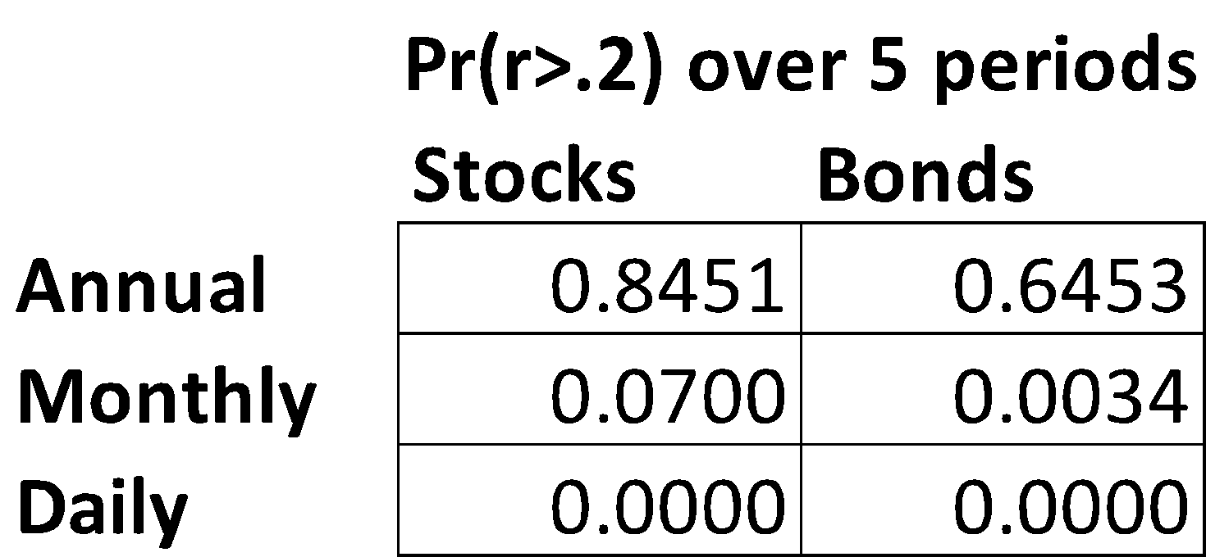

**5.**

The probability that an asset returns more than 20% over five periods based on sampling of historical returns. Again, these results are in line with the values of kurtosis and skewness that we predicted last week: stock returns are distributed with a left-skewness so have higher left tail risk, while bond returns are right skewed so have higher right tail risk.

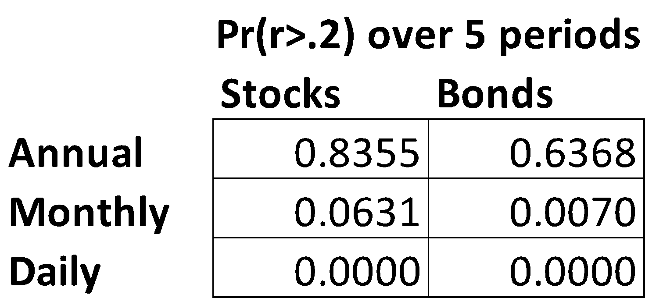

**6.**

Probability that stocks underperform bonds over 30 periods, analytically:

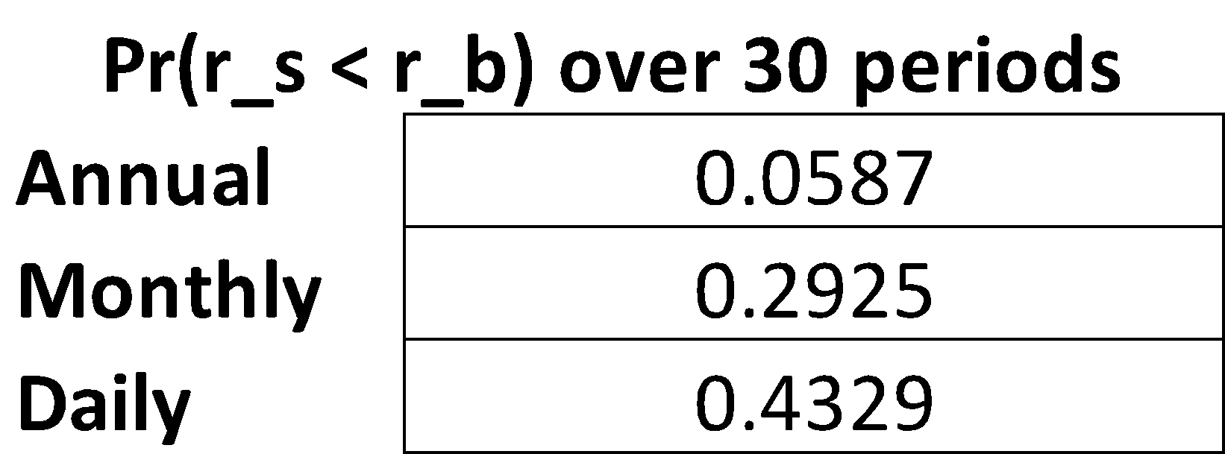

**7.**

Probability that stocks underperform bonds over 30 periods, from sampling historical returns. We see a higher probability than predicted that stocks underperform bonds over 30 years, but the probability is lower than predicted at the monthly and daily levels. Again, this is likely due to the fat-tailed distributions of returns at all levels.

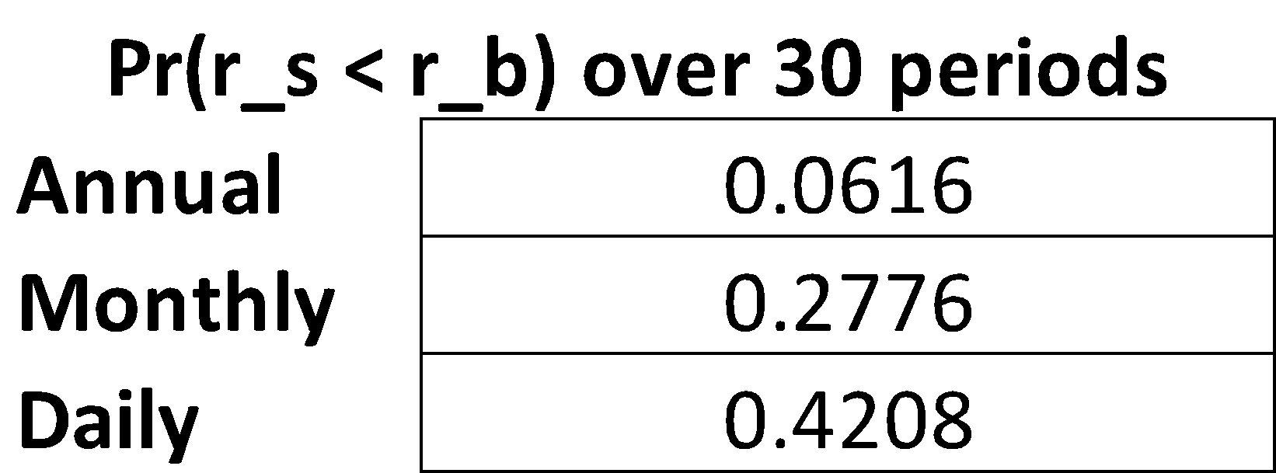

**C.**

**1.**

Pr(V25 > 1,000,000) ≥ .75 Pr(z > (-ln(V1) – 25(.1) + ln(106))/(.2sqrt(25))) ≥ .75 → α ≥ -0.67449

→ V1 ≥ $161,135; we can afford any of the three cars.

**2.**

a. 50% - this follows from the fact that E(Δ) in the relative shortfall formulation is 0, where Δ = ln(Vbond,T) – ln(VT-bill,T).

b. This result is independent of time horizon and volatility.

**3.**

Pr(VS/VB > K) = 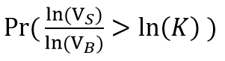 = Pr( ln(VS) - ln(VB) - ln(K) > 0 )

Setting the term on the left = “D”, E(D) = T(μs – μB) – ln(K)

Var(D) = σS2 + σB2 - 2ρσSσB

Then 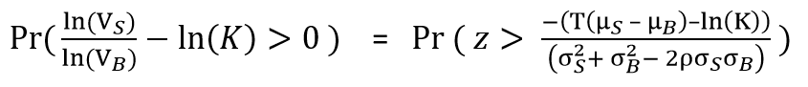

**4.**

We want to find t for (1+R)t = 2. For continuously compounding returns, ln(1+R) = r and

ln(1+R)t = ln(2) = tln(1+R) = tr → t = ln(2)/r = 0.69315/r (or 69.315/r%)

72 is close to 69.3, and has more factors so is easier to work with.