Portfolio Managment: Homework 10

Gal Skarishevsky, Nathan Matare, Brian Thompson, Lior Sahaf

June 1, 2017

# **A. Case Questions**

1. LTCM engaged in *convergence* and *relative value* strategies. Both strategies involved taking long and offsetting short in instruments that were substitutes. LTCM used the term *convergence* when there was a future date by which convergence in the value should occur. With *relative value*, convergence was expected but not guaranteed except over a very long horizon. For example, recently-issued U.S. bonds traded at lower yields than comparable maturity, older Treasury bonds. If this spread were wide, LTCM might purchase the off-the-run bond, and short the lower-yielding bond. With attractive financing rates, this position would make money if held to maturity.
2. The main similarities between DFA and LTCM are the fact that they both based their strategies on academie (nobel winners) and had them on their board. They both optimized their portfolio with mean variance optimization.They are different in the type of asset classes they hold. DFA held mostly public equities and mostly in a long-only portfolio. LTCM held alternative asset classes such as MBS and Bonds (and also public equities but as part of risk arbitrage strategy) and always hedged its position in order to get to market neutral portfolio. LTCM was highly leveraged and (in 1 point they even got to a leverage ratio of more than 40) and required 0 capital for its investment. All of their investments were 100% financed while DFA had hard investor's dollars for every position they took.
3. From inception, the Fund constraints its investment strategies in 2 manners. A constraint on its level of risk and a constraint subject to the requirement of maintaining adequate liquidity capital. The Management Company believed that these two constraints were not binding currently and the Fund has excess capital. This has occurred, primarily, because of a substantial increase in the capital base from the larger-than-expected, past realized rates of return, and high reinvestment rates elected by the Fund’s investors. Essentially, The fund became too big to exploit the mispricing it recognized and decided that in order to be on par with past performance it has to liquidate some of its positions and return them to investors. By shrinking the capital base to $4.7B, the leverage ratio went back up , amplifying returns to investors that stayed in the fund.

With the benefit of hindsight this seems like a bad decision. A Couple of months later LTCM faced a liquidity constraint that was much needed in order to hold positions in which their spread got wider. Since it was mostly convergence positions - the things that were required are additional capital and patience. The capital was crucial in order to hold the losing positions. The $2.7B would be pretty helpful in this case

1. LTCM received favorable financing conditions due to its transparent mark-to-market accounting practices, liquidity management, financing structure, and capital base.  This relatively cheap financing allowed them to take advantage of opportunities that had margins too narrow for other firms to exploit.
2. In general, LTCM measured risk in terms of the probability distribution of potential profits and losses. This included use of “value-at-risk” measures that were commonly employed by financial institutions. LTCM also employed economic stress testing which involved analyzing how the Fund’s positions would perform if a low probability, high impact event occurred. In assessing risk, LTCM also analyzed how the profits of its various positions were correlated. At the margin, a position that was uncorrelated with the remainder of the portfolio contributed relatively little risk, and therefore could be held in larger size. LTCM measured risk over both a one-year horizon and a one-month horizon. Over long horizons, the firm viewed the prices of financial instruments as being determined by their fundamental value. Thus, the long-run risk of a position was determined mainly by the risk of changes in fundamental value. Over short horizons, the prices of financial instruments were also affected by traders’ need to transact in a world of less than perfect liquidity. Finally, to determine the optimal position sizes for the trades, LTCM would calculate the mean- variance efficient frontier based on its estimates of risk, expected profit, and correlation for each trade.
3. A downturn in the MBS market led to a 16% loss to LTCM, thereby increasing leverage ratio. On August 17 Russia announced on defaulting its debt. Stock markets fell sharply that day and LTCM lost $550M, it worst day ever. By august, the fund had lost 52% of its beginning of year value. LTCM needed capital to support its position, and their CEO sent a desperate letter to investors asking for additional capital. The following month was even worth - investors lost 83% on September due to increased volatility in equity markets.

A2

1. The news that caused quantitative hedge funds’ losses were that a lot of hedge funds, with exposure to the US housing market, which was in a turmoil since the beginning of the year began to halt redemptions and close their doors. There are several explanations to why exactly why multiple quantitative hedge funds performed poorly in the first week of August 2007 but they all have in common the fact that the source of the ripple effect that caused the losses was struggling hedge funds with large exposures to the housing market.
2. There are three possible explanations that are mentioned in the case. The first one is that as the quant investment strategy became more popular, returns on common quant strategies decreased. In order to remain competitive, hedge funds levered up to squeeze more returns of the same strategies. This created a situation that multiple funds used roughly the same strategy with the same factors and were highly levered. In early 2007, deteriorating liquidity conditions in led to forced de-levering that when combined with multiple funds that make decisions based on the same factors created a liquidity spiral that made multiple funds sell at the same time.

The second explanation claims that a few hedge funds that suffered losses as a result of the subprime crisis de-levered sharply and to do that they used the most liquid assets they had – equities. This created a situation in which losses in an area separate from quant investing affected quant strategies because of the “bank-run” that was created around liquid equities.

The third explanation attacks more specifically the fact that most (or all) quant funds rely on the same models both for picking stocks and for managing risk. This created a unique situation in August 2007 in which the models of multiple funds suggested a sell at the same time in a response to the sells made by the other funds. This created an uncontrolled drop that had no fundamental reason besides different funds’ models reacting to each other.

1. We don’t think that August 2007 events have that much of effect on how we would look on a fund’s investment strategy. Obviously, the best option is to come up with some revolutionary proprietary investment factors that will be kept a secret and therefore will not be exposed to cross-reaction to other funds’ decisions but we think that in most cases that is not the case and funds can still make money by following the same strategies that were there for years (momentum, contrarian, value, etc.). However, we would have done two things differently. The first is controlling leverage. There are several examples in investing history to how brilliant strategies that relied on high levels of leverage caused a fund meltdown (LTCM) and therefore we would try to avoid low margin strategies that require high levels of leverage in order to produce decent returns. Second, we would try to make sure that at the base of most of our “traditional” strategies stands some principle that differentiates our fund even a little bit from what other funds are doing. Given that hedge funds do not disclose their strategies this could be tricky of course but using the best common knowledge, we believe that this could be achieved. For example, having a proprietary method of calculating a firm’s earnings/book value when investing in value stocks. We believe that reasonable levels of leverage in addition with making sure you are not just copying other funds’ strategies could decrease the odds of a coordinated drop of quant funds.

# B. Data Analysis

In order to conduct the analysis we write three functions: '', '', '', . computeOptionPrice outputs the standard Black-Scholes option price of a security given input parameters; runStrategy runs the strategy proposed in the question set; and getSharpeRatio computes the Sharpe Ratio of a set of strategies:

*Note there is a small bug somewhere in the code where the calculations do not match up exactly with the Professor's provided code.

computeOptionPrice <- function(S, K, T, rf, sigma){  
 # Implementation of theBlack-Scholes Option Value  
 # S is the price of the stock  
 # K is the strike price  
 # rf is the risk free rate  
 # T is the time  
 # sigma is the implied s&p volatility  
 d1 <- (log(S/K)+(rf+sigma^2/2)*T)/(sigma*sqrt(T))  
 d2 <- d1 - sigma * sqrt(T)  
  
 call <- S*pnorm(d1) - K*exp(-rf*T)*pnorm(d2)  
 put <- call + K*exp(-T*rf) - S   
 # put <- K*exp(-rf*T) * pnorm(-d2) - S*pnorm(-d1)   
 # alternative way of doing same calc  
  
 return(list(bs_call = call, bs_put = put))  
}  
  
runStrategy <- function(ledger = data, startdate, moneyness, beg_capital,   
 target_return, sp_volatility, tbill_return, ...){  
  
 # cut ledger based upon startdate  
 start_date <- as.Date(as.character(startdate), format = "%Y%m%d")  
 ledger <- ledger[which(index(ledger) == start_date):NROW(ledger)]  
  
 ledger$bs_put <- NA  
 ledger$capital <- NA  
 ledger$N <- NA  
 ledger$returns <- NA  
 ledger$compensation <- NA  
 ledger$index_return <- NA  
  
 monthly_eps <- endpoints(ledger, on = "months")[-1]  
 daily_eps <- endpoints(ledger, on = "days")[-1]  
  
 # init portfolio  
 stock_price = first(ledger)$spindx  
 strike_price = first(ledger)$spindx * moneyness  
 first_put <- computeOptionPrice(  
 S = stock_price,  
 K = strike_price,  
 T = 60,  
 rf = tbill_return,   
 sigma = sp_volatility  
 )$bs_put  
 # number of puts needed for target return  
 num_puts = target_return * beg_capital / as.numeric(first_put)   
 new_capital = beg_capital * (1 + target_return); # targeted return  
  
 # record first events  
 coredata(ledger)[1, 'capital'] <- new_capital  
 coredata(ledger)[1, 'bs_put'] <- first_put  
 coredata(ledger)[1, 'N'] <- num_puts  
  
 # start loop  
 k <- 1; while(new_capital > 0){  
  
 ep <- daily_eps[1 + k] # daily endpoint  
 if(is.na(ep)) break  
  
 period_before <- last(index(ledger[1:ep]), 2)[1]  
 period_date <- last(index(ledger[1:ep]), 2)[2]  
  
 old_capital <- as.numeric(ledger[period_before]$capital) # starting capital  
 new_capital = old_capital * (1 + tbill_return) # appreciated interest  
  
 if(period_date %in% index(ledger[monthly_eps])){ # do at end of each month  
  
 # print(paste("Exercising options at the end of month:", period_date))  
  
 # write off old options  
 stock_price = ledger[period_date]$spindx # get current price level  
 bs_put <- computeOptionPrice(  
 S = as.numeric(stock_price),  
 K = as.numeric(strike_price), # comes from init strike price or 30 days ago strike price  
 T = 30,  
 rf = tbill_return,   
 sigma = sp_volatility  
 )$bs_put  
  
 bs_cost <- bs_put * num_puts # number of puts wrote in last period  
 new_capital = new_capital - bs_cost # update capital after puts are written off  
  
 # write new options  
 strike_price = ledger[period_date]$spindx * moneyness # get current strike price  
 bs_put <- computeOptionPrice(  
 S = as.numeric(stock_price),  
 K = as.numeric(strike_price),   
 T = 60,  
 rf = tbill_return,   
 sigma = sp_volatility  
 )$bs_put  
   
 # number of puts needed for target return  
 num_puts = target_return * as.numeric(new_capital) / as.numeric(bs_put)   
 new_capital = new_capital * (1 + target_return);  
  
 # record option price and number  
 coredata(ledger)[index(ledger) == period_date][3] <- bs_put  
 coredata(ledger)[index(ledger) == period_date][5] <- num_puts  
  
 # compute compensation and metrics  
 rtrn = (new_capital - old_capital) / old_capital  
 coredata(ledger)[index(ledger) == period_date][6] <- rtrn  
  
 # compute compensation  
 compensation = (0.02 / 12 + 0.20 * max(rtrn - 21 * tbill_return, 0)) * old_capital  
 new_capital = new_capital - compensation  
  
 # compute monthly s&p returns  
 if(!exists("last_month")) last_month <- NA # init first month  
 current_return <- as.numeric(ledger[period_date]$spindx)  
 last_return <- as.numeric(ledger[last_month]$spindx)  
 index_return = (current_return - last_return) / last_return  
 if(length(index_return) == 0) index_return <- 0  
 coredata(ledger)[index(ledger) == period_date][8] <- index_return  
  
 # record capital and others  
 last_month <- period_date  
 coredata(ledger)[index(ledger) == period_date][7] <- compensation  
 }  
  
 coredata(ledger)[index(ledger) == period_date][4] <- new_capital  
 k <- k + 1  
 }  
  
 # print("Ran out of money!")  
 end_ledger <- ledger[1:which(index(ledger) == period_date)]  
 return(end_ledger)  
}  
  
getSharpeRatio <- function(ledger, tbill_return, ...){  
 SR_strategy <- mean(ledger$returns[-1] - 21 * tbill_return) / sd(ledger$returns[-1] )  
 SR_index <- mean(ledger$index_return[-1] - 21 * tbill_return) / sd(ledger$index_return[-1] )  
 output <- data.frame(Strategy = SR_strategy, Index = SR_index)  
 return(output)  
}

# B.1. Suppose you started your hedge fund on March 1, 1994.

## a)

We run the proposed strategy:

Last Date

|  |  |
| --- | --- |
|  | 1998-08-31 |
| spindx | 957.280000 |
| sprtrn | -0.068014 |
| bs_put | 0.089371 |
| capital | -103.249550 |
| N | -44.239114 |
| returns | -1.377628 |
| compensation | 0.453691 |
| index_return | -0.145797 |

Riteput goes out of business on 1998-08-31

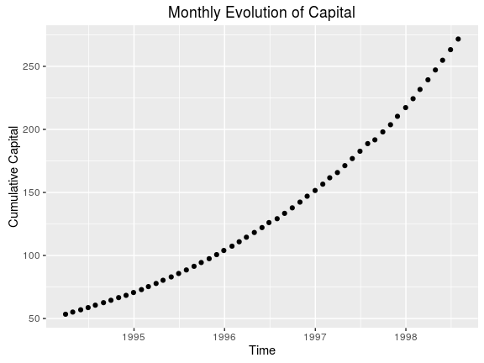

## b)

Riteput has all positive returns in this evaluation period (100%)

Sharpe Ratios

|  |  |
| --- | --- |
| Strategy | Index |
| 10.12844 | 0.509873 |

## c)

The Sharpe Ratio appears really good. But it's spurious, see below.

## d)

The Sharpe Ratio is based upon two metrics: backward looking returns and variance. Because our strategy essentially sells insurance against the market falling by more than 20%, naturally we reap steady returns with little deviation over the 'good' periods, periods when the market isn’t very volatile. However, when the market suffers a left tail event, a period when the market drops by more than 20%, we are forced to pay out our 'insurance' premiums.

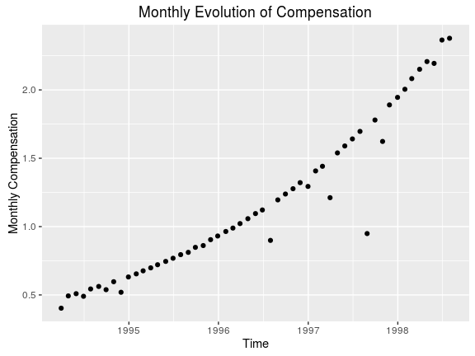

Total Compensation

|  |
| --- |
| compensation |
| 62.27834 |

## e)

Although RitePut reaps a significant compensation, RitePut is essentially gambling with investor's money. There is little skill involved in this strategy. RitePut is selling insurance against an unlikely, however inevitable, event. At some point RitePut will be wiped out by the huge loss.

## f)

Because the market became less volatile and reached a local price level minimum of 445. That is, the prior monthly returns experienced much more variance, and a 20% market drop was more likely in such a time period. Further, February’s price level was 467, and January’s was 481, both higher. You correctly found the local minimum were the market wouldn’t decrease more than 20%

# B.2. Answer all numerical questions in part 1 (without plots) when options are 15% and 10% out of the money (instead of 20%).

(Below) We set adjust the moneyness: (moneyness = 0.85). Riteput goes out of business on 1998-10-31, two months later than before. Better. However, the Sharpe Ratio is much worse. This is because we're now incorporating the negative returns and large standard deviations into the calculation. However, our compensation is much higher as we're able to persist longer given that we pay out at smaller left tail events (15% drop as opposed to 20% drop)

Last Date

|  |  |
| --- | --- |
|  | 2008-10-31 |
| spindx | 968.750000 |
| sprtrn | 0.015365 |
| bs_put | 0.734659 |
| capital | -102.402073 |
| N | -5.344513 |
| returns | -1.538714 |
| compensation | 0.315833 |
| index_return | -0.169425 |

Sharpe Ratios

|  |  |
| --- | --- |
| Strategy | Index |
| 0.247355 | 0.104428 |

Total Compensation

|  |
| --- |
| compensation |
| 130.3483 |

(Below) We set the moneyness to 90%: (moneyness = 0.90). In this case, Riteput doesn't go out of business. However, the Sharpe Ratio is much worse. This is because we're now incorporating the negative returns and large standard deviations into the calculation. However, our compensation is much higher as we're able to persist much longer than either a 20% or 15% moneyness. Now we pay out smaller premiums when the market drops below 10%, and given the amount of capital we have accumulated, we're able to cover our losses while continuing to charge a premium for our supposed 'skilled' service.

Last Date

|  |  |
| --- | --- |
|  | 2016-12-30 |
| spindx | 2238.830000 |
| sprtrn | -0.004637 |
| bs_put | 8.452996 |
| capital | 485.353366 |
| N | 2.226444 |
| returns | 0.035782 |
| compensation | 3.969781 |
| index_return | 0.018201 |

Sharpe Ratios

|  |  |
| --- | --- |
| Strategy | Index |
| 0.218066 | 0.110557 |

Total Compensation

|  |
| --- |
| compensation |
| 336.3052 |

# B.3. Suppose you can start your hedge fund on the 1st trading day of any month

## a) in the early 1980s, between January 1980 and December 1985

We run the proposed strategy:

Last Date

|  |  |
| --- | --- |
|  | 1987-10-30 |
| spindx | 251.790000 |
| sprtrn | 0.028680 |
| bs_put | 0.023507 |
| capital | -4201.625906 |
| N | -6873.572361 |
| returns | -11.937282 |
| compensation | 0.640163 |
| index_return | -0.217630 |

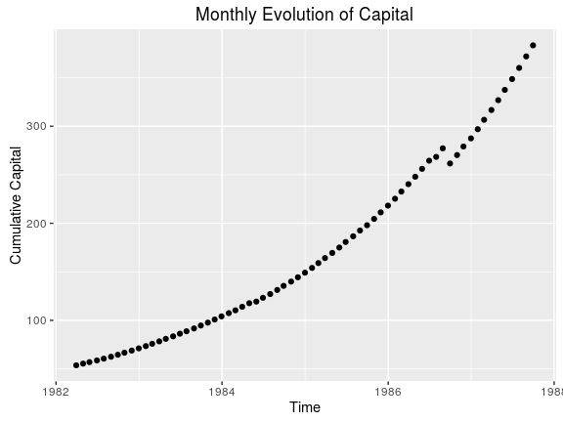

Sharpe Ratios

|  |  |
| --- | --- |
| Strategy | Index |
| 2.817917 | 0.351354 |

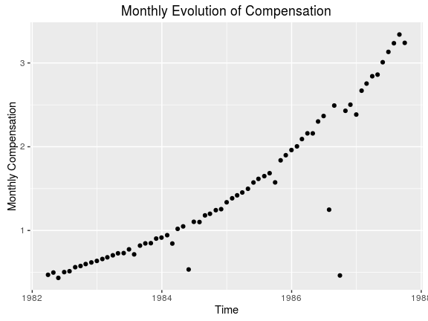

Total Compensation

|  |
| --- |
| compensation |
| 98.78964 |

Here, we notice that the first negative dip in capital doesn't come until late 1986. During this time period, we would want to start as early as possible. The fund collapsed toward late 1988 because of a large >20% drop in the market. RitePut, essentially, had to pay out huge premiums.

## b) in the 1990s, between January 1990 and December 1999

We run the proposed strategy:

Last Date

|  |  |
| --- | --- |
|  | 1998-08-31 |
| spindx | 957.280000 |
| sprtrn | -0.068014 |
| bs_put | 0.089371 |
| capital | -409.536024 |
| N | -175.473023 |
| returns | -1.377628 |
| compensation | 1.799549 |
| index_return | -0.145797 |

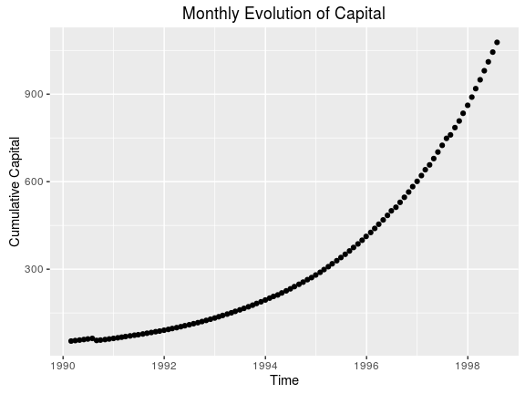

Sharpe Ratios

|  |  |
| --- | --- |
| Strategy | Index |
| 2.296534 | 0.30665 |

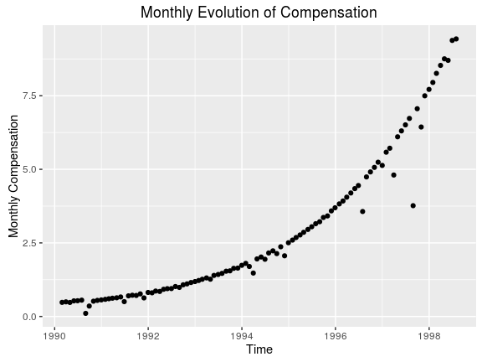

Total Compensation

|  |
| --- |
| compensation |
| 292.8264 |

During this period, we have a fairly optimal time to run the strategy. There is a small negative dip in capital in mid to late 1990 that affects the Sharpe Ratio and compensation. To optimize the performance metrics of this strategy, RitePut should start the fund in early 1991. The fund appears to have been wiped out by the tech-bubble burst. That is, the fund collapsed in late 1998 early 1999 because of a large >20% market drop. RitePut, essentially, had to pay out huge premiums.

## c) in the 2000s, between January 2000 and December 2016

We run the proposed strategy:

Last Date

|  |  |
| --- | --- |
|  | 2008-10-31 |
| spindx | 968.750000 |
| sprtrn | 0.015365 |
| bs_put | 0.090442 |
| capital | -889.070239 |
| N | -377.800520 |
| returns | -3.182083 |
| compensation | 0.678550 |
| index_return | -0.169425 |

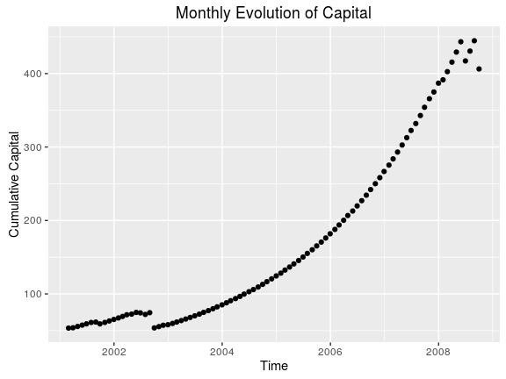

Sharpe Ratios

|  |  |
| --- | --- |
| Strategy | Index |
| 0.710748 | -0.0519 |

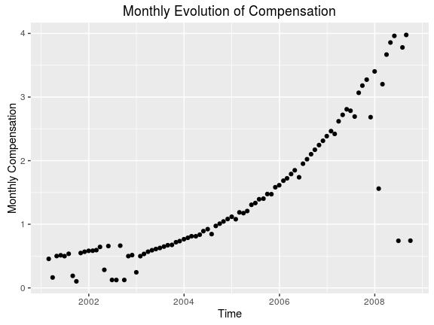

Total Compensation

|  |
| --- |
| compensation |
| 128.3203 |

This fund barely survived its early periods where it experienced several large payouts due to negative market price movement. Thus, it would have been optimal to start this strategy in early 2003 right after the turbulence of the early 2000s. The fund then appeared to suffer several large payouts towards the end of its tenure before going negative; it was able to cover some of them, but ultimetly went under. Notably, the compensation does well while the performance of fund (Sharpe Ratio) is relatively poor (due to the negative payouts, and increased variance).

# B.4. What techniques can investors use to detect Riteput’s strategy?

First, if one observes abnormally high Sharpe Ratios, that's the first indication. However, as we saw, this can be misleading. Thus a more robust technique an investor could use is to monitor the funds performance. That is, if one observes steady payouts without much variance one should be suspicious that said fund is simply offering insurance against extreme market events.

# B.5. Riteput is to Powerball as the duration of human pregnancy is to ...?

The time it takes to fly to NYC from ORD. Human pregnancy lasts about 10 months, while the time it takes to fly to New York from Chicago is two hours. In this case, we are comparing the likelihood of an extreme event(flight time)happening relative to a longterm norm (pregancy). Given that a 20% drop in the market is an extreme tail event (more than 2SD), it's more appropriate to compare 10 months to 2 hours. One hour, in our opinion, would be even more extreme—or a 3SD event, perhaps a strategy that exploited 30% moneyness puts.

# B.6. What if anything have you learnt from this exercise?

Be very careful about funds that promise steady returns, it's likely to be too good to be true. The fund, more likely, is just offering an insurance product to the broader market. If you time your entrance and exit into the fund well, it might pay off... but beware because you could stand to loose all your capital! And the incentive structure, read compensation, for the fund is not aligned in your best interest. That is, the fund gets to gamble with your money and make a killing while you bear all the risk—you could loose all your capital, while the fund walks away with a significant buck.

# **C. Exam Questions**

1. The reason is that hedge funds are weighting assets in a way in which the resulting portfolio will have a beta of zero. This means that the portfolio should not be correlated with the market at all (this is why it’s called market neutral). The way hedge funds do that is by going long on investments they estimate have positive alphas and going short on investments with negative alpha and make their returns from the relative movements between the two assets (again, not affected by market movements). This is why it’s called two-alpha strategy.
   1. We have two equations:

1.6Wa + 1.2Wb = 0

Wa+Wb = 1

Solving for this results in:

Wa = -3

Wb = 4

So we would go short 300% on Amgen and lon 400% on Genentech.

1. WA * A + Wb*B = -3*3 + 4*-2 = -17%. This is also the excess expected return of the portfolio (because =0). This is not an attractive portfolio.
2. Our three equations in this case will be:

WA+WB+WC = 1

1.6A + 1.2B = 0

3A - 2B > 0

The result is that for every WA>0 the portfolio will have a positive alpha while Wb = -4A/3 and Wc = A+3/3

1. Under the same principle the three equations are now:

WA+WB+WC = 1

1.6WA+1.2wb+1.8WC = 0

3WA-2WB-2WC >0

The results is:

WA > ⅖, WB = 3-WA/3, WC = -⅔*(WA+3)

1. Yes, in order to form a zero beta portfolio from three assets all three betas must be known
2. Assuming cumulative returns are lognormal, which is probably a poor assumption, we could say that the standard deviation of returns over a 10-year period is

σ1 year * sqrt(period length) = 0.2*sqrt(10) = 0.632

To achieve an (geometric) average annual return of 10%, the fund must return 1.110 = 2.594 times the initial investment.

The probability that a fund returns less than 10% annualized is therefore the standard normal CDF of (2.594/0.632) = 0.9999794

The probability that zero out of 50 funds achieve greater than 10% annualized returns is 0.999979450 = 0.998972, so the probability that at least one fund achieves 10% average returns is

1 - 0.998972 = 0.001028 = 0.1028%

More realistically, without assuming that the cumulative returns are lognormal we can run a simulation to capture the long-tail effect that increases over time.  Running this simulation 10,000 times results in a probability of achieving greater than 10% returns (final value > 2.594) of 3.7% for any given fund, or probability that no fund achieves 10% of 0.96350 = 0.1518.  Therefore, the probability that at least one fund achieves 10% returns is 1 - 0.1518 = 0.8482 = 84.82%.

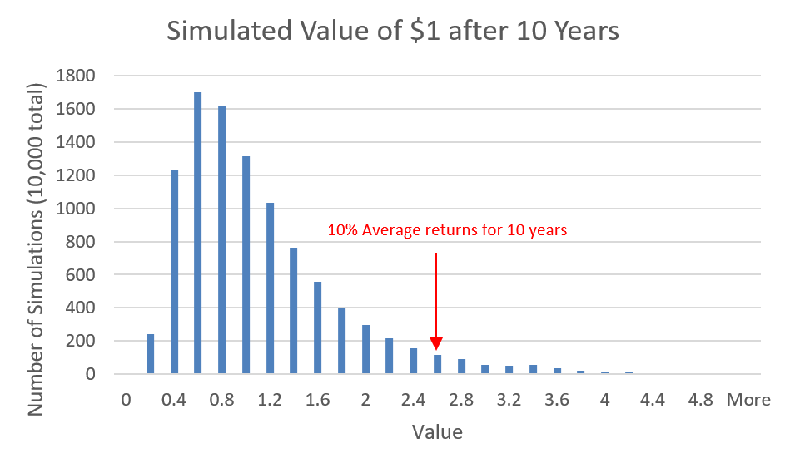

1. Wh that gives the highest Sharpe ratio according to the tangency portfolio equation results in the following:

Wh = 2%/20^2/(2%/20^2 + 6%/15^2) = 15.78%

The sharpe ratio will be calculated according to: Sp = sqrt(SH^2 + SM^2) = sqrt(0.1^2 + 0.4)= 0.64 which is higher than the market Sharpe ratio of 0.4

1. In expectation and ignoring fees, a market neutral investment should deliver the same return as cash since (in expectation) returns from the investment’s long and short position would cancel, leaving only the return on the cash holdings.  Ideally, the fund manager would generate some additional positive returns through an ability to pick the long and short positions successfully.  More realistically we could consider a market-neutral strategy an alternative to cash only to the extent that the strategy has a relatively low correlation with the market.  This correlation will vary between funds and could become larger during market downturns if unexpected risks are exposed in the fund’s positions.