Portfolio Management: Assignment 2

Gal Skarishevsky, Nathan Matare, Brian Thompson, Lior Sahaf

April 6, 2017

**Part A.1. Case Study**

1. **“If stock market movements are serially uncorrelated, then the risk of holding stocks diminishes as the holding period lengthens.” Comment.**

As discussed in the first class lecture, expected asset return increases linearly with the length of the holding period, while the volatility or risk of the asset increases linearly with the square root of the holding period. Thus, purchasing a risky asset with a lengthy intended holding period is less risky than purchasing the same asset for a short duration.

**2. Reconstruct as much as you can of Exhibits 1 and 2, and describe how you did it.**

We recreated exhibit 1 using growth rate formulas of Y = (1+r)t on a logarithmic y-axis, with 2σ confidence intervals at ert ± 2σsqrt(t).

We recreated exhibit 2 using Matlab’s “normcdf” function at 0 with mean 0.057t and standard deviation sqrt(t)*σ for the relative shortfall probability. For the put option value we used the “blsprice” function with price = 1, strike = e.06t, risk free rate = 0.06, time = t, and volatility = 0.16, all as given in the case.

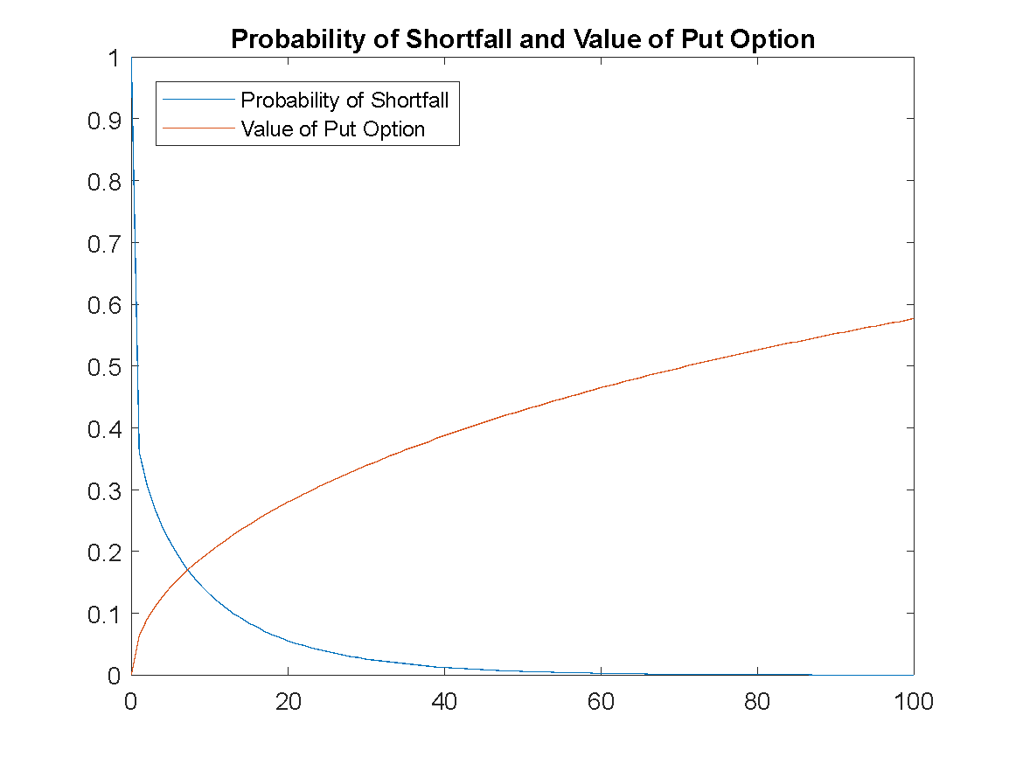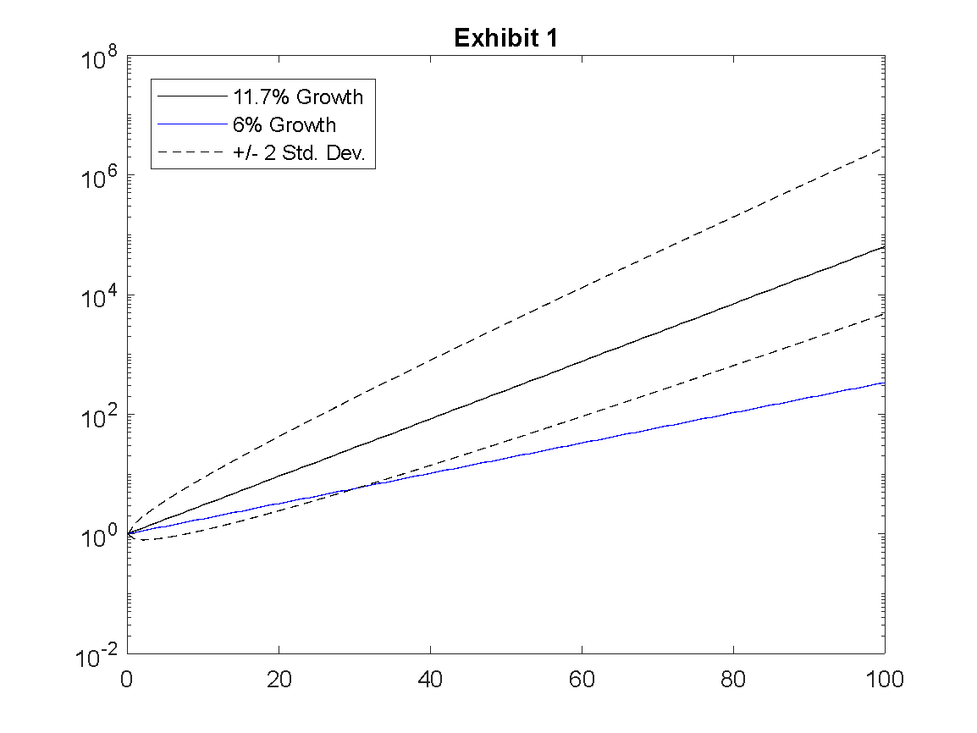

1. **Which of the two proposals (if any) should Ms. Adams accept?**

We believe that Ms. Adams should accept the second proposal. The first proposal, given the put options on the S&P500 is more risky than just holding the index so we think it’s less preferable to holding the index. The second proposal provides some upfront cash advantages and has the attributes and general risk level of holding the S&P500 index so we believe it is the preferable option.

**Part A.2. Case Study**

**1. Briefly summarize the key features of Vanguard’s business philosophy.**

Vanguard’s goal is to manage clients’ funds with a long-term view, and to offer better returns than competitors, with an emphasis on low costs to investors. The company reinforces this philosophy by being investor-owned, in order to ensure their goals remain aligned with their customers’.

**2. What are the two main theoretical arguments for reducing one’s stock allocation as one grows older?**

The human wealth argument: According to this rationale, an individual’s money-earning capacity (i.e. their salary) can be interpreted as a bond-like asset in that it pays a somewhat predictable revenue stream over time. Because this future revenue stream decreases as an investor ages, the present value of this bond-like cash flow decreases so the investor should allocate more of their portfolio to traditional fixed income assets to compensate.

Mean reversion of stock returns argument: According to the case, empirical evidence has shown that stock returns tend to be mean reverting, which results in stocks having a lower annualized volatility when held over longer time horizons. Because of this, investors would want to hold more stocks when they are younger and have a longer anticipated holding period.

**3. Do you agree with those arguments? Why or why not?**

We agree with the human wealth argument but not necessarily mean reversion. Intuitively, investors will want a stable, low risk cash flow stream to replace their foregone salaries after retirement as the human wealth argument states. Regardless of whether returns are mean reverting or unit root, investors will want a larger stock allocation when they are young, as the annualized volatility will increase as their holding period decreases.

**Part B. Data Analysis**

**1.** Our simulated returns match those obtained in homework one very closely, as expected since both assumed normality.

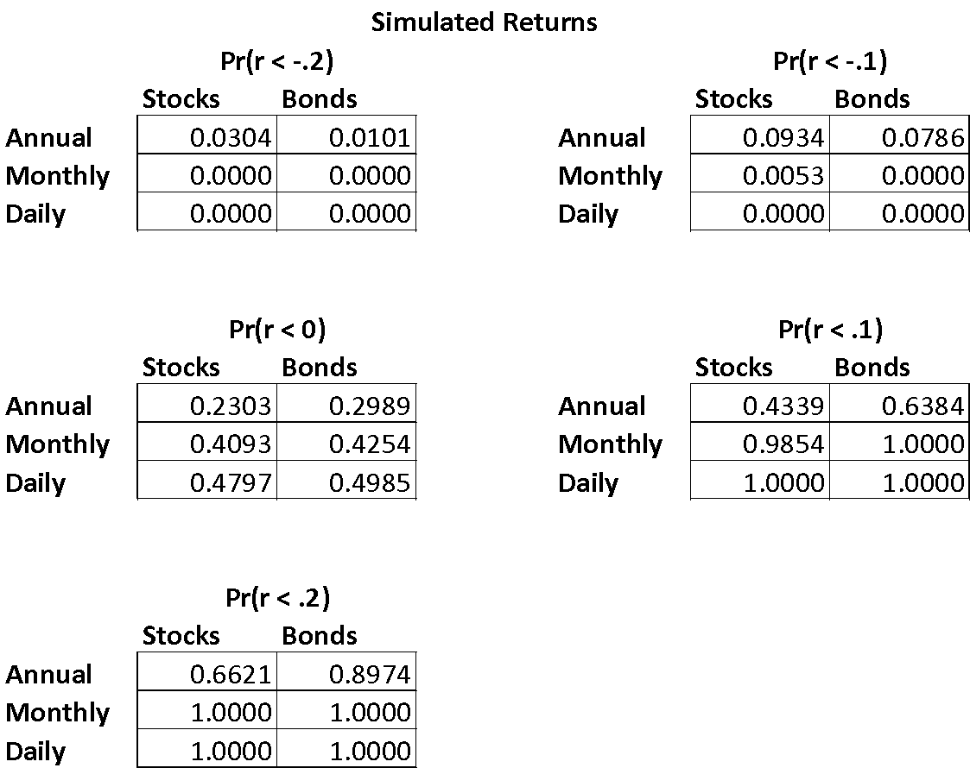

**2.** Our answers here do differ from those we obtained in part one, but in ways that we would expect given the high kurtosis and non-zero skewness of returns that we calculated last week (for example, we see a larger tail risk than normality predicted). Overall the predictions are fairly close to those under the normality assumption, but we do see differences of up to about 5% in some cases.

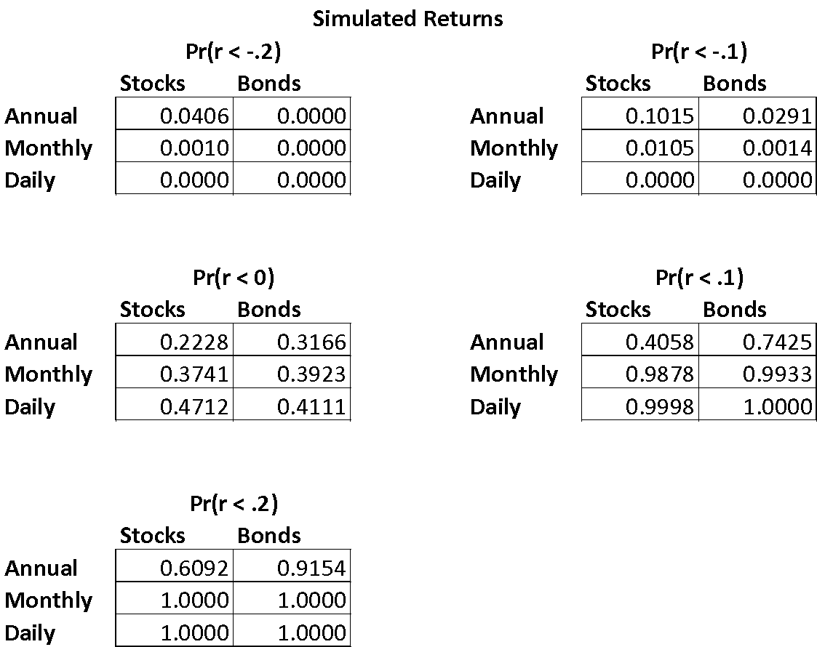

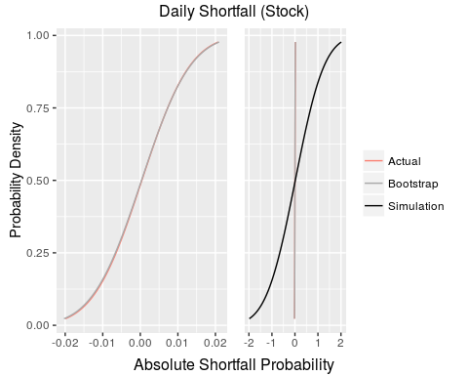Graphically, when we inspect the differences across stocks and bonds we notice several patterns:

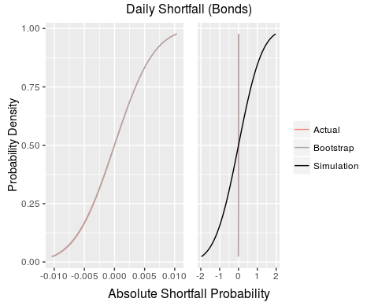

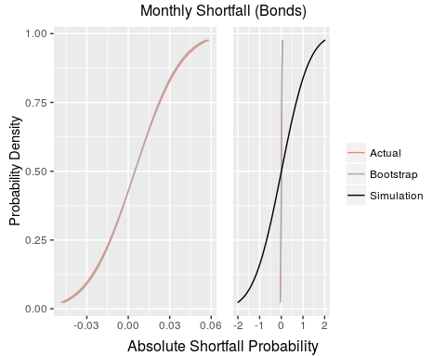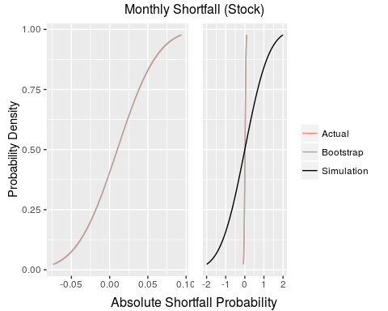

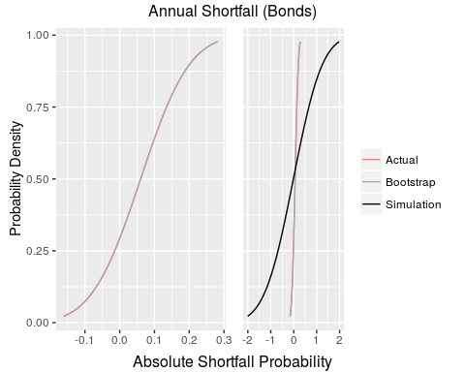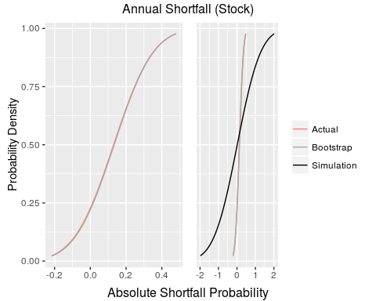

That is, as the time horizon increases (daily to annually), both the analytical approach and bootstrap (resampling) converge closer to the simulated normal distribution. However they never quite get to the normal distribution. Also to note, the resampling is very close to the analytical approach although it differs slightly; this is because of the randomness of the sampling method.

1. The probability that an asset returns more than 20% over five periods assuming lognormal returns:

|  |  |  |
| --- | --- | --- |
|  | stocks | bonds |
| Annually | 0.8405 | 0.64526 |
| Monthly | 0.0738 | 0.00344 |
| Daily | 0.0000 | 0.00000 |

1. The probability that an asset returns more than 20% over five periods based on simulation of a lognormal distribution of returns. As expected, the results are very close to those predicted in the previous question.

|  |  |  |
| --- | --- | --- |
|  | stocks | bonds |
| Annually | 0.8549 | 0.6380 |
| Monthly | 0.0684 | 0.0036 |
| Daily | 0.0000 | 0.0000 |

1. The probability that an asset returns more than 20% over five periods based on sampling of historical returns. Again, these results are in line with the values of kurtosis and skewness that we predicted last week: stock returns are distributed with a left-skewness so have higher left tail risk, while bond returns are right skewed so have higher right tail risk.

|  |  |  |
| --- | --- | --- |
|  | stocks | bonds |
| Annually | 0.8478 | 0.6367 |
| Monthly | 0.0629 | 0.0062 |
| Daily | 0.0000 | 0.0000 |

1. Probability that stocks underperform bonds over 30 periods, analytically (We include 5, and 100 periods for illustration that as the number of periods increases, the probability of stocks underperforming bonds decrease)

|  |  |  |  |  |  |
| --- | --- | --- | --- | --- | --- |
|  | T = 5 |  | T = 30 |  | T = 100 |
| Daily | 0.465 | Daily | 0.41387 | Daily | 0.345576 |
| Monthly | 0.374 | Monthly | 0.21615 | Monthly | 0.075834 |
| Annually | 0.165 | Annually | 0.00855 | Annually | 0.000007 |
|  |  |  |  |  |  |
|  |  |  |  |  |  |

1. Probability that stocks underperform bonds over 30 periods, from sampling historical returns. We see a higher probability than predicted that stocks underperform bonds over 30 years, but the probability is lower than predicted at the monthly and daily levels. Again, this is likely due to the fat-tailed distributions of returns at all levels.

|  |  |
| --- | --- |
|  | T = 30 |
| Daily | 0.4246 |
| Monthly | 0.2779 |
| Annually | 0.0184 |

**Part C.**

1. Pr(V25 > 1,000,000) ≥ .75 Pr(z > (-ln(V1) – 25(.1) + ln(106))/(.2sqrt(25))) ≥ .75 → α ≥ -0.67449

→ V1 ≥ $161,135; we can afford any of the three cars.

1. b_mu <- 0.003  
   b_sigma2 <- 0.015  
   b_sigma2 <- 0.3

Part A)

T <- 10 * 12 # in months  
rf_mu <- 0.003  
rf_sigma2 <- 0 # risk free  
  
Z <- sqrt(T) * (rf_mu - b_mu) / sqrt(b_sigma2)  
1 - pnorm(Z)

## [1] 0.5

50% - this follows from the fact that E(Δ) in the relative shortfall formulation is 0, where Δ = ln(Vbond,T) – ln(VT-bill,T).

Part B)

Generally, as the length of the time horizon grows(T), the probability that the risk free asset will outperform the risky asset decreases; that is, the probability goes to zero. Here, however, we have rf_mu = b_mu. Thus, the result is independent of the time horizon. Again, as for volatility, rf_mu = b_mu, and is equal to zero, so the numerator becomes zero making result independent of variance.

Pr(VS/VB > K) = 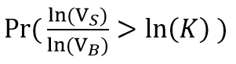 = Pr( ln(VS) - ln(VB) - ln(K) > 0 )

Setting the term on the left = “D”, E(D) = T(μs – μB) – ln(K)

Var(D) = σS2 + σB2 - 2ρσSσB

Then 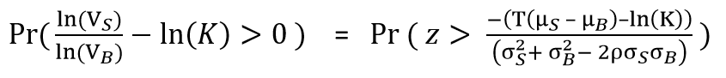

We want to find t for (1+R)t = 2. For continuously compounding returns, ln(1+R) = r and

ln(1+R)t = ln(2) = tln(1+R) = tr → t = ln(2)/r = 0.69315/r (or 69.315/r%)

1. s close to 69.3, and has more factors so is easier to work with.

**Part A)**

No I do not agree with Bill Gross. Assuming returns are i.i.d. (But not necessarily normal). By pure statistical chance alone, we would expect to observe a "long-run" average of high returns from stocks. That is, we could be observing returns on the right side of the distribution without calling into question any of our underlying assumptions. What would be flawed, however, would be to state, that now the market must overcorrect and start 'drawing' returns from the left side of the mean of the distribution. This is statistically unsound. Certainly we may begin to observe more negative returns from stocks; but as our homework discussed this noise will be washed out in the long run as we converge to a probability of one.

**Part B)**

While "pure intellectual fraud" is a bit harsh, I do agree with Nassim that the heuristic is misleading. It certainly mispresents overall risk. I believe that managers should use it as one metric, or one tool in their tool box to get a snapshot of their risk exposure. Relying solely on the metric in isolation, however, is folly; and one, instead, should use a dashboard of risk assessment tools. We discussed in the class the various problems with the VaR measure.