Untitled

Homework 2

April 6, 2017

##############  
# Homework 2 #  
##############  
  
########  
# Load Config Files  
########  
  
options("width" = 250)  
options(scipen = 999)  
options(digits = 003)  
  
library(xts); library(zoo); library(e1071);

## Loading required package: zoo

##   
## Attaching package: 'zoo'

## The following objects are masked from 'package:base':  
##   
## as.Date, as.Date.numeric

library(ggplot2); library(knitr); library(gridExtra)  
library(reshape2)  
  
set.seed(666) # the devils seed  
  
username <- Sys.info()[["user"]]  
dir <- paste("/home/", username, "/Documents/Education/Chicago_Booth/Classes/35120_Portfolio_Management/portfolio_management/mod2", sep = "")  
setwd(dir)  
  
getReturns <- function(name){  
 returns <- read.csv(name, skip = 4, sep = "\t", header = FALSE)  
   
 if(name == 'returns_annual.txt')   
 returns <- as.xts(returns[ ,-1], order.by = as.Date(as.character(returns[,1]), format = "%Y"))  
 else   
 returns <- as.xts(returns[ ,-1], order.by = as.Date(as.character(returns[,1]), format = "%Y%m%d"))  
   
 colnames(returns) <- c("SP500_rtrn", "BOND_rtrn")  
 return(returns)  
}  
  
daily <- getReturns('returns_daily.txt')  
monthly <- getReturns('returns_monthly.txt')  
annually <- getReturns('returns_annual.txt')  
  
# Notes  
# This is the same thing  
# 1 - pnorm(q = (0.05 - mean(annually$SP500_rtrn)) / sd(annually$SP500_rtrn), mean = 0, sd = 1, lower.tail = TRUE)  
# pnorm(q = (0.05 - mean(annually$SP500_rtrn)) / sd(annually$SP500_rtrn), mean = 0, sd = 1, lower.tail = FALSE)  
  
# Part B  
# Question 1 and 2  
  
makeAbsShortfall <- function(returns, title, sim_obs = 10000){  
   
 makeZScore <- function(x){  
  
 rtrn_mean <- mean(x)   
 rtrn_sd <- sd(x)  
 z_scores <- seq(  
 from = rtrn_mean - 2 * rtrn_sd,   
 to = rtrn_mean + 2 * rtrn_sd,  
 by = 4 * rtrn_sd / 100)  
 return(z_scores)   
 }  
  
 # Question 1; compute Prob(z < Z) via pnorm  
 rtrn_zscore <- makeZScore(returns)  
 pvalues <- pnorm(rtrn_zscore, mean = mean(returns), sd = sd(returns))  
  
 # Draw from standard normal; compute Prob(z < Z) via pnorm  
 simulation <- rnorm(sim_obs) # draw from standard normal  
 sim_zscore <- makeZScore(simulation)  
 pvalues_sim <- pnorm(sim_zscore, mean = mean(simulation), sd = sd(simulation))  
   
 # Bootstrap; compute Prob(z < Z) via pnorm  
 bootstrap <- sample(x = matrix(returns), size = sim_obs, replace = TRUE)  
 bootstrap_zscore <- makeZScore(bootstrap)  
 pvalues_bootstrap <- pnorm(bootstrap_zscore, mean = mean(bootstrap), sd = sd(bootstrap))  
   
 frame <- data.frame(pValue = pvalues, Actual = rtrn_zscore, Bootstrap = bootstrap_zscore, Simulation = sim_zscore)  
  
 p1 <- ggplot(melt(frame, id = "pValue")) +  
 geom_line(aes(x = value, y = pValue, colour = variable)) +  
 xlab(NULL) +  
 ylab(NULL) +  
 theme(axis.title.y = element_blank(), axis.text.y = element_blank(), axis.ticks.y = element_blank()) +  
 scale_colour_manual(values = c("salmon", "darkgrey", "black"), guide = guide_legend(title = NULL))  
  
 p2 <- ggplot(melt(frame[,-4], id = "pValue")) +  
 geom_line(aes(x = value, y = pValue, colour = variable)) +  
 xlab(NULL) +  
 ylab("Probability Density") +  
 scale_colour_manual(values = c("salmon", "darkgrey"), guide = guide_legend(title = NULL)) +  
 theme(legend.position = "none")  
  
 p_out <- grid.arrange(p2, p1, ncol = 2, top = title, bottom = "Absolute Shortfall Probability")  
 detail <- rbind(head(frame, 3), tail(frame, 3))  
 return(list(plot = p_out, detail = detail))  
}  
  
# Stocks  
  
stock_daily_answer <- makeAbsShortfall(daily$SP500_rtrn, title = "Daily Shortfall (Stock)")

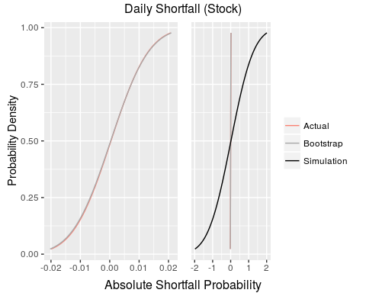

kable(stock_daily_answer$detail, digits = 6, caption = "Daily")

Daily

|  |  |  |  |  |
| --- | --- | --- | --- | --- |
|  | pValue | Actual | Bootstrap | Simulation |
| 1 | 0.0227 | -0.0199 | -0.0203 | -1.98 |
| 2 | 0.0250 | -0.0195 | -0.0199 | -1.94 |
| 3 | 0.0274 | -0.0191 | -0.0195 | -1.90 |
| 99 | 0.9726 | 0.0200 | 0.0202 | 1.93 |
| 100 | 0.9750 | 0.0204 | 0.0206 | 1.97 |
| 101 | 0.9772 | 0.0208 | 0.0210 | 2.01 |

stock_monthly_answer <- makeAbsShortfall(monthly$SP500_rtrn, title = "Monthly Shortfall (Stock)")

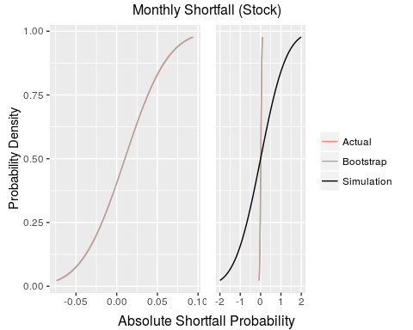

kable(stock_monthly_answer$detail, digits = 6, caption = "Monthly")

Monthly

|  |  |  |  |  |
| --- | --- | --- | --- | --- |
|  | pValue | Actual | Bootstrap | Simulation |
| 1 | 0.0227 | -0.0741 | -0.0730 | -2.00 |
| 2 | 0.0250 | -0.0724 | -0.0714 | -1.96 |
| 3 | 0.0274 | -0.0707 | -0.0697 | -1.92 |
| 99 | 0.9726 | 0.0909 | 0.0899 | 1.91 |
| 100 | 0.9750 | 0.0926 | 0.0915 | 1.95 |
| 101 | 0.9772 | 0.0942 | 0.0932 | 1.99 |

stock_annually_answer <- makeAbsShortfall(annually$SP500_rtrn, title = "Annual Shortfall (Stock)")

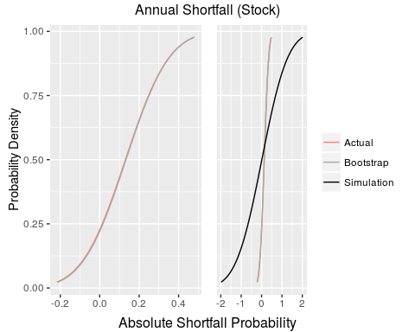

kable(stock_annually_answer$detail, digits = 6, caption = "Annually")

Annually

|  |  |  |  |  |
| --- | --- | --- | --- | --- |
|  | pValue | Actual | Bootstrap | Simulation |
| 1 | 0.0227 | -0.218 | -0.213 | -1.99 |
| 2 | 0.0250 | -0.211 | -0.206 | -1.95 |
| 3 | 0.0274 | -0.204 | -0.199 | -1.91 |
| 99 | 0.9726 | 0.465 | 0.466 | 1.94 |
| 100 | 0.9750 | 0.472 | 0.473 | 1.98 |
| 101 | 0.9772 | 0.479 | 0.480 | 2.02 |

# Bonds  
  
bond_daily_answer <- makeAbsShortfall(daily$BOND_rtrn, title = "Daily Shortfall (Bonds)")

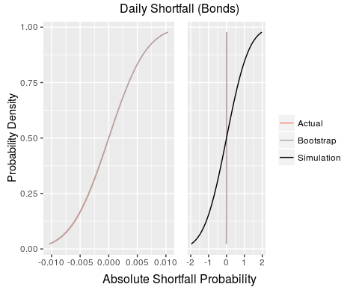

kable(bond_daily_answer$detail, digits = 6, caption = "Daily")

Daily

|  |  |  |  |  |
| --- | --- | --- | --- | --- |
|  | pValue | Actual | Bootstrap | Simulation |
| 1 | 0.0227 | -0.01030 | -0.01043 | -1.97 |
| 2 | 0.0250 | -0.01009 | -0.01022 | -1.93 |
| 3 | 0.0274 | -0.00988 | -0.01002 | -1.89 |
| 99 | 0.9726 | 0.00993 | 0.00996 | 1.89 |
| 100 | 0.9750 | 0.01013 | 0.01017 | 1.93 |
| 101 | 0.9772 | 0.01034 | 0.01038 | 1.97 |

bond_monthly_answer <- makeAbsShortfall(monthly$BOND_rtrn, title = "Monthly Shortfall (Bonds)")

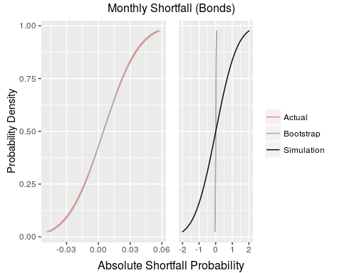

kable(bond_monthly_answer$detail, digits = 6, caption = "Monthly")

Monthly

|  |  |  |  |  |
| --- | --- | --- | --- | --- |
|  | pValue | Actual | Bootstrap | Simulation |
| 1 | 0.0227 | -0.0487 | -0.0469 | -2.02 |
| 2 | 0.0250 | -0.0476 | -0.0459 | -1.97 |
| 3 | 0.0274 | -0.0466 | -0.0449 | -1.93 |
| 99 | 0.9726 | 0.0562 | 0.0545 | 1.95 |
| 100 | 0.9750 | 0.0573 | 0.0555 | 1.99 |
| 101 | 0.9772 | 0.0583 | 0.0566 | 2.03 |

bond_annually_answer <- makeAbsShortfall(annually$BOND_rtrn, title = "Annual Shortfall (Bonds)")

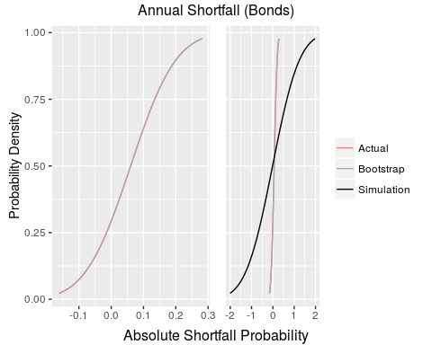

kable(stock_annually_answer$detail, digits = 6, caption = "Annually")

Annually

|  |  |  |  |  |
| --- | --- | --- | --- | --- |
|  | pValue | Actual | Bootstrap | Simulation |
| 1 | 0.0227 | -0.218 | -0.213 | -1.99 |
| 2 | 0.0250 | -0.211 | -0.206 | -1.95 |
| 3 | 0.0274 | -0.204 | -0.199 | -1.91 |
| 99 | 0.9726 | 0.465 | 0.466 | 1.94 |
| 100 | 0.9750 | 0.472 | 0.473 | 1.98 |
| 101 | 0.9772 | 0.479 | 0.480 | 2.02 |

# Question 3  
probReturn <- function(R, K = 1.20, T = 5){ # remeber to add 1 to K because of cum return  
 R <- matrix(R)  
 r <- log(1 + R) # turn return series into cum return  
 mu <- mean(r)  
 sigma2 <- var(r)  
  
 # Prob Vt < K  
 1 - pnorm(log(K), mean = mu * T, sd = sqrt(sigma2) * sqrt(T))  
  
 # formulaic approach; Prob(z < ln(K) - Tu / sqrt(T) *(sigma))  
 Z <- (log(K) - T * mu) / (sqrt(T) * sqrt(sigma2))  
 out <- as.numeric(1 - pnorm(Z))  
 return(out)  
}  
  
makeTable <- function(parent_function){  
  
 out <- cbind.data.frame(  
 stocks = rbind(  
 eval(parent_function(R = annually$SP500_rtrn)),  
 eval(parent_function(R = monthly$SP500_rtrn)),  
 eval(parent_function(R = daily$SP500_rtrn))  
 ),  
  
 bonds = rbind(  
 eval(parent_function(R = annually$BOND_rtrn)),  
 eval(parent_function(R = monthly$BOND_rtrn)),  
 eval(parent_function(R = daily$BOND_rtrn))),  
 row.names = c("Annually", "Monthly", "Daily")  
 )  
  
 out <- kable(out, digits = 6)  
 return(out)  
}  
  
makeTable(probReturn)

|  |  |  |
| --- | --- | --- |
|  | stocks | bonds |
| Annually | 0.8405 | 0.64526 |
| Monthly | 0.0738 | 0.00344 |
| Daily | 0.0000 | 0.00000 |

# Question 4  
simKnownDist <- function(R, K = 1.20, T = 5, sim_obs = 10000){  
  
 R_sims <- replicate(sim_obs, rnorm(T, mean = mean(R), sd = sd(R))) # sim_obs (n) draws from standard normal(given known params) for T periods  
   
 Vt <- apply(R_sims, 2, function(x) prod(x + 1)) # prod return series; each simulation addes 1 (because of cum) then is n1 X n2 x n3 x nn  
 Vt_log <- apply(R_sims, 2, function(x) exp(sum(log(x + 1)))) # from log'ed return series; now logged so it is the sum  
 stopifnot(all.equal(Vt, Vt_log))  
  
 prob_Vt_greater_than_K <- length(which(Vt_log > K)) / sim_obs # objective; since question asks for log_normal  
 return(prob_Vt_greater_than_K)  
}  
  
makeTable(simKnownDist)

|  |  |  |
| --- | --- | --- |
|  | stocks | bonds |
| Annually | 0.8549 | 0.6380 |
| Monthly | 0.0684 | 0.0036 |
| Daily | 0.0000 | 0.0000 |

# Question 5  
simBootstrap <- function(R, K = 1.20, T = 5, sim_obs = 10000){  
  
 R_sims <- replicate(sim_obs, sample(R, T), simplify = FALSE) # sim_obs (n) draws from data(bootstrap, given that returns are i.i.d) for T periods  
   
 Vt <- lapply(R_sims, function(x) prod(x + 1)) # prod return series; each simulation addes 1 (because of cum) then is n1 X n2 x n3 x nn  
 Vt_log <- lapply(R_sims, function(x) exp(sum(log(x + 1)))) # from log'ed return series; now logged so it is the sum  
 stopifnot(all.equal(Vt, Vt_log))  
  
 prob_Vt_greater_than_K <- length(which(Vt_log > K)) / sim_obs # objective; since question asks for log_normal  
 return(prob_Vt_greater_than_K)  
}  
  
makeTable(simBootstrap)

|  |  |  |
| --- | --- | --- |
|  | stocks | bonds |
| Annually | 0.8478 | 0.6367 |
| Monthly | 0.0629 | 0.0062 |
| Daily | 0.0000 | 0.0000 |

# Question 6  
stock.VS.bonds.Analytical <- function(Ra, Rb, T = 30, sim_obs = 10000){  
  
 Ra <- matrix(Ra)  
 ra <- log(1 + Ra) # turn return series into cum return  
 mu_a <- mean(ra)  
 sigma2_a <- var(ra)  
  
 Rb <- matrix(Rb)  
 rb <- log(1 + Rb)  
 mu_b <- mean(rb)  
 sigma2_b <- var(rb)  
  
 rho <- cor(Ra, Rb) # rho; not used  
 E_delta <- T * (mu_a - mu_b)  
 sigma2_delta <- T * (sigma2_a - sigma2_b)  
  
 # Prob(z < Z)  
 Z <- -E_delta / sqrt(sigma2_delta)  
 out <- pnorm(Z)  
 return(out)  
}  
  
makeTable2 <- function(parent_function, ...){  
   
 out <- rbind.data.frame(  
 eval(parent_function(  
 Ra = daily$SP500_rtrn,   
 Rb = daily$BOND_rtrn,  
 ... = ...  
 )),  
 eval(parent_function(  
 Ra = monthly$SP500_rtrn,   
 Rb = monthly$BOND_rtrn,  
 ... = ...  
 )),  
 eval(parent_function(  
 Ra = annually$SP500_rtrn,   
 Rb = annually$BOND_rtrn,   
 ... = ...  
 ))  
 )  
 colnames(out) <- paste("T = ", ..., sep = "")  
 rownames(out) <- c("Daily", "Monthly", "Annually")  
 out <- kable(out, digits = 6)  
 return(out)  
}  
  
makeTable2(stock.VS.bonds.Analytical, T = 5)

|  |  |
| --- | --- |
|  | T = 5 |
| Daily | 0.465 |
| Monthly | 0.374 |
| Annually | 0.165 |

makeTable2(stock.VS.bonds.Analytical, T = 30)

|  |  |
| --- | --- |
|  | T = 30 |
| Daily | 0.41387 |
| Monthly | 0.21615 |
| Annually | 0.00855 |

makeTable2(stock.VS.bonds.Analytical, T = 100)

|  |  |
| --- | --- |
|  | T = 100 |
| Daily | 0.345576 |
| Monthly | 0.075834 |
| Annually | 0.000007 |

# Question 7  
stock.VS.bonds.Bootstrap <- function(Ra, Rb, T = 30, sim_obs = 10000){  
  
 sample_indices <- replicate(sim_obs, sample(index(Ra), T), simplify = FALSE) # sim_obs (n) draws from data(bootstrap, given that returns are i.i.d) for T periods  
   
 sim_samples <- lapply(sample_indices, function(x) cbind(Ra[x], Rb[x])) # get the difference in returns across sim_obs (n) observations  
 sim_cumreturns <- lapply(sim_samples, function(x) c(prod(x$SP500_rtrn + 1), prod(x$BOND_rtrn + 1))) # now get the cum return across all universies  
  
 prob_Vs_greater_than_Vb <- length(which(unlist(lapply(sim_cumreturns, function(x) x[1] < x[2])))) / sim_obs #   
 return(prob_Vs_greater_than_Vb)  
}  
  
out <- cbind(  
 stock.VS.bonds.Bootstrap(Ra = daily$SP500_rtrn, Rb = daily$BOND_rtrn),  
 stock.VS.bonds.Bootstrap(Ra = monthly$SP500_rtrn, Rb = monthly$BOND_rtrn),  
 stock.VS.bonds.Bootstrap(Ra = annually$SP500_rtrn, Rb = annually$BOND_rtrn))  
  
rownames(out) <- "T = 30"  
kable(t(rbind(c("Daily", "Monthly", "Annually"), out)), digits = 6)

|  |  |
| --- | --- |
|  | T = 30 |
| Daily | 0.4246 |
| Monthly | 0.2779 |
| Annually | 0.0184 |

# Part C  
# Question 1   
mu <- 0.10  
sigma2 <- 0.2  
T <- 50 - 35  
  
car <- 1e5  
target <- 1e6  
savings <- 5e5 - car  
  
Z <- (log(target / savings) - T * mu) / (sqrt(T) * sqrt(sigma2))  
pnorm(Z) # probability of less than target amount: we cannot afford any of the cars

## [1] 0.368

# Question 2  
b_mu <- 0.003  
b_sigma2 <- 0.015  
b_sigma2 <- 0.3  
  
# Part A  
T <- 10 * 12 # in months  
rf_mu <- 0.003  
rf_sigma2 <- 0 # risk free  
  
Z <- sqrt(T) * (rf_mu - b_mu) / sqrt(b_sigma2)  
1 - pnorm(Z)

## [1] 0.5

# Part B  
# Generally, as the length of the time horizon grows(T),   
# the probability that the risk free asset will outperform the risky asset decreases; that is, the probability goes to zero.  
# However, here rf_mu = b_mu, thus the result is indepedent of the time horizon.  
# Again, as for volatility, rf_mu = b_mu, and is equal to 0, so the numeritor becomes 0, making the result indepedent of variance  
  
# Question 3  
# TO DO  
  
# Question 4  
# TO DO  
  
# Question 5  
# Part A  
# No I do not agree with Bill Gross. Assuming returns are i.i.d. (But not necessarily normal). By pure statistical chance alone, we would expect  
# to observe a "long-run" average of high returns from stocks. That is, we could be observing returns on the right side of the   
# distribution without calling into question any of our underlying assumptions. What would be flawed however, would be to state, that now the market must   
# overcorrect and start 'drawing' returns from the left side of the mean of the distribution. This is statistically unsound. Certainly we may   
# begin to observe more negative returns from stocks; but as our homework discussed this noise will be washed out in the long run as we converge to a   
# probability of one.   
  
# Part B  
# While "pure intellictual fraud" is a bit too harsh, I do argee with Nassim that the heuristic is misleading. It certainly mispresentes overall risk.  
# I believe that managers should use it as one metric, or one tool in their tool box to get a snapshot of their risk exposure. Releing soley on the metric  
# is folly; and one, instead, should use a dashboard of risk assessment tools.