Portfolio Managment: Homework 10

Gal Skarishevsky, Nathan Matare, Brian Thompson, Lior Sahaf

June 1, 2017

# B. Data Analysis

In order to conduct the analysis we write three functions: '', '', '', . computeOptionPrice outputs the standard Black-Scholes option price of a security given input parameters; runStrategy runs the strategy proposed in the question set; and getSharpeRatio computes the Sharpe Ratio of a set of strategies:

*Note there is a small bug somewhere in the code where the calculations do not match up exactly with the Professor's provided code.

computeOptionPrice <- function(S, K, T, rf, sigma){  
 # Implementation of theBlack-Scholes Option Value  
 # S is the price of the stock  
 # K is the strike price  
 # rf is the risk free rate  
 # T is the time  
 # sigma is the implied s&p volatility  
 d1 <- (log(S/K)+(rf+sigma^2/2)*T)/(sigma*sqrt(T))  
 d2 <- d1 - sigma * sqrt(T)  
  
 call <- S*pnorm(d1) - K*exp(-rf*T)*pnorm(d2)  
 put <- call + K*exp(-T*rf) - S   
 # put <- K*exp(-rf*T) * pnorm(-d2) - S*pnorm(-d1)   
 # alternative way of doing same calc  
  
 return(list(bs_call = call, bs_put = put))  
}  
  
runStrategy <- function(ledger = data, startdate, moneyness, beg_capital,   
 target_return, sp_volatility, tbill_return, ...){  
  
 # cut ledger based upon startdate  
 start_date <- as.Date(as.character(startdate), format = "%Y%m%d")  
 ledger <- ledger[which(index(ledger) == start_date):NROW(ledger)]  
  
 ledger$bs_put <- NA  
 ledger$capital <- NA  
 ledger$N <- NA  
 ledger$returns <- NA  
 ledger$compensation <- NA  
 ledger$index_return <- NA  
  
 monthly_eps <- endpoints(ledger, on = "months")[-1]  
 daily_eps <- endpoints(ledger, on = "days")[-1]  
  
 # init portfolio  
 stock_price = first(ledger)$spindx  
 strike_price = first(ledger)$spindx * moneyness  
 first_put <- computeOptionPrice(  
 S = stock_price,  
 K = strike_price,  
 T = 60,  
 rf = tbill_return,   
 sigma = sp_volatility  
 )$bs_put  
 # number of puts needed for target return  
 num_puts = target_return * beg_capital / as.numeric(first_put)   
 new_capital = beg_capital * (1 + target_return); # targeted return  
  
 # record first events  
 coredata(ledger)[1, 'capital'] <- new_capital  
 coredata(ledger)[1, 'bs_put'] <- first_put  
 coredata(ledger)[1, 'N'] <- num_puts  
  
 # start loop  
 k <- 1; while(new_capital > 0){  
  
 ep <- daily_eps[1 + k] # daily endpoint  
 if(is.na(ep)) break  
  
 period_before <- last(index(ledger[1:ep]), 2)[1]  
 period_date <- last(index(ledger[1:ep]), 2)[2]  
  
 old_capital <- as.numeric(ledger[period_before]$capital) # starting capital  
 new_capital = old_capital * (1 + tbill_return) # appreciated interest  
  
 if(period_date %in% index(ledger[monthly_eps])){ # do at end of each month  
  
 # print(paste("Exercising options at the end of month:", period_date))  
  
 # write off old options  
 stock_price = ledger[period_date]$spindx # get current price level  
 bs_put <- computeOptionPrice(  
 S = as.numeric(stock_price),  
 K = as.numeric(strike_price), # comes from init strike price or 30 days ago strike price  
 T = 30,  
 rf = tbill_return,   
 sigma = sp_volatility  
 )$bs_put  
  
 bs_cost <- bs_put * num_puts # number of puts wrote in last period  
 new_capital = new_capital - bs_cost # update capital after puts are written off  
  
 # write new options  
 strike_price = ledger[period_date]$spindx * moneyness # get current strike price  
 bs_put <- computeOptionPrice(  
 S = as.numeric(stock_price),  
 K = as.numeric(strike_price),   
 T = 60,  
 rf = tbill_return,   
 sigma = sp_volatility  
 )$bs_put  
   
 # number of puts needed for target return  
 num_puts = target_return * as.numeric(new_capital) / as.numeric(bs_put)   
 new_capital = new_capital * (1 + target_return);  
  
 # record option price and number  
 coredata(ledger)[index(ledger) == period_date][3] <- bs_put  
 coredata(ledger)[index(ledger) == period_date][5] <- num_puts  
  
 # compute compensation and metrics  
 rtrn = (new_capital - old_capital) / old_capital  
 coredata(ledger)[index(ledger) == period_date][6] <- rtrn  
  
 # compute compensation  
 compensation = (0.02 / 12 + 0.20 * max(rtrn - 21 * tbill_return, 0)) * old_capital  
 new_capital = new_capital - compensation  
  
 # compute monthly s&p returns  
 if(!exists("last_month")) last_month <- NA # init first month  
 current_return <- as.numeric(ledger[period_date]$spindx)  
 last_return <- as.numeric(ledger[last_month]$spindx)  
 index_return = (current_return - last_return) / last_return  
 if(length(index_return) == 0) index_return <- 0  
 coredata(ledger)[index(ledger) == period_date][8] <- index_return  
  
 # record capital and others  
 last_month <- period_date  
 coredata(ledger)[index(ledger) == period_date][7] <- compensation  
 }  
  
 coredata(ledger)[index(ledger) == period_date][4] <- new_capital  
 k <- k + 1  
 }  
  
 # print("Ran out of money!")  
 end_ledger <- ledger[1:which(index(ledger) == period_date)]  
 return(end_ledger)  
}  
  
getSharpeRatio <- function(ledger, tbill_return, ...){  
 SR_strategy <- mean(ledger$returns[-1] - 21 * tbill_return) / sd(ledger$returns[-1] )  
 SR_index <- mean(ledger$index_return[-1] - 21 * tbill_return) / sd(ledger$index_return[-1] )  
 output <- data.frame(Strategy = SR_strategy, Index = SR_index)  
 return(output)  
}

# B.1. Suppose you started your hedge fund on March 1, 1994.

## a)

We run the proposed strategy:

Last Date

|  |  |
| --- | --- |
|  | 1998-08-31 |
| spindx | 957.280000 |
| sprtrn | -0.068014 |
| bs_put | 0.089371 |
| capital | -103.249550 |
| N | -44.239114 |
| returns | -1.377628 |
| compensation | 0.453691 |
| index_return | -0.145797 |

Riteput goes out of business on 1998-08-31

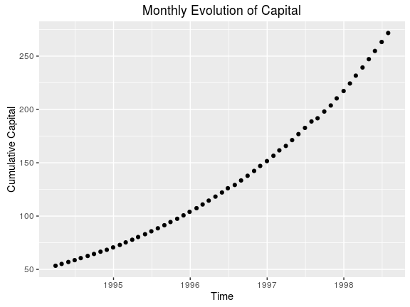

## b)

Riteput has all positive returns in this evaluation period (100%)

Sharpe Ratios

|  |  |
| --- | --- |
| Strategy | Index |
| 10.12844 | 0.509873 |

## c)

The Sharpe Ratio appears really good. But it's spurious, see below.

## d)

The Sharpe Ratio is based upon two metrics: backward looking returns and variance. Because our strategy essentially sells insurance against the market falling by more than 20%, naturally we reap steady returns with little deviation over the 'good' periods, periods when the market isn’t very volatile. However, when the market suffers a left tail event, a period when the market drops by more than 20%, we are forced to pay out our 'insurance' premiums.

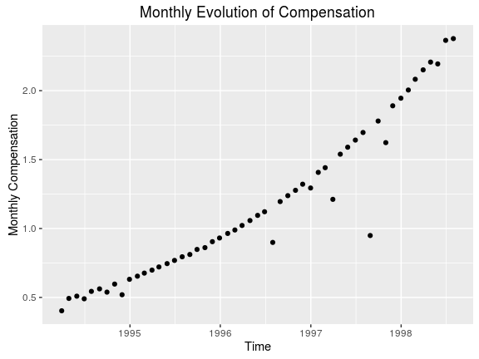

Total Compensation

|  |
| --- |
| compensation |
| 62.27834 |

## e)

Although RitePut reaps a significant compensation, RitePut is essentially gambling with investor's money. There is little skill involved in this strategy. RitePut is selling insurance against an unlikely, however inevitable, event. At some point RitePut will be wiped out by the huge loss.

## f)

Because the market became less volatile and reached a local price level minimum of 445. That is, the prior monthly returns experienced much more variance, and a 20% market drop was more likely in such a time period. Further, February’s price level was 467, and January’s was 481, both higher. You correctly found the local minimum were the market wouldn’t decrease more than 20%

# B.2. Answer all numerical questions in part 1 (without plots) when options are 15% and 10% out of the money (instead of 20%).

(Below) We set adjust the moneyness: (moneyness = 0.85). Riteput goes out of business on 1998-10-31, two months later than before. Better. However, the Sharpe Ratio is much worse. This is because we're now incorporating the negative returns and large standard deviations into the calculation. However, our compensation is much higher as we're able to persist longer given that we pay out at smaller left tail events (15% drop as opposed to 20% drop)

Last Date

|  |  |
| --- | --- |
|  | 2008-10-31 |
| spindx | 968.750000 |
| sprtrn | 0.015365 |
| bs_put | 0.734659 |
| capital | -102.402073 |
| N | -5.344513 |
| returns | -1.538714 |
| compensation | 0.315833 |
| index_return | -0.169425 |

Sharpe Ratios

|  |  |
| --- | --- |
| Strategy | Index |
| 0.247355 | 0.104428 |

Total Compensation

|  |
| --- |
| compensation |
| 130.3483 |

(Below) We set the moneyness to 90%: (moneyness = 0.90). In this case, Riteput doesn't go out of business. However, the Sharpe Ratio is much worse. This is because we're now incorporating the negative returns and large standard deviations into the calculation. However, our compensation is much higher as we're able to persist much longer than either a 20% or 15% moneyness. Now we pay out smaller premiums when the market drops below 10%, and given the amount of capital we have accumulated, we're able to cover our losses while continuing to charge a premium for our supposed 'skilled' service.

Last Date

|  |  |
| --- | --- |
|  | 2016-12-30 |
| spindx | 2238.830000 |
| sprtrn | -0.004637 |
| bs_put | 8.452996 |
| capital | 485.353366 |
| N | 2.226444 |
| returns | 0.035782 |
| compensation | 3.969781 |
| index_return | 0.018201 |

Sharpe Ratios

|  |  |
| --- | --- |
| Strategy | Index |
| 0.218066 | 0.110557 |

Total Compensation

|  |
| --- |
| compensation |
| 336.3052 |

# B.3. Suppose you can start your hedge fund on the 1st trading day of any month

## a) in the early 1980s, between January 1980 and December 1985

We run the proposed strategy:

Last Date

|  |  |
| --- | --- |
|  | 1987-10-30 |
| spindx | 251.790000 |
| sprtrn | 0.028680 |
| bs_put | 0.023507 |
| capital | -4201.625906 |
| N | -6873.572361 |
| returns | -11.937282 |
| compensation | 0.640163 |
| index_return | -0.217630 |

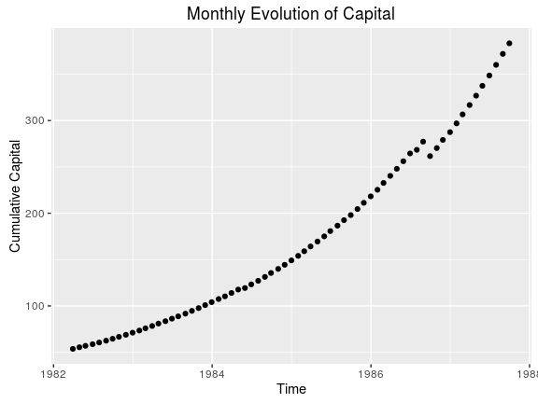

Sharpe Ratios

|  |  |
| --- | --- |
| Strategy | Index |
| 2.817917 | 0.351354 |

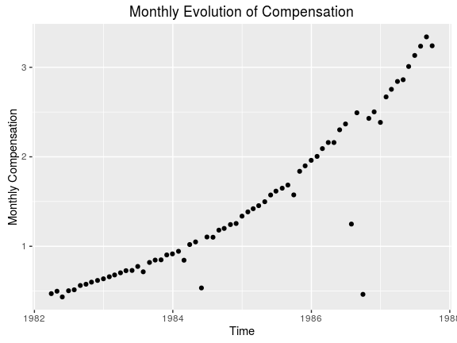

Total Compensation

|  |
| --- |
| compensation |
| 98.78964 |

Here, we notice that the first negative dip in capital doesn't come until late 1986. During this time period, we would want to start as early as possible. The fund collapsed toward late 1988 because of a large >20% drop in the market. RitePut, essentially, had to pay out huge premiums.

## b) in the 1990s, between January 1990 and December 1999

We run the proposed strategy:

Last Date

|  |  |
| --- | --- |
|  | 1998-08-31 |
| spindx | 957.280000 |
| sprtrn | -0.068014 |
| bs_put | 0.089371 |
| capital | -409.536024 |
| N | -175.473023 |
| returns | -1.377628 |
| compensation | 1.799549 |
| index_return | -0.145797 |

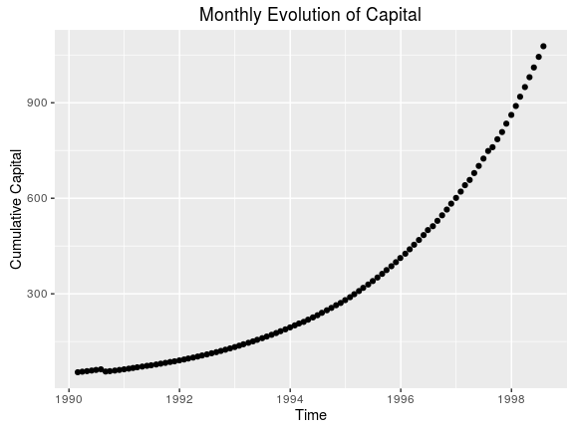

Sharpe Ratios

|  |  |
| --- | --- |
| Strategy | Index |
| 2.296534 | 0.30665 |

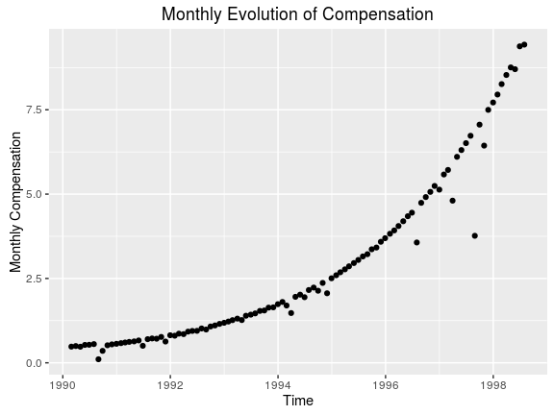

Total Compensation

|  |
| --- |
| compensation |
| 292.8264 |

During this period, we have a fairly optimal time to run the strategy. There is a small negative dip in capital in mid to late 1990 that affects the Sharpe Ratio and compensation. To optimize the performance metrics of this strategy, RitePut should start the fund in early 1991. The fund appears to have been wiped out by the tech-bubble burst. That is, the fund collapsed in late 1998 early 1999 because of a large >20% market drop. RitePut, essentially, had to pay out huge premiums.

## c) in the 2000s, between January 2000 and December 2016

We run the proposed strategy:

Last Date

|  |  |
| --- | --- |
|  | 2008-10-31 |
| spindx | 968.750000 |
| sprtrn | 0.015365 |
| bs_put | 0.090442 |
| capital | -889.070239 |
| N | -377.800520 |
| returns | -3.182083 |
| compensation | 0.678550 |
| index_return | -0.169425 |

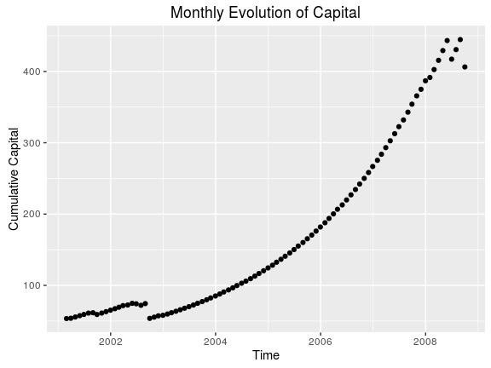

Sharpe Ratios

|  |  |
| --- | --- |
| Strategy | Index |
| 0.710748 | -0.0519 |

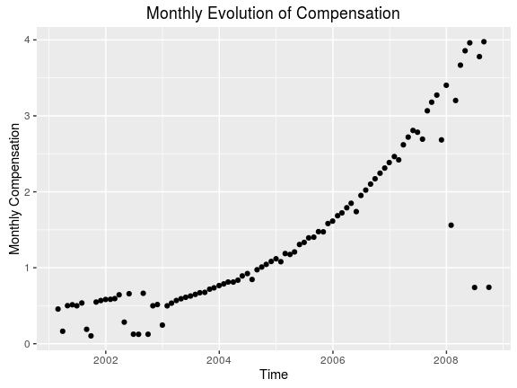

Total Compensation

|  |
| --- |
| compensation |
| 128.3203 |

This fund barely survived its early periods where it experienced several large payouts due to negative market price movement. Thus, it would have been optimal to start this strategy in early 2003 right after the turbulence of the early 2000s. The fund then appeared to suffer several large payouts towards the end of its tenure before going negative; it was able to cover some of them, but ultimetly went under. Notably, the compensation does well while the performance of fund (Sharpe Ratio) is relatively poor (due to the negative payouts, and increased variance).

# B.4. What techniques can investors use to detect Riteput’s strategy?

First, if one observes abnormally high Sharpe Ratios, that's the first indication. However, as we saw, this can be misleading. Thus a more robust technique an investor could use is to monitor the funds performance. That is, if one observes steady payouts without much variance one should be suspicious that said fund is simply offering insurance against extreme market events.

# B.5. Riteput is to Powerball as the duration of human pregnancy is to ...?

The time it takes to fly to NYC from ORD. Human pregnancy lasts about 10 months, while the time it takes to fly to New York from Chicago is two hours. In this case, we are comparing the likelihood of an extreme event(flight time)happening relative to a longterm norm (pregancy). Given that a 20% drop in the market is an extreme tail event (more than 2SD), it's more appropriate to compare 10 months to 2 hours. One hour, in our opinion, would be even more extreme—or a 3SD event, perhaps a strategy that exploited 30% moneyness puts.

# B.6. What if anything have you learnt from this exercise?

Be very careful about funds that promise steady returns, it's likely to be too good to be true. The fund, more likely, is just offering an insurance product to the broader market. If you time your entrance and exit into the fund well, it might pay off... but beware because you could stand to loose all your capital! And the incentive structure, read compensation, for the fund is not aligned in your best interest. That is, the fund gets to gamble with your money and make a killing while you bear all the risk—you could loose all your capital, while the fund walks away with a significant buck.