Tip-tilt Documentation

A brief guide.

If you need immediate help, contact Nolan at:

Tel: +33 06 61 36 96 26.

Email: [nolankmatthews@gmail.com](mailto:nolankmatthews@gmail.com)

**Loading the tip-tilt software**

In principle, the tip-tilt should be up and connected on the machines. If not, there are slightly different procedures for starting it.

**Cabling**: For both telescopes, ensure that the module camera, and tip-tilt are connected via USB to the tip-tilt computer, and that the tip-tilt power cable is connected. For David’s telescope, the ST4 cable also needs to be connected.

For MeO:

1.) Start an Anaconda Powershell as administrator (you can find it in the Windows taskbar) and when the prompt appears, enter in the command:

conda activate tiptilt_env

You should see that the text on the left of the prompt changed from (base) to (tiptilt_env)

2.) Run the tip-tilt python code by entering the following into the prompt:

spyder

3.) Run the AO tiptilt code by selecting the AOcontrol_v9.py file, and clicking the green arrow.

For David’s telescope:

1.) Load the Anaconda Navigator. It takes some time to load.

2.) Where it says “Applications on” select the Python_3-6-13_environment. It should look like this:

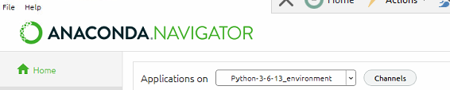

3.) Then in the panel with Spyder click “Launch”. This will take a few moments.

4.) Run the AO tip-tilt code by selecting the AOcontrol_v8.py file, and clicking the green arrow. If it is not open on the The interface may not immediately appear, and you need to click this icon 

**Running the tip-tilt software**

The main purpose of the tip-tilt is to correct for drifts in the telescope pointing, and also provide some minor improvement in the fiber injection at higher frequencies. Here is the general procedure I follow during observations.

When the tip-tilt loads you will be presented with the following interface:

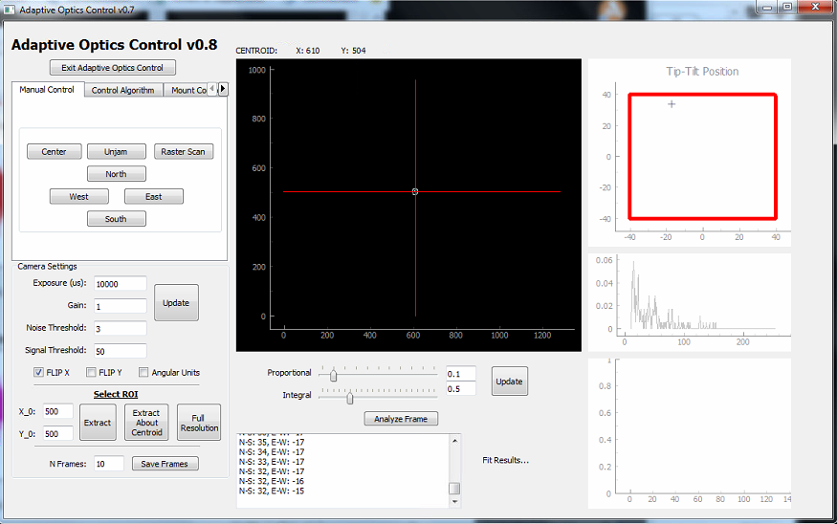

**Initialization:**

Ensure that the following parameters are set:

1.) “Flip X” is checked (this inverts the x-axis of the camera image).

2.) Set the noise threshold to 3. The noise threshold sets any camera pixels with a recorded value of less than this value to zero. This is required to suppress spurious counts for centroiding.

3.) Set the signal threshold to 20. The signal threshold sets the minimum value the camera must record to allow the control algorithm to run. The idea is that if no star is found, no commands should be sent.

4.) For most stars the exposure ranges from 1000 to 50000 us. My suggestion is to adjust it such that the dynamic range of the camera is well utilized. The middle plot on the right shows a histogram of the camera ADC values (ranging from 10 🡪 256, low values are chopped intentionally). If the exposure is too low (or there is no star), then you will see nothing, and if it is too high, you will see a sharp uptick at the 256 value, indicating that many pixels are saturated.

5.) Click ‘’Update’’.

6.) **For T1M:** In the ‘Mount Control’ tab, ensure that the value of ‘CMD Duration’ is set to 5:

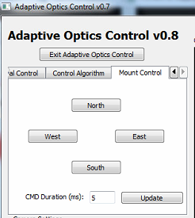

This sets the duration of the command sent to bump the telescope mount (longer means it slews the telescope more). It can be modified during observations, but I find that for T1M ‘5’ is a good value.

**Positioning the star image**

After the telescope has slewed to the star, it is useful to first move it to the location which roughly corresponds to the fiber tip. To mark it on the screen enter the following respective coordinates next to the “Update Optimal Position” position button in the “Control Algorithm” tab.

It should look like the following (this is for T1M):

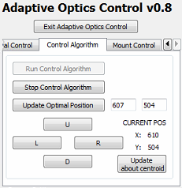

Once done, click “Update Optimal Position” and there will be a red cross marked for that point. Note that this also updates the setpoint for the control algorithm to this position.

If the star is in the field of view (FOV), then there should be a white circle that traces its centroid. If the white circle is displaced from the star (assuming it is clearly visible), it is possible that the noise threshold is too low, or that the exposure should be higher.

For MeO, it is easiest to let the observer use the manual control of the telescope (with their mouse) to guide the star to the red cross position. The commands sent by the tip-tilt code to MeO are in steps of 0.3”, and are limited to no more than once every 5 seconds so it moves very slowly.

For T1M, it is easiest to let the tip-tilt control algorithm do the job (but moving the telescope manually also works).

**Running the control algorithm:**

1.) To start the control algorithm after a setpoint has been chosen, simply click “Run control algorithm”. If it is working properly, the centroid (indicated by the white circle) should move towards the red cross.

🡪 If it fails, review the initialization steps above.

2.) Once running, the setpoint can be adjusted either by reentering the coordinates, or simply by clicking U,D,L,R in the “Control Algorithm” panel which adjusts it one pixel at a time (note 1 pixel = 3.75 um). When finding the optimal setpoint (maximal injection), this is very useful.

**Zooming into a subregion:**

It is useful to extract a subregion of the image when examining the star image for characterizing the turbulence, telescope focus, and for verifying the orientation of a binary.

**Please note:** Unfortunately, I have not yet incorporated the capability to zoom into a subregion while the control algorithm is running **and note doing so will cause undesired results!** The control algorithm can be run when zoomed in, but the setpoint is lost each time it is changed between full resolution / zoomed image. In general, I would recommend running the control algorithm in the full resolution mode and writing down the optimal setpoint when it is found in case you would like to zoom in, or the code crashes/needs to be restarted.

To zoom into a subregion you can either select it by its coordinate (generally not useful in observations, so I will not describe it), or simply click “Extract about Centroid”

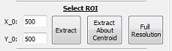

This will extract a 96 x 96 pixel region about the current centroid. Note that you may also need to click “Update about centroid” in order to redraw the red cross so that the display is shown correctly.

While observing a star in ‘zoomed’ mode, you will see something like the following:

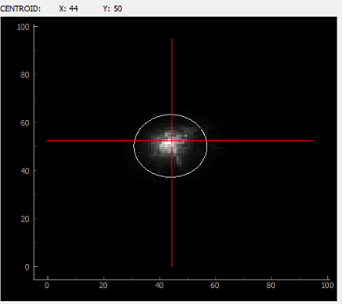

The white circle is centered about the centroid, and has the approximately the same diameter as the fiber core (100 um). Ideally, the star is well contained within the circle but in the case of bad seeing (> 1.5”), or a poor focus the wings will extend beyond the circle. Again, make sure the dynamic range of the camera is set properly so that you are not clipping low intensities / saturating high ones.

**Saving Frames:**

Tosaveframes, simply select the number of sequential frames you would like to save and click “Save Frames”:



This will automatically create and store the camera images in the same directory the code is located with a path “./YYYY_MM_DD/X/” on the date YYYY_MM_DD and where X represents the Nth time a series of frames were saved.

**NOTE:** It is a good idea to save frames when the relative orientation of the modules on each telescopes are checked.

**Restarting the tip-tilt software:**

In the case the tip-tilt software needs to be restarted (crashed, cable connection,…) follow this procedure:

1.) Kill the interface frame, it will likely become unresponsive if it crashed.

2.) Kill/restart the current kernel by clicking “X” in the Ipython window tab of Spyder. It is in the red circle here:

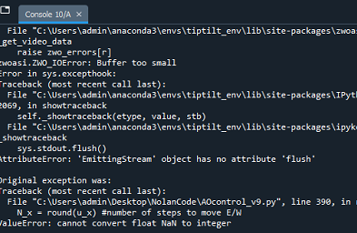

3.) Restart by clicking the green arrow in the Spyder IDE, making sure that ‘’AOcontrol_vX.py’’ is selected (it should be already).

**Troubleshooting:**

**Failure of the control algorithm/complete loss of counts:**

* Check the initialization steps, and ensure the parameters are set reasonably
* It is possible that the star moved outside the field of view of the telescope, or the current camera frame. In this case, it needs to be manually moved back into the frame. Note that if you are running in the “zoomed” mode during the control algorithm, the chances of the latter happening are much higher (especially on T1M in the case of wind).

**Fluctuations in the count rates:**

* For T1M, even slight wind can create difficulties in tracking. We noticed that at values above ~3-4 km/s (as seen in the CATS-GDIMM monitor) it becomes evident. If this occurs, it may be helpful to increase the integral value in the PI control up to 1.5 to 1.9, but it will not cancel out everything. Additionally, adjusting the CMD duration may have some effect here too, but I would recommend a range between 3 to 8 ms.
* For MeO, this is likely due to turbulence which can be verified by a large star image that extends far beyond the white circle.
* For MeO: if the control algorithm is freezing up, check the Ipython window of Spyder for this error message.



In this case, the TCP server will need to be restarted (done by clicking the button next to ”Serveur Viewer” at the bottom left of the MeO tracking software, and probably to be done by a MeO observer).

**Camera image not zooming properly:**

* Ensure that the control algorithm is turned off when zooming in/out on the camera
* If you clicked “Extract about Centroid” and it displays in a weird manner, you need to click “Update About Centroid”

**Error message “Limit switch reached, consider realigning with mount!” keeps popping up in the text log:**

* This indicates that the tip-tilt has gone beyond it’s working range. In principle, if the code keeps running and this error stops being reported, it’s OK to leave it as is. However, if it the tip-tilt fails to continue to track the object, you should stop the control algorithm, click “Unjam” in the Manual Control tab, give it 10 seconds, and then go back to running the control algorithm.