Title

# 

# Abstract

Carnivorous plants are a unique group of plants that have evolved to capture and digest prey to supplement their nutrient intake. Although they have been the subject of fascination and study for almost 140 years after Darwin’s book *Insectivorous Plants*, the origin of carnivorous *Utricularia* plant traps has not been discussed in detail. The genus *Utricularia*, or bladderworts, is the most diverse genus of carnivorous plants and draws attention because of their suction mechanism and tiny size of the bladder-like traps. The traps suck in prey in less than a millisecond, making this one of the fastest movements in the plant kingdom. In this research, we build a phylogenetic model for the evolution of carnivorous plant traps to test the “pitcher hypothesis” for the origin of the *Utricularia* trap, proposing a gradual evolutionary transition from simple adhesive traps to pitcher traps, and ultimately to *Utricularia*’s unique suction traps. We assembled phylogenetic trees for carnivorous plant species to test our hypothesis with statistical model comparison: the fit of a model where *Utricularia* bladder traps are essentially miniaturised pitcher traps is compared to a null model where any trap type can evolve into any other. The results suggested that among the 18 phylogenetic models evaluated, the res7abprCTE model, aligning with the pitcher hypothesis, emerged as the best-fitting model, as evidenced by its lowest AIC value and the highest AIC weight.

# 

# Introduction

## Carnivorous Plants: The Voracious Predator

The evolutionary history of plants spans billions of years, from their origins in ancient aquatic environments to their colonisation of land and subsequent diversification into a wide array of forms (Vries & Archibald, 2018). Plant adaptation is the result of evolutionary processes that enable plants to survive and reproduce in challenging environments, with traits that may be genetically fixed, structurally modified during growth, or temporarily adjusted in response to immediate conditions, particularly to endure environmental stresses (Körner, 2016). One remarkable example is *Dionaea muscipula*,the Venus' flytrap, which has modified leaves into snap traps that close rapidly when triggered by unsuspecting prey (Darwin, 1875). The plant has adapted to nutrient-poor soils by supplementing its diet with insects and small arthropods (Gaascht et al., 2013). These specialised features and behaviour are the fundamental elements shaping plants' ecological strategies (e.g. selective investment in trap sizes), enabling them to optimise their interactions with the environment and maximise their chances of survival and reproduction (Westoby et al., 2002).

‘This plant, commonly called Venus’ flytrap, from the rapidity and force of its movement, is one of the most wonderful in the world’ (Darwin, 1875). For nearly 150 years since Darwin's *Insectivorous Plants*, carnivorous plants have “captivated” scientists and nature enthusiasts alike—not only for their remarkable ability to capture prey, but also for their extraordinary adaptations and unique ecological strategies. The remarkable ability of the Venus’ flytrap to detect and rapidly respond to the presence of insects, culminating in the swift closure of its trap for capture and digestion, exemplifies nature’s ingenuity (Forterre et al., 2005). This extraordinary ability has garnered extensive recognition and praise, particularly highlighted by Darwin, thus representing the Venus’ flytrap as an iconic carnivorous plant. Darwin’s accolades have further increased focus on various carnivorous plant traps, captivating the attention of researchers and enthusiasts alike.

## Adhesive Traps

Adhesive traps are characterised by specialised structures on the plant’s surface, typically leaves, that secrete adhesive substances (Mithöfer, 2021). These secretions may serve a dual purpose: they attract unsuspecting prey through their alluring scent, and upon contact, the adhesive substances ensnare the prey, preventing escape (Tagawa & Watanabe, 2021). This trapping mechanism is particularly effective for capturing flying or crawling insects, providing these carnivorous plants with an additional source of nutrients vital for their survival (Tagawa et al., 2018). Most *Drosera* species (commonly known as sundews), such as *Drosera schizandra* from the *Droseraceae* family deploy ground-level adhesive leaves, whereas some species like *Drosera regia*, commonly known as the King Sundew, have filiform (long and skinny) leaves. *Byblis*, another carnivorous plant genus and Some *Pinguicula* species, like *Pinguicula filifolia*, a member of the Butterwort family, employ a similar strategy, with adhesive leaf surfaces that lure and capture prey, despite its genus mostly consisting of ground-level traps. *Roridula*, like *Roridula gorgonias* features glandular hairs on its filiform leaves that secrete a sticky mucilage, but unlike the adhesive substances found in fully carnivorous plants like *Drosera*, the mucilage produced by *Roridula* does not have digestive enzymes (Voigt et al., 2009). Instead, the plant relies on a mutualistic relationship with insect predators, specifically bugs (*Pameridea reut*) that feed on the trapped insects, absorbing their nutrients (Voigt et al., 2009). The *Roridula* plant benefits indirectly from the nutrients the bugs release during their feeding process; thus, some researchers consider them as protocarnivorous plants (Voigt & Gorb, 2010). These plants suggest a shared trapping niche despite their taxonomic differences.

## Snap Traps

Native to the warm-temperate wetlands of North and South Carolina, the Venus’ Flytrap (*Dionaea muscipula*) has specialised snap trap leaves with sensitive trigger hairs, which rapidly close when an insect contacts these trigger hairs to ensnare the prey (Gaascht et al., 2013; Böhm et al., 2016). In contrast, *Drosera burmannii*, also known as Burmann's Sundew, presents a different approach to carnivory. Its trapping mechanism involves sticky glandular hairs on its leaves like other *Drosera* species; however, it goes beyond conventional stickiness. Upon capturing prey, the tentacles undergo a rapid “snap” motion resembling the rapid closure of a snap trap, with the remarkable ability to reversibly bend toward the captured prey (Poppinga et al., 2013). Both *Dionaea muscipula* and *Drosera. burmannii* are known to survive in wetlands (Juniper et al. 1989). The Waterwheel Plant (*Aldrovanda vesiculosa*) is native to nutrient-poor freshwater habitats on several continents, and its aquatic snap trap is a specialised mechanism to capture aquatic invertebrates (Westermeier et al., 2018). The plant's submerged leaves are equipped with delicate trigger hairs, and when these hairs are disturbed by unsuspecting prey, the lobes of the leaf swiftly close together, entrapping the aquatic organisms within a fraction of a second (Adamec, 2018).

## Pitcher Traps

Monotypic family, *Neoenthaceae*, commonly known as Pitcher plants possess leaves that form deep cavities, making escape difficult for prey that fall in (Lee et al., 2016). The alluring design of the pitcher trap is enhanced by a combination of factors, in which they emit enticing scents and produce nectar, serving as irresistible invitations for insects (Hotti et al., 2017). The interior of the pitcher is lined with a slippery, waxy substance that makes it difficult for insects to maintain their footing; therefore, the insects struggle to escape, and they inevitably slip and fall into the liquid-filled cavity below (Moldowan et al., 2019). The pool of water at the pitcher's base may contain digestive enzymes or rely on symbiotic relationships with bacteria to break down the captured prey (Moldowan et al., 2019). Pitfall traps, exemplified by *Sarracenia*, *Nepenthes*, and *Heliamphora* are highly effective at ensnaring insects by the downward-pointing hairs and slick walls of the pitcher prevent most escape attempts, ensuring that the trapped insects remain within the confines of the trap. Among *Nepenthes*, many species feature two forms of pitchers on the same plant, with aerial or ground specialisations, often termed upper or lower traps (Moran, 1996). The upper pitchers of *Nepenthes rafflesiana* are suspended like chalices, and the lower pitchers are at the ground-level, which suggests the dimorphic approach to diversify its prey capture tactics, catering to insects from above and below (Di Giusto et al., 2010).

## Transitional Traps

Members of the *Nepenthaceae* family are traditionally considered pitcher plants, which trap prey via a pitfall mechanism; however, there are some exceptions. *Nepenthes inermis* exhibits characteristics of both sticky and pitcher traps within a single structure (Rice, 2007). The aerial pitcher trap of *Nepenthes inermis* boasts the classic shape associated with pitfall traps, yet its inner walls are adorned with a sticky substance (Rice, 2007), suggesting the possibility of trapping strategies intermediate between two pitfall and sticky trap carnivorous mechanisms. In the category of ground traps, *Pinguicula lutea* and many other *Pinguicula* species suggest an intermediate strategy between sticky and pitcher plant traps. Many Pinguicula exhibit slow leaf motion after prey capture, usually analogized to the sticky tentacle traps seen in *Drosera*. However, in *Pinguicula*, the whole leaf often curls (Scorza & Dornelas, 2011), with some species producing leaves that are highly curled even without prey capture, suggesting a possible first step towards the evolution of a pitfall trap.

## Eel Traps

*Sarracenia psittacina* and *Sarracenia purprea*, characterised by its hooded, decumbent pitchers, employs a eel trap mechanism for capturing prey instead of the conventional fluid-filled pitcher trap. This distinctive approach involves elongated inward-pointing hairs that impede prey exit, as Lloyd (1942) and Juniper et al. (1989) observed and documented. Remarkably, they have been observed capturing aquatic prey (protozoa and water bugs) even when submerged, affirming its unequivocal amphibious nature, thriving in areas prone to flooding (Schnell, 2002). Moreover, *Darlingtonia californica* mechanisms operate similarly through an eel trap mechanism; while the adult *Darlingonia* are typically erect, the juvenile pitchers often exhibit a decumbent orientation (Lloyd, 1942; Schnell, 2002), although trapping in the juvenile stage has not been confirmed. The enigmatic semi-aquatic plant *Genlisea*, which has received relatively limited scientific attention, possesses intriguing traps that primarily develop below the surface of wet environments (Płachno et al., 2020). The traps of *Genlisea* consist of tiny tubes adorned with specialised hairs that allow entry for unsuspecting prey but prevent their escape, featuring two outward-twisting arms that emanate from the mouth of the structure (Carmesin et al., 2021). The arms of the *Genlisea* trap incorporate a channel that is also lined with hairs, forming a directional guiding surface (Carmesin et al., 2021). This elaborate arrangement is believed to be a guiding mechanism, directing small organisms (e.g. protozoans) towards the mouth and digestive region of the trap (Carmesin et al., 2021).

## Aquatic Pitcher Traps

The suction traps of *Utricularia*, commonly known as bladderworts, are renowned for their rapid trapping mechanisms (Westermeier et al., 2017). They have evolved specialised tiny bladder-like structures, functioning as intricate underwater traps (Albert et al., 2010). *Utricularia* species are predominantly aquatic or semi-aquatic, inhabiting various freshwater environments across the globe (Westermeier et al., 2017). The unique aspect of *Utricularia* traps lies in their ability to generate a suction force for prey capture. These traps comprise a bladder or vesicle connected to the external environment through a trigger mechanism, and a slender stalk called the utricle (Singh et al., 2020). The utricle contains numerous small, hair-like structures called trigger hairs, susceptible to mechanical stimulation (Singh et al., 2020). The trigger hairs require only a slight touch or displacement to initiate the trapping process (Westermeier et al., 2017). The precise details of the process vary among species, but the general mechanism involves the rapid expulsion of water from the bladder, creating a sudden decrease in internal pressure (Laakkonen et al., 2006). This pressure differential generates a powerful suction force, causing the prey to be forcefully drawn into the bladder within a fraction of a second (Laakkonen et al., 2006). The efficiency of *Utricularia* traps is further enhanced by the presence of inward-facing bristles or valves at the entrance of the bladder, which allow water and smaller particles to pass through but prevent the escape of captured prey (Singh et al., 2020). Once inside the bladder, the prey becomes trapped and is subsequently digested by the plant's enzymatic secretions (Singh et al., 2020).

## Prior Attempts at Explaining the Origin of the *Utricularia* Trap

Although carnivorous plants have been the subject of interest and study for almost 150 years after Darwin’s book “*Insectivorous Plants*”, the origin of the *Utricularia* plant trap has remained mysterious. Even resolving the basic mechanism of trap function required the contributions of several notable figures in botany, including Charles Darwin and John William Lloyd. Darwin, renowned for his groundbreaking work on evolutionary theory, showed a keen interest in the carnivorous adaptations of plants, including *Utricularia*. In his book *Insectivorous Plants,* published in 1875, Darwin extensively studied bladderworts and provided valuable insights into their trapping mechanisms, although he did not realise or describe the incredible suction mechanism of the trap, despite observing and describing protozoans “suddenly” appearing in the trap. Darwin did recognise the remarkable complexity of their traps and discussed their adaptive significance in nutrient-poor environments. While Darwin cleared up the functional aspects of *Utricularia* traps, John William Lloyd, an American botanist, made significant contributions to our understanding of the plant's evolutionary history. In the early 20th century, Lloyd (1942) conducted extensive fieldwork, meticulously studying the distribution and diversity of bladderworts in North America. His observations and studies of *Utricularia* populations across different habitats provided critical insights into the plant's adaptive radiation and speciation. Recent research combining molecular phylogenetics, comparative morphology, and ecological studies has provided further insights into the origin of *Utricularia*. Phylogenetic analyses based on DNA sequencing have revealed the relationships between different *Utricularia* species and made clear their evolutionary history, confirming that bladderworts likely originated from a common ancestor and subsequently underwent diversification to occupy various aquatic habitats (Westermeier et al., 2017). The previously-suspected relationship of *Utricularia* to the other genera in the *Lentibulariaceae* (sister to Genlisea; the sister group of *Utricularia*+*Genlisia* is *Pinguicula*) was also confirmed.

While progress has been made in resolving the relationships of *Utricularia*, there is still a large unresolved question about how the unique, suction-powered bladderwort trap evolved, which goes right back to Darwin. After the publication of *Insectivorous Plants*, a notable letter exchange occurred between Charles Darwin and Alfred Russel Wallace. Darwin had offered suggestions about the origin of the Venus Flytrap (namely, that it had evolved from a *Drosera*-like ancestor, where increased leaf movement allowed the loss of sticky secretions). Wallace, the co-discovered of natural selection, was always on the lookout for puzzling cases, so he raised questions regarding the origin of *Utricularia* to stimulate further thought and scientific inquiry. However, Darwin could not explain the origin of *Utricularia* plant traps, and expressed bafflement, citing the lack of species exhibiting intermediate forms (Darwin Correspondence Project, 2023).

## The Pitcher Hypothesis

The pitcher hypothesis for the *Utricularia* trap aims to explain the evolutionary transitional stages that could lead to *Utricularia* bladder traps. The general idea that the bladder traps resemble miniaturised pitchers is mentioned by Lloyd (1942) and has been expanded upon by subsequent researchers, but detailed discussion is still sparse. The primary challenge in understanding the origin of the *Utricularia* trap lies in envisioning a plausible sequence of transitional forms between the traps of related plants, such as *Pinguicula* and *Utricularia*, as well as a common ancestor. Molecular phylogenetic studies have shown that species with complex traps, including *Dionaea*/*Aldrovanda*, *Utricularia*, and *Nepenthes*, are closely related to species with more straightforward flypaper traps (adhesive traps). This suggests some propensity for simpler flypaper traps to evolve into more complex traps over time (Ellison & Gotelli, 2001). As previously stated, *Pinguicula*, a genus closely related to *Utricularia* (Silva et al., 2016), exhibits pitcher-like tendencies, making it easier to envision transitional forms between flypaper traps and pitcher traps. Additionally, the cases of *Dionaea* (Venus flytrap) and *Aldrovanda* (waterwheel plant) demonstrate that highly specialised carnivorous plants with a preference for wet habitats can transition to an amphibious lifestyle if they can trap prey while submerged (Joyeux, 2013). The traps of *Genlisea*, another carnivorous plant genus, resemble advanced eel traps (Płachno et al., 2020). The similarities between *Genlisea* and *Utricularia* traps suggest a shared ancestry, with the common ancestor likely possessing a primitive form of an underground, aquatic epiascidiate leaf trap (Płachno et al., 2020). Further observations support the derivation of the *Genlisea*/*Utricularia* common ancestor from a pitcher plant convergent on a *Sarracenia psittacine* eel trap. The development of the advanced eel trap in *Genlisea* could have resulted from specialisation, with the twisted arms of the trap possibly evolving from appendages resembling *Darlingtonia* fishtails. In terms of suction traps of *Utricularia*, converting a primitive eel trap into a sophisticated suction trap is conceivable. The pitcher hypothesis of *Utricularia* posits a gradual evolutionary transition from flypaper traps to pitcher-like structures, eventually leading to the transition of bladder traps in *Utricularia* plants. The hypothesis integrates comparative morphology, molecular phylogenetics, and observations of related carnivorous plants to provide insights into the origins and adaptations of *Utricularia*'s unique trapping mechanism. However, all of the arguments above essentially add up to a hypothesis or evolutionary scenario, which might be criticised as a “just-so story”. Many of the proposed intermediates are hypothetical: for example, this scenario suggests that, between the divergence of *Pinguicula* from *Genlisea*+*Utricularia*, and the *Genlisea*+*Utricularia* split, there must have been a diversification of *Lentibulariaceae* pitcher plants which are now all extinct. According to conventional taxonomy, *Dionaea*, *Aldrovanda*, *Drosera*, as well as *Drosophyllum* and *Triphyophyllum*, are considered closely related (Kubitzki, 2003). This classification is based on shared floral, pollen, and glandular characteristics (Kubitzki, 2003). Furthermore, Darwin (1875) suggested that transitioning from a non-carnivorous plant with sticky hairs to a carnivorous plant with sticky hairs could be gradual. This implies that a passive flypaper trap, similar to *Drosophyllum*, could have evolved from a non-carnivorous ancestor adapting to a nutrient-poor environment (Darwin, 1875; Craw et al., 1999). Darwin (1875) also surveyed plants with various forms of movement, noting that motion acquisition could occur gradually, with slight advantages gained at each stage. This progression could lead to the faster movements observed in plants like *Drosera*. Therefore, adhesive traps may have evolved from non-carnivorous plants for the pitcher hypothesis. On top of Darwin's (1875) proposition, Lloyd (1942) and Juniper et al. (1989) also proposed that if the closing motions of a *Drosera*-like trap became fast enough, the adhesive glue could become superfluous and be lost as a trapping mechanism. Sticky tentacles might also become unnecessary, with a few retained as trigger hairs. It is imaginable that *Dionea* and *Aldrovanda* may have evolved from ground adhesive traps like *Drosera,* suggesting detailed evolutionary models for both adhesive traps and the subsequent transition of snap traps.

Molecular phylogenies confirmed previous insights, as Ellison and Gotelli (2001) outlined, suggesting that complex traps, including *Utricularia* bladder and pitcher traps, have evolved from simpler adhesive leaf traps, either aerial or ground-based. This suggests a progressive transformation from an adhesive trap to a pitcher trap; if pitchers typically evolved from adhesive traps, then *Pinguicula* traps could be seen as proto-pitcher analogues. Givnish et al. (1984) proposed a cost/benefit model for the evolution of plant carnivory, which suggests that the costs of carnivory, including the production of secreted mucilage and the acquisition of specialised carnivorous structures, are balanced against the benefits of nutrient acquisition from prey. In the case of *Pinguicula*, which is considered a transitional trap, the adaptation involves adhesive leaves that serve as adhesive traps. These leaves produce a sticky mucilage that captures and retains prey. The leaf movement in the *Pinguicula*, traditionally considered on the path to more complex motions, involves curling via a growth response (Lloyd, 1942). This curling is hypothesised to enhance leaf contact with prey, minimise nutrient loss, and protect prey from external elements. These functions are perfected to a greater degree in pitcher traps. The persistence of leaf curling in *Pinguicula*, even before prey capture, suggests a sacrifice of photosynthesis for an increased benefit in prey capture and retention, consistent with Givnish’s cost-benefit model. As well as *Pinguicula* reinterpreted as transitional traps, *Nepenthes inermis* also exemplifies the transitional traps by integrating both pitcher and adhesive trap mechanisms within its unique structure (Rice, 2007).

Revisiting the origin of the *Utricularia* trap, the evolution of the Utricularia trap likely involved the gradual transition, including the addition of trigger hairs and vertical doors, especially in more aquatic habitats. The gap between a simple *Pinguicula*-type flypaper trap and the hypothesised eel trap-pitcher (*Genlisea*) could be bridged by analogising the evolutionary history of other pitcher genera that transitioned from adhesive trap ancestors. On this hypothesis, the transition from a *Pinguicula*-like ancestor to *Utricularia* involved the adaptive radiation of pitcher traps similar to those seen in modern genera, challenging the misperception of pitcher plants as predominantly large and *Utricularia* traps as microscopic.

In this study, using the R packages phytools (Revell 2024) and ‘BioGeoBEARS’ (Matzke 2013), phylogenetic models each with different parameters are implemented to statistically compare different models for the evolution of carnivorous plant traps. The models, when applied to the evolution of carnivorous plant traps, allow for the estimation of ancestral trap types, analysing the evolutionary relationships of these unique adaptations. By including various parameters (rates of transitions) in the phylogenetic models, researchers can see which postulated transitions improve or degrade the fit of the models to the phylogenetic distribution of trap types. Specifically, this study investigates if the pitcher hypothesis fits better than other possible models, using Akaike Information Criterion (AIC) to measure the relative statistical fit of models.

# 

# Materials and Methods

## Collecting and Digitising Trees

Phylogenetic trees covering each carnivorous plant genus were collected from publications (Ellison et al., 2012; Fleischmann et al., 2010; Jobson et al., 2017; Liu & Smith, 2021; Murphy et al., 2020; Sen et al., 2020; Shimai et al., 2021). These covered the families *Droseraceae, Lentibulaceae, Sarraceiaceae,* and *Nepenthaceae*. Using WebPlotDigitizer (https://automeris.io/WebPlotDigitizer/), the *Utricularia* tree (Jobson et al., 2017) was digitised for constructing megaphylogeny. WebPlotDigitizer is a valuable tool for extracting data from graphical representations, such as phylogenetic trees, facilitating their quantitative analysis. Firstly, the *Utricularia* phylogenetic tree image was uploaded to the WebPlotDigitizer platform. Once the image is loaded, the tool allows calibrating the axes, ensuring accurate scaling for subsequent data extraction. The image may be calibrated by referencing features like scale bars or estimated time. With calibrated axes, it is manually digitised data points by adding points corresponding to tips, nodes and corners positions in the tree. The digitised data can subsequently be imported into tree digitisation using custom R functions released as “TreeRogue” (see **Fig. 1**). The same digitisation method was used for other phylogenetic trees that were collected from publications (see **Appendix 1-6**).

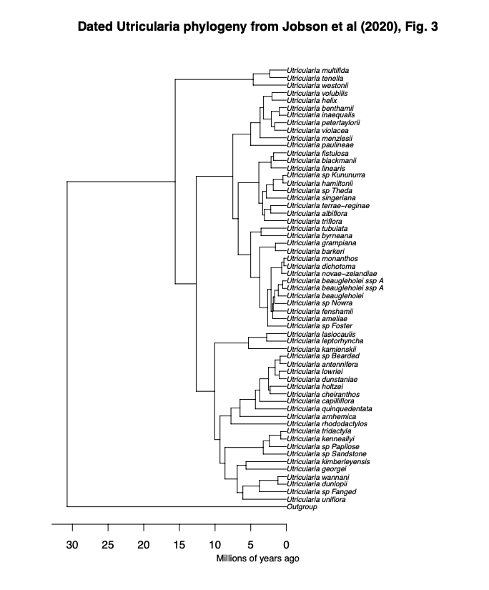

***Figure 1:*** Digitised *Utricularia* phylogenetic tree from Jobson et al. (2017). The tree was digitised using the WebPlotDigitizer tool, allowing quantitative data extraction from the original graphical representation. Calibration of axes was performed based on estimated time (million years ago), ensuring accurate scaling. Data points corresponding to tips, nodes, and corners positions were digitised.

## Classifications of Carnivorous Plant Trap Types

The phylogenetic model requires character states for a maximum likelihood analysis under the different models and Ancestral Character Estimation (ACE). Using sources from various publications and websites, species trap type, subtype, trapping zone, maximum trap size, and trap shape were implemented for every possible species on phylogenetic trees acquired from publications (see **Table. 1**). Trap type refers to sticky leaf, snap, transitional, pitcher, or suction trap. In contrast, the sub-trap refers to the more detailed category, which helps to identify character states. For example, *Nepenthes* are pitcher plants, and at this stage, it can be concluded that all *Nepenthes* possess pitcher traps. But some *Nepenthes,* like *Nepenthes inermis,* have a sticky inner wall, which suggests a transitional trap that possesses both adhesive and pitcher traps, as mentioned earlier. The trapping zone refers to the essential characteristics to determine whether traps are specialised for aerial, ground, amphibious or aquatic. Maximum trap size and shape are for reference to help further interpret the evolution of carnivorous plant traps. Some species and genera were not available for trapping size and shape, as they are poorly studied (e.g. *Genlisea*) Using this information obtained from various sources, the character states have been determined, which are coded as a number (See **Table. 2**).

***Table 1:*** Summary of character states for carnivorous plant traps for the phylogenetic model. The dataset includes information on species trap type (sticky leaf, snap, pitcher, or suction trap), subtype for detailed categorisation, trapping zone specificity (aerial, ground, amphibious, or aquatic), and reference values for maximum trap size and shape. The table serves as a condensed representation of the original, extensive dataset.

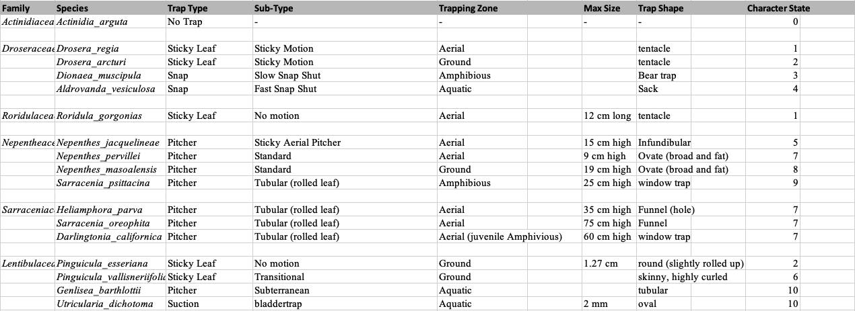

***Table 2:*** Ancestral States coded for each character state. There are 11 states, including a non- carnivorous state, “No trap”. “Aerial both” and “Ground both” refer to transitional traps, which possess sticky and pitcher traps.

| **Manual states** | **ACE states** | **Description** |
| --- | --- | --- |
| no trap | 1 | no trap |
| 1 | 2 | aerial sticky |
| 2 | 3 | ground sticky |
| 3 | 4 | amphibious snap trap |
| 4 | 5 | aquatic snap trap |
| 5 | 6 | aerial both |
| 6 | 7 | ground both |
| 7 | 8 | aerial pitcher |
| 8 | 9 | ground pitcher |
| 9 | 10 | amphibious pitcher |
| 10 | 11 | aquatic pitcher |

## Constructing a Megaphylogeny

We employed V.PhyloMaker, a R package designed to provide subtrees from a large precalculated phylogenies of vascular plants, to construct a comprehensive and expansive phylogenetic tree (Jin & Qian, 2019). The utilisation of V.PhyloMaker is particularly advantageous for handling large datasets, as it incorporates a mega-tree derived from two recent publications, encompassing an extensive compilation of 74,533 species and including all families within extant vascular plants. Notably, the package excels in both speed and scalability, demonstrating its prowess in generating phylogenies for substantial species lists. Leveraging the capabilities of V.PhyloMaker, we integrated digitised trees obtained from publications, thus creating a phylogenetic framework that captures the evolutionary relationships of a diverse array of plant species. This approach enhances the efficiency of phylogenetic analysis and allows for incorporating specific genera or species into the broader phylogenetic context. Using V.PhyloMaker, if the digitised tree is dated, we assembled it with the larger tree. The full model should include the gain and loss of plant carnivory along with trap transitions within carnivorous groups. However, running phylogenetic models on massive trees where the vast majority of taxa are non-carnivorous would be inefficient. To reduce the computational complexity and runtimes, we reduced the full tree to keep only the three successive noncarnivorous sister groups for each carnivorous clade, and then kept only one species per genus for those non-carnivorous plants. This reduced the tree from 74,533 species to around 2500 species.

## Time-scaling trees

When the digitised tree was not dated but had a branch length, we used the r8s program to produce an ultrametric, approximately time-scaled tree. The r8s program was pivotal in the temporal calibration and time scaling of non-dated digitised phylogenetic trees, effectively integrating them into a larger, dated phylogenetic framework (Sanderson, 2004). In the context of this study, r8s facilitated the precise time scaling of non-dated phylogenetic trees, aligning them with a broader phylogenetic context and providing insights into the evolutionary dynamics of the studied plant taxa. The digitised *Pinguicula* tree was not dated and had no branch lengths; however, we used the r8s program to impose several time constraints from the dated bigger *Pinguicula* subtree available in V.phyloMaker, and successfully combined with the larger tree.

## Transition Rate Matrices

Once the phylogenetic trees have been assembled, we made the score matrix for 18 models after inferring scores for each species by their trap types. Complex trap evolution model (labelled “CTE”, see **Table. 3**) represents the pitcher hypothesis for the origin of the *Utricularia* trap as a series of transitions between 11 states. The model involves 12 parameters of transition (see **Table. 4**) and this model was compared to alternative models that postulate other allowed transitions. For example, the simple equal-rates (ER) null model allows all trap types to have equal rates of transition into any other trap type (see **Table. 5**). It represents one version of an “anything is possible” model. The rest of the modelsare described in discussion. The rate matrix, organised as a square matrix, encapsulates the instantaneous rates of transition between different character states. When reading a rate matrix, the directional flow is from left (ancestral state) to top (descendant state). Diagonal elements denote remaining in the same state, while off-diagonal elements represent transition rates between distinct states. The loss of carnivory, which is indicated in the model that carnivorous traps lose their traps in ancestral state 2-11, thus transitioning into state 1. Rate 2 represents the gain of the carnivory that sticky leaf traps may have transitioned from the non-carnivorous plant (Darwin, 1875; Craw et al., 1999; Slack, 1988; Juniper et al.,1989). As Darwin (1875) observed the movement of sticky leaf traps, motion acquisition could occur gradually, which suggests that transition from aerial to ground adhesive or reverse can be considered (Rate 3). Moreover, *Dionea* and *Aldrovanda* may have evolved from ground adhesive traps like *Drosera* (Lloyd, 1942; Juniper et al., 1989), which are expressed in the model, transitioning from ground adhesive to amphibious snap trap (Rate 4), and from amphibious snap to aquatic snap trap (Rate 5). *Nepenthes*: tropical pitcher traps may have both upper and lower pitchers (Adlassnig et al., 2011), and the transition from aerial to ground pitcher traps or reverse are imaginable (Rate 6), as well as the transition of amphibious pitchers like *Sarracenia psittacina* from ground pitchers (Rate 7). Some species of Genlisea, with features like stomata on their underground tubers and mucilage-producing trichomes, exhibit adaptations for water interaction and nutrient absorption, which are vital in both amphibious and aquatic environments (Płachno et al., 2020). The evolution of starch-rich tubers in both Genlisea and Utricularia indicates a shared lineage (Płachno et al., 2020), suggesting that similar adaptive mechanisms could lead to the transition into aquatic suction traps (Rate 8). *Pinguicula*, a genus closely related to *Utricularia* (Silva et al., 2016), exhibits pitcher-like tendencies, making it easier to envision transitional forms between flypaper traps and pitcher traps (Rate 9 & 11: adhesive to transitional traps, and Rate 10 & 12: transitional to pitcher traps).

***Table 3:*** Score matrix of the pitcher hypothesis model. The numbers represent the rate of anagenetic transition in the trait.

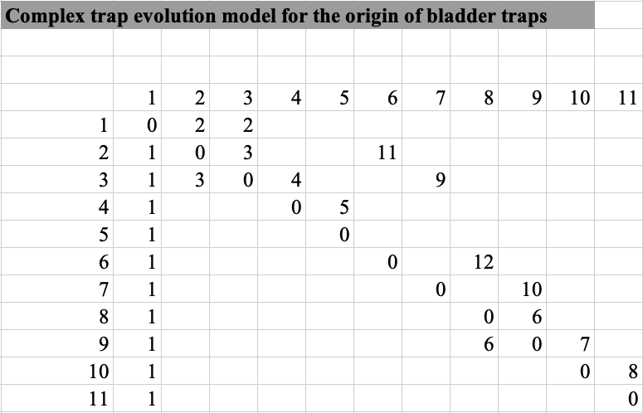

***Table 4:*** Lists of rate parameters under the Matzke 2005 (M05) model.

| **Rates** | **Description** |
| --- | --- |
| 1 | loss of carnivory |
| 2 | gain of carnivory |
| 3 | aerial-ground or reverse (sticky) |
| 4 | ground-amphibious (sticky to snap) |
| 5 | amphibious-aquatic (snap) |
| 6 | aerial-ground or reverse (pitcher) |
| 7 | ground-amphibious (pitcher-lobster) |
| 8 | amphibious-aquatic (lobster-aquatic pitcher) |
| 9 | sticky-transitional (ground) |
| 10 | transitional-pitcher (ground) |
| 11 | sticky-transitional (aerial) |
| 12 | transitional-pitcher (aerial) |

***Table 5:***Score matrix of equal-rates model. All character states have equal rates to transition into one another, represented by 1.

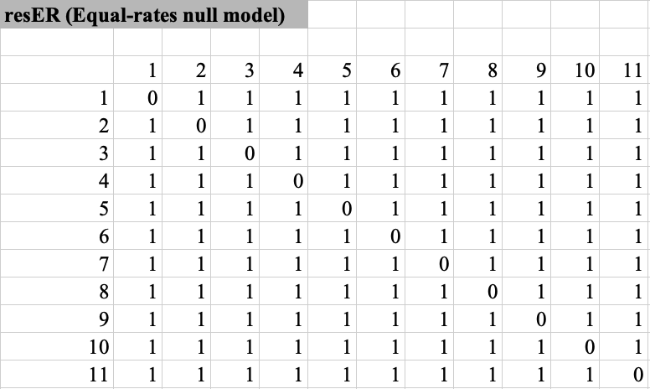

## Evaluating Markov Models for Ancestral Character Estimation

Using ‘phytools (Revell, 2024), Felsenstein's Pruning Algorithm was employed to calculate likelihoods – the probability of the observed trap type data under each proposed phylogenetic model. Felsenstein's Pruning Algorithm utilises the phylogenetic tree structure to calculate the probabilities of ancestral character states under proposed transition rates (Kosakovsky Pond et al., 2011). Starting from the tips of the assembled phylogenetic tree, with each species labelled according to their observed trap types (e.g., bladder traps, pitcher traps, flypaper traps), the algorithm proceeds recursively toward the tree's root. The algorithm calculates the probability of each trap type being ancestral to the observed tip data above it, for each internal node of the tree. If all descendant species share the same trap type, the ancestral node is assigned that trap type. If the descendant species have different trap types, the ancestral node is assigned likelihoods for each state. The algorithm continues to traverse the tree until the root is reached, assigning trap type likelihoods to each ancestral node. Once the algorithm has traversed the entire tree, the likelihoods are multiplied across all states, producing a total likelihood under the proposed model.

Maximum likelihood analysis under different models aims to assess the likelihood of the observed trap type distribution given each model and determine which model best fits the data. Maximum likelihood analysis is a statistical method commonly used in phylogenetics to estimate the parameters of a given model that maximises the probability of observing the observed data (Price et al., 2010). The analysis utilises a likelihood function that calculates the probability of observing the trap-type scores given the model's parameters for each model. The likelihood function considers the transition rates between trap types, the assignment of ancestral trap types, and the observed trap type scores for each species. The maximum likelihood estimation procedure searches for model parameters that maximise the likelihood function (Yang et al., 1995). They provide the parameter values that best explain the observed trap type distribution under each model, and these estimates allow us to evaluate the likelihood of the observed data given each model and compare the fit of the two models to the data. Finally, the Akaike Information Criterion (AIC) was used to assess the statistical significance of the difference in fit between the two models and determine which model better explains the trap type distribution (Lanfear et al., 2014). In the context of the maximum likelihood analysis for model comparison, the Akaike Information Criterion (AIC) is a widely used statistical measure to assess the relative goodness-of-fit of competing models. By running the maximum likelihood analysis on the score matrices derived from the null hypothesis model and the pitcher hypothesis model, we can quantitatively evaluate the support for each model and determine which model best fits.

Under a chosen model, the probability of different ancestral trap types can be estimated for ancestral species that have not been directly observed. By combining the likelihood calculations described above with an “up-pass” passing probabilities from the root of the tree to the tips, the algorithm can assign probabilities to each possible ancestral trap type and for each node. To estimate the number and timing of transitions, ancestral character estimation can be supplemented with stochastic mapping.

## Ancestral Character Estimation using phytools and BioGeoBEARS

Under the best model selected based on AIC and equal-rates null model, ancestral character estimation was performed to infer the most likely trap types of ancestral species in the phylogenetic tree using ‘phytools’ (Revell, 2024) and ‘BioGeoBEARS’ (Matzke, 2013). Ancestral character estimation allows reconstructing the trap-type evolution throughout the evolutionary history of the carnivorous plant lineage (Wilson et al., 2022). Phylogenetic stochastic mapping conducts probabilistic sampling of ancestral states to simulate possible evolutionary histories of trap types across the phylogenetic tree while considering the uncertainty associated with character changes. By implementing 100 stochastic simulations, each accounting for the variability in evolutionary processes, we generated a distribution of potential trap-type histories for each ancestral node. Phylogenetic stochastic mapping extends the traditional ancestral character estimation by acknowledging that character evolution is inherently stochastic. The approach allows for the exploration of alternative scenarios in which different trap types may have arisen at ancestral nodes, providing a more nuanced understanding of the potential states of these common ancestors. This probabilistic framework gives us insights into the likelihood of transitions between different trap types and the associated uncertainty in these evolutionary events. This integrative approach, combining the best model selected through AIC with phylogenetic stochastic mapping, enhances the robustness of our ancestral state reconstructions. It acknowledges the inherent complexity and uncertainty in the evolution of trap types within the carnivorous plant lineage. It provides a more comprehensive and realistic depiction of the ancestral states and their associated confidence intervals across the phylogeny.

## State Distribution Plot using “phytools” and “BioGeoBEARS”

To visualise the distribution of ancestral states along key branches within each family, state distribution plots were generated to illustrate changes in character state probabilities over time along these branches to provide a dynamic view of gradual state transitions. For each stochastic map, the cumulative time of transitions within each branch segment was recorded, and a dominant state was assigned to each time interval based on these cumulative timings. This data was organised into a matrix, where each row represented a stochastic map, and each column represented a time interval along the branch, capturing which state was dominant at each time slice along the branch length. To determine the prevalence of each state, the relative frequency of each state within each time interval was calculated across all stochastic maps, generating a probability distribution for each state over time along the branch. This information was summarised in a matrix of state proportions over time, where each cell represented the percentage of a specific state at a given time point along the branch. The final state distribution plot was created by visualising these probabilities as stacked density curves, with each colour-coded area representing the proportion of each state across intervals along the branch.

# 

# **Results**

## **Model Selection**

18 models provided a maximised log-likelihood (LnL) and AIC with AIC weights for each model (**Table. 6**). The best-fitting model res7abprCTE, which explains the pitcher hypothesis, was selected based on the lowest AIC value and the highest AIC weight (**Table. 6**).

***Table 6:*** AIC summary table for each phylogenetic model. Provided are model log-likelihoods, delta AIC (difference from the best/lowest AIC), relative likelihood (rel_likes), AIC values and weights.

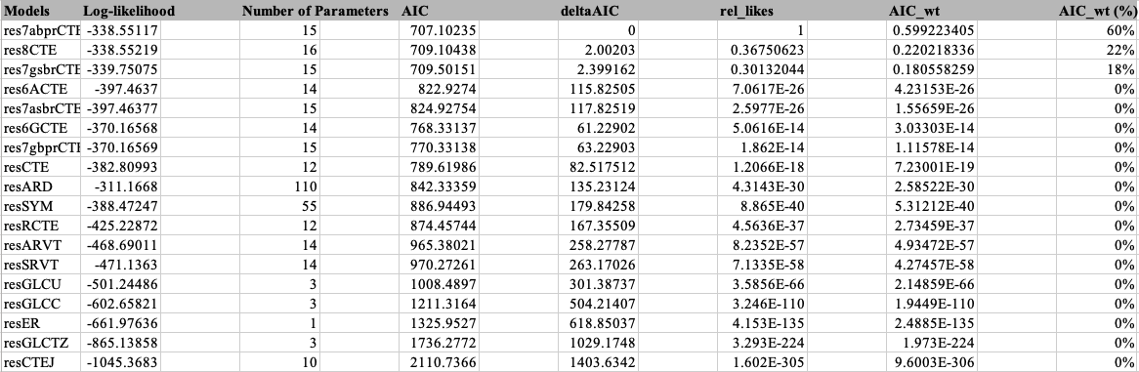

## ***Lentibulariaceae***

Phylogenetic stochastic mapping under the best-fitting res7abprCTE model suggests that the lowest common ancestor in *Lentibulariaceae* is non-carnivorous (indicated by the white node near the root, see **Fig. 2** for trap type colour labels). The ancestral character estimation indicates that the early carnivorous form in *Lentibulariaceae* may have started with a transitional trap type, represented here by grey nodes (see **Fig. 3**). This transitional state then diverged into more specialised traps over time (*Utricularia,* *Genlisea*, and *Pinguicula*). Notably, the ancestral transitional trap may have gradually evolved into the ancestral state of both eel and ground pitcher trap (lowest common ancestor of *Utricularia*+*Genlisea*). In contrast, the resER, equal-rates model shows different early carnivorous ancestral states, suggesting that it is an aquatic pitcher, combined with amphibious, transitional and non-carnivorous characters (see **Fig. 4**).

State distribution plots can visualise the change in ancestral states along key branches. The lowest common ancestor in *Lentibulariaceae* under res7abprCTE model shows non-carnivorous; however, the plot suggests that the common ancestor gradually transitioned, the ground adhesive and transitional state appears over time, and evolved into the ancestral transitional state, with ground adhesive character (see **Fig. 5**). The ancestral transitional state then lost ground adhesive character, the ground pitcher character appears alongside with losing the transitional trait over time, and evolved into the ancestral state of both eel and ground pitcher trap (see **Fig. 6**).

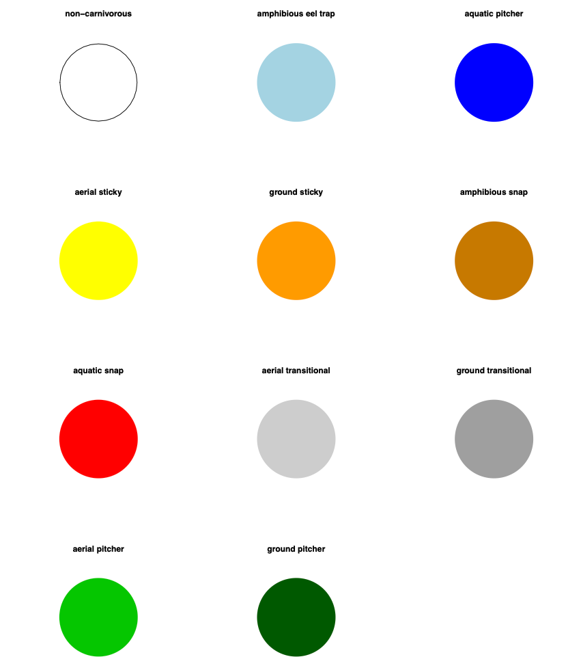

***Figure 2:*** Trap type legend for carnivorous plants, showing the various trapping mechanisms and their associated colours. Each pie chart represents a distinct trap type, with the colour indicating the trap’s classification.

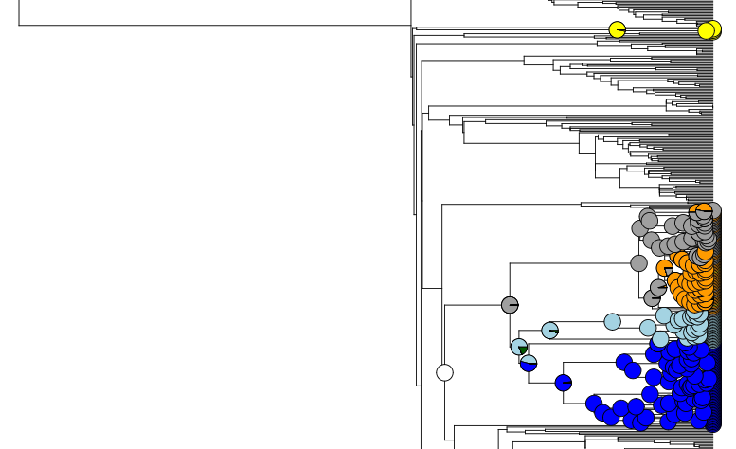

***Figure 3:*** Phylogenetic stochastic mapping in the *Lentibulariaceae* under the best-fitting model (res7abprCTE) suggests that the lowest common ancestor of the clade was non-carnivorous and the early carnivorous form was a transitional trap. The dark blue clade represents *Utricularia*, light blue represents *Genlisea*, and the clade mixed with grey and orange represents *Pinguicula*.

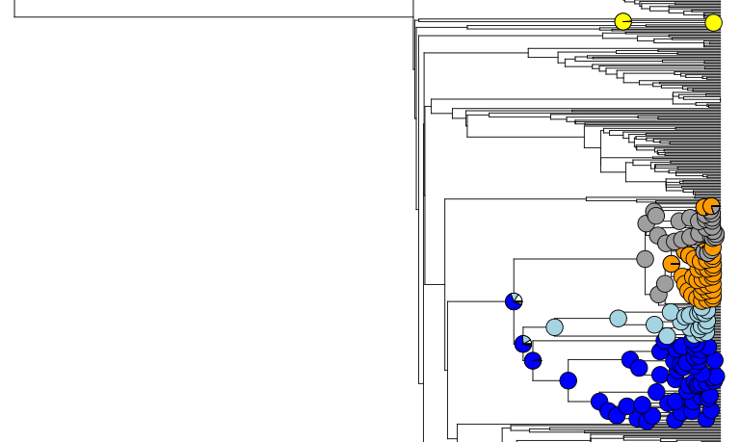

***Figure 4:*** Phylogenetic stochastic mapping in the *Lentibulariaceae* under the equal-rates model (resER) shows a different early carnivorous ancestral state, which suggests that it is an aquatic pitcher. The dark blue clade represents *Utricularia*, light blue represents *Genlisea*, and the clade mixed with grey and orange represents *Pinguicula*.

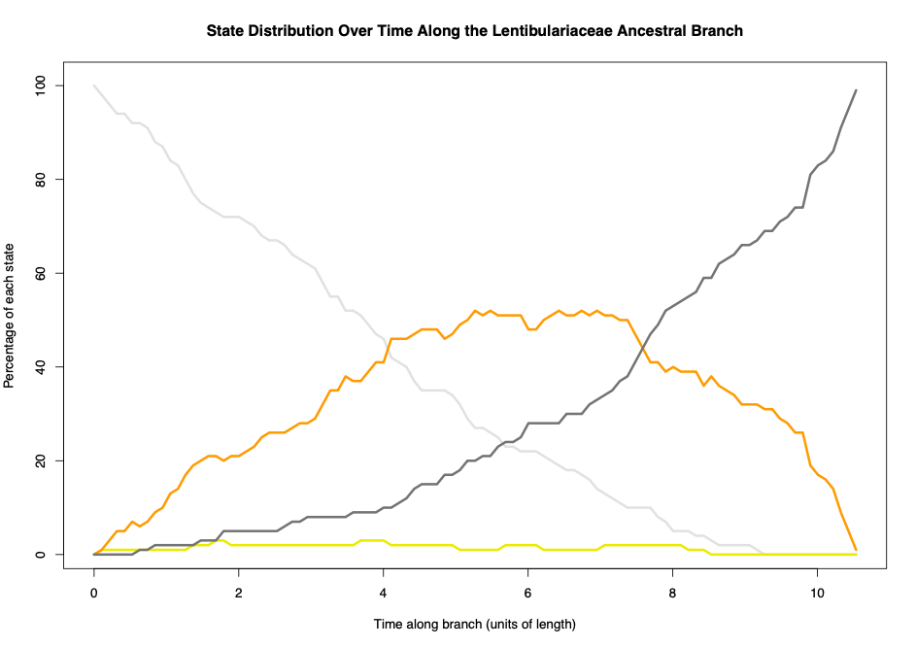

***Figure 5:*** State distribution over time along the Lentibulariaceae ancestral branch, showing the percentage of each state at different points along the branch's length. Colours represent different states: dark grey for the ground transitional state, orange for the ground adhesive state, yellow for the aerial adhesive state, and white for non-carnivorous state. The plot illustrates changes in the prevalence of each state over time, with the ground transitional state peaking in frequency before giving way to the ancestral amphibious state with ground pitch characteristics.

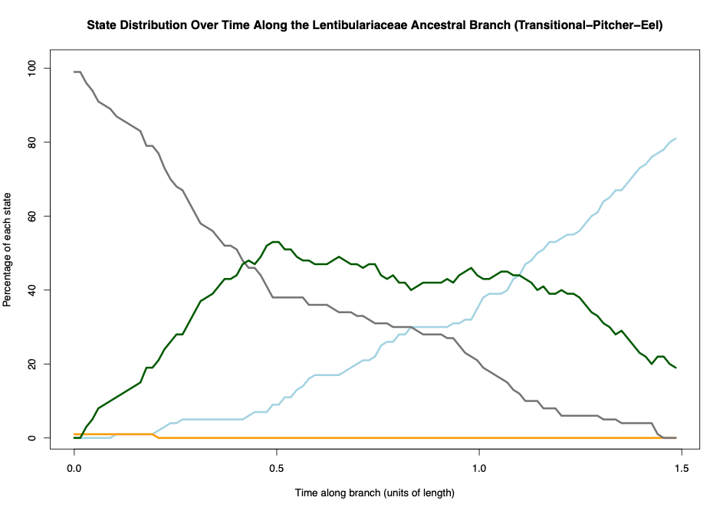

***Figure 6:*** State distribution over time along the Lentibulariaceae ancestral branch, showing the percentage of each state at different points along the branch's length. Colours represent different states: dark grey for the ground transitional state, orange for the ground adhesive state, dark green for the ground pitcher state, and light blue for amphibious eel trap. The plot illustrates changes in the prevalence of each state over time, with the amphibious eel trap peaking in frequency, with ground pitcher characteristics before giving way to the ancestral aquatic pitcher state with amphibious eel trap characteristics.

## 

# 

# 

## ***Sarraceniaceae***

The lowest common ancestor in *Sarraceniaceae* under the best model (res7abprCTE) appears to be non-carnivorous, with aerial and ground adhesive characters and the early carnivorous form is transitional+aerial pitcher, with ground pitcher character (see **Fig. 7**). The state distribution plot visualises the gradual evolutionary transition over time along this branch, suggesting that adhesive characters appear alongside aerial transitional character; however, adhesive characters disappear while pitcher characters appear over time (see **Fig. 8**).

## 

***Figure 7:*** Phylogenetic stochastic mapping in the *Sarraceniaceae* under the best-fitting model (res7abprCTE) suggests that the lowest common ancestor of the clade was non-carnivorous (with adhesive characteristics) and the early carnivorous form was a pitcher trap (with aerial transitional state). The clade mixed with dark green and light green represents *Sarraceniaceae*.

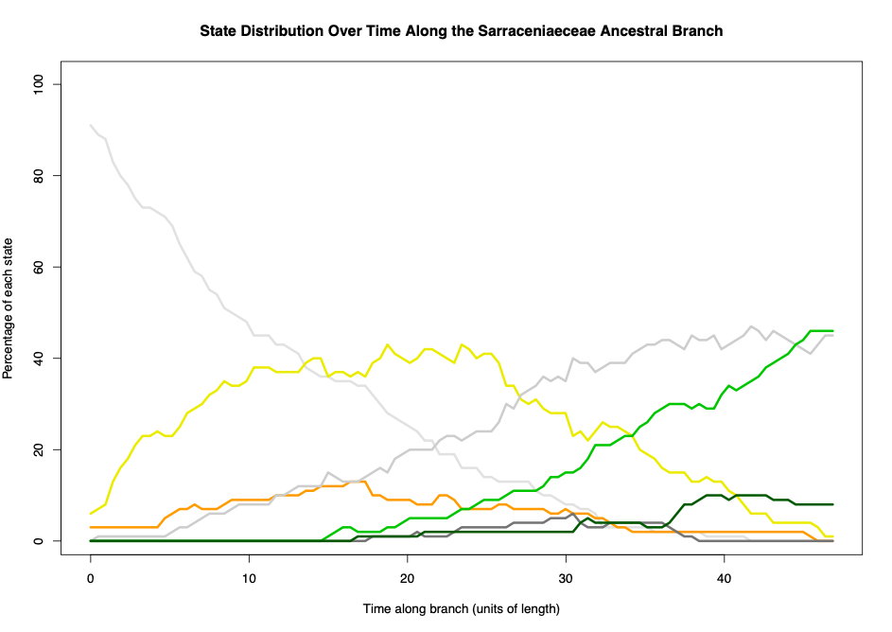

***Figure 8:*** State distribution over time along the *Sarraceniaceae* ancestral branch, showing the percentage of each state at different points along the branch's length. Colours represent different states: dark grey for the ground transitional state, orange for the ground adhesive state, yellow for the aerial adhesive state, dark green for the ground pitcher state, light green for the aerial pitcher state, and light grey for aerial transitional state, and white for non-carnivorous.

## ***Nepenthaceae* and *Droseraceae***

The lowest common ancestor of *Nepenthaceae* and *Droseraceae* under the best model (res7abprCTE) appears to be non-carnivorous and the early carnivorous form is an adhesive (aerial+ground) state (see **Fig. 9**). The state distribution plot along this branch shows that adhesive characters (aerial+ground) appear, and gradually evolved to the early carnivorous form of adhesive state (see **Fig. 10**).

## ***Nepenthaceae***

The lowest common ancestor of *Nepenthaceae* appears to be an adhesive state with ground transitional character (see **Fig. 9**). The ancestral state then gradually evolved to ancestral aerial pitcher state with aerial transitional character. The state distribution along this branch shows that adhesive state disappears alongside aerial transitional character appearing over time, which disappears over time, while aerial pitcher character takes over (see **Fig. 11**).

## ***Droseraceae***

The lowest common ancestor of *Droseraceae* appears to be a ground-based adhesive state (see **Fig. 9**). The state distribution plot shows the transition from the lowest common ancestor of *Nepenthaceae* and *Droseraceae*, that ground adhesive character gradually takes over as time goes on (see **Fig. 12**).

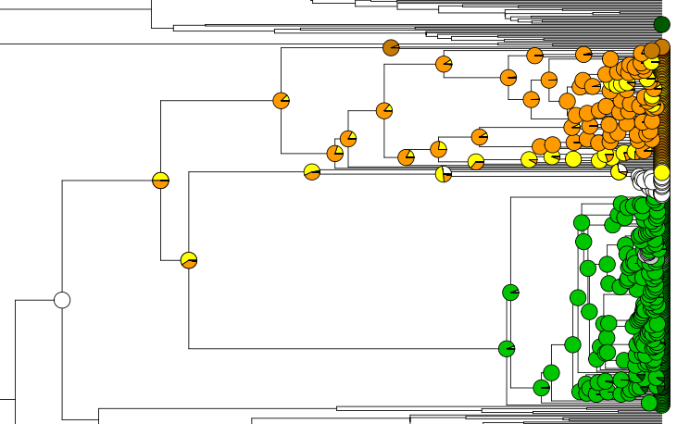

***Figure 9:*** Phylogenetic stochastic mapping in the *Nepenthaceae + Droseraceae* under the best-fitting model (res7abprCTE) suggests that the lowest common ancestor of the clades was non-carnivorous and the early carnivorous form was a adhesive trap. The green clade represents *Nepenthaceae*, and the clade mixed with yellow and orange represents *Droseraceae*.

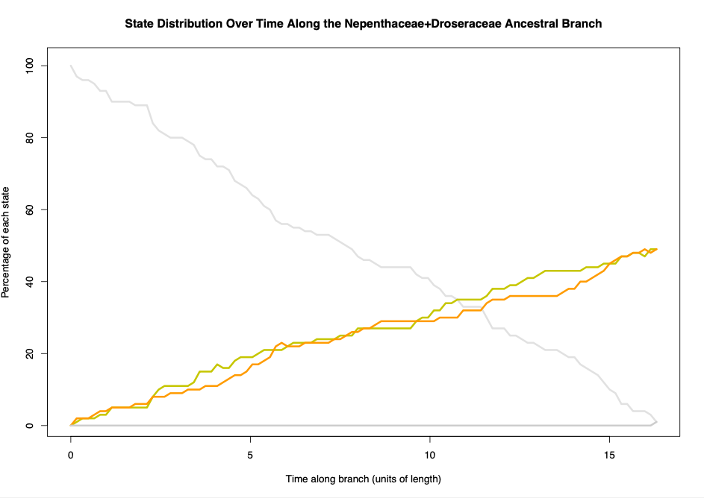

***Figure 10:*** State distribution over time along the *Nepenthaceae + Droseraceae* ancestral branch, showing the percentage of each state at different points along the branch's length. Colours represent different states: white for the ground transitional state, orange for the ground adhesive state, and yellow for the aerial adhesive state.

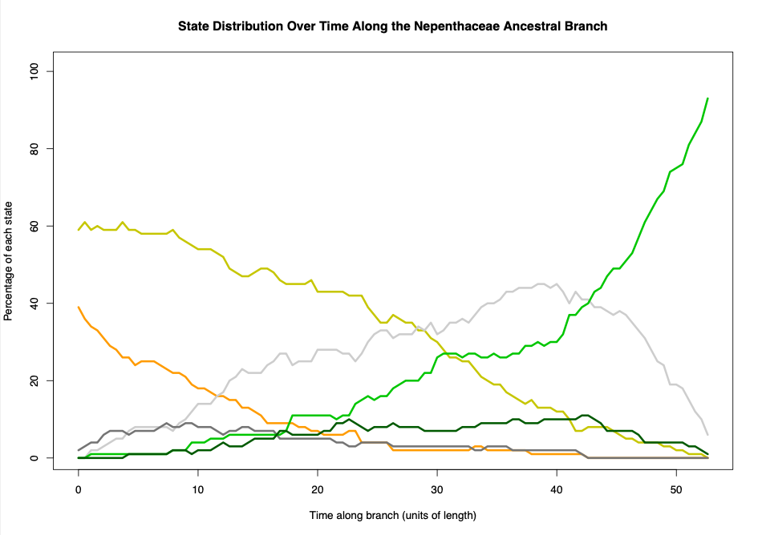

***Figure 11:*** State distribution over time along the *Nepenthaceae* ancestral branch, showing the percentage of each state at different points along the branch's length. Colours represent different states: dark grey for the ground transitional state, orange for the ground adhesive state, yellow for the aerial adhesive state, dark green for the ground pitcher state, light green for the aerial pitcher state, and light grey for aerial transitional state.

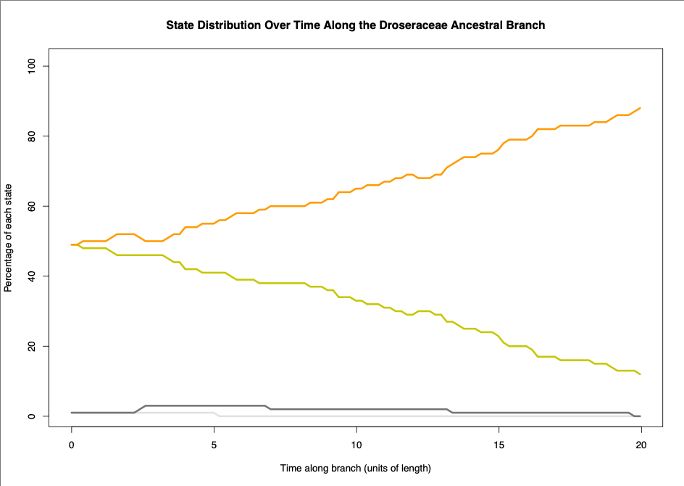

***Figure 12:*** State distribution over time along the *Droseraceae* ancestral branch, showing the percentage of each state at different points along the branch's length. Colours represent different states: white for the ground transitional state, orange for the ground adhesive state, yellow for the aerial adhesive state, and dark grey for the ground transitional state.

# 

# Discussion

Our analyses support the pitcher hypothesis, which posits a gradual evolutionary transition for the origin of *Utricularia* traps as models based on this hypothesis were consistently selected among the top eight models. The pitcher hypothesis models (resCTE, resRCTE, res6ACTE, res6GCTE, res7abprCTE, res7asbrCTE, res7gsbrCTE, res7asbrCTE, and res8CTE) explain ancestral carnivorous plants with simple flypaper traps (adhesive traps) evolved through an intermediate transitional state, exhibiting both adhesive and pitcher characteristics, before evolving into pitcher traps and subsequently evolving into *Utricularia* traps. These models explore different evolutionary transition scenarios, such as whether the transition from one to another is reversible. Among the models tested, the best-supported model was res7abprCTE, which aligns with the pitcher hypothesis; however, the model does not allow a transition from aerial transitional trap to the aerial adhesive trap. This indicates a constrained evolutionary pathway that may have favoured the transition of pitcher traits over reverting to or retaining aerial adhesive characteristics, suggesting a directional shift towards complex pitcher traps in the evolutionary history of these traps. State distribution plots along the *Nepenthaceae* and *Sarraceniaceae* ancestral branches further support this constrained evolutionary pathway (**Fig. 8** and **Fig. 11**). Initially, an aerial adhesive state (represented by yellow) is present; however, as time progresses, the aerial transitional state (represented by light grey) increasingly dominates, eventually overtaking the aerial adhesive state. This transition highlights a directional shift from simple adhesive traps towards more complex transitional characteristics, which likely facilitated the evolution of pitcher and *Utricularia* traps. The persistence of this pattern across both families reinforces the hypothesis of a gradual and constrained evolutionary trajectory within carnivorous plant lineages.

The best-fitting model res7abprCTE (pitcher hypothesis) was selected based on the lowest AIC value of 707.10235 and the highest AIC weight of 60%. The consistent selection of pitcher hypothesis models indicates that our models provide better fit to the data (megaphylogeny) than alternative scenarios. The 9th and 10th models selected were resSYM (symmetric model) and resARD (all-rates different model). The Symmetric (SYM) and All Rates Different (ARD) models are standard options in discrete-character evolution software, frequently employed to study the transition dynamics between discrete character states, such as those representing traits in evolutionary biology. The Symmetric model assumes that the rates of change between any two character states are equivalent in both directions, adhering to a symmetric transition matrix. In contrast, the All Rates Different (ARD) model relaxes this constraint, allowing for distinct rates for forward and reverse transitions between character states. This implies that the process of transitioning from one state to another might occur at different rates than the reverse transition. Both models serve as valuable tools for understanding the evolutionary dynamics of discrete traits, with the Symmetric model representing a more constrained scenario and the ARD model offering greater flexibility by acknowledging potential asymmetries in the rates of character state changes. ARD model scored log-likelihood of -311.1668, which is closer to zero than the best-fitting model res7abprCTE (-338.55117). At this stage, resARD model is better fit than res7abprCTE; however, the AIC (Akaike Information Criterion) is a statistical measure that balances the goodness of fit of a model with the complexity of the model, effectively penalising models with more parameters (Akaike, 1987). In the context of the phylogenetic models, resARD and res7abprCTE, the AIC scores provide a quantitative assessment of model performance. The AIC score incorporates both the likelihood of the model and the number of parameters, aiming to select the model that achieves the best balance between fit and simplicity. In comparing these models, resARD exhibits higher log-likelihood scores compared to the best-fitting model; however, the AIC considers the number of parameters in addition to the likelihood. The resARD model includes 110 parameters, and the res7abprCTE model has 15 parameters. AIC penalises models with more parameters, reflecting the principle of parsimony favouring simpler models that can adequately explain the data. This emphasises the trade-off between model complexity and goodness of fit, encouraging selection of a model that achieves a balance suitable for the specific dataset and research question.

Asymmetric and symmetric rate variation by trapping zone models (resARVT and resSRVT) refer to the implementation of rate transition parameters to the model based on trapping zones (aerial, ground, etc.) rather than trap types (pitcher, sticky, etc.). These models were selected at 12th and 13th based on their AIC. Regarding trapping zone models, resGLCTZ (gain-loss-change within trapping zone model) was selected at 17th. In addition, resGLCU (gain-loss-change unconstrained model) and resGLCC (gain-loss-change constrained model) were selected at 14th and 15th. The gain-loss-change unconstrained model allows for the loss of carnivory, gain of carnivory and the change between any types of trap. In contrast, the constrained model is limited in terms of allowing only for change within the same type of trap. These models are based on types of traps, rather than considering their trapping zones. As a result, these models' scores suggest that considering a singular aspect of the character state, whether it be the transition between trapping zones or types of traps, may offer an incomplete portrayal of the evolution of carnivorous plant traps. In particular, the resGLCTZ model, which focuses on gain-loss-change within trapping zones, and the resGLCU and resGLCC models, which respectively permit and restrict changes in trap types, underscore the significance of incorporating a comprehensive perspective. The resGLCU model, acknowledging the potential for loss and gain of carnivory and transitions across various trap types, recognises the complexity inherent in the evolutionary history of carnivorous plants. Conversely, the resGLCC model, constrained to changes within the same trap type, provides insights into more limited aspects of evolutionary dynamics. These nuanced distinctions emphasise that a holistic understanding of carnivorous plant trap evolution necessitates the consideration of both trapping zones and trap types. Moreover, models such as resARVT and resSRVT, which introduce rate transition parameters based on trapping zones over those exclusively centred on trap types (e.g., pitcher hypothesis models), highlight the significance of ecological adaptations associated with different trapping zones. It underscores the inadequacy of a unidimensional approach and advocates for a multifaceted framework that encapsulates the varied dimensions of carnivorous plant trap evolution. The equal-rate model (resER) refers to the model that all character states have equal rates to transition into any character states, which is ranked 16th under model selection. Finally, the worst model chosen was resCTEJ (Complex Trap Evolution-Jump model), which refers to the model based on pitcher hypothesis models; however these explains gradual evolutionary transitions (e.g. adhesive traps evolve to transitional traps, and then into pitcher traps), whereas resCTEJ model skips the evolutionary step (e.g. adhesive traps evolve to pitcher traps, without intermediate transitional state).

As articulated earlier, the equal-rate model (resER), ranking 16th under the model selection framework, posits uniform transition rates across all character states. While this model offers a simplified representation, it suggests that a more nuanced consideration of variable transition rates is essential for accurately capturing the intricacies of carnivorous plant trap evolution. Conversely, the resCTEJ model, rooted in the resM05 pitcher hypothesis, emerges as the least favoured model within the selection process. This discrepancy suggests the importance of modelling the gradual evolutionary transitions. The concept of a gradual evolutionary process posits that most evolutionary changes occur incrementally through gradual allelic substitution, leading to major adaptations over extended periods (Gould, 1980). The concept of gradualism, as opposed to punctuated equilibrium or abrupt jumps in evolutionary trajectories, has been a subject of extensive scientific discourse. Notably, the works of palaeontologists Stephen Jay Gould and Niles Eldredge proposed the theory of punctuated equilibrium, suggesting that evolutionary changes often occur rapidly in isolated populations, followed by prolonged periods of stability (Gould & Eldredge, 1977). In the carnivorous plant trap evolution context, the gradual process posited by res7abprCTE aligns with the broader understanding of evolutionary biology. For instance, a study on animal evolution by Douglas J. Emlen emphasises the role of gradual adaptation in shaping complex structures. The research on the evolution of exaggerated traits in insects shows that gradual changes in the function and form of weapons, driven by various mechanisms, contribute to the remarkable diversity observed in animal weapon structures (Emlen, 2008). This provides valuable perspectives on the significance of gradualism in diverse carnivorous plant traps.

# Pitcher to *Utricularia* bladder, the miniaturised aquatic pitcher traps

While our analyses strongly support the pitcher hypothesis, especially on gradual evolutionary transition from simple adhesive traps into pitcher traps through intermediate transitional traps, the key concept of the hypothesis; *Utricularia* bladder traps evolved from pitcher traps, is supported as well. The state distribution plot (**Fig. 6**) shows the transition from ancestral ground transitional traps to ancestral amphibious traps, with ground pitcher characteristics. The transition starts with the ancestral ground pitcher taking over the ancestral ground transitional characteristic, and the ancestral ground pitcher then gradually evolving into the ancestral amphibious pitcher traps, with some ground pitcher characteristics, which then later transitioning into aquatic pitcher, with some amphibious pitcher characteristic (**Fig. 6**).

Recent discovery, a new species of *Nepenthes pudica*, from North Kalimantan, Borno, is the first carnivorous plant species confirmed to use pitfall traps specifically in the underground environments (Dančák et al., 2022). These pitchers can capture prey of the same size as those caught by aerial and ground pitchers in other *Nepenthes* species, unlike other genera of carnivorous plants with underground traps that only catch microscopic or very small prey (Dančák et al., 2022). As previously mentioned Givnish et al. (1984) stated a cost/benefit model for the evolution of plant carnivory, which suggests that the costs of carnivory are metabolically costly to produce dye to require significant energy and resources. This creates a trade-off; the plant must balance the energy spent on creating these traps with the energy needed for other essential functions like photosynthesis. In the genus *Nepenthes*, this trade-off often leads to a spatial separation of functions within the same leaf; they have lamina, the main part of the leaf is primarily for photosynthesis, while they also have tendril that extends from lamina, which later develops into pitcher traps (Dančák et al., 2022). On the other hand, *Nepenthes pudica* shows an unusual separation of function at the level of shoot. It has aerial shoots that produce leaves that are exposed to sunlight, optimised for capturing light energy and performing photosynthesis, while subterranean shoots produce leaves, which later develop underground pitchers, where they capture soil-dwelling prey. These underground shoots likely lack chlorophyll, as their primary role is not photosynthesis but prey capture (Dančák et al., 2022). This strategy in *Nepenthes pudica* is similar to *Utricularia* species in that they exhibit the separation of function at the level of shoot; shoots having small bladder traps that catch small aquatic organisms, and shoots extending towards the surface where they can access the sunlight for photosynthesis (Dančák et al., 2022). *N. pudica's* unique shoot-level spatial separation where underground shoots develop pitchers and aerial shoots focus on photosynthesis, is similar to the aquatic *Utricularia*; therefore *N. pudica* could be seen as a transitional state between typical terrestrial pitcher plants and more specialised forms like *Utricularia*. The adaptation to subterranean prey capture could represent an intermediate step towards the evolution of more specialised aquatic traps, which aligns with our pitcher hypothesis.

# Limitations and Future Directions

The study on the evolutionary dynamics of carnivorous plant traps, particularly focusing on *Utricularia*, has its inherent limitations that should be considered. One significant constraint pertains to the data utilised in the analysis. The study's scope and depth may be contingent upon the availability and completeness of existing data on *Utricularia* and other carnivorous plant lineages. Incomplete or limited datasets could potentially introduce biases or gaps in our understanding of trap evolution. Addressing this limitation would require acquiring more extensive datasets or capitalising on future discoveries in carnivorous plant research. Another set of limitations arises from the modelling assumptions inherent in the study. While robust, the chosen models and methodologies involve certain assumptions about evolutionary processes. Simplifications within these models might not fully capture the intricacies of trap evolution. Exploring alternative modelling approaches could provide a more nuanced and comprehensive understanding of the evolutionary dynamics under consideration. Additionally, assessing the sensitivity of results to different modelling assumptions would contribute to a more robust interpretation of findings. The study's ecological context is another area of limitation. While the research delves into trap evolution, the intricate interplay between ecological factors and the evolutionary trajectories of carnivorous plants may not be fully captured. This limitation prompts future research avenues to explore the specific ecological triggers, nutrient dynamics, and interactions with other species that shape the evolution of carnivorous plant traps. Temporal resolution represents a further limitation. The study employs r8s for temporal calibration of non-dated trees, introducing a degree of uncertainty into the temporal aspects of trap evolution. Improved dating methods or access to more dated samples could enhance the temporal resolution of the study and provide a more accurate timeline for the evolutionary events under investigation.

Addressing the limitations outlined above opens up promising avenues for future research in the field of carnivorous plant trap evolution. One potential direction involves conducting ecological experiments in natural environments. Such experiments could explain the ecological triggers and selective pressures that drive the evolution of carnivorous plant traps. Exploring factors such as nutrient availability, prey abundance, and interspecies interactions would provide a more holistic understanding of the ecological context of carnivorous plant adaptations. Integrating genomic analysis into future studies represents another direction that researchers can better understand the molecular mechanisms driving trap development. Comparative genomics, in particular, could unveil key genes associated with different trap types and their evolution. A focus on functional morphology studies offers yet another avenue for future exploration. Detailed examinations of the functional morphology of various trap types can deepen our understanding of how specific adaptations contribute to prey capture and nutrient acquisition. This could involve anatomical studies and functional experiments to elucidate the mechanisms behind the diverse trapping strategies observed in carnivorous plants. Adding further species to our trap type database (for example, most of the large carnivorous genera are only partially sampled by published phylogenies) may increase our ability to statistically distinguish similar phylogenetic models. Comparative analyses across different plant families can reveal commonalities and differences in trap evolution, contributing to a more holistic understanding of this intriguing phenomenon. Finally, investigating long-term evolutionary trends represents a valuable future direction. This could involve exploring fossil evidence or examining the paleobiogeography of carnivorous plants may help gain insights into the extended temporal perspective of carnivorous plant trap evolution. Such long-term perspectives could reveal patterns and trends that may not be apparent in phylogenies of living species.

# 

# Acknowledgements

I would like to express my sincere gratitude to Dr. Nick Matzke, whose expertise in phylogeny and biogeography and unwavering support made this research possible. His guidance, from introducing the research to providing assistance in bioinformatics and computational analysis, has been invaluable. I appreciate his patience in helping me navigate R studio coding and answering my numerous questions. I am truly grateful for the opportunity he gave me to delve into my passion for evolution, phylogeny, and biogeography.

# Supplementary Materials

11-rates matrix excel

Model selection excel

Carnivorous plant data excel

# 

# **Appendices**

# 

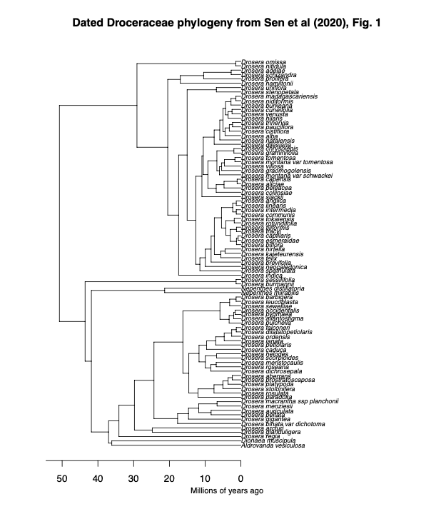

**Appendix 1:** Digitised *Droceraceae* phylogenetic tree from Sen et al. (2020), Fig. 1. The tree was manually digitised using the WebPlotDigitizer tool, allowing quantitative data extraction from the original graphical representation. Calibration of axes was performed based on estimated time (million years ago), ensuring accurate scaling. Data points corresponding to tips, nodes, and corners positions were digitised.

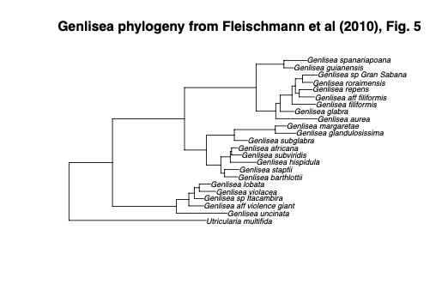

**Appendix 2:** Digitised *Genlisea* phylogenetic tree from Fleischmann et al. (2010), Fig. 5. The tree was manually digitised using the WebPlotDigitizer tool, allowing quantitative data extraction from the original graphical representation. Calibration of axes was performed based on branch length (0.03), ensuring accurate scaling. Data points corresponding to tips, nodes, and corners positions were digitised.

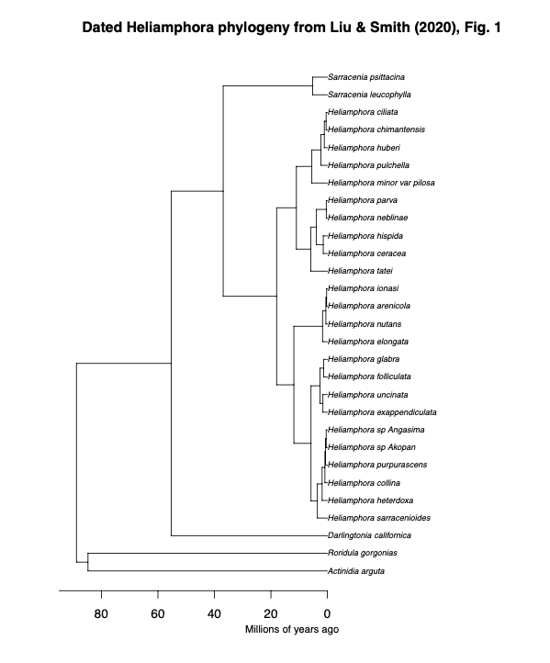

**Appendix 3:** Digitised *Heliamphora* phylogenetic tree from Liu and Smith (2020), Fig. 1. The tree was manually digitised using the WebPlotDigitizer tool, allowing quantitative data extraction from the original graphical representation. Calibration of axes was performed based on estimated time (million years ago), ensuring accurate scaling. Data points corresponding to tips, nodes, and corners positions were digitised.

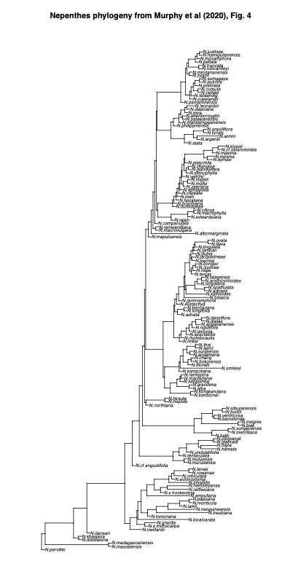

**Appendix 4:** Digitised *Nepenthes* phylogenetic tree from Murphy et al. (2020), Fig. 4. The tree was manually digitised using the WebPlotDigitizer tool, allowing quantitative data extraction from the original graphical representation. Calibration of axes was performed based on branch length (0.5), ensuring accurate scaling. Data points corresponding to tips, nodes, and corners positions were digitised.

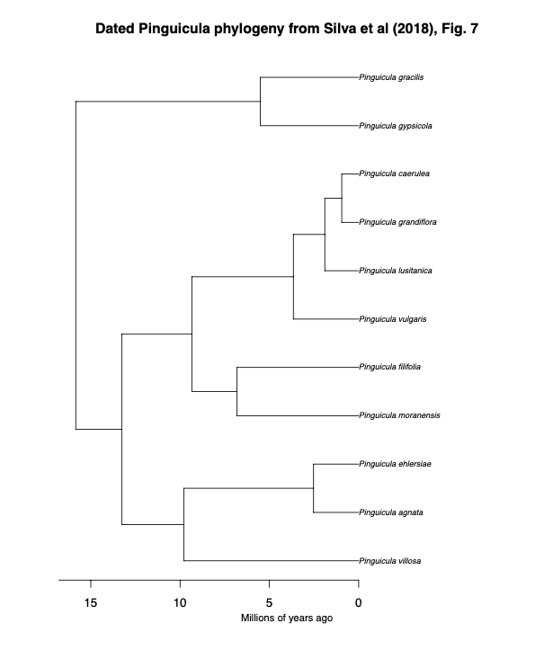

**Appendix 5:** Digitised *Pinguicula* phylogenetic tree from Shimai et al. (2021), S1 Fig. 1. The tree was manually digitised using the WebPlotDigitizer tool, allowing quantitative data extraction from the original graphical representation. The tree was not available for estimated and branch length; thus used r8s programme to ensure accurate scaling when assembling trees. Data points corresponding to tips, nodes, and corners positions were digitised.

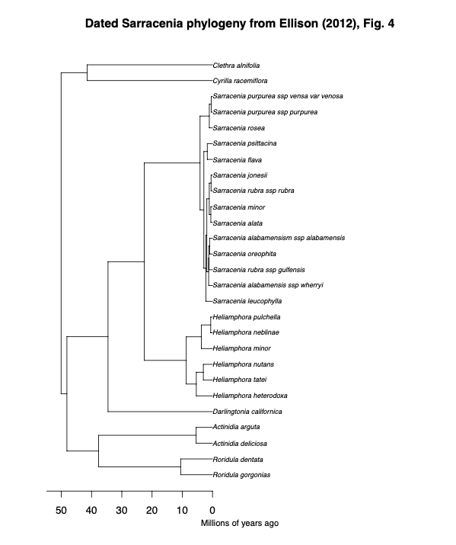

**Appendix 6:** Digitised *Sarracenia* phylogenetic tree from Ellison et al. (2012), Fig. 4. The tree was manually digitised using the WebPlotDigitizer tool, allowing quantitative data extraction from the original graphical representation. Calibration of axes was performed based on estimated time (million years ago), ensuring accurate scaling. Data points corresponding to tips, nodes, and corners positions were digitised.

# References

Adamec, L. (2018). Biological flora of Central Europe: Aldrovanda vesiculosa L. *Perspectives in Plant Ecology, Evolution and Systematics*, *35*, 8–21.<https://doi.org/10.1016/j.ppees.2018.10.001>

Adlassnig, W., Peroutka, M., & Lendl, T. (2011). Traps of carnivorous pitcher plants as a habitat: Composition of the fluid, biodiversity and mutualistic activities. *Annals of Botany*, *107*(2), 181–194.

Akaike, H. (1987). Factor analysis and AIC. *Psychometrika*, *52*(3), 317–332.<https://doi.org/10.1007/BF02294359>

Albert, V. A., Jobson, R. W., Michael, T. P., & Taylor, D. J. (2010). The carnivorous bladderwort (Utricularia, Lentibulariaceae): A system inflates. *Journal of Experimental Botany*, *61*(1), 5–9.<https://doi.org/10.1093/jxb/erp349>

Böhm, J., Scherzer, S., Krol, E., Kreuzer, I., von Meyer, K., Lorey, C., Mueller, T. D., Shabala, L., Monte, I., Solano, R., Al-Rasheid, K. A. S., Rennenberg, H., Shabala, S., Neher, E., & Hedrich, R. (2016). The Venus Flytrap Dionaea muscipula Counts Prey-Induced Action Potentials to Induce Sodium Uptake. *Current Biology*, *26*(3), 286–295.<https://doi.org/10.1016/j.cub.2015.11.057>

Carmesin, C. F., Fleischmann, A. S., Klepsch, M. M., Westermeier, A. S., Speck, T., Jansen, S., & Poppinga, S. (2021). Structural gradients and anisotropic hydraulic conductivity in the enigmatic eel traps of carnivorous corkscrew plants (Genlisea spp.). *American Journal of Botany*, *108*(12), 2356–2370.<https://doi.org/10.1002/ajb2.1779>

Craw, R. C., Grehan, J. R., & Heads, M. J. (1999). *Panbiogeography: Tracking the History of Life*. Oxford University Press, Incorporated.<http://ebookcentral.proquest.com/lib/auckland/detail.action?docID=430300>

Dančák, M., Majeský, Ľ., Čermák, V., Golos, M. R., Płachno, B. J., & Tjiasmanto, W. (2022). First record of functional underground traps in a pitcher plant: Nepenthes pudica (Nepenthaceae), a new species from North Kalimantan, Borneo. *PhytoKeys*, *201*, 77–97.<https://doi.org/10.3897/phytokeys.201.82872>

Darwin, C. & D. Appleton and Company. (1900). *Insectivorous Plants: By Charles Darwin, M. A., F. R. S.* D. Appleton and Company; Nineteenth Century Collections Online.<https://link.gale.com/apps/doc/BHEQGZ888129421/NCCO?sid=bookmark-NCCO&xid=feda1b5f&pg=4>

Darwin Correspondence Project, “Letter no. 10085,” accessed on 6 June 2023,

<https://www.darwinproject.ac.uk/letter/?docId=letters/DCP-LETT-10085.xml>

Di Giusto, B., Bessière, J.-M., Guéroult, M., Lim, L. B. L., Marshall, D. J., Hossaert-Mckey, M., & Gaume, L. (2010). Flower-scent mimicry masks a deadly trap in the carnivorous plant Nepenthes rafflesiana. *Journal of Ecology*, *98*(4), 845–856.

Ellison, A. M., Butler, E. D., Hicks, E. J., Naczi, R. F. C., Calie, P. J., Bell, C. D., & Davis, C. C. (2012). Phylogeny and Biogeography of the Carnivorous Plant Family Sarraceniaceae. *PLoS ONE*, *7*(6), e39291.<https://doi.org/10.1371/journal.pone.0039291>

Ellison, A. M., & Gotelli, N. J. (2001). Evolutionary ecology of carnivorous plants. *Trends in Ecology & Evolution*, *16*(11), 623–629.<https://doi.org/10.1016/S0169-5347(01)02269-8>

Emlen, D. J. (2008). The Evolution of Animal Weapons. *Annual Review of Ecology, Evolution, and Systematics*, *39*, 387–413.

Fleischmann, A., Schäferhoff, B., Heubl, G., Rivadavia, F., Barthlott, W., & Müller, K. F. (2010). Phylogenetics and character evolution in the carnivorous plant genus Genlisea A. St.-Hil. (Lentibulariaceae). *Molecular Phylogenetics and Evolution*, *56*(2), 768–783.<https://doi.org/10.1016/j.ympev.2010.03.009>

Forterre, Y., Skotheim, J. M., Dumais, J., & Mahadevan, L. (2005). How the Venus flytrap snaps. *Nature*, *433*(7024), 421–425.<https://doi.org/10.1038/nature03185>

Gaascht, F., Dicato, M., & Diederich, M. (2013). Venus Flytrap (Dionaea muscipula Solander ex Ellis) Contains Powerful Compounds that Prevent and Cure Cancer. *Frontiers in Oncology*, *3*, 202.<https://doi.org/10.3389/fonc.2013.00202>

Gould, S. J. (1980). Is a New and General Theory of Evolution Emerging? *Paleobiology*, *6*(1), 119–130.

Gould, S. J., & Eldredge, N. (1977). Punctuated Equilibria: The Tempo and Mode of Evolution Reconsidered. *Paleobiology*, *3*(2), 115–151.

Hotti, H., Gopalacharyulu, P., Seppänen-Laakso, T., & Rischer, H. (2017). Metabolite profiling of the carnivorous pitcher plants Darlingtonia and Sarracenia. *PLoS One*, *12*(2), e0171078.<https://doi.org/10.1371/journal.pone.0171078>

Jin, Y., & Qian, H. (2019). V.PhyloMaker: An R package that can generate very large phylogenies for vascular plants. *Ecography*, *42*(8), 1353–1359.<https://doi.org/10.1111/ecog.04434>

Jobson, R. W., Baleeiro, P. C., & Reut, M. S. (2017). Molecular phylogeny of subgenus Polypompholyx (Utricularia; Lentibulariaceae) based on three plastid markers: Diversification and proposal for a new section. *Australian Systematic Botany*, *30*(3), 259–278.<https://doi.org/10.1071/SB17003>

Juniper, B. E., Robins, R. J. and Joel, D. M., 1989. The Carnivorous Plants. Academic

Press, London ; San Diego.

Körner, C. (2016). Plant adaptation to cold climates. *F1000Research*, *5*.<https://doi.org/10.12688/f1000research.9107.1>

Kosakovsky Pond, S. L., Murrell, B., Fourment, M., Frost, S. D. W., Delport, W., & Scheffler, K. (2011). A Random Effects Branch-Site Model for Detecting Episodic Diversifying Selection. *Molecular Biology and Evolution*, *28*(11), 3033–3043.<https://doi.org/10.1093/molbev/msr125>

Krupa, J. J., Hopper, K. R., Gruber, S. B., Schmidt, J. M., & Harwood, J. D. (2020). Plant–animal interactions between carnivorous plants, sheet‐web spiders, and ground‐running spiders as guild predators in a wet meadow community. *Ecology and Evolution*, *10*(11), 4762–4772.<https://doi.org/10.1002/ece3.6230>

Kubitzki, K. (2003). Droseraceae. In K. Kubitzki & C. Bayer (Eds.), *Flowering Plants · Dicotyledons: Malvales, Capparales and Non-betalain Caryophyllales* (pp. 198–202). Springer.<https://doi.org/10.1007/978-3-662-07255-4_21>

Laakkonen, L., Jobson, R. W., & Albert, V. A. (2006). A New Model for the Evolution of Carnivory in the Bladderwort Plant (Utricularia): Adaptive Changes in Cytochrome c Oxidase (COX) Provide Respiratory Power. *Plant Biology*, *8*(6), 758–764.<https://doi.org/10.1055/s-2006-924459>

Lanfear, R., Calcott, B., Kainer, D., Mayer, C., & Stamatakis, A. (2014). Selecting optimal partitioning schemes for phylogenomic datasets. *BMC Evolutionary Biology*, *14*, 82.<https://doi.org/10.1186/1471-2148-14-82>

Lee, L., Zhang, Y., Ozar, B., Sensen, C. W., & Schriemer, D. C. (2016). Carnivorous Nutrition in Pitcher Plants ( *Nepenthes* spp.) via an Unusual Complement of Endogenous Enzymes. *Journal of Proteome Research*, *15*(9), 3108–3117.<https://doi.org/10.1021/acs.jproteome.6b00224>

Liu, S., & Smith, S. D. (2021). Phylogeny and biogeography of South American marsh pitcher plant genus Heliamphora (Sarraceniaceae) endemic to the Guiana Highlands. *Molecular Phylogenetics and Evolution*, *154*, 106961.<https://doi.org/10.1016/j.ympev.2020.106961>

Lloyd, F. E., & Lloyd, F. E. (1942). *The carnivorous plants, by Francis Ernest Lloyd* (pp. 1–376). Chronica Botanica Company.<https://doi.org/10.5962/bhl.title.5965>

Matzke N (2013). _BioGeoBEARS: BioGeography with Bayesian (and Likelihood)

Evolutionary Analysis in R Scripts_. University of

California, Berkeley, Berkeley, CA.

Mithöfer, A. (2021). A spotlight on prey-induced metabolite dynamics in sundew. A commentary on: ‘Metabolomic analysis reveals reliance on secondary plant metabolites to facilitate carnivory in the Cape sundew, Drosera capensis.’ *Annals of Botany*, *128*(3), v–vi.<https://doi.org/10.1093/aob/mcab093>

Moldowan, P. D., Smith, M. A., Baldwin, T., Bartley, T., Rollinson, N., & Wynen, H. (2019). Nature’s pitfall trap: Salamanders as rich prey for carnivorous plants in a nutrient-poor northern bog ecosystem. *Ecology*, *100*(10), 1–4.

Moran, J. A. (1996). Pitcher Dimorphism, Prey Composition and the Mechanisms of Prey Attraction in the Pitcher Plant Nepenthes Rafflesiana in Borneo. *Journal of Ecology*, *84*(4), 515–525.<https://doi.org/10.2307/2261474>

Murphy, B., Forest, F., Barraclough, T., Rosindell, J., Bellot, S., Cowan, R., Golos, M., Jebb, M., & Cheek, M. (2020). A phylogenomic analysis of Nepenthes (Nepenthaceae). *Molecular Phylogenetics and Evolution*, *144*, 106668.<https://doi.org/10.1016/j.ympev.2019.106668>

Newell, S. J., & Nastase, A. J. (1998). Efficiency of Insect Capture by Sarracenia purpurea (Sarraceniaceae), the Northern Pitcher Plant. *American Journal of Botany*, *85*(1), 88–91.<https://doi.org/10.2307/2446558>

Paradis, E., & Schliep, K. (2019). ape 5.0: An environment for modern phylogenetics and evolutionary analyses in R. *Bioinformatics*, *35*(3), 526–528.<https://doi.org/10.1093/bioinformatics/bty633>

Płachno, B. J., Link to external site, this link will open in a new window, Silva, S. R., Link to external site, this link will open in a new window, Świątek, P., Dixon, K. W., Lustofin, K., Seber, G. C., Miranda, V. F. O., & Link to external site, this link will open in a new window. (2020). Structural Features of Carnivorous Plant (Genlisea, Utricularia) Tubers as Abiotic Stress Resistance Organs. *International Journal of Molecular Sciences*, *21*(14), 5143.<https://doi.org/10.3390/ijms21145143>

Poppinga, S., Masselter, T., & Speck, T. (2013). Faster than their prey: New insights into the rapid movements of active carnivorous plants traps. *BioEssays*, *35*(7), 649–657.<https://doi.org/10.1002/bies.201200175>

Poppinga, S., Tim, K., Amélie, M., Speck, O., & Speck, T. (2016). Comparative kinematical analyses of Venus flytrap (Dionaea muscipula) snap traps. *Beilstein Journal of Nanotechnology*, *7*, 664–674.<https://doi.org/10.3762/bjnano.7.59>

Price, M. N., Dehal, P. S., & Arkin, A. P. (2010). FastTree 2 – Approximately Maximum-Likelihood Trees for Large Alignments. *PLoS ONE*, *5*(3), e9490.<https://doi.org/10.1371/journal.pone.0009490>

Revell, L. J. (2024). phytools 2.0: An updated R ecosystem for phylogenetic comparative methods (and other things). *PeerJ*.<https://doi.org/10.7717/peerj.16505>

Rice, B. (2007). Carnivorous plants with hybrid trapping strategies. *Carnivorous Plant Newsletter*, *36*(1), 23–27.<https://doi.org/10.55360/cpn361.br152>

Sanderson, M. J. (n.d.). *R8s, version 1.70 User’s Manual*.

Scorza, L. C. T., & Dornelas, M. C. (2011). Plants on the move: Towards common mechanisms governing mechanically-induced plant movements. *Plant Signaling & Behavior*, *6*(12), 1979.<https://doi.org/10.4161/psb.6.12.18192>

Sen, S., Tiwari, N., & Ganesan, R. (2020). *Eocene origin, Miocene diversification and intercontinental dispersal of the genus Drosera (Droseraceae)* (p. 2020.08.06.240234). bioRxiv.<https://doi.org/10.1101/2020.08.06.240234>

Shimai, H., Setoguchi, H., Roberts, D. L., & Sun, M. (2021). Biogeographical patterns and speciation of the genus Pinguicula (Lentibulariaceae) inferred by phylogenetic analyses. *PLOS ONE*, *16*(6), e0252581.<https://doi.org/10.1371/journal.pone.0252581>

Schnell, D.E. 2002, Carnivorous plants of the United States and Canada. (2nd Edition)

Timber Press, Portland, 468p

Silva, S. R., Diaz, Y. C. A., Penha, H. A., Pinheiro, D. G., Fernandes, C. C., Miranda, V. F. O., Michael, T. P., & Varani, A. M. (2016). The Chloroplast Genome of Utricularia reniformis Sheds Light on the Evolution of the ndh Gene Complex of Terrestrial Carnivorous Plants from the Lentibulariaceae Family. *PLOS ONE*, *11*(10), e0165176.<https://doi.org/10.1371/journal.pone.0165176>

Singh, K., Reyes, R. C., Campa, G., Jr, Brown, M. D., Hidalgo, F., Berg, O., Müller, U. K., & Link to external site, this link will open in a new window. (2020). Suction Flows Generated by the Carnivorous Bladderwort Utricularia—Comparing Experiments with Mechanical and Mathematical Models. *Fluids*, *5*(1), 33.<https://doi.org/10.3390/fluids5010033>

Slack, A. and Gate, J., 1988. Carnivorous plants. MIT Press, Cambridge, Mass.

Srivastava, A., Rogers, W. L., Breton, C. M., Cai, L., & Malmberg, R. L. (2011).

Transcriptome Analysis of Sarracenia, an Insectivorous Plant. *DNA Research: An*

*International Journal for Rapid Publication of Reports on Genes and Genomes*,

*18*(4), 253–261.<https://doi.org/10.1093/dnares/dsr014>

Tagawa, K., & Watanabe, M. (2021). Group foraging in carnivorous plants: Carnivorous plant Drosera makinoi (Droseraceae) is more effective at trapping larger prey in large groups. *Plant Species Biology*, *36*(1), 114–118.<https://doi.org/10.1111/1442-1984.12290>

Tagawa, K., Watanabe, M., & Yahara, T. (2018). Pollinator trapping in selfing carnivorous plants, Drosera makinoi and D. toyoakensis (Droseraceae). *Ecological Research*, *33*(2), 487–494.<https://doi.org/10.1007/s11284-018-1572-6>

Voigt, D., Gorb, E., & Gorb, S. (2009). Hierarchical organisation of the trap in the protocarnivorous plant Roridula gorgonias (Roridulaceae). *Journal of Experimental Biology*, *212*(19), 3184–3191.<https://doi.org/10.1242/jeb.034280>

Voigt, D., & Gorb, S. (2010). Desiccation resistance of adhesive secretion in the protocarnivorous plant Roridula gorgonias as an adaptation to periodically dry environment. *Planta*, *232*(6), 1511–1515.

Vries, J. de, & Archibald, J. M. (2018). Plant evolution: Landmarks on the path to terrestrial life. *The New Phytologist*, *217*(4), 1428–1434.

Westermeier, A. S., Fleischmann, A., Müller, K., Schäferhoff, B., Rubach, C., Speck, T., & Poppinga, S. (2017). Trap diversity and character evolution in carnivorous bladderworts (Utricularia, Lentibulariaceae). *Scientific Reports (Nature Publisher Group)*, *7*, 1–24.<https://doi.org/10.1038/s41598-017-12324-4>

Westermeier, A. S., Sachse, R., Poppinga, S., Vögele, P., Adamec, L., Speck, T., & Bischoff, M. (2018). How the carnivorous waterwheel plant (Aldrovanda vesiculosa) snaps. *Proceedings of the Royal Society B: Biological Sciences*, *285*(1878), 20180012.<https://doi.org/10.1098/rspb.2018.0012>

Westoby, M., Falster, D. S., Moles, A. T., Vesk, P. A., & Wright, I. J. (2002). Plant Ecological Strategies: Some Leading Dimensions of Variation between Species. *Annual Review of Ecology and Systematics*, *33*, 125–159.

Yang, Z., Goldman, N., & Friday, A. (1995). Maximum Likelihood Trees from DNA Sequences: A Peculiar Statistical Estimation Problem. *Systematic Biology*, *44*(3), 384–399.<https://doi.org/10.2307/2413599>

Zhang, M., Lenaghan, S. C., Xia, L., Dong, L., He, W., Henson, W. R., & Fan, X. (2010). Nanofibers and nanoparticles from the insect-capturing adhesive of the Sundew (Drosera ) for cell attachment. *Journal of Nanobiotechnology*, *8*, 20.<https://doi.org/10.1186/1477-3155-8-20>