Title

# 

# Abstract

Carnivorous plants have been the subject of fascination and research in the almost 150 years since Darwin codified the subject in book *Insectivorous Plants.* The origin of complex trapping mechanisms from structures adapted for photosynthesis is of particular interest. While Darwin and others put forward hypotheses for the origin of the Venus Flytrap and other traps, the origin of the tiny and complex bladder traps of genus *Utricularia* has not been discussed in detail, despite *Utricularia being* the most diverse genus of carnivorous plants. The traps suck in prey in less than a millisecond, making this one of the fastest movements in the plant kingdom. In this research, we build a phylogenetic model for the evolution of carnivorous plant traps to test the “pitcher hypothesis” for the origin of the *Utricularia* trap, proposing a gradual evolutionary transition from simple adhesive traps to pitcher traps, and ultimately to *Utricularia*’s unique suction traps. We assembled phylogenetic trees for carnivorous plant species to test our hypothesis with statistical model comparison: the fit of a model where *Utricularia* bladder traps are essentially miniaturised pitcher traps is compared to less constrained null models where any trap type can evolve into any other. The results suggested that among the 18 phylogenetic models evaluated, the res7abprCTE model, aligning with the pitcher hypothesis, emerged as the best-fitting model, with an AIC weight of 60%, and two other similar pitcher-hypothesis models garnering the remaining 40%. We propose that by statistically comparing models representing detailed, stepwise, pathways for the evolution of complex adaptations, we should be able to convert exercises in "adaptive storytelling," where verbal scenarios are subjectively judged on plausibility, into the modern phylogenetic framework of statistical model comparison.

# 

The account of *Utricularia* is most marvellous & quite new to me. I am rather surprised that you do not make any remarks on the origin of these extraordinary contrivances for capturing insects. Did you think they were too obvious? I dare say there is no difficulty, but I feel sure they will be seized on as *inexplicable* by *Nat. Select.* & your silence on the point will be held to show that *you consider them so*! [...] Here are plants which lose their roots & leaves to acquire the same results by infinitely complex modes! What a wonderfull & long continued series of variations must have led up to the perfect “*trap*” in *Utricularia*, while at any stage of the process the same end might have been gained by a little more development of roots & leaves, as in 9999 plants out of 10,000!

– Alfred Russel Wallace to Darwin, 21 July 1875 (italics & spelling original)

If at any time you are curious on subject, you will find development of the Droseraceæ discussed in closing part of Chapt. XV [of *Insectivorous Plants*], and I think I have thrown some light on the acquirement of wonderful power of digestion.— With respect to Utricularia, I can explain nothing, for there are no gradational genera, and even the embryology or development of the present bladders not made out.

– Darwin to Wallace, 22 July 1875

Introduction

For nearly 150 years since Darwin's *Insectivorous Plants*, carnivorous plants have “captivated” scientists and enthusiasts alike—not only for their remarkable ability to capture prey, but also for their extraordinary adaptations and unique ecological strategies. The remarkable ability of the Venus’ flytrap ('one of the most wonderful in the world’; Darwin, 1875a) to detect and rapidly respond to the presence of insects, culminating in the swift closure of its trap for capture and digestion, exemplifies nature’s ingenuity (Forterre et al., 2005). This extraordinary ability has garnered extensive recognition, making Venus’ flytrap the iconic carnivorous plant. However, the bladder traps of the genus *Utricularia* (bladderworts) are arguably even more astounding. Darwin directly observed pretty "suddenly" appearing in bladderwort traps, but imagined that the mechanism was a passive one. Lloyd (1942) explicated the full complexity of the trap, where prey are sucked in by negative pressure after prey disturbs a trigger hair which opens a double-hinged door, after which the mechanism resets. Lloyd analogized bladder traps "without exaggeration" to an imaginary self-resetting mousetrap with 20+ necessary components, cooperating with “an astounding degree of mechanical delicacy depending on a fineness of structure scarcely equalled elsewhere in the plant kingdom” (Lloyd 1942).

## Prior Attempts at Explaining the Origin of the *Utricularia* Trap

While progress has been made in resolving the relationships of *Utricularia* and understanding their diversification to occupy various terrestrial and aquatic habitats (Westermeier et al., 2017), there is still a large unresolved question about how the unique bladderwort trap evolved, which goes right back to Darwin. In *Insectivorous Plants*, Darwin had offered suggestions about the origin of the Venus Flytrap (namely, that it had evolved from a *Drosera*-like ancestor, where the speed of leaf movement increased to the point that sticky secretions could be lost). However, Alfred Russel Wallace, the co-discovered of natural selection, was always on the lookout for puzzling cases, and wrote Darwin about the origin of *Utricularia* (Wallace 1875). However, Darwin expressed mystification, saying, "I can explain nothing, for there are no gradational genera" (Darwin 1875b). The lack of intermediate forms stymied the usual Darwinian method of proposing a scenario where a series of functional steps is postulated, based on homologous and/or analogous adaptations.

Much of the commentary after Darwin has also expressed bafflement. Lloyd (1942) wrote, “How the highly specialized organs of capture could have evolved seems to defy our present knowledge.” Even in explicit discussions of carnivorous plant evolution one finds no answers. Givnesh (1989) argues that the complex traps of *Dionaea* and *Utricularia* must somehow be derived from simpler traps similar to those of their relatives, but writes that the relationship between the *Genlisea* trap and the traps of *Pinguicula* and *Utricularia* remains “totally obscure.” Juniper et al. discuss the evolution of other trap forms in some detail, but of *Utricularia* they write that it remains “an intractable problem in evolution” and that “[t]here is no complete natural analog to this trap to our knowledge anywhere else in the plant kingdom, nor any satisfactory evolutionary path” (Juniper et al., 1989 ). Benzing (1987) only made a few very vague suggestions, one of them being that the bladder trap originated in a fashion similar to that proposed by Juniper for the origin of *Dionaea* from a *Drosera*-like ancestor (Juniper, 1986; Mazrimas and Juniper, 1987; Juniper et al., 1989). Ellison (2001), like Lloyd, noted only that the relationship between *Utricularia* and *Pinguicula*, the latter having only simple sticky leaves as traps, must have some significance. In his massive monograph on *Utricularia*, Taylor (1989) could only say that the variation in the trap “gives us, or at least me, no inkling as to how this evolved.” D’Amato (1998) expresses skepticism of gradualistic evolution to account for carnivorous plant traps in general, and goes so far as to suggest that the solution may lie in “cosmic catastrophism.”

One early paper focused entirely on the question of the origin of *Utricularia*’s traps (Snyder 1987), proposing that in a *Pinguicula*-like ancestor, a mutation created air sacs in the plant’s roots, which then evolved into floats and from there into bladder traps. This was critiqued on many fundamental grounds (bladderwort traps are homologous to leaves, not roots; aquatic Lentibulariaceae float without floats, etc.) by Cheek (1987). However, Cheek suggested no alternative hypothesis, saying only, “it is still extremely difficult to imagine, let alone reconstruct, how this, the most sophisticated animal trapping device in the plant world (Lloyd, 1942), evolved.”

Papers by Fleischmann and colleagues (Fleischmann 2012; Fleischmann et al. 2018) link the bladder trap to the other traps in Lentibulariaceae; this hypothesis bears several similarities to the pitcher hypothesis so is discussed below.

## The Pitcher Hypothesis

The pitcher hypothesis suggests that the common ancestor of *Utricularia* and its sister genus *Genlisea* evolved from a group of pitcher plants in the family Lentibulariaceae that is now entirely extinct. Furthermore, the hypothesis postulates several transitions between different types of pitcher traps in this extinct group. This hypothesis, we freely concede, seems at first glance to be extravagant, relying as it does on postulating numerous extinct transitional forms for which there is not a shred of living or fossil evidence. The obvious risk is that the hypothesis is dismissed as an evidence-free "just-so story." However, we propose that modern methods in phylogenetic modelling of character evolution allow us to take verbal arguments about the plausibility of evolutionary scenarios, and convert them into exercises in statistical model comparison, where the support for various hypotheses can be quantified.

Although Lloyd (1942) mentioned in passing that bladder traps resemble miniaturised pitchers, to our knowledge the first place the pitcher hypothesis was suggested was a web article by a carnivorous plant enthusiast (Cook 2001). Matzke (2005) proposed a more detailed version of this hypothesis, which we review here. The primary challenge in understanding the origin of the *Utricularia* trap lies in conceiving of a plausible sequence of transitional forms between the traps of related genera, such as *Pinguicula* and *Genlisea*. The conceptual difficulty has probably been enhanced by the fact that the various traps are typically categorised (ref) by their apparently highly distinct mechanisms: flypaper traps (which may or may not have slow motion), snap traps, pitcher traps, the "eel trap" of *Genlisea*, and the suction traps of *Utricularia*.

However, a variety of discoveries have gradually broken down the borders between these trap types. First, molecular phylogenetic studies have shown that species with complex traps, including *Dionaea*/*Aldrovanda*, *Utricularia*, *Sarracenia*, and *Nepenthes*, are closely related to species with more straightforward flypaper traps (adhesive traps). This suggests some propensity for simpler flypaper traps to evolve into more complex traps over time (Ellison & Gotelli, 2001). Second, careful reviews of trap mechanisms (ref1, ref2) have suggested a number of cases where species have trap mechanisms that are intermediate between the main categories. For example, the upper traps of *Nepenthes inermis* are clearly pitchers, yet the insides of the pitchers are sticky rather than slippery, and operate as adhesive traps rather than pitfall traps. *Pinguicula,* the sister of the *Genlisea*/*Utricularia* clade (Silva et al., 2016), is typically described as having flypaper traps and slow motion. However, some *Pinguicula* species have leaves so highly curled that they seem to approach simple pitcher forms, making it easier to envision transitional forms between flypaper traps and pitcher traps. Other pitcher plants, rather than relying on a pitfall mechanism, use a eel trap strategy where a small entrance is combined with features like light windows and one-way hairs that may impede prey exit (*Sarracenia psittacina*; *Darlingtonia*); *Nepenthes aristolochioides* combines a small vertical entrance and light windows with sticky insides. *S. psittacina*'s trap lies prostrate on the ground and is thought to operate amphibiously.

In addition, previous work on the evolution of the snap traps suggests how large changes in trap mechanism may occur. Darwin (1875) surveyed plants with various forms of movement, noting that motion acquisition could occur gradually, with slight advantages gained at each stage. This progression could lead to the faster movements observed in plants like *Drosera*. Darwin (1875) and Juniper et al. (1989) also proposed that if the closing motions of a *Drosera*-like trap became fast enough, the adhesive glue could become superfluous and be lost as a trapping mechanism. Sticky tentacles might also become unnecessary, with a few retained as trigger hairs. The idea that the snap traps evolved from adhesive traps was confirmed by molecular phylogenetic results putting *Drosera*, and *Drosophyllum* as successive sister groups (Ellison and Gotelli 2001). The same study also showed that *Nepenthes* is another descendant of the same adhesive-trap ancestor of the group. The fact that *Dionaea* is amphibious can trap prey while submerged, while *Aldrovanda* is fully aquatic, also gives a hint of how the terrestrial/aquatic barrier can be crossed (Joyeux, 2013).

The pitcher hypothesis for the origin of the *Utricularia* traps emerges by arranging all trap mechanisms on two axes (Figure 1). One axis is the specialisation of traps for different microenvironments: aerial, ground, amphibious, and submerged. The second axis is an adhesive-to-pitcher continuum. Trap mechanisms that have been observed in living species, and transitional series that have been postulated in carnivorous plant evolution, can then be mapped onto this framework. For example, the origin of *Aldrovanda*'s aquatic snap trap is postulated to proceed from adhesive traps, through an amphibious Dionaea-like stage, to a fully aquatic snap trap. To explain the origin of the *Utricularia* trap, the proposed stages of the pitcher hypothesis are: (a) ancestral flypaper traps, (b) transitional flypaper/pitcher-like traps, (c) a ground pitcher trap, (d) amphibious eel trap, and finally (d) a fully aquatic suction trap.

| Figure 1. The pitcher model for the origin of *Utricularia*'s bladder traps is presented as a transition between a series of stages, within the overall context of convergent evolution of carnivorous plant trapping mechanisms.  [Hi Masafumi! For a new Figure 1, I recommend you re-do this table from 2005. E.g., do it in Powerpoint. Please put in (A) some additional examples where known, (B) color-code the cell backgrounds to match the color codes in your phylogeny/character mapping figures, (C) put in the state numbers as well. (D) I would delete the arrows, which have some additional implications that might be confusing.] |
| --- |

The evidence for the plausibility of transition from (a) to (c) is argued above. The argument for (c) to (e) begins with the fact that the traps of *Genlisea* resemble advanced eel traps (Płachno et al., 2020). The similarities between *Genlisea* and *Utricularia* traps suggest a shared ancestry, with the common ancestor likely possessing a homologous epiascidiate leaf trap (Płachno et al., 2020). The pitcher hypothesis proposes that this common ancestor was an amphibious eel trap, prostrate on the ground or shallowly buried in moss or soil, much like some living *Genlisea* traps grow horizontally rather than vertically down into the substrate (Lloyd 1942). We suggest that this postulated ancestor is similar enough in form and mechanism to the *S. psittacina* eel trap to be plausible; small *S. psittacina* traps even overlap large *Genlisea* traps in size. From this common ancestor, the development of the advanced eel trap in *Genlisea* could have resulted from specialisation, with the twisted arms of the trap possibly evolving from appendages resembling *Darlingtonia* fishtails. Converting the ancestral eel trap into a *Utricularia* suction trap begins with curling the edge of the entrance inwards to form a one-way valve that further impedes escape of live prey and the nutrients diffusing from decaying prey. The addition of suction is then a gradual improvement on eel-trap functionality, helping bring struggling prey into the "pitcher"/digestion chamber. As suction trap capability improves, the reliance on eel trap mechanisms, like hairs that guide prey towards the entrance, can reduce (although some living *Utricularia* still use hairs in an apparent eel-trap-like mechanism to guide prey to the trap door).

Undoubtedly, this scenario does not address many morphological details, let alone molecular ones, but we suggest that determining the major functional stages by which a complex adaptation evolved is a crucial first step in solving an evolutionary puzzle. The major advantage of proposing a series of stages, and the transitions between them, is that this creates an explicit model of trap evolution that can be fit to a dataset consisting of a phylogenetic tree containing the carnivorous plant clades and their noncarnivorous relatives, and tip data encoding the trap type of each species. In this study, models allowing different transitions and different numbers of parameters are implemented to statistically compare different models for the evolution of carnivorous plant traps. The fit of the pitcher model is compared to other possible models, using Akaike Information Criterion (AIC) to measure the relative statistical fit of models. The best-fit models are then used in stochastic character mapping, to estimate ancestral trap types, and the timing and number of transitions between trap types.

# 

# Materials and Methods

## Collecting and Digitising Trees

Phylogenetic trees covering each carnivorous plant genus were collected from publications (Ellison et al., 2012; Fleischmann et al., 2010; Jobson et al., 2017; Liu & Smith, 2021; Murphy et al., 2020; Sen et al., 2020; Shimai et al., 2021). These covered the families Droseraceae, Lentibulaceae, Sarraceiaceae, and Nepenthaceae. Digitisation was accomplished using WebPlotDigitizer (https://automeris.io/WebPlotDigitizer/), and the digitised data for each tree was converted to Newick format using custom R functions released as “TreeRogue” (see **Supp. Mat.**).

The digitized trees of carnivorous plant clades were grafted onto an angiosperm megaphylogeny from V.PhyloMaker, a R package designed to provide subtrees from a large precalculated phylogenies of vascular plants (Jin & Qian, 2019), using a custom R script. When the digitised tree was not dated but had molecular branch lengths, we used r8s (Sanderson, 2004) to produce an ultrametric, approximately time-scaled tree. The digitised Pinguicula tree was not dated and had no branch lengths; however, we used the r8s program to impose several time constraints from the dated Pinguicula subtree available in V.phyloMaker, and combined it with the larger tree. The above procedure produced a reasonable tree reflecting the dates from recent publications, without the inefficiency of repeating many dating analyses from scratch, an analysis which would still result in phylogenies with substantial dating uncertainty. We expect that our model-comparison results hinge primary on the topology of the tree and coding of trap type data, and would not be greatly affected by moderate changes in the dating.

Because running phylogenetic models on massive trees where the vast majority of taxa are non-carnivorous would be inefficient, we reduced the full tree to keep only the three successive noncarnivorous sister groups for each carnivorous clade, and then kept only one species per genus for other non-carnivorous clades. This reduced the tree from 74,533 species to around 2500 [get the number], XYZ of which are carnivorous.

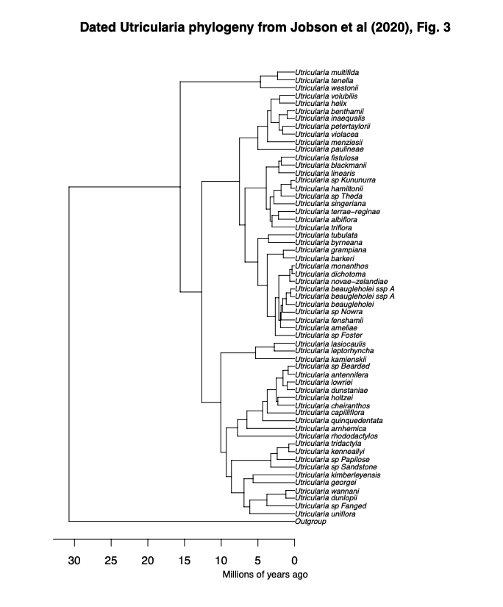

***Figure 1:*** Digitised *Utricularia* phylogenetic tree from Jobson et al. (2017). The tree was digitised using the WebPlotDigitizer tool, allowing quantitative data extraction from the original graphical representation. Calibration of axes was performed based on estimated time (million years ago), ensuring accurate scaling. Data points corresponding to tips, nodes, and corners positions were digitised. [move to Supp. Mat.]

## Classifications of Carnivorous Plant Trap Types

For each sampled carnivorous species, trap type, subtype, trapping zone, maximum trap size, and trap shape were coded for every species based on data acquired from publications (see **Table 1**). Trap type refers to sticky leaf, snap, transitional, pitcher, or suction trap. In contrast, the sub-trap refers to the more detailed category, which helps to identify character states. For example, all *Nepenthes* are pitcher plants, but some *Nepenthes,* like *Nepenthes inermis,* have a sticky inner wall, which suggests a transitional trap that possesses both adhesive and pitcher traps. The trapping zone refers to the essential characteristics to determine whether traps are specialised for aerial, ground, amphibious or aquatic. Maximum trap size and shape are for reference to help further interpret the evolution of carnivorous plant traps. Some species and genera were not available for trapping size and shape, as they are poorly studied (e.g. *Genlisea*) Using this information obtained from various sources, the character states have been determined, which are coded as a number (See **Table. 2**).

***Table 1: Example coding***  of character states for carnivorous plant traps for the phylogenetic model. The dataset includes information on species trap type (sticky leaf, snap, pitcher, or suction trap), subtype for detailed categorisation, trapping zone specificity (aerial, ground, amphibious, or aquatic), and reference values for maximum trap size and shape. For the full data table, see Supplemental Data.

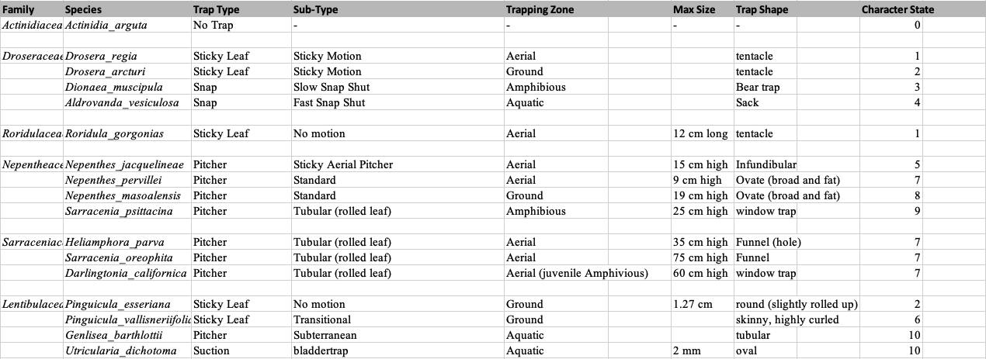

[merge Table 2 into the new Figure 1] ***Table 2:*** Ancestral States coded for each character state. There are 11 states, including a non- carnivorous state, “No trap”. “Aerial both” and “Ground both” refer to transitional traps, which possess sticky and pitcher traps.

| **Manual states** | **ACE states** | **Description** |
| --- | --- | --- |
| no trap | 1 | no trap |
| 1 | 2 | aerial sticky |
| 2 | 3 | ground sticky |
| 3 | 4 | amphibious snap trap |
| 4 | 5 | aquatic snap trap |
| 5 | 6 | aerial both |
| 6 | 7 | ground both |
| 7 | 8 | aerial pitcher |
| 8 | 9 | ground pitcher |
| 9 | 10 | amphibious pitcher |
| 10 | 11 | aquatic pitcher |

## Time-scaling trees

## Transition Rate Matrices

Once the phylogenetic trees have been assembled, we made transition matrices for 18 models after coding each species by its trap type. The Complex Trap Evolution model (labelled “CTE”, see **Table 3**) represents the pitcher hypothesis for the origin of the *Utricularia* trap as a series of transitions between 11 states. The model involves 12 transition rate parameters (see **Table 4**) and this model was compared to alternative models that postulate other allowed transitions. For example, the simple equal-rates (ER) null model allows all trap types to have equal rates of transition to any other trap type (see **Table 5**). It represents one version of an “anything is possible” model. The rest of the modelsare described in Discussion. The transition rate matrix encapsulates the instantaneous rates of transition between ancestral state (left) to descendant (top) states. In the CTE model, the loss of carnivory is indicated by rate 1, representing transitions from any other state to state 1. Rate 2 represents the gain of carnivory postulating that sticky leaf traps were the first form of carnivory to evolve from non-carnivorous ancestors (Darwin, 1875; Craw et al., 1999; Slack, 1988; Juniper et al.,1989). Other rates are as indicated in Table 3.

***Table 3: Transition***  matrix for the Complex Trap Evolution (CTE) model postulated in Figure 1, which includes the pitcher hypothesis for the origin of the Utricularia trap. Each number represents a different free transition rate parameter in the model. [NOTE: add the trap type labels to the 11 states on the left, and the top. Readers won't remember what states are what.]

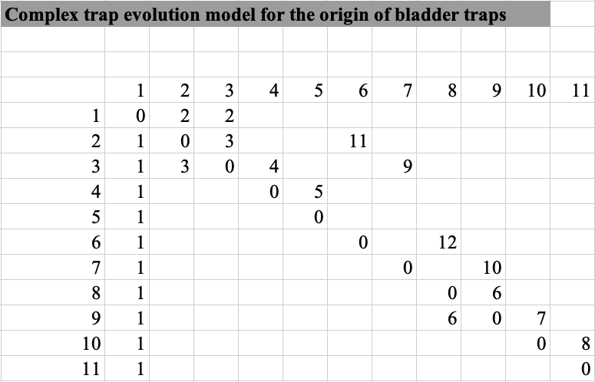

***Table 4:*** Lists of rate parameters under the Matzke 2005 (M05) model. [Does M05 = CTE? It's OK if not, just be clear. I think Table 4 can be cut, and you just put the trap type names into the left and top of Table 3]

| **Rates** | **Description** |
| --- | --- |
| 1 | loss of carnivory |
| 2 | gain of carnivory |
| 3 | aerial-ground or reverse (sticky) |
| 4 | ground-amphibious (sticky to snap) |
| 5 | amphibious-aquatic (snap) |
| 6 | aerial-ground or reverse (pitcher) |
| 7 | ground-amphibious (pitcher-eel) |
| 8 | amphibious-aquatic (eel-aquatic pitcher) |
| 9 | sticky-transitional (ground) |
| 10 | transitional-pitcher (ground) |
| 11 | sticky-transitional (aerial) |
| 12 | transitional-pitcher (aerial) |

***Table 5:***Score matrix of equal-rates model. All character states have equal rates to transition into one another, represented by 1.

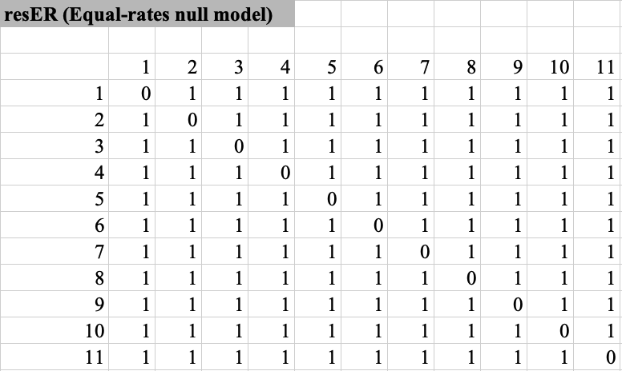

## Evaluating Markov Models for Ancestral Character Estimation

Using the XXX function of phytools (Revell, 2024), , maximum likelihood was used to estimate parameter values that best explain the observed trap type distribution under each model. The maximized log-likelihood (lnL) under each model was used to calculate the Akaike Information Criterion (AIC) for each model, in order to measure the statistical difference in fit between all models (Lanfear et al., 2014).

Ancestral Character Estimation using phytools and BioGeoBEARS

Under a given model, the probability of different ancestral trap types was estimated for ancestral species using ancestral character estimation. To estimate the number and timing of transitions, ancestral character estimation was supplemented with stochastic mapping (function simmap (?) in phytools).

Phylogenetic stochastic mapping conducts probabilistic sampling of ancestral states to simulate possible evolutionary histories of trap types across the phylogenetic tree while considering the uncertainty associated with character changes. We ran 100 stochastic simulations to generate generated a distribution of potential trap-type histories for each ancestral node.

To visualise the distribution of ancestral states along key branches within each family, state distribution plots were generated to illustrate changes in character state probabilities over time along these branches to provide a dynamic view of gradual state transitions. For each stochastic map, the cumulative time of transitions within each branch segment was recorded, and a dominant state was assigned to each time interval based on these cumulative timings. This data was organised into a matrix, where each row represented a stochastic map, and each column represented a time interval along the branch, capturing which state was dominant at each time slice along the branch length. To determine the prevalence of each state, the relative frequency of each state within each time interval was calculated across all stochastic maps, generating a probability distribution for each state over time along the branch. This information was summarised in a matrix of state proportions over time, where each cell represented the percentage of a specific state at a given time point along the branch. The final state distribution plot was created by visualising these probabilities as stacked density curves, with each colour-coded area representing the proportion of each state across intervals along the branch.

# 

# **Results**

## **Model Selection**

18 models provided a maximised log-likelihood (LnL) and AIC with AIC weights for each model (**Table. 6**). The best-fitting model res7abprCTE, which explains the pitcher hypothesis, was selected based on the lowest AIC value and the highest AIC weight (**Table. 6**).

***Table 6:*** AIC summary table for each phylogenetic model. Provided are model log-likelihoods, delta AIC (difference from the best/lowest AIC), relative likelihood (rel_likes), AIC values and weights.

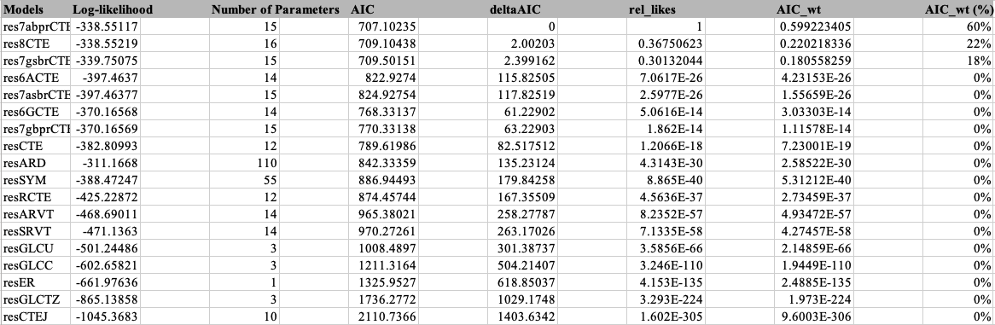

## ***Lentibulariaceae***

Phylogenetic stochastic mapping under the best-fitting res7abprCTE model suggests that the lowest common ancestor in *Lentibulariaceae* is non-carnivorous (indicated by the white node near the root, see **Fig. 2** for trap type colour labels). The ancestral character estimation indicates that the early carnivorous form in *Lentibulariaceae* may have started with a transitional trap type, represented here by grey nodes (see **Fig. 3**). This transitional state then diverged into more specialised traps over time (*Utricularia,* *Genlisea*, and *Pinguicula*). Notably, the ancestral transitional trap may have gradually evolved into the ancestral state of both eel and ground pitcher trap (lowest common ancestor of *Utricularia*+*Genlisea*). In contrast, the resER, equal-rates model shows different early carnivorous ancestral states, suggesting that it is an aquatic pitcher, combined with amphibious, transitional and non-carnivorous characters (see **Fig. 4**).

State distribution plots can visualise the change in ancestral states along key branches. The lowest common ancestor in *Lentibulariaceae* under res7abprCTE model shows non-carnivorous; however, the plot suggests that the common ancestor gradually transitioned, the ground adhesive and transitional state appears over time, and evolved into the ancestral transitional state, with ground adhesive character (see **Fig. 5**). The ancestral transitional state then lost ground adhesive character, the ground pitcher character appears alongside with losing the transitional trait over time, and evolved into the ancestral state of both eel and ground pitcher trap (see **Fig. 6**).

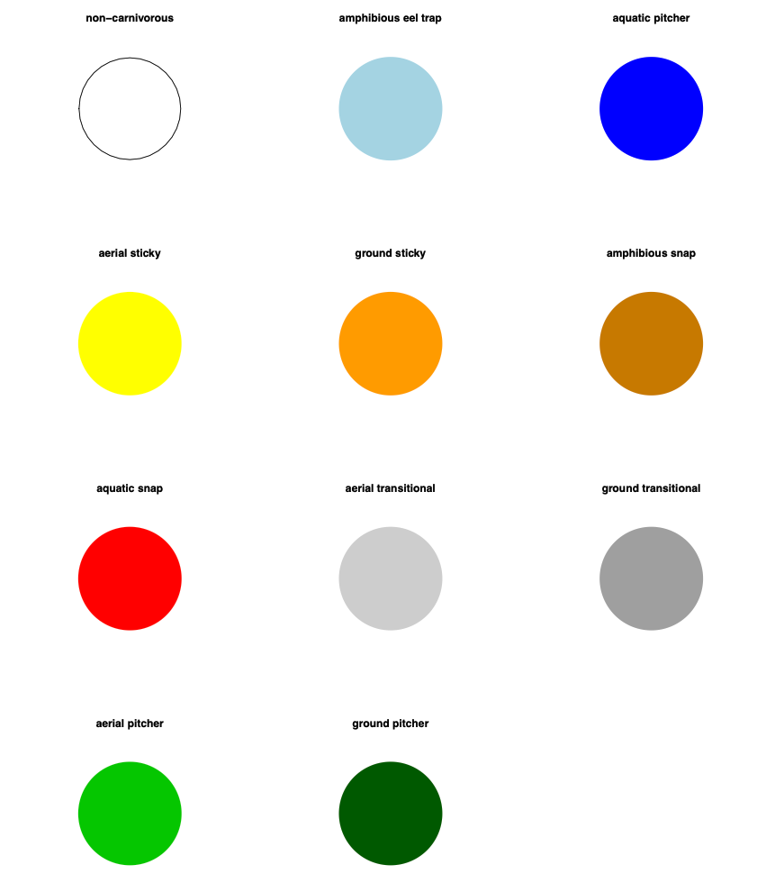

***Figure 2:*** Trap type legend for carnivorous plants, showing the various trapping mechanisms and their associated colours. Each pie chart represents a distinct trap type, with the colour indicating the trap’s classification.

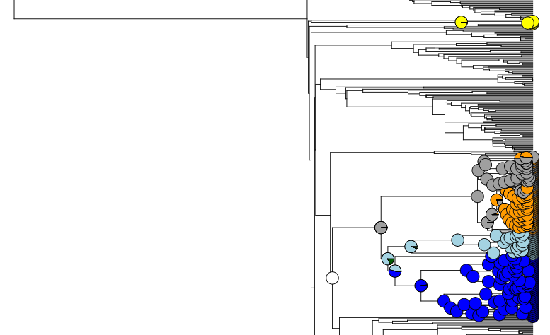

***Figure 3:*** Phylogenetic stochastic mapping in the *Lentibulariaceae* under the best-fitting model (res7abprCTE) suggests that the lowest common ancestor of the clade was non-carnivorous and the early carnivorous form was a transitional trap. The dark blue clade represents *Utricularia*, light blue represents *Genlisea*, and the clade mixed with grey and orange represents *Pinguicula*.

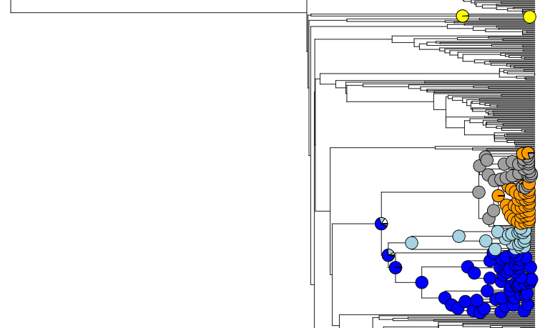

***Figure 4:*** Phylogenetic stochastic mapping in the *Lentibulariaceae* under the equal-rates model (resER) shows a different early carnivorous ancestral state, which suggests that it is an aquatic pitcher. The dark blue clade represents *Utricularia*, light blue represents *Genlisea*, and the clade mixed with grey and orange represents *Pinguicula*.

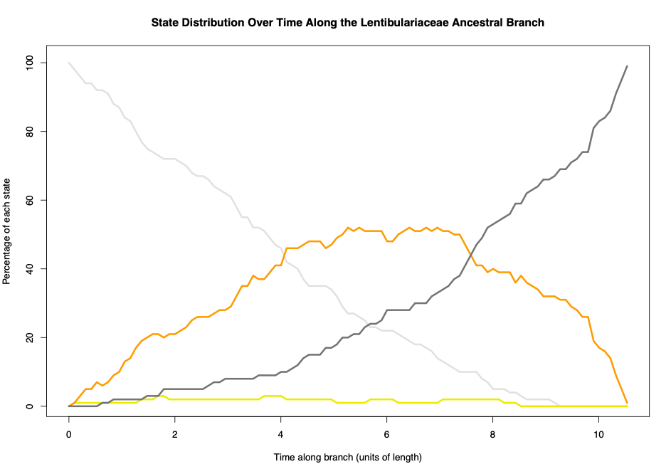

***Figure 5:*** State distribution over time along the Lentibulariaceae ancestral branch, showing the percentage of each state at different points along the branch's length. Colours represent different states: dark grey for the ground transitional state, orange for the ground adhesive state, yellow for the aerial adhesive state, and white for non-carnivorous state. The plot illustrates changes in the prevalence of each state over time, with the ground transitional state peaking in frequency before giving way to the ancestral amphibious state with ground pitch characteristics.

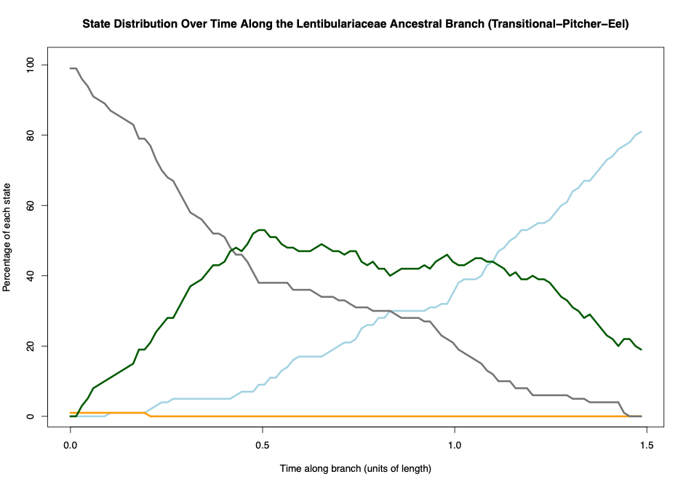

***Figure 6:*** State distribution over time along the Lentibulariaceae ancestral branch, showing the percentage of each state at different points along the branch's length. Colours represent different states: dark grey for the ground transitional state, orange for the ground adhesive state, dark green for the ground pitcher state, and light blue for amphibious eel trap. The plot illustrates changes in the prevalence of each state over time, with the amphibious eel trap peaking in frequency, with ground pitcher characteristics before giving way to the ancestral aquatic pitcher state with amphibious eel trap characteristics.

## 

# 

# 

## ***Sarraceniaceae***

The lowest common ancestor in *Sarraceniaceae* under the best model (res7abprCTE) appears to be non-carnivorous, with aerial and ground adhesive characters and the early carnivorous form is transitional+aerial pitcher, with ground pitcher character (see **Fig. 7**). The state distribution plot visualises the gradual evolutionary transition over time along this branch, suggesting that adhesive characters appear alongside aerial transitional character; however, adhesive characters disappear while pitcher characters appear over time (see **Fig. 8**).

## 

***Figure 7:*** Phylogenetic stochastic mapping in the *Sarraceniaceae* under the best-fitting model (res7abprCTE) suggests that the lowest common ancestor of the clade was non-carnivorous (with adhesive characteristics) and the early carnivorous form was a pitcher trap (with aerial transitional state). The clade mixed with dark green and light green represents *Sarraceniaceae*.

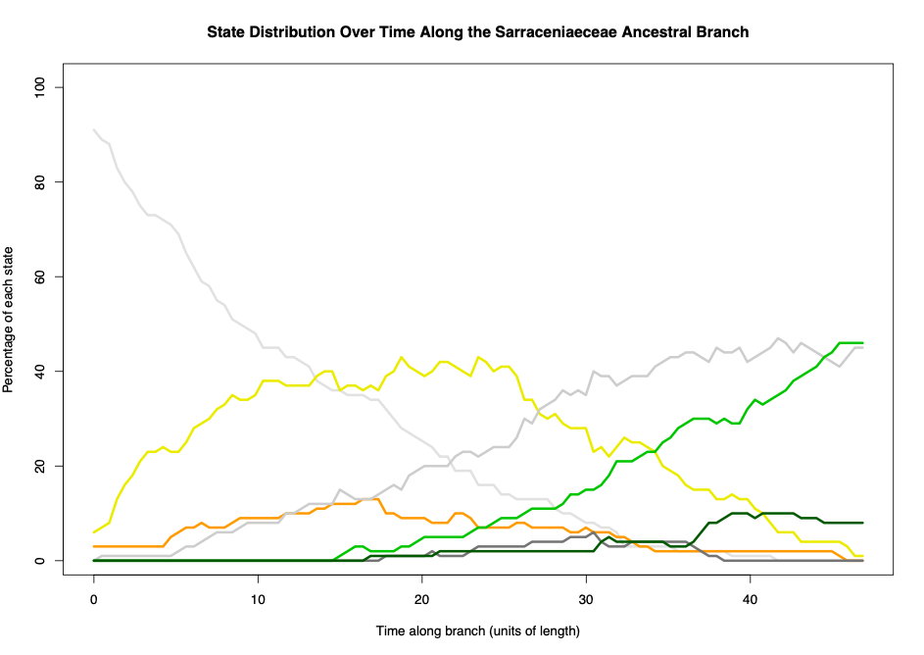

***Figure 8:*** State distribution over time along the *Sarraceniaceae* ancestral branch, showing the percentage of each state at different points along the branch's length. Colours represent different states: dark grey for the ground transitional state, orange for the ground adhesive state, yellow for the aerial adhesive state, dark green for the ground pitcher state, light green for the aerial pitcher state, and light grey for aerial transitional state, and white for non-carnivorous.

## ***Nepenthaceae* and *Droseraceae***

The lowest common ancestor of *Nepenthaceae* and *Droseraceae* under the best model (res7abprCTE) appears to be non-carnivorous and the early carnivorous form is an adhesive (aerial+ground) state (see **Fig. 9**). The state distribution plot along this branch shows that adhesive characters (aerial+ground) appear, and gradually evolved to the early carnivorous form of adhesive state (see **Fig. 10**).

## ***Nepenthaceae***

The lowest common ancestor of *Nepenthaceae* appears to be an adhesive state with ground transitional character (see **Fig. 9**). The ancestral state then gradually evolved to ancestral aerial pitcher state with aerial transitional character. The state distribution along this branch shows that adhesive state disappears alongside aerial transitional character appearing over time, which disappears over time, while aerial pitcher character takes over (see **Fig. 11**).

## ***Droseraceae***

The lowest common ancestor of *Droseraceae* appears to be a ground-based adhesive state (see **Fig. 9**). The state distribution plot shows the transition from the lowest common ancestor of *Nepenthaceae* and *Droseraceae*, that ground adhesive character gradually takes over as time goes on (see **Fig. 12**).

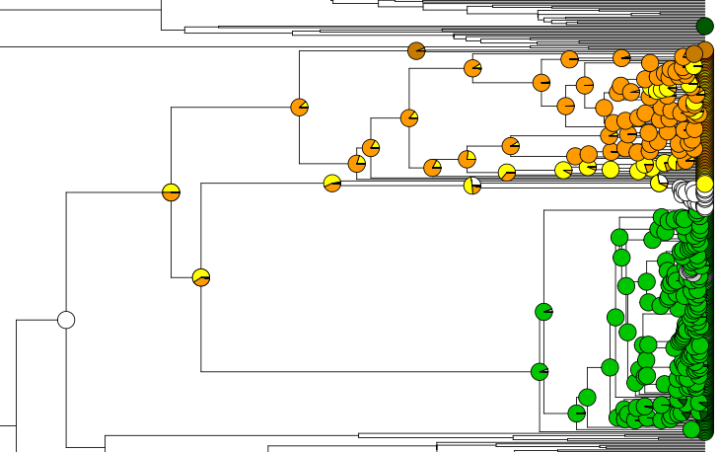

***Figure 9:*** Phylogenetic stochastic mapping in the *Nepenthaceae + Droseraceae* under the best-fitting model (res7abprCTE) suggests that the lowest common ancestor of the clades was non-carnivorous and the early carnivorous form was a adhesive trap. The green clade represents *Nepenthaceae*, and the clade mixed with yellow and orange represents *Droseraceae*.

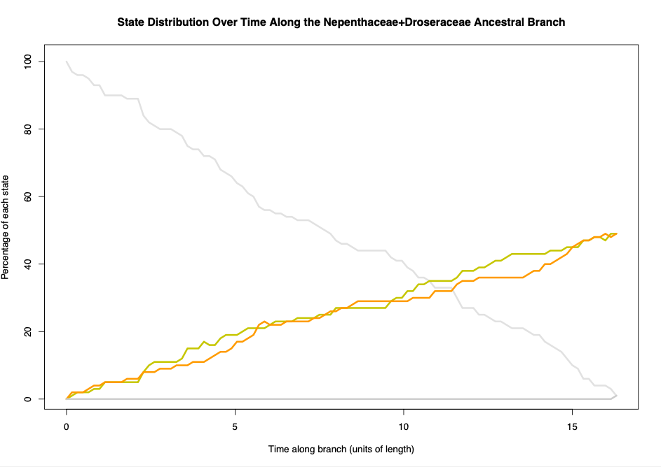

***Figure 10:*** State distribution over time along the *Nepenthaceae + Droseraceae* ancestral branch, showing the percentage of each state at different points along the branch's length. Colours represent different states: white for the ground transitional state, orange for the ground adhesive state, and yellow for the aerial adhesive state.

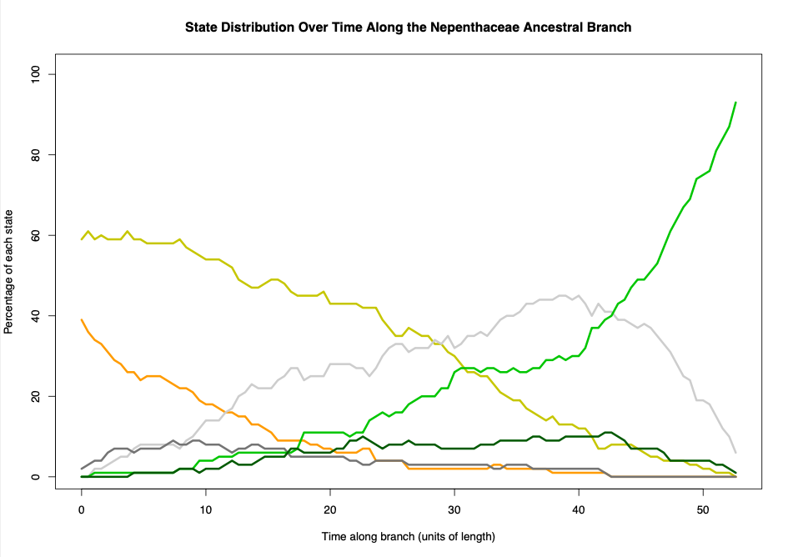

***Figure 11:*** State distribution over time along the *Nepenthaceae* ancestral branch, showing the percentage of each state at different points along the branch's length. Colours represent different states: dark grey for the ground transitional state, orange for the ground adhesive state, yellow for the aerial adhesive state, dark green for the ground pitcher state, light green for the aerial pitcher state, and light grey for aerial transitional state.

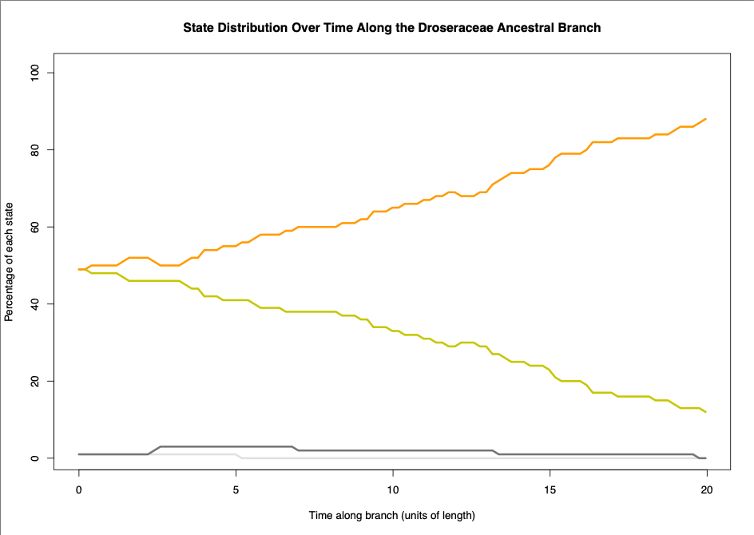

***Figure 12:*** State distribution over time along the *Droseraceae* ancestral branch, showing the percentage of each state at different points along the branch's length. Colours represent different states: white for the ground transitional state, orange for the ground adhesive state, yellow for the aerial adhesive state, and dark grey for the ground transitional state.

# 

# Discussion

Our analyses support the pitcher hypothesis, which posits a gradual evolutionary transition for the origin of *Utricularia* traps as models based on this hypothesis were consistently selected among the top eight models. The pitcher hypothesis models (resCTE, resRCTE, res6ACTE, res6GCTE, res7abprCTE, res7asbrCTE, res7gsbrCTE, res7asbrCTE, and res8CTE) explain ancestral carnivorous plants with simple flypaper traps (adhesive traps) evolved through an intermediate transitional state, exhibiting both adhesive and pitcher characteristics, before evolving into pitcher traps and subsequently evolving into *Utricularia* traps. These models explore different evolutionary transition scenarios, such as whether the transition from one to another is reversible. Among the models tested, the best-supported model was res7abprCTE, which aligns with the pitcher hypothesis; however, the model does not allow a transition from aerial transitional trap to the aerial adhesive trap. This indicates a constrained evolutionary pathway that may have favoured the transition of pitcher traits over reverting to or retaining aerial adhesive characteristics, suggesting a directional shift towards complex pitcher traps in the evolutionary history of these traps. State distribution plots along the *Nepenthaceae* and *Sarraceniaceae* ancestral branches further support this constrained evolutionary pathway (**Fig. 8** and **Fig. 11**). Initially, an aerial adhesive state (represented by yellow) is present; however, as time progresses, the aerial transitional state (represented by light grey) increasingly dominates, eventually overtaking the aerial adhesive state. This transition highlights a directional shift from simple adhesive traps towards more complex transitional characteristics, which likely facilitated the evolution of pitcher and *Utricularia* traps. The persistence of this pattern across both families reinforces the hypothesis of a gradual and constrained evolutionary trajectory within carnivorous plant lineages.

The best-fitting model res7abprCTE (pitcher hypothesis) was selected based on the lowest AIC value of 707.10235 and the highest AIC weight of 60%. The consistent selection of pitcher hypothesis models indicates that our models provide better fit to the data (megaphylogeny) than alternative scenarios. The 9th and 10th models selected were resSYM (symmetric model) and resARD (all-rates different model). The Symmetric (SYM) and All Rates Different (ARD) models are standard options in discrete-character evolution software, frequently employed to study the transition dynamics between discrete character states, such as those representing traits in evolutionary biology. The Symmetric model assumes that the rates of change between any two character states are equivalent in both directions, adhering to a symmetric transition matrix. In contrast, the All Rates Different (ARD) model relaxes this constraint, allowing for distinct rates for forward and reverse transitions between character states. This implies that the process of transitioning from one state to another might occur at different rates than the reverse transition. Both models serve as valuable tools for understanding the evolutionary dynamics of discrete traits, with the Symmetric model representing a more constrained scenario and the ARD model offering greater flexibility by acknowledging potential asymmetries in the rates of character state changes. ARD model scored log-likelihood of -311.1668, which is closer to zero than the best-fitting model res7abprCTE (-338.55117). At this stage, resARD model is better fit than res7abprCTE; however, the AIC (Akaike Information Criterion) is a statistical measure that balances the goodness of fit of a model with the complexity of the model, effectively penalising models with more parameters (Akaike, 1987). In the context of the phylogenetic models, resARD and res7abprCTE, the AIC scores provide a quantitative assessment of model performance. The AIC score incorporates both the likelihood of the model and the number of parameters, aiming to select the model that achieves the best balance between fit and simplicity. In comparing these models, resARD exhibits higher log-likelihood scores compared to the best-fitting model; however, the AIC considers the number of parameters in addition to the likelihood. The resARD model includes 110 parameters, and the res7abprCTE model has 15 parameters. AIC penalises models with more parameters, reflecting the principle of parsimony favouring simpler models that can adequately explain the data. This emphasises the trade-off between model complexity and goodness of fit, encouraging selection of a model that achieves a balance suitable for the specific dataset and research question.

Asymmetric and symmetric rate variation by trapping zone models (resARVT and resSRVT) refer to the implementation of rate transition parameters to the model based on trapping zones (aerial, ground, etc.) rather than trap types (pitcher, sticky, etc.). These models were selected at 12th and 13th based on their AIC. Regarding trapping zone models, resGLCTZ (gain-loss-change within trapping zone model) was selected at 17th. In addition, resGLCU (gain-loss-change unconstrained model) and resGLCC (gain-loss-change constrained model) were selected at 14th and 15th. The gain-loss-change unconstrained model allows for the loss of carnivory, gain of carnivory and the change between any types of trap. In contrast, the constrained model is limited in terms of allowing only for change within the same type of trap. These models are based on types of traps, rather than considering their trapping zones. As a result, these models' scores suggest that considering a singular aspect of the character state, whether it be the transition between trapping zones or types of traps, may offer an incomplete portrayal of the evolution of carnivorous plant traps. In particular, the resGLCTZ model, which focuses on gain-loss-change within trapping zones, and the resGLCU and resGLCC models, which respectively permit and restrict changes in trap types, underscore the significance of incorporating a comprehensive perspective. The resGLCU model, acknowledging the potential for loss and gain of carnivory and transitions across various trap types, recognises the complexity inherent in the evolutionary history of carnivorous plants. Conversely, the resGLCC model, constrained to changes within the same trap type, provides insights into more limited aspects of evolutionary dynamics. These nuanced distinctions emphasise that a holistic understanding of carnivorous plant trap evolution necessitates the consideration of both trapping zones and trap types. Moreover, models such as resARVT and resSRVT, which introduce rate transition parameters based on trapping zones over those exclusively centred on trap types (e.g., pitcher hypothesis models), highlight the significance of ecological adaptations associated with different trapping zones. It underscores the inadequacy of a unidimensional approach and advocates for a multifaceted framework that encapsulates the varied dimensions of carnivorous plant trap evolution. The equal-rate model (resER) refers to the model that all character states have equal rates to transition into any character states, which is ranked 16th under model selection. Finally, the worst model chosen was resCTEJ (Complex Trap Evolution-Jump model), which refers to the model based on pitcher hypothesis models; however these explains gradual evolutionary transitions (e.g. adhesive traps evolve to transitional traps, and then into pitcher traps), whereas resCTEJ model skips the evolutionary step (e.g. adhesive traps evolve to pitcher traps, without intermediate transitional state).

As articulated earlier, the equal-rate model (resER), ranking 16th under the model selection framework, posits uniform transition rates across all character states. While this model offers a simplified representation, it suggests that a more nuanced consideration of variable transition rates is essential for accurately capturing the intricacies of carnivorous plant trap evolution. Conversely, the resCTEJ model, rooted in the resM05 pitcher hypothesis, emerges as the least favoured model within the selection process. This discrepancy suggests the importance of modelling the gradual evolutionary transitions. The concept of a gradual evolutionary process posits that most evolutionary changes occur incrementally through gradual allelic substitution, leading to major adaptations over extended periods (Gould, 1980). The concept of gradualism, as opposed to punctuated equilibrium or abrupt jumps in evolutionary trajectories, has been a subject of extensive scientific discourse. Notably, the works of palaeontologists Stephen Jay Gould and Niles Eldredge proposed the theory of punctuated equilibrium, suggesting that evolutionary changes often occur rapidly in isolated populations, followed by prolonged periods of stability (Gould & Eldredge, 1977). In the carnivorous plant trap evolution context, the gradual process posited by res7abprCTE aligns with the broader understanding of evolutionary biology. For instance, a study on animal evolution by Douglas J. Emlen emphasises the role of gradual adaptation in shaping complex structures. The research on the evolution of exaggerated traits in insects shows that gradual changes in the function and form of weapons, driven by various mechanisms, contribute to the remarkable diversity observed in animal weapon structures (Emlen, 2008). This provides valuable perspectives on the significance of gradualism in diverse carnivorous plant traps.

# Pitcher to *Utricularia* bladder, the miniaturised aquatic pitcher traps

While our analyses strongly support the pitcher hypothesis, especially on gradual evolutionary transition from simple adhesive traps into pitcher traps through intermediate transitional traps, the key concept of the hypothesis; *Utricularia* bladder traps evolved from pitcher traps, is supported as well. The state distribution plot (**Fig. 6**) shows the transition from ancestral ground transitional traps to ancestral amphibious traps, with ground pitcher characteristics. The transition starts with the ancestral ground pitcher taking over the ancestral ground transitional characteristic, and the ancestral ground pitcher then gradually evolving into the ancestral amphibious pitcher traps, with some ground pitcher characteristics, which then later transitioning into aquatic pitcher, with some amphibious pitcher characteristic (**Fig. 6**).

Recent discovery, a new species of *Nepenthes pudica*, from North Kalimantan, Borno, is the first carnivorous plant species confirmed to use pitfall traps specifically in the underground environments (Dančák et al., 2022). These pitchers can capture prey of the same size as those caught by aerial and ground pitchers in other *Nepenthes* species, unlike other genera of carnivorous plants with underground traps that only catch microscopic or very small prey (Dančák et al., 2022). As previously mentioned Givnish et al. (1984) stated a cost/benefit model for the evolution of plant carnivory, which suggests that the costs of carnivory are metabolically costly to produce dye to require significant energy and resources. This creates a trade-off; the plant must balance the energy spent on creating these traps with the energy needed for other essential functions like photosynthesis. In the genus *Nepenthes*, this trade-off often leads to a spatial separation of functions within the same leaf; they have lamina, the main part of the leaf is primarily for photosynthesis, while they also have tendril that extends from lamina, which later develops into pitcher traps (Dančák et al., 2022). On the other hand, *Nepenthes pudica* shows an unusual separation of function at the level of shoot. It has aerial shoots that produce leaves that are exposed to sunlight, optimised for capturing light energy and performing photosynthesis, while subterranean shoots produce leaves, which later develop underground pitchers, where they capture soil-dwelling prey. These underground shoots likely lack chlorophyll, as their primary role is not photosynthesis but prey capture (Dančák et al., 2022). This strategy in *Nepenthes pudica* is similar to *Utricularia* species in that they exhibit the separation of function at the level of shoot; shoots having small bladder traps that catch small aquatic organisms, and shoots extending towards the surface where they can access the sunlight for photosynthesis (Dančák et al., 2022). *N. pudica's* unique shoot-level spatial separation where underground shoots develop pitchers and aerial shoots focus on photosynthesis, is similar to the aquatic *Utricularia*; therefore *N. pudica* could be seen as a transitional state between typical terrestrial pitcher plants and more specialised forms like *Utricularia*. The adaptation to subterranean prey capture could represent an intermediate step towards the evolution of more specialised aquatic traps, which aligns with our pitcher hypothesis.

# Limitations and Future Directions

The study on the evolutionary dynamics of carnivorous plant traps, particularly focusing on *Utricularia*, has its inherent limitations that should be considered. One significant constraint pertains to the data utilised in the analysis. The study's scope and depth may be contingent upon the availability and completeness of existing data on *Utricularia* and other carnivorous plant lineages. Incomplete or limited datasets could potentially introduce biases or gaps in our understanding of trap evolution. Addressing this limitation would require acquiring more extensive datasets or capitalising on future discoveries in carnivorous plant research. Another set of limitations arises from the modelling assumptions inherent in the study. While robust, the chosen models and methodologies involve certain assumptions about evolutionary processes. Simplifications within these models might not fully capture the intricacies of trap evolution. Exploring alternative modelling approaches could provide a more nuanced and comprehensive understanding of the evolutionary dynamics under consideration. Additionally, assessing the sensitivity of results to different modelling assumptions would contribute to a more robust interpretation of findings. The study's ecological context is another area of limitation. While the research delves into trap evolution, the intricate interplay between ecological factors and the evolutionary trajectories of carnivorous plants may not be fully captured. This limitation prompts future research avenues to explore the specific ecological triggers, nutrient dynamics, and interactions with other species that shape the evolution of carnivorous plant traps. Temporal resolution represents a further limitation. The study employs r8s for temporal calibration of non-dated trees, introducing a degree of uncertainty into the temporal aspects of trap evolution. Improved dating methods or access to more dated samples could enhance the temporal resolution of the study and provide a more accurate timeline for the evolutionary events under investigation.

Addressing the limitations outlined above opens up promising avenues for future research in the field of carnivorous plant trap evolution. One potential direction involves conducting ecological experiments in natural environments. Such experiments could explain the ecological triggers and selective pressures that drive the evolution of carnivorous plant traps. Exploring factors such as nutrient availability, prey abundance, and interspecies interactions would provide a more holistic understanding of the ecological context of carnivorous plant adaptations. Integrating genomic analysis into future studies represents another direction that researchers can better understand the molecular mechanisms driving trap development. Comparative genomics, in particular, could unveil key genes associated with different trap types and their evolution. A focus on functional morphology studies offers yet another avenue for future exploration. Detailed examinations of the functional morphology of various trap types can deepen our understanding of how specific adaptations contribute to prey capture and nutrient acquisition. This could involve anatomical studies and functional experiments to elucidate the mechanisms behind the diverse trapping strategies observed in carnivorous plants. Adding further species to our trap type database (for example, most of the large carnivorous genera are only partially sampled by published phylogenies) may increase our ability to statistically distinguish similar phylogenetic models. Comparative analyses across different plant families can reveal commonalities and differences in trap evolution, contributing to a more holistic understanding of this intriguing phenomenon. Finally, investigating long-term evolutionary trends represents a valuable future direction. This could involve exploring fossil evidence or examining the paleobiogeography of carnivorous plants may help gain insights into the extended temporal perspective of carnivorous plant trap evolution. Such long-term perspectives could reveal patterns and trends that may not be apparent in phylogenies of living species.

# 

# Acknowledgements

I would like to express my sincere gratitude to Dr. Nick Matzke, whose expertise in phylogeny and biogeography and unwavering support made this research possible. His guidance, from introducing the research to providing assistance in bioinformatics and computational analysis, has been invaluable. I appreciate his patience in helping me navigate R studio coding and answering my numerous questions. I am truly grateful for the opportunity he gave me to delve into my passion for evolution, phylogeny, and biogeography.

# Supplementary Materials

11-rates matrix excel

Model selection excel

Carnivorous plant data excel

# 

# **Appendices**

# 

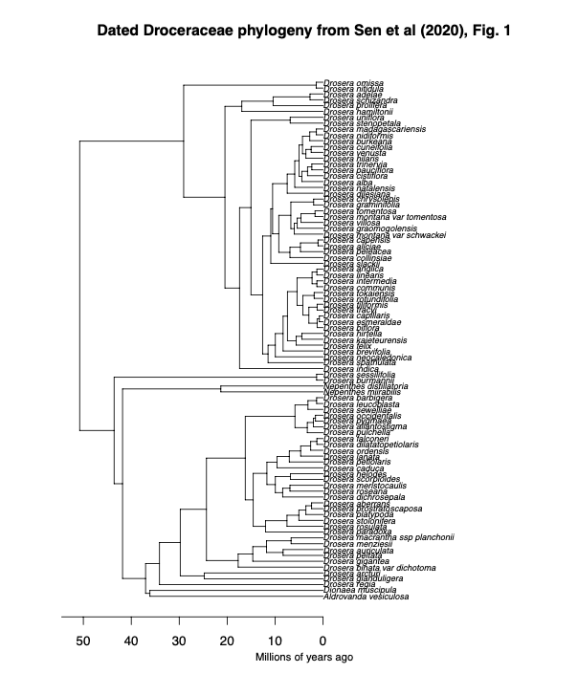

**Appendix 1:** Digitised *Droceraceae* phylogenetic tree from Sen et al. (2020), Fig. 1. The tree was manually digitised using the WebPlotDigitizer tool, allowing quantitative data extraction from the original graphical representation. Calibration of axes was performed based on estimated time (million years ago), ensuring accurate scaling. Data points corresponding to tips, nodes, and corners positions were digitised.

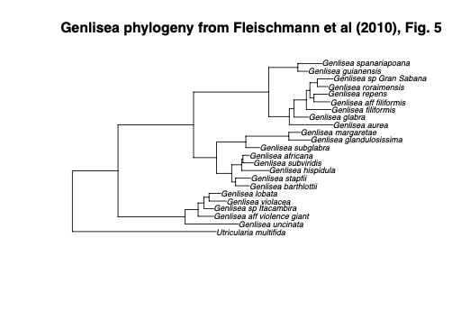

**Appendix 2:** Digitised *Genlisea* phylogenetic tree from Fleischmann et al. (2010), Fig. 5. The tree was manually digitised using the WebPlotDigitizer tool, allowing quantitative data extraction from the original graphical representation. Calibration of axes was performed based on branch length (0.03), ensuring accurate scaling. Data points corresponding to tips, nodes, and corners positions were digitised.

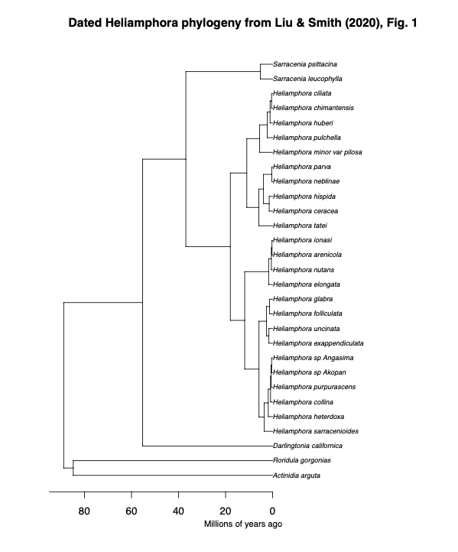

**Appendix 3:** Digitised *Heliamphora* phylogenetic tree from Liu and Smith (2020), Fig. 1. The tree was manually digitised using the WebPlotDigitizer tool, allowing quantitative data extraction from the original graphical representation. Calibration of axes was performed based on estimated time (million years ago), ensuring accurate scaling. Data points corresponding to tips, nodes, and corners positions were digitised.

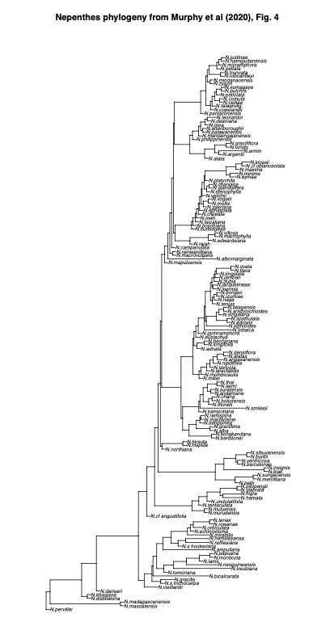

**Appendix 4:** Digitised *Nepenthes* phylogenetic tree from Murphy et al. (2020), Fig. 4. The tree was manually digitised using the WebPlotDigitizer tool, allowing quantitative data extraction from the original graphical representation. Calibration of axes was performed based on branch length (0.5), ensuring accurate scaling. Data points corresponding to tips, nodes, and corners positions were digitised.

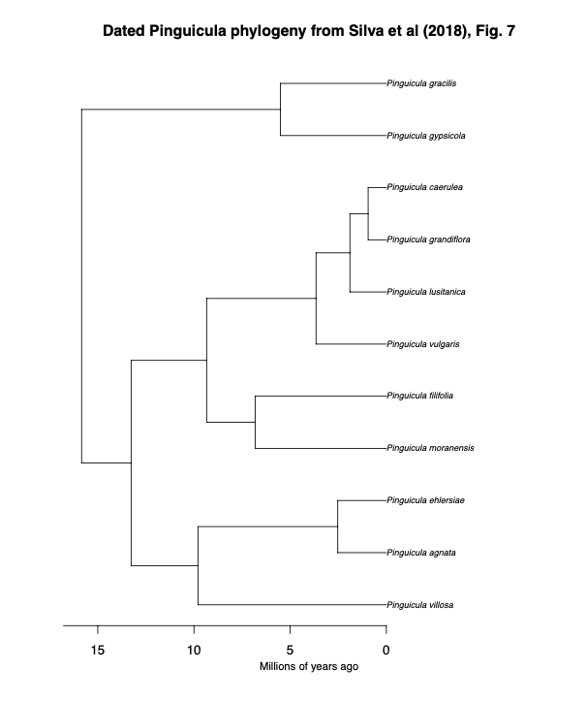

**Appendix 5:** Digitised *Pinguicula* phylogenetic tree from Shimai et al. (2021), S1 Fig. 1. The tree was manually digitised using the WebPlotDigitizer tool, allowing quantitative data extraction from the original graphical representation. The tree was not available for estimated and branch length; thus used r8s programme to ensure accurate scaling when assembling trees. Data points corresponding to tips, nodes, and corners positions were digitised.

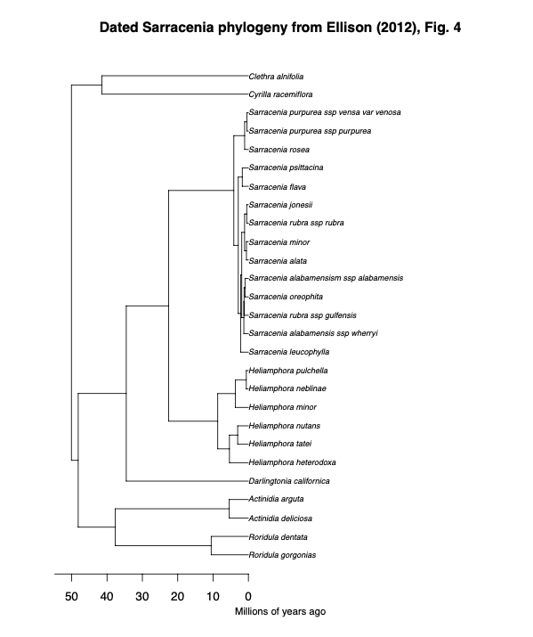

**Appendix 6:** Digitised *Sarracenia* phylogenetic tree from Ellison et al. (2012), Fig. 4. The tree was manually digitised using the WebPlotDigitizer tool, allowing quantitative data extraction from the original graphical representation. Calibration of axes was performed based on estimated time (million years ago), ensuring accurate scaling. Data points corresponding to tips, nodes, and corners positions were digitised.

# References

Adamec, L. (2018). Biological flora of Central Europe: Aldrovanda vesiculosa L. *Perspectives in Plant Ecology, Evolution and Systematics*, *35*, 8–21.<https://doi.org/10.1016/j.ppees.2018.10.001>

Adlassnig, W., Peroutka, M., & Lendl, T. (2011). Traps of carnivorous pitcher plants as a habitat: Composition of the fluid, biodiversity and mutualistic activities. *Annals of Botany*, *107*(2), 181–194.

Akaike, H. (1987). Factor analysis and AIC. *Psychometrika*, *52*(3), 317–332.<https://doi.org/10.1007/BF02294359>

Albert, V. A., Jobson, R. W., Michael, T. P., & Taylor, D. J. (2010). The carnivorous bladderwort (Utricularia, Lentibulariaceae): A system inflates. *Journal of Experimental Botany*, *61*(1), 5–9.<https://doi.org/10.1093/jxb/erp349>

Böhm, J., Scherzer, S., Krol, E., Kreuzer, I., von Meyer, K., Lorey, C., Mueller, T. D., Shabala, L., Monte, I., Solano, R., Al-Rasheid, K. A. S., Rennenberg, H., Shabala, S., Neher, E., & Hedrich, R. (2016). The Venus Flytrap Dionaea muscipula Counts Prey-Induced Action Potentials to Induce Sodium Uptake. *Current Biology*, *26*(3), 286–295.<https://doi.org/10.1016/j.cub.2015.11.057>

Carmesin, C. F., Fleischmann, A. S., Klepsch, M. M., Westermeier, A. S., Speck, T., Jansen, S., & Poppinga, S. (2021). Structural gradients and anisotropic hydraulic conductivity in the enigmatic eel traps of carnivorous corkscrew plants (Genlisea spp.). *American Journal of Botany*, *108*(12), 2356–2370.<https://doi.org/10.1002/ajb2.1779>

Cook, Steve R. (2001). When plants kill, accessed online: October 10, 2001. URL: <https://web.archive.org/web/20040207035715/http://www.steve.gb.com/vegetable_empire/murder.html>

Craw, R. C., Grehan, J. R., & Heads, M. J. (1999). *Panbiogeography: Tracking the History of Life*. Oxford University Press, Incorporated.<http://ebookcentral.proquest.com/lib/auckland/detail.action?docID=430300>

Dančák, M., Majeský, Ľ., Čermák, V., Golos, M. R., Płachno, B. J., & Tjiasmanto, W. (2022). First record of functional underground traps in a pitcher plant: Nepenthes pudica (Nepenthaceae), a new species from North Kalimantan, Borneo. *PhytoKeys*, *201*, 77–97.<https://doi.org/10.3897/phytokeys.201.82872>

Darwin, C. & D. Appleton and Company. (1875). *Insectivorous Plants*. London: Murray. <https://darwin-online.org.uk/content/frameset?itemID=F1217&viewtype=text&pageseq=1>

Darwin, C.D. (1875b), “Letter no. 10088,” Darwin Correspondence Project. accessed on 6 June 2023. <https://www.darwinproject.ac.uk/letter/?docId=letters/DCP-LETT-10088.xml>

Wallace, A. R. (1875), “Letter no. 10085,” Darwin Correspondence Project. accessed on 6 June 2023. <https://www.darwinproject.ac.uk/letter/?docId=letters/DCP-LETT-10085.xml>

Di Giusto, B., Bessière, J.-M., Guéroult, M., Lim, L. B. L., Marshall, D. J., Hossaert-Mckey, M., & Gaume, L. (2010). Flower-scent mimicry masks a deadly trap in the carnivorous plant Nepenthes rafflesiana. *Journal of Ecology*, *98*(4), 845–856.

Ellison, A. M., Butler, E. D., Hicks, E. J., Naczi, R. F. C., Calie, P. J., Bell, C. D., & Davis, C. C. (2012). Phylogeny and Biogeography of the Carnivorous Plant Family Sarraceniaceae. *PLoS ONE*, *7*(6), e39291.<https://doi.org/10.1371/journal.pone.0039291>

Ellison, A. M., & Gotelli, N. J. (2001). Evolutionary ecology of carnivorous plants. *Trends in Ecology & Evolution*, *16*(11), 623–629.<https://doi.org/10.1016/S0169-5347(01)02269-8>

Emlen, D. J. (2008). The Evolution of Animal Weapons. *Annual Review of Ecology, Evolution, and Systematics*, *39*, 387–413.

Fleischmann, A., Schäferhoff, B., Heubl, G., Rivadavia, F., Barthlott, W., & Müller, K. F. (2010). Phylogenetics and character evolution in the carnivorous plant genus Genlisea A. St.-Hil. (Lentibulariaceae). *Molecular Phylogenetics and Evolution*, *56*(2), 768–783.<https://doi.org/10.1016/j.ympev.2010.03.009>

Forterre, Y., Skotheim, J. M., Dumais, J., & Mahadevan, L. (2005). How the Venus flytrap snaps. *Nature*, *433*(7024), 421–425.<https://doi.org/10.1038/nature03185>

Gaascht, F., Dicato, M., & Diederich, M. (2013). Venus Flytrap (Dionaea muscipula Solander ex Ellis) Contains Powerful Compounds that Prevent and Cure Cancer. *Frontiers in Oncology*, *3*, 202.<https://doi.org/10.3389/fonc.2013.00202>

Gould, S. J. (1980). Is a New and General Theory of Evolution Emerging? *Paleobiology*, *6*(1), 119–130.

Gould, S. J., & Eldredge, N. (1977). Punctuated Equilibria: The Tempo and Mode of Evolution Reconsidered. *Paleobiology*, *3*(2), 115–151.

Hotti, H., Gopalacharyulu, P., Seppänen-Laakso, T., & Rischer, H. (2017). Metabolite profiling of the carnivorous pitcher plants Darlingtonia and Sarracenia. *PLoS One*, *12*(2), e0171078.<https://doi.org/10.1371/journal.pone.0171078>

Jin, Y., & Qian, H. (2019). V.PhyloMaker: An R package that can generate very large phylogenies for vascular plants. *Ecography*, *42*(8), 1353–1359.<https://doi.org/10.1111/ecog.04434>

Jobson, R. W., Baleeiro, P. C., & Reut, M. S. (2017). Molecular phylogeny of subgenus Polypompholyx (Utricularia; Lentibulariaceae) based on three plastid markers: Diversification and proposal for a new section. *Australian Systematic Botany*, *30*(3), 259–278.<https://doi.org/10.1071/SB17003>

Juniper, B. E., Robins, R. J. and Joel, D. M., 1989. The Carnivorous Plants. Academic

Press, London ; San Diego.

Körner, C. (2016). Plant adaptation to cold climates. *F1000Research*, *5*.<https://doi.org/10.12688/f1000research.9107.1>

Kosakovsky Pond, S. L., Murrell, B., Fourment, M., Frost, S. D. W., Delport, W., & Scheffler, K. (2011). A Random Effects Branch-Site Model for Detecting Episodic Diversifying Selection. *Molecular Biology and Evolution*, *28*(11), 3033–3043.<https://doi.org/10.1093/molbev/msr125>

Krupa, J. J., Hopper, K. R., Gruber, S. B., Schmidt, J. M., & Harwood, J. D. (2020). Plant–animal interactions between carnivorous plants, sheet‐web spiders, and ground‐running spiders as guild predators in a wet meadow community. *Ecology and Evolution*, *10*(11), 4762–4772.<https://doi.org/10.1002/ece3.6230>

Kubitzki, K. (2003). Droseraceae. In K. Kubitzki & C. Bayer (Eds.), *Flowering Plants · Dicotyledons: Malvales, Capparales and Non-betalain Caryophyllales* (pp. 198–202). Springer.<https://doi.org/10.1007/978-3-662-07255-4_21>

Laakkonen, L., Jobson, R. W., & Albert, V. A. (2006). A New Model for the Evolution of Carnivory in the Bladderwort Plant (Utricularia): Adaptive Changes in Cytochrome c Oxidase (COX) Provide Respiratory Power. *Plant Biology*, *8*(6), 758–764.<https://doi.org/10.1055/s-2006-924459>

Lanfear, R., Calcott, B., Kainer, D., Mayer, C., & Stamatakis, A. (2014). Selecting optimal partitioning schemes for phylogenomic datasets. *BMC Evolutionary Biology*, *14*, 82.<https://doi.org/10.1186/1471-2148-14-82>

Lee, L., Zhang, Y., Ozar, B., Sensen, C. W., & Schriemer, D. C. (2016). Carnivorous Nutrition in Pitcher Plants ( *Nepenthes* spp.) via an Unusual Complement of Endogenous Enzymes. *Journal of Proteome Research*, *15*(9), 3108–3117.<https://doi.org/10.1021/acs.jproteome.6b00224>

Liu, S., & Smith, S. D. (2021). Phylogeny and biogeography of South American marsh pitcher plant genus Heliamphora (Sarraceniaceae) endemic to the Guiana Highlands. *Molecular Phylogenetics and Evolution*, *154*, 106961.<https://doi.org/10.1016/j.ympev.2020.106961>

Lloyd, F. E., & Lloyd, F. E. (1942). *The carnivorous plants, by Francis Ernest Lloyd* (pp. 1–376). Chronica Botanica Company.<https://doi.org/10.5962/bhl.title.5965>

Matzke, N. (2005). "Evolution of the *Utricularia* Bladder Trap: A Short Summary." *Bay Area Carnivorous Plant Society Newsletter*, Spring 2005. <https://web.archive.org/web/20120711211927/http://www.bacps.org/2005Spring.html#utrictrap>

Matzke N (2013). BioGeoBEARS: BioGeography with Bayesian (and Likelihood)

Evolutionary Analysis in R Scripts_. University of

California, Berkeley, Berkeley, CA.

Mithöfer, A. (2021). A spotlight on prey-induced metabolite dynamics in sundew. A commentary on: ‘Metabolomic analysis reveals reliance on secondary plant metabolites to facilitate carnivory in the Cape sundew, Drosera capensis.’ *Annals of Botany*, *128*(3), v–vi.<https://doi.org/10.1093/aob/mcab093>

Moldowan, P. D., Smith, M. A., Baldwin, T., Bartley, T., Rollinson, N., & Wynen, H. (2019). Nature’s pitfall trap: Salamanders as rich prey for carnivorous plants in a nutrient-poor northern bog ecosystem. *Ecology*, *100*(10), 1–4.

Moran, J. A. (1996). Pitcher Dimorphism, Prey Composition and the Mechanisms of Prey Attraction in the Pitcher Plant Nepenthes Rafflesiana in Borneo. *Journal of Ecology*, *84*(4), 515–525.<https://doi.org/10.2307/2261474>

Murphy, B., Forest, F., Barraclough, T., Rosindell, J., Bellot, S., Cowan, R., Golos, M., Jebb, M., & Cheek, M. (2020). A phylogenomic analysis of Nepenthes (Nepenthaceae). *Molecular Phylogenetics and Evolution*, *144*, 106668.<https://doi.org/10.1016/j.ympev.2019.106668>

Newell, S. J., & Nastase, A. J. (1998). Efficiency of Insect Capture by Sarracenia purpurea (Sarraceniaceae), the Northern Pitcher Plant. *American Journal of Botany*, *85*(1), 88–91.<https://doi.org/10.2307/2446558>

Paradis, E., & Schliep, K. (2019). ape 5.0: An environment for modern phylogenetics and evolutionary analyses in R. *Bioinformatics*, *35*(3), 526–528.<https://doi.org/10.1093/bioinformatics/bty633>

Płachno, B. J.; Silva, S. R., Świątek, P., Dixon, K. W., Lustofin, K., Seber, G. C., Miranda, V. F. O. (2020). Structural Features of Carnivorous Plant (Genlisea, Utricularia) Tubers as Abiotic Stress Resistance Organs. *International Journal of Molecular Sciences*, *21*(14), 5143.<https://doi.org/10.3390/ijms21145143>

Poppinga, S., Masselter, T., & Speck, T. (2013). Faster than their prey: New insights into the rapid movements of active carnivorous plants traps. *BioEssays*, *35*(7), 649–657.<https://doi.org/10.1002/bies.201200175>

Poppinga, S., Tim, K., Amélie, M., Speck, O., & Speck, T. (2016). Comparative kinematical analyses of Venus flytrap (Dionaea muscipula) snap traps. *Beilstein Journal of Nanotechnology*, *7*, 664–674.<https://doi.org/10.3762/bjnano.7.59>

Price, M. N., Dehal, P. S., & Arkin, A. P. (2010). FastTree 2 – Approximately Maximum-Likelihood Trees for Large Alignments. *PLoS ONE*, *5*(3), e9490.<https://doi.org/10.1371/journal.pone.0009490>

Revell, L. J. (2024). phytools 2.0: An updated R ecosystem for phylogenetic comparative methods (and other things). *PeerJ*.<https://doi.org/10.7717/peerj.16505>

Rice, B. (2007). Carnivorous plants with hybrid trapping strategies. *Carnivorous Plant Newsletter*, *36*(1), 23–27.<https://doi.org/10.55360/cpn361.br152>

Sanderson, M. J. (n.d.). *R8s, version 1.70 User’s Manual*.

Scorza, L. C. T., & Dornelas, M. C. (2011). Plants on the move: Towards common mechanisms governing mechanically-induced plant movements. *Plant Signaling & Behavior*, *6*(12), 1979.<https://doi.org/10.4161/psb.6.12.18192>

Sen, S., Tiwari, N., & Ganesan, R. (2020). *Eocene origin, Miocene diversification and intercontinental dispersal of the genus Drosera (Droseraceae)* (p. 2020.08.06.240234). bioRxiv.<https://doi.org/10.1101/2020.08.06.240234>

Shimai, H., Setoguchi, H., Roberts, D. L., & Sun, M. (2021). Biogeographical patterns and speciation of the genus Pinguicula (Lentibulariaceae) inferred by phylogenetic analyses. *PLOS ONE*, *16*(6), e0252581.<https://doi.org/10.1371/journal.pone.0252581>

Schnell, D.E. 2002, Carnivorous plants of the United States and Canada. (2nd Edition)

Timber Press, Portland, 468p

Silva, S. R., Diaz, Y. C. A., Penha, H. A., Pinheiro, D. G., Fernandes, C. C., Miranda, V. F. O., Michael, T. P., & Varani, A. M. (2016). The Chloroplast Genome of Utricularia reniformis Sheds Light on the Evolution of the ndh Gene Complex of Terrestrial Carnivorous Plants from the Lentibulariaceae Family. *PLOS ONE*, *11*(10), e0165176.<https://doi.org/10.1371/journal.pone.0165176>

Singh, K., Reyes, R. C., Campa, G., Jr, Brown, M. D., Hidalgo, F., Berg, O., Müller, U. K., & Link to external site, this link will open in a new window. (2020). Suction Flows Generated by the Carnivorous Bladderwort Utricularia—Comparing Experiments with Mechanical and Mathematical Models. *Fluids*, *5*(1), 33.<https://doi.org/10.3390/fluids5010033>

Slack, A. and Gate, J., 1988. Carnivorous plants. MIT Press, Cambridge, Mass.

Srivastava, A., Rogers, W. L., Breton, C. M., Cai, L., & Malmberg, R. L. (2011).

Transcriptome Analysis of Sarracenia, an Insectivorous Plant. *DNA Research: An*

*International Journal for Rapid Publication of Reports on Genes and Genomes*,

*18*(4), 253–261.<https://doi.org/10.1093/dnares/dsr014>

Tagawa, K., & Watanabe, M. (2021). Group foraging in carnivorous plants: Carnivorous plant Drosera makinoi (Droseraceae) is more effective at trapping larger prey in large groups. *Plant Species Biology*, *36*(1), 114–118.<https://doi.org/10.1111/1442-1984.12290>

Tagawa, K., Watanabe, M., & Yahara, T. (2018). Pollinator trapping in selfing carnivorous plants, Drosera makinoi and D. toyoakensis (Droseraceae). *Ecological Research*, *33*(2), 487–494.<https://doi.org/10.1007/s11284-018-1572-6>

Voigt, D., Gorb, E., & Gorb, S. (2009). Hierarchical organisation of the trap in the protocarnivorous plant Roridula gorgonias (Roridulaceae). *Journal of Experimental Biology*, *212*(19), 3184–3191.<https://doi.org/10.1242/jeb.034280>

Voigt, D., & Gorb, S. (2010). Desiccation resistance of adhesive secretion in the protocarnivorous plant Roridula gorgonias as an adaptation to periodically dry environment. *Planta*, *232*(6), 1511–1515.

Vries, J. de, & Archibald, J. M. (2018). Plant evolution: Landmarks on the path to terrestrial life. *The New Phytologist*, *217*(4), 1428–1434.

Westermeier, A. S., Fleischmann, A., Müller, K., Schäferhoff, B., Rubach, C., Speck, T., & Poppinga, S. (2017). Trap diversity and character evolution in carnivorous bladderworts (Utricularia, Lentibulariaceae). *Scientific Reports (Nature Publisher Group)*, *7*, 1–24.<https://doi.org/10.1038/s41598-017-12324-4>

Westermeier, A. S., Sachse, R., Poppinga, S., Vögele, P., Adamec, L., Speck, T., & Bischoff, M. (2018). How the carnivorous waterwheel plant (Aldrovanda vesiculosa) snaps. *Proceedings of the Royal Society B: Biological Sciences*, *285*(1878), 20180012.<https://doi.org/10.1098/rspb.2018.0012>

Westoby, M., Falster, D. S., Moles, A. T., Vesk, P. A., & Wright, I. J. (2002). Plant Ecological Strategies: Some Leading Dimensions of Variation between Species. *Annual Review of Ecology and Systematics*, *33*, 125–159.

Yang, Z., Goldman, N., & Friday, A. (1995). Maximum Likelihood Trees from DNA Sequences: A Peculiar Statistical Estimation Problem. *Systematic Biology*, *44*(3), 384–399.<https://doi.org/10.2307/2413599>

Zhang, M., Lenaghan, S. C., Xia, L., Dong, L., He, W., Henson, W. R., & Fan, X. (2010). Nanofibers and nanoparticles from the insect-capturing adhesive of the Sundew (Drosera ) for cell attachment. *Journal of Nanobiotechnology*, *8*, 20.<https://doi.org/10.1186/1477-3155-8-20>