Masafumi Obara

307223067

**Title:**

**Main Supervisor:** Nicholas Matzke

**Co-supervisors:** Shane Wright, Matthew Fuller, Tanya Renner

**Backgrounds:**

Historical biogeography seeks to understand how species and clades have come to occupy their present-day distributions by reconstructing where species or lineages were located geographically and when those movements or changes happened (**Ronquist & Sanmartín, 2011**). Modern phylogenetic tools have transformed this field, enabling researchers to reconstruct ancestral ranges, infer dispersal pathways, and test explicit models of range evolution across geological timescales.

A central challenge in historical biogeography is the phenomenon of long-distance dispersal (LDD), where species colonize geographically distant regions across barriers such as oceans (**Jordano, 2017**). Long-distance dispersal (LDD) has often been viewed with skepticism, with some critics arguing that it resembles a "miracle" rather than a scientific explanation (**Nathan, 2006**). This is because successful LDD events typically depend on a highly improbable chain of events—such as the presence of a specific seed-dispersing bird, the survival of seeds during transit, and suitable environmental conditions for germination upon arrival. Such rare and stochastic processes make it easy to retroactively explain observed distribution patterns by appealing to chance, while potentially ignoring contradictory evidence (e.g., if a bird species does not actually migrate between the relevant regions, the LDD hypothesis fails). This highlights the danger of relying too heavily on random-chance explanations without critically evaluating alternative evidence or mechanisms.

Yet, LDD remains a necessary explanation in many cases, especially when no plausible geological or vicariant processes can account for observed disjunctions. DNA phylogenies, for example, demonstrate that many lineages in Aotearoa New Zealand must have arrived via overwater dispersal, with only a minority representing ancient Gondwanan relicts (**Vanderpoorten et al., 2010**). Models used to infer biogeographic history from phylogenies are themselves subject to the “miracle” critique (**Garcia-R & Matzke, 2021**), particularly when they employ unrealistic assumptions—such as equal dispersal probabilities between all regions, regardless of distance or geography. These oversimplifications can lead to misleading results.

(move this to aim & objectives) A key aim of this research is to move beyond such assumptions by identifying and quantifying the main drivers of LDD using biologically and physically informed models. To this end, I will develop state-dependent speciation and extinction (SSE) models that extend beyond BioGeoBEARS-type frameworks by explicitly incorporating lineage extinction—an important but often neglected factor in biogeographic modeling. These models will be designed with parameter efficiency in mind, where rates are formulated as functions of measurable physical and ecological variables. Comparisons to simpler null models using AIC or Bayes factors will provide statistical rigor, helping to evaluate whether mechanistic components significantly improve explanatory power. Our approach will draw on large-scale phylogenies, trait databases, and paleogeographic data derived from GPlates. By integrating factors such as geographic distance, area size, dispersal-related traits, wind and ocean currents, and ecological niches, we aim to construct a comprehensive and testable framework for understanding the processes shaping long-distance dispersal and evolutionary patterns. Model performance will be validated using real-world data, ensuring reliability in capturing both biogeographic and macroevolutionary complexity.

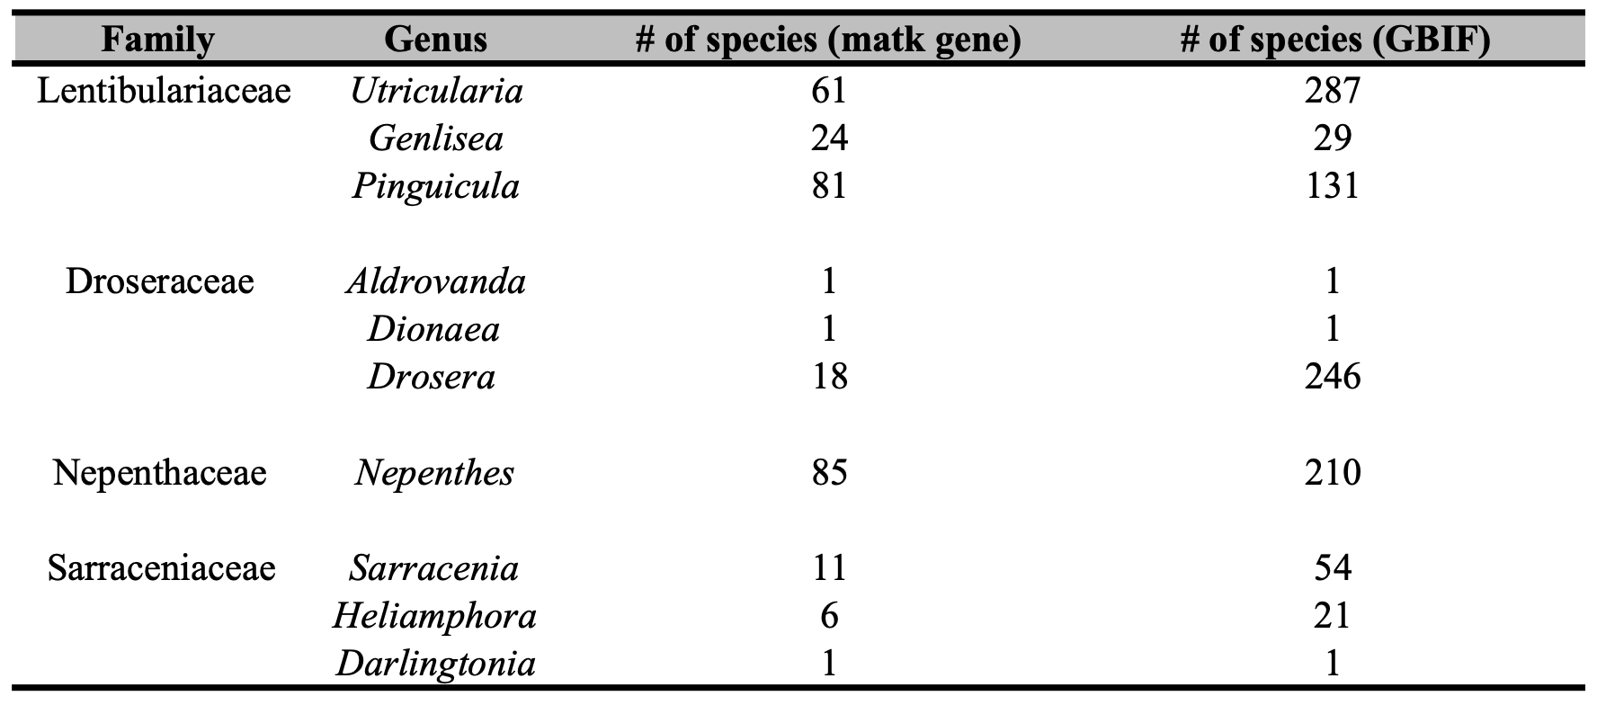

**Aims & Objectives**

**Research Design**

**Resources**

**Potential problems**

**Revised timeline of research**

**References**

Garcia-R, J. C., & Matzke, N. J. (2021). Trait-dependent dispersal in rails (Aves: Rallidae): Historical biogeography of a cosmopolitan bird clade. *Molecular Phylogenetics and Evolution*, *159*, 107106.<https://doi.org/10.1016/j.ympev.2021.107106>

Jordano, P. (2017). What is long-distance dispersal? And a taxonomy of dispersal events. *Journal of Ecology*, *105*(1), 75–84.<https://doi.org/10.1111/1365-2745.12690>

Nathan, R. (2006). Long-Distance Dispersal of Plants. *Science (New York, N.Y.)*, *313*, 786–788.<https://doi.org/10.1126/science.1124975>

Ronquist, F., & Sanmartín, I. (2011). Phylogenetic Methods in Biogeography. *Annual Review of Ecology, Evolution, and Systematics*, *42*(Volume 42, 2011), 441–464.<https://doi.org/10.1146/annurev-ecolsys-102209-144710>

Vanderpoorten, A., Gradstein, S. R., Carine, M. A., & Devos, N. (2010). The ghosts of Gondwana and Laurasia in modern liverwort distributions. *Biological Reviews*, *85*(3), 471–487.<https://doi.org/10.1111/j.1469-185X.2009.00111.x>