Model Comparison Supports the Pitcher Origin of Utricularia Suction Traps

Abstract
Carnivorous plants have been the subject of fascination and research for almost 150 years since Darwin codified the subject in his book Insectivorous Plants. The origin of complex trapping mechanisms from structures adapted for photosynthesis is of particular interest. While Darwin and others proposed the origin of the Venus flytrap and other traps, the origin of the tiny and complex bladder traps of the genus Utricularia have not been discussed in detail despite Utricularia being the most diverse genus of carnivorous plants. In this study, we test the “pitcher hypothesis,” which proposes that Utricularia traps evolved through a gradual transition from adhesive traps to pitcher traps and suction traps. We constructed phylogenetic trees for carnivorous plant species and evaluated 18 evolutionary models using statistical model comparison. The best-fitting model (PH-7R-AAI), consistent with the pitcher hypothesis, had an AIC weight of 60%, with two similar models accounting for the remaining 40%. These results support a stepwise evolutionary pathway to the bladder trap. Our approach demonstrates how detailed adaptive scenarios can be tested by comparing statistically defined evolutionary models, allowing verbal hypothesis to be translated into evidence-based phylogenetic inference. (187 words)

Keywords: Utricularia, Evolution, Carnivorous plants
Subject area: Evolutionary biology
Introduction
For nearly 150 years since Darwin's Insectivorous Plants, carnivorous plants have "captivated" scientists and enthusiasts alike—not only for their ability to capture prey but also for their extraordinary adaptations and unique ecological strategies. Across lineages, carnivorous plants have evolved diverse traps, including the snap traps of Dionaea muscipula (Venus flytrap), the adhesive traps of Drosera (sundews) and Pinguicula (butterworts), and the pitfall pitchers of Nepenthes. The ability of the Venus flytrap ('one of the most wonderful in the world'; Darwin, 1875a) to detect and rapidly respond to the presence of insects exemplifies nature's ingenuity (Forterre et al., 2005). This extraordinary ability has garnered extensive recognition, making the Venus flytrap the iconic carnivorous plant. However, the bladder traps of the genus Utricularia (bladderworts) are arguably even more astounding. Darwin directly observed prey "suddenly" appearing in bladderwort traps but imagined that the mechanism was passive. Lloyd (1942) described the bladder trap’s full complexity, wherein disturbance of a trigger hair causes a double-hinged door to open, drawing in prey via negative pressure before the trap resets. He also analogised bladder traps "without exaggeration" to an imaginary self-resetting mousetrap with 20+ necessary components, cooperating with "an astounding degree of mechanical delicacy depending on a fineness of structure scarcely equalled elsewhere in the plant kingdom" (Lloyd, 1942).

Prior Attempts at Explaining the Origin of the Utricularia Trap
While progress has been made in resolving the relationships of Utricularia and understanding their diversification to occupy various terrestrial and aquatic habitats (Westermeier et al., 2017), there is still a significant unresolved question about how the unique bladderwort trap evolved, which goes right back to Darwin. Alfred Russel Wallace, who co-discovered natural selection, was always on the lookout for puzzling cases and wrote Darwin about the origin of Utricularia (Wallace, 1875). Although Darwin proposed evolutionary origins for other carnivorous plant traps, he expressed mystification at the origin of Utricularia's bladder traps due to the lack of known intermediate forms (Darwin, 1875b). Juniper et al. (1989) discuss the evolution of other trap forms in some detail, but of Utricularia, they write that it remains "an intractable problem in evolution" and that there is no complete natural analogue to this trap to our knowledge anywhere else in the plant kingdom, nor any satisfactory evolutionary path.

The Pitcher Hypothesis
We propose the pitcher hypothesis; the common ancestor of Utricularia and its sister genus Genlisea evolved from a group of pitcher plants in the family Lentibulariaceae that is now entirely extinct. This hypothesis entails multiple transitions between distinct pitcher trap types in the extinct group. While such a scenario risks being dismissed as a speculative "just-so story," advances in phylogenetic modelling now allow verbal hypotheses to be rigorously tested through statistical model comparison.
Lloyd (1942) noted the resemblance between bladder traps and miniature pitchers—a connection further developed in stepwise evolutionary models (Cook, 2001; Matzke, 2005). The main challenge lies in imagining plausible intermediate forms between trap types in Pinguicula, Genlisea, and Utricularia, especially as these are typically treated as discrete categories (Mithöfer, 2022): flypaper, snap, pitcher, eel, and suction traps. However, recent findings increasingly blur these boundaries. Molecular phylogenies show that species with complex traps (e.g. Dionaea, Aldrovanda, Utricularia) are closely related to those with simpler adhesive traps, supporting a trajectory from flypaper to more complex mechanisms (Ellison & Gotelli, 2001). Morphological studies (Clarke, 2001; McPherson, 2009; Roccia et al., 2016) have identified several intermediate forms—for example, Nepenthes inermis pitchers function as sticky traps rather than pitfalls, and curled leaves in Pinguicula lutea resemble primitive pitchers. Some species even employ hybrid strategies, such as eel-like traps with one-way hairs (Sarracenia psittacina, Darlingtonia) or sticky-light-window combinations (Nepenthes aristolochioides). These examples help bridge morphological gaps and make the pitcher hypothesis more plausible.

The pitcher hypothesis for the origin of the Utricularia traps emerges by arranging all trap mechanisms on two axes (Figure 1). One axis is the specialisation of traps for different microenvironments: aerial, ground, amphibious, and submerged. The second axis is an adhesive-to-pitcher continuum. Trap mechanisms that have been observed in living species and intermediate series that have been postulated in carnivorous plant evolution can then be mapped onto this framework. For example, the origin of Aldrovanda's aquatic snap trap is postulated to proceed from adhesive traps through an amphibious Dionaea-like stage to a fully aquatic snap trap. To explain the origin of the Utricularia trap, the proposed stages of the pitcher hypothesis are: (a) ancestral flypaper traps, (b) intermediate adhesive/pitcher-like traps, (c) a ground pitcher trap, (d) amphibious eel trap, and finally (e) a fully aquatic suction trap.

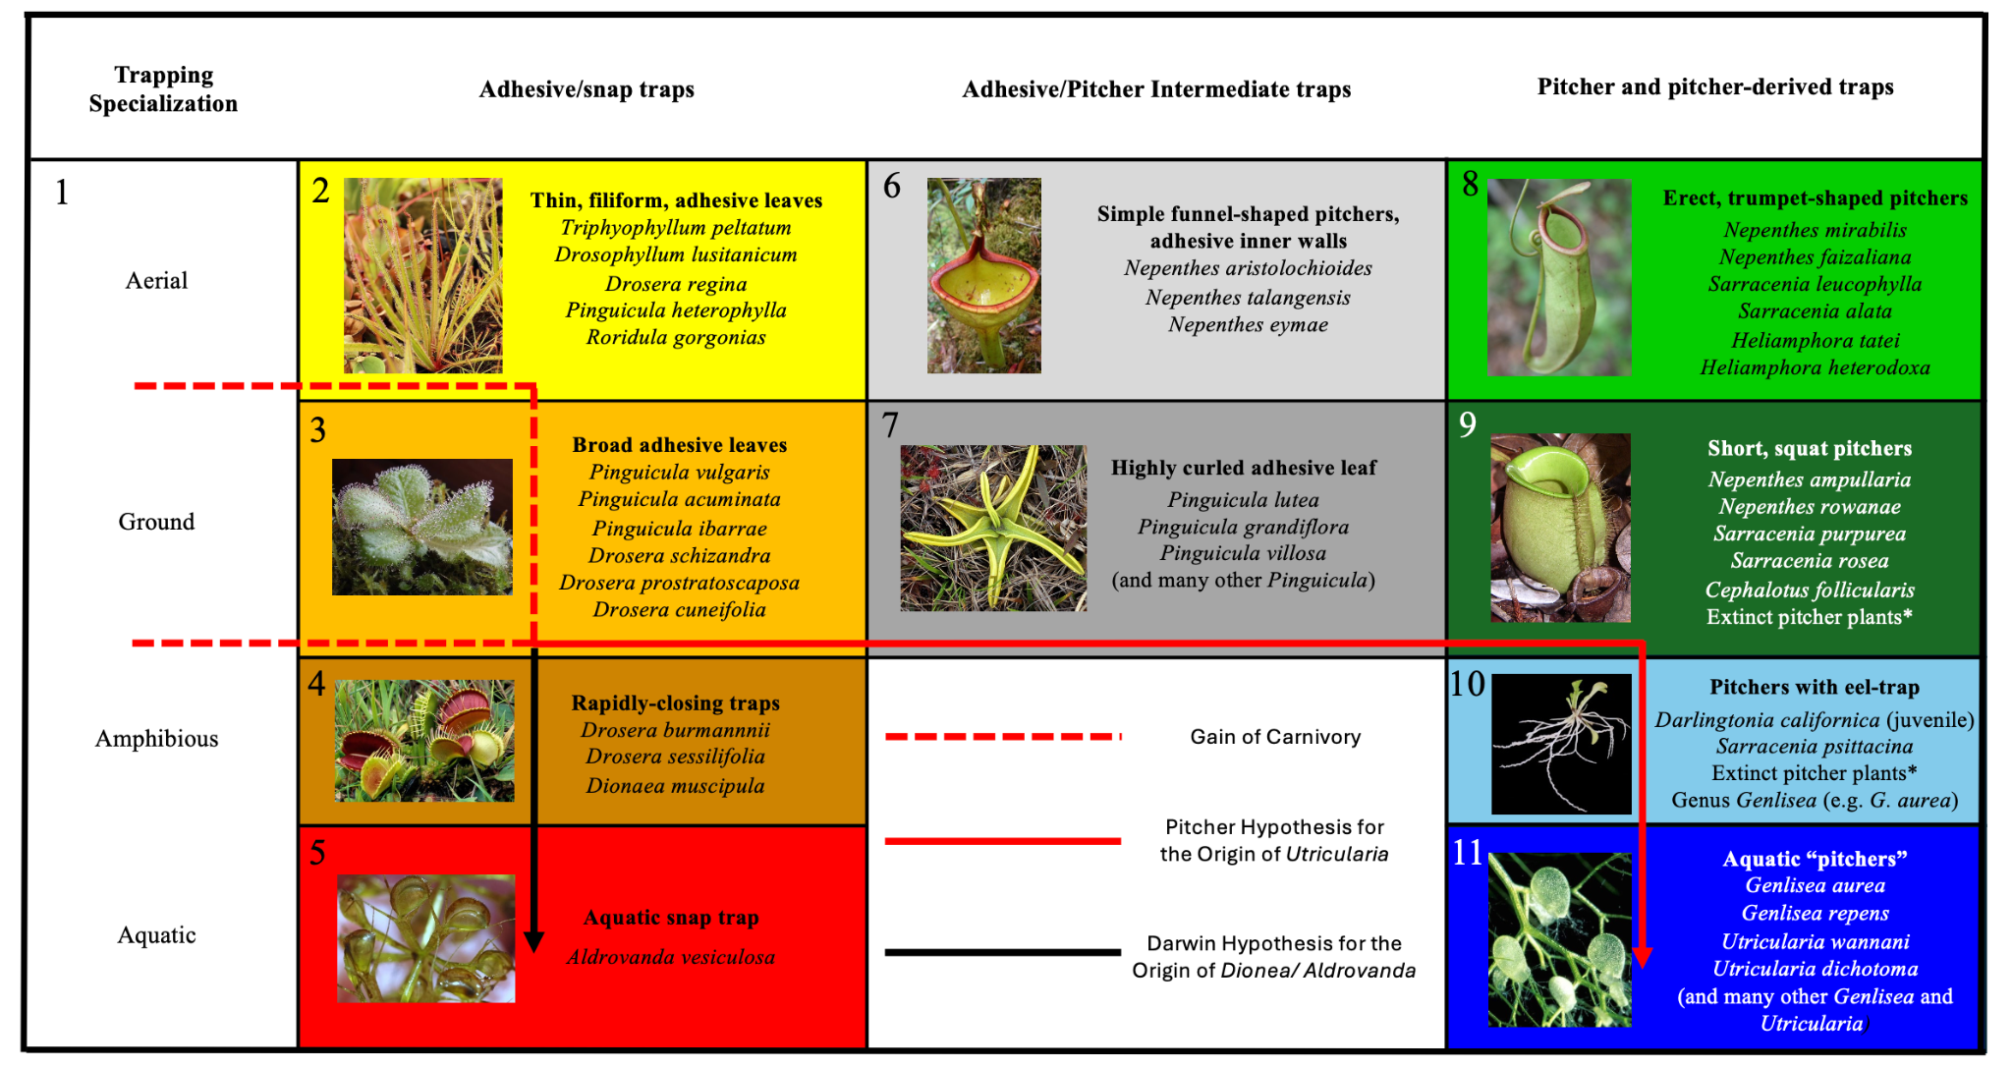
Figure 1. The pitcher model for the origin of Utricularia's bladder traps is presented as a transition between a series of stages within the overall context of the convergent evolution of carnivorous plant trapping mechanisms. There are 11 states that are represented by numbers and colour-coded to match the colour codes in phylogeny/character mapping figures. Character states are explained as follows: (1) non-carnivorous, (2) aerial adhesive/ flypaper trap, (3) ground adhesive/ flypaper trap, (4) amphibious snap trap, (5) aquatic snap trap, (6) aerial adhesive/pitcher intermediate trap, (7) ground adhesive/pitcher intermediate trap, (8) aerial pitchers, (9) ground pitchers, (10) amphibious pitchers, and (11) aquatic pitchers.

The evidence for the plausibility of the transition from (a) to (c) is argued above. The argument for (c) to (e) begins with the fact that the traps of Genlisea resemble advanced eel traps. The similarities between Genlisea and Utricularia traps suggest a shared ancestry, with the common ancestor likely possessing a homologous tubular leaf trap (Płachno et al., 2020).

The significant advantage of proposing a series of stages and the transitions between them is that this creates an explicit model of trap evolution that can be fit to a dataset consisting of a phylogenetic tree containing the carnivorous plant clades and their non-carnivorous relatives and tip data encoding the trap type of each species. In this study, models allowing different transitions and different numbers of parameters are implemented to statistically compare different models for the evolution of carnivorous plant traps. The fit of the pitcher model is compared to other possible models, using the Akaike Information Criterion (AIC) to measure the relative statistical fit of models. The best-fit models are then used in stochastic character mapping to estimate ancestral trap types and the timing and number of transitions between trap types.

Materials and Methods

Collecting and Digitising Trees
Phylogenetic trees covering each carnivorous plant genus were collected from publications (Ellison et al., 2012; Fleischmann et al., 2010; Jobson et al., 2017; Liu & Smith, 2021; Murphy et al., 2020; Sen et al., 2020; Shimai et al., 2021). These covered the families Droseraceae, Lentibulaceae, Sarraceiaceae, and Nepenthaceae. Digitisation was accomplished using WebPlotDigitizer (https://automeris.io/WebPlotDigitizer/), and the digitised data for each tree was converted to Newick.

The digitised trees of carnivorous plant clades were grafted onto an angiosperm megaphylogeny from V.PhyloMaker, an R package designed to provide subtrees from a large precalculated phylogenies of vascular plants (Jin & Qian, 2019). When the digitised tree was not dated but had molecular branch lengths, we used r8s (Sanderson, 2004) to produce an ultrametric, approximately time-scaled tree. The digitised Pinguicula tree was not dated and had no branch lengths; however, we used the r8s program to impose several time constraints from the dated Pinguicula subtree available in V.phyloMaker and combined it with the larger tree. The above procedure produced a reasonable tree reflecting the dates from recent publications without the inefficiency of repeating many dating analyses from scratch. This analysis would still result in phylogenies with substantial dating uncertainty. We reduced the whole tree to keep only the three successive non-carnivorous sister groups for each carnivorous clade. We then kept only one species per genus for other non-carnivorous clades. This reduced the tree from 74,533 species to around 1879, 432 of which are carnivorous.

Classifications of Carnivorous Plant Trap Types
For each sampled carnivorous species, trap type, subtype, trapping zone, maximum trap size, and trap shape were coded for every species based on data acquired from publications (see Supp. Mat.). Trap type refers to sticky leaf, snap, adhesive/pitcher intermediate, pitcher, or suction trap. In contrast, the sub-trap refers to the more detailed category, which helps to identify character states. For example, all Nepenthes are pitcher plants; however, some Nepenthes, like Nepenthes inermis, have a sticky inner wall, which suggests an adhesive/pitcher intermediate trap that possesses both adhesive and pitcher traps. The trapping zone refers to the essential characteristics to determine whether traps are specialised for aerial, ground, amphibious or aquatic. Based on these classifications, we coded the character states as a number (see Figure 1).

Transition Rate Matrices
Once the phylogenetic trees had been assembled, we made transition matrices for 18 models after coding each species by its trap type. The base pitcher hypothesis (PH) model (see Table 1) represents the pitcher hypothesis for the origin of the Utricularia trap as a series of transitions between 11 states. The model involves 12 transition rate parameters, and this model was compared to alternative models that postulate other allowed transitions. For example, the simple equal-rates (ER) null model allows all trap types to have equal rates of transition to any other trap type (see Table 2). It represents one version of an "anything is possible" model. The rest of the models with rate descriptions can be found in Supp Mat. In the PH model, the loss of carnivory is indicated by rate 1, representing transitions from any other state to state 1. Rate 2 represents the gain of carnivory, postulating that sticky leaf traps were the first form of carnivory to evolve from non-carnivorous ancestors (Darwin, 1875; Craw et al., 1999; Slack, 1988; Juniper et al.,1989). Other rates are indicated in Table 1. [Mention other rate matrix]

Table 1. The Pitcher Hypothesis (PH) model is postulated in Figure 1, which includes the pitcher hypothesis for the origin of the Utricularia trap. Each number represents a different free transition rate parameter in the model.
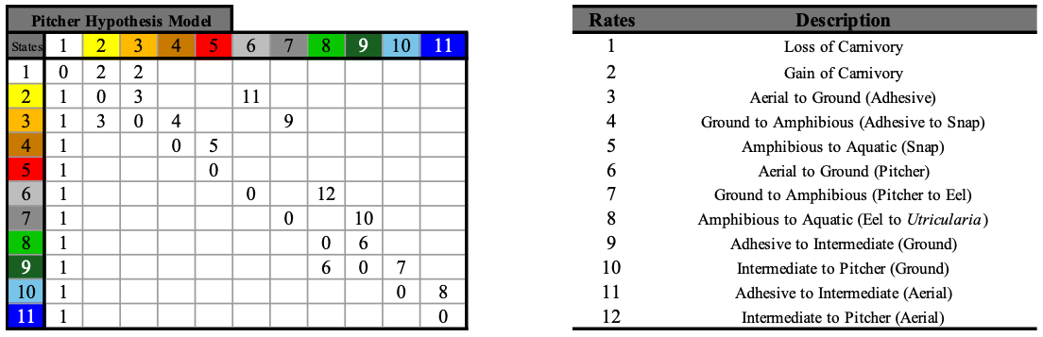

Table 2. Score matrix of equal-rates model. All character states have equal rates to transition into one another, represented by 1.

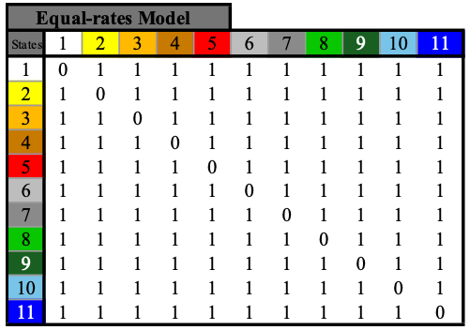

Evaluating Markov Models for Ancestral Character Estimation
We used the "fitMk.parallele" function in phytools (Revell, 2024) to estimate maximum likelihood parameters for various evolutionary models of trap-type transitions. Model fit was evaluated using the maximised log-likelihood (lnL) and Akaike Information Criterion (AIC) scores (Lanfear et al., 2014). Ancestral trap types were inferred using ancestral character estimation, and transition dynamics were further explored with stochastic mapping using the function "simmap" in phytools. To visualise how trap types changed over time within key branches, we generated state distribution plots. These plots were based on a matrix recording dominant states at regular time intervals across multiple stochastic maps. The proportion of each state over time was calculated by aggregating state frequencies across maps, and visualised as stacked density curves, with colour-coded regions showing the probability of each trap type along the length of the branch.

Results

Model Selection
Maximised log-likelihood (LnL) and AIC with AIC weights for each of the 18 models are shown in Table 3. The best-fitting model was PH-7R-AAI, which is one of the pitcher hypothesis model variants. This model was selected based on the lowest AIC value of 707.10235 and the highest AIC weight of nearly 60%. Two similar models (PH-8R and PH-7R-GIP) account for the remaining ∼40% of the weight, bringing the combined support for the top three models to >99.9% of the credible set. These results indicate that models allowing the transitional pathways represented in the pitcher hypothesis for the origin of Utricularia strongly outperform many other possible models, including those that permit a broader range of transitions between traps, such as the parameter-poor Equal Rates (ER) model or the parameter-richer All Rates Different (ARD) model.

Table 3. AIC summary table for each phylogenetic model. Provided are model log-likelihoods, delta AIC (difference from the best/lowest AIC), relative likelihood (rel_likes), AIC values and weights.
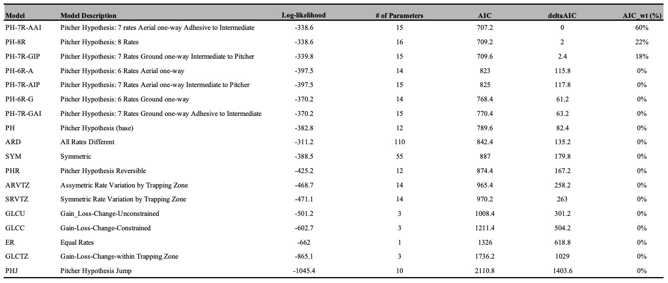

Lentibulariaceae
Phylogenetic stochastic mapping under the best-fitting PH-7R-AAI model suggests that the branch below the common ancestor of Lentibulariaceae was non-carnivorous (indicated by the white circle at the branch bottom). However, the most recent common ancestor of crown Lentibulariaceae was likely carnivorous with "intermediate" trap having both adhesive and pitcher traits indicated by the grey circle, and ground pitcher trap indicated by dark green circle (see Figure 2). The ancestral trap then diverged into more specialised traps over time (Utricularia, Genlisea, and Pinguicula). State distribution plots visualise the change in ancestral state probabilities along the root branch of Lentibulariaceae, suggesting that a non-carnivorous ancestor (very light grey line, equivalent to white circles) likely acquired ground adhesive traits (orange + yellow line) in the middle of the branch, which becomes most probable. The ground adhesive/pitcher intermediate traits (dark grey line) then become the most probable state (see Figure 3a) and finally, the ground pitcher traits become the most probable state which is the common ancestor of Lentibulariaceae.

Many of the early branches in the Pinguicula radiation reconstruct as ground adhesive/pitcher intermediate traps, like some living Pinguicula. On the branch ancestral to the common ancestor of Genlisea + Utricularia, the ground pitcher traits (dark green line) become the most probable, which decrease as time goes on along the branch. The hypothesised amphibious eeltrap pitcher is the most probable trap type, leading to the last common ancestor node for the two genera (see Figure 3b).
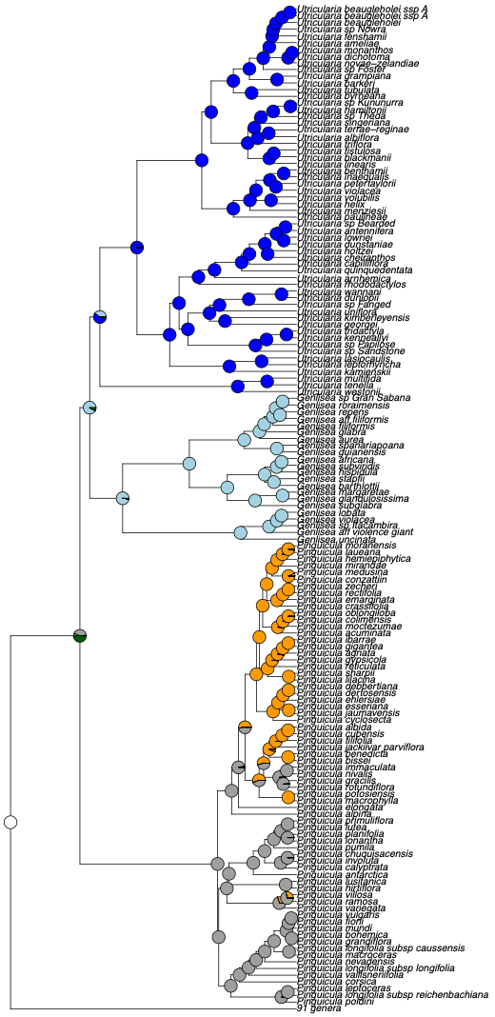
Figure 2. Ancestral trap state estimation for Lentibulariaceae under the best-fitting model (PH-7R-AAI) suggests that the branch below the common ancestor of the clade was non-carnivorous (white) and the common ancestor node had adhesive/pitcher intermediate+ground pitcher traits. The dark blue clade represents Utricularia bladder traps, light blue represents Genlisea eeltraps, and the clade mixed with orange and grey represents Pinguicula.

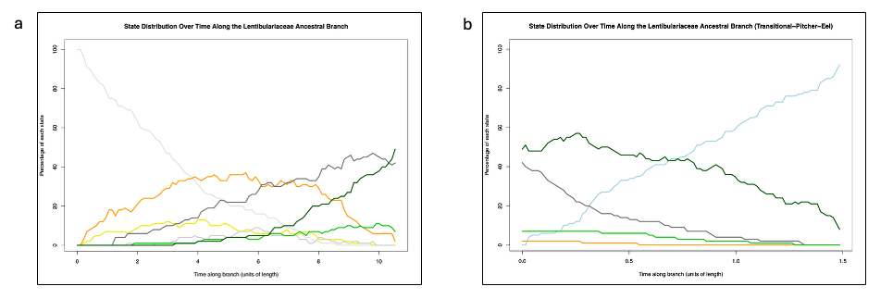
Figure 3. (a) State distribution over time along the Lentibulariaceae ancestral branch, showing the percentage of each state at different points along the branch's length. The plot illustrates changes in the prevalence of each state over time, with the ground adhesive/pitcher intermediate and ground pitcher traits peaking in frequency. (b) State distribution over time along the Genlisea +Utricularia ancestral branch, showing the percentage of each state at different points along the branch's length. The plot illustrates changes in the prevalence of each state over time, with the amphibious eel trap peaking in frequency, with ground pitcher traits decreasing over time.

Discussion
Our analyses support the pitcher hypothesis, which proposes a gradual evolutionary transition from adhesive traps to Utricularia bladder traps via a pitcher trap intermediate. Models based on this hypothesis were consistently ranked among the top eight. These models (e.g., PH, PHR, PH-6R-A, PH-7R-AAI, PH-8R) describe a pathway where ancestral flypaper traps evolve through traps with both adhesive and pitcher traits, then to pitcher traps, amphibious eel traps, and finally aquatic bladder traps. They explore scenarios such as whether transitions are reversible. The best-supported model, PH-7R-AAI, does not permit reversal from the adhesive/pitcher intermediate to adhesive traps, suggesting an evolutionary constraint—intermediate traps may evolve toward pitcher traits but not back to adhesive forms.
The consistent selection of pitcher hypothesis models indicates they fit the data (phylogeny and observed trap types) better than alternatives. The 9th and 10th ranked models were SYM (symmetric transitions) and resARD (all rates different). While ARD had a higher log-likelihood (-311.2 vs. -338.6 for PH-7R-AAI), it was heavily penalised for its 110 free parameters, compared to just 15 in the best-fitting model. AIC penalises complexity to avoid overfitting, which explains the preference for simpler, biologically grounded models like PH-7R-AAI. Zone-based models such as ARVTZ and SRVTZ, which apply rate variation by trapping zone (e.g. aerial, ground), ranked 12th and 13th. Gain-loss-change models (GLCU, GLCC, GLCTZ) were ranked 14th to 17th. These models test whether carnivory can be gained, lost, or altered within trap types or zones. The constrained versions restrict transitions to within categories (e.g., between trap types but not across zones). Their lower performance suggests that such restrictions oversimplify trap evolution. In essence, their results test and reject the hypothesis that traps evolve strictly within ecological zones or functional categories.
These findings underscore that a comprehensive understanding of carnivorous trap evolution must account for both ecological context (trapping zones) and functional morphology (trap types). Although zone-based models (e.g., ARVTZ) capture important ecological aspects, pitcher hypothesis models provide a better overall fit, reinforcing the importance of transitional trap forms in evolutionary history. The equal-rate model (ER), which assumes uniform transition rates, ranked 16th. The poorest-performing model, PHJ, does not permit the adhesive/pitcher intermediate trap as part of transitions to bladder traps (e.g., adhesive to pitcher), performing poorly and further emphasising the significance of intermediate adhesive/pitcher forms in trap evolution.

Limitations and Future Directions
This study on the evolutionary dynamics of carnivorous plant traps—especially in Utricularia—has several limitations. A primary constraint lies in the available data. The analysis relies on existing data across carnivorous plant lineages, which may be incomplete or unevenly sampled. Expanding genomic and morphological data, particularly for Lentibulariaceae, would improve resolution and reduce potential biases.
Another limitation stems from the modelling framework. For tractability, trap evolution was discretised into 11 trap types. While this enables hypothesis testing about broad evolutionary stages, it oversimplifies variation. Future work could incorporate continuous traits (e.g. trap size), break down traps into component traits (e.g. trichomes, mucilage), or account for trap dimorphism (e.g. seasonal or zone-specific trap variation).
Additionally, while the models capture morphological transitions, ecological factors such as habitat, nutrient availability, and species interactions were not explicitly modelled. Future research should explore how these factors influence trap evolution, including potential ecological drivers of major transitions.
A further limitation relates to phylogenetic dating. Our dated supertree was constructed by merging existing dated clades with undated ones scaled using r8s. While practical, this method introduces temporal uncertainty—especially in regions like the short branch between Genlisea+Utricularia and the Lentibulariaceae ancestor. This unexpectedly short timeframe (under 2 million years) for major trap transitions may reflect artefacts of tree construction. Although model comparisons are valid because all were run on the same tree, a future study could attempt a full re-dating of Lentibulariaceae, though this is hindered by limited fossil calibrations.

