Title: 3di paired with aminoacid sequence offers better resolved trees, and deeper branches: when alpha-helices are kept in check.

Large proportions of alpha-helices may render 3di alphabets information-poor; the histone-fold as an example of 3di failing.

Acknowledgements.

- Grant funding?
- NesI
- Ant Poole
- Jordan Douglas
- Ashar Malik

People:
Fullmer, CPL, Matzke?

Acknowledgements:
Jordan Douglas, Ashar Malik?, Anthony M. Poole

ABSTRACT

INTRODUCTION
It has long understood that protein shape conveyed information (Lake et al., 1984). This three-dimensional structure holds information that has been obscured or destroyed in sequences (Rost, 1999; Illergård et al., 2009). Attempts have been made to directly use this structural protein data as phylogenetic information (Lundin et al., 2012). This approach has also been extended into using protein simulations to create a pseudo-support set of shapes to proxy the degree of uncertainty (Malik et al., 2020). Unfortunately, many of these methods lack a model of evolution and/or are computationally expensive. The recent development of large language models (“AI”) for protein classification and prediction, such as Folkseek and Foldmason, has opened new possibilities for model-based structural phylogenetics (Gilchrist et al., 2024; van Kempen et al., 2024).

Foldseek’s 3di classification alphabet has informed a swarm of developments which have burst in multiple directions like a firework. This range includes a multi-locus sequence analysis equivalent (Kim et al., 2025), local residue-distance phylogeny (Moi et al., 2023), and further fold and function prediction (Malik et al., 2024). Most interesting to us, is the use of 3di to perform model-based phylogenetic inference. By harnessing the 3di alphabet into rate and substitution matrices, existing softwares and methods can be employed on explicitly three-dimensional data (Garg and Hochberg, 2024; Puente-Lelievre et al., 2024a; Puente-lelievre et al., 2024). While these early reports are promising, several questions remain poorly resolved in the suitability of 3di as phylogenetic characters.

One of the largest attractions of 3di, and structural phylogenetics writ large, is the prospect of resolving the earliest branches of protein evolution. These early branches represent some of the earliest evolution in life’s history. In many protein superfamilies, they would predate the Last Universal Common Ancestor (LUCA). The practical question is whether 3di fulfills that hope and resolves them.

We start with a dataset of Histone-fold proteins. This fold was almost certainly present in the last Archaeal common ancestor, and was probably present in LUCA (Alva and Lupas, 2018; Hocher et al., 2023). We show that for the Histone-fold, 3di-only inference produces trees with less resolution than sequence-only inferences. We also show that 3di+sequence partitioned inferences, while on average better, still fail to resolve the deeper nodes in the phylogeny.

We then expand our analysis to include 9 other superfamilies to test if the secondary structure characteristics of the Histone-fold superfamily are responsible for 3di’s poor performance. Our results suggest that proteins containing large proportions of alpha-helices may result in drops in the information content of the 3di-coded alphabet and a commensurate drop in phylogenetic resolution.

RESULTS

The Histone-fold dataset’s sequences are in the twilight zone. The overall sequence similarity across the alignment is only 19.8%; at the lower bound of the canonical twilight zone (Doolittle et al., 1986; Rost, 1999). Further, IQ-TREE2 estimated pairwise ML substitution rates as high as 9 substitutions per site, with an average of 4.13 substitutions per site. (See File in SuppRepository). An amino acid alignment of this nature can probably be assumed to contain limited phylogenetic information. However, the distribution of distances is not uniform. Over 93% of pairwise comparisons were under 30% identity. And 69% were 20% or less. There are multiple clusters, representing 6.7% of the data, with pairwise similarities greater than 40%. Indeed, more than 2% of comparisons were over 90% similarity. This suggests that a tree would likely have some resolution for at least a handful of clans.

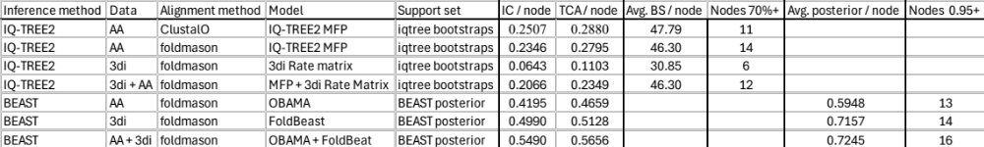
Table 1. Histone-Fold Tree Statistics. Trees inferred with the 3di rate matrix are worse (maximum likelihood) or only slightly better (Bayesian) than amino acids alone. Partitioned analyses are also either worse (ML) or only slightly better (Bayesian) than the amino acids alone. While Bayesian provided marginally more well resolved nodes, these are concentrated in the crown. Thus, 3di is not working for these data.

There is no resolution at deeper branches.
The ClustalO-aligned tree largely matched these expectations. Most branches show extremely weak bootstrap support values. However, several clans, mostly just shallow groups of a couple tips, receive 70%+. The net is a mean of 47.8% per branch. Internode certainty scores calculated from the bootstrap set were 0.251 and 0.288 per branch (IC & TCA, respectively). (Figure X?)

This unsuitability of sequence-based analysis for the Histones, particularly the inability to resolve deeper nodes, lends to incorporating data from the three-dimensional structure of the proteins. We leverage the recent development of Foldseek, Foldmason, and the creation of a rate matrix for their 3di characters to use high speed, phylogenetics tools such as IQ-TREE2 and BEAST (Gilchrist et al., 2024; van Kempen et al., 2024).

Alignment method does not affect deeper branch resolution.
To supply a structurally-informed alignment, Foldmason was used to generate a new aminoacid alignment. When inferring a tree, IQ-TREE2 selected the same model (LG+G4) as with the ClustalO alignment. The tree metrics were also quite similar to the ClustalO-aligned tree. 46.3% mean bootstrap, IC & TCAs per branch of 0.235 and 0.280. While all metrics were slightly lower, it is not clear that a slightly different selection of bootstrapped datasets could not bridge the gaps. Further, although the two topologies are separated by an estimated 15 SPR events, the better supported clans in both are almost identical. The close similarities between the trees from the two alignment methods suggests that the lack of resolution in the topologies are probably not due to alignment, but more fundamentally, a lack of information in the aminoacid sequences. (Figure X?)

3di does not salvage the situation.
ML + the 3di rate matrix is outperformed by the Foldmason-informed AA alignment.
Next, we used Foldmason’s alignment of 3di characters to infer a 3di phylogeny. This phylogeny was systematically less resolved than those from the aminoacid alignments. The mean bootstrap percentage using the 3di matrix was only 30.8%. Whereas the Foldmason-aligned aminoacids averaged 46.3%. Similarly, the IC and TCA scores for the 3di method’s outputs were .064 and 0.110, respectively. These are notably lower than the aminoacid’s 0.235 and 0.280. While many of the clans highly supported in the AA trees remain, their support values are blanketly reduced. In terms of internal consistency, the 3di method is outperformed by the aminoacid alignment using ML. (Figure X/Y?)

Using Bayesian methods may offer improvements.
We examined the possibility that the method of tree inference could change 3di’s performance by employing BEAST2. Using the Foldmason-aligned AA, BEAST’s posterior set produced IC and TCA values of 0.419, and 0.465. These are appreciably higher than either AA alignment under ML. Likewise, 3di was improved to slightly higher levels (0.499, 0.513). Additionally, the number (13-14) of nodes with significant support (>= 95%) was as high or higher (6-14) than the significantly supported (>=70%) ML nodes. This suggests that the Bayesian approach may provide some advantage over ML. However, given the nature of Bayesian inference, sampling large numbers of extremely similar trees, it may be inappropriate to directly compare IC/TCA between bootstraps and Bayesian posteriors.

3di + AA helps?
3di should serve to bring out deeper evolutionary signal obscured by sequences saturated by substitutions. However, in doing so, much of the more recent evolution will be lost. This lends itself to the presumption that it could be paired with sequence data to resolve deeper nodes while the sequences resolve shallower ones. We tested this assumption through partitioned analyses incorporating both the Foldmason-informed AA and 3di alignments.

The resulting ML tree was underwhelming. The mean bootstrap percentage was comparable to the two AA alignments (46.3% vs 47.8 and 46.3%). The IC/TCAs were both slightly worse (0.207 and 0.235). However, the Bayesian inference returned both the highest average posterior and also the highest IC/TCA values of the Bayesian analyses. However, the improvements over the 3di inference were highly marginal (0.549 IC, 0.566 TCA, and 0.725 average posterior). Perhaps most encouraging, this iteration provided the most significantly supported nodes (16) of any analysis so far. This reinforces the possibility of the Bayesian approach may provide a better approach than ML. Unfortunately, the well supported nodes remain mostly shallow. The deeper nodes, which are the ones of particular interest, remain mysterious. (Figure Z?) (Table Refs throughout)

We sought to test the assumption that 3di would resolve deeper nodes through changing more slowly than sequence. We employed a GammaSpike model in BEAST on the partition dataset that allows the rate of evolution to change at branching events <Jordan>. Against expectation, the sequence did not reject GammaSpike, although it did not accept it. Equally against assumptions, the 3di data accepted the model. This suggests the AA data may be evolving in a smoother, more clock-like, manner than the 3di data.

Overall, 3di is performing quite poorly with this dataset.

Is the problem histones’ brevity and structural simplicity?
There are a couple of plausible explanations for the inability of 3di, or a combination if 3di and sequence, to provide better supported trees. And particularly, ones with that have strong support in the deeper nodes.

The first is that the histone proteins are short. The average sequence is only 83.9 aminoacids long. More sequence simply tends to carry more information (Rokas and Carroll, 2005). Second, the histones are extremely helix-heavy. This histone dataset is composed of an average of 69.2% percent helices. The 3di alignments are dominated by only two character states (V, 50.9% and D, 15.7%); comprising almost exactly two-thirds of all residues. In contrast, it takes the 9 most common aminoacids to sum to the same proportion.

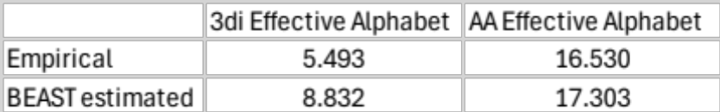
Table 2. Histone-fold dataset effective alphabet sizes. The alphabet of 3di characters is substantially smaller than that of the amino acids.
The apparent result of these two possible causes is a lack of information being conveyed by the alignments. Particularly in the 3di alignment. Using entropies to estimate the effective alphabet sizes of the empirical and BEAST-estimated character frequencies reveals that the 3di sequences are functionally using an alphabet of only 5.5 (empirical) or 8.8 (BEAST estimated) characters while the AA are using a 16.5-17.3 sized alphabet.

Are these small alphabets and poor support metrics the result of short proteins, too many alpha-helices, or too much secondary structural elements in general? We created an expanded dataset by selecting 9 superfamilies from SCOP 1.75. We attempted to choose a balance between the four relevant fold types (alpha-helix only, beta-sheet only, and the two alpha + beta-containing folds), as well as a range of average protein lengths. We did include a third alpha-only as this is the fold most like the Histone-fold we were evaluating. Superfamilies were filtered and clustered (see Methods) before running them through the same maximum-likelihood tree inferences in IQ-TREE2.

We investigated the patterns in the superfamilies through calculation of correlations and significance values for the superfamily characteristics and tree support values (Fig Correlogram). We found several significant correlations of particular note.

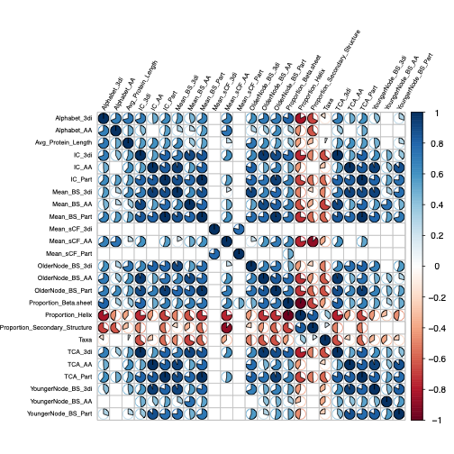
Figure 1. Pearson correlations of protein superfamily characteristics and phylogeny support values. Display cutoff is p = 0.01. Smaller alphabet size is significantly correlated with reduced resolution. Similarly, the proportion of the protein composed of helices is correlated with smaller alphabets and reduced resolution.

We found that most of our metrics of resolution (bootstraps, IC/TCA, and site concordance factors) were significantly, and mostly strongly correlated. The partial exception is site concordance, where the 3di only and partition values correlated with little else. This suggests they are measuring broadly similar things, as we would broadly hope.

The average sequence length was significantly positively correlated with nearly every measurement of branch support. This aligns with the idea that the shorter proteins, such as the Histones, do not carry as much phylogenetically informative information as longer proteins.

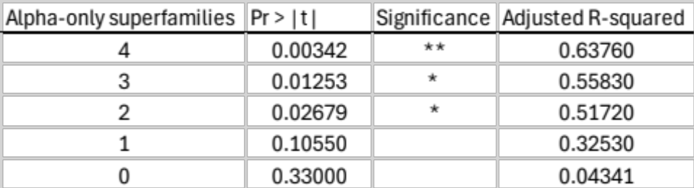
Supp Table LM- Alpha-only Folds 3. Linear regression of alpha-only superfamilies vs 3di alphabet size. When the number of alpha-only superfamilies is reduced to 2, the same number of superfamilies in the other 3 fold types, the relationship remains strong and significant.

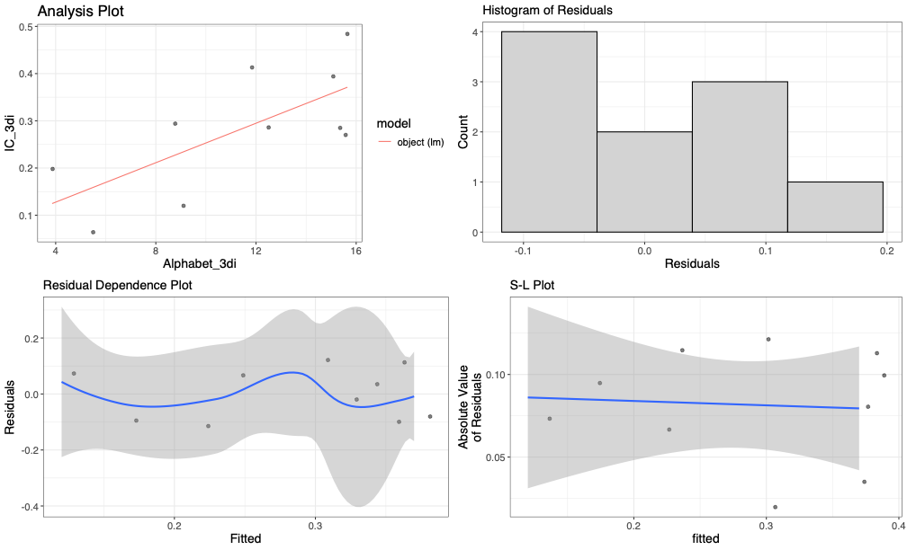
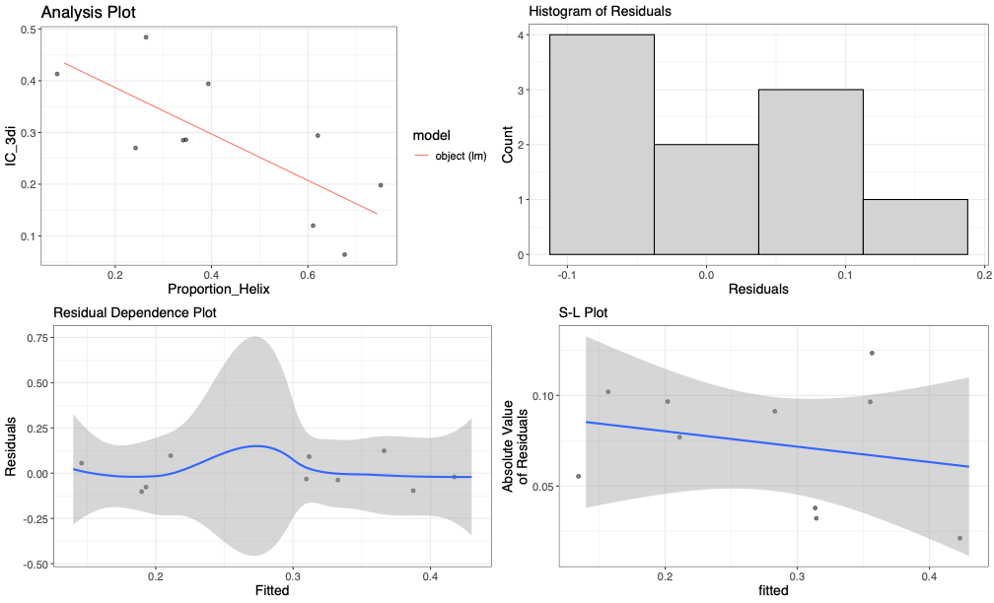
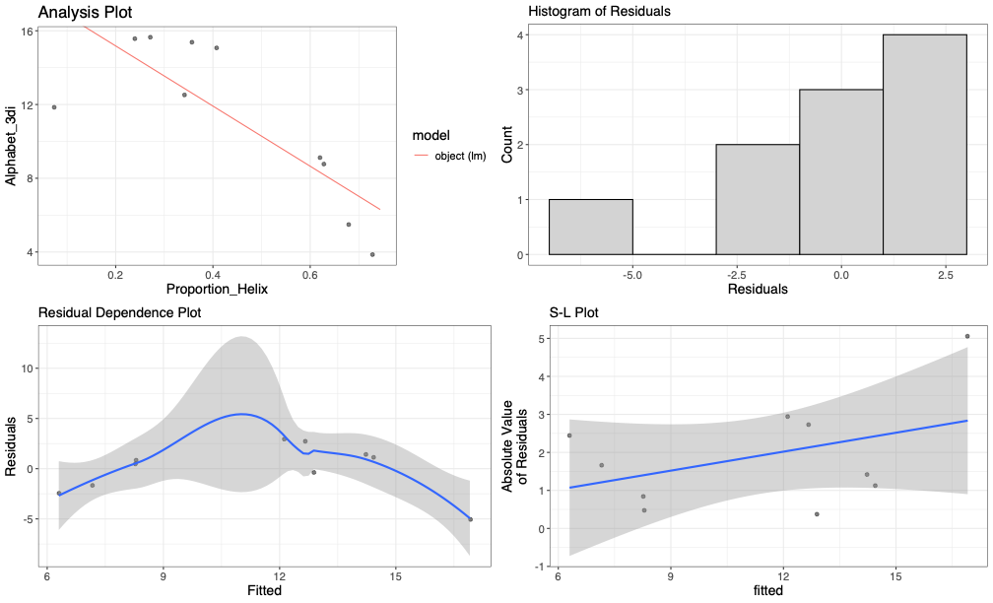
A
B
C
Figure 2. Linear Regressions of relationships between Phylogeny resolution (IC 3di), 3di Alphabet size, and Proportion of Helices. A) 3di Alphabet vs Proportion of Helix. B) 3di IC values vs Proportion of Helices; C) 3di IC values vs 3di Alphabet sizes. Increasing proportion of helices appears to drive down the 3di alphabet size. In turn, smaller 3di alphabets appear to drive down phylogenetic resolution.

Smaller alphabet sizes significantly correlate with lower support values. This was true of all but three measurements of support for 3di and seven for AA. This supports our supposition that a lack of information carriage results in less phylogenetically informative sites.

Helix proportion is significantly anti-correlated with both alphabet size and support values. This characteristic was by far the largest anti-correlation with alphabet size. This was far more emphatic for the 3di alphabets than AA (although the link remains strong). This suggests that there could be an antagonistic relationship between alpha helices and information content in proteins.

We were concerned that this result could be a bias from including four alpha-only superfamilies and only 2 of each other fold type. We tested this by removing one, two, three, or all of the alpha-only superfamilies and calculating linear regressions between helix proportion and alphabet size. While the effect size dropped, including only two still shows a significant relationship, indicating that this is a real factor.

Conversely, beta-sheet proportion is positively correlated with alphabet size, as well as higher average support values. As both alphabet sizes are inversely correlated with support values, it seems reasonable to conclude that enrichment in helices, and perhaps paucity of beta-sheets, is a major cause in in the histones’ poor resolution.

Total secondary structure is also significantly anti-correlated with support values. This may be selection bias at work. 4 of the 6 largest secondary structure proportions are alpha-helix only fold proteins. It seems entirely possible that adding a few more b/c/d fold superfamilies might severely undercut this correlation.

Total taxa is anti-correlated with higher support values.
It is unclear if this is a global statement, or a coincidence from the data. The two most taxa-rich superfams are the histones and a-25-1. These are both in the bottom two or three for every support metric. This could easily be a case of finding two with very low numbers. Conversely, it has been shown that adding more taxa does not increase resolution in the fashion that adding more genes does <Rokas & Carrol>.

That average protein length is inversely anti-correlated with both helix proportion and total secondary structure is a point of caution about using only 10 superfamilies to draw these lessons. A much larger analysis with a far larger portion of SCOP would be invaluable in confirming these insights.

Does 3di resolve deeper nodes better than AA?
Probably not. Both AA and 3di provided higher support values to shallower branches than deeper ones. On average, AA was 6% higher in bootstraps for deeper nodes. Which could indicate 3di is not superior deeper in the tree. On the other hand, the partitioned analyses did better than either AA or 3di. The gains were particularly notable in the young nodes with 10% (p = 0.0226 for AA vs Partition) and 18% (p=0.0017 for 3di vs Partition). Unfortunately, the older nodes gained less support, 10% and 15%. And that support was less significant (p = 0.0980 & 0.0369, respectively). However, they are still clear gains and, at worst, are on the edge of significance. This suggests that 3di may have something to offer in conjunction with AA. Particularly, if the proteins are not highly enriched in helices.

Methods.

Histone data. The initial histone dataset consists of 36 proteins selected from SCOP superfamily a.22.1 and proteins identified as containing the Histone-fold in Structome (Malik et al., 2023). They also represent a subset of those used in (Malik, 2018). See Table S1-HistoneProtTable for full listing.

Secondary structure annotation. DSSP, as implemented in XSSP (Kabsch and Sander, 1983; Touw et al., 2015). All three helix types (H, G, I) were combined into a single proportion. Likewise, both beta-sheet types (B, E) were also combined into a single proportion. Total secondary structure proportion is helix + sheet values.

ICTC. uncertainty of the support sets Internode Certainty (IC) scores (Kobert et al., 2016) were calculated by mapping support sets against reference trees as implemented in RAxML v8.1 (Stamatakis, 2014). IC represents a quantification of the level of disagreement in a support set for a particular node in a phylogeny. The IC decreases as the bootstrap value drops and as the dissenting samples agree on fewer rival topologies. I.e., a bipartition supported by 51% of the bootstraps would score much higher if the conflicting samples represented 49 different alternatives than it would if there were only a single alternative. The tree certainty average value (TCA) is the average of IC values across the entire tree, representing an assessment of overall conflict in the support set.

SCOP superfamilies. SCOP 1.75 supplied the categorization information (Hubbard et al., 1999; Andreeva et al., 2008). Superfamilies were initially chosen at near random for processing. PDB files for each superfamily were downloaded from the PDB database. Each superfamily was processed in a manner based on the filtering and clustering described for STRUCTOME (Malik et al., 2023). All proteins below 50aa and above 350aa were excluded. UCLUST performed centroid clustering of the remaining proteins at 90% identity (Edgar, 2010). This made phylogenetics with the superfamily far more tractable. However, it also meant that there was no guarantee that each assigned family would have a representative. Or that component families would have equal or proportional representation. From the resultant superfamilies with at least 4 remaining members, 9 were chosen: 3 “a,” and 2 each of “b/c/d.” The goal was to evenly sample the 4 major classes containing alpha-helix and beta-sheet containing proteins (alpha-only, beta-only, a+b, and a/b). Another goal was to sample across a variety of size ranges, such that we could interrogate both sequence length and secondary structure composition as explanations for the histones’ poor performance with 3di.

Mean bootstrap values. Scripting was done in R. Bootstrap scores were extracted from trees in the R library ape and means calculated with R’s mean function (Paradis and Schliep, 2019).

Aminoacid (AA) phylogenetic inference. The ClustalO algorithm as implemented in SeaView (Gouy et al., 2021) created the initial histone AA alignments. Foldmason was employed to create structurally-informed AA alignments which constitute the vast majority of analyses presented here (Gilchrist et al., 2024). Maximum likelihood interference of phylogenies was done in IQ-TREE2 with model chosen by IQ-TREE’s model finder (Minh et al., 2020).

3di phylogenetic inference. Foldmason was employed to create structurally-informed 3di alignments (Gilchrist et al., 2024). Maximum likelihood interference of phylogenies was done in IQ-TREE2 with model chosen by IQ-TREE’s model finder (Minh et al., 2020). The model for all 3di alignments was set to the 3di rate matrix provided in Puente-Lelievre et al., 2024 (Puente-Lelievre et al., 2024a).

Partitioned aminoacid and 3di. Partitioned analyses were performed with IQ-TREE2 with the “-p” option (Minh et al., 2020) The 3di alignments were assigned the 3di rate model while the the AA alignments used IQ-TREE’s model finder.

Bayesian partition analysis. As above, but in BEAST with OBAMA, Gammaspike (?), and FoldBeast, for 10 million samples. (Suchard et al., 2018; Bouckaert et al., 2019)

Linked tree – 30 million steps
Gammaspike – 15 million steps
Gammaspike. Both AA and 3di failed to accept or reject the gammaspike model. 3di = 0.9363, which is a narrow accept. AA = 0.115 is narrowly ambiguous, but leaning heavily towards reject. This suggests the AA data may be evolving in a smoother form than the 3di data.

FoldBEAST: https://github.com/jordandouglas/FoldBeast/
GammaSpike (Douglas et al., 2024)
OBAMA (Bouckaert, 2020)

3di rate matrix. The rate matrix from (Puente-Lelievre et al., 2024b) was used with all 3di alignments. Four superfamilies (a.35.1, a.38.1, a.39.2, and b.122.1) were tested using the alternate rate matrices presented in (Garg and Hochberg, 2024). Their average bootstrap percentages were both lower (51% vs 45%, and 49%). Linear regression found the difference to be weakly significant (p = 0.018 and 0.0299). This indicated resolution would be better with the Puente-Lelievre rate matrix (Supp Table Garg).

Effective Alphabet Size. Raw character frequencies from alignments were obtained from IQ-TREE2 (Minh et al., 2020). Estimated frequencies for the Histone-fold dataset were obtained from BEAST posteriors (Suchard et al., 2018). Shannon entropies were calculated for each alignment, summed and converted into an effective alphabet size (Shannon, 1948).

$$Effective alphabet size= e ^-\sum_{base=1}^{20}{{Freq}_{base}}*Ln\left({Freq}_{base}\right)$$

sCF. Site concordance factors were calculated in IQ-TREE2 with the -blfix option (Minh et al., 2020; Mo et al., 2023). For 3di alignments, the model was fixed to the 3di rate matrix. IQ-TREE was allowed to re-estimate AA models.

Correlogram. R function Cor was used to calculate Pearson correlations. cor.test was used to calculate significance. Linear models were calculated with R’s lm function. The R library Corrplot (Wei and Simko, 2024) visualized the correlogram. Only correlations with significance p = < 0.01 were displayed.

Old/Young nodes. Midpoint rootings were made by tree length. Assumption, but as good as any, probably. Distances to the root for each node were calculated with R library castor (Louca and Doebeli, 2018). Take median. All nodes closer to root than median are old. Further are young. Calculate bs like before

Discussion.

On a specific level, we show that the 3di method performs poorly on the Histone-fold superfamily. Sequence-only phylogenies showed stronger resolution than 3di-only inferences. Additionally, partitioned analyses incorporating both data types, while improving overall resolution, failed to adequately resolve deeper nodes. More generally, we present evidence, using nine additional superfamilies, that the characteristics of the Histone-fold superfamily may undermine its suitability for 3di-based analysis. The generally short length aligns with the well-established phenomenon of shorter sequences being able to hold less information (Rokas and Carroll, 2005). Additionally, their high proportions of alpha-helices appear to be driving decreases in the information content of the 3di-coded alignment and a commensurate drop in phylogenetic resolution.

The 3di-version of the Histone-fold dataset accepted, albeit by a narrow margin (0.936 vs 0.910 posterior), the GammaSpike model. The aminoacid data, however, failed to accept nor reject the model. This would suggest that 3di has a less clock-like rate of evolution than the aminoacids. This is unexpected, as we would anticipate the 3di alphabet to be capturing the slower changing information of protein shape. Additionally, 3di-derived measures have been argued to evolve in a more clock-like fashion than sequence data <Moi>. We are unsure why we would see this. Our speculation is that the Histone-fold dataset is so poor character state diversity and so dominated by just two states that very few changes happening along a branch represent a major enough departure for the model to perceive a change in the rate of evolution.

In this work, we focused on the resolution of inferred phylogenies. We did not focus on the actual topologies the methods produced. As we do not know the “true” history of any of these superfamilies we felt that making judgements on which methods were more or less “right” was more of a distraction than not. We feel that it is more interesting to test those sorts of questions when we have highly resolved phylogenies than it is with ones where most of the branches are negligibly supported.

Bibliogrpahy

Alva, V., and Lupas, A. N. (2018). Histones predate the split between bacteria and archaea. Bioinformatics, 1–5. doi: 10.1093/bioinformatics/bty1000
Andreeva, A., Howorth, D., Chandonia, J. M., Brenner, S. E., Hubbard, T. J. P., Chothia, C., et al. (2008). Data growth and its impact on the SCOP database: New developments. Nucleic Acids Res 36, 419–425. doi: 10.1093/nar/gkm993
Bouckaert, R. R. (2020). OBAMA: OBAMA for Bayesian aminoacid model averaging. PeerJ 8, 1–15. doi: 10.7717/peerj.9460
Bouckaert, R., Vaughan, T. G., Barido-Sottani, J., Duchêne, S., Fourment, M., Gavryushkina, A., et al. (2019). BEAST 2.5: An advanced software platform for Bayesian evolutionary analysis. PLoS Comput Biol 15, 1–28. doi: 10.1371/journal.pcbi.1006650
Doolittle, R. F., Feng, D. F., Johnson, M. S., and McClure, M. A. (1986). Relationships of human protein sequences to those of other organisms. Cold Spring Harb Symp Quant Biol 51 Pt 1, 447–455. doi: 10.1101/sqb.1986.051.01.054
Douglas, J., Bouckaert, R., Harris, S. C., Carter, C. W., and Wills, P. R. (2024). Evolution is coupled with branching across many granularities of life. bioRxiv, 2024.09.08.611933. Available at: https://www.biorxiv.org/content/10.1101/2024.09.08.611933v1%0Ahttps://www.biorxiv.org/content/10.1101/2024.09.08.611933v1.abstract
Edgar, R. C. (2010). Search and clustering orders of magnitude faster than BLAST. Bioinformatics 26, 2460–2461. doi: 10.1093/bioinformatics/btq461
Garg, S., and Hochberg, G. K. (2024). A general substitution matrix for structural phylogenetics. bioRxiv.
Gilchrist, C. L. M., Mirdita, M., and Steinegger, M. (2024). Multiple Protein Structure Alignment at Scale with FoldMason. doi: 10.1101/2024.08.01.606130
Gouy, M., Tannier, E., Comte, N., and Parsons, D. P. (2021). “Seaview Version 5: A Multiplatform Software for Multiple Sequence Alignment, Molecular Phylogenetic Analyses, and Tree Reconciliation BT - Multiple Sequence Alignment: Methods and Protocols,” ed. K. Katoh (New York, NY: Springer US), 241–260. doi: 10.1007/978-1-0716-1036-7_15
Hocher, A., Laursen, S. P., Radford, P., Tyson, J., Lambert, C., Stevens, K. M., et al. (2023). Histones with an unconventional DNA-binding mode in vitro are major chromatin constituents in the bacterium Bdellovibrio bacteriovorus. Nat Microbiol 8, 2006–2019. doi: 10.1038/s41564-023-01492-x
Hubbard, T. J. P., Ailey, B., Brenner, S. E., Murzin, A. G., and Chothia, C. (1999). SCOP: A structural classification of proteins database. Nucleic Acids Res 27, 254–256. doi: 10.1093/nar/27.1.254
Illergård, K., Ardell, D. H., and Elofsson, A. (2009). Structure is three to ten times more conserved than sequence—A study of structural response in protein cores. Proteins: Structure, Function, and Bioinformatics 77, 499–508. doi: https://doi.org/10.1002/prot.22458
Kabsch, W., and Sander, C. (1983). Dictionary of protein secondary structure: Pattern recognition of hydrogen-bonded and geometrical features. Biopolymers 22, 2577–2637. doi: https://doi.org/10.1002/bip.360221211
Kim, D., Park, S., and Steinegger, M. (2025). Unicore Enables Scalable and Accurate Phylogenetic Reconstruction with Structural Core Genes Open Access. GBE. doi: https://doi.org/10.1093/gbe/evaf109
Kobert, K., Salichos, L., Rokas, A., and Stamatakis, A. (2016). Computing the Internode Certainty and Related Measures from Partial Gene Trees. Mol Biol Evol 33, 1606–1617. doi: 10.1093/molbev/msw040
Lake, J. A., Henderson, E., Oakes, M., and Clark, M. W. (1984). Eocytes: a new ribosome structure indicates a kingdom with a close relationship to eukaryotes. Proceedings of the National Academy of Sciences 81, 3786–3790. doi: 10.1073/pnas.81.12.3786
Louca, S., and Doebeli, M. (2018). Efficient comparative phylogenetics on large trees. Bioinformatics 34, 1053–1055. doi: 10.1093/bioinformatics/btx701
Lundin, D., Poole, A. M., Sjoberg, B. M., and Hogbom, M. (2012). Use of structural phylogenetic networks for classification of the ferritin-like superfamily. Journal of Biological Chemistry 287, 20565–20575. doi: 10.1074/jbc.M112.367458
Malik, A. J. (2018). Exploring deep phylogenies using protein structure. Massey University.
Malik, A. J., Langer, D., Verma, C. S., Poole, A. M., and Allison, J. R. (2023). Structome: a tool for the rapid assembly of datasets for structural phylogenetics. Bioinformatics Advances 3, 1–10. doi: 10.1093/bioadv/vbad134
Malik, A. J., Poole, A. M., and Allison, J. R. (2020). Structural Phylogenetics with Confidence. Mol Biol Evol 37, 2711–2726. doi: 10.1093/molbev/msaa100
Malik, A. J., Puente-Lelievre, C., and Matzke, N. (2024). On use of tertiary structure characters in hidden Markov models for protein fold prediction. 1–12. Available at: https://doi.org/10.1101/2024.04.08.588419
Minh, B. Q., Schmidt, H. A., Chernomor, O., Schrempf, D., Woodhams, M. D., Von Haeseler, A., et al. (2020). IQ-TREE 2: New Models and Efficient Methods for Phylogenetic Inference in the Genomic Era. Mol Biol Evol 37, 1530–1534. doi: 10.1093/molbev/msaa015
Mo, Y. K., Lanfear, R., Hahn, M. W., and Minh, B. Q. (2023). Updated site concordance factors minimize effects of homoplasy and taxon sampling. Bioinformatics 39, 1–2. doi: 10.1093/bioinformatics/btac741
Moi, D., Bernard, C., Steinegger, M., Nevers, Y., Langleib, M., and Dessimoz, C. (2023). Structural phylogenetics unravels the evolutionary diversification of communication systems in gram-positive bacteria and their viruses. bioRxiv, 2023.09.19.558401. Available at: http://biorxiv.org/content/early/2023/10/02/2023.09.19.558401.abstract
Paradis, E., and Schliep, K. (2019). Ape 5.0: An environment for modern phylogenetics and evolutionary analyses in R. Bioinformatics 35, 526–528. doi: 10.1093/bioinformatics/bty633
Puente-Lelievre, C., Malik, A. J., Douglas, J., Ascher, D., Matthew, B., Allison, J., et al. (2024a). Tertiary-interaction characters enable fast, model-based structural phylogenetics beyond the twilight zone. BioArXiv. doi: https://doi.org/10.1101/2023.12.12.571181
Puente-Lelievre, C., Malik, A. J., Douglas, J., Ascher, D., Matthew, B., Allison, J., et al. (2024b). Tertiary-interaction characters enable fast, model-based structural phylogenetics beyond the twilight zone. BioArXiv. doi: https://doi.org/10.1101/2023.12.12.571181
Puente-lelievre, C., Ridone, P., Douglas, J., Amritkar, K., Kaçar, B., Baker, M., et al. (2024). Molecular and structural innovations of the stator motor complex at the dawn of flagellar motility. 1–13.
Rokas, A., and Carroll, S. B. (2005). More genes or more taxa? The relative contribution of gene number and taxon number to phylogenetic accuracy. Mol Biol Evol 22, 1337–1344. doi: 10.1093/molbev/msi121
Rost, B. (1999). Twilight zone of protein sequence alignments. Protein Engineering, Design and Selection 12, 85–94. doi: 10.1093/protein/12.2.85
Shannon, C. E. (1948). A mathematical theory of communication. e Bell System Technical Journal, 27, 379–423. doi: doi: 10.1002/j.1538-7305.1948.tb01338.x.
Stamatakis, A. (2014). RAxML version 8: A tool for phylogenetic analysis and post-analysis of large phylogenies. Bioinformatics 30, 1312–1313. doi: 10.1093/bioinformatics/btu033
Suchard, M. A., Lemey, P., Baele, G., Ayres, D. L., Drummond, A. J., and Rambaut, A. (2018). Bayesian phylogenetic and phylodynamic data integration using BEAST 1.10. Virus Evol 4, 1–5. doi: 10.1093/ve/vey016
Touw, W. G., Baakman, C., Black, J., Te Beek, T. A. H., Krieger, E., Joosten, R. P., et al. (2015). A series of PDB-related databanks for everyday needs. Nucleic Acids Res 43, D364–D368. doi: 10.1093/nar/gku1028
van Kempen, M., Kim, S. S., Tumescheit, C., Mirdita, M., Lee, J., Gilchrist, C. L. M., et al. (2024). Fast and accurate protein structure search with Foldseek. Nat Biotechnol 42, 243–246. doi: 10.1038/s41587-023-01773-0
Wei, T., and Simko, V. (2024). R package “corrplot”: Visualization of a Correlation Matrix. Available at: https://github.com/taiyun/corrplot

