**Polyploidy does not determine functional traits in New Zealand angiosperms.**

Luke G. Liddell1*, Nicholas M. Matzke1, William G. Lee2

1 School of Biological Sciences, University of Auckland, Auckland, 1010, New Zealand

2 Ecosystems & Conservation, Manaaki Whenua — Landcare Research Dunedin | Ōtepoti, Dunedin, 9054, New Zealand

* Corresponding author (email: [llid035@aucklanduni.ac.nz](mailto:llid035@aucklanduni.ac.nz))

**Word Count**

Introduction: 536, Materials and Methods: 1653, Results: 489, Discussion: 1068, number of Figures: 6, number of tables: 4

**Orcids**

Luke G. Liddell: 0000-0003-3794-5844

Nicholas M. Matzke: 0000-0002-8698-7656

William G. Lee: 0000-0001-7717-0807

**Summary**

* Many studies have demonstrated functional trait differences between plant taxa of different ploidy levels, however it remains unclear whether there are any consistent broad-scale relationships between ploidy level and functional trait variation. We measured and compared the leaf functional traits of 60 New Zealand angiosperm taxa representing a wide range of ploidy levels across ten genera.
* Selected species were grown under common garden conditions for two full season before the following traits were measured: leaf area, leaf weight, leaf carbon, leaf nitrogen, leaf phosphorous, δ13C and δ15N. Specific leaf area, C:N ratio, and N:P ratio were also calculated, and potential height (reflecting body size) was further included. Linear mixed effects modelling was used to determine whether there was any correlation between ploidy level and within-genus trait variation.
* Specific leaf area was the only trait significantly related to within-genus ploidy variation, although the effect size was small. Two traits relating to leaf carbon, as well as the third principal component of overall trait variation, might predict between-genus variation in ploidy level.
* There was no evidence for large/consistent directional trends in the relationship between ploidy level and functional traits among the New Zealand angiosperms tested in this study.

**Key Words**

Leaf traits, whole-genome duplication, polyploidy, New Zealand flora, leaf isotopes, functional ecology

**Introduction**

Many studies have found significant functional trait shifts associated with whole genome duplication (polyploidy) in comparative investigations of different ploidy levels. Examples these include:

* Leaf morphology traits such as leaf area, leaf length, leaf mass, leaf mass area/specific leaf area (SLA), leaf perimeter, leaf thickness, and petiole length (Baker *et al.*, 2017; Wang *et al.*, 2017; Greer *et al.*, 2018; Wei *et al.*, 2020; Diatta *et al.*, 2022).
* Leaf nutrient traits such as leaf nitrogen (%N), leaf C13 to C12 ratio (δ13C), and leaf N15 to N14 ratio (δ15N) (Greer *et al.*, 2018; Diatta *et al.*, 2022).
* Leaf cellular/physiological traits such as leaf growth rate, stomata density, and stomata size (Ni *et al.*, 2009; Oswald and Nuismer, 2011; Diallo *et al.*, 2016; Greer *et al.*, 2018; Wei *et al.*, 2020; Mtileni, Venter and Glennon, 2021).

In additional to changes in individual traits, polyploidy has also produced novel trait combinations (Schranz and Osborn, 2004; Oswald and Nuismer, 2011; Han *et al.*, 2020; López-Jurado, Mateos-Naranjo and Balao, 2022). Polyploidy has also been associated with increases in phenotypic trait plasticity (Hahn, Kleunen and Müller-Schärer, 2012). However, despite the substantial evidence for polyploidy-linked trait shifts, it is unclear if there is any consistent direction to these trait shifts. Many of the cited studies observe different and sometimes opposing relationships between ploidy level and trait values. In general, it seems that size-based traits (e.g., stomata size, leaf size, plant height) tend to increase at higher ploidy levels, perhaps as a consequence of enlarged genomes (Sugiyama, 2005; Brodribb, Jordan and Carpenter, 2013; Guignard *et al.*, 2016). Nutrient levels and measures of leaf economics in contrast often show either no difference between ploidy levels, a non-linear effect, or conflicting effects between studies. Trait shifts following whole genome duplication may also result from neo-functionalisation of redundant genes (Tao *et al.*, 2021).

In addition to direct effects of WGD on functional traits, morphological traits may change plant ecology and biogeography. Globally, polyploidy in plants has been positively correlated with occupancy of colder habitats, especially post-glacial regions, more arid/drought-prone habitats, younger/less stable habitats, non-forest environments, and high nutrient sites — especially phosphorus (Brochmann *et al.*, 2004; Raabová, Fischer and Münzbergová, 2008, 2008; Manzaneda *et al.*, 2012; Oberlander *et al.*, 2016; Rice *et al.*, 2019). Polyploidy may enhance traits that facilitate niche expansion into different environments.

The NZ flora is composed predominantly of perennial evergreens, with elevated levels of diversification and hybridization associated with polyploid series. Some plant genera in NZ have up to six different ploidy levels, e.g. *Leptinella* (Apiaceae, 2*x*–12*x*) and *Plantago* (Plantaginaceae, 2*x*–16*x*). As well as exhibiting a wide range of ploidy levels, many plant groups present in NZ often show extensive morphological variation, likely a result of adaptive radiations which are relatively common on isolated landmasses (Kichenin *et al.*, 2013; McGlone, Buitenwerf and Richardson, 2016; Alam *et al.*, 2020; Mologni *et al.*, 2022; Thomas *et al.*, 2023). The variation in both morphology and ploidy level, as well as widely documented chromosome counts (Murray & de Lange, 2013), makes the New Zealand flora an excellent system in which to investigate the relationship between elevated ploidy levels and functional traits across many species.

**Materials and Methods**

Focal genera

For this study, three individuals of 59 species from ten genera of NZ angiosperms were chosen, representing seven families. All genera selected have species from at least three different ploidy levels indigenous to NZ. The species included in this study ensure that at least two different ploidy levels in each genus are represented (see Table 1 for more details). The study genera are *Coprosma* (Rubiaceae), *Leptinella* (Asteraceae), *Libertia* (Iridaceae), *Lobelia* (Campanulaceae), *Melicytus* (Violaceae), *Olearia* (Asteraceae), *Plantago* (Plantaginaceae), *Poa* (Poaceae), *Rytidosperma* (Poaceae), and *Veronica* (Plantaginaceae). In terms of growth form, these can broadly be grouped into woody dicots (*Coprosma*, *Melicytus*, *Olearia*, *Veronica*), herbaceous dicots (*Leptinella*, *Lobelia*, *Plantago*), and herbaceous monocots (*Libertia*, *Poa*, *Rytidosperma*).

Table 1 Focal genera information.

|  |  |  |  |
| --- | --- | --- | --- |
| Genus | Family | Growth Form | # NZ Native Species |
| *Coprosma* | Rubiaceae | Woody Dicot | 55 |
| *Leptinella* | Asteraceae | Herbaceous Dicot | 25 |
| *Libertia* | Iridaceae | Monocot | 9 |
| *Lobelia* | Campanulaceae | Herbaceous Dicot | 13 |
| *Melicytus* | Violaceae | Woody Dicot | 14 |
| *Olearia* | Asteraceae | Woody Dicot | 43 |
| *Plantago* | Plantaginaceae | Herbaceous Dicot | 11 |
| *Poa* | Poaceae | Monocot | 38 |
| *Rytidosperma* | Poaceae | Monocot | 21 |
| *Veronica* | Plantaginaceae | Woody Dicot | 124 |
| Genus | # NZ Ploidy Levels | Ploidy Levels Sampled | Base chr # |
| *Coprosma* | 5 (2*x*,4*x*,6*x*,7*x*,10*x*) | 3 (2*x*,6*x*,10*x*) | 22 |
| *Leptinella* | 6 (2*x*,4*x*,6*x*,8*x*,10*x*,12*x*) | 4 (2*x*,4*x*,10*x*,12*x*) | 26 |
| *Libertia* | 3 (2*x*,6*x*,12*x*) | 3 (2*x*,6*x*,12*x*) | 19 |
| *Lobelia* | 5 (2*x*,4*x*,6*x*,10*x*,20*x*) | 3 (2*x*,6*x*,12*x*) | 7 |
| *Melicytus* | 4 (2*x*,3*x*,4*x*,6*x*) | 4 (2*x*,3*x*,4*x*,6*x*) | 16 |
| *Olearia* | 5 (2*x*,4*x*,5.3*x*,6*x*,8*x*) | 3 (2*x*,5.3*x*,6*x*) | 54 |
| *Plantago* | 6 (2*x*,4*x*,8*x*,10*x*,12*x*,16*x*) | 3 (2*x*,8*x*,16*x*) | 6 |
| *Poa* | 4 (4*x*,12*x*,16*x*,38*x*) | 4 (4*x*,12*x*,16*x*,38*x*) | 7 |
| *Rytidosperma* | 4 (2*x*,4*x*,6*x*,13*x*) | 2 (2*x*,4*x*) | 12 |
| *Veronica* | 3 (6*x*,12*x*,18*x*) | 3 (6*x*,12*x*,18*x*) | 7 |

* Two varieties of *Veronica* macrocarpa with different ploidy levels — var. *latisepala* (12*x*) and var. *macrocarpa* (16*x*) — were collected and are treated as separate taxa for the purposes of this study.

Growing conditions

A common garden experiment was established to measure the traits of our selected species when grown under identical conditions. All individuals per species were obtained from specialist indigenous plant nurseries, potted in plastic with garden potting mix and grown in Dunedin, New Zealand (45°50'34"S, 170°29'52"E, and 167m ASL). Location of plants in the garden was randomised within 5 blocks and plants were watered regularly. Plants were collected in 2017–2018 as mature adults and grown for two seasons under standard conditions, with traits measurements in 2020.

Ploidy levels

Comparing the effects of WGD on traits requires a consistent way of treating ploidy levels across different genera. Of particular importance is how the chromosome number for each genus is defined. The assignment of ploidy levels in *Libertia* (*x*=19), *Leptinella* (*x*=26), *Lobelia* (*x*=7), and *Plantago* (*x*=6) is relatively straightforward, with the lowest observed ploidy levels in each genus being present in NZ, with all polyploid chromosome counts being divisible by the lowest ploidy level (Rice *et al.*, 2015). Previous studies have assigned *Leptinella* a base chromosome level of *x* = 13 (Himmelreich, Breitwieser and Oberprieler, 2012, 2014), however the lowest chromosome count observed in the genus is 2n = 52, and every species has a chromosome count divisible by this number, so we use *x* = 26 as the base chromosome level.

In *Coprosma* (*x*=22), *Melicytus* (*x*=16), and *Rytidosperma* (*x*=12), species at the lowest observed ploidy levels are present in NZ. However, some of the polyploid species have odd numbers of chromosome sets (7*x*, 3*x*, and 13*x* respectively) (Rice *et al.*, 2015). This could mean that the original base chromosome number in these genera are half of what is observed among extant species. Alternatively, WGD can sometimes produce species with an odd numbers of chromosome sets. As each genus contains only a single species with an odd ploidy level, we have opted to define the base chromosome number using the lowest 2n chromosome counts observed for these three genera, maintaining the odd ploidy levels.

The treatment of the ploidy levels in *Olearia* (*x*=9), *Poa* (*x*=7), and *Veronica* (*x*=7) is more complex. The lowest ploidy levels observed among NZ species are polyploid when compared to species from other landmasses. For this study, the lowest chromosome counts in NZ are treated as though they were diploid, e.g., the 6*x* *Veronica* species are treated as 2*x*. We do this for two reasons: First, our main interest is in the impact of within-NZ ploidal variation on morphological traits. Second, different generic circumscriptions may change the lowest chromosome count at the generic level. For example, *Veronica* sect. *Hebe* was formerly treated as a separate genus *Hebe* (Garnock-Jones, Albach and Briggs, 2007). If the choice had instead been made to split *Veronica* to preserve *Hebe*, then ploidy levels of NZ species would range from 2*x* to6*x* rather than 6*x* to 18*x*. Starting from the lowest ploidy level present in NZ provides a uniform way of comparing ploidy levels. We do not do this for *Olearia* however, as the genus has been shown to consist of two clearly polyphyletic clades. All of the NZ *Olearia* species belong to a clade more closely related to *Celmisia*, with a base chromosome count of *x* = 54 (Cross, Quinn and Wagstaff, 2002; Saldivia *et al.*, 2022).

Leaf area, leaf weight, and specific leaf area

We measured the dry weight and surface area of leaves of each species and used these to determine SLA. SLA encapsulates several key plant features, including relative growth rate, shade tolerance, and leaf longevity (Wright *et al.*, 2004). Leaf samples were collected from 3 individuals per species, dried, stored and measured to determine SLA following the methods of Cornelissen et al. (2003). We used a flatbed scanner to determine leaf area.

Leaf nutrients

Leaf carbon (C), nitrogen (N), and phosphorous (P) were measured to identify variation in nutrient uptake of these key nutrients under common garden conditions. Leaf N and P indicate photosynthetic rate and nutritional quality (Cornelissen *et al.*, 2003). We used dried SLA samples from three individuals per species for stoichiometry analyses at the Manaaki Whenua — Landcare Research Environmental Chemistry Laboratory (Palmerston North). Each sample was ≥1 g, except for species with small leaves for which we pooled samples from up to three individuals to have at least 0.05 g of dried material. Nitrogen content was determined with the Kjeldahl wet oxidation process (Blakemore, L. C., Searle, P. L., and Daly, B. K., 1987). Phosphorus and N content in the digest were measured using a flow injection analyser (QuikChem8500).

Isotopes

As well as measuring leaf C and N, we also determined the relative abundances of the C13 and N15 isotopes. Differences in these isotopes could point to differences in the uptake and cycling of C and N. Carbon-13 is of particular interest, as polyploidy has been reported to change stomata size/density, potentially altering the extent to which C13 is discriminated against during C uptake. Dried plant material was ground to a fine powder using a ball mill. The stable isotope ratio of C and N was measured by IsoTrace at the University of Otago by Dumas combustion to CO2 and N2 in an elemental analyzer (Carlo Erba NC2500). The isotopic compositions of the sample gases were measured by a Europa Scientific 20-20 ANCA Mass Spectrometer operating in continuous flow mode. Delta values were normalized and reported against the international standards Vienna Pee Dee Belemnite (VPDB) and atmospheric N (AIR) for δ13C and δ15N, respectively. Normalization was made by 3-point calibration with 2 glutamic acid international reference materials (USGS) and a laboratory EDTA standard (Elemental Microanalysis) for C (USGS-40 = −26.2 ‰, USGS-41 = 37.8 ‰, EDTA = -38.93 ‰) and N (USGS-40 = −4.52 ‰, USGS-41 = 47.57 ‰, EDTA = -0.73 ‰). Analytical precision was checked by comparing results from analyzed quality control standards EDTA-OAS against accepted values. All measured values for the quality control standards were in the range of accepted values.

Plant size traits

Height is a key functional trait influencing competitive outcomes related to organism size (Díaz *et al.*, 2016; Joswig *et al.*, 2022). Height for woody species were taken from McGlone et al. (2010). The heights for herbaceous species were determined from floras and personal observation giving only a single data point per species. All size-related traits (height, leaf size, leaf area) were log-transformed.

Traits vs ploidy level

The relationship between polyploidy and leaf traits was tested using linear regression models. These were fit in R using the lm function in base R and the lmer function from the lme4 package. In order to control for the effect of genus-level differences in trait variation, the lme4 package (Bates *et al.*, 2015) was used to fit mixed-effect linear regression models, with genus as a random effect on the trait intercept, and ploidy level as a fixed effect on the slope of the linear regression.

Traits vs binary whole-genome duplication

We also investigated the impact of WGD on trait values by comparing species with the lowest ploidy level against those with elevated ploidy levels. This may be a more meaningful way of testing the effect of polyploidy on traits if recurrent WGD events (e.g., 4*x* to 8*x*) have little additional impact on functional traits. We compared diploids vs polyploid for 8 of the 10 genera studied, while 4*x* *Poa* and 6*x* *Veronica* species (the lowest ploidy levels present in NZ) are also assigned to the “Low Ploidy” group. To analyse trait differences between the two ploidy groups we used permutation tests implemented in the coin package (Hothorn *et al.*, 2006), which are robust to violations of normality. To control for genus-level trait differences, mixed effects regression models were again used, this time with ploidy treated as a binary rather than continuous fixed effect.

Genus-level relationships between polyploidy and trait values

The mixed-effects models controlled for between-genus trait variation, however it is also possible that between-genus trait variation may predict how much WGD occurs within a genus. Examples of this could be traits associated with perenniality (e.g. leaf longevity traits) and herbaceousness (e.g. lower height), both of which have been shown to be important global-scale predictors of polyploidy (Rice *et al.*, 2019). The data collected in this study are not sufficient to test such hypotheses, however preliminary plots are presented to illustrate the relationship between median trait values of interest and mean ploidy levels for each genus.

Principal components

Plant functional traits are not necessarily independent, potentially being correlated in ways that reflect trade-offs in adaptive strategy (Wright et al., 2004). The two key axes of above-ground functional trait variation are body size and leaf economics (Díaz *et al.*, 2016). Principal components analysis was performed on the traits in R using the prcomp function, in order to subsequently test whether overall functional trait variation correlated with ploidy level in ways that are not transparent when examining individual traits. The missMDA package (Josse and Husson, 2016) was used to impute missing data. The syndRomics package (Torres-Espín *et al.*, 2021) was used to test the significance of each principal component (PC), as well the significance and robustness of the loadings for each PC. The PCs that were found to be statically significant were analysed in the same manner as the individual traits.

**Results**

Linear regression — continuous ploidy level

δ13C and %C show statistically significant correlations with ploidy level when linear regression is used to model the relationship between ploidy level and trait values, (Fig. 1). δ13C shows a positive relationship and %C shows a negative relationship. Only δ13C continues to show a statistically significant relationship following correction for multiple testing, predicting a 0.109 ‰ increase in δ13C with each additional chromosome set.

Permutation tests — binary low vs. high ploidy

δ13C and N:P ratio show significant differences between the low-ploidy and high-ploidy species groups using permutation tests to evaluate trait differences (Fig. 2). δ13C increases for the high-ploidy group, while the N:P ratio decreases. Neither correlation remains significant following correction for multiple testing.

Linear mixed effects models — continuous ploidy level

N:P ratio and SLA showed statistically significant negative relationships with ploidy level when linear mixed effects models are used to account for trait differences between genera (Table 2). Only SLA remained statistically significant following correction for multiple testing (P = 0.001), showing a negative relationship with ploidy level — a predicted decrease of 0.3685 kg per m2 for every additional chromosome set (Table 2, Fig. 3).

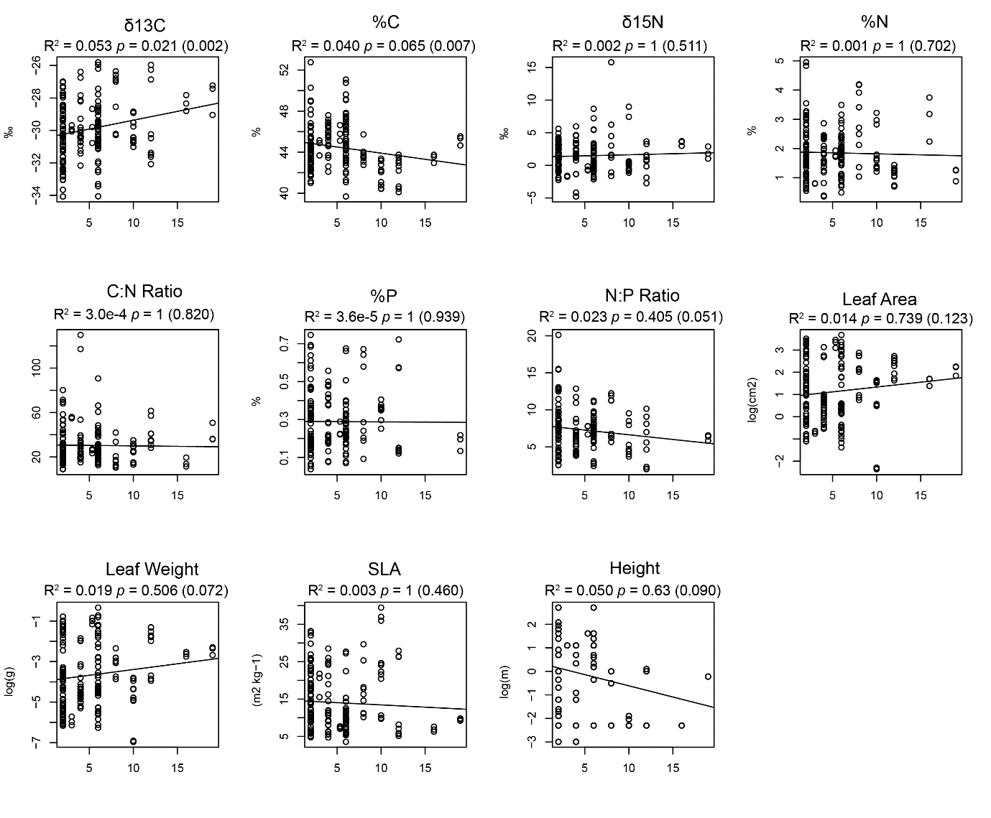

Figure 1. Linear regression correlations between ploidy levels (x axis) and trait values (y axis). p values (raw in brackets), and R2 are shown for each trait.

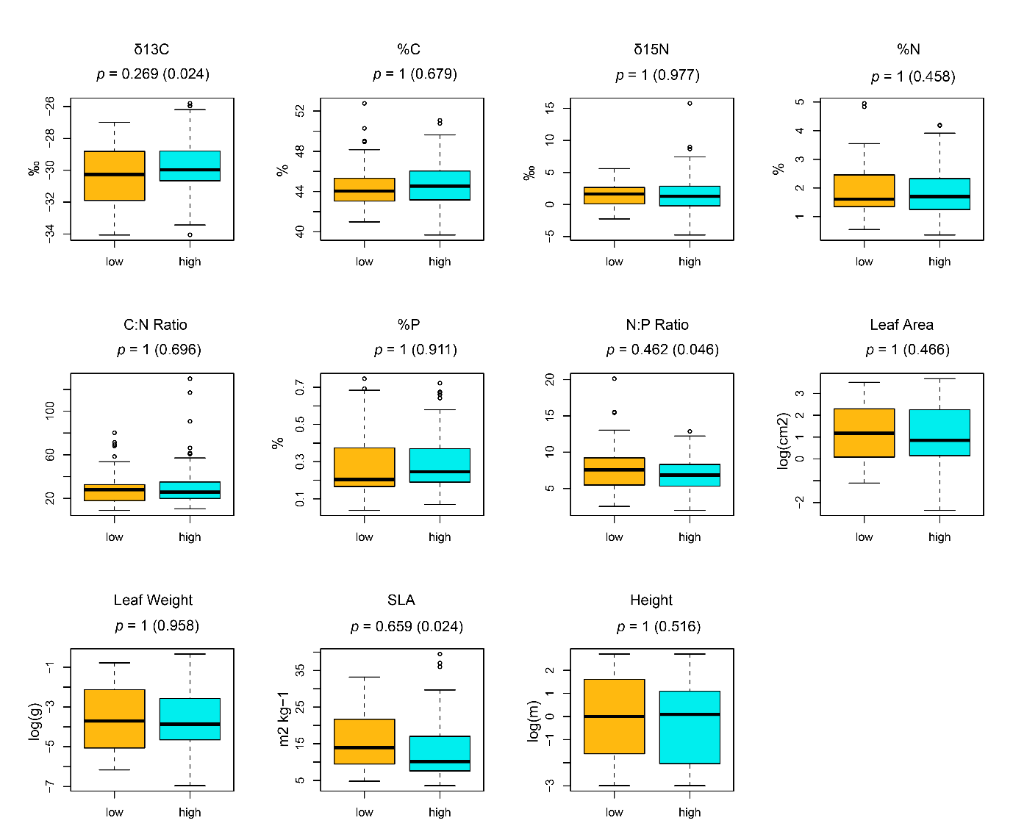

Figure 2. Comparison of trait values in high and low ploidy groups. Raw p values shown in brackets.

Table 2. Results of linear mixed effects models comparing functional traits and continuous ploidy level (raw p values shown in brackets in column 1).

|  |  |  |  |
| --- | --- | --- | --- |
| Trait | p Value (raw) | Effect Size | Marginal R2 |
| δ13C | 1(0.13) | 0.043 | 0.80% |
| %C | 1(0.23) | -0.041 | 0.52% |
| δ15N | 1(0.35) | 0.046 | 0.48% |
| %N | 1(0.67) | -0.007 | 0.08% |
| C:N Ratio | 1(0.86) | 0.047 | 0.01% |
| %P | 1(0.43) | -0.002 | 0.21% |
| N:P Ratio | 0.47(0.047) | -0.107 | 1.49% |
| Leaf Area (cm2) | 1(0.90) | -0.003 | 0.01% |
| Leaf Weight (g) | 1(0.30) | 0.026 | 0.32% |
| SLA (m2 kg−1) | 0.001(0.0001) | -0.369 | 2.24% |
| Height (m) | 1(0.76) | -0.009 | 0.04% |

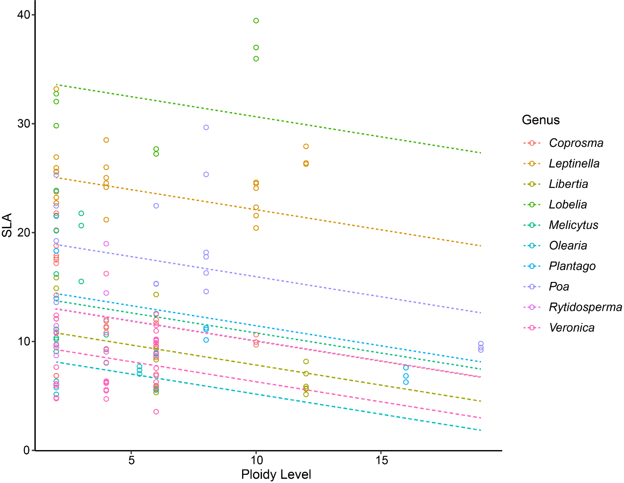

Figure 3. Results of the linear mixed effects model of the relationship between ploidy level and significant leaf area, with genus-level trait variation modelled as a random effect on the intercept. Each line shows the overall inferred trend, offset on the y-axis by the genus-level trait differences.

Linear mixed effect model — binary low vs. high ploidy

δ13C, N:P ratio, leaf area, and SLA showed statistically significant differences between the low-ploidy and high-ploidy groups using linear mixed effects models. δ13C values were higher in the high-ploidy group, and the other traits were all higher in the low-ploidy group (Table 3). None of these differences were statistically significant following correction for multiple testing.

Table 3. Results of linear mixed effects models comparing functional traits and binary ploidy level (raw p values shown in brackets).

|  |  |  |  |
| --- | --- | --- | --- |
| Trait | p Value (raw) | Effect Size | Marginal R2 |
| δ13C | 0.15(0.02) | 0.488 | 1.70% |
| %C | 1(0.76) | 0.075 | 0.03% |
| δ15N | 1(0.98) | -0.008 | 0.00% |
| %N | 1(0.62) | -0.059 | 0.09% |
| C:N Ratio | 1(0.59) | 1.014 | 0.05% |
| %P | 1(0.82) | 0.004 | 0.02% |
| N:P Ratio | 0.16(0.02) | -0.858 | 1.91% |
| Leaf Area (cm2) | 0.16(0.02) | -0.395 | 1.53% |
| Leaf Weight (g) | 1(0.15) | -0.261 | 0.53% |
| SLA (m2 kg−1) | 0.06(0.006) | -1.907 | 1.04% |
| Height (m) | 1(0.59) | -0.117 | 0.11% |

Do principal components of trait variation correlate with ploidy?

Principal components analysis of the 11 individual traits found that the first three principal components (PCs) explained 31%, 20% and 15% of trait variation respectively, significantly more than expected by chance (Fig. 4a).

The first principal component (PC1) involved all traits except for δ15N (Fig. 4b) and captured variation in both leaf economics and body size; traits associated with increased leaf longevity were positively correlated with body size. The second principal component (PC2) represents covariation among all four N-related traits. The third principal component (PC3) represents variation in leaf size, as well as a positive relationship between leaf size and δ13C.

The only statistically significant correlation that any of the components show with ploidy is a positive relationship between PC3 and continuous ploidy level when using linear regression (Table 4). This correlation remains significant (P = 0.001) after correction for multiple testing, with an estimated increase of 0.09 for each additional chromosome set.

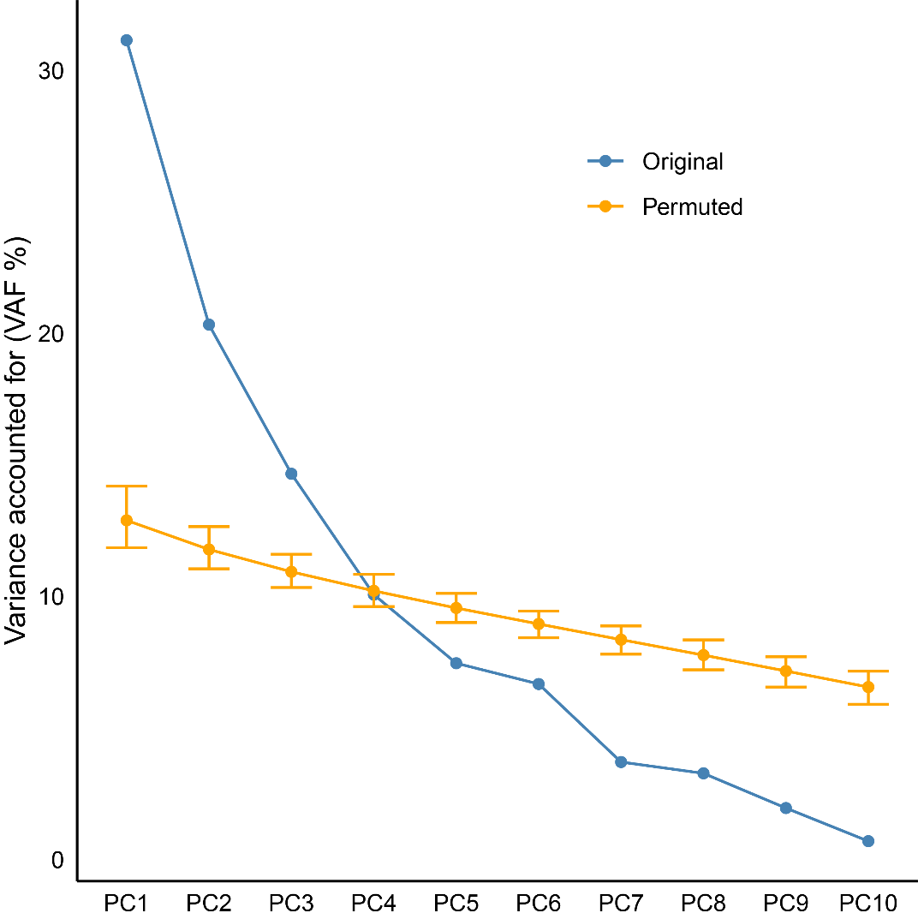

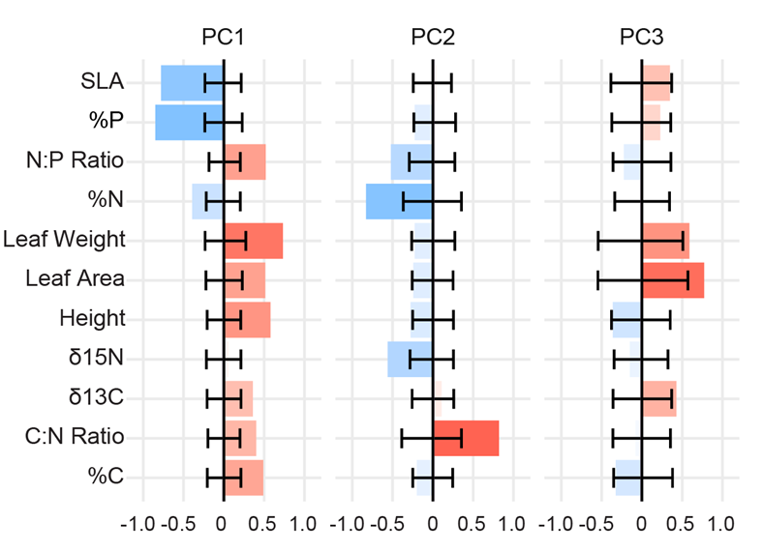

Figures 4a–b. Results of the principal components analysis of the 11 functional traits measured. a) The variance-accounted-for plot comparing each principal component vs. the results from random permutations of the trait values. b) The strength of each trait loading (x axis) for the three significant principal components. Error bars for both graphs show the 95% confidence interval based on random permutations of the original dataset.

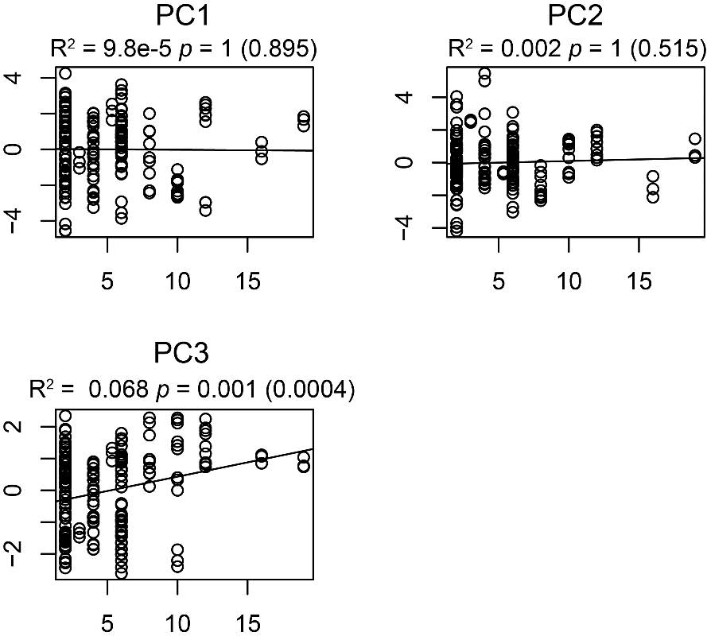

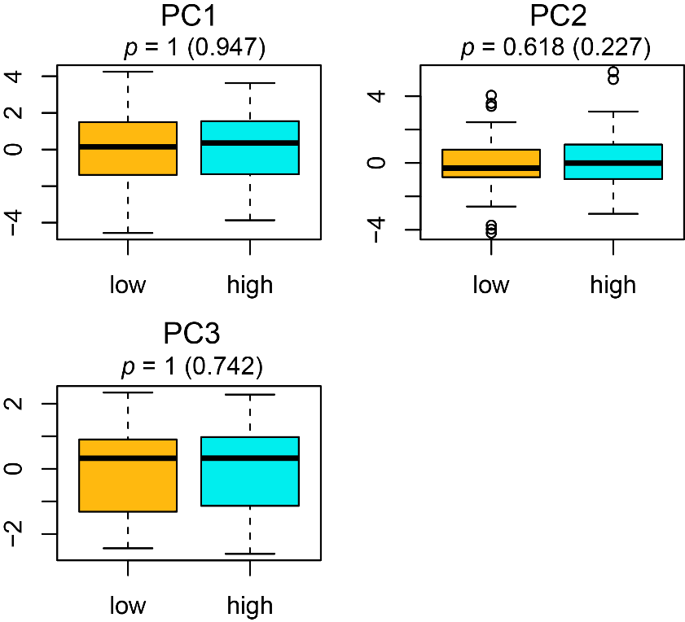

Figure 5a–b. Scatterplots and boxplots showing the relationships between the three statistically significant trait Principal Components and ploidy level treated as a) a continuous variable analysed with linear regression, or b) a binary variable analysed with permutation tests. p values and R2 (for the linear regression only) are included, with raw p values in brackets.

Table 4. Significance and effect sizes for tests of correlation between the three significant principal components and ploidy level, treated as both a continuous and binary variable.

|  |  |  |  |
| --- | --- | --- | --- |
| Continuous Ploidy | | | |
| Trait | p Value (raw) | Effect Size | Marginal R2 |
| PC1 | 1(0.512) | 0.016 | 0.09% |
| PC2 | 1(0.587) | 0.014 | 0.08% |
| PC3 | 1(0.342) | 0.017 | 0.24% |
| Binary Ploidy | | | |
| Trait | p Value (raw) | Effect Size | Marginal R2 |
| PC1 | 0.882(0.468) | -0.126 | 0.09% |
| PC2 | 0.318(0.106) | 0.284 | 0.57% |
| PC3 | 0.882(0.441) | -0.099 | 0.13% |

Are genus-level trait values correlated with higher ploidy levels?

δ13C, %C, and PC3 all show significant relationships with ploidy level when using linear regression, but not when using linear mixed effect models (Figure 1, Table 2). This suggests that these correlations may be driven by between-genus variation in traits and ploidy levels. Figure 6 shows that between the genera there appear to be correlations between median trait values and mean ploidy level.

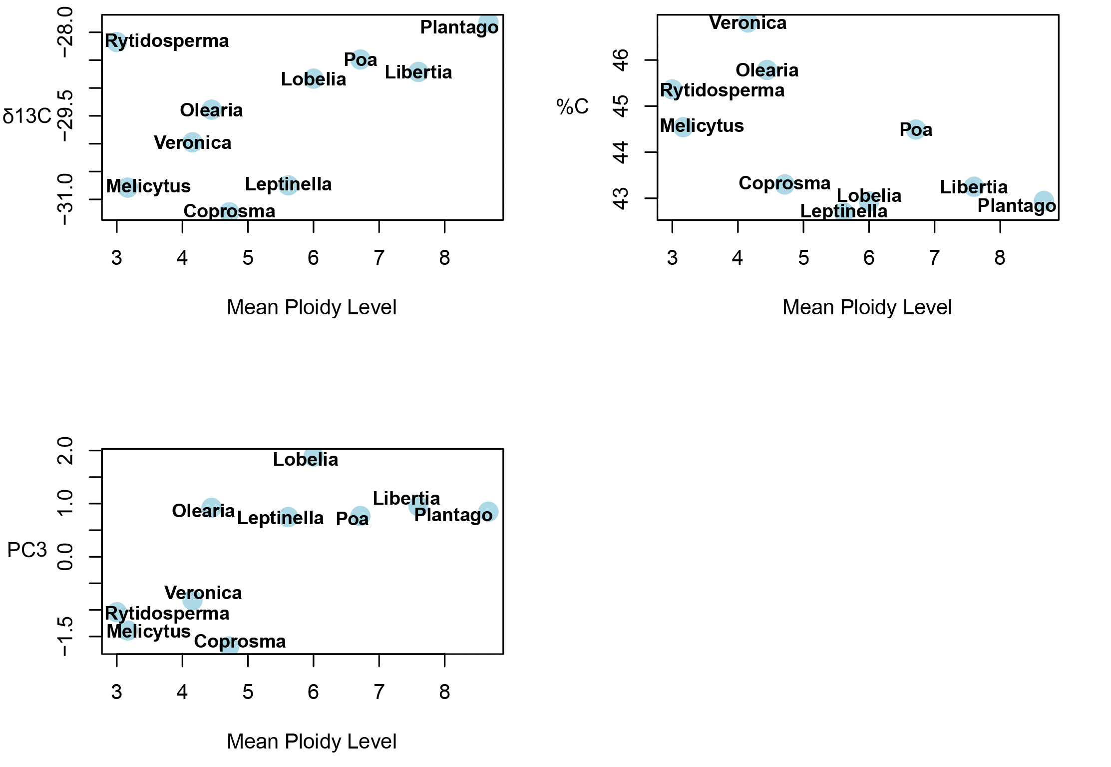

Figure 6. Scatterplots showing relationships between median trait value and mean ploidy level for each genus. The three variables shown are those which show the three strongest correlations with ploidy level.

**Discussion**

The only significant trait shift that may be driven by increased ploidy level is a relatively small decrease in SLA. For all other trait there is no evidence that within-genus trait variation is correlated with differences in ploidy level. Several other traits (δ13C, %C, and PC3) correlate with ploidy level overall, but not when the effects of genus identity on trait values are accounted for. We also found that ploidy level does not correlate with any traits when treated as a binary variable, regardless of whether genus-level trait variation is included in the analysis. This suggests that accounting for recurrent WGD events (e.g., 4*x* to 8*x*) by treating ploidy level as a continuous variable may be important in detecting relationships with functional traits. This can be seen clearly in the scatterplot/linear regression results for δ13C, %C, and PC3, where the trends appear to be driven primarily by the species that are 8*x* and above (Figs. 1 & 5a). While we have little evidence for WGD driving directional shifts in functional traits, it is remains possible that plant physiology changes at higher ploidy levels rather than the morphological traits measured here.

The absence of any trend in foliar %P (and %N) is atypical, as environmental P levels are considered an important factor controlling the geographic distribution of polyploids, potentially because of the high P content of DNA (Raabová, Fischer and Münzbergová, 2008; Šmarda *et al.*, 2013; Guignard *et al.*, 2016). N:P ratios decline with increasing ploidy level, however the effect size (-0.107 per chromosome set) and marginal R2 (0.0149) are both small (Table 2), and not significant following correction for multiple testing. Some authors have linked polyploidy to increased nutrient dependence more broadly, rather than P specifically (Chao *et al.*, 2013; Anneberg and Segraves, 2020; Walczyk and Hersch-Green, 2022). However, this is not apparent in our study for N and P (Figs. 1 & 2, Tables 2 & 3).

We found strong support for a negative correlation between ploidy level and SLA, although this effect is relatively small (marginal R2 = 0.0224, Table 2). Overall, SLA decreases by 0.3685 kg per m2 for each additional chromosome set; a leaf of median area (2.6cm2) would be predicted to weigh 165.0 mg in a 2*x* species, 173.0 mg in a 4*x* species, and 192 mg in an 8*x* species. The estimated difference in SLA between 2*x* vs 8*x* congeners (2.21 kg per m2) covers approximately 3.12% of the global range of SLA/LMA (Díaz *et al.*, 2016). This is equivalent to only a ~70m increase in altitude based on the variation in community SLA reported along an elevation gradient in Sides et al. (2014). However, none of the other leaf economics traits show a similar relationship with ploidy level. We suggest the observed relationship between SLA and ploidy level is non-adaptive, reflecting physical changes associated with cell size as genomes expand. One possible explanation for the ploidy/SLA correlation is that the effect of WGD on genome size could increase cell size and therefore leaf thickness (Cavalier-Smith, 2005; Brodribb, Jordan and Carpenter, 2013; Guignard *et al.*, 2016).

The fact that δ13C, %C, and PC3 are all significantly correlated with ploidy level when using linear regression (Fig. 1; Table 4) — but not linear mixed effects analysis (Table 3) — suggests that genus-level differences in ploidy levels and trait values are driving these correlations. This supports the idea that genus-level differences in these traits might predict the extent to which whole-genome duplication occurs, as appears to be the case in Fig. 5, a perspective supported in a study of the global distribution of polyploid plants (Rice *et al.*, 2019). In particular, polyploidy is associated with perenniality and herbaceousness, suggesting that WGD may occur more frequently in plant groups exhibiting these lifeforms (Otto and Whitton, 2000; Husband, Baldwin and Suda, 2013; Zenil-Ferguson, Ponciano and Burleigh, 2017; Van Drunen and Husband, 2019). Because of this, genera displaying functional traits associated with smaller body size (associated with herbaceousness) and greater leaf longevity (associated with perenniality) might be expected to contain more high-ploidy species. However, the variables identified in this study as potentially predicting between-genus ploidy variation do not support this. The lower %C seen at higher ploidy levels would be more typical of fast growing acquisitive leaves, and the positive correlation between PC3 and ploidy suggests genera with larger leaves (indicative of larger body-sizes) tend to have more high-ploidy species. It is worth noting however that the three groups with the highest average ploidy levels among the sampled species are all herbaceous (*Libertia*, *Plantago*, and *Poa*).

Our findings reject the hypothesis that WGD has large, adaptive, directional effects on functional traits in the New Zealand flora. However, it is possible that WGD has a non-directional effect on trait evolution, perhaps via additional genetic content facilitating rapid adaptation to novel conditions (Alix *et al.*, 2017; Tao *et al.*, 2021). Additionally, allopolyploidy may allow for unique combinations of genes, and/or a wider range of gene expression pathways (Soltis and Soltis, 2000; Gaeta *et al.*, 2007). If WGD promotes an increased rate of trait evolution then this could lead to both faster increases and decreases in trait values, depending on the circumstances of each WGD event. If there are no restrictions on extreme trait values (e.g., a Brownian motion model of trait evolution), then we might expect faster trait evolution to result in greater trait variance between high-ploidy species. Our trait scatterplots in Figs. 1 and 5a do not show any evidence of increasing trait variance at higher ploidy levels. However, if trait values are constrained towards an optimum (e.g., an Ornstein-Uhlenbeck model), then faster trait evolution does not necessarily increase trait variance between high-ploidy species.

**Conclusion**

Most of the functional traits measured do not appear to show any relationship to ploidy level, nor any differences between the low-ploidy and high ploidy groups. δ13C and %C, as well as the PC3 axis of trait variation, show a significant correlation with ploidy level, however this is likely to be a result of between-genus differences in trait values — these traits do not show any within-genus relationship to ploidy level. The only trait which is significantly correlated with intra-generic trait variation is SLA, which declines as ploidy level increases. This effect is relatively small and is not mirrored in other leaf-economics traits, perhaps representing an effect of increased genome size has on leaf thickness, rather than an adaptive effect of WGD on leaf function.

**Competing interests**

None Declared.

**Author contributions**

LGL and WGL conceived of the study and selected the genera and species to use. WGL managed the common garden experiment and collected the trait data. LGL and NJM conducted the statistical analyses. LGL wrote the first draft of the manuscript and prepared the figures and tables. All authors reviewed and edited the final manuscript.

**Data availability**

Data used in this study are available at…

**References**

Alam, M.A. *et al.* (2020) ‘Shoot flammability is decoupled from leaf flammability, but controlled by leaf functional traits’, *Journal of Ecology*, 108(2), pp. 641–653. Available at: https://doi.org/10.1111/1365-2745.13289.

Alix, K. *et al.* (2017) ‘Polyploidy and interspecific hybridization: partners for adaptation, speciation and evolution in plants’, *Annals of Botany*, 120(2), pp. 183–194. Available at: https://doi.org/10.1093/aob/mcx079.

Anneberg, T.J. and Segraves, K.A. (2020) ‘Nutrient enrichment and neopolyploidy interact to increase lifetime fitness of Arabidopsis thaliana’, *Plant and Soil*, 456(1), pp. 439–453. Available at: https://doi.org/10.1007/s11104-020-04727-6.

Baker, R.L. *et al.* (2017) ‘Polyploidy and the relationship between leaf structure and function: implications for correlated evolution of anatomy, morphology, and physiology in Brassica’, *BMC Plant Biology*, 17(1), p. 3. Available at: https://doi.org/10.1186/s12870-016-0957-3.

Bates, D. *et al.* (2015) ‘Fitting Linear Mixed-Effects Models Using lme4’, *Journal of Statistical Software*, 67, pp. 1–48. Available at: https://doi.org/10.18637/jss.v067.i01.

Blakemore, L. C., Searle, P. L., and Daly, B. K. (1987) ‘Methods for chemical analysis of soils’. Department of Scientific and Industrial Research.

Brochmann, C. *et al.* (2004) ‘Polyploidy in arctic plants’, *Biological Journal of the Linnean Society*, 82(4), pp. 521–536. Available at: https://doi.org/10.1111/j.1095-8312.2004.00337.x.

Brodribb, T.J., Jordan, G.J. and Carpenter, R.J. (2013) ‘Unified changes in cell size permit coordinated leaf evolution’, *New Phytologist*, 199(2), pp. 559–570. Available at: https://doi.org/10.1111/nph.12300.

Cavalier-Smith, T. (2005) ‘Economy, Speed and Size Matter: Evolutionary Forces Driving Nuclear Genome Miniaturization and Expansion’, *Annals of Botany*, 95(1), pp. 147–175. Available at: https://doi.org/10.1093/aob/mci010.

Chao, D.Y. *et al.* (2013) ‘Polyploids Exhibit Higher Potassium Uptake and Salinity Tolerance in Arabidopsis’, *Science*, 341(6146), pp. 658–659. Available at: https://doi.org/10.1126/science.1240561.

Cornelissen, J.H.C. *et al.* (2003) ‘A handbook of protocols for standardised and easy measurement of plant functional traits worldwide’, *Australian Journal of Botany*, 51(4), pp. 335–380. Available at: https://doi.org/10.1071/bt02124.

Cross, E.W., Quinn, C.J. and Wagstaff, S.J. (2002) ‘Molecular evidence for the polyphyly of Olearia (Astereae: Asteraceae)’, *Plant Systematics and Evolution*, 235(1), pp. 99–120. Available at: https://doi.org/10.1007/s00606-002-0198-9.

Diallo, A.M. *et al.* (2016) ‘Polyploidy can Confer Superiority to West African Acacia senegal (L.) Willd. Trees’, *Frontiers in Plant Science*, 7. Available at: https://www.frontiersin.org/articles/10.3389/fpls.2016.00821 (Accessed: 24 November 2022).

Diatta, O. *et al.* (2022) ‘Leaf morphology and stable isotope ratios of carbon and nitrogen in Acacia senegal (L.) Wild trees vary with climate at the geographic origin and ploidy level’, *Trees*, 36(1), pp. 295–312. Available at: https://doi.org/10.1007/s00468-021-02206-8.

Díaz, S. *et al.* (2016) ‘The global spectrum of plant form and function’, *Nature*, 529(7585), pp. 167–171. Available at: https://doi.org/10.1038/nature16489.

Gaeta, R.T. *et al.* (2007) ‘Genomic Changes in Resynthesized Brassica napus and Their Effect on Gene Expression and Phenotype’, *The Plant Cell*, 19(11), pp. 3403–3417. Available at: https://doi.org/10.1105/tpc.107.054346.

Garnock-Jones, P., Albach, D. and Briggs, B.G. (2007) ‘Botanical names in Southern Hemisphere Veronica (Plantaginaceae): sect. Detzneria, sect. Hebe, and sect. Labiatoides’, *TAXON*, 56(2), pp. 571–582. Available at: https://doi.org/10.1002/tax.562028.

Greer, B.T. *et al.* (2018) ‘Polyploidy influences plant–environment interactions in quaking aspen (Populus tremuloides Michx.)’, *Tree Physiology*, 38(4), pp. 630–640. Available at: https://doi.org/10.1093/treephys/tpx120.

Guignard, M.S. *et al.* (2016) ‘Genome size and ploidy influence angiosperm species’ biomass under nitrogen and phosphorus limitation’, *New Phytologist*, 210(4), pp. 1195–1206. Available at: https://doi.org/10.1111/nph.13881.

Hahn, M.A., Kleunen, M. van and Müller-Schärer, H. (2012) ‘Increased Phenotypic Plasticity to Climate May Have Boosted the Invasion Success of Polyploid Centaurea stoebe’, *PLoS One*, 7(11), p. e50284. Available at: https://doi.org/10.1371/journal.pone.0050284.

Han, T.-S. *et al.* (2020) ‘Polyploidy promotes species diversification of Allium through ecological shifts’, *New Phytologist*, 225(1), pp. 571–583. Available at: https://doi.org/10.1111/nph.16098.

Himmelreich, S., Breitwieser, I. and Oberprieler, C. (2012) ‘Phylogeny, biogeography, and evolution of sex expression in the southern hemisphere genus Leptinella (Compositae, Anthemideae)’, *Molecular Phylogenetics and Evolution*, 65(2), pp. 464–481. Available at: https://doi.org/10.1016/j.ympev.2012.07.001.

Himmelreich, S., Breitwieser, I. and Oberprieler, C. (2014) ‘Phylogenetic relationships in the extreme polyploid complex of the New Zealand genus Leptinella (Compositae: Anthemideae) based on AFLP data’, *TAXON*, 63(4), pp. 883–898. Available at: https://doi.org/10.12705/634.19.

Hothorn, T. *et al.* (2006) ‘A Lego System for Conditional Inference’, *The American Statistician*, 60(3), pp. 257–263. Available at: https://doi.org/10.1198/000313006X118430.

Husband, B.C., Baldwin, S.J. and Suda, J. (2013) ‘The Incidence of Polyploidy in Natural Plant Populations: Major Patterns and Evolutionary Processes’, in J. Greilhuber, J. Dolezel, and J.F. Wendel (eds) *Plant Genome Diversity Volume 2: Physical Structure, Behaviour and Evolution of Plant Genomes*. Vienna: Springer, pp. 255–276. Available at: https://doi.org/10.1007/978-3-7091-1160-4_16.

Josse, J. and Husson, F. (2016) ‘missMDA: A Package for Handling Missing Values in Multivariate Data Analysis’, *Journal of Statistical Software*, 70, pp. 1–31. Available at: https://doi.org/10.18637/jss.v070.i01.

Joswig, J.S. *et al.* (2022) ‘Climatic and soil factors explain the two-dimensional spectrum of global plant trait variation’, *Nature Ecology & Evolution*, 6(1), pp. 36–50. Available at: https://doi.org/10.1038/s41559-021-01616-8.

Kichenin, E. *et al.* (2013) ‘Contrasting effects of plant inter- and intraspecific variation on community-level trait measures along an environmental gradient’, *Functional Ecology*, 27(5), pp. 1254–1261. Available at: https://doi.org/10.1111/1365-2435.12116.

López-Jurado, J., Mateos-Naranjo, E. and Balao, F. (2022) ‘Polyploidy promotes divergent evolution across the leaf economics spectrum and plant edaphic niche in the Dianthus broteri complex’, *Journal of Ecology*, 110(3), pp. 605–618. Available at: https://doi.org/10.1111/1365-2745.13823.

Manzaneda, A.J. *et al.* (2012) ‘Environmental aridity is associated with cytotype segregation and polyploidy occurrence in Brachypodium distachyon (Poaceae)’, *New Phytologist*, 193(3), pp. 797–805. Available at: https://doi.org/10.1111/j.1469-8137.2011.03988.x.

McGlone, M.S., Buitenwerf, R. and Richardson, S.J. (2016) ‘The formation of the oceanic temperate forests of New Zealand’, *New Zealand Journal of Botany*, 54(2), pp. 128–155. Available at: https://doi.org/10.1080/0028825X.2016.1158196.

McGlone, M.S., Richardson, S.J. and Jordan, G.J. (2010) ‘Comparative biogeography of New Zealand trees: species richness, height, leaf traits and range sizes’, *New Zealand Journal of Ecology*, 34(1), pp. 137–151.

Mologni, F. *et al.* (2022) ‘Functional traits explain non-native plant species richness and occupancy on northern New Zealand islands’, *Biological Invasions*, 24(7), pp. 2135–2154. Available at: https://doi.org/10.1007/s10530-022-02762-1.

Mtileni, M.P., Venter, N. and Glennon, K.L. (2021) ‘Ploidy differences affect leaf functional traits, but not water stress responses in a mountain endemic plant population’, *South African Journal of Botany*, 138, pp. 76–83. Available at: https://doi.org/10.1016/j.sajb.2020.11.029.

Murray, B. and de Lange, P. (2013) ‘Contributions to a chromosome atlas of the New Zealand flora – 40. Miscellaneous counts for 36 families’, *New Zealand Journal of Botany*, 51(1), pp. 31–60. Available at: https://doi.org/10.1080/0028825X.2012.747969.

Ni, Z. *et al.* (2009) ‘Altered circadian rhythms regulate growth vigour in hybrids and allopolyploids’, *Nature*, 457(7227), pp. 327–331. Available at: https://doi.org/10.1038/nature07523.

Oberlander, K.C. *et al.* (2016) ‘Species-rich and polyploid-poor: Insights into the evolutionary role of whole-genome duplication from the Cape flora biodiversity hotspot’, *American Journal of Botany*, 103(7), pp. 1336–1347. Available at: https://doi.org/10.3732/ajb.1500474.

Oswald, B.P. and Nuismer, S.L. (2011) ‘Neopolyploidy and Diversification in Heuchera Grossulariifolia’, *Evolution*, 65(6), pp. 1667–1679. Available at: https://doi.org/10.1111/j.1558-5646.2010.01208.x.

Otto, S.P. and Whitton, J. (2000) ‘Polyploid Incidence and Evolution’, *Annual Review of Genetics*, 34.

Raabová, J., Fischer, M. and Münzbergová, Z. (2008) ‘Niche differentiation between diploid and hexaploid Aster amellus’, *Oecologia*, 158(3), pp. 463–472. Available at: https://doi.org/10.1007/s00442-008-1156-1.

Rice, A. *et al.* (2015) ‘The Chromosome Counts Database (CCDB) – a community resource of plant chromosome numbers’, *New Phytologist*, 206(1), pp. 19–26. Available at: https://doi.org/10.1111/nph.13191.

Rice, A. *et al.* (2019) ‘The global biogeography of polyploid plants’, *Nature Ecology & Evolution*, 3(2), pp. 265–273. Available at: https://doi.org/10.1038/s41559-018-0787-9.

Saldivia, P. *et al.* (2022) ‘A Generic Taxonomic Synopsis of the Pleurophyllum Clade (Asteraceae: Astereae: Celmisiinae) with the Recognition of the New Zealand Endemic New Genus Macrolearia’, *Systematic Botany*, 47(2), pp. 607–634. Available at: https://doi.org/10.1600/036364422X16512564801722.

Schranz, M.E. and Osborn, T.C. (2004) ‘De novo variation in life-history traits and responses to growth conditions of resynthesized polyploid Brassica napus (Brassicaceae)’, *American Journal of Botany*, 91(2), pp. 174–183. Available at: https://doi.org/10.3732/ajb.91.2.174.

Sides, C.B. *et al.* (2014) ‘Revisiting Darwin’s hypothesis: Does greater intraspecific variability increase species’ ecological breadth?’, *American Journal of Botany*, 101(1), pp. 56–62. Available at: https://doi.org/10.3732/ajb.1300284.

Šmarda, P. *et al.* (2013) ‘Effect of phosphorus availability on the selection of species with different ploidy levels and genome sizes in a long-term grassland fertilization experiment’, *New Phytologist*, 200(3), pp. 911–921. Available at: https://doi.org/10.1111/nph.12399.

Soltis, P.S. and Soltis, D.E. (2000) ‘The role of genetic and genomic attributes in the success of polyploids’, *Proceedings of the National Academy of Sciences*, 97(13), pp. 7051–7057. Available at: https://doi.org/10.1073/pnas.97.13.7051.

Sugiyama, S.-I. (2005) ‘Polyploidy and Cellular Mechanisms Changing Leaf Size: Comparison of Diploid and Autotetraploid Populations in Two Species of Lolium’, *Annals of Botany*, 96(5), pp. 931–938. Available at: https://doi.org/10.1093/aob/mci245.

Tao, X. *et al.* (2021) ‘Neofunctionalization of a polyploidization-activated cotton long intergenic non-coding RNA DAN1 during drought stress regulation’, *Plant Physiology*, 186(4), pp. 2152–2168. Available at: https://doi.org/10.1093/plphys/kiab179.

Thomas, A.E. *et al.* (2023) ‘Multiple origins of mountain biodiversity in New Zealand’s largest plant radiation’, *Journal of Biogeography*, n/a(n/a). Available at: https://doi.org/10.1111/jbi.14589.

Torres-Espín, A. *et al.* (2021) ‘Reproducible analysis of disease space via principal components using the novel R package syndRomics’, *eLife*. Edited by M. Zaidi and M. Barton, 10, p. e61812. Available at: https://doi.org/10.7554/eLife.61812.

Van Drunen, W.E. and Husband, B.C. (2019) ‘Evolutionary associations between polyploidy, clonal reproduction, and perenniality in the angiosperms’, *New Phytologist*, 224(3), pp. 1266–1277. Available at: https://doi.org/10.1111/nph.15999.

Walczyk, A.M. and Hersch-Green, E.I. (2022) ‘Do water and soil nutrient scarcities differentially impact the performance of diploid and tetraploid Solidago gigantea (Giant Goldenrod, Asteraceae)?’, *Plant Biology*, 24(6), pp. 1031–1042. Available at: https://doi.org/10.1111/plb.13448.

Wang, Z. *et al.* (2017) ‘Implications of polyploidy events on the phenotype, microstructure, and proteome of Paulownia australis’, *PLOS ONE*, 12(3), p. e0172633. Available at: https://doi.org/10.1371/journal.pone.0172633.

Wei, N. *et al.* (2020) ‘Genome duplication effects on functional traits and fitness are genetic context and species dependent: studies of synthetic polyploid Fragaria’, *American Journal of Botany*, 107(2), pp. 262–272. Available at: https://doi.org/10.1002/ajb2.1377.

Wright, I.J. *et al.* (2004) ‘The worldwide leaf economics spectrum’, *Nature*, 428(6985), pp. 821–827. Available at: https://doi.org/10.1038/nature02403.

Zenil-Ferguson, R., Ponciano, J.M. and Burleigh, J.G. (2017) ‘Testing the association of phenotypes with polyploidy: An example using herbaceous and woody eudicots’, *Evolution*, 71(5), pp. 1138–1148. Available at: https://doi.org/10.1111/evo.13226.