Nathan Mausbach

8-11-22

Mod 1

GitHub: <https://github.com/nmausbach/csd-340.git>

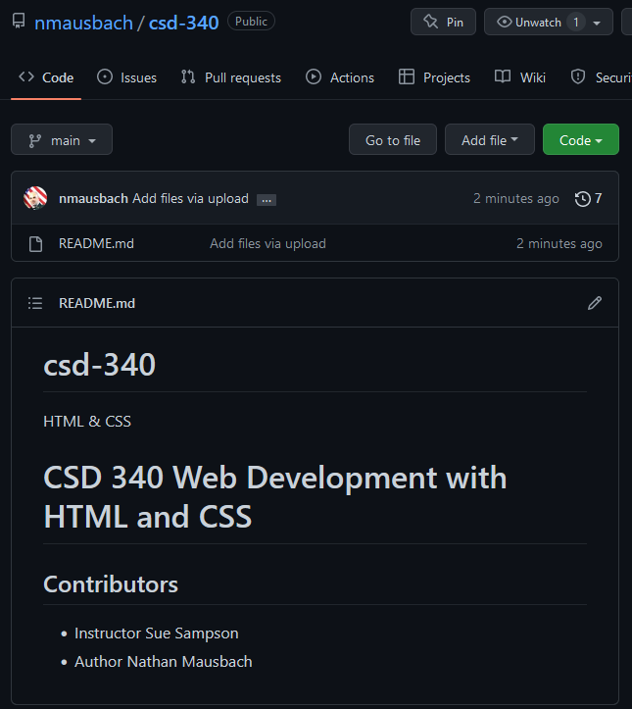

Local directory

