A Comparative study of K-Nearest Neighbour, Support Vector Machine and Multi-Layer Perceptron for Thalassemia Screening.

Abstract. In this paper we investigate the feasibility of two typical techniques of Pattern Recognition in the classification for Thalassemia screening. They are Support Vector Machine (SVM) and K-Nearest Neighbour (K-NN). We compare SVM and KNN, which rely on Statistical Learning Theory, with an Multi-Layer Perceptron (MLP) classifier. We propose a two-classifier system based on SVM. The first layer is used to differentiate between pathological cases and non-pathological cases while the second layer is used to discriminate between two different pathological cases ( α-thalassemia against β-thalassemia) from the first output layer (pathological cases).
The MLP classifier gives slightly better results than SVM although the amount of data available is limited. Both techniques enable thalassemia carriers to be discriminated from healthy subjects with 95% specificity, although he sensitivity of MLP is 92% while that of SVM is 83%.

Introduction

Thalassemias are genetic defects that are commonly found in many parts of the world including Africa, the Far East, and Mediterranean regions[1]. In order to know how many people suffer from this disease the heterozygous population should be screened. A 1st –level analysis using hemo-cromocytometric data and a 2nd-level examination (total HbA₂, globin chain synthesis, and genetic analysis)[2][3] should be carried out to identify α and β thalassemia carriers. Although total HbA₂, globin chain synthesis, and genetic analysis can identify carriers accurately, they are time-consuming and expensive. Thus an automated diagnostic support system could be of use when a 1st classification based only on the hemachromocytometric data is made. There is already a classification system based on MLP [4].
We want to make a comparative study of K-Nearest Neighbour [5], Support Vector Machine [8][9] and Multi-Layer Perceptron [6][11] for Thalassemia Screening for determination of the best performance on thalassemias data reported in [4]. First we investigate the performance of KNN and SVM in the discrimination healthy/sick then we propose a multy-layer classifier based on SVM which, after the determination of healthy/sick, differentiate between the two different pathological cases ( α-thalassemia against β-thalassemia) .

Descrizione classificatori

Support Vector Machine
Support Vector Machines [8][9][10] perform pattern recognition for two-class problems by determining the separating hyperplane with maximum distance to the closest points of the training set. These points are called support vectors .
We show in the near figure the separating hyperplane; the Margin is called ρ. The hyperplane is equidistant from the nearest class point (white and black group). These points are called support vectors .
ρ

ρ

If the data is not linearly separable in the input space, a non-linear trasformation φ(.) can be applied which maps the data points x ∈R^{n} into a high (possibly infinite) dimensional space Η which is called feature space. The data in the feature space is then separated by the optimal hyperplane as described above.
The mapping φ(.) is represented in the SVM classifier by a kernel function K(,) which defines an inner product in H i.e. K(x,t) = φ(x) φ(t). The decision function of the SVM has the form :
f(x) = Σ_{i} α_{i} y_{i} K(x_{i} , x) i:1,..,l (1)
where l is the number of data points, and y_{i} ∈{-1,1} is the class label of training point x_{j} . Coefficients α_{i in} Eq. (1) can be found solving a quadratic programming problem with linear constrains [9]. The support vectors are the nearest points to the separating boundary and are the only ones for which α_{i} in Eq (1) can be nonzero.
An important family of admissible kernel functions are:
- Gaussian kernel, K(x,y) = exp(-||x-y||/2σ² ), where σ is the variance of the Gaussian.
- Polinomial kernel, K(x,y) = (1+ x y)^{d} , where d is the degree of the polynomial (d=0 for linear kernel).
Let M be the distance of the support vectors to the hyperplane . This quantity is called margin and it is related to the coefficients in Eq. (1) ,

M = (Σ_{i} α_{i} )^{1/2} i:1,..,l (2)
0 < α_{i} < C
The margin is an indicator of the separability of the data. In fact, the expected error probability of an SVM is bounded by the average of quantity C²/lM², with C the radius of the smallest sphere containing the data points in the feature space.

K-Nearest Neighbour
K-Nearest Neighbour classifier [5][7] employ the hypothesis that pattern of the same class aim tightly to concentrate around an typical pattern, representative of the same class.
Let x* be the unknown point (unknown pattern). s_{i} ∈ {s₁ , s_{N} } = S is the nearest point (NN) from x* if
d(x,s_{i} ) = min_{l} d(x,s₁ ) l = 1..N
where d() is a distance measurement definitly in the feature space.
Considering every point of S as a class-prototype, thus we can use the relationship above as classification-rule, 1-NN, which associate pattern x to the j class , which contains s_{i} .
1-NN rule can be generalized for the definition of K-NN rule. K-NN rule uses the k nearest point of S from x. K-NN rule associate pattern x to the j class which has the higher number of elements betwin nearest K.
Called U(x) the group of the K nearest point from x. For example with odd K and two class, ϖ₁ e ϖ_{2 ,} the decision rule indicate the class which has the higher number of elements in U(x).

In the near figure, we show with black, in the center, the test pattern while inside the circle (representative of euclidean distance), there are k=5 train pattern for the valutation.

For this type of classifier, it is necessary to have a not very small train set and a good discriminating distance notion. KNN has a good performance in multi-class problem solving simultaneusly the discrimination of all class. For a good classification it is suitable the determination of the best K; K value is often approximately near to the square of N.

Database and features normalization
The initial database that was used to train the computer to classify patients consisted of 304 clinical records based on a thalassemia screening carried out by Ozieri Hospital at a state school. Several state schools of Northern Sardinia were used in the test. Each 8th year student (14- to 15-year-old boys and girls) took part in the screening. Although the records can be considered a random sample, subjects with iron deficiency were excluded from the test, as in their case iron levels in the blood must be normalised before thalassemia diagnosis can be made[9].
Hemachromocytometric data, HbA₂ and genetic determination of the main thalassemia defects (α^{3.7} and α^{Nco} variants) were used to make the medical diagnoses. HbA₂ was determined to identify β carriers. 27 subjects had a HbA₂ ≥ 4%, while HbA₂ ≤ 3% in the other 277 cases. Medical analysis…….., the 1st group were diagnosed as being β carriers. Genetic analysis was used to diagnose α carriers.
Si sono fatti diversi tentativi di normalizzazione dei valori delle feature ma nessuno di essi ha portato ad un diretto vantaggio. L’analisi per componenti principali (PCA) [5][7], nel migliore dei casi, ha ridotto a tre le features rilevanti al fine della discriminazione ma la successiva applicazione dei classificatori, i cui risultati sono descritti in seguito, dopo questa trasformazione sono sempre stati minori o al più uguali al caso senza normalizzazione. In definitiva i dati che sono stati considerati rilevanti alla fine della classificazione si sono ridotti all’utilizzo dei valori di RBC, Hb, Ht, MCV non normalizzati. Le 304 cartelle sono state inoltre divise in un insieme di dati di “test” pari a 108 cartelle (con 55 casi normali, 44 α, 9 β) e un insieme di addestramento, detto “train”, costituito da 196 cartelle (con 141 casi normali, 37 α, 18 β).

Methods

System used for data analysis
All calculations were carried out by using AMD K6 III 400 MHz computer running Windows 98 operating system ; only for SVM_light we used version 7.2 of Red Hat (LINUX) operating system.

PCA
We realized PCA with version 6 of Simulink MATLAB program ; in the first (bad) approch we used all train-feature (without G6PD and Globuli bianchi che non vengono rilevate con le normali analisi del sangue) obtaining a trasformation matrix of 196 (train pattern ) x 8 (feature); in the best approch we used in input only four features (RBC, Hb, Ht, MCV) obtaining a trasformation matrix of 196x3 .

KNN
K-NN analysis was performed by usig self-written parogram coded by C but the same result can be obtanined using LNKnet software that is available from MIT Lincoln Laboratory (HTTP://www.ll.mit.edu/IST/). The best K is find trying all k from 1 to 60 .

SVM
SVM classification was performed by using version 4 of SVM_light software that is available in the following location :
ftp://ftp-ai.cs.uni-dortmund.de/pub/Users/thorsten/svm_light/current/svm_light.tar.gz
We tryed with defaults parameter with LOO options. We have repeted the classification using a linear, polinomial and rbf kernel . For each case we tryed many C value parameters until to obtain the best relativity accuracy .

Experimental results

Using KNN classifier to differentiate between pathological cases and non-pathological cases allowed to obtain 85% of accuracy with 93% of specificity (percentage of non pathologic cases correctly classified) and 77% of sensitivity (percentage of pathologic cases correctly classified). The corresponding results are reported in table 1.
 | N | M | OK | BAD | TOT | ACC.
N | 92.73 | 7.27 | 51 | 4 | 55 | 92.73
M | 22.64 | 77.36 | 41 | 12 | 53 | 77.36
 |  |  | 92 | 16 | 108 | 85.19
Table 1
Tabella relativa all’applicazione del KNN per K=23 nella discriminazione tra pazienti sani e quelli malati
Using SVM, for the same discrimination betwin pathological cases against non pathological cases, the best result of accuracy is approximately 89% (with 95% of specificity and 83% of sensivity) obtained with linear kernel, parameter C = 10 and validations with leave-one-out (LOO) algorithm [13][14][15]. Details are showed in table 2 . We obtained the same result of accuracy using linear kernel but C = 1 : we have in this case a different sensivity and specificity as showed in table 3.

 | N | M | OK | BAD | TOT | ACC.
N | 94.55 | 5.45 | 52 | 3 | 55 | 94.55
M | 16.98 | 83.02 | 44 | 9 | 53 | 83.02
 |  |  | 96 | 12 | 108 | 88.89
Tabella 2
Tabella relativa all’applicazione della SVM per kernel lineare per c=10 nella discriminazione tra pazienti sani e quelli malati
 | N | M | OK | BAD | TOT | ACC.
N | 92.73 | 7.27 | 51 | 4 | 55 | 92.73
M | 15.09 | 84.91 | 45 | 8 | 53 | 84.91
 |  |  | 96 | 12 | 108 | 88.89
Tabella 3
Tabella relativa all’applicazione della SVM per kernel lineare per c=1 nella discriminazione tra pazienti sani e quelli malati

The discrimination betwin α and β pathologies is obtained by a second classification layer specialized on these patterns that receive, in input, the first classifier output responsible of the subdivision healthy/sick; the approch is showed below in the block diagram.

sane
data
Classifier 1
(SVM)

Classifier 2
(SVM or KNN)

α
β

As is proved on the table 1 and 2, the best classification healthy/sick has been obtained with SVM therefore this classifier is been used as first classifer. Test for the discrimination α pathologies against β pathologies supplied the same result for KNN and SVM classifier; we showed these on the table 4 and 5. Occorre notare che l’esiguo numero di cartelle di pazienti sani, che vengono erroneamente passati al classificatore 2, vengono considerati correttamente classificati quando gli viene associata la talassemia di tipo α.

 | α | β | OK | BAD | TOT | ACC.
α | 92.5 | 7.5 | 37 | 3 | 40 | 92.5
β | 11.11 | 88.89 | 8 | 1 | 9 | 88.89
 |  |  | 45 | 4 | 49 | 91.84
Table 4
Tabella relativa all’applicazione, come classificatore 2, della SVM per kernel lineare per c=0.001, o equivalentemente per KNN con valore di k = 23, nella discriminazione dei pazienti malati (SVM primario con c = 1) tra pazienti con talassemia α o β

 | α | β | OK | BAD | TOT | ACC.
α | 92.11 | 7.89 | 35 | 3 | 38 | 92.11
β | 11.11 | 88.89 | 8 | 1 | 9 | 88.89
 |  |  | 43 | 4 | 47 | 91.49
Table 5
Tabella relativa all’applicazione, come classificatore 2, della SVM per kernel lineare per c=0.001, o equivalentemente per KNN con valore di k = 23, nella discriminazione dei pazienti malati (SVM primario con c = 10) tra pazienti con talassemia α o β

Analisi dei risultati

Come è stato accennato nell’introduzione, si vuole fare un’analisi comparativa delle prestazioni della SVM e KNN, con le prestazioni ottenute attraverso una combinazione di reti neurali specializzate [4] per le quali riportiamo i risultati di seguito in tabella 6 e 7.

 | N | M | OK | BAD | TOT | ACC.
N | 94.55 | 5.45 | 52 | 3 | 55 | 94.55
M | 7.5 | 92.45 | 49 | 4 | 53 | 92.45
 |  |  | 101 | 7 | 108 | 93.52
Tabella 6
Tabella relativa all’applicazione delle reti neurali specializzate. Nel dettaglio vediamo i risultati relativi alla discriminazione sani- malati

 | N | α | β | OK | BAD | TOT | ACC.
N | 94.55 | 5.45 | 0 | 52 | 3 | 55 | 94.55
α | 10 | 90.91 | 0 | 40 | 4 | 44 | 90.91
β | 0 | 33.33 | 66.67 | 6 | 3 | 9 | 66.67
 |  |  |  | 98 | 10 | 108 | 90.74
Tabella 7
Tabella relativa all’applicazione delle reti neurali specializzate. Riportiamo il risultato complessivo della discriminazione delle reti specializzate per i casi normali, α,β

E’ opportuno osservare che l’utilizzo del KNN come discriminatore tra pazienti sani e malati non è efficace ed allo stesso modo, pur non avendo riportato i risultati, si può affermare che non siano promettenti i metodi che cercavano di risolvere, sia con il KNN che con la SVM, un problema a tre classi o meglio di classificare direttamente i pazienti sani da quelli aventi la talassemia di tipo α e da quelli aventi la talassemia di tipo β.
A questo punto è possibile fare il confronto tra i valori della tabella 2 e quelli della tabella 6, tutti relativi alla discriminazione principale tra pazienti sani e malati. Si nota come le percentuali di specificità siano identiche mentre differiscano di qualche punto le percentuali di sensibilità, a vantaggio delle reti neurali specializzate rispetto alla SVM. Osservando meglio i valori assoluti si nota che, effettivamente, tale differenza è determinata da un numero esiguo di cartelle (5) su un insieme di test piuttosto limitato: In sostanza, in attesa di un necessario confronto su un insieme di dati di test più ampio rispetto a quello a disposizione, si può affermare che i due classificatori siano pressoché equivalenti nella discriminazione sani contro malati.
Per quanto riguarda il riconoscimento tra talassemia di tipo α e di tipoβ è opportuno osservare, dalle tabelle 4,5,7, che il classificatore SVM ha prestazioni simili al classificatore con reti neurali specializzate nell’individuazione della talassemia α mentre un’accuratezza superiore sui casi di talassemia β: Anche in questo bisogna far notare che i valori percentuali siano fortemente condizionati dai pochi dati di test ed andrebbero verificati su un set più ampio.

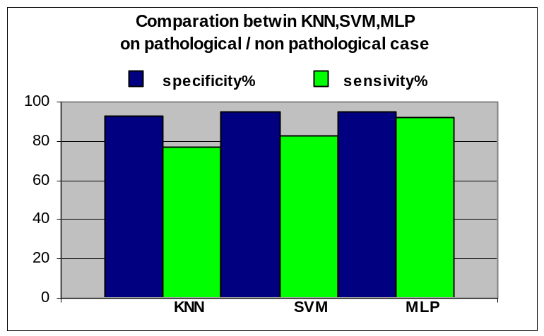
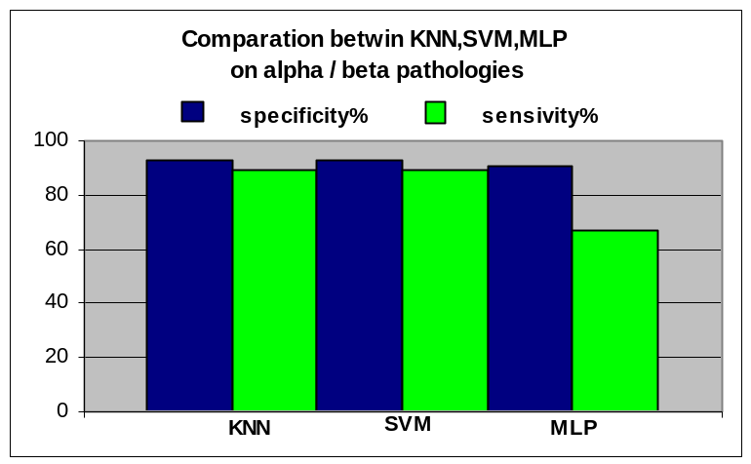

Conclusions

The ability of the classifiers to complement[16] one another in discriminating between sick and healthy subjects was checked, to see how much they overlapped. Generally speaking the SVP classifier and the MLP classifier erred in the same cases. This shows that the two classifiers work in the same field and thus, from the evidence presented above, are not complementary. No multi-classification criteria, such as combining the two classifiers, would improve the accuracy of the method

A study on cases where patients where falsely diagnosed positive showed that these subjects had the RBC, Hb, Ht, and MCV parameters in the same range as pathological cases. Thus it is difficult to identify thalassamia using automatic classification techniques based on these parameters.
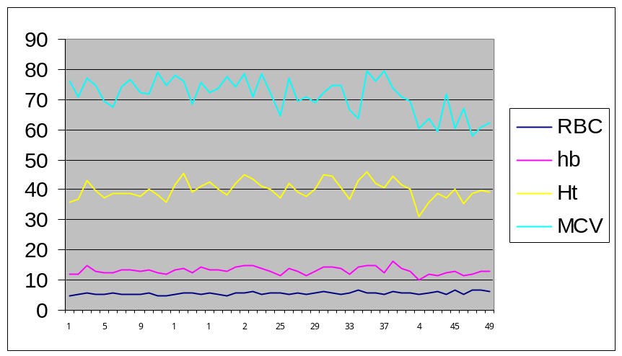
Andamento dei parametri RBC,Hb,Ht,MCV per pazienti giudicati malati dal classificatore primario (SVM)

The same is true in cases where patients were falsely diagnosed as negative. It is very difficult to distinguish between thallassemia α cases and healthy subjects using the above mentioned parameters, although talassemia β cases can be easily distinguished from healthy subjects when these methods are used.
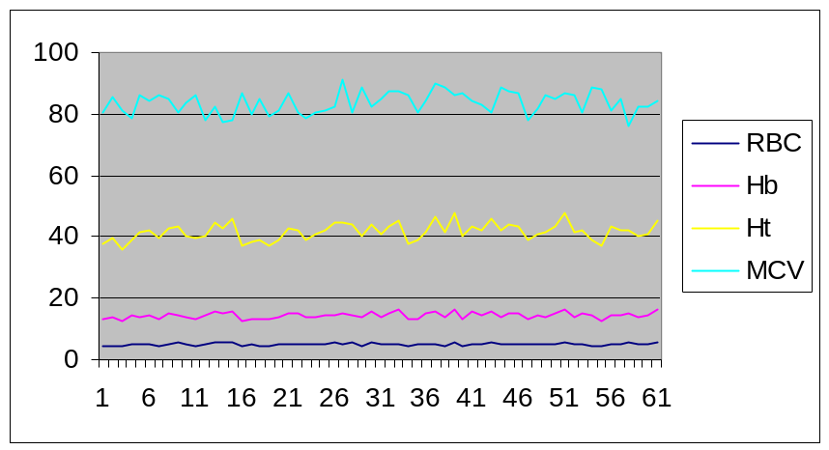
Andamento dei parametri RBC,Hb,Ht,MCV per pazienti giudicati sani dal classificatore primario (SVM)

Finally it can be said that the proposed method is as efficient as, and can be compared to, specialised neural networks. In addition analysis of the results obtained using SVM and MLP networks shows that their specific accuracy and sensitivity cannot be improved using the parameters studied here. The results obtained are, without question, very good because they are extremely accurate, but the results should be verified by further tests to increase the quantity of available data.

References
[1] Bunn FH, Forget BG, Ranney HM. Hemoglobinopathies. Philadelphia, PA:WB Saunders; 1997
[2] Thalassemia Working Party of the British Committee for Standars in Haematology Task Force. Guidelines for investigations of the alpha and beta thalassemia traits. J.Clin Pathol. 1994;47:289-95.
[3] British Committeee for standards in Haematology. Guideline: the laboratory diagnosis of haemaoglobinopathies. Br J Haemato. 1998;101:783-92.
[4] A Real-Time Classification System of Thalassemic Pathologies Based on Artificial Neural Networks on Medical Decision Making Jen-Feb 2002.
[5] S. Serpico, G. Vernazza “Teorie e tecniche del riconoscimento”, CUSL “Il gabbiano” 1997.
[6] U. Bottigli Neural Networks in medical phisycs. Phisys Med . 1993;9:75-81.
[7] O. Duda, P. E. Hart, D. G. Stark, “Pattern Classification“, second edition, A Wiley-Interscience Publication John Wiley & Sons.
[8] N.Cristianini,J. Shave-Taylor. “An Introduction to Support Vector Machine”(and other kernel-based learning methods). Cambridge University Press 2000.
[9] V.N.Vapnik. “Statistical Learning Theory.Wiley”, New York , 1998.
[10] M. Pontil, A. Verri “Properties of Support Vector Machines”, Neural Computation, Vol. 10, pp 955-974, 1998.
[11] T. Mitchell “Machine Learning” , McGraw-Hill 1997.
[12] Y.Yao,P.Frasconi,M.Pontil,“Fingerprint Classification with Combinations of Support Vector Machine” 3nd International Conference of Audio- and Video- Based Person Authentication AVBPA (Halmstad, Sweden, June 2001), pp.253-259.
[13] T. Joachims, Making large-Scale SVM Learning Pratical Advances in Kernel Methods – Suppurt Vector Learning, B. Scholkopf and C. Burges and A. Smola (ed.), MIT-Press, 1999.
[14] Kearns Mj. Ron D.Algorithmic stability and sanity-chek bounds for leave-one-out cross-validation. In :Preceedings of the Tenth Annual ACM Workshop on Computational Learning Theory, Nashville, Tennessee, 1997 Jul 6-9. ACM Press; 1997, p. 152-162. PROVIDE LOCATION OF PUBLICATION.
[15] Holden SB. PAC-Like upper bounnds for the sample complexity of leave-one-out cross validation. Paper presented at: Ninth Annual ACM Workshop on Computational Learning Theory; 1996 Jun 28; Desenzano del Garda, Italy.
[16] S. Raudys, “Combining the Expert Networks: a Review” Proc. of Int. Conference Neural Networks and Artificial Intelligence (R.Sadykhov ed.), 2-5 October 2001, Minsk, Belorus, pp. 81-91.

Per la SVM è stato utilizzato l’algoritmo del one-vs-all attraverso il quale si confronta separatamente una classe alla volta contro tutte le altre insieme[12].
Possiamo affermare solo che siano simili perché, a causa del diverso approccio col quale avvengono le classificazioni, le percentuali in questo caso si riferiscono ad un numero di campioni α differenti.

