A Comparative study of K-Nearest Neighbour, Support Vector Machine and Multi-Layer Perceptron for Thalassemia Screening.

Abstract. In this paper we investigate the feasibility of two typical techniques of Pattern Recognition in the classification for Thalassemia screening. They are Support Vector Machine (SVM) and K-Nearest Neighbour (K-NN). We compare SVM and KNN, which rely on Statistical Learning Theory, with an Multi-Layer Perceptron (MLP) classifier. We propose a two-classifier system based on SVM. The first layer is used to differentiate between pathological cases and non-pathological cases while the second layer is used to discriminate between two different pathological cases ( α-thalassemia against β-thalassemia) from the first output layer (pathological cases).
The MLP classifier gives slightly better results than SVM although the amount of data available is limited. Both techniques enable thalassemia carriers to be discriminated from healthy subjects with 95% specificity, although he sensitivity of MLP is 92% while that of SVM is 83%.

Introduction

Thalassemias are genetic defects that are commonly found in many parts of the world including Africa, the Far East, and Mediterranean regions[1]. In order to know how many people suffer from this disease the heterozygous population should be screened. A 1st –level analysis using hemo-cromocytometric data and a 2nd-level examination (total HbA₂, globin chain synthesis, and genetic analysis)[2][3] should be carried out to identify α and β thalassemia carriers. Although total HbA₂, globin chain synthesis, and genetic analysis can identify carriers accurately, they are time-consuming and expensive. Thus an automated diagnostic support system could be of use when a 1st classification based only on the hemachromocytometric data is made. There is already a classification system based on MLP [4].
We want to make a comparative study of K-Nearest Neighbour [5], Support Vector Machine [8][9] and Multi-Layer Perceptron [6][11] for Thalassemia Screening for determination of the best performance on thalassemias data reported in [4]. First we investigate the performance of KNN and SVM in the discrimination healthy/sick then we propose a multy-layer classifier based on SVM which, after the determination of healthy/sick, differentiate between the two different pathological cases ( α-thalassemia against β-thalassemia) .

Descrizione classificatori

Support Vector Machine
Support Vector Machines [8][9][10] perform pattern recognition for two-class problems by determining the separating hyperplane with maximum distance to the closest points of the training set. These points are called support vectors .
We show in the near figure the separating hyperplane; the Margin is called ρ. The hyperplane is equidistant from the nearest class point (white and black group). These points are called support vectors .
ρ

ρ

If the data is not linearly separable in the input space, a non-linear transformation φ(.) can be applied which maps the data points x ∈R^{n into} a high (possibly infinite) dimensional space Η which is called feature space. The data in the feature space is then separated by the optimal hyperplane as described above.
The mapping φ(.) is represented in the SVM classifier by a kernel function K (,) which defines an inner product in H i.e. K(x,t) = φ(x) φ(t). The decision function of the SVM has the form:
f(x) = Σ_{i} α_{i} y_{i} K(x_{i} , x) i:1,..,l (1)
where l is the number of data points, and y_{i} ∈{-1,1} is the class label of training point x_{j} . Coefficients α_{i} in equation (1) can be found solving a quadratic programming equation with linear constraints [9]. The support vectors are the nearest points to the separating boundary and are the only ones for which α_{i} in Equation (1) can be other than zero.
An important family of admissible kernel functions are:
- Gaussian kernel, K(x,y) = exp(-||x-y||/2σ² ), where σ is the variance of the Gaussian.
- Polynomial kernel, K(x,y) = (1+ x y)^{d} , where d is the degree of the polynomial (d=0 for linear kernel).
Let M be the distance of the support vectors from the hyperplane. This quantity is called margin and it is related to the coefficients in Equation (1),

M = (Σ_{i} α_{i} )^{1/2} i:1,..,l (2)
The margin is an indicator of how separable the data is. In fact, the expected probability error of an SVM is bounded by the average of quantity C²/lM², with C the radius of the smallest sphere containing the data points in the feature space.

K-Nearest Neighbour
K-Nearest Neighbour classifier [5][7] uses the hypothesis that patterns of the same class tend to concentrate tightly around a typical pattern, which is representative of the same class.
Let x* be the unknown point (unknown pattern). s_{i} ∈ {s₁ , s_{N} } = S is the nearest point (NN) from x* if
d(x,s_{i} ) = min_{l} d(x,s₁ ) l = 1..N
where d() is a distance measurement definitely in the feature space.
Considering every point of S as a class-prototype, we can thus use the relationship above as a classification-rule, 1-NN, which associates pattern x to the j class , which contains s_{i} .
1-NN rule can be generalised for the definition of K-NN rule. K-NN rule uses the k nearest point of S from x. K-NN rule associates pattern x to the j class which has the higher number of elements between nearest K.
the group of the K nearest point from x is called U(x). For example with odd K and two class, ϖ₁ e ϖ_{2 ,} the decision rule indicates the class which has the higher number of elements in U(x).

In the near figure, we show with black, in the center, the test pattern while inside the circle (representative of euclidean distance), there are k=5 train pattern for the valutation.

For this type of classifier, it is necessary to have train set which is not too small, and a good discriminating distance. KNN performs well in multi-class simultaneous problem solving for discriminating all classes. the determination of the best K is suitable for good classification. The value of K is often approximately near to the square of N.

Database and features normalisation
The initial database that was used to train the computer to classify patients consisted of 304 clinical records based on a thalassemia screening carried out by Ozieri Hospital at a state school. Several state schools of Northern Sardinia were used in the test. Each 8th year student (14- to 15-year-old boys and girls) took part in the screening. Although the records can be considered a random sample, subjects with iron deficiency were excluded from the test, as in their case iron levels in the blood must be normalised before thalassemia diagnosis can be made[9].
Hemachromocytometric data, HbA₂ and genetic determination of the main thalassemia defects (α^{3.7} and α^{Nco} variants) were used to make the medical diagnoses. HbA₂ was determined to identify β carriers. 27 subjects had a HbA₂ of ≥ 4%, while HbA₂ was ≤ 3% in the other 277 cases. The 1st group were diagnosed as being β carriers by medical analysis. Genetic analysis was used to diagnose α carriers.
Various attempts were made to normalise the values of the feature but none demonstrated particular advantages. Analysis of the principal components (PCA) [5][7], reduced the number of relevant features to three in the best cases. However the successive application of the classifiers after this transformation, described below, were always less than or at best the same as that without normalisation. The data which were considered relevant at the end of classification were reduced to using the values of non-normalised RBC, Hb, Ht, MCV. The data from the 304 clinical records were divided into 108 test data groups (with 55 normal cases, 44 α, 9 β) and a conglomeration of training, called “train”, made up of 196 clinical records (141 normal cases, 37 α, 18 β).

Methods

System used for data analysis
All calculations were carried out by using an AMD K6 III 400 MHz computer running Windows 98 operating system. We used version 7.2 of Red Hat (LINUX) operating system. only for SVM_light

PCA
We carried out PCA with version 6 of the Simulink MATLAB program. In the first (not successful) approach we used the all train-feature (without G6PD and white blood corpuscles, which were not found by normal blood analysis) obtaining a transformation matrix of 196 (train pattern ) x 8 (feature). In the best approach we used only four features in the input (RBC, Hb, Ht, MCV), obtaining a transformation matrix of 196x3 .

KNN
K-NN analysis was performed by using a tailor-made self-written program coded by C but the same result could be obtained using LNKnet software, which is available from MIT Lincoln Laboratory (HTTP://www.ll.mit.edu/IST/). The best K was found by testing all k values from 1 to 60 .

SVM
SVM classification was performed by using version 4 of SVM_light software. This is available in the following location :
ftp://ftp-ai.cs.uni-dortmund.de/pub/Users/thorsten/svm_light/current/svm_light.tar.gz
We tried using defaults parameter with LOO options. We repeated the classification using a linear, polynomial and rbf kernel. For each case we tried many C value parameters until the best relative accuracy was obtained.

Experimental results

Using KNN classifier to differentiate between pathological cases and non-pathological cases enabled us to obtain 85% of accuracy with 93% of specificity (percentage of non pathologic cases correctly classified) and 77% of sensitivity (percentage of pathologic cases correctly classified). The results are reported in table 1.
 | N | M | OK | BAD | TOT | ACC.
N | 92.73 | 7.27 | 51 | 4 | 55 | 92.73
M | 22.64 | 77.36 | 41 | 12 | 53 | 77.36
 |  |  | 92 | 16 | 108 | 85.19
Table 1
Tabella relativa all’applicazione del KNN per K=23 nella discriminazione tra pazienti sani e quelli malati

Using SVM, for the same type of discrimination between pathological cases and non pathological cases, the best result in terms of accuracy is approximately 89% (with 95% of specificity and 83% of sensitivity) obtained with linear kernel, parameter C = 10 and validations a with leave-one-out (LOO) algorithm [13][14][15]. The details are shown in table 2 . We obtained the same results in terms of accuracy using linear kernel but C = 1 : in this case sensitivity and specificity were different as shown in table 3.

 | N | M | OK | BAD | TOT | ACC.
N | 94.55 | 5.45 | 52 | 3 | 55 | 94.55
M | 16.98 | 83.02 | 44 | 9 | 53 | 83.02
 |  |  | 96 | 12 | 108 | 88.89
Tabella 2
Tabella relativa all’applicazione della SVM per kernel lineare per c=10 nella discriminazione tra pazienti sani e quelli malati
 | N | M | OK | BAD | TOT | ACC.
N | 92.73 | 7.27 | 51 | 4 | 55 | 92.73
M | 15.09 | 84.91 | 45 | 8 | 53 | 84.91
 |  |  | 96 | 12 | 108 | 88.89
Tabella 3
Tabella relativa all’applicazione della SVM per kernel lineare per c=1 nella discriminazione tra pazienti sani e quelli malati

The discrimination between α and β pathologies is obtained by using a second classification layer specialised on these patterns , which receives, as input, the first classifier output which divides the cases into healthy and sick; the approach is shown below in the block diagram.

healty
data
Classifier 1
(SVM)

Classifier 2
(SVM or KNN)

α
β

As is shown in Tables 1 and 2, the best classification of healthy and sick was with SVM, and so this classifier was used as first classifier. Tests for discriminating α pathologies from β pathologies gave the same results for KNN and SVM classifiers. These are shown on Tables 4 and 5. It should be noted that the small number of clinical records of healthy patients which were erroneously passed to classifier 2 were considered to be correctly classified when they were associated with type α thalassemia.

 | α | β | OK | BAD | TOT | ACC.
α | 92.5 | 7.5 | 37 | 3 | 40 | 92.5
β | 11.11 | 88.89 | 8 | 1 | 9 | 88.89
 |  |  | 45 | 4 | 49 | 91.84
Table 4
Tabella relativa all’applicazione, come classificatore 2, della SVM per kernel lineare per c=0.001, o equivalentemente per KNN con valore di k = 23, nella discriminazione dei pazienti malati (SVM primario con c = 1) tra pazienti con talassemia α o β

 | α | β | OK | BAD | TOT | ACC.
α | 92.11 | 7.89 | 35 | 3 | 38 | 92.11
β | 11.11 | 88.89 | 8 | 1 | 9 | 88.89
 |  |  | 43 | 4 | 47 | 91.49
Table 5
Tabella relativa all’applicazione, come classificatore 2, della SVM per kernel lineare per c=0.001, o equivalentemente per KNN con valore di k = 23, nella discriminazione dei pazienti malati (SVM primario con c = 10) tra pazienti con talassemia α o β

Analysis of the results

As was stated in the introduction we wished to make a comparative analysis of the performance of SVM and KNN, by analysing their performance through a combination of specialised neural networks [4]. The results are reported in Tables 6 and 7.

 | N | M | OK | BAD | TOT | ACC.
N | 94.55 | 5.45 | 52 | 3 | 55 | 94.55
M | 7.5 | 92.45 | 49 | 4 | 53 | 92.45
 |  |  | 101 | 7 | 108 | 93.52
Tabella 6
Tabella relativa all’applicazione delle reti neurali specializzate. Nel dettaglio vediamo i risultati relativi alla discriminazione sani- malati

 | N | α | β | OK | BAD | TOT | ACC.
N | 94.55 | 5.45 | 0 | 52 | 3 | 55 | 94.55
α | 10 | 90.91 | 0 | 40 | 4 | 44 | 90.91
β | 0 | 33.33 | 66.67 | 6 | 3 | 9 | 66.67
 |  |  |  | 98 | 10 | 108 | 90.74
Tabella 7
Tabella relativa all’applicazione delle reti neurali specializzate. Riportiamo il risultato complessivo della discriminazione delle reti specializzate per i casi normali, α,β

It should be noted that KNN is not efficient in discriminating between healthy and sick patients. Equally, although the results are not shown here, we are not suggesting a method to resolve, either with KNN or SVM, a three class problem , or in other words a way of directly classifying healthy patients from those with type α or β thalassemia.
At this point the values shown in Table 2 can be compared with those in Table 6. These discriminate principally between healthy and sick patients. The specificity percentages are identical while the sensitivity percentages are different, with the specialised neural network performing better than SVM. Closer analysis of the absolute values shows that this difference in sensitivity is due to the small number of clinical records (5) in a test which was, unfortunately, limited in scope. Basically, while waiting to compare the results with a larger data set than that available to us, one can provisionally state that the two classifiers are almost equivalent in their ability to discriminate sick from healthy patients.
As far as their ability to recognise type α from type β thalassemia is concerned, the following observations may be made. It can be seen in Tables 4,5 and 7, that the SVM classifier performs similarly to the specialised neural network classifier when identifying thalassemia α and is more accurate in the case of thalassemia β. Once again one must bear in mind that the results come from a very small data set andmust be verified by analysis of more extensive data.
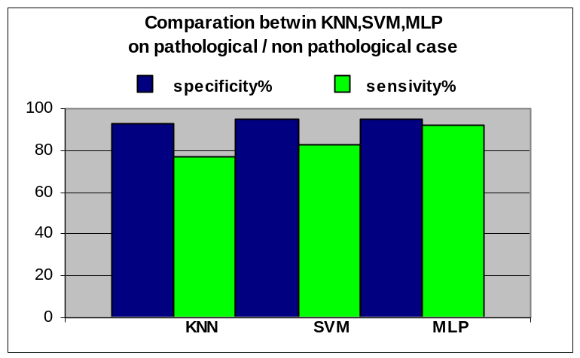
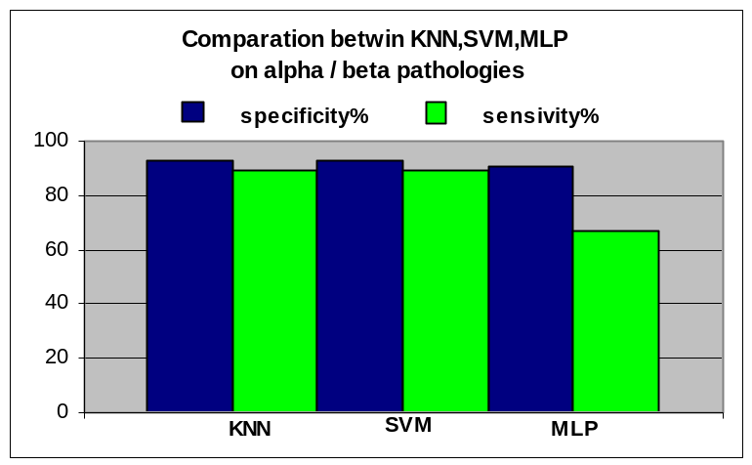

Conclusions

The ability of the classifiers to complement[16] one another in discriminating between sick and healthy subjects was checked, to see how much they overlapped. Generally speaking the SVP classifier and the MLP classifier erred in the same cases. This shows that the two classifiers work in the same field and thus, from the evidence presented above, are not complementary. No multi-classification criteria, such as combining the two classifiers, would improve the accuracy of the method

A study on cases where patients where falsely diagnosed positive showed that these subjects had the RBC, Hb, Ht, and MCV parameters in the same range as pathological cases. Thus it is difficult to identify thalassamia using automatic classification techniques based on these parameters.
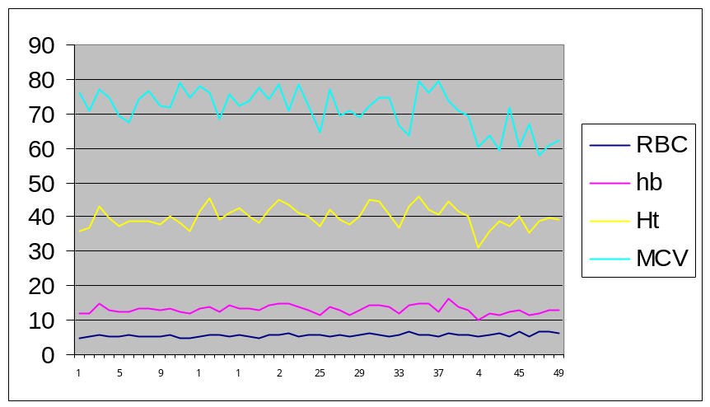
Andamento dei parametri RBC,Hb,Ht,MCV per pazienti giudicati malati dal classificatore primario (SVM)

The same is true in cases where patients were falsely diagnosed as negative. It is very difficult to distinguish between thallassemia α cases and healthy subjects using the above mentioned parameters, although talassemia β cases can be easily distinguished from healthy subjects when these methods are used.
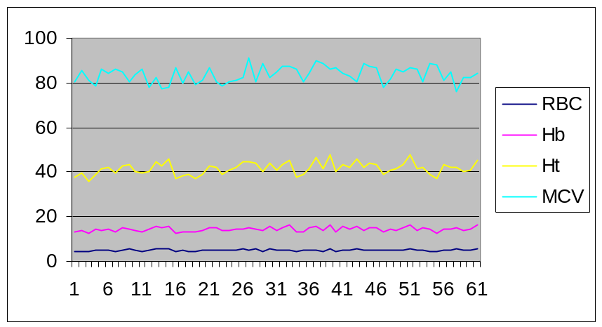
Andamento dei parametri RBC,Hb,Ht,MCV per pazienti giudicati sani dal classificatore primario (SVM)

Finally it can be said that the proposed method is as efficient as, and can be compared to, specialised neural networks. In addition analysis of the results obtained using SVM and MLP networks shows that their specific accuracy and sensitivity cannot be improved using the parameters studied here. The results obtained are, without question, very good because they are extremely accurate, but the results should be verified by further tests to increase the quantity of available data.

References
[1] Bunn FH, Forget BG, Ranney HM. Hemoglobinopathies. Philadelphia, PA:WB Saunders; 1997
[2] Thalassemia Working Party of the British Committee for Standars in Haematology Task Force. Guidelines for investigations of the alpha and beta thalassemia traits. J.Clin Pathol. 1994;47:289-95.
[3] British Committeee for standards in Haematology. Guideline: the laboratory diagnosis of haemaoglobinopathies. Br J Haemato. 1998;101:783-92.
[4] A Real-Time Classification System of Thalassemic Pathologies Based on Artificial Neural Networks on Medical Decision Making Jen-Feb 2002.
[5] J. Kittler, F.Roli : Multiple Classifier System, Second International Workshop, MCS 2001 Cambridge, UK, July 2-4,2001, Proceedings. Lecture Notes in Computer Science 2096 Springer 2001, ISBN 3-540-42284-6
[5] S. Serpico, G. Vernazza “Teorie e tecniche del riconoscimento”, CUSL “Il gabbiano” 1997.
[6] U. Bottigli Neural Networks in medical phisycs. Phisys Med . 1993;9:75-81.
[7] O. Duda, P. E. Hart, D. G. Stark, “Pattern Classification“, second edition, A Wiley-Interscience Publication John Wiley & Sons.
[8] N.Cristianini,J. Shave-Taylor. “An Introduction to Support Vector Machine”(and other kernel-based learning methods). Cambridge University Press 2000.
[9] V.N.Vapnik. “Statistical Learning Theory.Wiley”, New York , 1998.
[10] M. Pontil, A. Verri “Properties of Support Vector Machines”, Neural Computation, Vol. 10, pp 955-974, 1998.
[11] T. Mitchell “Machine Learning” , McGraw-Hill 1997.
[12] Y.Yao,P.Frasconi,M.Pontil,“Fingerprint Classification with Combinations of Support Vector Machine” 3nd International Conference of Audio- and Video- Based Person Authentication AVBPA (Halmstad, Sweden, June 2001), pp.253-259.
[13] T. Joachims, Making large-Scale SVM Learning Pratical Advances in Kernel Methods – Suppurt Vector Learning, B. Scholkopf and C. Burges and A. Smola (ed.), MIT-Press, 1999.
[14] Kearns Mj. Ron D.Algorithmic stability and sanity-chek bounds for leave-one-out cross-validation. In :Preceedings of the Tenth Annual ACM Workshop on Computational Learning Theory, Nashville, Tennessee, 1997 Jul 6-9. ACM Press; 1997, p. 152-162. PROVIDE LOCATION OF PUBLICATION.
[15] Holden SB. PAC-Like upper bounnds for the sample complexity of leave-one-out cross validation. Paper presented at: Ninth Annual ACM Workshop on Computational Learning Theory; 1996 Jun 28; Desenzano del Garda, Italy.
[16] S. Raudys, “Combining the Expert Networks: a Review” Proc. of Int. Conference Neural Networks and Artificial Intelligence (R.Sadykhov ed.), 2-5 October 2001, Minsk, Belorus, pp. 81-91.

The algorithm one-vs-all was used for SVM. This enabled us to compare each class against the others all together. [12].
We can only say that they were similar because, due to the different approaches used in the classification, the percentage in this case refers to a different number of α samples.

