Natalie Bahr

6/7/2022

Databases

SQL Final Project

**Part 1**

1. Run a query that creates a table named Authors that has the following columns: AuthorID, FullName, BirthCountry.
   * AuthorID is the primary key and auto increments.
2. Add the following Authors table:

|  |  |
| --- | --- |
| **FullName** | **BirthCountry** |
| **Jane Austen** | England |
| **Charles Dickens** | England |
| **Mark Twain** | United States |

1. Run a query to see all of the authors within the database.

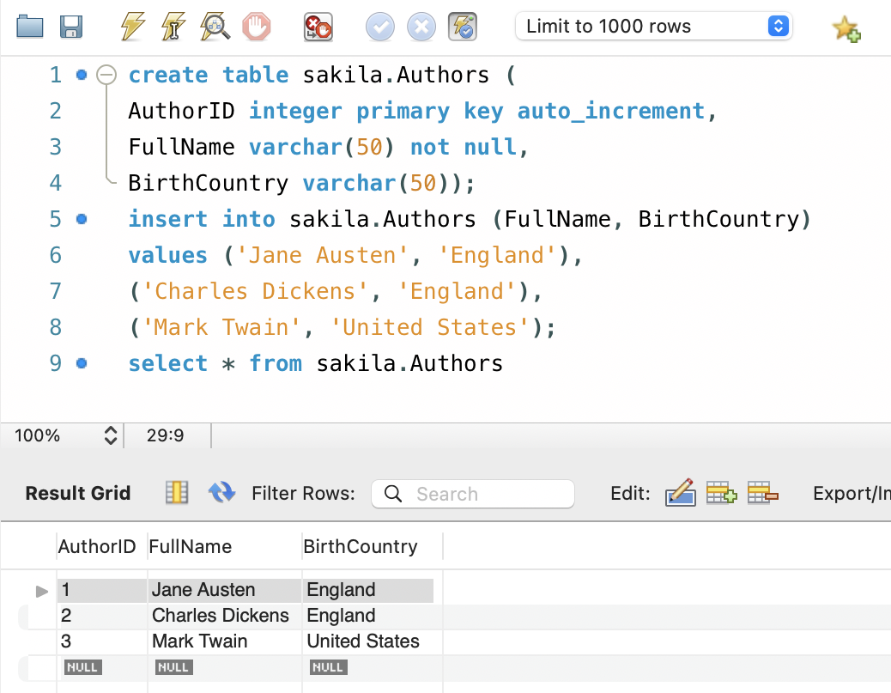

**Part 2**

1. Run a query that creates a table named Books that has the following columns: BookID, Name, AuthorID.
   * BookID is the primary key and auto increments.
   * AuthorID is a foreign key that referenced the Authors table on the AuthorID column.
2. Add the following the Books table:

|  |  |
| --- | --- |
| **Name** | **AuthorID** |
| **Pride and Prejudice** | 1 |
| **Sense and Sensibility** | 1 |
| **The Pickwick Papers** | 2 |

1. Run a query to see all of the books within the database.

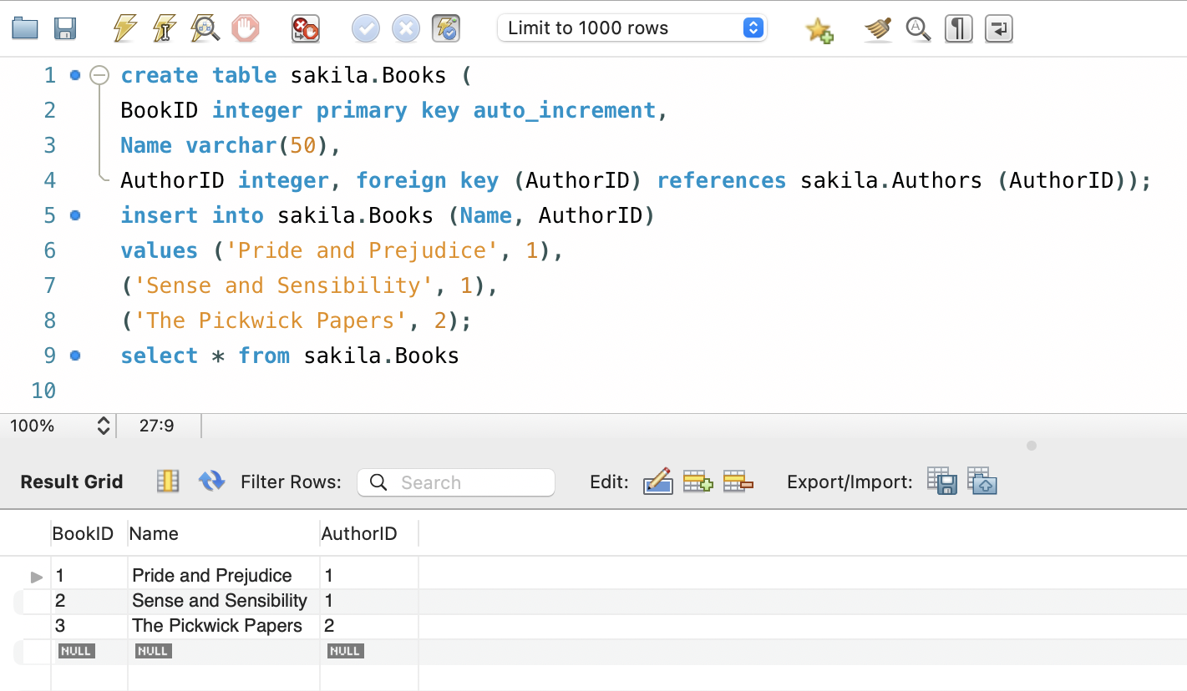

**Part 3**

1. Run a query that joins the Authors and Books table together using the AuthorID foreign key.

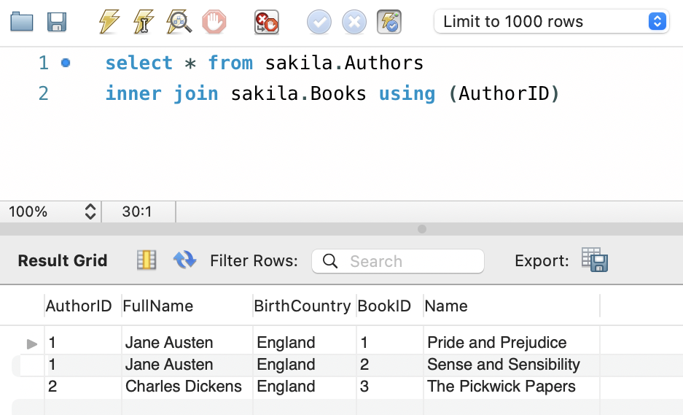

1. Next, create a view named AuthorBooks using the join query created in step 1 adding the following parameters:
   * Show only the Authors full name and book name.
   * Rename the column name results using the AS keyword.
     + The Authors FullName should display as AuthorName.
     + The Books Name should display as BookName.
   * Order the results alphabetically by the authors full name.
2. Lastly, run a query to see the view you just created.

