Natalie Bahr

6/2/2022

Databases

SQL: Practice Hands On Lesson 3

Run the following queries:

1. Write a query that Inserts a new actor into the database. Once you have completed the insert, write a query to view all information for that specific actor.

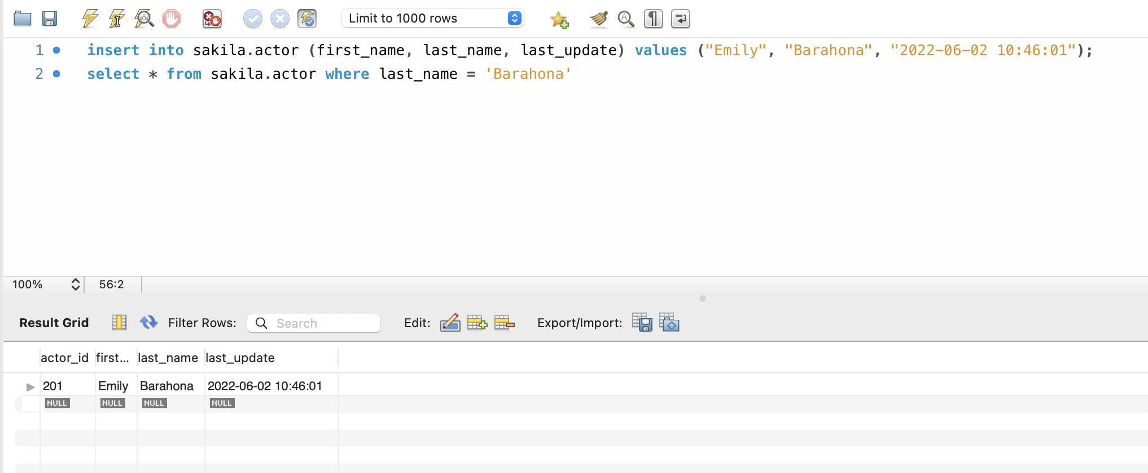

1. Write a query to Update the actor that you just inserted. Give your new actor a first_name of Emmy and a last_name of Rock. When you have completed that update, run another query to see your updated actor.

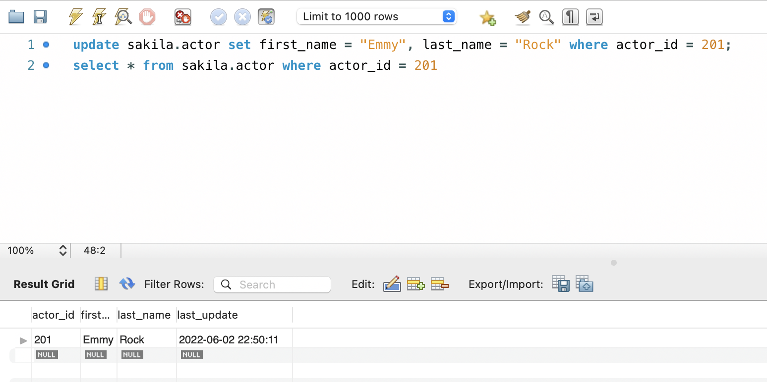

1. Write a query that finds all staff that do not have a value specified for password.

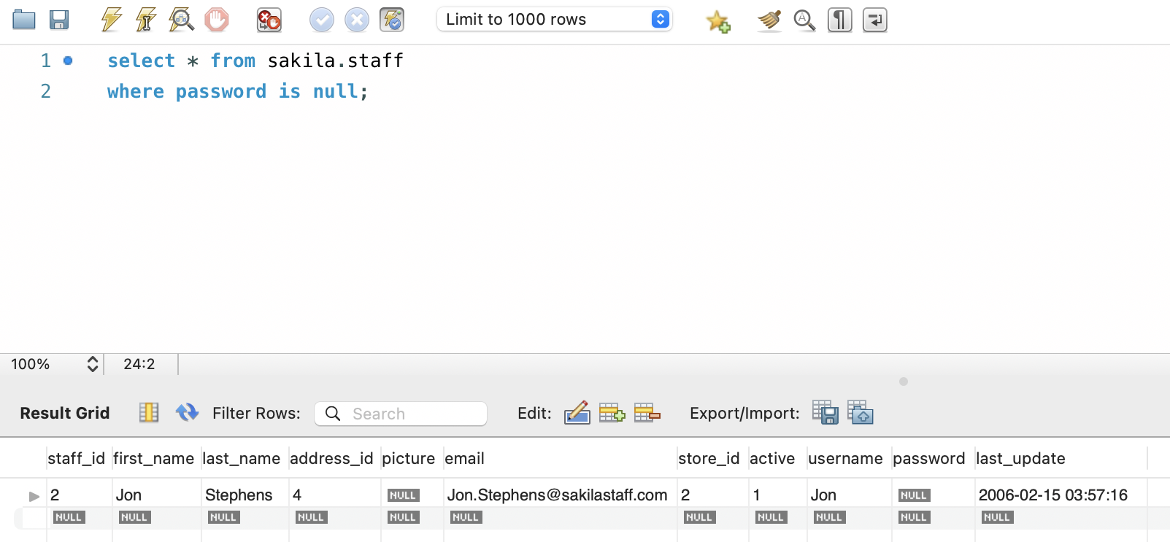

1. Write a query that finds all staff's information that has a value for first_name and store_id.

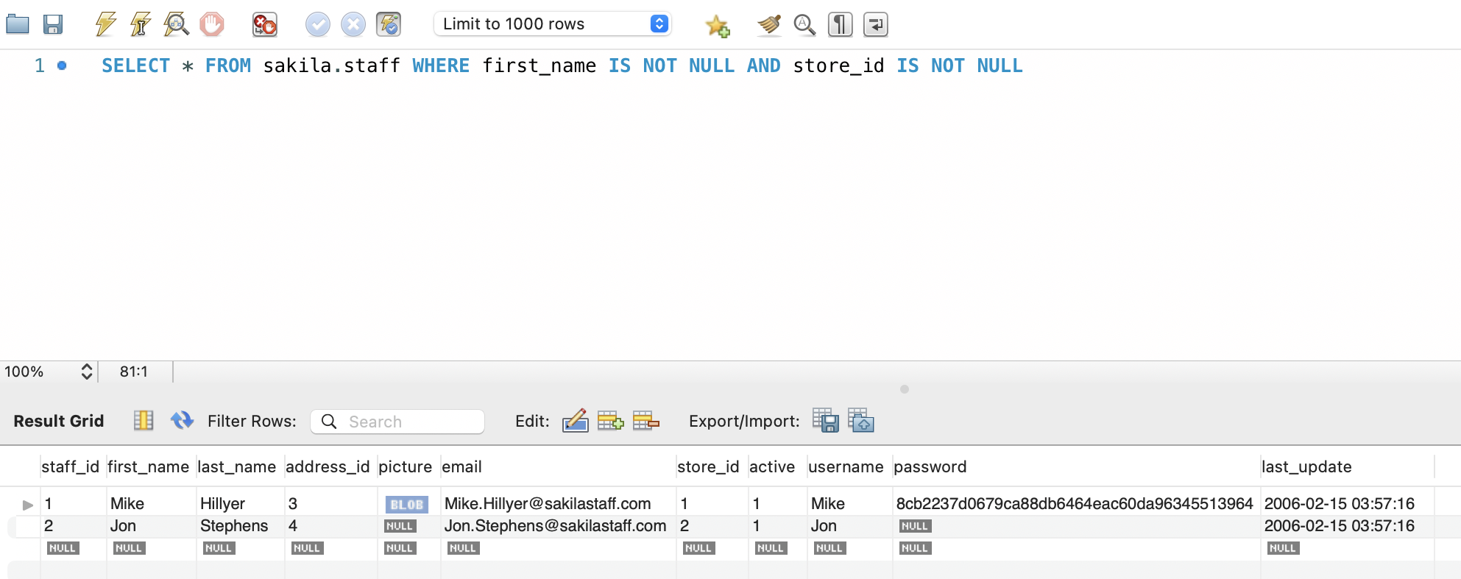

1. Write a query that updates all people with a Null value in the address2 column. If the district is Alberta, put address2 as Canada, and if the district is QLD, put Australia.

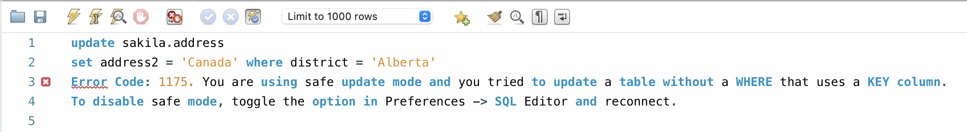

Second query:

