First: This one does not have any headline or title. I might use the “file name” here and then replace all level n headings with n+1 in the post process?!?

A plain YT link: https://www.youtube.com/watch?v=iEIFl6gp58Q
Just another paragraph.
<$Scr_Ps::0>A link IN a caption: https://www.youtube.com/watch?v=iEIFl6gp58Q
<!$Scr_Ps::0>
Image link:

Image link with caption:
<$Scr_Ps::0>Reactor is released - GET IT NOW!
<!$Scr_Ps::0>Image with no link … but I don’t see where the center formatting comes from:

Image with no link but a caption:
<$Scr_Ps::0>Reactor-Installer.lua
<!$Scr_Ps::0>…

The original name of the `Reactor-Installer.lua` image was “image261”; via “Scale image” context menu it has been scaled and renamed to “Reactor-Installer.lua Icon Image Example” here:

Did a “Save As Picture …” into the .scriv package folder - makes little sense:
An image inserted via Drag’n’Drop:
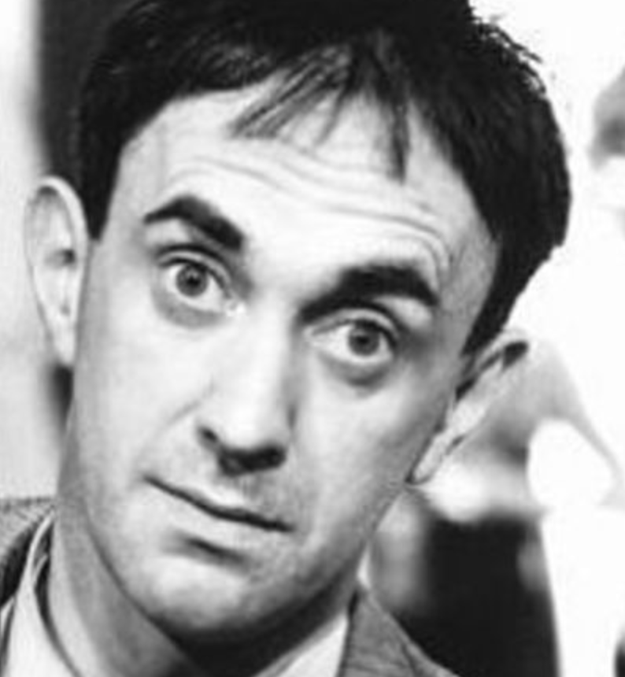
<$Scr_Ps::0>caption
<!$Scr_Ps::0>… interesting to see that the filename is preserved!

