**Problem 1: Endings (100 points)**

Find on the D2L two datafiles, “namesBoys” and “namesGirls”, containing the 1000 most popular baby names in the United States in 2010. Define a function that reads the two datafiles into memory storing them in two lists. For each letter, a through z, count the number of times a name ends in a particular letter. Finally, print the counts to the console in well formatted and sorted columns, so that the data line up nicely. For example…

Letter Boys Girls  
a 9 380  
b 4 0  
c 8 1  
d 31 3  
e 102 188  
f 2 0

…..

Finally, include as a comment at the end of your code a paragraph discussing any interesting differences you found in the comparison of the endings of boys and girls names.

Submission: Submit a single .py file containing all the code to the D2L. Do not zip or archive the file. Your code must include comments at the top including your name, date and the honor statement, “I have not given or received any unauthorized assistance on this assignment.” Each function must include a docstring and be commented appropriately.

**Problem 2: Ellipse: (100 points)**

In this problem you will use a random numbers to estimate the area of an ellipse. An ellipse is a curve in a plane surrounding two focal points such that the sum of the distances to the two focal points is constant for every point on the curve. – Wikipedia.

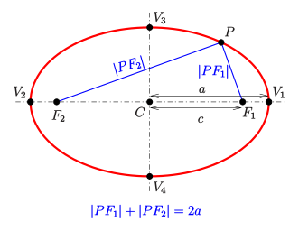

Write a Function that asks the user to enter the x and y coordinates for the two focal points, the length of the major axis and the number of random points to employ. Your program should then compute and print the area of the ellipse. For example:

Welcome!

This program will use random numbers to compute the area of an ellipse.

Enter the position of F1 (format: x y): 2 4.5

User input

Enter the position of F2 (format: x y): 3.6 -2

Enter the length of the major axis (format: l): 14

Enter the number of random points (format: n): 100000

Output

Thinking…

The area of the ellipse is approximately XXXXXXX.

Submission: Submit a single .py file containing all the code to the D2L. Do not zip or archive the file. Your code must include comments at the top including your name, date and the honor statement, “I have not given or received any unauthorized assistance on this assignment.” Each function must include a docstring and be commented appropriately.