Metadata Schema Coordination Meeting

1. Meeting Goal
The goal of this meeting is to explore how different initiatives working on metadata schemas can align efforts and potentially coordinate development for Post-acute infection syndromes (PAIS) in the context of the European Health Data Space (EHDS).
Specifically we aim to:
- Share the current status of metadata schema development in each initiative
- Identify overlaps and differences
- Explore whether a shared or aligned metadata framework could be developed
- Discuss potential next steps for coordination.
Please add comments or input directly in this document before the meeting

2. Meeting Information
Doodle for scheduling:
https://doodle.com/group-poll/participate/aQKKPpld
Proposed meeting window:
10:00 - 11:00 9th April 2026
Next meeting with Shuxin & Hajar: April 29, 2026
Organizer:
Shuxin Zhang
Supporting organizer:
Margreet

3. Participants and Perspectives
Perspective | Initiative / Organization | Representative
EHDS perspective  (DCAT-AP) | Health-RI | Hannah
Post-COVID perspective | PCNN | Bianca, Hajar
ME/CFS perspective | NMCB | Jos, Shuxin
Biobank perspective | BBMRI.nl | Peggy
Funder perspective | ZonMw | Margreet

4. Current Work (Please Add Brief Updates)
Each initiative is invited to add a short update (3–5 bullets).

EHDS / Health-RI
- Current activities:
  - HRI metadata schema aligned with EHDS (HealthDCAT-AP)
  - Implement HRI metadata schema in catalogue
  - Onboard diverse group of data holders (umcs + domain nodes + individual organisations)
- Relevant frameworks: HealthDCAT-AP
- Key challenges:
  - Finding consensus in how to fill in metadata schema
  - Supporting data holders in onboarding
  - HealthDCAT-AP is quite general → does not fulfill needs of all dataholders
- Health-RI Metadata Model
  - Harvesting metadata from FDPs at umc’s or the central FDP at HRI
  - Or push from Dataverse
- Onboard email: onboarding@health-ri.nl

PCNN
- Current metadata work:
  - Metadata collected of 32 (pre-PCNN) studies (shuxin: variable level)
  - Human readable metadataformat available through PCNN-Projects/Metadata-format based on EMIF metadata format (shuxin: study level)
  - Health RI checked overlap our metadata format and needed metadata for EHDS - there is overlap, but more differences
  - Exploring examples of online, searchable metadata catalogi: YODA, CKAN, Molgenis
- Existing standards used: for now only in codebook:
  - Snomed ct
  - Loinc
  - NCIT
  - (hajar?)
- Key needs:
  - Discuss how to align metadata, codebook, studymanagement
  - How to take metadata into account in the codebook? Metadata is on a different level than individual variables, namely on study level (aligns more with desired studymanagementsystem?). Should these be in the same codebook and are ontologies needed for all study level variables?
  - Discuss the optimal way: where to collect which metadata? UMCs will be obliged under EHDS to report metadata of their studies, where to draw the line? Aim: collect enough for PCNN, but avoid double work for researchers
  - Will there be a PAIS-node? If so, where exactly?

NMCB
- Current metadata work:
  - NMCB codebook available
  - No existing metadata schema
  - Demand for ‘organizing’ our metadata

BBMRI.nl

Metadata for biobanks
- Metadata model: which attributes are used to describe the data and how should they be provided?
  - Mandatory and recommended information
  - Format: human- and machine-readable
  - Controlled vocabularies
- Health-RI metadata model: general metadata model
  - Aligned with EHDS metadata model (HealthDCAT-AP)
  - General + health-related fields
  - Not specific for biobanks
- Current agreement: 1 catalogue entry per Biobank or Collection in the National Health Data Catalogue
  - Via onboarding route of the umc
  - For multi-center projects: via coordinating center
  - Agreements about how to provide specific information:
    - Available biosamples
    - Population specifics
Note:
- information regarding FAIR Data Point Amsterdam: https://fdp.healthdataspace.amsterdam
- Contact Erik van Iperen (e.p.vaniperen@amsterdamumc.nl) en Rene Oostergo (r.j.oostergo@umcg.nl) for more detailed information.
- Existing biobank metadata standards

ZonMw
- Expectations from a funder perspective:
  - Current: Search for options
    - to reuse existing data,
    - To use domain-specific standards,
    - To engage a data steward,
    - To ensure sufficient budget for DS & ds-activities.
  - DMP
  - Under development: machine-actionable DMP and PIDs
  - A minimal set of md to enrich the description of datasets (number of participants/subjects, variables,
- Interoperability priorities:
  - Controlled vocabulary for
    - generic health terms (EHDS compliant) and
    - (to be developed) detailed terms for rich description of health/disease,
    - topics to describe context.
  - PIDs (ROR, ORCID, doi)

5. Existing Resources (Please Add Links)
Participants are encouraged to add relevant documents, schemas, or frameworks.
Example:
Resource | Link | Comment
Health-RI metadata schema | https://github.com/Health-RI/health-ri-metadata
Health-RI Data Catalogue | https://catalogus.healthdata.nl/en
PCNN metadata dictionary | https://github.com/PCNN-Projects/Metadata-format
NMCB variable list | NMCB Codebook
BBMRI MIABIS standard | https://www.bbmri-eric.eu/howtomiabis/
Metadata schemes for covid-19 (2021-2025):  - Project admin  - Project content  - Collection Ie.g. biosamples)  - Dataset (dcat) | M4M - GO FAIR Foundation
Bioportal | ZonMW COVID-19 | NCBO BioPortal  ZonMw Generic Terms | NCBO BioPortal
Nanopublication templates | Publish a new Nanopublication | nanodash  Publish a new Nanopublication | nanodash
Renske: see the initiatives that are mentioned in grant proposals | Not to be linked yet | Create an overview
Bianca: in PCNN currently a inventory is being performed to see who is participating in a HORIZON call
DCAT metadata schema | https://www.w3.org/TR/vocab-dcat-3/#basic-example

6. Key Questions for the Meeting
Add questions to discuss:.
- What minimum metadata set should exist across PAIS cohorts?
- How can PAIS cohorts align with EHDS requirements?
- Can we reuse existing standards such as MIABIS or other health metadata frameworks?
- Should we aim for a shared schema or mapping between schemas?
  - Margreet: A minimal set of common md-elements

- How can metadata schema be translated into tangible products such as data catalogue?
Margreet:
  - Develop an input-form for researchers to provide md
  - Catalogue to expose the md (complementing the EHDS national catalogue0
  - Search-find-request-procedure to request data access (hdab?)
  - Data access - terms of use for data
  - Predefined Sparql-queries to analyse collected (meta)data for knowledge generation
  - visualizations
Add additional questions below.

7. Expected Outcomes of the Meeting
Potential outcomes may include:
- Agreement on shared metadata principles
- Identification of common metadata domains
- Planning md-actions
  - Margreet suggests:
    - Meet to decide on the metadata elements within a md-scheme for a more detailed description of the project content
    - Use the terms/controlled vocabularies that are already developed in the PCNN-codebook end biobank-metadata
  - Reske suggests:
    - Find similar initiatives in national and EU to collaborate
- Who will participate, roles

8. Agenda (Draft – to be updated)
- Introduction and meeting objective (5 min)
- Short updates from each initiative
  - PCNN + NMCB (PAIS)
  - BBMRI
  - Health-RI
- Discussion on overlaps and alignment opportunities
- Discussion on EHDS relevance
- Agreement on next steps
  - In May 2026 > Shuxin will send out a doodle
Bianca: make it for researchers as easy as possible, FAIR Data Point is too complex, how PCNN network stands for Health-RI Data Catalogue: https://catalogus.healthdata.nl/en
We can create a PAIS node in Health-RI, but there is no funding yet.
Next step: April 29, 2026
Shuxin & Hajar & Margreet
We must set a feasible scope for the mecvs/PCNN-metadata-development, considering:
- Health-dcat-ap-NL
- Responsibilities of partners: role - support - development:
  - Health-RI >> ask their support for issues that are part of THEIR responsibility!
  - Funder / ZonMw >> identifies needs and initiatives solutions, but other must carry out …..
  - Consortium & funded projects (ZonMw, mecvs, pcnn, pais)
  - Other stakeholders who have interest in well established metadata system
- Available experts, time, budget
Metadata system:
- Metadata scheme
  - Health-dcat-ap-nl > use this as much as possible. For additional metadata, create your own schema.
  - Additional md-schemes, ‘other md-scheme’ (create/follow a standard > which one?)
  - Controlled vocabularies
  - Does health-dcat provide all the attributes (in recommended set) for a rich description of data?
    - I miss an attribution in health-dcat for ‘variables’
    - What we miss, can be connected >>
  - Connecting other md-schemes to Health-dcat-ap-nl with help of:
    - Dcat: qualified attribution (roles, e.g. funder, ….)
    - Dcat: qualified relation (e.g. connect the codebook
    - PIDs: grant-id, orcid, ror, doi

- Metadata input form
  - Onboarding HRI
  - maDMP ZonMw (under development)
  - Additional md-schemes for ‘other md-scheme’ with m.a.endpoint / e.g. FDP, nanopublication (to be developed by institute, consortium, or …..)

- Metadata exposure > md-catalogue, data platform, website
  - National Catalogue
To do’s:
- Margreet wants to ask Mijke/Hannah how we can work according to the above.
- Shuxin/Hajar will be available to explain the use case with the code book, xls of PCNN, onboarding process
- The pcnn metadata dictionary xls: …. It can be seen as an entry form for researchers, but we must discuss with HRI how to align it with H-dcat-md-scheme > to be discussed with HRI/Mijke.
- Codebook PAIS > extra info to be added by Shuxin & Hajar:
  - …..
- Shuxin focusses:
  - on the documenting his work before he leaves for his next position;
  - Onboarding NMCB
- Shuxin rough thoughts about connection between Health-DCAPT-AP-NL and codebook:
  - The simple way:
    - <NMCB> <dcat:uses> <link of PAIS Codebook>
  - The advanced way:
    - <NMCB> <dcat:collect> <c31_fatigue>
    - <NMCB> <dcat:collect> <biological_sex>
    - ….
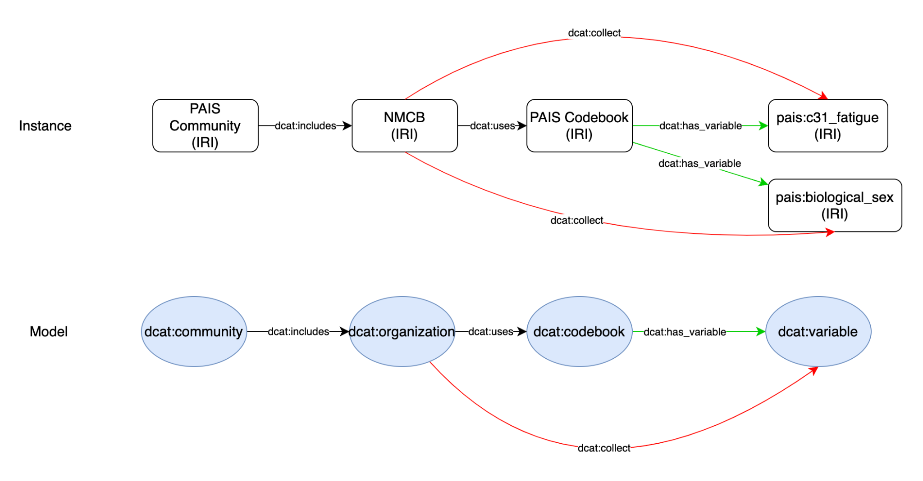

One mapping: pcnn:fatigue → mapped to → sct:fatigue (sct:123456)
FAIR variable name:
- sct_12345 —> <http://snomed.info/id/12345>
- ncit_2356667
URI - sct:12345
PREFIX sct: <http://snomed.info/id/>
PREFIX ncit: <http://purl.obolibrary.org/obo/NCIT_>

Sct:fatigue → http://snomed.info/id/fatigue
Different mapping relations:
- pcnn_fatigue → sct_fatigue
  - pcnn:fatigue → skos:exactMatching → sct:fatigue
- Pcnn_sleeping_tiredness_10_days → sct_sleeping_tiredness_{10d}
  - pcnn:sleeping_tiredness_10_days → skos:narrowerthan → sct:sleeping_tiredness (WE DO NOT CREATE ONE FOR SNOMED CT)
  - Pcnn:sleeping_tiredness_10_days → skos:exactMatching → sct:sleeping_tiredness_10_days (When we ask SCT to create a new one)
- pcnn:fatigue → skos:exactMatching → sct:fatigue

pais:mapping01 rdf:type dcat:mappings
dcat:has_subject pcnn:fatigue
dcat:has_predicate skos:narrowMatching
dcat:has_object sct:fatigue_related
dcat:author ocird:hajar
dcat:status “wait for SNOEMD CT new codes”

