9_BasicPlotsAsNotebook

Niall McGuinness

October, 2022

Table of Contents

# Visualising Data with R Studio

The first block of R code in this r Notebook will download any necessary packages, compile where necessary and load them for use in this file.

## Load Packages

We include tidyr because it allows us to support tables that are paged (e.g. line 66 when we output the chickwts data).

Change include to TRUE and see what happens when you Knit the output HTML document.

## Show Available Data Sets

We should probably comment out this code as it keeps opening and switching to the Viewer window!

## Examine Data

Change echo to TRUE and see what happens when you Knit the output HTML document.

## weight feed  
## 1 179 horsebean  
## 2 160 horsebean  
## 3 136 horsebean  
## 4 227 horsebean  
## 5 217 horsebean  
## 6 168 horsebean  
## 7 108 horsebean  
## 8 124 horsebean  
## 9 143 horsebean  
## 10 140 horsebean  
## 11 309 linseed  
## 12 229 linseed  
## 13 181 linseed  
## 14 141 linseed  
## 15 260 linseed  
## 16 203 linseed  
## 17 148 linseed  
## 18 169 linseed  
## 19 213 linseed  
## 20 257 linseed  
## 21 244 linseed  
## 22 271 linseed  
## 23 243 soybean  
## 24 230 soybean  
## 25 248 soybean  
## 26 327 soybean  
## 27 329 soybean  
## 28 250 soybean  
## 29 193 soybean  
## 30 271 soybean  
## 31 316 soybean  
## 32 267 soybean  
## 33 199 soybean  
## 34 171 soybean  
## 35 158 soybean  
## 36 248 soybean  
## 37 423 sunflower  
## 38 340 sunflower  
## 39 392 sunflower  
## 40 339 sunflower  
## 41 341 sunflower  
## 42 226 sunflower  
## 43 320 sunflower  
## 44 295 sunflower  
## 45 334 sunflower  
## 46 322 sunflower  
## 47 297 sunflower  
## 48 318 sunflower  
## 49 325 meatmeal  
## 50 257 meatmeal  
## 51 303 meatmeal  
## 52 315 meatmeal  
## 53 380 meatmeal  
## 54 153 meatmeal  
## 55 263 meatmeal  
## 56 242 meatmeal  
## 57 206 meatmeal  
## 58 344 meatmeal  
## 59 258 meatmeal  
## 60 368 casein  
## 61 390 casein  
## 62 379 casein  
## 63 260 casein  
## 64 404 casein  
## 65 318 casein  
## 66 352 casein  
## 67 359 casein  
## 68 216 casein  
## 69 222 casein  
## 70 283 casein  
## 71 332 casein

## [1] horsebean horsebean horsebean horsebean horsebean horsebean horsebean  
## [8] horsebean horsebean horsebean linseed linseed linseed linseed   
## [15] linseed linseed linseed linseed linseed linseed linseed   
## [22] linseed soybean soybean soybean soybean soybean soybean   
## [29] soybean soybean soybean soybean soybean soybean soybean   
## [36] soybean sunflower sunflower sunflower sunflower sunflower sunflower  
## [43] sunflower sunflower sunflower sunflower sunflower sunflower meatmeal   
## [50] meatmeal meatmeal meatmeal meatmeal meatmeal meatmeal meatmeal   
## [57] meatmeal meatmeal meatmeal casein casein casein casein   
## [64] casein casein casein casein casein casein casein   
## [71] casein   
## Levels: casein horsebean linseed meatmeal soybean sunflower

## [1] "weight" "feed"

## 'data.frame': 71 obs. of 2 variables:  
## $ weight: num 179 160 136 227 217 168 108 124 143 140 ...  
## $ feed : Factor w/ 6 levels "casein","horsebean",..: 2 2 2 2 2 2 2 2 2 2 ...

## weight feed  
## 1 179 horsebean  
## 2 160 horsebean  
## 3 136 horsebean  
## 4 227 horsebean  
## 5 217 horsebean  
## 6 168 horsebean  
## 7 108 horsebean  
## 8 124 horsebean  
## 9 143 horsebean  
## 10 140 horsebean

## weight feed  
## 60 368 casein  
## 61 390 casein  
## 62 379 casein  
## 63 260 casein  
## 64 404 casein  
## 65 318 casein  
## 66 352 casein  
## 67 359 casein  
## 68 216 casein  
## 69 222 casein  
## 70 283 casein  
## 71 332 casein

## weight feed   
## Min. :108.0 casein :12   
## 1st Qu.:204.5 horsebean:10   
## Median :258.0 linseed :12   
## Mean :261.3 meatmeal :11   
## 3rd Qu.:323.5 soybean :14   
## Max. :423.0 sunflower:12

## Example - Stripchart

A Stripchart with title (main) and plot character (pch) set. Try typing ?pch in the console and hitting Enter to see help on what difference values for pch will look like.

# title and plotting character set  
stripchart(chickwts$weight,   
 main = "Strip Chart of Chick Weights",  
 pch = 21)

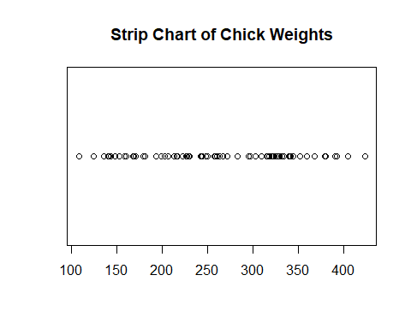

## Example - Stripchart

A Histogram with title (main) and x/y labels (xlab, ylab) and color set. Try setting color using rgb() (e.g., col = rgb(1,0,0) or col = “#FF0000”).

For more information on HTML Hex Codes click [here](https://htmlcolorcodes.com/). To find color palettes that are compatible use one of the color palette pickers located [here](https://htmlcolorcodes.com/resources/best-color-palette-generators/)

# title and xy labels and color  
hist(chickwts$weight, main = "Frequency of Chick Weights",  
 xlab = "Chick Weight (grams)",  
 ylab = "Weight Range Frequency",  
 col = "red")

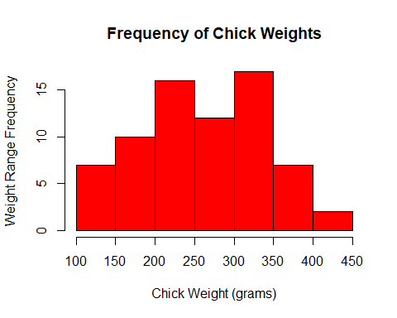

## Example - Boxplot - 1

A simple Boxplot with title and y-label.

# simple box plot  
boxplot(chickwts$weight,  
 main = "Weight of Chickens",  
 ylab = "Weight(grams)")

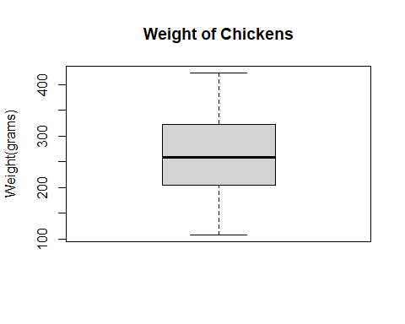

## Example - Boxplot - 2

A Boxplot comparing across a number of categories using ~.

# box-plot (multiple categories using ~)   
boxplot(chickwts$weight~chickwts$feed,   
 main = "Chick Weights in Grams",  
 col = rgb(0.75, 0.5, 0.75))

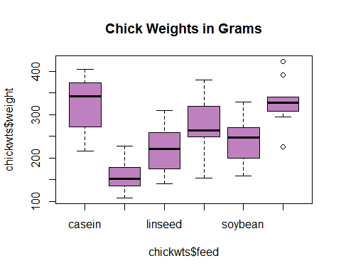

## Example - Boxplot - 2

A Piechart using data defined in two vectors. Title, labels, edges, border, and colors for each pie segment have been set.

sunshinePerDay <- c(6, 12, 17, 13)  
cities <- c("dublin", "paris", "narvik", "caracas")  
  
# uncomment the parameters (i.e. edges, main, border) to see what each parameter does  
pie(x = sunshinePerDay,   
 labels = cities,   
 edges = 64,  
 main = "Hours Sunshine on 21st June 2022",   
 border = TRUE,  
 col = c("#9CAFB7","#ADB993","#D0D38F","#F6CA83"))

