BANK ACCOUNT MONITORING

A Mini-Project Report
Submitted
By

Gaddam.Ramakrishna
168W1F0003

Under the esteemed guidance of
B.SRINIVAS SIR
MCA,(Ph.D)
Asst.PROFESSOR



DEPARTMENT OF COMPUTER APPLICATIONS

V.R.SIDDHARTHA ENGINEERING COLLEGE
(Autonomous)
(Affiliated to JNTUK, Kakinada)

KANURU, VIJAYAWADA-520007

ANDHRA PRADESH

2018-19

ABSTRACT
Bank Account Monitoring is an Android application allows user to keep track of current balance in different bank accounts held by the user and the transactions of those accounts

The following are the major operations in this application.
- Adding new bank account
- Login to User account
- Depositing Money
- Withdraw money
- Add Beneficiary Details
- Transfer Funds to Beneficiary
- Mini Statement of all transactions

I

INDEX

Content Page No.
Abstract I
Acknowledgement II
Declaration III

Chapter 1: Introduction 01
  - Background 01
  - Objectives 01
  - Purpose and Scope 01
1.3.1Purpose 02
1.3.2Scope
………………………………
…………………………………

Chapter 2: System Analysis 03

  - Existing System 03
  - Proposed System 03
  - Requirement Analysis 03
  - Hardware Requirements 04
  - Software Requirements 04
  - Justification of selection of Technology 05

Chapter 3: System Design 10

  - Module Division 10
  - Data Dictionary 11
  - ER Diagrams 12
  - DFD/UML Diagrams 13

Chapter 4: Implementation and Testing 18

  - Code 18
  - Testing Approach 60
4.2.1Unit Testing 60
4.2.2 Integration System 61

Chapter 5: Results and Discussions 62
Chapter 6: Conclusion and Future Work 71
Chapter 7: References 72

Chapter 1

Introduction

1.1 Background
Bank Account Monitoring is an Android application allows user to keep track of current balance in different bank accounts held by the user and the transactions of those accounts

1.2 Objectives
- Adding new bank account
- Login to User account
- Depositing Money
- Withdraw money
- Add Beneficiary Details
- Transfer Funds to Beneficiary
- Mini Statement of all transactions

1.3 Purpose and Scope
1.3.1 Purpose
The purpose of this Bank account monitoring is to make users simple by making their transactions easy and fast. This monitors all the details of the users very accurately and stores them in the app. It provides security also. By using this time and energy will be saved.

1.3.2 Scope
The scope of this project is to easy transactions between the users. This records all the details of the users and keeps them safe. No other user can view these transactions and security is provided. This is very helpful and easy. It transfers within few minutes and make easy for all the users. By using this time management is used.

Chapter 2

System Analysis

2.1 EXISTING SYSTEM
The present system has some drawbacks. If a user want to deposit or withdraw the money to any other user they have to go the bank and wait in a line till they turn gets and then complete their work.
2.2 PROPOSED SYSTEM
This app is proposed in order to makes transactions easy and fast. By using this app we can overcome this drawback. We need not wait in line for hours by using this app it makes very simple. This proposed to make time management and save the energy. This provides security also for all the users. It displays the details within minutes.

2.3 REQUIREMENT ANALYSIS
2.3.1. Problem Definition
Bank Account Monitoring is an Android application allows user to keep track of current balance in different bank accounts held by the user and the transactions of those accounts
The following are the major operations in this application are Adding new bank account, Login to User account, Depositing Money, Withdraw money, Add Beneficiary Details, Transfer Funds to Beneficiary, Mini Statement of all transactions.

2.3.2. Requirement Specification
The process of studying and analyzing the user needs to arrive at a definition of the problem domain and system requirements objectives. Discovery of boundaries of new system and how it must interact with its environment within the new problem domain. Detect and resolve conflicts between (user) requirements Negotiate priorities of users. Prioritize and triage requirements such that managers can give realistic project estimates and developers can design, implement, and test .Classify requirements information into various categories and allocate requirements to sub-systems. Evaluate requirements for desirable qualities.
We have seen how to specify requirements in terms of structure, standards, and writing rules, but: How to identify the real problems to solve in the elicitation results? How to detect conflicting aspects? How to negotiate to resolve conflicts? How to decide what is important and a priority? How to ensure that nothing is forgotten? How to validate that the findings of the analysis are good? How to use models in this context? invention and definition of the behavior of a new system (solution domain) such that it will produce the required effects in the problem domain. Start from a knowledge of the problem domain and the required effects determined by elicitation and analysis. Generally involves modeling. Results in the specification document precise expression of requirements, may include models.
Requirement modeling:
This is an essential task in specifying requirements map elements obtained by elicitation to a more precise form help better understand the problem Help find what is missing or needs further discussion different modeling languages Informal: natural language Goal-oriented modeling(GRL) Functional modeling: UML(Unified Modeling Notation) SDL(Specification and Description Language) Logic, UCM(Use Case Maps).
Requirement classification:
In order to better understand and manage the large number of requirements, it is important to organize them in logical clusters it is possible to classify the requirements by the following categories. Features Use cases Mode of operation User class. This makes it easier to understand the intended capabilities of the product and more effective to manage and prioritize large groups rather than requirements.

2.4 HARDWARE REQUIREMENTS
- Hard Disk : 500GB
- RAM : 8GB
- Processor : I5 processor

2.5 SOFTWARE REQUIREMENTS
- Operating System : Windows XP and higher versions
- User Interface : Android Studio
- Programming Language : Java
- Other technologies : Android Studio, Apk
- IDE/Workbench : Android Studio
- Database : SQL lite

2.6 JUSTIFICATION OF PLATFORM
Android is an open source and Linux-based Operating System for mobile devices such as smartphones and tablet computers. Android was developed by the Open Handset Alliance, led by Google, and other companies.
Android offers a unified approach to application development for mobile devices which means developers need only develop for Android, and their applications should be able to run on different devices powered by Android.
The first beta version of the Android Software Development Kit (SDK) was released by Google in 2007 where as the first commercial version, Android 1.0, was released in September 2008.
On June 27, 2012, at the Google I/O conference, Google announced the next Android version, 4.1 Jelly Bean. Jelly Bean is an incremental update, with the primary aim of improving the user interface, both in terms of functionality and performance.
The source code for Android is available under free and open source software licenses. Google publishes most of the code under the Apache License version 2.0 and the rest, Linux kernel changes, under the GNU General Public License version 2.

Android Applications
Android applications are usually developed in the Java language using the Android Software Development Kit.
Once developed, Android applications can be packaged easily and sold out either through a store such as Google Play, SlideME, Opera Mobile Store, Mobango, F-droid and the Amazon Appstore.
Android powers hundreds of millions of mobile devices in more than 190 countries around the world. It's the largest installed base of any mobile platform and growing fast. Every day more than 1 million new Android devices are activated worldwide.
This tutorial has been written with an aim to teach you how to develop and package Android application. We will start from environment setup for Android application programming and then drill down to look into various aspects of Android applications.

What is API level?
API Level is an integer value that uniquely identifies the framework API revision offered by a version of the Android platform.
Platform Version | API Level | VERSION_CODE
Android 6.0 | 23 | MARSHMALLOW
Android 5.1 | 22 | LOLLIPOP_MR1
Android 5.0 | 21 | LOLLIPOP
Android 4.4W | 20 | KITKAT_WATCH | KitKat for Wearables Only
Android 4.4 | 19 | KITKAT
Android 4.3 | 18 | JELLY_BEAN_MR2
Android 4.2, 4.2.2 | 17 | JELLY_BEAN_MR1
Android 4.1, 4.1.1 | 16 | JELLY_BEAN
Android 4.0.3, 4.0.4 | 15 | ICE_CREAM_SANDWICH_MR1
Android 4.0, 4.0.1, 4.0.2 | 14 | ICE_CREAM_SANDWICH
Android 3.2 | 13 | HONEYCOMB_MR2
Android 3.1.x | 12 | HONEYCOMB_MR1
Android 3.0.x | 11 | HONEYCOMB
Android 2.3.4  Android 2.3.3 | 10 | GINGERBREAD_MR1
Android 2.3.2  Android 2.3.1  Android 2.3 | 9 | GINGERBREAD
Android 2.2.x | 8 | FROYO
Android 2.1.x | 7 | ECLAIR_MR1
Android 2.0.1 | 6 | ECLAIR_0_1
Android 2.0 | 5 | ECLAIR
Android 1.6 | 4 | DONUT
Android 1.5 | 3 | CUPCAKE
Android 1.1 | 2 | BASE_1_1
Android 1.0 | 1 | BASE

Set-up Java Development Kit (JDK)
You can download the latest version of Java JDK from Oracle's Java site − Java SE Downloads. You will find instructions for installing JDK in downloaded files, follow the given instructions to install and configure the setup. Finally set PATH and JAVA_HOME environment variables to refer to the directory that contains java and javac, typically java_install_dir/bin and java_install_dir respectively.
If you are running Windows and installed the JDK in C:\jdk1.8.0_102, you would have to put the following line in your C:\autoexec.bat file.
set PATH=C:\jdk1.8.0_102\bin;%PATH%
set JAVA_HOME=C:\jdk1.8.0_102
Alternatively, you could also right-click on My Computer, select Properties, then Advanced, then Environment Variables. Then, you would update the PATH value and press the OK button.
On Linux, if the SDK is installed in /usr/local/jdk1.8.0_102 and you use the C shell, you would put the following code into your .cshrc file.
setenv PATH /usr/local/jdk1.8.0_102/bin:$PATH
setenv JAVA_HOME /usr/local/jdk1.8.0_102
Alternatively, if you use Android studio, then it will know automatically where you have installed your Java.

Android IDEs
There are so many sophisticated Technologies are available to develop android applications, the familiar technologies, which are predominantly using tools as follows
- Android Studio
- Eclipse IDE(Deprecated)

Chapter 3
System Design
3.1 MODULE DIVISION
- User
User Module
In this module the user can register as account holder, and after login into the system, he can deposit the amount, and can move the money from one account to another account, and he can generate min-statement. A user can add beneficiary and can manage the beneficiary details like delete and update.

3.2 DATA DICTIONARY

Register
Column | Type | Null | Default | Links to | Comments | MIME
Customer-id | Varchar(50) | No
name | varchar(50) | No
email (Primary) | varchar(50) | No
password | varchar(50) | No
phone | varchar(50) | No
Balance | Float | No

Transaction
Column | Type | Null | Default | Links to | Comments | MIME
Transaction-id | Varchar(50) | No
Customer-id | Varchar(50) | No
Trans-date | Date | No
Amount | float | No
Type of transaction | varchar(50) | No
From account | varchar(50) | No
To Account | Varchar(50) | No

3.3 E-R DIAGRAMS

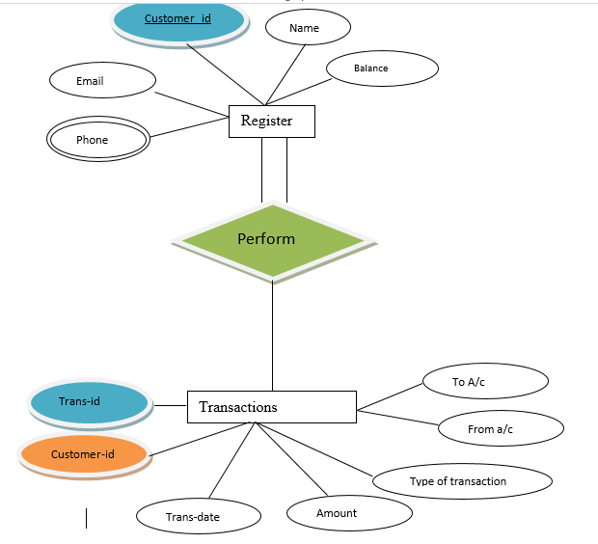
An Entity Relationship Diagram (ERD) is a visual representation of different entities within a system and how they relate to each other. An entity can be a person, place, event, or object that is relevant to a given system. An attribute is a property, trait, or characteristic of an entity, relationship, or another attribute.

3.4 UML DIAGRAMS
Data Flow Diagram:
DFD is also called as bubble chart. It is a simple graphical formalism that can be used to represent a system in terms of input data to the system, various processing carried out on this data, and the output data is generated by this system.
Data flow diagram (DFD) is one of the most important modeling tools. It is used to model the system components. These components are the system process, the data used by the process, an external entity that interacts with the system and the information flows in the system.
DFD shows how the information moves through the system and how it is modified by a series of transformations. It is a graphical technique that depicts information flow and the transformations that are applied as data moves from input to output.
DFD is also known as bubble chart. A DFD may be used to represent a system at any level of abstraction. DFD may be partitioned into levels that represent increasing information flow and functional detail.
UML Diagrams:
UML stands for Unified Modeling Language. UML is a standardized general-purpose modeling language in the field of object-oriented software engineering. The standard is managed, and was created by, the Object Management Group.
The goal is for UML to become a common language for creating models of object oriented computer software. In its current form UML is comprised of two major components: a Meta-model and a notation. In the future, some form of method or process may also be added to; or associated with, UML.
The Unified Modeling Language is a standard language for specifying, Visualization, Constructing and documenting the artifacts of software system, as well as for business modeling and other non-software systems.
The UML represents a collection of best engineering practices that have proven successful in the modeling of large and complex systems.
The UML is a very important part of developing objects oriented software and the software development process. The UML uses mostly graphical notations to express the design of software projects.
Goals:
The Primary goals in the design of the UML are as follows:
- Provide users a ready-to-use, expressive visual modeling Language so that they can develop and exchange meaningful models.
- Provide extendibility and specialization mechanisms to extend the core concepts.
- Be independent of particular programming languages and development process.
- Provide a formal basis for understanding the modeling language.
- Encourage the growth of OO tools market.
- Support higher level development concepts such as collaborations, frameworks, patterns and components.
- Integrate best practices.
UML Diagrams
A diagram is the graphical presentation of a set of elements, most often rendered as a connected graph of vertices (things) and arcs (relationships). There are two types of diagrams, they are: Structural and Behavioral Diagrams.
Structural Diagrams
The UML is four structural diagrams exist to visualize, specify, construct and document the static Aspects of a system. Icon View the static parts of a system using one of the following diagrams. Structural diagrams consist of Class Diagram, Object Diagram, Component Diagram, and Deployment Diagram.
Behavioral Diagrams
The UML’s five behavioral diagrams are used to visualize, specify, construct, and document the dynamic aspects of a system. The UML’s behavioral diagrams are roughly organized around the major ways which can model the dynamics of a system. Behavioral diagrams consists of Use case Diagram, Sequence Diagram, Collaboration Diagram, State chart Diagram, Activity Diagram.
Use Case Diagram:
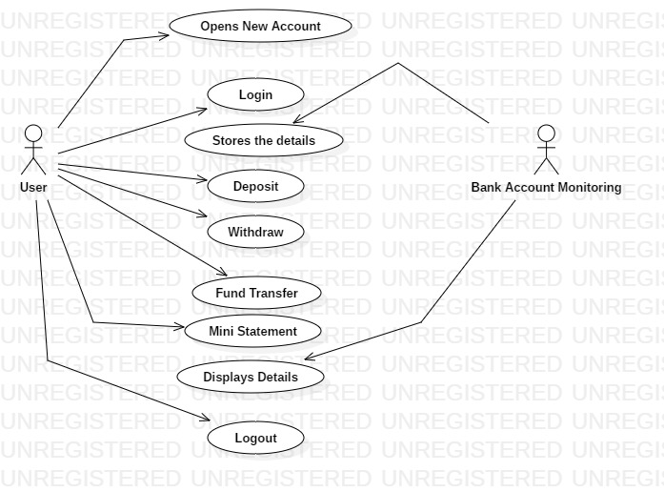
Fig: 3.4.1

Use case diagrams are used to gather the requirements of a system including internal and external influences. These requirements are mostly design requirements. Hence, when a system is analyzed to gather its functionalities, use cases are prepared and actors are identified.
Actors can be a human user, some internal applications, or may be some external applications. When we are planning to draw a use case diagram, we should have the following items identified.
- Functionalities to be represented as use case
- Actors
- Relationships among the use cases and actors.

Sequence Diagram:
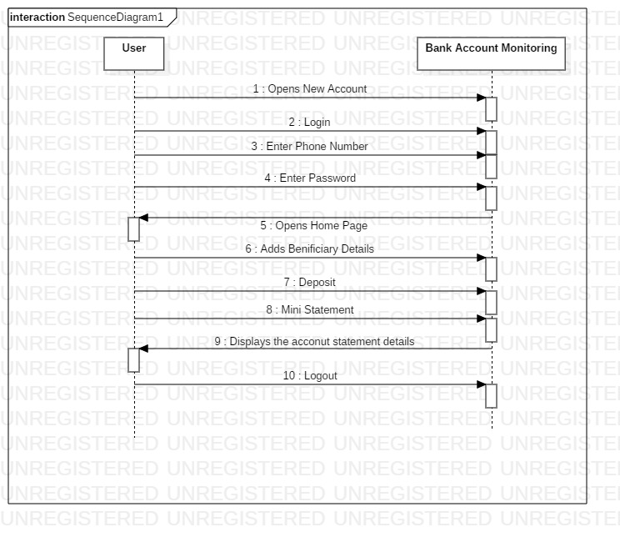
Fig: 3.4.2

A sequence diagram in Unified Modeling Language (UML) is a kind of interaction diagram that shows how processes operate with one another and in what order. It is a construct of a Message Sequence Chart. Sequence diagrams are sometimes called event diagrams, event scenarios, and timing diagrams.

Activity Diagram

User Activity
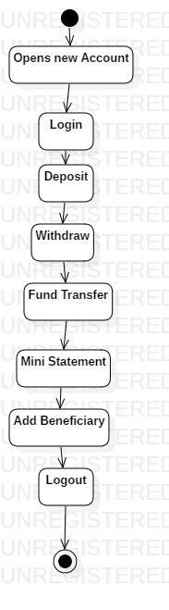
Fig: 3.4.3
Activity diagrams are graphical representations of workflows of stepwise activities and actions with support for choice, iteration and concurrency. In the Unified Modeling Language, activity diagrams can be used to describe the business and operational step-by-step workflows of components in a system. An activity diagram shows the overall flow of control.

Class Diagram:
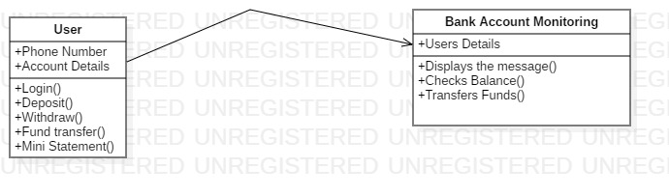
Fig: 3.4.4
Class diagram is a static diagram. It represents the static view of an application. Class diagram is not only used for visualizing, describing, and documenting different aspects of a system but also for constructing executable code of the software application.
Class diagram describes the attributes and operations of a class and also the constraints imposed on the system. The class diagrams are widely used in the modelling of object oriented systems because they are the only UML diagrams, which can be mapped directly with object-oriented languages.

Chapter 4

Implementation and Testing

CODING:

Main activity.java:
package com.bhuvansoftwares.bankapp;
import android.content.Intent;
import android.support.v7.app.AppCompatActivity;
import android.os.Bundle;
import android.view.View;
import android.widget.LinearLayout;
public class MainActivity extends AppCompatActivity {
LinearLayout newLinear;
LinearLayout loginLinear;
@Override
protected void onCreate(Bundle savedInstanceState) {
super.onCreate(savedInstanceState);
setContentView(R.layout.activity_main);
newLinear=(LinearLayout)findViewById(R.id.newLinear);
loginLinear=(LinearLayout)findViewById(R.id.loginLinear);
newLinear.setOnClickListener(new View.OnClickListener() {
@Override
public void onClick(View view) {
Intent intent=new Intent(getApplicationContext(),NewAccountAct.class);
startActivity(intent);
finish();
}
});
loginLinear.setOnClickListener(new View.OnClickListener() {
@Override
public void onClick(View view) {
Intent intent=new Intent(getApplicationContext(),LoginAct.class);
startActivity(intent);
finish();
}
});
}
}

NewAccountAct.java:
package com.bhuvansoftwares.bankapp;
import android.content.Intent;
import android.support.v7.app.AppCompatActivity;
import android.os.Bundle;
import android.view.View;
import android.widget.Button;
import android.widget.EditText;
import android.widget.Toast;
public class NewAccountAct extends AppCompatActivity {
EditText nameEdit;
EditText phoneEdit;
EditText emailEdit;
EditText pwdEdit;
Button btnRegister;
DatabaseHelper myDB;
@Override
protected void onCreate(Bundle savedInstanceState) {
super.onCreate(savedInstanceState);
setContentView(R.layout.activity_new_account);
init();
}
public void init()
{
myDB=new DatabaseHelper(getApplicationContext());
nameEdit=(EditText)findViewById(R.id.editName);
phoneEdit=(EditText)findViewById(R.id.editPhone);
emailEdit=(EditText)findViewById(R.id.editEmail);
pwdEdit=(EditText)findViewById(R.id.editPassword);
btnRegister=(Button)findViewById(R.id.btnRegister);
btnRegister.setOnClickListener(new View.OnClickListener() {
@Override
public void onClick(View view) {
verify();
}
});
}
public void verify()
{
if(nameEdit.getText().toString().length()>0)
{
if(phoneEdit.getText().toString().length()==10)
{
if(pwdEdit.getText().toString().length()>=4)
{
if(emailEdit.getText().toString().length()>0)
{
if(myDB.insertNewUser(nameEdit.getText().toString(),phoneEdit.getText().toString(),pwdEdit.getText().toString(),emailEdit.getText().toString()))
{
Toast.makeText(getApplicationContext(), "Success", Toast.LENGTH_LONG).show();
Bundle bundle=new Bundle();
bundle.putString("ph",phoneEdit.getText().toString());
Intent intent = new Intent(getApplicationContext(), HomeAct.class);
intent.putExtras(bundle);
startActivity(intent);
finish();
}
else
Toast.makeText(getApplicationContext(), "Try Again.", Toast.LENGTH_LONG).show();
}
else
{
emailEdit.requestFocus();
emailEdit.setError("Password must be 4 or more letters");
}
}
else
{
pwdEdit.requestFocus();
pwdEdit.setError("Password must be 4 or more letters");
}
}
else
{
phoneEdit.requestFocus();
phoneEdit.setError("Phone Number must be 10 digits Only");
}
}
else
{
nameEdit.requestFocus();
nameEdit.setError("Name required");
}
}
}
LoginAct.java:
package com.bhuvansoftwares.bankapp;
import android.app.AlertDialog;
import android.content.DialogInterface;
import android.content.Intent;
import android.database.Cursor;
import android.support.v7.app.AppCompatActivity;
import android.os.Bundle;
import android.view.View;
import android.widget.Button;
import android.widget.EditText;
public class LoginAct extends AppCompatActivity {
EditText phoneEdit;
EditText pwdEdit;
Button btnLogin;
DatabaseHelper myDB;
@Override
protected void onCreate(Bundle savedInstanceState) {
super.onCreate(savedInstanceState);
setContentView(R.layout.activity_login);
phoneEdit=(EditText)findViewById(R.id.editPhone);
pwdEdit=(EditText)findViewById(R.id.editPassword);
btnLogin=(Button)findViewById(R.id.btnLogin);
myDB=new DatabaseHelper(getApplicationContext());
btnLogin.setOnClickListener(new View.OnClickListener() {
@Override
public void onClick(View view) {
if(phoneEdit.getText().toString().length()==10)
{
if(pwdEdit.getText().toString().length()>0)
{
int exis=0;
Cursor res=myDB.getUserData(phoneEdit.getText().toString());
while (res.moveToNext())
{
exis=1;
if(res.getString(3).equals(pwdEdit.getText().toString()))
{
Bundle bundle=new Bundle();
bundle.putString("ph",phoneEdit.getText().toString());
Intent intent=new Intent(getApplicationContext(),HomeAct.class);
intent.putExtras(bundle);
startActivity(intent);
finish();
}
else
{
mesage("Invalid Password");
}
}
res.close();
if(exis==0)
{
mesage("Invalid Credentials");
}
}
else
mesage("Enter Password");
}
else
mesage("Enter Phone Number");
}
});
}
public void mesage(String msg)
{
AlertDialog.Builder builder1 = new AlertDialog.Builder(LoginAct.this);
builder1.setMessage("Invalid Credentials.");
builder1.setCancelable(true);
builder1.setPositiveButton(
"OK, Quit",
new DialogInterface.OnClickListener() {
public void onClick(DialogInterface dialog, int id) {
dialog.cancel();
//finish();
}
});
AlertDialog alert11 = builder1.create();
alert11.show();
}
}

homeAct.java:
package com.bhuvansoftwares.bankapp;
import android.app.AlertDialog;
import android.content.DialogInterface;
import android.content.Intent;
import android.database.Cursor;
import android.support.v7.app.AppCompatActivity;
import android.os.Bundle;
import android.view.View;
import android.widget.CursorAdapter;
import android.widget.LinearLayout;
import android.widget.TextView;
import android.widget.Toast;
public class HomeAct extends AppCompatActivity {
String phone="";
String accno="";
LinearLayout depositLinear;
LinearLayout withdrawLinear;
LinearLayout fundTransfer;
LinearLayout miniStatement;
LinearLayout beneficiaryLinear;
DatabaseHelper myDB;
TextView tvName;
TextView tvAccNo;
TextView tvBalance;
@Override
protected void onCreate(Bundle savedInstanceState) {
super.onCreate(savedInstanceState);
setContentView(R.layout.activity_home);
Bundle bundle=getIntent().getExtras();
phone=bundle.getString("ph");
depositLinear=(LinearLayout)findViewById(R.id.depositLinear);
withdrawLinear=(LinearLayout)findViewById(R.id.withdrawLinear);
fundTransfer=(LinearLayout)findViewById(R.id.transferLinear);
miniStatement=(LinearLayout)findViewById(R.id.miniLinear);
beneficiaryLinear=(LinearLayout)findViewById(R.id.benificiaryLinear);
myDB=new DatabaseHelper(getApplicationContext());
tvName=(TextView)findViewById(R.id.tvName);
tvAccNo=(TextView)findViewById(R.id.tvAccNo);
tvBalance=(TextView)findViewById(R.id.tvBal);
final Bundle bundle1=new Bundle();
bundle1.putString("ph",phone);
getData();
depositLinear.setOnClickListener(new View.OnClickListener() {
@Override
public void onClick(View view) {
if(phone.length()==10) {
Intent intent = new Intent(getApplicationContext(), DepositAct.class);
intent.putExtras(bundle1);
startActivity(intent);
}
else
mesage();
}
});
withdrawLinear.setOnClickListener(new View.OnClickListener() {
@Override
public void onClick(View view) {
if(phone.length()==10) {
Intent intent = new Intent(getApplicationContext(), WithdrawAct.class);
intent.putExtras(bundle1);
startActivity(intent);
}
else
mesage();
}
});
fundTransfer.setOnClickListener(new View.OnClickListener() {
@Override
public void onClick(View view) {
if(phone.length()==10) {
Intent intent = new Intent(getApplicationContext(), FundTransferAct.class);
intent.putExtras(bundle1);
startActivity(intent);
}
else
mesage();
}
});
miniStatement.setOnClickListener(new View.OnClickListener() {
@Override
public void onClick(View view) {
if(phone.length()==10) {
Intent intent = new Intent(getApplicationContext(), MiniStmtAct.class);
intent.putExtras(bundle1);
startActivity(intent);
}
else
mesage();
}
});
beneficiaryLinear.setOnClickListener(new View.OnClickListener() {
@Override
public void onClick(View view) {
if(phone.length()==10) {
Intent intent = new Intent(getApplicationContext(), BeneficiaryAct.class);
intent.putExtras(bundle1);
startActivity(intent);
}
else
mesage();
}
});
}
@Override
protected void onResume() {
super.onResume();
int depAmt=myDB.getDepSum(accno);
int withAmt=myDB.getWithSum(accno);
tvBalance.setText("A/C Bal: "+String.valueOf(depAmt-withAmt));
}
public void mesage()
{
AlertDialog.Builder builder1 = new AlertDialog.Builder(HomeAct.this);
builder1.setMessage("Something went wrong. Try Again");
builder1.setCancelable(true);
builder1.setPositiveButton(
"OK Close",
new DialogInterface.OnClickListener() {
public void onClick(DialogInterface dialog, int id) {
dialog.cancel();
//finish();
}
});
AlertDialog alert11 = builder1.create();
alert11.show();
}
public void getData()
{
Cursor res=myDB.getUserData(phone);
while (res.moveToNext())
{
tvName.setText("Name: "+res.getString(1));
tvAccNo.setText("A/C Num: "+res.getString(5));
}
res.close();
String acno=myDB.getAccNo(phone);
accno=acno;
int depAmt=myDB.getDepSum(acno);
int withAmt=myDB.getWithSum(acno);
tvBalance.setText("A/C Bal: "+String.valueOf(depAmt-withAmt));
}
}

DepositAct.java:
package com.bhuvansoftwares.bankapp;
import android.app.AlertDialog;
import android.app.Notification;
import android.app.NotificationChannel;
import android.app.NotificationManager;
import android.app.PendingIntent;
import android.app.TaskStackBuilder;
import android.content.Context;
import android.content.DialogInterface;
import android.content.Intent;
import android.os.Build;
import android.provider.Settings;
import android.support.v4.app.NotificationCompat;
import android.support.v7.app.AppCompatActivity;
import android.os.Bundle;
import android.view.View;
import android.widget.Button;
import android.widget.EditText;
import android.widget.Toast;
public class DepositAct extends AppCompatActivity {
EditText editAmount;
Button btnDeposit;
DatabaseHelper myDB;
String ph="";
String accno="";
@Override
protected void onCreate(Bundle savedInstanceState) {
super.onCreate(savedInstanceState);
setContentView(R.layout.activity_deposit);
Bundle bundle=getIntent().getExtras();
ph=bundle.getString("ph");
editAmount=(EditText)findViewById(R.id.editAmount);
btnDeposit=(Button)findViewById(R.id.btnDeposit);
myDB=new DatabaseHelper(getApplicationContext());
if(ph.length()==10)
{
accno=myDB.getAccNo(ph);
}
btnDeposit.setOnClickListener(new View.OnClickListener() {
@Override
public void onClick(View view) {
if(editAmount.getText().toString().length()>=3) {
if (accno.length() > 0) {
if (myDB.newTransaction(accno, editAmount.getText().toString(), 1,"DEPOSIT")) {
Toast.makeText(getApplicationContext(), "Success", Toast.LENGTH_LONG).show();
updateBal();
} else
mesage("Transaction Failed. Reason Unknown");
}
else
mesage("Invalid Account found. Try Again");
}
else
mesage("Deposit should be 100 or more");
}
});
}
public void mesage(String msg) {
AlertDialog.Builder builder1 = new AlertDialog.Builder(DepositAct.this);
builder1.setMessage(msg);
builder1.setCancelable(true);
builder1.setPositiveButton(
"OK Close",
new DialogInterface.OnClickListener() {
public void onClick(DialogInterface dialog, int id) {
dialog.cancel();
//finish();
}
});
AlertDialog alert11 = builder1.create();
alert11.show();
}
public void updateBal()
{
generateNotification(getApplicationContext(),"Your A/C is Credit with Rs."+editAmount.getText().toString()+".00 through Deposit. ","Depost Success");
}
public void generateNotification(Context context, String msg, String title)
{
NotificationManager notificationManager = (NotificationManager) context.getSystemService(Context.NOTIFICATION_SERVICE);
int notificationId = 1;
String channelId = "channel-01";
String channelName = "Channel Name";
int importance = NotificationManager.IMPORTANCE_HIGH;
if (android.os.Build.VERSION.SDK_INT >= android.os.Build.VERSION_CODES.O) {
NotificationChannel mChannel = new NotificationChannel(
channelId, channelName, importance);
notificationManager.createNotificationChannel(mChannel);
}
NotificationCompat.Builder mBuilder = new NotificationCompat.Builder(context, channelId)
.setSmallIcon(R.mipmap.ic_launcher)
.setContentTitle(title)
.setContentText(msg);
Intent intent=new Intent(getApplicationContext(),MiniStmtAct.class);
Bundle bundle=new Bundle();
bundle.putString("ph",ph);
intent.putExtras(bundle);
TaskStackBuilder stackBuilder = TaskStackBuilder.create(context);
stackBuilder.addNextIntent(intent);
PendingIntent resultPendingIntent = stackBuilder.getPendingIntent(
0,
PendingIntent.FLAG_UPDATE_CURRENT
);
mBuilder.setContentIntent(resultPendingIntent);
notificationManager.notify(notificationId, mBuilder.build());
/*
NotificationManager manager;
Notification myNotication;
manager = (NotificationManager) context.getSystemService(context.NOTIFICATION_SERVICE);
Intent intent = new Intent(context,MiniStmtAct.class);
intent.setFlags(Intent.FLAG_ACTIVITY_NEW_TASK);
PendingIntent pendingIntent = PendingIntent.getActivity(context, 1, intent, 0);
Notification.Builder builder = new Notification.Builder(context);
builder.setAutoCancel(true);
builder.setTicker("this is ticker text");
builder.setContentTitle(title);
builder.setContentText(msg);
builder.setSmallIcon(R.drawable.bankapp);
builder.setContentIntent(pendingIntent);
builder.setSound(Settings.System.DEFAULT_NOTIFICATION_URI);
// builder.setOngoing(true);
builder.setSubText(""); //API level 16
//builder.setNumber(100);
builder.build();
myNotication = builder.getNotification();
manager.notify(0, myNotication);
/*
//API level 8
Notification myNotification8 = new Notification(R.drawable.bankapp, "this is ticker text 8", System.currentTimeMillis());
Intent intent2 = new Intent(DepositAct.this, MiniStmtAct.class);
PendingIntent pendingIntent2 = PendingIntent.getActivity(getApplicationContext(), 2, intent2, 0);
//myNotification8.setLatestEventInfo(getApplicationContext(), "API level 8", "this is api 8 msg", pendingIntent2);
manager.notify(11, myNotification8);*/
}
}
MiniStatement.java:
package com.bhuvansoftwares.bankapp;
import android.database.Cursor;
import android.support.v7.app.AppCompatActivity;
import android.os.Bundle;
import android.widget.TableLayout;
import android.widget.TableRow;
import android.widget.TextView;
public class MiniStmtAct extends AppCompatActivity {
DatabaseHelper myDB;
String phone="";
TextView tvName;
TextView tvAccNo;
TextView tvBalance;
@Override
protected void onCreate(Bundle savedInstanceState) {
super.onCreate(savedInstanceState);
setContentView(R.layout.activity_mini_stmt);
Bundle bundle=getIntent().getExtras();
phone=bundle.getString("ph");
tvName=(TextView)findViewById(R.id.tvName);
tvAccNo=(TextView)findViewById(R.id.tvAccNo);
tvBalance=(TextView)findViewById(R.id.tvBal);
myDB=new DatabaseHelper(getApplicationContext());
getData();
showTrans();
}
public void showTrans()
{
TableLayout ll = (TableLayout) findViewById(R.id.table);
TextView tv;
TextView[] tvList;
TextView[] tvDesc;
TextView[] tvAmount;
// Row Header
TableRow row= new TableRow(this);
// TableRow.LayoutParams lp = new TableRow.LayoutParams(TableRow.LayoutParams.WRAP_CONTENT);
TableRow.LayoutParams lp = new TableRow.LayoutParams(TableRow.LayoutParams.WRAP_CONTENT);
row.setPadding(10,10,0,10);
row.setLayoutParams(lp);
//checkBox = new CheckBox(this);
tv = new TextView(this);
tv.setText(" Id");
//checkBox.setText("Raju");
row.addView(tv);
tv = new TextView(this);
tv.setText(" Desc");
row.addView(tv);
tv = new TextView(this);
tv.setText(" Amount");
row.addView(tv);
ll.addView(row, 0);
Cursor res = myDB.getMiniStatement(myDB.getAccNo(phone));
int totalContacts=res.getCount();
tvList=new TextView[totalContacts];
tvDesc=new TextView[totalContacts];
tvAmount=new TextView[totalContacts];
//phoneEdit=new EditText[totalContacts];
int i=0;
while(res.moveToNext())
{
row= new TableRow(this);
//buffer.append("Id: " + res.getString(0) + "\n");
lp = new TableRow.LayoutParams(TableRow.LayoutParams.WRAP_CONTENT);
row.setPadding(10,20,0,10);
row.setLayoutParams(lp);
//Check box to display id
tvList[i] = new TextView(this);
tvList[i].setId(Integer.valueOf(i));
tvList[i].setText(" "+res.getString(0));
//Edit text to display name
tvDesc[i] = new TextView(this);
tvDesc[i].setId(Integer.valueOf((i * 10) + 2));
tvDesc[i].setText(" "+res.getString(4));
//Edit text to display phone number
tvAmount[i] = new TextView(this);
if(res.getInt(3)==1)
tvAmount[i].setText(" + "+res.getString(2));
else if(res.getInt(3)==0)
tvAmount[i].setText(" - "+res.getString(2));
tvAmount[i].setId(Integer.valueOf((i * 10) + 3));
row.addView(tvList[i]);
row.addView(tvDesc[i]);
row.addView(tvAmount[i]);
ll.addView(row,i+1);
i++;
}
// contactCount=i; //Total displayed contacts
}
public void getData()
{
Cursor res=myDB.getUserData(phone);
while (res.moveToNext())
{
tvName.setText("Name: "+res.getString(1));
tvAccNo.setText("A/C Num: "+res.getString(5));
}
res.close();
String acno=myDB.getAccNo(phone);
// accno=acno;
int depAmt=myDB.getDepSum(acno);
int withAmt=myDB.getWithSum(acno);
tvBalance.setText("A/C Bal: "+String.valueOf(depAmt-withAmt));
}
}

DataBaseHelper:
package com.bhuvansoftwares.bankapp;
import android.content.ContentValues;
import android.content.Context;
import android.database.Cursor;
import android.database.sqlite.SQLiteDatabase;
import android.database.sqlite.SQLiteOpenHelper;
import android.util.Log;
import java.util.Calendar;
/**
* Created by V.Siva on 23/02/2016.
*/
public class DatabaseHelper extends SQLiteOpenHelper {
public static final String DATABASE_NAME="MYBANK2";
public static final String TABLE_ACCOUNT="ACCOUNT_TABLE";
public static final String TABLE_BENEFICIARY="BENEFICIARY_TABLE";
public static final String TABLE_TRANS="TRANS_TABLE";
public DatabaseHelper(Context context) {
super(context, DATABASE_NAME, null, 1);
try {
SQLiteDatabase db = this.getWritableDatabase();
}
catch (Exception ex)
{
Log.v("VIRTUAL Error: ",ex.getMessage());
}
}
@Override
public void onCreate(SQLiteDatabase db) {
db.execSQL("create table " + TABLE_ACCOUNT + " (ID INTEGER PRIMARY KEY AUTOINCREMENT,NAME TEXT,PHONE TEXT, PWD TEXT,EMAIL TEXT,ACCNO TEXT)");
db.execSQL("create table " + TABLE_TRANS + " (ID INTEGER PRIMARY KEY AUTOINCREMENT,ACCNO TEXT,AMOUNT INTEGER,TRANSTYPE INTEGER,SRC TEXT)");
db.execSQL("create table " + TABLE_BENEFICIARY + " (ID INTEGER PRIMARY KEY AUTOINCREMENT,ACCNO TEXT,BENACCNO TEXT,BENNAME TEXT,BENBANK TEXT,IFSC TEXT)");
}
@Override
public void onUpgrade(SQLiteDatabase db, int oldVersion, int newVersion) {
db.execSQL("DROP TABLE IF EXISTS " + TABLE_ACCOUNT);
db.execSQL("DROP TABLE IF EXISTS " + TABLE_TRANS);
db.execSQL("DROP TABLE IF EXISTS " + TABLE_BENEFICIARY);
onCreate(db);
}
//STUID TEXT,PWD TEXT,FNAME TEXT,LNAME TEXT,EMAIL TEXT,PHONE TEXT,BRANCH TEXT,YEAR TEXT
public boolean insertNewUser(String name, String phone, String pwd, String email)
{
try {
SQLiteDatabase db = this.getWritableDatabase();
ContentValues contentValues = new ContentValues();
contentValues.put("NAME", name);
contentValues.put("PHONE", phone);
contentValues.put("PWD", pwd);
contentValues.put("EMAIL", email);
contentValues.put("ACCNO", "01421010002253"+String.valueOf(getMaxId()+1));
long result;
result = db.insert(TABLE_ACCOUNT, null, contentValues);
if (result == -1)
return false;
else
return true;
}
catch (Exception ex)
{
Log.v("VIRTUAL 2: ",ex.getMessage());
return false;
}
}
public Cursor getUserData(String phone)
{
SQLiteDatabase db=this.getWritableDatabase();
Cursor res=db.rawQuery("select * from " + TABLE_ACCOUNT+" where PHONE="+phone , null);
return res;
}
public boolean newTransaction(String accno, String amount, int type,String src)
{
try {
SQLiteDatabase db = this.getWritableDatabase();
ContentValues contentValues = new ContentValues();
contentValues.put("ACCNO", accno);
contentValues.put("AMOUNT", amount);
contentValues.put("TRANSTYPE", type);
contentValues.put("SRC", src);
long result;
result = db.insert(TABLE_TRANS, null, contentValues);
if (result == -1)
return false;
else
return true;
}
catch (Exception ex)
{
Log.v("VIRTUAL 3: ",ex.getMessage());
return false;
}
}
public String getAccNo(String ph)
{
SQLiteDatabase db=this.getWritableDatabase();
Cursor res=db.rawQuery("select ACCNO from " + TABLE_ACCOUNT+" where PHONE="+ph , null);
String accno="";
while(res.moveToNext())
{
accno=res.getString(0);
}
res.close();
return accno;
}
public int getDepSum(String accno)
{
SQLiteDatabase db=this.getWritableDatabase();
Cursor res=db.rawQuery("select AMOUNT from " + TABLE_TRANS+" where ACCNO='"+accno+"' and TRANSTYPE=1" , null);
int bal=0;
Log.d("VIRTUAL:","ACC No: "+accno);
while(res.moveToNext())
{
bal+=res.getInt(0);
// Log.d("VIRTUAL:","in While: "+bal);
}
res.close();
Log.d("VIRTUAL:","Dep: "+bal);
return bal;
}
public int getWithSum(String accno)
{
SQLiteDatabase db=this.getWritableDatabase();
Cursor res=db.rawQuery("select AMOUNT from " + TABLE_TRANS+" where ACCNO='"+accno+"' and TRANSTYPE=0" , null);
int bal=0;
while(res.moveToNext())
{
bal+=res.getInt(0);
// Log.d("VIRTUAL:","in While: "+bal);
}
res.close();
Log.d("VIRTUAL:","With: "+bal);
return bal;
}
public Cursor getMiniStatement(String accno)
{
SQLiteDatabase db=this.getWritableDatabase();
Cursor res=db.rawQuery("select * from " + TABLE_TRANS+" where ACCNO='"+accno+"'" , null);
return res;
}
public boolean deleteBeneficiary(String benaccno)
{
try {
SQLiteDatabase db = this.getWritableDatabase();
ContentValues contentValues = new ContentValues();
//ACCNO TEXT,BENACCNO TEXT,BENNAME TEXT,BENBANK TEXT,IFSC
// contentValues.put("BENACCNO", benaccno);
long result;
Cursor re=getBeneficiaryByAccno(benaccno);
result=db.delete(TABLE_BENEFICIARY, "BENACCNO=?", new String[]{String.valueOf(benaccno)});
if (result == -1)
return false;
else
return true;
}
catch (Exception ex)
{
Log.v("VIRTUAL 2: ",ex.getMessage());
return false;
}
}
public Cursor getBeneficiaryList(String accno)
{
SQLiteDatabase db=this.getWritableDatabase();
Cursor res=db.rawQuery("select * from " + TABLE_BENEFICIARY+" where ACCNO='"+accno+"'" , null);
return res;
}
public Cursor getBeneficiaryByAccno(String accno)
{
SQLiteDatabase db=this.getWritableDatabase();
Cursor res=db.rawQuery("select * from " + TABLE_BENEFICIARY+" where BENACCNO='"+accno+"'" , null);
return res;
}
public boolean saveBeneficiary(String accno,String name, String benaccno, String bank, String ifsc)
{
try {
SQLiteDatabase db = this.getWritableDatabase();
ContentValues contentValues = new ContentValues();
//ACCNO TEXT,BENACCNO TEXT,BENNAME TEXT,BENBANK TEXT,IFSC
contentValues.put("ACCNO", accno);
contentValues.put("BENACCNO", benaccno);
contentValues.put("BENNAME", name);
contentValues.put("BENBANK", bank);
contentValues.put("IFSC", ifsc);
long result;
Cursor re=getBeneficiaryByAccno(benaccno);
int ex=0;
if(re.moveToNext())
ex=1;
re.close();
if(ex==0)
result = db.insert(TABLE_BENEFICIARY, null, contentValues);
else
result=db.update(TABLE_BENEFICIARY, contentValues, "BENACCNO=?", new String[]{String.valueOf(benaccno)});
if (result == -1)
return false;
else
return true;
}
catch (Exception ex)
{
Log.v("VIRTUAL 2: ",ex.getMessage());
return false;
}
}
public int getMaxId()
{
SQLiteDatabase db=this.getWritableDatabase();
Cursor res=db.rawQuery("select max(ID) from " + TABLE_ACCOUNT , null);
int uid=0;
while(res.moveToNext())
{
uid=res.getInt(0);
}
res.close();
return uid;
}
public String getPhone()
{
SQLiteDatabase db=this.getWritableDatabase();
Cursor res=db.rawQuery("select PHONE from " + TABLE_ACCOUNT , null);
String ph="";
while (res.moveToNext())
{
ph=res.getString(0);
}
return ph;
}
}
activity_main.xml:
<?xml version="1.0" encoding="utf-8"?>
<LinearLayout xmlns:android="http://schemas.android.com/apk/res/android"
xmlns:app="http://schemas.android.com/apk/res-auto"
xmlns:tools="http://schemas.android.com/tools"
android:layout_width="match_parent"
android:layout_height="match_parent"
android:orientation="vertical"
android:padding="16dp"
tools:context=".MainActivity">
<ImageView
android:layout_width="match_parent"
android:layout_height="200dp"
android:src="@drawable/bankapp"
android:scaleType="fitXY"/>
<LinearLayout
android:id="@+id/newLinear"
android:layout_width="match_parent"
android:layout_height="70dp"
android:layout_marginTop="30dp"
android:background="@drawable/shadeback"
android:gravity="center_vertical"
android:orientation="horizontal"
android:padding="15dp">
<ImageView
android:layout_width="90dp"
android:layout_height="match_parent"
android:scaleType="fitXY"
android:src="@drawable/newac" />
<TextView
android:layout_width="wrap_content"
android:layout_height="wrap_content"
android:layout_marginLeft="10dp"
android:text="Open New Account"
android:textColor="@android:color/background_dark"
android:textSize="20dp"
android:textStyle="bold" />
</LinearLayout>
<LinearLayout
android:id="@+id/loginLinear"
android:layout_width="match_parent"
android:layout_height="70dp"
android:layout_marginTop="20dp"
android:background="@drawable/shadeback"
android:gravity="center_vertical"
android:orientation="horizontal"
android:padding="15dp">
<ImageView
android:layout_width="70dp"
android:layout_height="match_parent"
android:scaleType="fitXY"
android:src="@drawable/signin" />
<TextView
android:layout_width="wrap_content"
android:layout_height="wrap_content"
android:layout_marginLeft="20dp"
android:text="Log In"
android:textColor="@android:color/background_dark"
android:textSize="20dp"
android:textStyle="bold" />
</LinearLayout>
</LinearLayout>

activity_beneficiary.xml:

<?xml version="1.0" encoding="utf-8"?>
<LinearLayout xmlns:android="http://schemas.android.com/apk/res/android"
xmlns:app="http://schemas.android.com/apk/res-auto"
xmlns:tools="http://schemas.android.com/tools"
android:layout_width="match_parent"
android:layout_height="match_parent"
android:orientation="vertical"
android:gravity="center_horizontal"
android:padding="16dp"
tools:context=".BeneficiaryAct">
<TextView
android:id="@+id/textView3"
android:layout_width="wrap_content"
android:layout_height="wrap_content"
android:text="Beneficiary Management"
android:textColor="@color/colorAccent"
android:textSize="20sp"
android:textStyle="bold" />
<LinearLayout
android:layout_width="match_parent"
android:layout_height="wrap_content"
android:gravity="center_horizontal"
android:paddingTop="15dp"
android:paddingBottom="15dp"
android:layout_marginTop="15dp"
android:orientation="horizontal">
<Spinner
android:layout_width="match_parent"
android:layout_height="wrap_content"
android:layout_gravity="center_vertical"
android:layout_weight="1"
android:id="@+id/spnBenef"/>
<Button
android:id="@+id/btnBenDelete"
android:layout_width="wrap_content"
android:layout_height="wrap_content"
android:layout_marginLeft="15dp"
android:layout_marginRight="10dp"
android:background="@color/colorAccent"
android:text="Delete"
android:textColor="@android:color/background_light"
android:textStyle="bold" />
</LinearLayout>
<LinearLayout
android:layout_width="match_parent"
android:layout_height="wrap_content">
<ScrollView
android:layout_width="match_parent"
android:layout_height="match_parent"
android:layout_marginTop="20dp">
<LinearLayout
android:layout_width="match_parent"
android:layout_height="match_parent"
android:background="@android:color/holo_blue_light"
android:gravity="center_horizontal"
android:orientation="vertical"
android:paddingLeft="16dp"
android:paddingTop="16dp"
android:paddingRight="16dp"
android:paddingBottom="16dp">
<EditText
android:id="@+id/editName"
android:layout_width="match_parent"
android:layout_height="wrap_content"
android:background="#FFFFFF"
android:ems="10"
android:hint="Full Name"
android:inputType="textPersonName"
android:padding="12dp" />
<EditText
android:id="@+id/editAccNo"
android:layout_width="match_parent"
android:layout_height="wrap_content"
android:layout_marginTop="10dp"
android:background="#FFFFFF"
android:ems="10"
android:hint="Account Number"
android:inputType="phone"
android:padding="12dp" />
<EditText
android:id="@+id/editBankName"
android:layout_width="match_parent"
android:layout_height="wrap_content"
android:layout_marginTop="10dp"
android:background="#FFFFFF"
android:ems="10"
android:hint="Bank Name"
android:inputType="textPersonName"
android:padding="12dp" />
<EditText
android:id="@+id/editIFSC"
android:layout_width="match_parent"
android:layout_height="wrap_content"
android:layout_marginTop="10dp"
android:background="#FFFFFF"
android:ems="10"
android:hint="IFSC Code"
android:inputType="textEmailAddress"
android:padding="12dp" />
<Button
android:id="@+id/btnBenSave"
android:layout_width="150dp"
android:layout_height="wrap_content"
android:layout_marginTop="20dp"
android:background="@android:color/holo_green_dark"
android:text="Save"
android:textColor="@android:color/background_light"
android:textStyle="bold" />
</LinearLayout>
</ScrollView>
</LinearLayout>
</LinearLayout>
Activity_new_account.xml:
<?xml version="1.0" encoding="utf-8"?>
<RelativeLayout xmlns:android="http://schemas.android.com/apk/res/android"
xmlns:app="http://schemas.android.com/apk/res-auto"
xmlns:tools="http://schemas.android.com/tools"
android:layout_width="match_parent"
android:layout_height="match_parent"
android:background="#EAF2F8"
tools:context=".NewAccountAct">
<ImageView
android:layout_width="match_parent"
android:layout_height="150dp"
android:src="@drawable/newacc"
android:padding="16dp"
android:id="@+id/imgReg"
android:scaleType="centerCrop"/>
<LinearLayout
android:layout_width="match_parent"
android:layout_height="match_parent"
android:orientation="vertical"
android:gravity="center_horizontal"
android:layout_below="@+id/imgReg"
android:layout_marginTop="-50dp">
<ImageView
android:layout_width="100dp"
android:layout_height="100dp"
android:padding="15dp"
android:background="@drawable/rounded"
android:src="@drawable/pencil"
android:scaleType="centerCrop"/>
<ScrollView
android:layout_width="match_parent"
android:layout_height="match_parent"
android:layout_marginTop="20dp">
<LinearLayout
android:layout_width="match_parent"
android:layout_height="match_parent"
android:paddingLeft="16dp"
android:paddingRight="16dp"
android:gravity="center_horizontal"
android:orientation="vertical">
<EditText
android:id="@+id/editName"
android:layout_width="match_parent"
android:layout_height="wrap_content"
android:background="#FFFFFF"
android:ems="10"
android:hint="Full Name"
android:inputType="textPersonName"
android:padding="12dp" />
<EditText
android:id="@+id/editPhone"
android:layout_width="match_parent"
android:layout_height="wrap_content"
android:layout_marginTop="10dp"
android:background="#FFFFFF"
android:ems="10"
android:hint="Phone No"
android:inputType="phone"
android:padding="12dp" />
<EditText
android:id="@+id/editPassword"
android:layout_width="match_parent"
android:layout_height="wrap_content"
android:layout_marginTop="10dp"
android:background="#FFFFFF"
android:ems="10"
android:hint="Password"
android:inputType="textPassword"
android:padding="12dp" />
<EditText
android:id="@+id/editEmail"
android:layout_width="match_parent"
android:layout_height="wrap_content"
android:layout_marginTop="10dp"
android:background="#FFFFFF"
android:ems="10"
android:hint="Email"
android:inputType="textEmailAddress"
android:padding="12dp" />
<Button
android:id="@+id/btnRegister"
android:layout_width="150dp"
android:layout_height="wrap_content"
android:layout_marginTop="20dp"
android:background="@android:color/holo_green_dark"
android:text="Register"
android:textColor="@android:color/background_light"
android:textStyle="bold" />
</LinearLayout>
</ScrollView>
</LinearLayout>
</RelativeLayout>

4.2 TESTING APPROACH

Testing is a process of executing a program with the intent of finding an error. A good test case is one that has a high probability of finding an as-yet –undiscovered error. A successful test is one that uncovers an as-yet- undiscovered error. System testing is the stage of implementation, which is aimed at ensuring that the system works accurately and efficiently as expected before live operation commences.
It verifies that the whole set of programs hang together. System testing requires a test consists of several key activities and steps for run program, string, system and is important in adopting a successful new system. This is the last chance to detect and correct errors before the system is installed for user acceptance testing.
The software testing process commences once the program is created and the documentation and related data structures are designed. Software testing is essential for correcting errors. Otherwise the program or the project is not said to be complete. Software testing is the critical element of software quality assurance and represents the ultimate the review of specification design and coding. Testing is the process of executing the program with the intent of finding the error. A good test case design is one that as a probability of finding a yet undiscovered error. A successful test is one that uncovers a yet undiscovered error. Any engineering product can be tested in one of the two ways:
The purpose of testing is to discover errors. Testing is the process of trying to discover every conceivable fault or weakness in a work product. It provides a way to check the functionality of components, sub-assemblies, assemblies and/or a finished product It is the process of exercising software with the intent of ensuring that the Software system meets its requirements and user expectations and does not fail in an unacceptable manner. There are various types of test. Each test type addresses a specific testing requirement.

4.2.1Unit Testing
Unit testing involves the design of test cases that validate that the internal program logic is functioning properly, and that program inputs produce valid outputs. All decision branches and internal code flow should be validated. It is the testing of individual software units of the application .it is done after the completion of an individual unit before integration. This is a structural testing, that relies on knowledge of its construction and is invasive. Unit tests perform basic tests at component level and test a specific business process, application, and/or system configuration. Unit tests ensure that each unique path of a business process performs accurately to the documented specifications and contains clearly defined inputs and expected results.

4.2.2 Integration System
Software integration testing is the incremental integration testing of two or more integrated software components on a single platform to produce failures caused by interface defects.
The task of the integration test is to check that components or software applications, e.g. components in a software system or – one step up – software applications at the company level – interact without error.

Test Results: All the test cases mentioned above passed successfully. No defects encountered.

Acceptance Testing

User Acceptance Testing is a critical phase of any project and requires significant participation by the end user. It also ensures that the system meets the functional requirements.

Test Results: All the test cases mentioned above passed successfully. No defects encountered.

Chapter 5

Results and Discussions
Home page

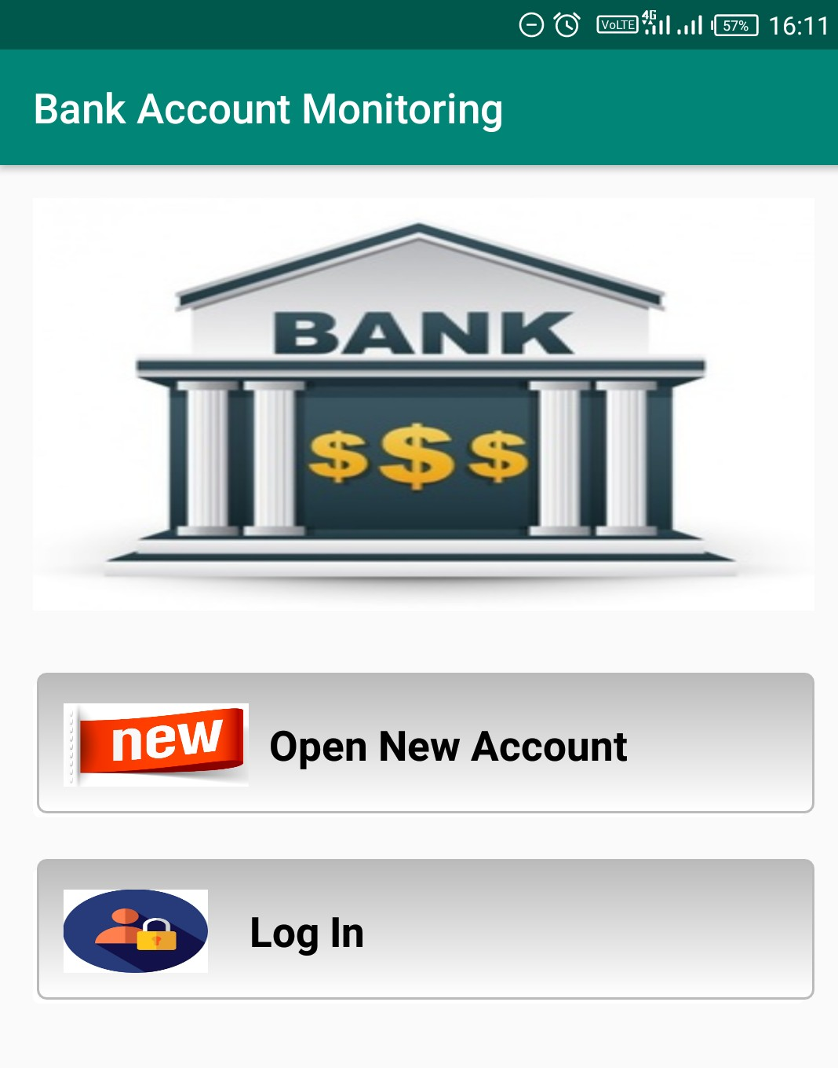
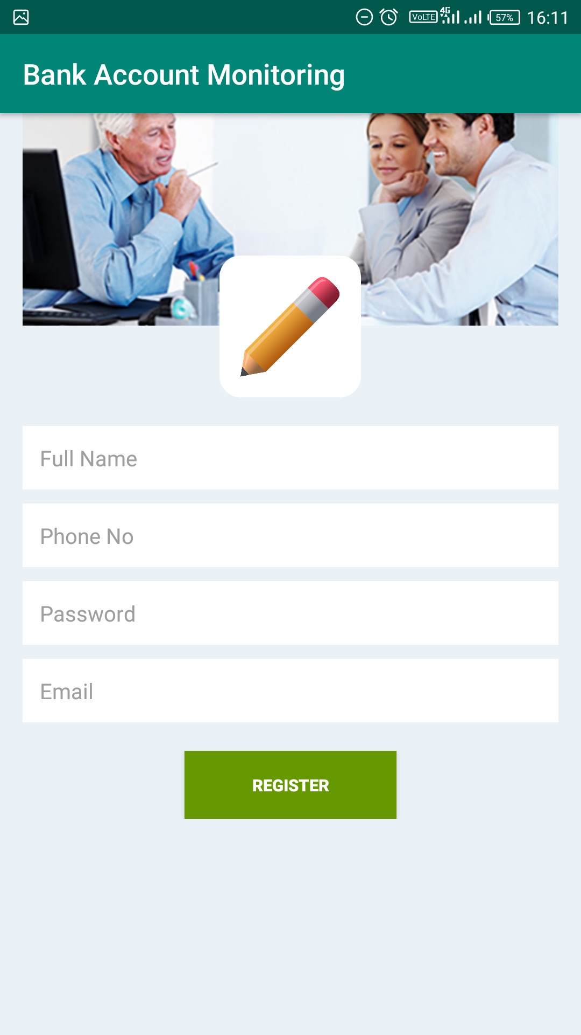
Registration page

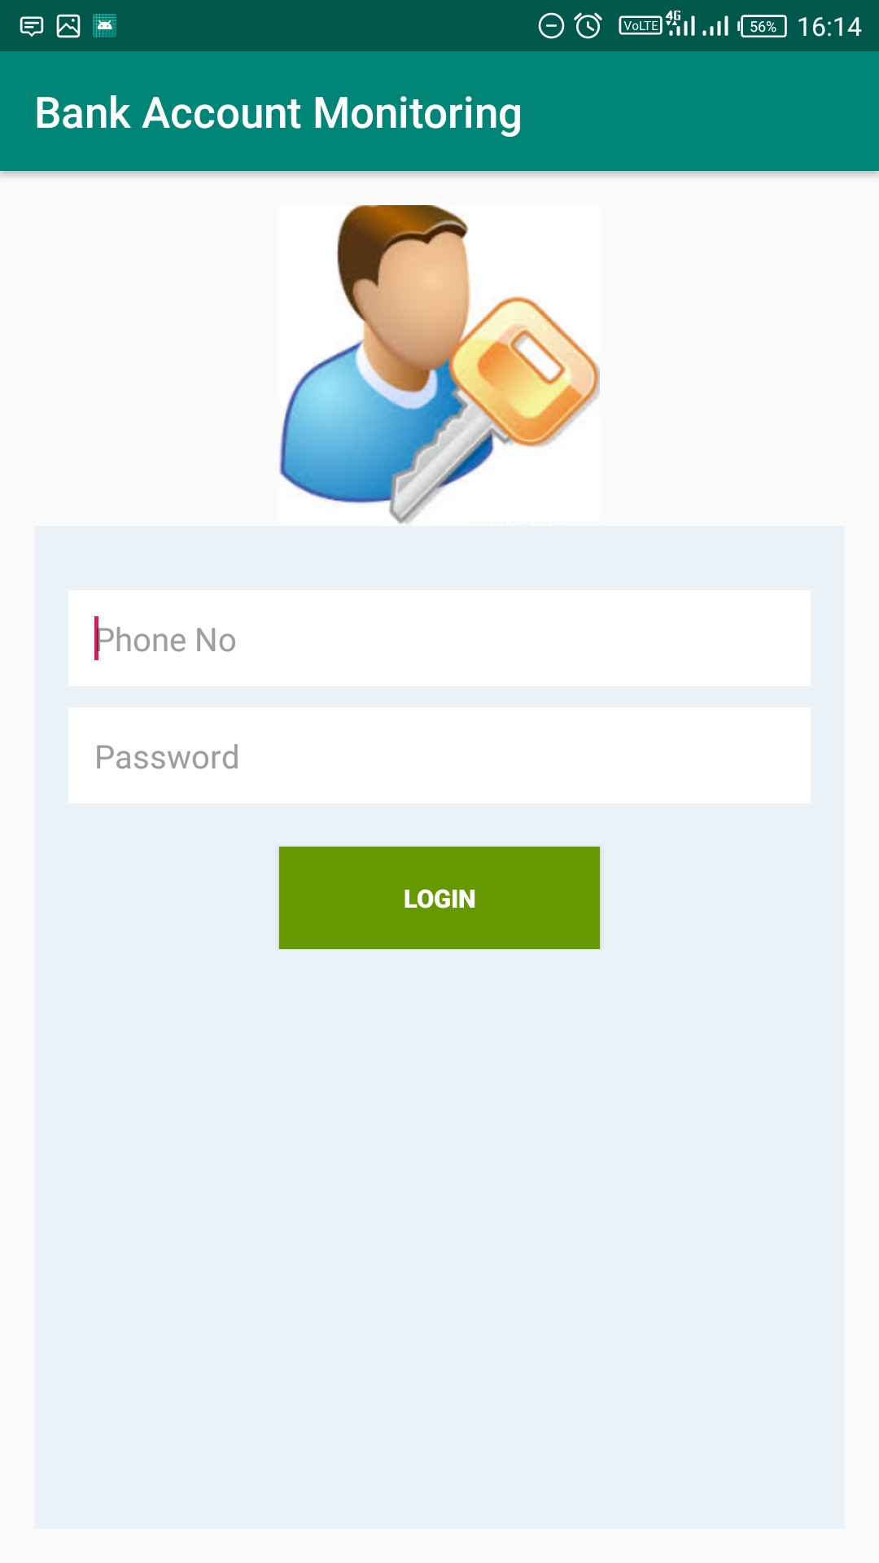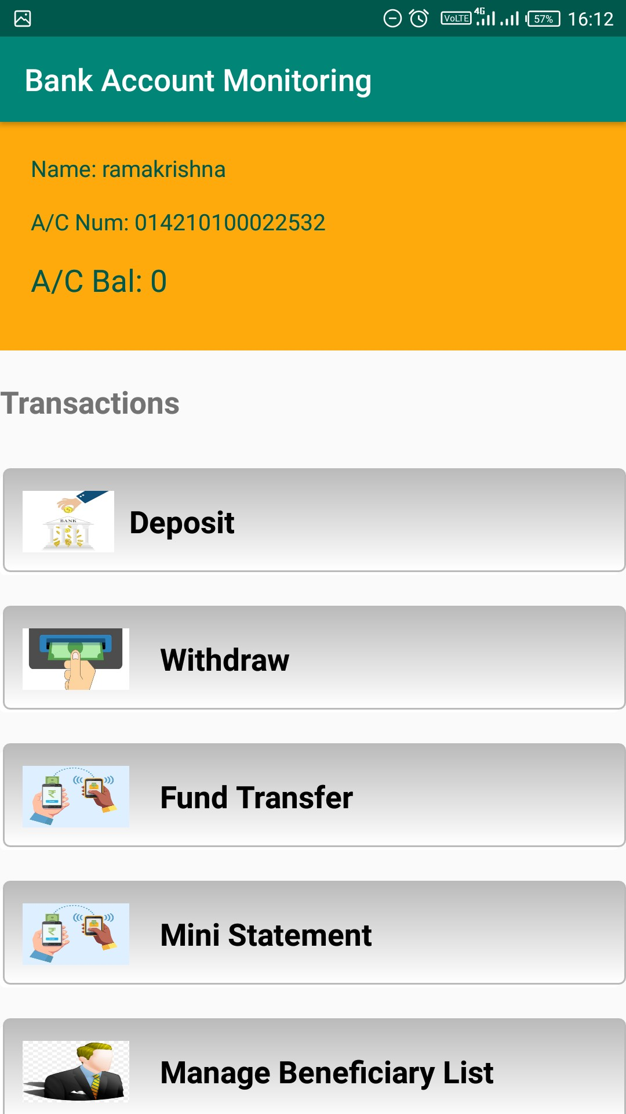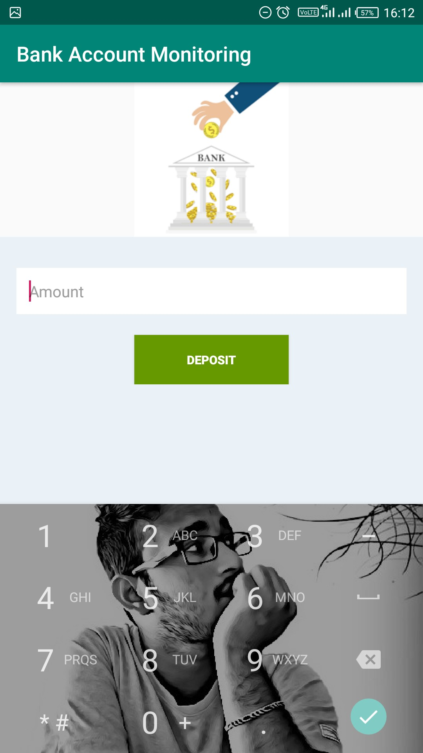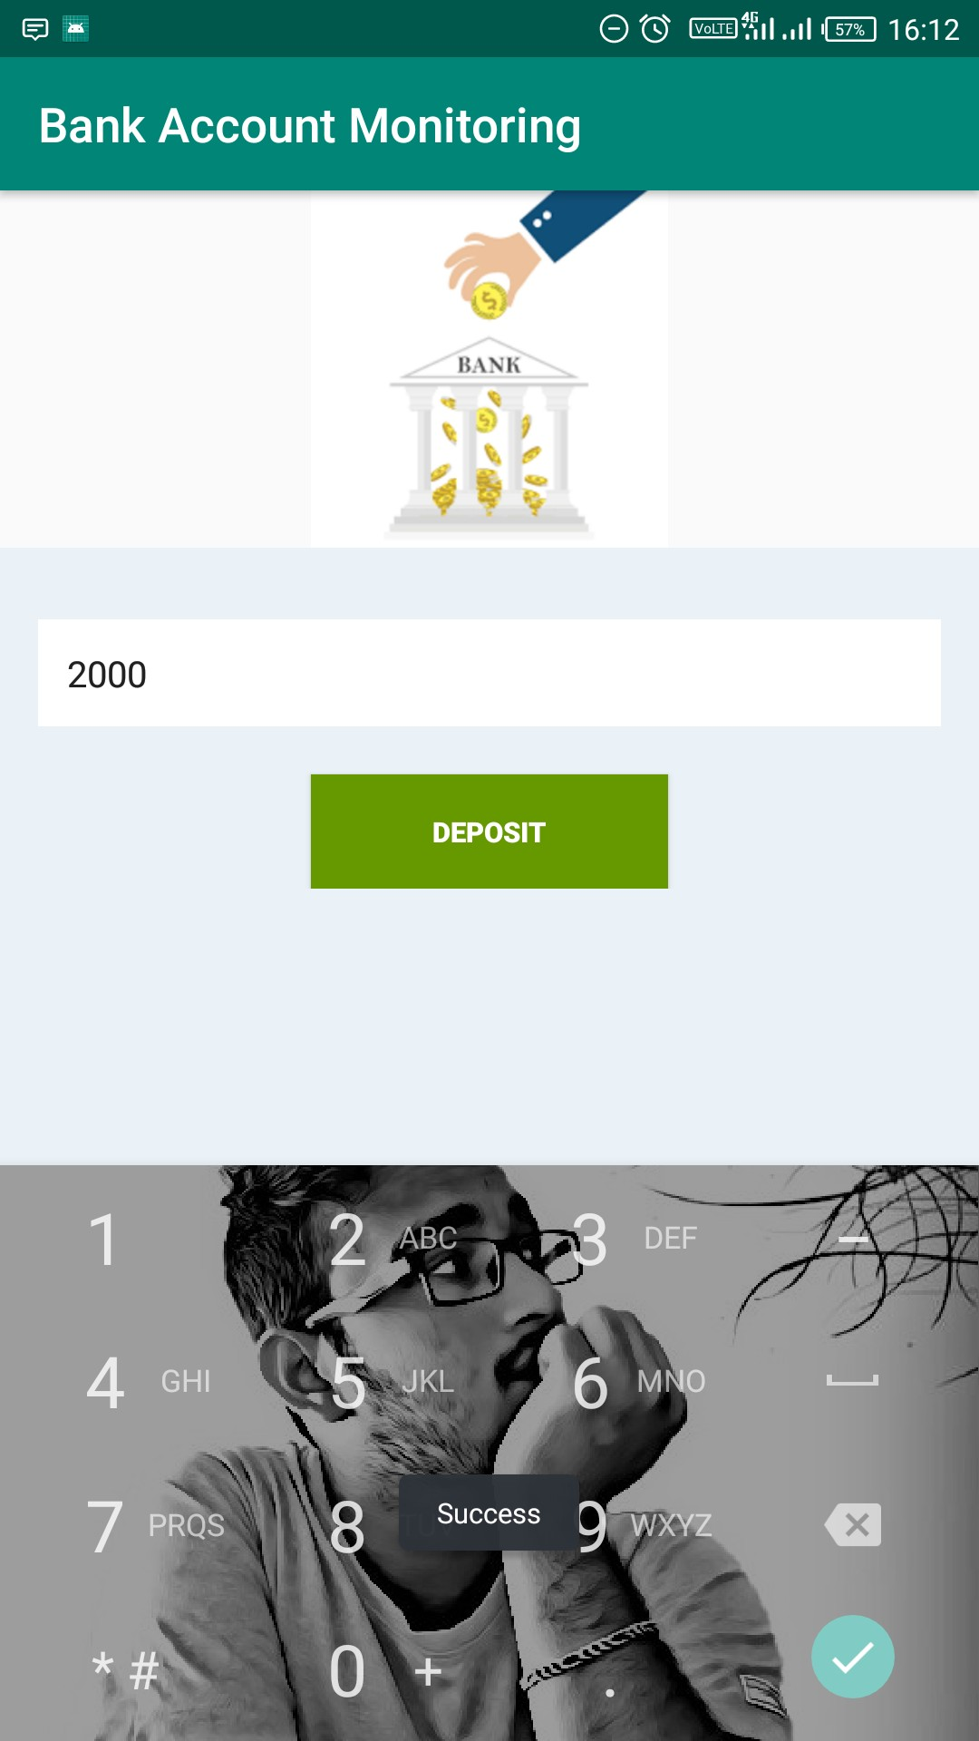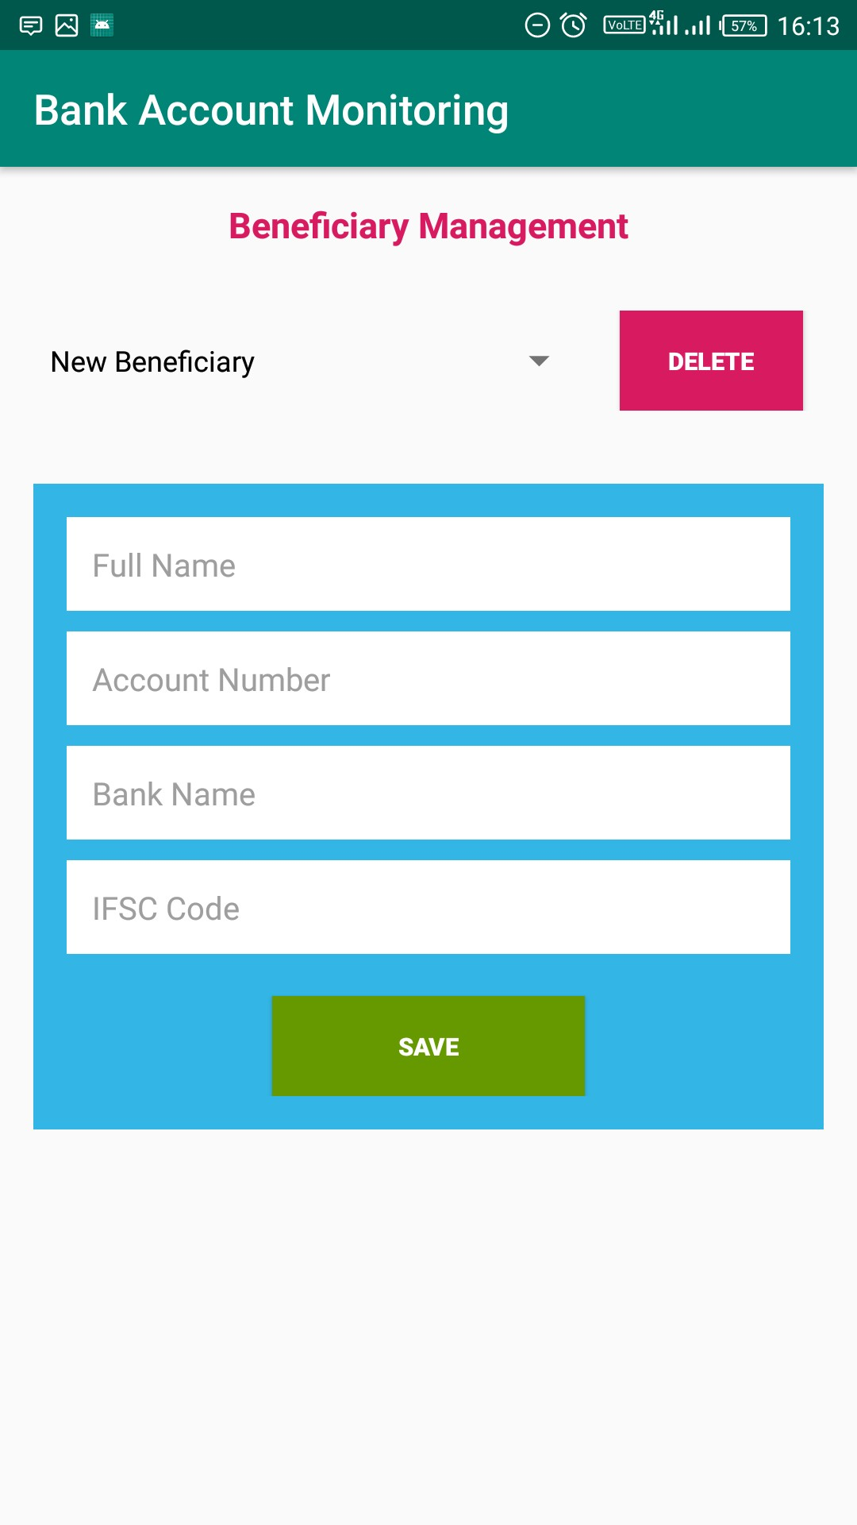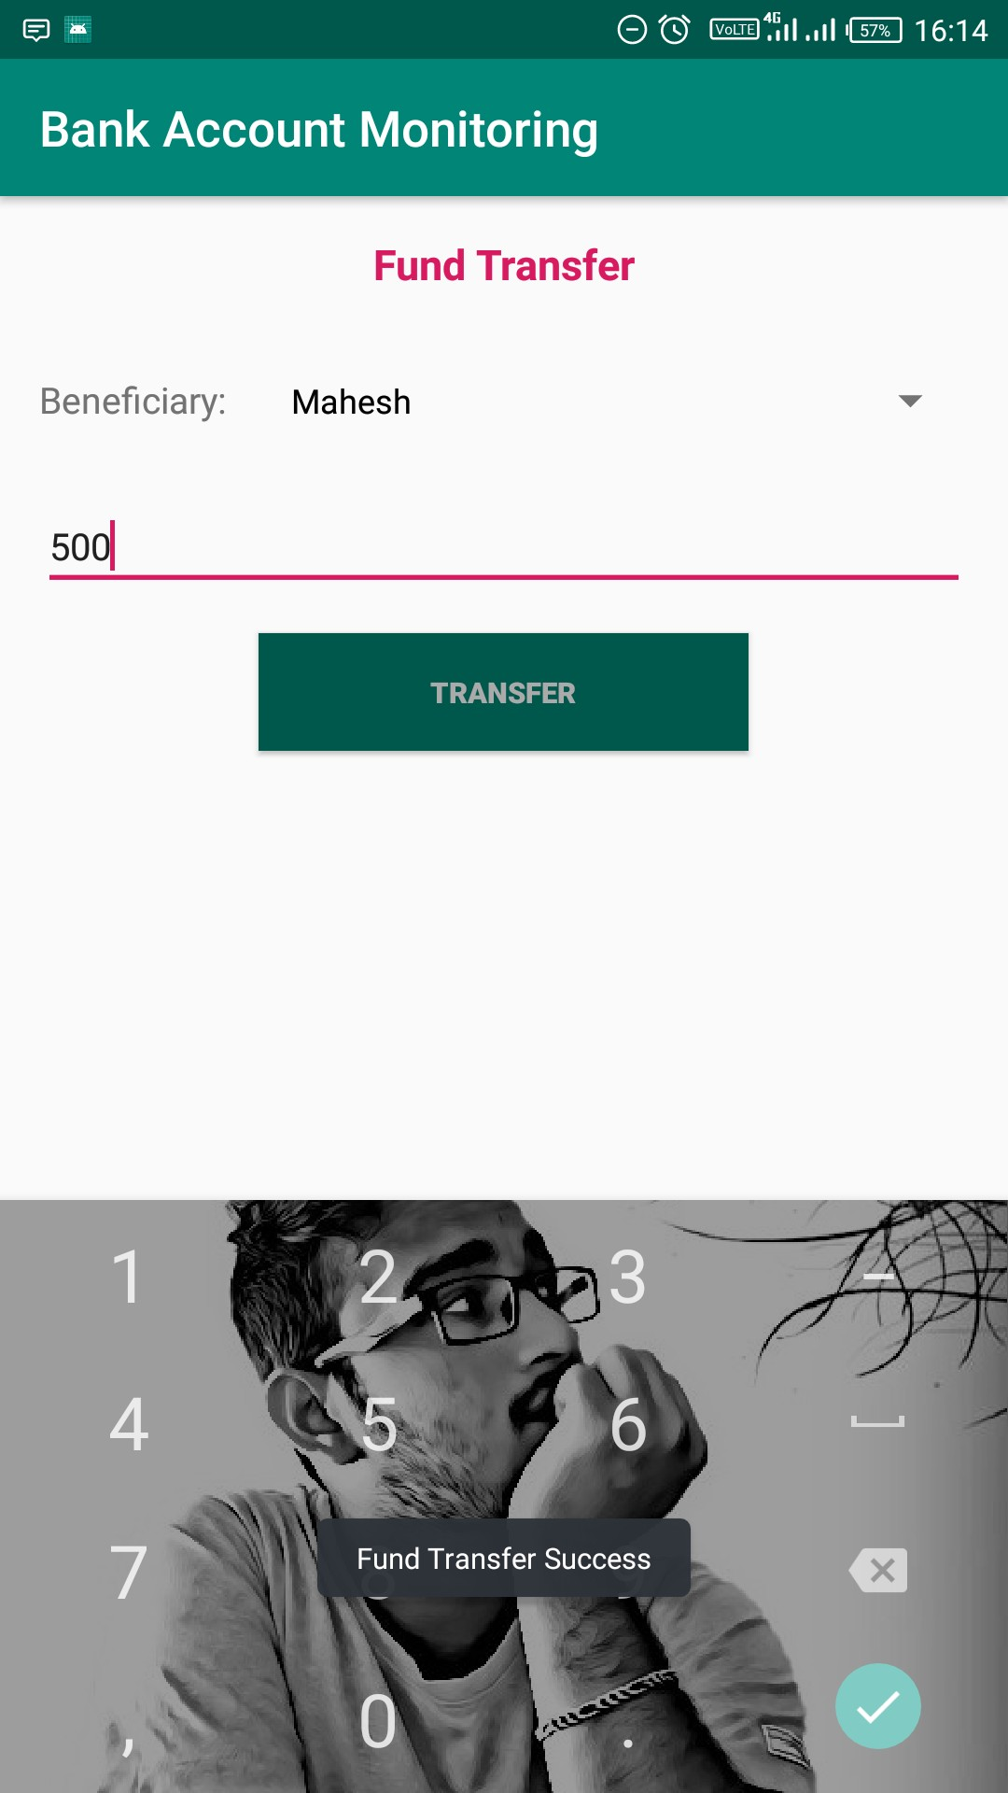
Login page
Main page
Depostit to Account
Adding Beneficiary details
Traner of funds to beneficiary
Transfer of funds

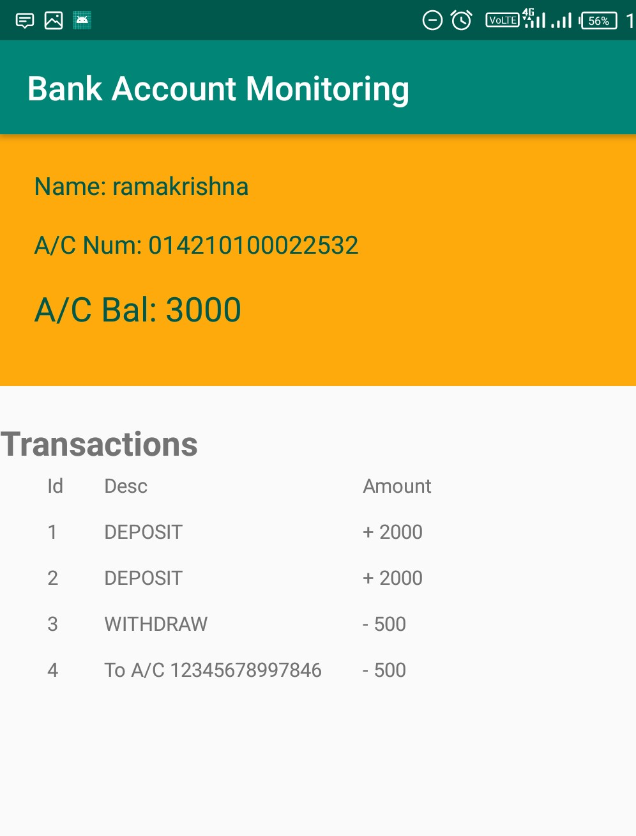

Ministatement

Chapter 6

Conclusion and Future Work

In order to overcome the existing system this website is created, it gives the online services to all the users who wants to deposit and transfer money and wants to check their account mini statement. This is the easiest and simple way to make transactions. By using this the bank monitors all the user’s details and stores them safely and securely. No other user cannot view other user details. Time management is saved.

The convenience of a Bank account monitoring is a major consideration for the users who likes to store their details securely. This monitoring is done throughout the day continuously.

Chapter 7

References

- Introduction to Android: http://developer.android.com/guide/index.html.
- Android API: http://developer.android.com/reference/packages.html
- Java 6 API: http://docs.oracle.com/javase/6/docs/api/
- Android Fundamentals: http://developer.android.com/guide/components/fundamentals.html
- The Java Tutorials: http://docs.oracle.com/javase/tutorial/
- Android User Interfaces: http://developer.android.com/guide/topics/ui/index.html
- Layout: http://developer.android.com/guide/topics/ui/declaring-layout.html
- Common Tasks: http://developer.android.com/guide/appendix/faq/commontasks.html
- Google Maps: http://code.google.com/android/add-ons/google-apis/maps-overview.html
- Iconography: http://developer.android.com/guide/practices/ui_guidelines/icon_design.html
- Sample Source Code: http://developer.android.com/resources/samples/get.html
- Android Training: http://developer.android.com/training/index.html.
- Android Developer's Blog: http://android-developers.blogspot.com/
- Developer FAQ: http://developer.android.com/resources/faq/
- Developer Forums: http://developer.android.com/resources/community-groups.html
- Android Developer's Group: http://groups.google.com/group/android-developers?lnk=
- XDA-Developers Forums: http://forum.xda-developers.com/

